HW10: สลากกินแบ่งรัฐบาล
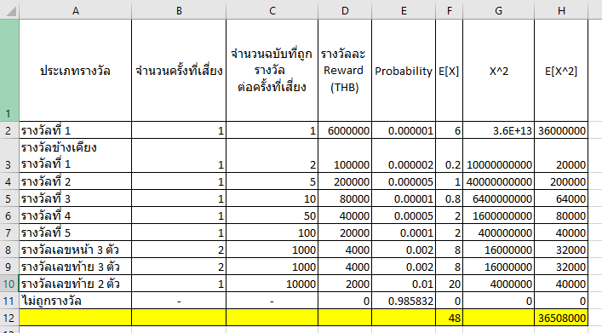
Stochastic optimization
1. Calculate the probability of winning each prize
ตอบ [=E2:E11]
2. Calculate the expectation of the reward.
ตอบ 48 [=SUMPRODUCT(E2:E11,D2:D11)]
3. (optional) Calculate the variance and the standard deviation of the reward. (Need to account for the case when reward=0“ถูกกิน”)
ตอบ Var = 36,505,696 [=H12 - (F12^2)], std = 6041.99 [=SQRT(36,505,696)]
4. Unit cost of lottery ticket 𝑐=80 THB. If we make a decision based on the expected profit (reward – cost), should we buy a lottery ticket or not?
ตอบ E[profit] = E[reward] – E[cost] = 48 – 80 = -32, ดังนั้นเราไม่ควรซื้อ lottery ticket เพราะให้ผลตอบแทนเฉลี่ยติดลบ

Simulation optimization
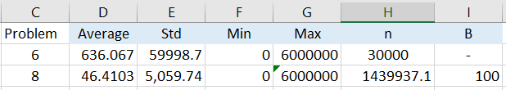
5. Excel: Simulate 𝑛=30,000 replications. Use seed 123
6. Compute the following statistics of rewards.
7. If we want the half width of the 95% confidence interval to be 𝐵=100, what should be the number of replications?
ตอบ 1,439,937.1 [=(4*(E2^2)) / ($I$3^2)]
8. Repeat problem 6 using the number of replications found from 7.

Appendix


