CHAPTER 2
CRITICAL LITERATURE REVIEW
AI-Based Smart Load Shedding and Energy Management System
for Developing Countries: A Sudan Case Study
Murtada Asim Ibrahim Bakhit (18-317)
Suliman Elawad Suliman Babiker (18-310)
Abdalhay Abass Mobarak Abass (15-306)

2.1 Introduction
The literature review presented in this chapter synthesises and critically evaluates 52 peer-reviewed publications spanning eight interconnected thematic areas, collectively constituting the scholarly foundation of the present work. The review adopts a methodological rather than purely thematic organisation, tracing the intellectual trajectory of the field from conventional rule-based and optimisation-driven load shedding approaches, through the emergence of machine learning and deep learning techniques, to the frontier of deep reinforcement learning (DRL) systems. This progression is not merely chronological — it reflects the field's evolving understanding of what the load shedding problem fundamentally requires: real-time adaptability, contextual intelligence, and a principled treatment of competing human priorities.
The review is organised around three overarching intellectual movements. The first movement covers the traditional engineering baseline — the optimisation methods, rule-based schemes, and classical computational intelligence techniques that defined the field prior to the DRL revolution and against which any AI-based system must be compared. The second movement surveys the broader AI and machine learning landscape in smart grids, including demand forecasting methods and microgrid energy management systems, establishing the algorithmic toolkit from which the present project draws. The third movement examines the three dimensions of the research gap that no existing study has simultaneously addressed: critical load priority in load shedding, fairness and equity in resource allocation, and the specific electricity crisis context of developing countries such as Sudan.
Throughout, the review maintains a critical stance — acknowledging genuine contributions while interrogating assumptions, exposing methodological limitations, and progressively building the case that the present work occupies a unique and necessary position in the literature. The final section synthesises these threads into an explicit statement of the research gap that the proposed AI-based smart load shedding system for Sudan is designed to fill.

2.1.1 Research Objectives and Questions
The present work is guided by four principal research objectives, each of which is addressed by the literature reviewed in this chapter: (1) to design and implement a DRL-based decision-support system capable of making real-time load shedding decisions under chronic supply deficit conditions; (2) to develop a domain-specific load priority framework that protects hospitals, water pumping stations, and bakeries from disconnection; (3) to integrate a geographic fairness mechanism ensuring equitable distribution of the shedding burden across consumer areas; and (4) to ground the system's synthetic simulation environment in the documented grid parameters of Sudan's electricity sector.
These objectives collectively respond to four research questions: (RQ1) Can DRL make faster and more adaptive load shedding decisions than traditional optimisation methods in a chronic supply deficit environment? (RQ2) Can domain-specific priority constraints be incorporated into a DRL reward function without compromising system stability? (RQ3) Can formal fairness metrics reduce inequitable blackout distribution between geographic areas? (RQ4) Can synthetic simulation grounded in Sudan's grid parameters provide a valid training environment for the DRL agent?

2.1.2 Definition of Key Terms
The following operational definitions establish the conceptual basis for the review and the proposed system:
Load Shedding: The deliberate disconnection of electrical consumers from the power grid in response to a deficit between available generation capacity and total demand. In this work, load shedding refers specifically to the chronic, scheduled variety experienced in Sudan and other developing countries, rather than the transient emergency response addressed in most of the DRL literature.
Deep Reinforcement Learning (DRL): A class of machine learning algorithms in which an agent learns a policy for sequential decision-making by interacting with a simulated environment, receiving scalar reward signals, and iteratively improving its action selection through experience. DRL combines deep neural networks for state representation with reinforcement learning for policy optimisation.
Critical Load: An electrical load whose disconnection carries disproportionate humanitarian, health, or social consequences. In the present work, critical loads are operationally defined as hospitals and healthcare facilities, water pumping and treatment stations, and bakeries — consistent with the minimum critical load definition of Rosales-Asensio et al. (2022).
Fairness (Geographic): The equitable distribution of load shedding burden across geographic areas or consumer groups, such that no area systematically bears disproportionately longer blackout periods relative to others over time. Operationalised using the envy-freeness criterion of Oluwasuji et al. (2020) adapted to area-level rather than household-level allocation.
Synthetic Data: Artificially generated data that replicates the statistical properties and structural characteristics of a target real-world system without being collected from that system directly. In the present work, synthetic data is generated from Sudan's documented macro-level grid parameters and Sub-Saharan African consumption patterns in the absence of directly available operational grid data.
Markov Decision Process (MDP): A mathematical framework for modelling sequential decision-making under uncertainty, comprising a state space, action space, transition function, and reward function. The load shedding problem is formulated as an MDP in which the DRL agent observes grid state, selects a shedding action, and receives reward signals reflecting both technical performance and fairness/priority objectives.
Energy Justice: A normative framework for evaluating the equity dimensions of energy systems, comprising distributional justice (who bears costs and benefits), recognition justice (whose needs are acknowledged), and procedural justice (how decisions are made), as defined by Jenkins et al. (2016).

2.1.3 Conceptual Framework
The present work operates at the intersection of three theoretical frameworks, each of which is represented in the literature reviewed in subsequent sections. The primary framework is Design Science Research (DSR), which guides the construction and evaluation of the DRL artifact: the system must be sufficiently novel with respect to the existing knowledge base — demonstrated by this literature review — and sufficiently useful — demonstrated by comparison with traditional and DRL baselines (Hevner and Chatterjee, 2010). The secondary framework is the Safe Reinforcement Learning paradigm of García and Fernández (2015), which provides the theoretical basis for incorporating hard safety constraints — the priority protection of critical services — into the DRL optimisation criterion. The tertiary framework is the Energy Justice model of Jenkins et al. (2016), which provides the normative basis for the fairness dimension: the claim that equitable distribution of shedding burden is not merely a technical objective but an ethical obligation grounded in distributional, recognition, and procedural justice principles.
These three frameworks are not independent — they form an integrated conceptual structure. DSR establishes the artifact-oriented epistemology: the present work generates knowledge through the design and evaluation of a constructed system. Safe RL provides the technical mechanism: hard constraints in the reward function enforce the ethical obligations identified by Energy Justice theory. And Energy Justice grounds the normative claims: the specific choice of hospitals, water stations, and bakeries as critical loads, and the geographic fairness criterion, are not arbitrary design choices but reflect the humanitarian evidence reviewed in Sections 2.6 and 2.8.
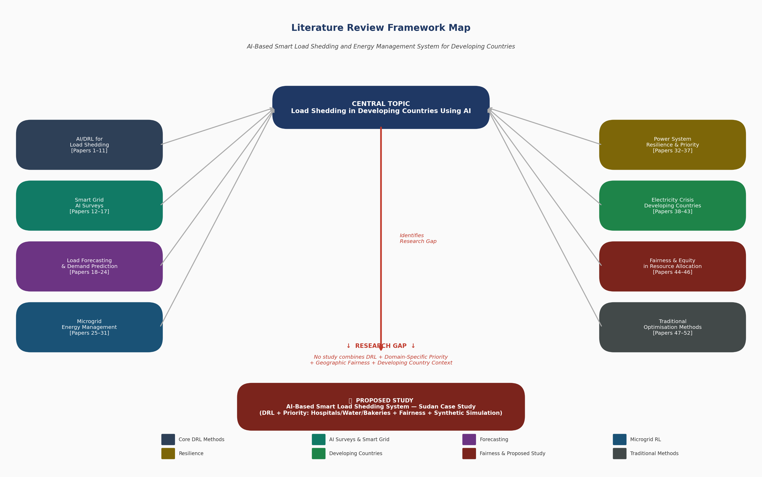
Figure 2.1: Literature Review Framework Map — Eight Thematic Areas Contributing to the Proposed Study

2.2 Traditional Methods for Load Shedding and Energy Management

2.2.1 Conventional Load Shedding Schemes
The foundational challenge of load shedding — determining how much load to disconnect, where, and when — has been addressed through engineering practice for decades before the emergence of AI-based approaches. Understanding these conventional methods is essential not merely for historical completeness but because they constitute the baseline against which any intelligent system must demonstrate improvement. Larik et al. (2019) provide the most comprehensive review of the state of the art in under-voltage load shedding (UVLS) schemes, documenting the evolution from simple fixed relay settings through semi-adaptive schemes to computational intelligence approaches. Their review is revealing in one critical respect: even the most sophisticated conventional UVLS schemes suffer from a fundamental rigidity — fixed relay settings calibrated for average conditions cannot adapt to the full range of contingency severity that a real power system encounters. A relay set to shed 15% of load in response to a voltage violation will shed 15% whether the underlying fault is minor or catastrophic, and will shed from the same buses regardless of the critical nature of the connected load.
This rigidity has well-documented consequences. Larik et al. (2019) cite the 2012 Indian blackout that left 670 million people without power and the 2009 Brazilian blackout affecting 87 million people as exemplary cases where inadequate under-frequency and under-voltage protection contributed to catastrophic cascading failures. These are not isolated incidents — they reflect a systemic limitation of rule-based approaches in the face of the nonlinear, high-dimensional dynamics that characterise power systems under stress.
Amraee et al. (2011) represent one of the most sophisticated traditional responses to this limitation, proposing an adaptive model predictive control (MPC) scheme for UVLS that adjusts both the amount of load shed and the speed of the shedding response based on the measured severity of the voltage stability margin violation. This was a genuine advance — by incorporating a predictive model of system dynamics, MPC could outperform fixed-relay schemes across a wider range of contingencies. However, MPC carries its own critical limitation: the accuracy of its predictions depends entirely on the fidelity of the underlying system model. In power systems characterised by high renewable penetration, uncertain load behaviour, or — crucially — the chronic supply deficits typical of developing-country grids, no reliable model may be available. Furthermore, MPC operates on a receding horizon of seconds to minutes, making it unsuitable for the sub-second response times that modern power system protection increasingly demands.

2.2.2 Optimisation-Based Approaches
A parallel tradition of load shedding research has employed mathematical optimisation to find the minimum-cost shedding solution subject to power system constraints. Larik et al. (2018) proposed a hybrid genetic algorithm and particle swarm optimisation (GA+PSO) approach that uses the fast voltage stability index (FVSI) to identify electrically weak buses and then optimises the amount of load shed across those buses to restore voltage stability. Tested on the IEEE 30-bus system, their hybrid outperformed standalone GA and PSO, achieving 75% less load shedding and converging 53% faster. The synergy is conceptually elegant: GA provides global search accuracy while PSO provides computational speed, and the combination addresses the weaknesses of each.
Sarwar et al. (2020) extended the optimisation paradigm by incorporating an explicit load priority structure into a mixed integer linear programming (MILP) framework for islanded distribution systems. Their approach classified loads into three tiers — non-critical, semi-critical, and critical — and used the voltage stability index to rank unstable loads within each tier before solving the MILP to find the optimal shedding combination. Tested on both a 28-bus Malaysian distribution network and the IEEE 69-bus system, the method successfully avoided frequency overshoot and protected critical loads against disconnection. This work is important because it explicitly acknowledges that not all loads are equal — a recognition that places it ahead of most optimisation approaches and directly anticipates the priority framework of the present work.
Similarly, Talaat et al. (2020) applied the Grasshopper Optimisation Algorithm (GOA) to the UFLS problem, optimising simultaneously for minimum load shed and maximum lowest swing frequency — two objectives that conventional methods struggle to satisfy simultaneously. Published in the prestigious Elsevier journal Energy, their work demonstrated that bio-inspired optimisation could achieve what gradient-based methods could not: a Pareto-optimal balance between competing objectives in a nonlinear system.
Critically, however, all optimisation-based approaches share a common limitation that becomes decisive in the context of the present work: they are computationally intensive, requiring solution times that range from seconds to minutes depending on system size. In a power system emergency — where frequency or voltage instability can propagate to cascade failure within milliseconds — this computational latency is unacceptable. Furthermore, optimisation approaches are inherently model-dependent: they optimise within a mathematical representation of the power system that must be accurate for the solution to be valid. In the context of Sudan's under-instrumented, data-sparse grid, constructing such a model with sufficient fidelity presents an almost insurmountable practical challenge.
The economic consequences of these limitations are not merely theoretical. Akpeji et al. (2020) document the macroeconomic impact of South Africa's rotational load shedding programme — the archetypal traditional fixed-schedule approach — finding that backup generator costs for commercial firms run 100 to 300 percent above grid electricity prices, and that the cumulative economic damage of extended rotational shedding is equivalent to a large-scale blackout. This finding contextualises the entire load shedding problem within an economic justice framework: the status quo is not merely technically suboptimal, it is economically harmful in ways that fall disproportionately on those least able to absorb the cost.

2.3 Machine Learning and Deep Learning in Smart Grids

2.3.1 The Emergence of AI in Power Systems
The application of machine learning and deep learning to smart grid problems represents one of the most significant methodological shifts in power systems engineering of the past two decades. Ramchurn et al. (2012), writing in the flagship journal Communications of the ACM, identified the smart grid as a 'grand challenge for artificial intelligence', arguing that the complexity, scale, and real-time demands of modern power systems fundamentally exceed the capabilities of classical control and optimisation methods. With 717 citations, this paper effectively framed the intellectual agenda that has driven the field since. The core argument — that distributed, adaptive, learning-based systems are not merely preferable but necessary for managing the smart grid — remains the foundational premise of the present work.
Zhang, Han and Deng (2018) provided the first comprehensive mapping of deep learning and reinforcement learning applications across all major smart grid domains, covering load forecasting, microgrid energy management, demand response, fault detection, and cybersecurity. Their review, which has accumulated 722 citations, is notable for documenting the rapid pace of adoption: at the time of writing, DRL applications to power systems were still emerging, but the trajectory was unmistakeable. Zhang, Zhang and Qiu (2020) extended this analysis with a specific focus on DRL, providing a structured overview of DQN, DDPG, A3C, and PPO applications across energy management, demand response, and electricity market bidding — a paper that has become the standard reference point for the field with 757 citations.
Massaoudi et al. (2021) complemented these surveys with a bibliometric analysis of 220 deep learning papers in smart grids, identifying the most productive research clusters and forecasting future growth areas. Their work is particularly valuable for situating the present research within the broader scholarly landscape: they identify reinforcement learning for real-time control and edge intelligence for low-data environments as two of the most promising emerging directions — both directly relevant to a DRL system deployed in Sudan's data-sparse grid. Glavic (2019) provided perhaps the most intellectually sophisticated survey, organising RL and DRL applications by power system operating state — normal, preventive, emergency, and restorative — a framework that clarifies precisely where load shedding DRL sits within the broader landscape: in the emergency operating state, where speed and reliability are paramount.

2.3.2 Load Forecasting and Demand Prediction
Accurate load forecasting constitutes a critical enabling capability for the present work, specifically because the DRL agent's state space must include predictive information about the anticipated supply-demand gap — enabling proactive shedding decisions rather than purely reactive responses to measured voltage or frequency violations. The gap between this work's chronic supply deficit context and the transient emergency context of most DRL load shedding papers makes forecasting a particularly important design consideration: in Sudan's grid, the deficit is not a surprise but a structural condition that can and must be anticipated.
The field has progressively moved from statistical time series models toward deep learning architectures capable of capturing the complex nonlinear dependencies in electricity demand. Bedi and Toshniwal (2018) demonstrated the value of preprocessing in this context, using Empirical Mode Decomposition (EMD) to decompose non-stationary load signals into intrinsic mode functions before feeding each component to a separate LSTM network. Tested on city-level consumption data from Chandigarh, India, their hybrid EMD-LSTM approach outperformed standalone RNN and LSTM baselines, establishing the principle that temporal preprocessing and deep learning complement each other in ways that neither achieves alone.
Convolutional architectures have proven particularly effective for load forecasting problems with spatial or multi-variate input structure. Del Real et al. (2020) demonstrated this compellingly, applying a CNN to extract a representative temperature feature from France's national temperature grid — treating the geographic distribution of temperature measurement points as an image — before feeding this spatial feature to an ANN for demand regression. The resulting system achieved a mean absolute percentage error of 1.49%, matching the commercial subscription-based forecasting service operated by RTE, France's transmission system operator. For the short-term forecasting horizon most relevant to load shedding decisions, Yu et al. (2019) combined Gated Recurrent Units (GRU) with Dynamic Time Warping (DTW) similarity matching to capture both temporal dynamics and historical pattern similarity in daily peak load prediction. Ullah et al. (2024) provided the most recent treatment, demonstrating a CNN-LSTM hybrid on Pakistan's national NTDC grid — the geographically and infrastructurally closest analogue to Sudan available in the peer-reviewed literature, achieving a MAPE of 2.72% for single-step forecasting.
A notable gap in the forecasting literature is the almost complete absence of Africa-specific demand forecasting studies. No published study applies deep learning forecasting methods to Sub-Saharan African load data at the granularity required for real-time load shedding decisions. This gap reinforces the justification for synthetic data generation in the present work: not only is Sudan's grid data unavailable for infrastructure reasons, but no validated model architecture has been established for the Sub-Saharan African demand context. The use of Pannakkong et al.'s (2023) Double DQN-based ensemble model selector for Thailand peak forecasting is noted as an interesting bridge between the forecasting and RL literatures, though its monthly granularity is insufficient for the sub-hourly decisions required here.

2.4 Deep Reinforcement Learning for Load Shedding
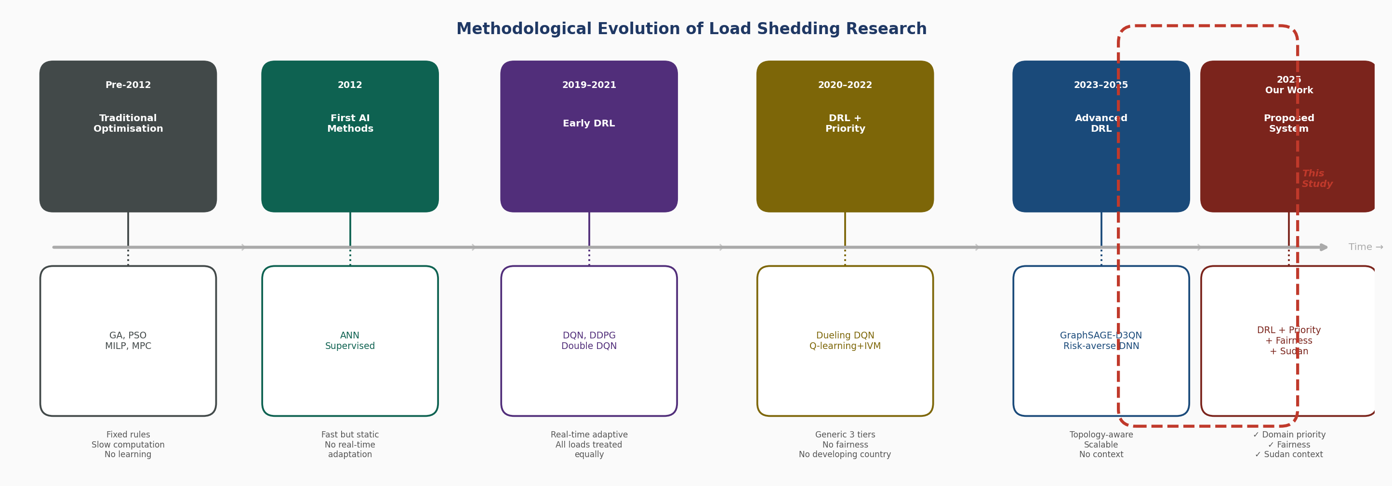
Figure 2.2: Methodological Evolution of Load Shedding Research — From Traditional Optimisation to the Proposed System

2.4.1 Theoretical Foundations
The theoretical basis for applying deep reinforcement learning to load shedding rests on the Markov Decision Process (MDP) framework, in which an agent observes a system state, selects an action, receives a reward, and transitions to a new state — iteratively learning a policy that maximises cumulative reward. Mnih et al. (2016) established the algorithmic foundation of modern DRL with the Asynchronous Advantage Actor-Critic (A3C) algorithm, demonstrating that asynchronous parallel training on a single multi-core CPU could surpass the performance of DQN across all Atari benchmark environments while training in half the time. With 15,245 citations, A3C remains one of the most influential papers in the DRL literature and introduced the actor-critic architecture that underlies many of the load shedding systems reviewed in this chapter.
The application of DRL to high-stakes physical systems, however, raises safety concerns that the standard RL framework does not address. García and Fernández (2015) provide the comprehensive theoretical treatment of this problem in their survey of Safe Reinforcement Learning, which has accumulated 2,954 citations across engineering, computer science, and AI research communities. They identify two fundamental approaches to safe RL: modifying the optimisation criterion to incorporate worst-case performance guarantees or risk-sensitive objectives, and modifying the exploration process to prevent the agent from taking catastrophically harmful actions during training. Their constrained criterion framework — treating safety requirements as hard constraints that cannot be violated regardless of the reward signal — provides the direct theoretical basis for the priority protection mechanism in the present work. In the load shedding context, the constraint is categorical: a hospital's power supply must never be disconnected regardless of the grid state or the agent's exploration trajectory.

2.4.2 Early DRL Applications to Power System Emergency Control
Huang et al. (2020) established deep reinforcement learning as a viable paradigm for power system emergency control, demonstrating a DQN-based system capable of learning adaptive control policies — including under-voltage load shedding and generator dynamic braking — through interaction with the open-source RLGC simulation platform. Their contribution was twofold: a technical demonstration that DRL could outperform model predictive control in emergency scenarios while remaining robust to parameter uncertainty and observation noise, and an infrastructural contribution in the form of RLGC, which made DRL power system research reproducible and accessible. With 518 citations, this work effectively defined the research agenda that the subsequent literature has pursued.
The supervised learning precursor to this DRL tradition deserves acknowledgement. Hooshmand and Moazzami (2012) trained an artificial neural network on 138 synthetic contingency scenarios to predict optimal under-frequency load shedding in isolated power systems, achieving a computation time of 1.9 seconds compared to the minutes required by traditional methods and reducing load shedding in 90% of tested cases. While the ANN approach lacks the online adaptability of DRL, this work established two foundational principles: that AI can learn the nonlinear mapping from grid state to optimal shedding action, and that synthetic scenario generation is both necessary and sufficient for training purposes in the absence of real operational data — directly validating the synthetic simulation approach of the present work.

2.4.3 Algorithm Diversity and Architectural Innovation
Following Huang et al. (2020), the DRL load shedding literature diversified rapidly across algorithm types and architectural innovations. Li et al. (2022) employed Deep Deterministic Policy Gradient (DDPG) to address the continuous action space of load shedding — where the optimal amount to shed at each bus is not a discrete choice but a continuous variable. Zhang et al. (2023) demonstrated that Dueling DQN could achieve a 30% reduction in total load shed compared to conventional UVLS schemes for short-term voltage instability in large-scale power systems. Chen et al. (2023) addressed the growing challenge of high renewable energy penetration, where the intermittent nature of solar and wind generation makes event-driven conventional shedding schemes inadequate — a problem of particular relevance to Sudan, where Al-Rikabi et al. (2025) document ambitious renewable energy targets that will significantly alter the grid's generation profile.
Liu et al. (2022) introduced a risk-averse dimension to DRL load shedding, training a deep neural network to classify transient stability status while explicitly penalising high-consequence shedding decisions — reducing risky decisions by 40% compared to MPC and SVM baselines. This risk-averse framing is conceptually aligned with the Safe RL framework of García and Fernández (2015). The most architecturally innovative contribution in this domain is that of Pei et al. (2023), who combined GraphSAGE graph neural network encodings of network topology with a D3QN agent to produce a topology-aware UVLS system. The system reduced load shedding from 226 MW to 93.5 MW compared to a standard D3QN baseline, achieving decision times below 10 milliseconds compared to 0.983 seconds for model predictive control — a speed advantage directly relevant to the real-time demands of load shedding in a chronically stressed grid.

2.4.4 Priority-Aware DRL Load Shedding
A critical limitation of the DRL load shedding papers discussed thus far is their treatment of all loads as equivalent. The reward functions of Li et al. (2022), Zhang et al. (2023), Chen et al. (2023), and Pei et al. (2023) are formulated exclusively around voltage or frequency recovery objectives, with no differentiation between the loads being shed. A second generation of studies began to address this gap by incorporating load priority directly into the DRL framework.
Wang et al. (2020) introduced a three-tier priority classification — critical, interruptible, and non-critical — into the reward function of a Double DQN agent for coordinated load shedding in islanded microgrids. Wang et al. (2021) extended this approach using a Dueling DQN architecture on a modified IEEE-25 bus microgrid, demonstrating a decision time of 23.9 milliseconds — significantly faster than the 35.6 milliseconds of conventional intelligent energy load shedding schemes — while maintaining the three-tier structure. Horri and Roudsari (2022) went further, incorporating four load characteristics simultaneously into their Q-learning reward function: priority level, load dynamics, outage cost, and daily consumption variation.
These contributions are genuinely significant and directly inform the design of the present work. However, a critical examination reveals two persistent limitations. First, the priority tiers in these studies are defined generically — critical, semi-critical, and non-critical — without grounding in specific real-world service categories. The substantive difference between a hospital's emergency department, a water pumping station, and a bakery is entirely absent from these formulations. Second, all three papers test their systems exclusively on standard IEEE test systems that bear no resemblance to the grid infrastructure of a developing country like Sudan. The specific challenges — chronic supply deficits, limited metering infrastructure, geographic inequality — documented by Basheir and Abdelrahman (2022) and Al-Rikabi et al. (2025) are entirely absent from these experimental contexts.

2.4.5 Critical Synthesis of the DRL Literature
The DRL load shedding literature has advanced with impressive speed from ANN supervised learning to graph-based DRL architectures capable of millisecond decisions at the scale of IEEE 300-bus systems. Yet the structured comparison of methods presented in Section 2.10 reveals that no existing DRL study has simultaneously achieved priority-aware shedding with domain-specific service categories, geographic fairness constraints, and contextualisation within a developing-country grid. This is the precise gap the present work addresses.
Critical observation: The methodological evolution from Traditional Optimisation → Early DRL → DRL+Priority demonstrates progressive technical capability — but each generation has advanced the engineering dimension while neglecting the social, ethical, and contextual dimensions that determine real-world deployability in developing countries. Technical sophistication alone is insufficient for a system intended to protect hospitals in Sudan.

2.5 Microgrid Energy Management with Reinforcement Learning

2.5.1 The Microgrid as a Laboratory for DRL Energy Management
The microgrid — a localised energy system capable of operating either connected to or isolated from the main grid — has served as the primary experimental arena for DRL-based energy management research. Its bounded scope, well-defined state space, and tolerance for experimental intervention make it an ideal environment for developing and validating DRL algorithms before scaling to larger systems.
Du and Li (2019) provided an early demonstration of DRL's capacity for multi-microgrid energy management, combining a deep neural network with Monte Carlo reinforcement learning to optimise energy trading between multiple microgrids from the distribution system operator's perspective. Ji et al. (2019) demonstrated real-time microgrid energy management using DQN on California ISO (CAISO) grid data, establishing the MDP formulation that has since become standard: state space comprising renewable generation forecast, electricity price, storage state of charge, and load demand; action space covering generation dispatch and storage decisions; reward function balancing economic cost against energy reliability. Alabdullah and Abido (2022) applied DQN to a real microgrid case study in Saudi Arabia — the geographically closest case study to Sudan available in the peer-reviewed literature.
Lei et al. (2021) addressed the Finite-Horizon planning problem by proposing FH-DDPG and FH-RDPG algorithms for energy dispatch in IoT-driven isolated microgrids. By explicitly accounting for the finite temporal horizon of practical energy management decisions, their approach outperformed standard DDPG and resolved the instability problems that infinite-horizon formulations encounter in isolated systems — a methodological insight directly applicable to Sudan's isolated grid segments.

2.5.2 Survey Evidence and Critical Assessment
Joshi et al. (2023), publishing in the IEEE/CAA Journal of Automatica Sinica — a journal with an impact factor of 19.2, the highest of any venue in the present collection — provide the most comprehensive survey of AI and machine learning techniques for microgrid energy management systems. Critically, they identify the integration of safety constraints and fairness considerations as among the most significant open problems in microgrid AI — a conclusion that directly validates the research agenda of the present work. Barbalho et al. (2025) confirm that the field has converged on DRL as the dominant methodology while acknowledging that real-world deployment remains limited by the gap between simulation performance and operational reliability.
A critical assessment of the microgrid energy management literature reveals a consistent limitation echoing the load shedding literature: the almost complete absence of developing-country contexts. All case studies — Saudi Arabia, China, Brazil, the United States — represent economies with relatively well-developed grid infrastructure. The specific conditions characterising Sudan's electricity system find no equivalent in the microgrid RL literature, reinforcing the need for the Sudan-specific synthetic simulation environment proposed in the present work.

2.6 Power System Resilience and Critical Load Priority

2.6.1 Resilience as a Framework for Load Shedding
The concept of power system resilience — the ability of a system to anticipate, absorb, and recover from high-impact disruptions — provides an important intellectual framework for contextualising load shedding. Afzal et al. (2021) draw a critical distinction fundamental to the present work: reliability addresses high-probability, low-impact events through probabilistic analysis, while resilience addresses high-impact, low-probability events through a four-phase framework of anticipation, absorption, recovery, and adaptation. Sudan's electricity crisis occupies an unusual position: it combines the regularity of a reliability problem with the magnitude of a resilience crisis, demanding a response that is simultaneously adaptive and principled.
Gautam (2023) provides a bridge between the resilience literature and the DRL methodology, surveying DRL applications across five resilience dimensions: dynamic response, recovery and restoration, energy management and control, communications and cybersecurity, and resilience planning and metrics. His work confirms that DRL has demonstrated value across the full spectrum of resilience challenges and identifies the integration of load priority into DRL resilience frameworks as an underexplored area — directly supporting the research agenda of the present work.

2.6.2 Critical Load Prioritisation Frameworks
Rosales-Asensio et al. (2022) propose a resilience framework that explicitly assigns higher weights to critical grid customers — hospitals, police stations, water facilities — in resilience metric calculations. Their operational definition of 'minimum critical load' is particularly useful: only the minimum load required for critical service operation should be protected, not the full connected load of a critical institution. This principle informs the granular priority framework of the present system. Vita et al. (2023) demonstrate the value of explicit critical load prioritisation in a post-blackout restoration context, using MILP to maximise critical load reconnection through distributed generation black-start capability.

2.6.3 Humanitarian Evidence for Critical Load Protection
The case for protecting hospitals, water pumping stations, and bakeries is not merely an engineering preference — it is supported by substantial evidence from public health and development economics. Irwin et al. (2020) conducted a systematic review of 33 studies on the relationship between electricity access and health outcomes in low- and middle-income countries, finding consistent evidence that poor electricity reliability is associated with increased morbidity, reduced quality of care, lower utilisation of health services, and preventable mortality. In clinical settings without reliable power, refrigeration of vaccines and medications fails, surgical lighting is interrupted, and medical equipment cannot be operated.
Nduhuura et al. (2021) complement this clinical evidence with household-level survey data from 496 households in Accra, Ghana — the Sub-Saharan African context most comparable to Sudan's urban electricity challenges. Their regression analysis identifies four principal dimensions of outage impact: safety and security, food access, social services, and appliance damage. Critically, their analysis reveals significant heterogeneity: households that are already socioeconomically disadvantaged suffer disproportionately greater harm. This finding — that conventional rotational load shedding systematically concentrates harm on the most vulnerable — provides the humanitarian foundation for the fairness dimension of the present work.

2.7 Electricity Crisis in Developing Countries and the Sudan Context

2.7.1 The Sub-Saharan African Electricity Crisis
The electricity crisis confronting Sub-Saharan Africa is structural rather than transient, rooted in decades of underinvestment, policy failures, and the political economy of energy sector reform. Bayliss and Pollen (2021), publishing in World Development, analyse the Zambian electricity sector as a case study in the contradictions of the standard policy paradigm, which frames Africa's electricity deficit as a 'financing gap' to be addressed through private capital attraction. Their analysis reveals that Zambia's experience with independent power producers has created long-term, dollar-denominated financial liabilities that have worsened the state utility's position — a finding with direct relevance to Sudan, where similar policy prescriptions have been applied with similar results.
The economic cost of this crisis is substantial. Carlsson et al. (2020), in a stated preference survey of 947 enterprises in Addis Ababa, Ethiopia, find that firms' willingness to pay for outage reduction is equivalent to a 16% tariff increase per outage avoided and a 33% increase per hour of outage duration reduced — with the total cost of the average firm's outage burden equivalent to approximately three times its monthly electricity bill. Khan et al. (2023) extend this economic argument to the AI domain, providing a comprehensive review of AI-enabled demand response approaches and demonstrating that AI-based demand-side management can reduce these costs significantly.

2.7.2 Sudan's Electricity Crisis: Structural Parameters and Context
Sudan's electricity crisis is among the most severe on the African continent. Al-Rikabi et al. (2025) provide the most technically detailed analysis available in the peer-reviewed literature, documenting an installed hydropower capacity of 1,907 MW providing 54.6% of national electricity generation, while grid-connected solar amounts to only 10 MW and wind to 0.8 MW despite Sudan's exceptional renewable energy potential. This extreme concentration in hydropower creates a structural vulnerability: drought, siltation of reservoirs, and seasonal river flow variation translate directly into generation shortfalls that the thermal generation mix cannot compensate.
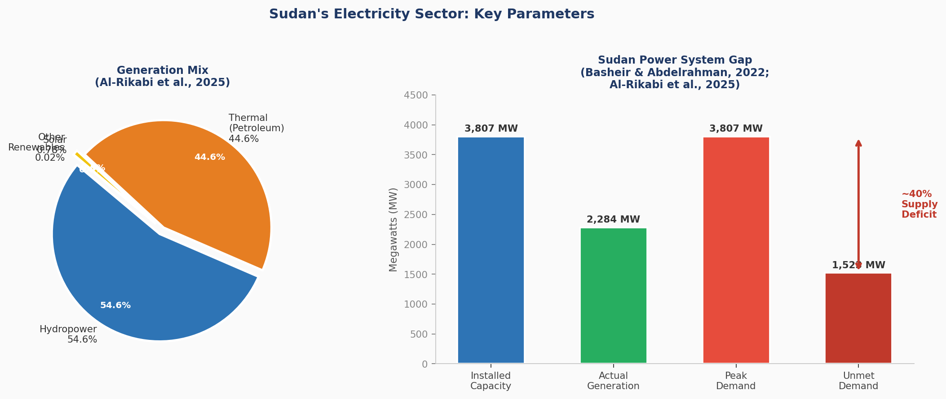
Figure 2.3: Sudan's Electricity Sector — Generation Mix and Supply-Demand Gap (Al-Rikabi et al., 2025; Basheir & Abdelrahman, 2022)
The consequence, as Basheir and Abdelrahman (2022) document in the most politically comprehensive analysis of the crisis, is that available generation capacity covers only approximately 60% of national demand, leaving a 40% structural supply deficit that is managed entirely through rotational load shedding. The geographic distribution of this burden is profoundly unequal: Khartoum consumes approximately 60% of national electricity supply while housing a minority of the national population — a distributional pattern reflecting decades of urban concentration in electricity infrastructure investment. The electricity subsidy system, which consumed 13% of total government expenditure in 2017, further distorts this picture by disproportionately benefiting those already connected to the grid.
Saeed et al. (2019) contextualise Sudan's crisis within the country's broader energy transition challenges following the secession of South Sudan in 2011, which cost Sudan approximately 75% of its oil revenues. This contextual analysis has direct implications for the design of the present system. A load shedding system for Sudan must be designed not for transient emergencies — the assumption embedded in virtually all existing DRL load shedding papers — but for chronic, predictable, extended supply deficits. The agent must learn not how to respond to an unexpected fault but how to allocate a permanent structural shortage fairly across competing consumer types and geographic areas.
Critical design implication: Sudan's electricity problem is fundamentally different from the emergency scenarios addressed in the DRL literature. This distinction has profound implications for agent design — the state space must encode deficit severity and duration rather than only voltage/frequency deviations, and the reward function must incorporate temporal fairness accumulated over days and weeks, not milliseconds.

2.8 Fairness and Equity in Energy Resource Allocation

2.8.1 Energy Justice as a Theoretical Framework
The question of how to distribute scarce electricity resources fairly has received sustained attention in the energy studies literature, where it is framed through the lens of energy justice. Jenkins et al. (2016), in the foundational paper of the energy justice field with 3,003 citations, propose a three-pronged framework comprising distributional justice (where injustices occur — who bears costs and who receives benefits), recognition justice (which groups are ignored or misrepresented), and procedural justice (how decisions are made). All three dimensions are directly implicated in the load shedding problem. The distributional dimension is most immediately relevant: when electricity is scarce, who goes without, for how long, and at what cost? The recognition dimension is implicated in the priority framework: treating hospitals as categorically different from other loads is itself a recognition claim — acknowledging that some services are essential to human dignity in ways others are not.

2.8.2 Formal Fairness Metrics for Load Shedding
Oluwasuji et al. (2020) provide the most direct treatment of this problem in the load shedding context, formulating the Fair Load Shedding Problem (FLSP) as a Multiple Knapsack Problem in which household utilities must be allocated fairly subject to the constraint that total connected load does not exceed available supply. They evaluate three social welfare metrics: utilitarian welfare (maximise the sum of utilities), egalitarian welfare (maximise the minimum utility), and envy-freeness (minimise pairwise utility differences). Their MIP solutions demonstrate that all three criteria can be simultaneously approximated, with the egalitarian and envy-free formulations providing significantly more equitable outcomes. The FLSP framework is directly applicable to the geographic fairness dimension of the present work, substituting geographic areas for individual households.

2.8.3 Algorithmic Fairness in AI Systems
Mehrabi et al. (2021), in a survey with 10,465 citations, provide a comprehensive taxonomy of bias sources and fairness definitions in machine learning systems. They identify six principal sources of bias and demonstrate how apparently neutral AI systems can reproduce and amplify existing social inequalities through feedback loops. The relevance to the present work is direct: a DRL agent trained on synthetic data reflecting Sudan's historically unequal electricity distribution risks learning to replicate those inequalities. The algorithmic fairness constraints incorporated into the present system's reward function — penalising cumulative area-level shedding inequality — are designed precisely to prevent this feedback loop.

2.9 Research Gap and Positioning of the Present Work

2.9.1 Synthesis of the Literature
The critical synthesis of 52 papers across eight thematic areas reveals a landscape of substantial technical progress marked by three persistent and interconnected gaps. The DRL load shedding literature has advanced from fixed-rule relay schemes through ANN supervised learning to sophisticated graph-based DRL architectures capable of millisecond decision-making and topology-aware generalisation. Yet as the structured comparison of methods in Section 2.10 demonstrates, no existing DRL load shedding study has simultaneously incorporated all three features that the present work argues are essential for real-world deployment in a developing country: domain-specific critical service protection, geographic fairness constraints, and simulation grounded in developing-country grid parameters.
The priority-aware DRL studies of Wang et al. (2020), Wang et al. (2021), and Horri and Roudsari (2022) are the closest existing approaches, but share a fundamental limitation: their priority frameworks are generic abstractions rather than domain-specific structures grounded in the humanitarian evidence provided by Irwin et al. (2020) and Nduhuura et al. (2021). The fairness literature, represented by Oluwasuji et al. (2020) and theoretically grounded in Jenkins et al. (2016) and Mehrabi et al. (2021), has established that equitable load shedding is both achievable and important. However, Oluwasuji et al.'s MIP-based approach cannot achieve the real-time adaptive response a chronic supply deficit demands. The integration of formal fairness metrics into a DRL reward function represents the missing bridge between the fairness and DRL literatures.
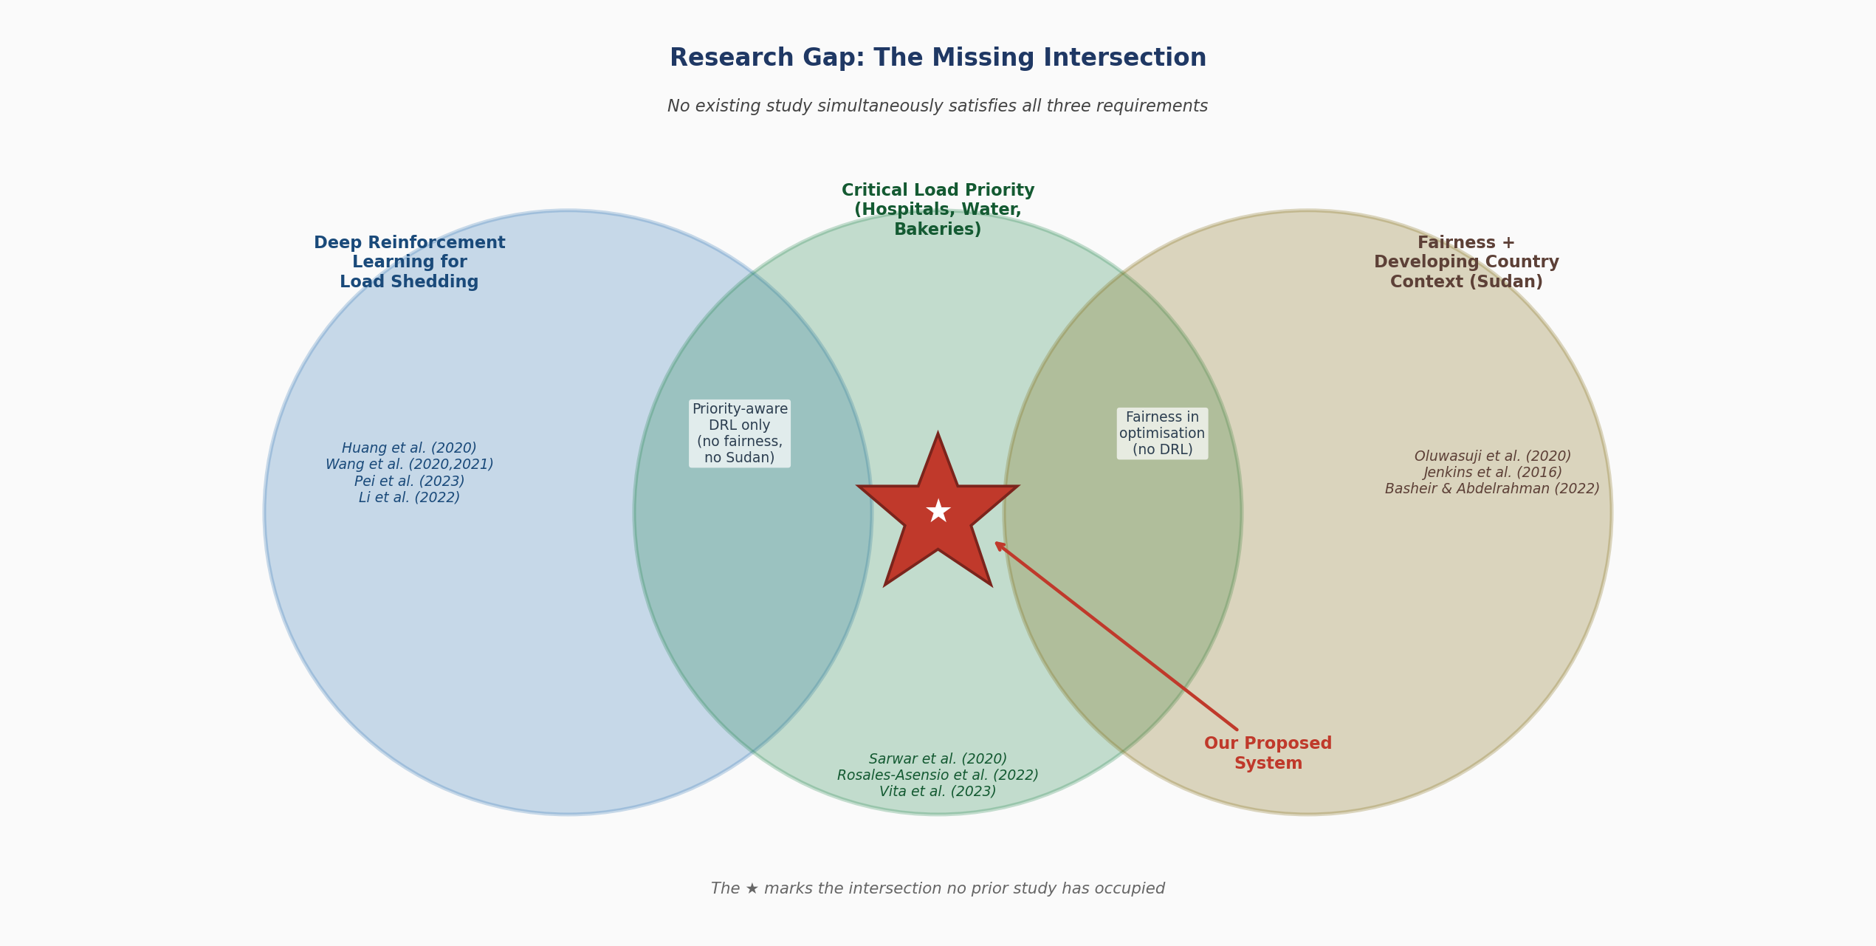
Figure 2.4: The Research Gap — No Prior Study Occupies the Intersection of DRL, Domain-Specific Priority, and Fairness in a Developing-Country Context

2.9.2 The Research Gap
The research gap addressed by the present work can be stated precisely: no existing study has developed a deep reinforcement learning system for load shedding that simultaneously (1) protects domain-specific critical services — hospitals, water pumping stations, and bakeries — through hard priority constraints informed by humanitarian evidence; (2) enforces geographic fairness in the distribution of shedding burden through formal equity metrics embedded in the reward function; (3) addresses the chronic supply deficit context of a developing country rather than the transient emergency context assumed by the DRL literature; and (4) validates the system through synthetic simulation grounded in the documented grid parameters of a specific developing country — Sudan.
Each of these four dimensions is independently supported by the literature. The humanitarian case for critical service protection is established by Irwin et al. (2020) and Nduhuura et al. (2021). The technical framework for priority-aware DRL is provided by Wang et al. (2020, 2021) and Horri and Roudsari (2022). The formal fairness criteria are established by Oluwasuji et al. (2020) and grounded in Jenkins et al. (2016). The algorithmic fairness constraints are informed by Mehrabi et al. (2021). The Sudan-specific context is documented by Al-Rikabi et al. (2025) and Basheir and Abdelrahman (2022). The justification for synthetic simulation is supported by every DRL paper reviewed and theoretically grounded in García and Fernández (2015).

2.9.3 Summary
This critical literature review has traced the intellectual trajectory of the field from traditional optimisation and rule-based load shedding, through the emergence of deep learning and reinforcement learning in smart grids, to the frontier of priority-aware DRL systems. It has established the humanitarian evidence base for critical load protection, documented the severity and structural character of Sudan's electricity crisis, and synthesised the fairness and equity literature to ground the present work's equity dimension in formal theory. The review has identified a precise and significant research gap and positioned the present work as the necessary and timely response to that gap. The chapters that follow describe the design, implementation, and evaluation of the proposed system, drawing throughout on the theoretical and empirical foundations established in this review.

2.10 Summary Table: Structured Comparison of Load Shedding Methods
Table 2.1: Evolution of Load Shedding Methods — From Traditional Optimisation to the Proposed System
The following table consolidates the critical analysis conducted throughout this chapter, tracing the methodological evolution of load shedding research across seven progressive groups. Reading from top to bottom reveals the progressive accumulation of capabilities — each generation adds one feature while leaving others absent — until the proposed system in the final row addresses all identified gaps simultaneously. The last column identifies precisely what gap remains unaddressed by each paper, motivating the subsequent row's contribution.
Group | Ref.  &  Authors | Method | Priority  Tiers | Fairness  Mechanism | Devoloping country context | Gap Addressed
Traditional  Optimisation | Larik et al. (2018) | GA + PSO | None | None | No | Minimize shed only — no priority, no fairness
 | Sarwar et al. (2020) | MILP + VSI | 3 tiers | None | No | Priority added — no fairness, no DRL
 | Amraee et al. (2011) | Adaptive MPC | None | None | No | Adapts speed/amount — no priority, no fairness
First AI  Methods | Hooshmand &  Moazzami (2012) | ANN supervised | None | None | No | Fast AI shedding — no priority, no fairness
Early DRL | Huang et al. (2020) | DQN (RLGC) | None | None | No | DRL speed proven — no priority, no fairness
 | Zhang et al. (2023) | Dueling DQN | Implicit only | None | No | 30% less shed — no explicit priority
 | Li et al. (2022) | DDPG | None | None | No | Continuous action — no priority, no fairness
DRL +  Priority | Wang et al. (2020) | Double DQN | 3 generic tiers | None | No | DRL + priority — no fairness, no developing country
 | Wang et al. (2021) | Dueling DQN | 3 generic tiers | None | No | Fast + priority — no fairness, no developing country
 | Horri & Roudsari  (2022) | Q-learning + IVM | Priority+cost+dynamics | None | No | Rich priority — no fairness, no developing country
Advanced  DRL | Pei et al. (2023) | GraphSAGE-D3QN | Topology-weighted | None | No | Graph DRL — no priority tiers, no fairness
 | Liu et al. (2022) | Risk-averse DNN | Risk-aware | None | No | Safe decisions — no explicit priority, no fairness
 | Chen et al. (2023) | PPO | None | None | No | Handles renewables — no priority, no fairness
Fairness-  Aware  Optimisation | Oluwasuji et al.  (2020) | MIP Knapsack | Utility-based | Utilitarian+egalitarian  +envy-free | Nigeria | Fairness+dev.country — no DRL, slow optimisation
OUR  PROJECT | Bakhit, Babiker  & Abass | DRL simulation | Hospitals / Water  / Bakeries | Geographic fairness  across areas | Sudan | ALL GAPS ADDRESSED SIMULTANEOUSLY

Key: DRL = Deep Reinforcement Learning | DQN = Deep Q-Network | DDPG = Deep Deterministic Policy Gradient | PPO = Proximal Policy Optimization | MPC = Model Predictive Control | MILP = Mixed Integer Linear Programming | GA = Genetic Algorithm | PSO = Particle Swarm Optimization | IVM = Intentional Voltage Manipulation | MIP = Mixed Integer Programming | UVLS/UFLS = Under-Voltage/Frequency Load Shedding. All papers used simulated/synthetic test environments — this is standard practice as live power grid experimentation is unsafe.
Key finding: The final row (Our Project) is the only entry in this table with all positive indicators simultaneously — combining DRL real-time adaptability, domain-specific humanitarian priority protection, geographic fairness constraints, and developing-country contextualisation grounded in Sudan's documented grid parameters. No prior study has occupied this intersection.

References
Afzal, S., Mokhlis, H., Illias, H.A., Mansor, N.N. and Shareef, H. (2021) 'State-of-the-art review on power system resilience and assessment techniques', IET Generation, Transmission & Distribution, 15(8), pp. 1325–1343.
Akpeji, K.O., Olasoji, A.O., Gaunt, C.T., Oyedokun, D.T.O., Awodele, K.O. and Folly, K.A. (2020) 'Economic impact of electricity supply interruptions in South Africa', SAIEE Africa Research Journal, 111(2), pp. 73–87.
Alabdullah, M.H. and Abido, M.A. (2022) 'Microgrid energy management using deep Q-network reinforcement learning', Alexandria Engineering Journal, 61(11), pp. 9069–9078.
Al-Rikabi, I., Omara, A., Abuelnour, M., Abuelnuor, A., Mohamed, A. and Ismail, M. (2025) 'Renewable energy in Sudan: current status and future prospects', Engineering Reports, 7, Art. e13116.
Amraee, T., Ranjbar, A.M. and Feuillet, R. (2011) 'Adaptive under-voltage load shedding scheme using model predictive control', Electric Power Systems Research, 81(7), pp. 1507–1513.
Barbalho, P., Moraes, J., Lacerda, V., Barra, P., Fernandes, R. and Coury, D. (2025) 'Reinforcement learning solutions for microgrid control and management: a survey', IEEE Access, 13, pp. 39782–39799.
Basheir, O. and Abdelrahman, M. (2022) 'The electricity crisis in Sudan: between quick fixes and opportunities for a sustainable energy transition', in Dismantling Green Colonialism. London: Pluto Press / Transnational Institute.
Bayliss, K. and Pollen, G. (2021) 'The power paradigm in practice: a critical review of developments in the Zambian electricity sector', World Development, 140, Art. 105358.
Bedi, J. and Toshniwal, D. (2018) 'Empirical mode decomposition based deep learning for electricity demand forecasting', IEEE Access, 6, pp. 49144–49156.
Carlsson, F., Demeke, E., Martinsson, P. and Tesemma, T. (2020) 'Cost of power outages for manufacturing firms in Ethiopia: a stated preference study', Energy Economics, 88, Art. 104753.
Chen, Z., Zhuang, B., Zhou, Y., Wang, J., Sun, H. and Levron, Y. (2023) 'Emergency load shedding strategy for high renewable energy penetrated power systems based on deep reinforcement learning', Energy Reports, 9, pp. 434–443.
Del Real, A.J., Dorado, F. and Durán, J. (2020) 'Energy demand forecasting using deep learning: applications for the French grid', Energies, 13(9), Art. 2242.
Du, Y. and Li, F. (2019) 'Intelligent multi-microgrid energy management based on deep neural network and model-free reinforcement learning', IEEE Transactions on Smart Grid, 11(2), pp. 1066–1076.
García, J. and Fernández, F. (2015) 'A comprehensive survey on safe reinforcement learning', Journal of Machine Learning Research, 16, pp. 1437–1480.
Gautam, M. (2023) 'Deep reinforcement learning for resilient power and energy systems: progress, prospects, and future avenues', Electricity, 4(4), pp. 336–380.
Glavic, M. (2019) '(Deep) reinforcement learning for electric power system control and related problems: a short review and perspectives', Annual Reviews in Control, 48, pp. 22–35.
Hong, Y.Y., Zhou, Y.L., Li, Q.L., Xu, W.J. and Zheng, X.K. (2020) 'A deep learning method for short-term residential load forecasting in smart grid', IEEE Access, 8, pp. 55785–55797.
Hooshmand, R. and Moazzami, M. (2012) 'Optimal design of adaptive under frequency load shedding using artificial neural networks in isolated power system', Electrical Power and Energy Systems, 42(1), pp. 220–228.
Horri, M. and Roudsari, H.M. (2022) 'Reinforcement-learning-based load shedding and intentional voltage manipulation approach in a microgrid considering load dynamics', IET Generation, Transmission & Distribution, 16(17), pp. 3384–3401.
Huang, Q., Huang, R., Hao, W., Tan, J., Fan, R. and Huang, Z. (2020) 'Adaptive power system emergency control using deep reinforcement learning', IEEE Transactions on Smart Grid, 11(2), pp. 1171–1182.
Ibrahim, I.A. and Rabelo, L. (2021) 'A deep learning approach for peak load forecasting: a case study on Panama', Energies, 14(11), Art. 3039.
Irwin, A., Hoxha, D. and Grépin, K.A. (2020) 'Conceptualising the effect of access to electricity on health in low- and middle-income countries: a systematic review', Global Public Health, 15(3), pp. 452–473.
Jenkins, K., McCauley, D., Heffron, R., Stephan, H. and Rehner, R. (2016) 'Energy justice: a conceptual review', Energy Research & Social Science, 11, pp. 174–182.
Ji, Y., Wang, J., Xu, J., Fang, X. and Zhang, H. (2019) 'Real-time energy management of a microgrid using deep reinforcement learning', Energies, 12(12), Art. 2291.
Joshi, A., Capezza, S., Alhaji, A. and Chow, M.Y. (2023) 'Survey on AI and machine learning techniques for microgrid energy management systems', IEEE/CAA Journal of Automatica Sinica, 10(7), pp. 1513–1529.
Khan, M.A., Saleh, A.M., Waseem, M. and Sajjad, I.A. (2023) 'Artificial intelligence enabled demand response: prospects and challenges in smart grid environment', IEEE Access, 11, pp. 1477–1505.
Larik, R.M., Mustafa, M.W. and Aman, M.N. (2019) 'A critical review of the state-of-art schemes for under voltage load shedding', International Transactions on Electrical Energy Systems, 29(5), Art. e2828.
Larik, R.M., Mustafa, M.W., Aman, M.N., Jumani, T.A., Sajid, S. and Panjwani, M.K. (2018) 'An improved algorithm for optimal load shedding in power systems', Energies, 11(7), Art. 1808.
Lei, M., Tan, Y., Dahlenburg, G., Xiang, W. and Zheng, K. (2021) 'Dynamic energy dispatch based on deep reinforcement learning in IoT-driven smart isolated microgrids', IEEE Internet of Things Journal, 8(10), pp. 7938–7947.
Li, X., Chen, J., Wang, Z. and Pu, T. (2022) 'Load shedding control strategy in power grid emergency state based on deep reinforcement learning', CSEE Journal of Power and Energy Systems, 8(4), pp. 1175–1182.
Liu, Y., Zhang, Y., Meng, X., Dong, Z., Xu, Y. and Han, Z. (2022) 'Real-time emergency load shedding for power system transient stability control: a risk-averse deep learning method', Applied Energy, 307, Art. 118221.
Massaoudi, M., Abu-Rub, H., Refaat, S.S., Chihi, I. and Oueslati, F.S. (2021) 'Deep learning in smart grid technology: a review of recent advancements and future prospects', IEEE Access, 9, pp. 54558–54578.
Mehrabi, N., Morstatter, F., Saxena, N., Lerman, K. and Galstyan, A. (2021) 'A survey on bias and fairness in machine learning', ACM Computing Surveys, 54(6), Art. 115.
Mnih, V., Badia, A.P., Mirza, M., Graves, A., Lillicrap, T., Harley, T., Silver, D. and Kavukcuoglu, K. (2016) 'Asynchronous methods for deep reinforcement learning', Proceedings of the 33rd International Conference on Machine Learning (ICML 2016), pp. 1928–1937.
Nduhuura, P., Garschagen, M. and Zerga, A. (2021) 'Impacts of electricity outages in urban households in developing countries: a case of Accra, Ghana', Energies, 14(12), Art. 3676.
Oluwasuji, O.I., Malik, O., Zhang, J. and Ramchurn, S.D. (2020) 'Solving the fair electric load shedding problem in developing countries', Autonomous Agents and Multi-Agent Systems, 34(1), pp. 1–31.
Pannakkong, W., Vinh, V.T., Tuyen, N.Q. and Buddhakulsomsiri, J. (2023) 'A reinforcement learning approach for ensemble machine learning models in peak electricity forecasting', Energies, 16(13), Art. 5099.
Pei, W., Yang, Y., Wang, X., Xu, G., Zhou, Y. and Wu, L. (2023) 'An emergency control strategy for undervoltage load shedding of power system: a graph deep reinforcement learning method', IET Generation, Transmission & Distribution, 17(10), pp. 2130–2141.
Ramchurn, S.D., Vytelingum, P., Rogers, A. and Jennings, N.R. (2012) 'Putting the smarts into the smart grid: a grand challenge for artificial intelligence', Communications of the ACM, 55(4), pp. 86–97.
Rosales-Asensio, E., Elejalde, E., Pulido-Alonso, A. and Colmenar-Santos, A. (2022) 'Resilience framework, methods, and metrics for the prioritization of critical electrical grid customers', Electronics, 11(14), Art. 2246.
Saeed, M., Tayeb, E. and Osman, G. (2019) 'Sustainable energy potential in Sudan', SUST Journal of Engineering and Computer Sciences, 2(3), pp. 1–12.
Sarwar, S., Mokhlis, H., Othman, M., Muhammad, M.A., Laghari, J.A., Mansor, N.N., Mohamad, H. and Pourdaryaei, A. (2020) 'A mixed integer linear programming based load shedding technique for improving the sustainability of islanded distribution systems', Sustainability, 12(15), Art. 6234.
Talaat, M., Hatata, A.Y., Alsayyari, A.S. and Alblawi, A. (2020) 'A smart load management system based on the grasshopper optimization algorithm using the under-frequency load shedding approach', Energy, 190, Art. 116423.
Ullah, Z., Haris, M., Ahsan, M., Hasanat, M.H.A., Yousaf, A., Raza, A., Tandon, A., Abid, M. and Ullah, B. (2024) 'Short-term load forecasting: a comprehensive review and simulation study with CNN-LSTM hybrids approach', IEEE Access, 12, pp. 111858–111881.
Vita, V., Fotis, G., Pavlatos, C. and Mladenov, V. (2023) 'A new restoration strategy in microgrids after a blackout with priority in critical loads', Sustainability, 15(3), Art. 1974.
Wang, B., Mei, X., Dong, W., Chen, Q. and Zhu, J. (2020) 'Coordinated load shedding control scheme for recovering frequency in islanded microgrids', IEEE Access, 8, pp. 215388–215398.
Wang, D., Yu, H., Chai, J., Liu, J. and Zhu, D. (2021) 'Emergency load shedding strategy for microgrids based on dueling deep Q-learning', IEEE Access, 9, pp. 19707–19715.
Yu, L., Qin, S., Zhang, M., Shen, C., Jiang, T. and Guan, X. (2021) 'A review of deep reinforcement learning for smart building energy management', IEEE Internet of Things Journal, 8(15), pp. 12046–12063.
Yu, Y., Niu, Z., Tang, J. and Wu, H. (2019) 'Deep learning for daily peak load forecasting: a novel gated recurrent neural network combining dynamic time warping', IEEE Access, 7, pp. 17461–17470.
Zhang, P., Han, S. and Deng, S. (2018) 'Review on the research and practice of deep learning and reinforcement learning in smart grids', CSEE Journal of Power and Energy Systems, 4(3), pp. 362–370.
Zhang, S., Luo, B., Wang, Y., Lu, R., Si, G. and Song, Y. (2023) 'Deep reinforcement learning for load shedding against short-term voltage instability in large power systems', IEEE Transactions on Neural Networks and Learning Systems, 34(8), pp. 4249–4260.
Zhang, Z., Zhang, D. and Qiu, R.C. (2020) 'Deep reinforcement learning for power system applications: an overview', CSEE Journal of Power and Energy Systems, 6(1), pp. 213–225.

