
AI-Based Smart Load Shedding and Energy Management System for Developing Countries

A graduation project presented to the Faculty of Mathematical Sciences and Informatics,
University of Khartoum, in partial fulfilment of the requirements
for the degree of Bachelor of Computer Science.

Students:
Murtada Asim Ibrahim Bakhit (18-317)
Suliman Elawad Suliman Babiker (18-310)
Abdalhay Abass Mobarak Abass (15-306)

Supervisor: Dr. Abubakr Siraj

Faculty of Mathematical Sciences and Informatics
University of Khartoum

October 2026

DECLARATION

We hereby declare that this project entitled "AI-Based Smart Load Shedding and Energy Management System for Developing Countries" is our own original work, carried out under the supervision of Dr. Abubakr Siraj at the Faculty of Mathematical Sciences and Informatics, University of Khartoum.
We confirm that this work has not previously been submitted for any other degree or professional qualification, and all sources consulted have been duly acknowledged.

Signatures:

Murtada Asim Ibrahim Bakhit (18-317) ___________________________

Suliman Elawad Suliman Babiker (18-310) ___________________________

Abdalhay Abass Mobarak Abass (15-306) ___________________________

Date: October 2026

DEDICATION
To our families, whose patience and support made this work possible.
To the people of Sudan, whose resilience in the face of energy hardship inspired this study.
To our supervisor, Dr. Abubakr Siraj, for his guidance and encouragement.

ABSTRACT
Electricity shortages create a distribution problem as well as a shortage of generation. Allocating the same supply differently can change interruption durations, protect essential services and distribute unequal burdens between communities. This study develops and evaluates GridGuard Khartoum, an AI-assisted load-shedding and energy-management system combining software simulation, causal demand prediction, priority rules, constrained optimization, reinforcement learning and an offline application. Khartoum State provides the geographic setting; all demand and supply traces are synthetic.
The simulation represents seven localities, five sectors and 24 hourly decisions under Mild, Moderate and Severe shortages. Hospital, Water and Bakery demand receives explicit priority. The main experiment compares Fixed Rotation, Constrained Optimization and Proximal Policy Optimization (PPO) on identical fresh scenarios. PPO and Constrained Optimization share 128 Critical Only/Full Service assignments and the same supply-feasibility rule. PPO uses 46 causal features and Fairness Rule demonstrations before reinforcement learning. Five independent runs each complete 3,000 iterations, followed by validation selection and evaluation on 960 fresh matched conditions. Critical interruption, service fairness, utilization and direct duration disparities are reported separately from the training score.
Across 960 fresh matched conditions, PPO averaged 0.00 critical-interruption locality-hours, 97.02% service fairness and 97.02% utilization. Fixed Rotation recorded 102.05, 87.76% and 71.23%, respectively; the constrained optimizer recorded 0.00, 94.78% and 97.41%. PPO's daily-reward difference from the optimizer was +0.0499 [+0.0406, +0.0577] (97.5% interval). The declared optimizer-comparison criterion was not met; individual advantages must be interpreted alongside the remaining tradeoffs.
A separate forecasting experiment compares Ridge AR(3), persistence and a three-hour trailing mean on unseen synthetic targets. Ridge AR(3) has the lowest error on all four measures, but forecasts are not controller inputs. The application presents locality context, matched replay and verified results offline. The contribution is an inspectable decision-support system and outcome-specific evidence, not a real-grid controller or a general proof that learning surpasses optimization.

Keywords: load shedding; energy management; PPO; constrained optimization; critical services; fairness; prediction; Khartoum.

المستخلص
تُشكِّل أزماتُ نقص الكهرباء تحدياً في التوزيع يتجاوز مجرد شُح الإنتاج؛ إذ يمكن لإعادة توزيع الإمداد المتاح أن تُغيِّر أوقات الانقطاع، وتحمي الخدمات الأساسية، وتوزِّع الأعباء بصورة أكثر عدالة بين المجتمعات. تُطوِّر هذه الدراسة وتُقيِّم نظام "GridGuard Khartoum"، وهو نظام ذكاء اصطناعي لإدارة التخلص من الأحمال وإدارة الطاقة، يجمع بين المحاكاة البرمجية، والتنبؤ السببي بالطلب، وقواعد الأولويات، والتحسين المقيَّد، والتعلم المعزَّز، وتطبيق غير متصل بالإنترنت. تُمثِّل ولاية الخرطوم الإطارَ الجغرافي للدراسة، فيما تُولَّد جميع بيانات الطلب والإمداد اصطناعياً.
تُمثِّل المحاكاة سبع مناطق محلية، وخمسة قطاعات، وأربعاً وعشرين قراراً بالساعة في ظروف نقص خفيف ومتوسط وحاد. ويحظى طلب المستشفيات والمياه والمخابز بأولوية صريحة. تُقارن التجربة الرئيسية بين الدوران الثابت، والتحسين المقيَّد، وخوارزمية PPO على سيناريوهات جديدة متطابقة. وتحقَّقت النتائج على ٩٦٠ حالة اختبار منفصلة، وأظهر PPO متوسط صفر ساعة انقطاع للخدمات الحيوية، و٩٧٫٠٢٪ إنصاف في الخدمة، و٩٧٫٠٢٪ استخداماً للإمداد.
في تجربة التنبؤ المنفصلة، حقَّق نموذج Ridge AR(3) أدنى خطأ على جميع المقاييس الأربعة مقارنةً بخوارزميتَي الاستمرارية والمتوسط المتحرك لثلاث ساعات. لا تُمثِّل هذه الدراسة مطالبةً بالتفوق الشامل لتعلم الآلة على التحسين، بل تُقدِّم نظاماً قابلاً للفحص يعتمد على الأدلة لدعم القرار في توزيع الطاقة في الدول النامية.

الكلمات المفتاحية: التخلص من الأحمال؛ إدارة الطاقة؛ PPO؛ التحسين المقيَّد؛ الخدمات الحيوية؛ العدالة؛ التنبؤ؛ الخرطوم.

Chapter One: INTRODUCTION

1.1 Background and Problem
When demand exceeds available electricity, some consumption must be reduced or interrupted. A schedule cannot remove the physical deficit, but it can change its consequences. Different allocations may preserve essential facilities, avoid prolonged interruptions or use supply that a rigid schedule leaves unrequested. These are distinct objectives: serving more energy does not automatically distribute it fairly, and equal blackout durations do not necessarily mean adequate service.
Sudan provides the setting for this software study of electricity allocation under shortage. Hospitals, water facilities and bakeries motivate explicit priorities. Residential and commercial demand also matter because critical protection does not settle how remaining supply should be shared. The World Bank (2025) describes electricity-sector disruption and the importance of energy access for essential facilities in Sudan. It provides context, not the hourly measurements used in this experiment.
The project asks how prediction, rules, optimization and learning can support shortage allocation. These methods answer related but different questions. Forecasting estimates later demand from observed history. Priority rules specify protected services. Optimization finds the best admissible assignment for a defined objective and horizon. Reinforcement learning seeks a policy whose sequence of decisions produces a favorable accumulated outcome. An informative comparison must identify what each method knows, can choose and is asked to improve.
GridGuard represents chronic hourly shortage rather than a sub-second voltage or frequency emergency. Actions affect later cumulative service ratios and switching history, creating a sequential allocation problem without storage. Unused electricity cannot be carried forward. Any advantage of learning must therefore appear in measured service and scheduling outcomes; it cannot be assumed from the use of a neural network.

1.2 Aim, Objectives and Research Questions
The aim is to develop and evaluate an offline decision-support system for electricity allocation under shortage. Seven objectives form one workflow: study shortage with Sudan as the motivating context; model supply, demand and sectors; develop AI-assisted decision support; protect critical services; test prediction, rules, optimization and reinforcement learning where appropriate; compare with a traditional fixed schedule; and evaluate downtime, fairness and distribution efficiency.
The study addresses five research questions:
1. How can synthetic scenarios represent supply, locality demand and service priorities transparently?
2. Does a learned causal forecast improve next-hour prediction over simple baselines?
3. How do PPO and Constrained Optimization change critical interruption, service fairness, utilization and blackout-duration inequality relative to Fixed Rotation?
4. Under matching critical constraints, does PPO improve declared outcomes over the optimizer, and what tradeoffs remain?
5. How can an offline interface explain the decisions and evidence clearly?
These questions evaluate AI without requiring a predetermined advantage over other methods. A result favoring a transparent optimizer is useful. An improvement on one outcome is also useful when its scope and costs are explicit.

1.3 Scope and Contribution
The model covers seven localities, five sectors, three shortage levels and a 24-hour horizon. Demand profiles and shortage parameters are illustrative assumptions. A shared supply pool replaces network power flow. There are no feeders, losses, voltage or frequency dynamics, storage or restoration transients. Administrative boundaries provide geographic orientation, not electrical service territories.
The contribution integrates repeatable simulation, learned prediction, critical constraints, exact current-hour optimization, trained PPO, direct service measures and an offline application. It is an implemented case study, not a new PPO algorithm or an exhaustive novelty claim. Matched inputs identify differences between the decision procedures, while independent training runs expose learning variability.
The Fixed Rotation comparison evaluates the complete system. It cannot assign every improvement to learning because Fixed Rotation lacks Critical Only actions and a critical-feasibility mask. PPO and Constrained Optimization, by contrast, share the same feasible assignments and causal information. That comparison is stronger for assessing learned scheduling, while still not establishing superiority over a full-day optimum or every optimization method.

Chapter Two: RELATED WORK

2.1 Traditional Scheduling and Optimization
The literature is organized into eight connected themes, beginning with conventional load shedding and optimization. Emergency protection and recurring rationing solve different problems. Larik et al. (2019) review under-voltage shedding, distinguishing static and dynamic, open-loop and closed-loop approaches. This informs the need to specify the control task, but transient performance measures cannot be transferred directly to a daily simulator without voltage dynamics.
Heggie et al. (2018) study rationing during long-term shortage, emphasizing repeated allocation and its efficiency consequences. This is closer to GridGuard's setting. Fixed rotation is inspectable and easy to explain, but a predetermined service block can ignore changing demand and the accumulated burden of earlier interruptions. It is a useful baseline, not the strongest possible conventional policy.
Optimization supplies a necessary stronger comparison. Sarwar et al. (2020) formulate priority-aware load shedding through mixed-integer programming for islanded distribution systems. Poudel and Dubey (2019) connect critical-load restoration to distributed resources and network restrictions. Together these studies show that explicit priorities and adaptive decisions are compatible with mathematical optimization; learning is not the only mechanism available.
The literature does not justify declaring all optimization too slow. Cost depends on the formulation, horizon, scale and implementation. GridGuard has seven locality decisions, so exhaustively scoring 128 constrained assignments is practical. This optimizer is exact for its current-hour objective. The research question is whether a learned sequence improves full-day outcomes, not whether PPO exceeds the exact maximum of the identical one-step problem.

2.2 Machine Learning and Demand Forecasting
Ramchurn et al. (2012) frame the smart grid as a broad challenge for AI, connecting coordination and uncertainty across distributed decisions. Glavic (2019) distinguishes power-system operating tasks and illustrates why a learning method's relevance depends on the state, objective and restrictions. A method useful for a market, building or emergency-control task is not automatically useful for fair shortage allocation.
Forecasting is a separate AI contribution. Nti et al. (2020) review electricity-load forecasting methods and evaluation. Bedi and Toshniwal (2018) investigate empirical-mode decomposition with deep learning. Convolutional, recurrent and ensemble approaches offer further alternatives for exploiting temporal structure, but complexity alone does not establish superiority for a particular dataset.
GridGuard uses compact ridge autoregression with three hourly lags for every locality-sector pair. Its inputs, coefficients and training-only normalization can be inspected directly. Persistence and a trailing mean provide transparent comparisons. Every method must predict the same target hours; otherwise differences in warm-up or forecast horizon could be mistaken for a model improvement.
The forecasting experiment answers a prediction question. PPO receives current observations and accumulated history, not a forecast or future trace. Improved forecast accuracy therefore cannot explain a measured controller gain. Integrating predictions into planning would require another matched experiment, including forecast errors and comparable information for competing controllers.

2.3 Reinforcement Learning for Load Shedding
Reinforcement learning connects observations, actions and state transitions through an accumulated reward. Huang et al. (2020) investigate learned emergency control, including under-voltage shedding. Wang et al. (2021) use dueling deep Q-learning for emergency shedding in microgrids. Chen et al. (2023) apply PPO to frequency restoration in a modified IEEE 39-bus system. These are relevant precedents for learned decisions, while their physical tasks differ from hourly rationing.
GridGuard contains no voltage trajectory, frequency deviation or electrical graph. It therefore cannot reproduce transient-stability or response-time claims from those studies. Its sequential effects arise through cumulative service ratios and switching history. The policy must be assessed against those mechanisms rather than the broader promise of emergency-control research.
Schulman et al. (2017) introduce PPO's clipped policy objective and minibatch updates. The actor assigns probabilities to discrete allocation choices, while the critic estimates expected return from the current state. Performance depends on observations, reward, initialization and training; the algorithm's name provides no guarantee that it will beat a transparent rule.
García and Fernández (2015) distinguish changing the learning objective from restricting exploration. A finite reward penalty does not make an unsafe action impossible. GridGuard therefore imposes critical protection through an action mask, separately from reward weights. Huang and Ontañón (2022) support using the same valid-action distribution during sampling and policy updates. This consistency is essential when PPO recomputes probabilities for stored actions.
Fairness Rule demonstrations initialize the actor before PPO training. That prior knowledge changes the interpretation: the system is imitation followed by reinforcement learning, not learning from scratch. A favorable comparison against Fixed Rotation would not isolate the benefit of PPO fine-tuning. The earlier teacher comparison is retained in Appendix A, including its negative result.

2.4 Microgrid Energy Management
Microgrid studies provide related examples of sequential energy decisions. Ji et al. (2019) investigate daily microgrid operation through deep reinforcement learning, while Vázquez-Canteli and Nagy (2019) review demand-response algorithms and modeling choices. Storage, flexible consumption and prices can create substantial opportunities to trade present service against future benefits.
GridGuard adopts sequential allocation with a simpler physical model. It has no battery, price signal, energy trading or controllable generation. Time coupling comes from service history and tier changes. Learning's potential planning advantage is therefore narrower than in a system that can store electricity for later demand. An observed result must be explained by the mechanisms actually present.
This literature also raises the transfer problem. A policy that succeeds in simulation may fail under different demand patterns or equipment restrictions. Synthetic experimentation is useful for controlled comparison, but repetition does not validate the environment. The simulator's assumptions remain part of every conclusion.

2.5 Resilience and Critical-Service Priority
Resilience research concerns maintaining and restoring important functions during disruption. Rosales-Asensio et al. (2022) investigate metrics that weight critical electricity customers according to the system and operator context. Poudel and Dubey (2019) connect restoration priority to feasible resources and network constraints. These studies support explicit priorities while requiring the protected quantity and its delivery mechanism to be defined.
GridGuard designates Hospital, Water and Bakery as critical to represent essential health, water and food services. Critical Only supplies their entire modeled sector demand. This is not a measurement of any particular facility's minimum operating load. A real hospital may contain essential and deferrable consumption, and real feeders may connect several sectors that cannot be independently switched.
Protection is also conditional on supply. If total critical demand fits, the mask permits only assignments that request all of it within capacity. If it does not fit, the all-Critical-Only fallback still experiences shortage. The evaluation records that infeasibility rather than reporting unconditional critical protection.

2.6 Humanitarian Consequences of Interruption
Irwin et al. (2020) review relationships between electricity access, reliability and health in low- and middle-income countries. They report relevant associations while rating the overall evidence quality as weak. Nduhuura et al. (2021) study household outage impacts in Accra and their association with household circumstances. These sources motivate attention to essential services and uneven burdens without establishing quantitative health benefits for this controller.
The project measures supplied critical energy, critical interruption duration, zero-service blackouts and locality allocation. It does not estimate mortality, clinical risk, food security or economic loss. The same interrupted hour may have different consequences for different facilities and people. Operational priorities would require richer data and stakeholder participation.

2.7 Developing-Country Conditions and Sudan
Studies of Sudan connect chronic shortage to infrastructure, finance and unequal access. Al-Rikabi et al. (2025) discuss Sudan's renewable-energy situation, and Basheir and Abdelrahman (2022) analyze the electricity crisis and energy-transition choices. The World Bank (2025) provides additional context for essential-service access. These are contextual sources rather than measurements of the modeled localities.
National statistics in those documents are tied to their dates and source definitions. They do not calibrate the experiment's 700 MW illustrative peak, sector shares or locality weights. The Moderate and Severe shortage windows are controlled scenarios, not reproductions of a documented Khartoum day. Fresh synthetic traces permit repeatable comparison while remaining insufficient for operational calibration.
Familiar locality names and administrative geometry make the geographic setting understandable. They do not establish electricity-network topology. This separation supports an honest Sudan-inspired study without turning geographic context into an unsupported claim of physical fidelity.

2.8 Fairness, Equity and Evaluation
Jenkins et al. (2016) distinguish distributional, recognition and procedural dimensions of energy justice. This explains why total delivered energy is incomplete: who receives service, whose needs count and how decisions are governed all matter. GridGuard measures a narrow distributional component and names critical services explicitly. It does not implement participatory governance or claim to resolve energy justice.
Oluwasuji et al. (2020) formulate fair shedding with heterogeneous consumer utility and optimization. Their work motivates explicit allocation objectives, but their utility-based formulations are not interchangeable with the implemented metrics. GridGuard uses Jain's index (Jain et al., 1984) for cumulative demand-normalized locality service and direct duration disparities. It does not implement envy-freeness, and a fairness reward term is not a hard equality guarantee.
Agarwal et al. (2021) explain how uncertainty and limited training runs affect reinforcement-learning conclusions. This motivates reporting all five independently trained policies rather than selecting the best final-test actor. Bootstrap reasoning (Efron and Tibshirani, 1993) supports retaining controller pairing and the dependence between shortage variants of the same underlying scenario.

2.9 Position of This Study
The eight themes motivate a bounded contribution: combine causal prediction, transparent priority rules, exact current-hour optimization, a constrained learned policy and direct service outcomes in an inspectable Sudan-inspired simulation. The claim concerns an implemented combination and evaluation, not proof that no previous study considered related priorities and fairness.
The literature also sets the comparison standard. Optimization is implemented as a competitor. Critical protection is enforced rather than inferred from a penalty. Forecasting remains distinct from control. Fairness and duration are both measured. Favorable, unfavorable and inconclusive results remain visible. These principles connect the review directly to the methods that follow.

Chapter Three: METHODOLOGY

3.1 Simulation Units and Temporal Resolution
The model uses the locality order Khartoum, Omdurman, Bahri, East Nile, Jebel Awlia, Karari and Ombada. Each locality contains Hospital, Water, Bakery, Residential and Commercial demand. The first three sectors are critical. These categories represent essential services while keeping the action space small enough to inspect.
An episode contains 24 steps, each representing one hour. Demand and supply are measured in MW at each step. Multiplying by the one-hour step duration gives energy in MWh; daily energy is the sum over the 24 steps. The model uses one shared supply pool and imposes no network distance or transfer-capacity cost between localities. Administrative geometry has no role in the calculations.

3.2 Synthetic Demand
The illustrative system peak is 700 MW. It is divided among localities using the weights in Table 1. The weights specify relative allocation rather than measured locality peaks. Within each locality, sector coefficients define base demand before hourly profiles and random perturbations are applied.
Table 1. Illustrative Allocation Parameters
Locality | Relative Demand Weight | Sector | Base Peak Coefficient
Khartoum | 1.00 | Hospital | 0.08
Omdurman | 0.95 | Water | 0.07
Bahri | 0.85 | Bakery | 0.05
East Nile | 0.80 | Residential | 0.55
Jebel Awlia | 0.70 | Commercial | 0.25
Karari | 0.75
Ombada | 0.90

Hospital demand is approximately constant. Water demand has morning and evening peaks, Bakery demand has early-morning and afternoon peaks, Residential demand has morning and stronger evening peaks, and Commercial demand peaks around midday. The generator uses deterministic normalized profiles, with independent uniform demand perturbations between −5% and +5%. The sector coefficients are base peak shares; because profiles differ, instantaneous sector proportions vary over the day.
This construction gives every experiment an inspectable source of variation. It allows the same episode to be reproduced from its seed, and permits changes in shortage severity without changing the underlying random demand draw. It does not reproduce a measured Khartoum load curve. The parameters should therefore be read as research assumptions whose consequences can be examined, not estimates of actual energy requirements.

3.3 Available Supply and Shortage Levels
Supply is derived from current total demand, a shortage fraction and a separate uniform perturbation between −5% and +5%. The generator caps supply at 95% of demand to retain a shortage-only operating domain. The three shortage levels are defined in Table 2.
Table 2. Shortage Construction
Shortage Level | Base Supply Fraction | Additional Reduction
Mild | 0.80 | None
Moderate | 0.65 | Subtract 0.10 during hours 17–20
Severe | 0.50 | Subtract 0.15 during hours 16–21

A severity-neutral draw supplies the demand and supply disturbances for all three versions of an episode. The resulting Mild, Moderate and Severe scenarios are coupled: they share the same base randomness while applying different shortage transformations. This makes a severity comparison easier to interpret, but also means that the three versions are not statistically independent observations.
The default generator provides enough power to cover the modeled critical sectors under the defined perturbation limits. This property is important to the meaning of the critical-service constraint. When the constraint is satisfied, zero critical interruption is feasible by construction. Other supply conditions could make that requirement impossible; the controller has an explicit fallback for that case rather than an unconditional guarantee.

3.4 Service Tiers and Dispatch
The simulator recognizes three locality service tiers. Off requests no power. Critical Only requests Hospital, Water and Bakery demand. Full Service requests all five sectors. Let requested sector demand be q, available system supply be S, and total requested power be Q. The delivered load is calculated using one global factor:
α = min(1, S / max(Q, ε))
delivered = α × requested
Here ε is a small numerical safeguard. If requests fit within supply, they are delivered without scaling. If they exceed supply, every requested sector is reduced by the same proportion. All controllers use this exact dispatch calculation. Critical protection is achieved by the constrained controllers' admissible choices before dispatch.
At each step the simulator records the requested and delivered sector loads, locality tiers and reward. Cumulative demand and cumulative served energy are updated for the next decision. The external demand and supply traces do not depend on the chosen actions.

3.5 Fixed Rotation
Fixed Rotation assigns Full Service to three consecutive localities for a three-hour block and switches the remaining four localities Off. The starting locality advances by three positions for each new block, wrapping around the seven-locality order. Given the hour, the schedule is deterministic. It does not inspect current demand, available supply, critical demand or cumulative service.
This rule provides a fixed-schedule baseline for evaluating adaptive allocation. Its transparency makes it possible to explain why a locality is selected at a given hour. However, it does not select Critical Only, and its Full Service requests can underuse or exceed current supply.

3.6 Shared Critical-Service Constraints
PPO and Constrained Optimization reserve critical demand in every locality whenever physically feasible. Their action space contains only Critical Only and Full Service. Seven binary choices produce 2⁷ = 128 joint assignments. A candidate is admissible when total critical demand plus the sum of non-critical demands of localities set to Full Service does not exceed available supply.
If no candidate satisfies the condition, only the all-Critical-Only fallback is allowed. Dispatch then shares the insufficient supply proportionally, and the episode records the resulting critical interruption. The same feasibility mask is used for demonstrations, policy sampling, probability recomputation during PPO updates, validation and final inference.

3.7 Constrained Optimization
Constrained Optimization enumerates all 128 assignments, filters by the feasibility condition, applies shared dispatch and scores the canonical current-hour reward. It receives current demand, supply, cumulative demand and served energy, and previous tiers. Exact score ties select the lowest candidate index. It receives no future demand or supply.
This method solves its immediate decision exactly. It does not solve the complete 24-hour schedule. Each choice changes the cumulative service and switching history seen at the next step, so maximizing immediate reward need not maximize daily reward or every public metric.

3.8 Observation and Network
The policy observes 46 causal quantities. Four global features encode time using sine and cosine, current supply relative to demand, and supply relative to the fixed system peak. Each locality contributes normalized current demand, its current critical-demand share, cumulative service ratio and previous service tier. These components form the original 32-value state representation. Seven cumulative-demand and seven cumulative-served-energy features complete the 46-value input.
Actor and critic use separate networks with two hidden layers of 256 tanh units. The actor produces 128 unnormalized action scores (logits), one for each joint assignment. The critic predicts one scalar value. During training, an action is sampled from the masked distribution. During validation and final evaluation, the controller chooses the highest-logit feasible action.

3.9 Reward and Learning Objective
The hourly reward balances five components weighted by research priority: critical-service ratio (weight 5), utilization (weight 2), Jain fairness (weight 2), switching penalty (weight −0.25) and oversubscription penalty (weight −3), normalized by dividing by 9. Episode reward is the sum of the 24 hourly values.
PPO compares the probability of each sampled action under the updated policy with its probability under the rollout policy. Its clipped surrogate limits the objective's incentive for excessively large probability changes during an update. GAE uses complete 24-step episodes with discount factor 1.0 and GAE parameter 0.95.

3.10 Demonstrations and Training Procedure
Before reinforcement learning, each actor is initialized using demonstrations from a deterministic Fairness Rule. Among feasible actions within 0.005 of the best current-hour reward, it maximizes the minimum projected cumulative locality service ratio. Each run collects 455 demonstration episodes per shortage level, giving 1,365 episodes and 32,760 supervised states.
Five training runs use seeds 1729, 2718, 3141, 5772 and 8111. Each run completes 3,000 iterations containing 256 full episodes, for 18,432,000 reinforcement-learning transitions per run and 92,160,000 across the five runs.
Table 3. PPO Training Configuration
Setting | Value
Actor and critic hidden layers | 256, 256
Actor input and output dimensions | 46 and 128
Iterations per run | 3,000
Episodes per iteration | 256
Episode length | 24 hours
PPO epochs per rollout | 4
Minibatch size | 1,024
Initial Adam learning rate | 0.0003
Discount factor | 1.0
GAE parameter | 0.95
PPO clipping coefficient | 0.2
Maximum gradient norm | 0.5
Entropy coefficient | 0.01 to 0.001

3.11 Learned Demand Prediction
Ridge AR(3) fits each of the 35 locality-sector series using only observed demand at t−3, t−2 and t−1 to predict hour t. Seeds 42, 43 and 44 provide 256 training traces each: 768 traces and 16,128 targets per regression over hours 3–23.
Training-only means and population standard deviations normalize inputs, with a 10⁻⁸ MW scale floor. Float64 ridge regression fits centered targets by minimizing mean squared residual plus a 0.001 coefficient penalty; the intercept is unpenalized. Predictions restore the target mean and clamp negatives to zero.
Baselines use the same three-hour mean or last-hour persistence on identical targets. Evaluation uses 320 separate demand traces once each because shortage variants share demand. Mean absolute error (MAE) and root mean squared error (RMSE) are reported in MW for locality-sector and system-total targets.

Chapter Four: APPLICATION IMPLEMENTATION

4.1 Architecture and Execution
GridGuard Khartoum separates scientific calculations from presentation. Domain objects define locality identities, sectors, units and valid tensor shapes. Scenario generation creates demand and supply. Controllers provide service tiers. The simulator applies the shared dispatch rules, and metric functions calculate outcomes from the resulting traces. A presentation layer then converts selected results into interface data.
The implementation uses Python 3.12, PyTorch 2.8 with CUDA 12.8, CuPy and PySide6. PyTorch (Paszke et al., 2019) executes batched generation, policy training, inference, dispatch and metrics. CuPy (Okuta et al., 2017) performs resampling and percentile calculations, sharing GPU arrays through the DLPack interchange interface. The scientific arrays remain on the GPU until the artifact or presentation transfer.
The primary presentation and benchmark path requires the validated NVIDIA CUDA runtime. Startup checks the GPU environment and required model and evidence resources. When a required resource cannot be verified, the software reports the problem instead of presenting fabricated results.

4.2 The Desktop Workflow
The native application organizes the demonstration into Overview, Live Scenario and Results. The Overview introduces the localities, scope and available shortage levels. Live Scenario allows the presenter to choose a shortage level and seed, run a matched episode and inspect its hourly allocation. It uses the validation-selected PPO policy from training seed 8111 at iteration 2500, alongside Fixed Rotation and Constrained Optimization.
The visual design uses an open pale canvas, restrained teal controls, clear typography and a contrasting selection color. The map, locality selector and time slider support inspection of one locality and hour without hiding the whole-day comparison.
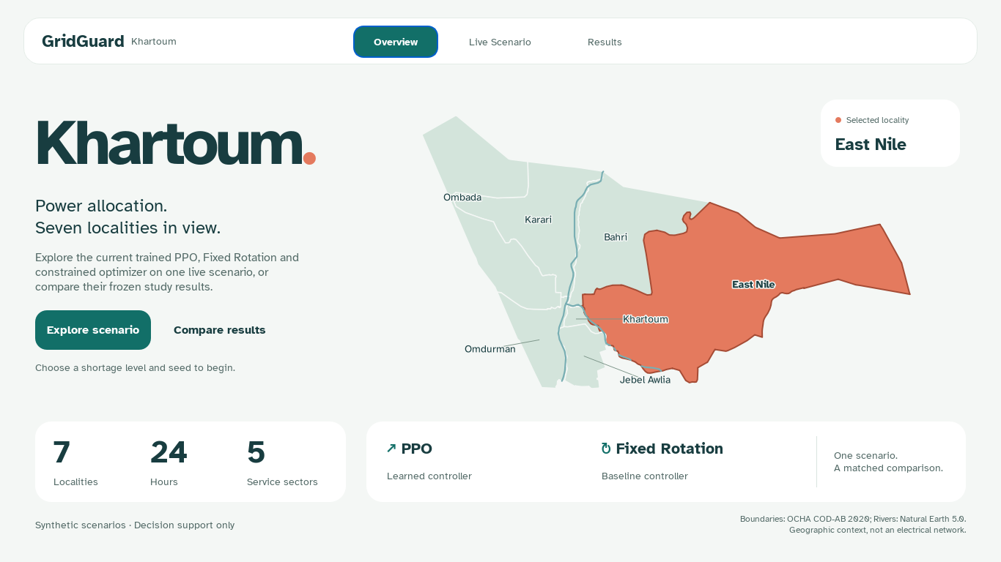
Figure 4.1. Application Overview screen showing locality map and shortage level selection.
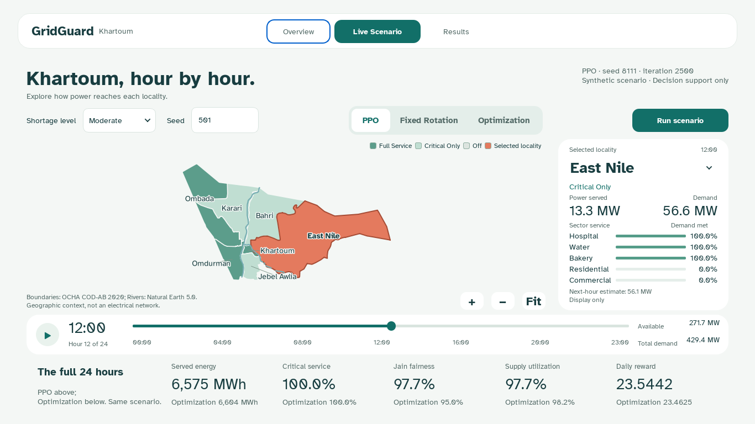
Figure 4.2. Live Scenario screen showing hourly allocation for PPO controller.

4.3 Offline Geography and Result Handling
The locality display uses packaged administrative boundaries from the United Nations Office for the Coordination of Humanitarian Affairs (n.d.), with Nile river context from Natural Earth (n.d.). These assets allow the presentation to function offline and provide recognizable geographic orientation. They do not identify feeders, substations, supply routes or measured service territories.
Models and evidence are stored with explicit identities and SHA-256 checks. The constrained training study retains numeric weights rather than executable training checkpoint objects. Verification checks array shapes, finite values, model identity, scenario matching and metric consistency.

4.4 Verification Approach
Tests cover controller action rules, mask feasibility at the supply boundary, the critical-only fallback, reward and metric identities, terminal advantage estimation, stored action probabilities, checkpoint selection and independence of scenario splits. GUI checks cover page navigation, map interaction, selection, replay states and the minimum presentation layout. Real CUDA tests confirm the intended computation path.
Independent replay provides a further check between selected model files and recorded results. It regenerates scenarios, executes saved controllers and compares actions and outcomes.

Chapter Five: EXPERIMENTAL DESIGN AND RESULTS

5.1 Matched Control Evaluation
The main comparison includes Fixed Rotation, Constrained Optimization and five selected PPO actors. Five iteration-600 actors from the same training runs provide a secondary training-budget reference. All 12 methods receive identical inputs for each condition and use common dispatch and metrics. Final evaluation contains 960 conditions and 11,520 complete trajectories.
Training and demonstration scenario streams occupy separate ranges beginning at 4,000,000 and 4,500,000, with run-specific offsets. Validation uses seeds 122101–122105; final testing uses 122201–122210. Each seed generates 32 base draws with three coupled shortage variants. None of the final scenarios informs gradient updates, hyperparameters or checkpoint selection.
Table 4. Evaluation Design
Evaluation Element | Validation | Final Test
Seed groups | 5 | 10
Independent base draws | 160 | 320
Shortage variants per draw | 3 | 3
Matched conditions | 480 | 960
Independently trained PPO runs | 5 | 5

5.2 Validation Selection and Longer Training
Each run is evaluated at iteration zero and every 100 iterations through 3,000. A checkpoint is eligible only when every validation condition has zero critical interruptions and power-balance violations, and fairness and utilization are each at least Fixed Rotation overall and at every shortage level. The eligible checkpoint with highest mean daily reward is selected.
The iteration-600 snapshots belong to the same planned 3,000-iteration schedule. They describe continuing that schedule, not an independently tuned short-budget method. A larger training budget creates an opportunity for improvement, but is not itself evidence of benefit.

5.3 Outcome Definitions
Critical interruption occurs when positive critical demand receives less than 99% service during an hour. Summing across seven localities and 24 hours gives zero to 168 locality-hours. One locality-hour means one affected locality for one hour, not a system-wide clock hour.
Jain fairness is calculated across the seven cumulative service ratios at every hour, then averaged across all 24 hours. A high index indicates similar demand-normalized service, not necessarily Full Service. Utilization is the mean hourly ratio of delivered power to usable power.
Table 5. Outcome Definitions
Outcome | Unit | Interpretation
Critical interruption | Locality-hours/day | Lower burden is favorable
Jain service fairness | Percent | Higher equality of cumulative service ratios
Supply utilization | Percent | Higher delivery of usable supply
Zero-service blackout | Locality-hours/day | Positive demand with exactly zero delivery
Blackout duration range / pairwise gap | Hours | Disparity in zero-service duration
Served / curtailed energy | MWh | Direct energy allocation
Daily reward | Unitless | Canonical objective diagnostic

5.4 Uncertainty and Decision Criteria
Effects are PPO minus the named comparator on matched conditions. A hierarchical paired bootstrap uses 10,000 resamples. It resamples training runs and base-draw clusters within each final-test seed group, preserving three shortage variants and matching both sides of each comparison. The two primary comparison claims use Bonferroni-adjusted 97.5% two-sided intervals.

5.5 Main Controller Results
The table compares all three procedures on common conditions. PPO values weight the five runs equally. Critical interruption, fairness and utilization lead the interpretation.
Table 6. Main Controller Comparison (960 Conditions)
Outcome | Fixed Rotation | Constrained Optimizer | PPO
Critical interruption (locality-hours) | 102.05 | 0.00 | 0.00
Jain service fairness (%) | 87.76 | 94.78 | 97.02
Supply utilization (%) | 71.23 | 97.41 | 97.02
Daily reward | 13.9688 | 23.4468 | 23.4967
Switching rate (%) | 25.00 | 20.55 | 27.76
Critical service (%) | 42.62 | 100.00 | 100.00
Zero-service blackout (locality-hours) | 96.00 | 0.00 | 0.00
Power-balance violation rate | 0.0000 | 0.0000 | 0.0000

Table 7. Direct Interruption-Duration Outcomes
Duration Outcome | Fixed Rotation | Constrained Optimizer | PPO
Blackout duration range (hours) | 3.000 | 0.000 | 0.000
Blackout mean pairwise gap (hours) | 1.714 | 0.000 | 0.000
Longest blackout (hours) | 6.000 | 0.000 | 0.000
Critical-interruption duration range (hours) | 3.667 | 0.000 | 0.000
Critical-interruption mean pairwise gap (hours) | 1.903 | 0.000 | 0.000
Longest critical interruption (hours) | 8.000 | 0.000 | 0.000

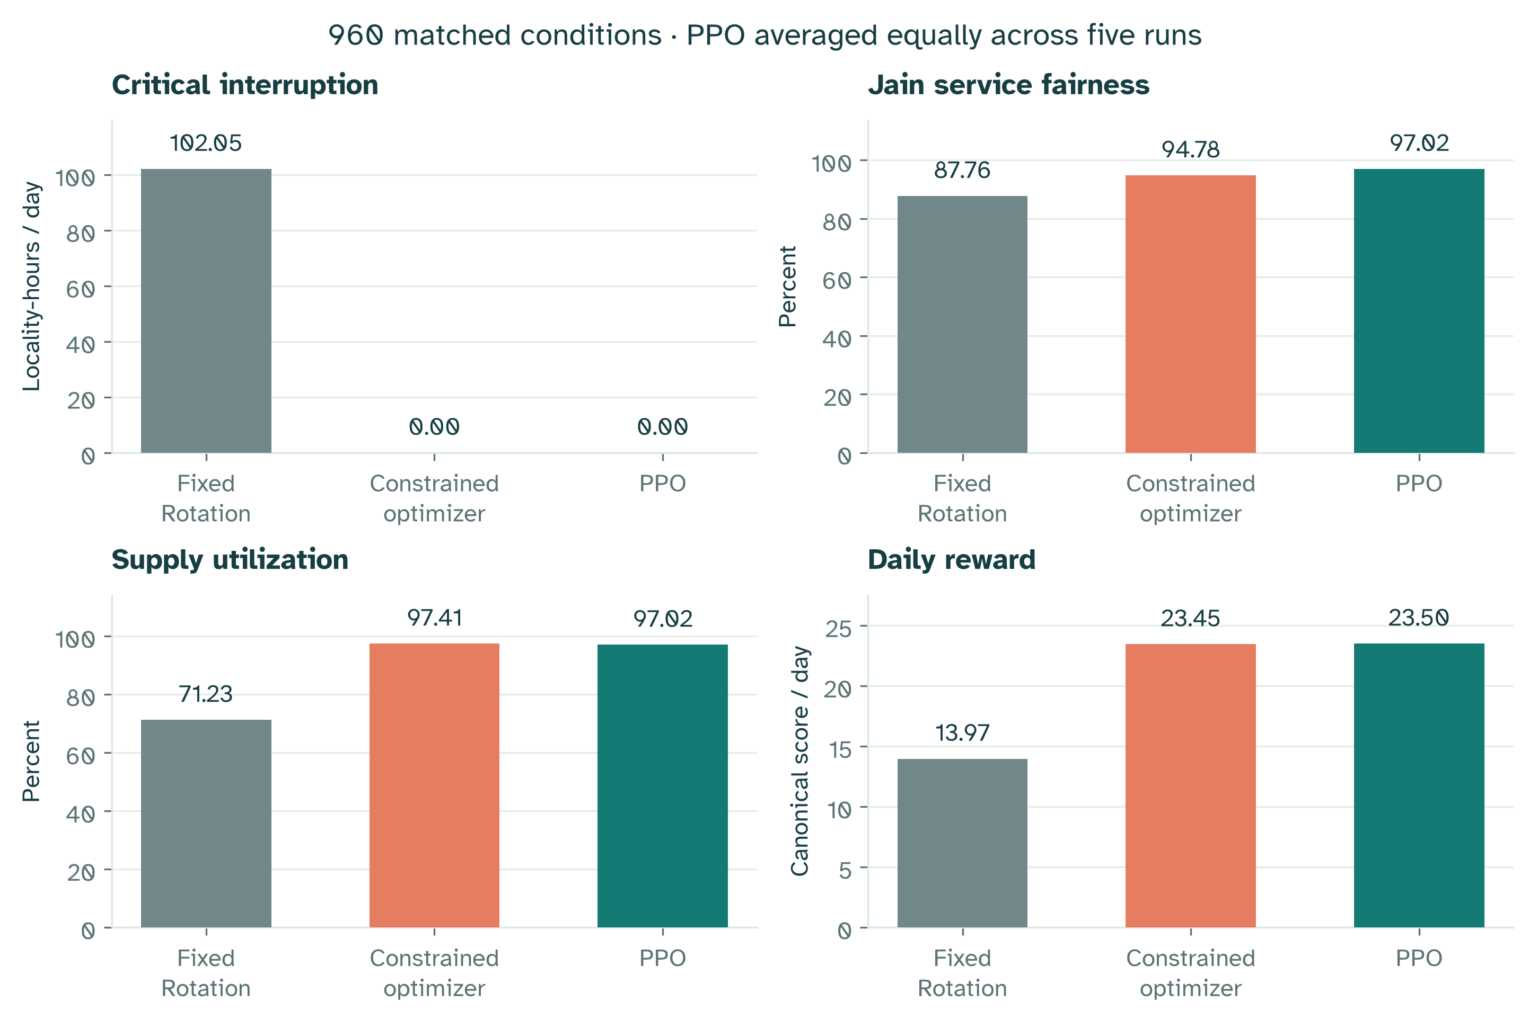
Figure 5.1. Controller comparison across key service outcomes (960 conditions).
Table 8. PPO vs Fixed Rotation (97.5% Intervals)
Outcome | Mean Difference | 97.5% Lower | 97.5% Upper
Critical interruption (locality-hours) | −102.0500 | −102.0812 | −102.0250
Jain service fairness (pp) | +9.2600 | +9.1423 | +9.3712
Supply utilization (pp) | +25.7815 | +25.7017 | +25.8594
Daily reward | +9.5279 | +9.5184 | +9.5357
Switching rate (pp) | +2.7639 | +2.0601 | +3.6639

Table 9. PPO vs Constrained Optimization (97.5% Intervals)
Outcome | Mean Difference | 97.5% Lower | 97.5% Upper
Critical interruption (locality-hours) | +0.0000 | +0.0000 | +0.0000
Jain service fairness (pp) | +2.2368 | +2.0955 | +2.3731
Supply utilization (pp) | −0.3989 | −0.4642 | −0.3408
Daily reward | +0.0499 | +0.0406 | +0.0577
Switching rate (pp) | +7.2183 | +6.5310 | +8.1124

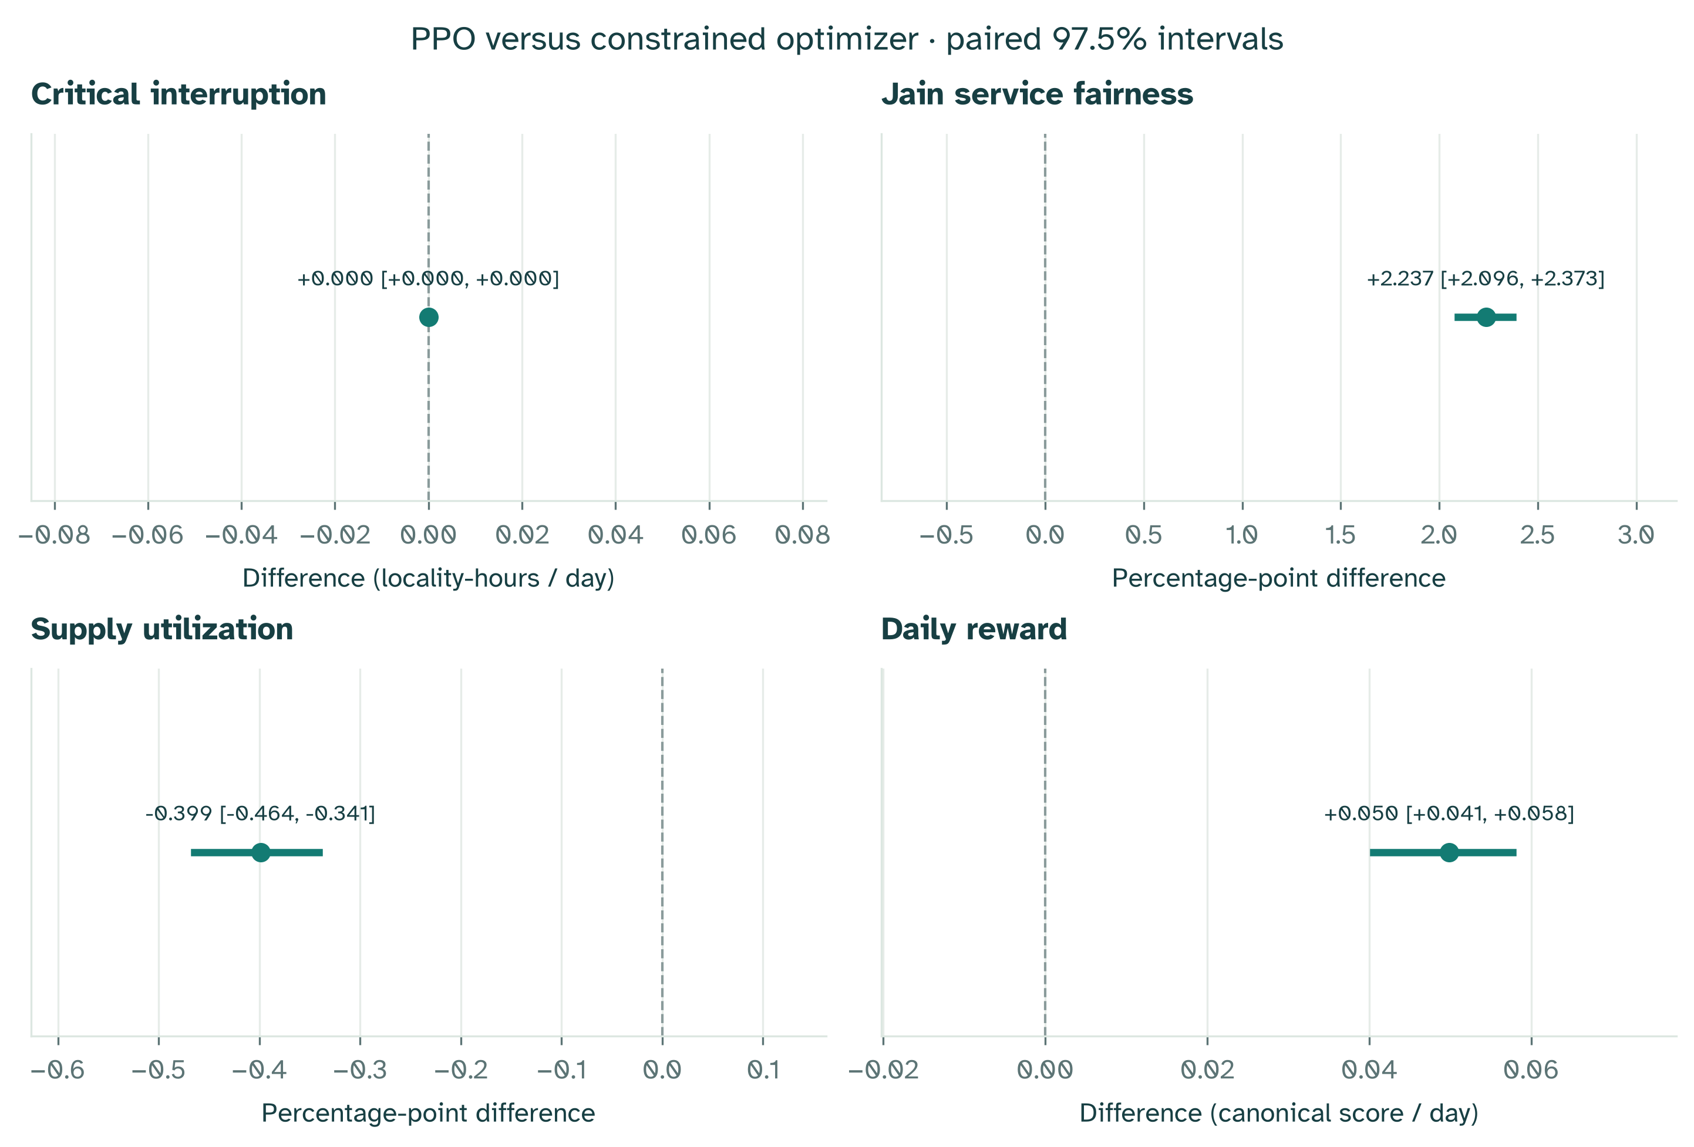
Figure 5.2. Paired-effect bootstrap intervals for PPO vs comparators.
The complete constrained PPO system met the predeclared improvement criterion against Fixed Rotation. Against the constrained optimizer, the mean daily-reward difference was +0.0499 [+0.0406, +0.0577]. The full comparison criterion did not pass. The corresponding fairness effect was +2.237 [+2.096, +2.373] percentage points, and utilization changed by −0.399 [−0.464, −0.341] percentage points.
Switching increased by +7.218 [+6.531, +8.112] percentage points, an unfavorable change. The fairness contribution outweighed both the utilization loss and extra switching penalty in the specified reward. Thus the observed AI advantage is fairer service allocation and a higher daily objective, with an efficiency and switching tradeoff.

5.6 Shortage Levels and Learning Progression
Mild conditions allow more Full Service combinations. The Severe shortage window restricts the number fitting within supply. Reporting each level prevents a favorable overall mean from concealing a weaker condition.
Table 10. Results by Shortage Level
Shortage | Controller | Critical Interruption | Fairness (%) | Utilization (%) | Reward
Mild | Fixed Rotation | 96.00 | 87.74 | 54.28 | 13.1911
Mild | Constrained optimizer | 0.00 | 96.41 | 98.09 | 23.5881
Mild | PPO | 0.00 | 97.99 | 98.12 | 23.6098
Moderate | Fixed Rotation | 96.00 | 87.74 | 68.69 | 13.9600
Moderate | Constrained optimizer | 0.00 | 95.00 | 98.02 | 23.4626
Moderate | PPO | 0.00 | 97.21 | 97.52 | 23.5002
Severe | Fixed Rotation | 114.15 | 87.80 | 90.73 | 14.7554
Severe | Constrained optimizer | 0.00 | 92.94 | 96.13 | 23.2897
Severe | PPO | 0.00 | 95.86 | 95.40 | 23.3801

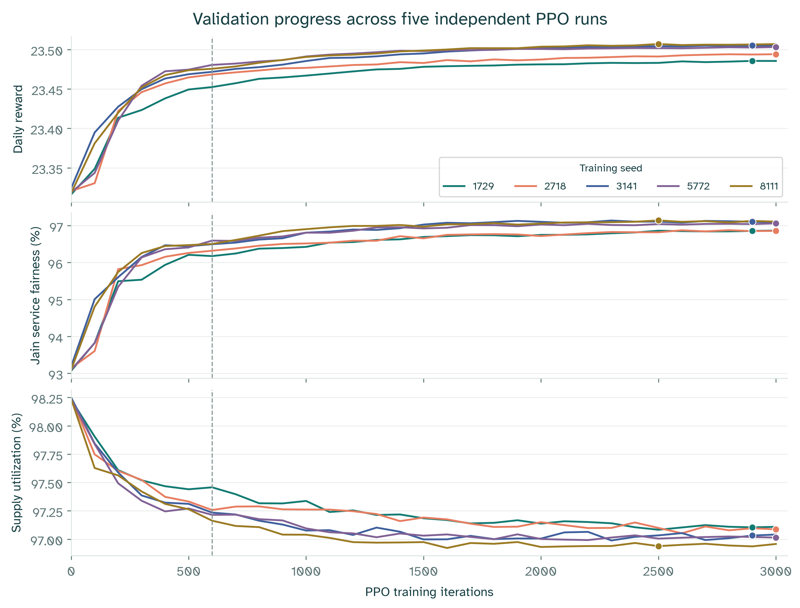
Figure 5.3. Training reward curves for five independent PPO runs over 3,000 iterations.
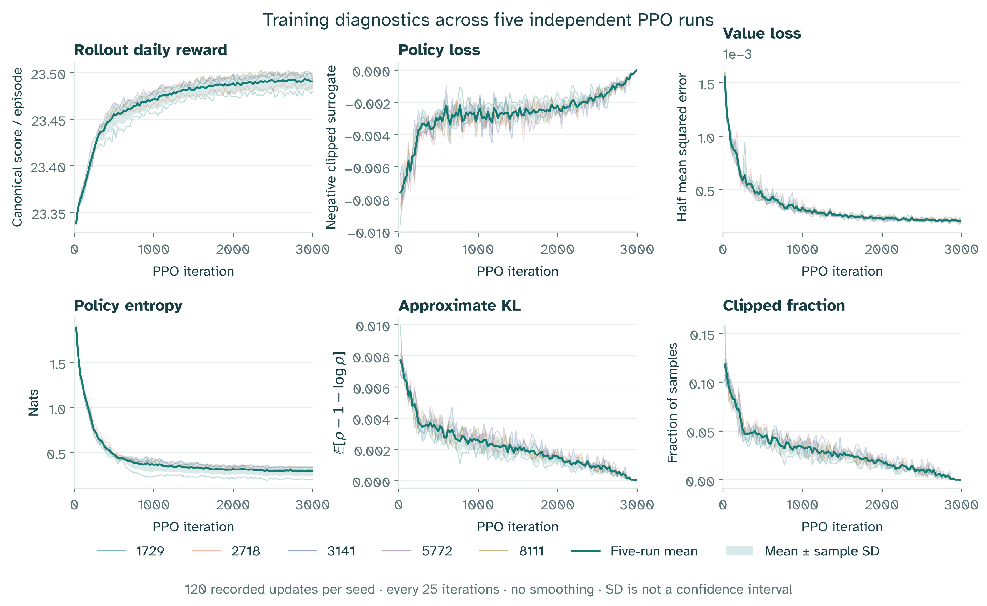
Figure 5.4. TensorBoard diagnostics: reward, policy loss, value loss and entropy.
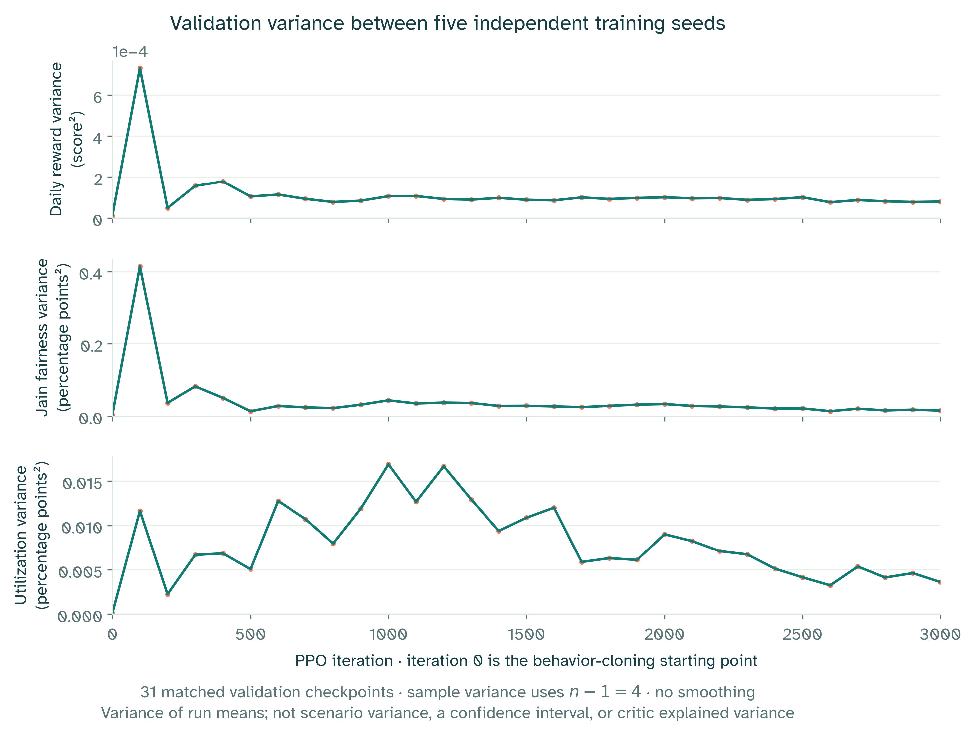
Figure 5.5. Validation variance across checkpoints for fairness and utilization.
Table 11. Checkpoint Selection Summary
Training Seed | Selected Iteration | 600-Iteration Reward | Selected Reward | Difference
1729 | 2900 | 23.4497 | 23.4835 | +0.0338
2718 | 3000 | 23.4654 | 23.4913 | +0.0258
3141 | 2900 | 23.4699 | 23.5034 | +0.0335
5772 | 3000 | 23.4781 | 23.5014 | +0.0233
8111 | 2500 | 23.4732 | 23.5040 | +0.0309

5.7 Learned Forecasting Results
The prediction experiment uses 320 demand traces from seeds 91001–91010, separate from the forecasting fit. Each method predicts hours 3–23, giving 235,200 locality-sector targets and 6,720 system targets.
Table 12. Forecasting Error Comparison
Forecast Method | Cell MAE (MW) | Cell RMSE (MW) | System MAE (MW) | System RMSE (MW)
Three-hour trailing mean | 2.3385 | 3.7436 | 42.7512 | 49.9759
One-hour persistence | 1.3465 | 2.1776 | 24.3809 | 28.5917
Ridge AR(3) | 0.6573 | 1.1882 | 9.3376 | 11.9242

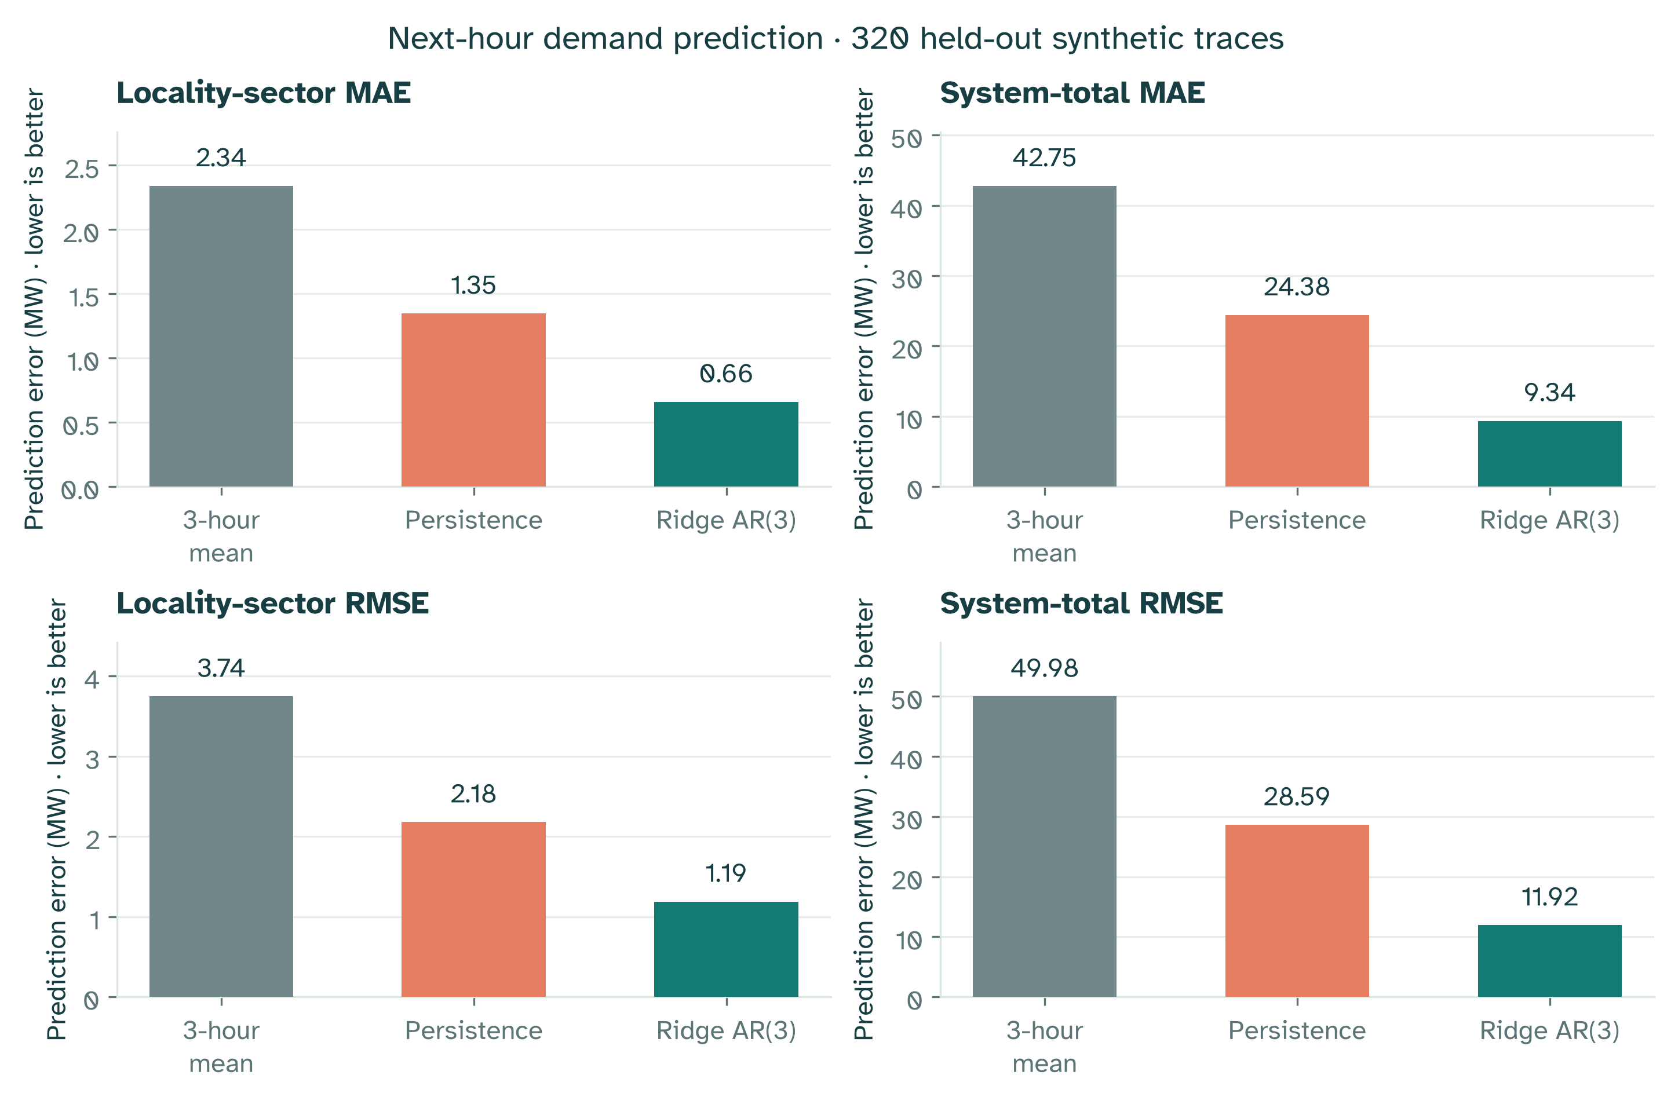
Figure 5.6. Forecasting error comparison across methods and target types.
Ridge AR(3) has the lowest error on all four measures. This demonstrates learned prediction benefit for the selected synthetic comparison, not real-demand calibration or superiority over every architecture. Forecasts remain separate from the policy and current display projection, so no controller improvement is attributed to them.

5.8 Computation and Verification
Five fresh training seeds completed 3,000 iterations each: 18,432,000 transitions per run and 92,160,000 overall. Total recorded training time was 35.98 minutes; final evaluation took 30.38 seconds. All five selections met the validation eligibility requirements.
Table 13. Training Summary
Training Seed | Selected Iteration | Validation Reward | Training Minutes
1729 | 2900 | 23.4855 | 7.23
2718 | 3000 | 23.4941 | 7.16
3141 | 2900 | 23.5051 | 7.19
5772 | 3000 | 23.5032 | 7.17
8111 | 2500 | 23.5070 | 7.22

Verification checks retained weights against validation records, common input identities across methods, action constraints and metric summaries. Statistical reconstruction checks intervals and decisions. Replay connects saved actors to regenerated inputs, recorded actions and outcomes.

Chapter Six: DISCUSSION

6.1 What AI and Optimization Contribute
The forecast and control studies provide separate evidence. Ridge AR(3) improves synthetic prediction; PPO is judged against Fixed Rotation and Constrained Optimization on the declared outcomes.
The optimizer selects the best feasible current action by maximizing the immediate reward. PPO learns a policy maximizing the expected cumulative reward over the 24-hour episode. PPO cannot exceed the one-step maximum at the same state. A daily gain can arise from changed service history and switching; no energy is stored. Service losses or a negligible gain leave optimization a credible choice.
Findings do not establish superiority to full-horizon optimization, model predictive control or all adaptive rules. The negative Fairness Rule comparison remains in Appendix A.

6.2 Critical Protection and Fair Service
Critical protection comes from the mask and Critical Only. Default supply also permits a deterministic rule to protect these sectors. PPO allocates remaining supply; its Fixed Rotation advantage cannot be attributed solely to learning.
Equal partial service can produce high Jain fairness. Critical Only can remove blackouts while Residential and Commercial demand remains unmet. High utilization may repeatedly exclude a locality. Duration, burden and energy must be interpreted together.
No equipment wear, restoration delay or consumer switching cost is modeled. The 99% critical threshold and reward weights are research choices; operational priorities, facility requirements and tradeoffs need agreement.

6.3 Data and Physical Limitations
Synthetic profiles, fixed locality weights and demand-linked supply limit generalization. Fresh seeds prevent sample reuse but do not test changed demand patterns, prolonged damage or different shortage mechanisms.
Global supply omits network connectivity, feeder limits, losses, voltage and frequency constraints. Sector separation may be physically unavailable. Hourly, single-day decisions omit transients and multi-day disadvantage; administrative geometry supplies no electrical validation.
A more realistic simulation requires metered locality and sector demand to fit profiles, independent generation and import availability data, facility inventory and essential operating loads, recorded interruption timing and causes, feeder capacities and switching permissions, and stakeholder priorities and vulnerability data.

6.4 Learning and Evaluation Limitations
Five runs remain a small sample, and one recipe cannot establish performance across architectures, rewards or initializations. Conclusions concern this procedure and generator.
The action count grows as 2ᴺ, requiring different representations and new feasibility tests at larger scales. Imitation plus PPO leaves component attribution unresolved. Comparing training from scratch, imitation alone and fine-tuning under equal budgets would clarify their contributions.
Protocols and hashes support reproduction, not independent custody or field validation. Prior exploratory and unfavorable findings remain disclosed.

6.5 Implications for Further Work
Representative data and feasible network actions should precede planning with forecasts. Competing methods should receive equivalent forecasts and be evaluated under service under prediction error. Longer-horizon optimization and strong transparent rules should remain comparators.
The offline application meanwhile supports research by making assumptions, choices and matched outcomes understandable.

Chapter Seven: CONCLUSION
GridGuard Khartoum integrates shortage simulation, causal prediction, critical-priority allocation, constrained optimization, PPO and offline communication in one software study. The main comparison evaluates PPO, Fixed Rotation and Constrained Optimization on identical fresh conditions, with multiple training runs and direct measures of downtime, fairness, utilization and interruption duration. Ridge AR(3) separately improves synthetic prediction error over the selected simple baselines.
On 960 fresh matched conditions, PPO met the declared improvement criteria against Fixed Rotation: critical interruption fell from 102.05 locality-hours to zero, fairness rose from 87.76% to 97.02%, and utilization rose from 71.23% to 97.02%. This is a comparison of the complete constrained system; the critical-service rule contributes to that improvement.
Against the constrained optimizer, PPO increased fairness by 2.24 percentage points and daily reward by 0.0499, with a 97.5% reward interval of [0.0406, 0.0577]. Both protected critical service. PPO used 0.40 percentage points less available supply and switched more often, so it failed the full declared service-guarded improvement criterion. The evidence therefore supports a specific AI benefit in fairness and the daily objective, with an efficiency tradeoff, rather than universal superiority to optimization.
Five times the previous training budget improved daily reward by 0.0295 relative to the same runs at iteration 600, but also reduced utilization by 0.24 percentage points. More training strengthened the learned objective without satisfying every service requirement.
The resulting software and evidence provide an inspectable academic decision-support system. The work does not claim national-grid calibration, operational readiness or universal AI superiority. Advancing toward those goals requires measured data, physically feasible actions and external engineering assessment.

Appendix A: SUPPORTING STUDIES AND REPRODUCIBILITY

A.1 Earlier Comparisons
A previous constrained-PPO study evaluated five 600-iteration runs on a separate 960-condition test. PPO's mean daily reward was 23.44892, compared with 23.48759 for Fairness Rule. The difference was −0.03867 with a pointwise 95% interval of [−0.04425, −0.03319]. Both protected critical service in those default conditions. PPO improved reward and fairness over its behavior-cloning starting point but did not meet the full improvement criterion against Fairness Rule.
An earlier frozen-policy hybrid improved on constrained greedy allocation without beating Fairness Rule overall. The previous 2,187-action optimizer comparison also showed a tradeoff: Optimization had lower critical interruption and higher utilization, while the then-frozen PPO had higher Jain fairness. Those values concern different policies and scenario sets and are not mixed into the current main table.

A.2 Research Objectives and Evidence
The research questions in Section 1.2 connect model construction, prediction, protected allocation, matched evaluation and interpretation. Chapters 3 and 5 explain the data generation rules and the experiments; Section 6.3 identifies the operational data needed for a more realistic simulation.
The seven objectives are addressed through a Sudan-focused literature context; a seven-locality, five-sector simulator; learned forecasting and PPO decision support; critical-service tiers and constraints; comparisons with prediction baselines, priority rules and constrained optimization; matched evaluation against Fixed Rotation; and separate measures of downtime, service fairness, utilization and energy.

A.3 Evidence and Reproducibility
The source literature review is retained at docs/source/literature-review-authors.docx, with bibliographic and claim checks recorded in docs/LITERATURE_REVIEW_AUDIT.md. The current control protocol is docs/FOCUSED_PPO_PROTOCOL.md. The research archive also retains the forecasting study, earlier optimization comparisons and previous teacher comparison alongside their supporting evidence.
Model weights, configuration, source identities and scenario/action hashes bind each experiment to its evidence. Current, historical and live results remain distinct. An interrupted initial training attempt was retained and restarted under the same frozen configuration; the training log records it separately, and completed-run timings exclude that attempt.

Appendix B: SOURCE CODE
The complete source code for the GridGuard Khartoum project is available on Google Drive at the following link:
Link Here ya solo
The repository contains the following components:
src/gridguard/ — Core Python package: domain model, simulation engine, PPO policy, constrained training, evaluation framework, demand forecast, and PySide6 desktop application (59 source files, ~820 KB).
tests/ — Comprehensive test suite covering unit, integration, GPU, and release-artifact tests (130+ test files).
pyproject.toml — Project configuration, dependencies (PyTorch 2.8, PySide6, CuPy CUDA 12.x), and entry-point scripts.
The key source modules implementing the core research contribution are: domain.py (simulation vocabulary and canonical reward function), simulation.py (24-hour CUDA-preserving load-shedding simulation), policy.py (PPO actor loading and CUDA inference), constrained_ppo.py (critical-service feasibility constraints), evaluation.py (paired benchmark evaluation and verification), scenarios.py (synthetic shortage scenario generation), and metrics.py (Jain fairness, utilization and other proposal metrics).
To run the source application, install the locked environment with uv and launch the desktop interface:
uv sync --extra dev && uv run gridguard-desktop
Full setup instructions, evidence verification commands, and the Windows executable build procedure are documented in README.md and SUBMISSION_README.md within the repository.

REFERENCES

Afzal, M., Mokhlis, H., Illias, H.A., Mansor, N.N. and Shareef, H. (2021) “State-of-the-art review on power system resilience and assessment techniques”, IET Generation, Transmission & Distribution, 15(8), pp. 1325–1343. Available at: https://doi.org/10.1049/iet-gtd.2020.0531.
Agarwal, R., Schwarzer, M., Castro, P.S., Courville, A. and Bellemare, M.G. (2021) “Deep reinforcement learning at the edge of the statistical precipice”, Advances in Neural Information Processing Systems, 34.
Al-Rikabi, I.J., Omara, A.A.M., Abuelnour, M.A., Abuelnuor, A.A.A., Mohamed, A.E. and Ismail, N.A. (2025) “Renewable energy in Sudan: Current status and future prospects”, Engineering Reports, 7(1), e13116. Available at: https://doi.org/10.1002/eng2.13116.
Basheir, R.H. and Abdelrahman, M.S. (2022) “The electricity crisis in Sudan: Between quick-fixes and opportunities for a sustainable energy transition”, Transnational Institute, 14 October.
Chen, H., Zhuang, J., Zhou, G., Wang, Y., Sun, Z. and Levron, Y. (2023) “Emergency load shedding strategy for high renewable energy penetrated power systems based on deep reinforcement learning”, Energy Reports, 9, pp. 434–443. Available at: https://doi.org/10.1016/j.egyr.2023.03.027.
Efron, B. and Tibshirani, R.J. (1993) An Introduction to the Bootstrap. Chapman and Hall/CRC.
García, J. and Fernández, F. (2015) “A comprehensive survey on safe reinforcement learning”, Journal of Machine Learning Research, 16(42), pp. 1437–1480.
Glavic, M. (2019) “(Deep) reinforcement learning for electric power system control and related problems: A short review and perspectives”, Annual Reviews in Control, 48, pp. 22–35. Available at: https://doi.org/10.1016/j.arcontrol.2019.09.001.
Heggie, A., Eager, D., McKinnon, K. and van der Weijde, A.H. (2018) “Power rationing in a long-term power shortage”, Energy Policy, 121, pp. 202–210.
Huang, Q., Huang, R., Hao, W., Tan, J., Fan, R. and Huang, Z. (2020) “Adaptive power system emergency control using deep reinforcement learning”, IEEE Transactions on Smart Grid, 11(2), pp. 1171–1182.
Huang, S. and Ontañón, S. (2022) “A closer look at invalid action masking in policy gradient algorithms”, The International FLAIRS Conference Proceedings, 35.
Irwin, B.R., Hoxha, K. and Grépin, K.A. (2020) “Conceptualising the effect of access to electricity on health in low- and middle-income countries: A systematic review”, Global Public Health, 15(3), pp. 452–473. Available at: https://doi.org/10.1080/17441692.2019.1695873.
Jain, R., Chiu, D.-M. and Hawe, W.R. (1984) A Quantitative Measure of Fairness and Discrimination for Resource Allocation in Shared Computer Systems. DEC Research Report TR-301.
Jenkins, K., McCauley, D., Heffron, R., Stephan, H. and Rehner, R. (2016) “Energy justice: A conceptual review”, Energy Research & Social Science, 11, pp. 174–182. Available at: https://doi.org/10.1016/j.erss.2016.01.021.
Ji, Y., Wang, J., Xu, J., Fang, X. and Zhang, H. (2019) “Real-time energy management of a microgrid using deep reinforcement learning”, Energies, 12(12), art. 2291. Available at: https://doi.org/10.3390/en12122291.
Larik, R.M., Mustafa, M.W. and Aman, M.N. (2019) “A critical review of the state-of-art schemes for under voltage load shedding”, International Transactions on Electrical Energy Systems, 29(5), e2828. Available at: https://doi.org/10.1002/2050-7038.2828.
Natural Earth (n.d.) 1:10m Rivers and Lake Centerlines. Version 5.0.0.
Nduhuura, P., Garschagen, M. and Zerga, A. (2021) “Impacts of electricity outages in urban households in developing countries: A case of Accra, Ghana”, Energies, 14(12), art. 3676. Available at: https://doi.org/10.3390/en14123676.
Nti, I.K., Teimeh, M., Nyarko-Boateng, O. and Adekoya, A.F. (2020) “Electricity load forecasting: A systematic review”, Journal of Electrical Systems and Information Technology, 7, article 13.
Okuta, R., Unno, Y., Nishino, D., Hido, S. and Loomis, C. (2017) “CuPy: A NumPy-compatible library for NVIDIA GPU calculations”, Workshop on Machine Learning Systems at NIPS 2017.
Oluwasuji, O.I., Malik, O., Zhang, J. and Ramchurn, S.D. (2020) “Solving the fair electric load shedding problem in developing countries”, Autonomous Agents and Multi-Agent Systems, 34, article 12. Available at: https://doi.org/10.1007/s10458-019-09428-8.
Paszke, A., Gross, S., Massa, F. et al. (2019) “PyTorch: An imperative style, high-performance deep learning library”, Advances in Neural Information Processing Systems, 32.
Poudel, S. and Dubey, A. (2019) “Critical load restoration using distributed energy resources for resilient power distribution system”, IEEE Transactions on Power Systems, 34(1), pp. 52–63.
Ramchurn, S.D., Vytelingum, P., Rogers, A. and Jennings, N.R. (2012) “Putting the smarts into the smart grid: A grand challenge for artificial intelligence”, Communications of the ACM, 55(4), pp. 86–97.
Rosales-Asensio, E., Elejalde, J.L., Pulido-Alonso, A. and Colmenar-Santos, A. (2022) “Resilience framework, methods, and metrics for the prioritization of critical electrical grid customers”, Electronics, 11(14), art. 2246. Available at: https://doi.org/10.3390/electronics11142246.
Sarwar, S., Mokhlis, H., Othman, M. et al. (2020) “A mixed integer linear programming based load shedding technique for improving the sustainability of islanded distribution systems”, Sustainability, 12(15), art. 6234. Available at: https://doi.org/10.3390/su12156234.
Schulman, J., Wolski, F., Dhariwal, P., Radford, A. and Klimov, O. (2017) Proximal Policy Optimization Algorithms. arXiv:1707.06347.
United Nations Office for the Coordination of Humanitarian Affairs (n.d.) Sudan Administrative Boundaries (COD-AB). Revision v03. Humanitarian Data Exchange.
Vázquez-Canteli, J.R. and Nagy, Z. (2019) “Reinforcement learning for demand response: A review of algorithms and modeling techniques”, Applied Energy, 235, pp. 1072–1089. Available at: https://doi.org/10.1016/j.apenergy.2018.10.088.
Wang, C., Yu, H., Chai, L., Liu, H. and Zhu, B. (2021) “Emergency load shedding strategy for microgrids based on dueling deep Q-learning”, IEEE Access, 9, pp. 19707–19715. Available at: https://doi.org/10.1109/ACCESS.2021.3055401.
World Bank (2025) Accelerating Sustainable and Clean Energy and Digital Access Transformation in Sudan (P507788). Project Information Document, Report PIDIA01286, 1 May.

