On-Chain Anatomy of the FTX Run:
Pre-Disclosure Stablecoin Outflows and the Operational Halt

Boon Chuan Lim
Independent Researcher, Singapore
ORCID: 0009-0005-8477-9393

Working Paper — Draft
April 2026

Abstract
Using a descriptive case-study methodology applied to publicly available data from the FTX Hot Wallet on Ethereum, we document the on-chain anatomy of the November 2022 FTX collapse. Three findings emerge. First, a sustained net stablecoin outflow began approximately October 18, 2022, with cumulative net outflows reaching $304 million by November 1—two weeks before the CoinDesk article that triggered public attention. Second, customer activity following public disclosure was visible primarily as a sharp rise in transaction count rather than as a proportional acceleration of average net outflow rate: mean hourly transaction count more than doubled (107 to 249, a 2.33-fold increase) between the pre-news and news windows, while average net outflow rate per hour remained essentially unchanged ($0.70M to $0.71M). Third, the operational halt of withdrawals is precisely visible in the on-chain record: hot wallet transaction activity dropped from 540 transactions in the 18:00 UTC hour of November 8 to 38 transactions in the following hour, with twenty hours of zero on-chain activity in the subsequent four days. Contemporaneous public reporting by CoinDesk and Protos described the halt within hours of the on-chain transition, while formal corporate confirmation came only with the November 11 bankruptcy filing. These findings suggest that on-chain transparency provided meaningful operational visibility into both the slow-burn run and the precise moment of failure.

Keywords: cryptocurrency, market microstructure, on-chain analysis, FTX, stablecoin, exchange runs, financial transparency
JEL Classification: G14, G21, G23

1. Introduction
The collapse of FTX Trading Ltd. in November 2022 was the most severe failure of a centralized cryptocurrency exchange to date. Within a single week, an exchange that had handled tens of billions of dollars in customer assets ceased withdrawals, signed and lost an acquisition agreement, and filed for Chapter 11 bankruptcy. Subsequent investigation revealed that customer funds had been used to support trading operations at affiliated firm Alameda Research, with billions of dollars in liabilities exceeding available assets at the time of failure.
A distinctive feature of cryptocurrency exchanges is that their primary operational wallets are publicly observable on blockchains. Unlike traditional financial intermediaries, where customer flows are private until reported through regulatory disclosure, every stablecoin movement to and from an FTX wallet on Ethereum was visible to any observer with access to a free public node, with a latency on the order of seconds to minutes corresponding to the chain's block production interval. This raises a basic empirical question: what did the FTX collapse look like on-chain, and when?
This paper documents three features of the FTX collapse using public on-chain data, applying a descriptive case-study methodology rather than formal causal inference. We focus on stablecoin transfers (USDT and USDC) into and out of the FTX Hot Wallet on Ethereum during the period October 15 to November 25, 2022. This is one observable channel among several. FTX bankruptcy filings indicate that approximately $7.81 billion in customer funds was withdrawn during November 6–11 across all chains and asset types (Federal Reserve Bank of Chicago, 2023), of which the channel we observe captured net stablecoin outflows of $191.3 million, or about 2.4% of the bankruptcy-filed total. The paper's contribution is therefore not to reconstruct the full magnitude of the run, but to document the temporal and structural anatomy of one publicly observable channel at hourly resolution. We make no causal claims about the relationship between on-chain activity and market behavior.
Our findings are as follows. First, a sustained net stablecoin outflow from the hot wallet began approximately October 18, 2022, fully two weeks before the November 2 CoinDesk article that brought concerns about Alameda Research's balance sheet to public attention. The cumulative net outflow during this pre-disclosure period reached $304 million. Second, the period of intense customer activity following the November 2 disclosure manifested primarily as a 2.33-fold increase in mean hourly transaction count rather than as a proportional acceleration of average net outflow rate; the median absolute flow per hour roughly doubled while the maximum hourly flow magnitude actually fell, consistent with a regime in which intermittent large transfers gave way to sustained moderate-volume customer activity. Third, the on-chain record contains a precise hourly timestamp for the operational halt: transaction count from the hot wallet collapsed from 540 in the 18:00 UTC hour of November 8 to 38 in the following hour, with twenty hours of zero on-chain activity in the four days that followed. Contemporaneous public reporting (CoinDesk, 2022; Protos, 2022) described the halt within hours of the on-chain transition; formal corporate confirmation came with the bankruptcy filing on November 11.
These findings contribute to the literature on cryptocurrency market microstructure and exchange transparency in two ways. First, they document the on-chain signature of a major exchange failure with hourly resolution, providing a granular reference for subsequent research on the FTX event. Second, they highlight a property of public blockchain infrastructure that is qualitatively different from traditional disclosure mechanisms: operational events at centralized exchanges that route through public wallets are visible at the resolution of the underlying blockchain, regardless of whether the exchange chooses to disclose them.
The remainder of the paper is organized as follows. Section 2 reviews relevant literature. Section 3 describes our data sources. Section 4 presents the three documentary findings. Section 5 discusses implications and limitations. Section 6 concludes.

2. Related Literature
This paper relates to three strands of literature: cryptocurrency market microstructure, theoretical and empirical work on financial runs and the limits of disclosure, and a small but growing body of empirical work on the FTX collapse specifically.

2.1 Cryptocurrency market microstructure
A growing literature characterizes price formation, arbitrage, and liquidity in cryptocurrency markets. Makarov and Schoar (2020) document large and recurrent arbitrage opportunities across cryptocurrency exchanges, particularly across geographic regions, and identify capital controls and limits to arbitrage capital movement as the primary impediments to price convergence. Within their framework, they decompose signed volume on each exchange into common and idiosyncratic components, finding that the common component explains roughly 80% of bitcoin returns while the idiosyncratic exchange-level components help explain the residual cross-venue arbitrage spreads. Their central argument—that crypto exchange microstructure differs materially from traditional equity markets in the persistence of cross-venue dispersion—provides important context for the present study, in that operational events at any single venue can have effects that do not propagate efficiently across the broader market.
Most existing crypto microstructure work uses exchange-side data: trade tapes, order book snapshots, or aggregated venue-level statistics. The on-chain operational data we use is qualitatively different. Where exchange-side data captures transactions visible in market activity, on-chain wallet data captures the underlying movement of assets between custodial entities. The two views are complementary: exchange-side data reveals how an exchange behaves as a market venue, while on-chain wallet data reveals how an exchange behaves as a custodian.
We are unaware of prior work that combines these views in the specific way undertaken here—using public on-chain wallet activity at a centralized exchange to document operational events at hourly resolution. Methodologically, the closest precedent for the use of public blockchain data in finance research is Griffin and Shams (2020), who use on-chain Tether transfer data to investigate whether stablecoin issuance influenced Bitcoin prices during the 2017 boom. Their identification strategy clusters Tether flows from a small number of large addresses to argue for a supply-side mechanism in cryptocurrency price formation. The present paper differs in object (a single venue's operational anatomy rather than market-wide price dynamics) and in claim (descriptive documentation rather than causal inference), but shares the basic premise that public on-chain data, when properly aggregated to identifiable economic agents, can be used to study questions that opaque proprietary records make difficult. A closer antecedent in subject matter is Vidal-Tomás, Briola, and Aste (2023), discussed in Section 2.3 below.

2.2 Financial runs and the limits of disclosure
The classical theory of bank runs is established by Diamond and Dybvig (1983), in which the maturity transformation performed by banks creates a coordination problem among depositors that can resolve into self-fulfilling withdrawal panics. Brunnermeier and Pedersen (2009) extend the analysis to market liquidity, modeling a "liquidity spiral" in which margin requirements, intermediary funding constraints, and market liquidity interact and reinforce each other: tighter funding leads to reduced liquidity provision, which raises margins, which tightens funding further. This mechanism has been influential in interpreting episodes of market stress in which initial shocks propagate through endogenous changes in market and funding conditions.
Gorton and Zhang (2023) extend the run-theoretic framing directly to the cryptoasset context. They argue that stablecoins are economically equivalent to circulating private money issued by unregulated banks, drawing parallels to the U.S. Free Banking Era of 1837–1863 and to the 2008 Reserve Primary Fund "breaking the buck" event. Under this characterization, stablecoin holders are subject to the same coordination problems that drive runs on uninsured deposits and money market funds, and stablecoin issuers face the same fundamental tension between the demand for redeemability at par and the illiquidity or opacity of backing assets. While our paper studies stablecoin flows at a centralized exchange rather than the issuer level, the Gorton–Zhang framing is directly relevant: the customer demand for stablecoin withdrawals from FTX is, in their terms, demand for redemption of a private claim against an entity whose backing was opaque.
Theoretical work specific to cryptoasset platforms has also begun to develop. Cong, Li, and Wang (2021) develop a dynamic model of token adoption in which user network externalities create intertemporal feedback between platform adoption and token value, with explicit appeals to the strategic-complementarity and fragility literature (Goldstein and Pauzner, 2005). While their model is concerned with token valuation under endogenous adoption rather than withdrawal dynamics specifically, the underlying mechanism—that adoption decisions are complementary across users and that token value depends on the user base—provides a theoretical scaffold for understanding why centralized cryptoasset venues might be vulnerable to rapid loss of confidence.
The FTX collapse exhibits some properties of a classical run—sustained withdrawal pressure followed by an operational halt—and some properties qualitatively different from runs on traditional intermediaries. The most consequential difference, for our purposes, is observability. In traditional banking, deposit flows are private to the bank until reported through regulatory disclosure or, in extremis, through bank failure proceedings. Depositors face a coordination problem partly because they cannot directly observe each other's actions in real time. Cryptocurrency exchanges that route customer flows through identifiable on-chain wallets break this informational structure: the analog of "depositor flows" is, at least partially, public information at sub-minute resolution.
A separate literature considers the role of disclosure timing in financial-stability events more broadly. We do not engage this literature in detail here, but note that the FTX setting provides an unusual empirical setting in which the latency between operational events and official disclosure can be measured directly against on-chain timestamps.

2.3 The FTX collapse
A small but growing literature analyzes the FTX collapse and its implications. Vidal-Tomás, Briola, and Aste (2023) provide the closest empirical antecedent to the present paper. They use on-chain data and tick-by-tick trade data to investigate the causes and propagation of the FTX failure, identifying the May 2022 Terra-Luna collapse as a contributing antecedent and characterizing the role of FTX's native FTT token in the firm's leverage structure. Their analysis emphasizes price discovery and market reaction; the present paper focuses on the operational anatomy of the wallet-level outflow and the precise timing of the halt, which they do not document in this form.
At a higher level, the broader implications of the FTX collapse for crypto-related financial stability have been examined by Auer et al. (2022), who use a novel database on retail use of crypto exchange apps to characterize trading behavior around both the Terra/Luna and FTX events. Their finding that "whales" reduced bitcoin holdings ahead of small holders during stress episodes is consistent with the broader pattern of informed-versus-uninformed asymmetry that on-chain monitoring may surface.
Aramonte, Huang, and Schrimpf (2021) and the subsequent BIS work on DeFi lending characterize the procyclical and self-referential properties of crypto leverage, providing context for why a single large CEX failure could propagate through the wider crypto ecosystem. Azar et al. (2024) place the FTX collapse within a broader Federal Reserve framework for assessing financial stability risks from digital assets, noting that the FTX failure is a paradigmatic example of a centralized exchange run within a complex crypto conglomerate. The Federal Reserve Bank of Chicago retrospective on the 2022 crypto runs (2023) provides aggregated bankruptcy-filing-derived statistics on outflow patterns across multiple failed crypto platforms, characterizing the FTX international platform's withdrawal pause as occurring on November 8, 2022.
Relative to this literature, the contribution of the present paper is narrow but specific. We document the wallet-level on-chain signature of the FTX collapse with hourly resolution, including a pre-disclosure outflow phase and a precise operational halt timestamp. The findings complement existing work on price discovery, retail behavior, and broader financial-stability implications by providing a granular operational reference for the November 2022 events.

3. Data
All data used in this paper is publicly available at no cost. We document data sources and processing in detail to support reproduction.

3.1 On-chain transaction data
We collect ERC-20 transfer records for two stablecoins—Tether (USDT) and USD Coin (USDC)—into and out of four publicly identified FTX-affiliated wallet addresses, using the Etherscan API V2. The four addresses are the FTX Hot Wallet (0x2FAF…6AD2), the FTX Cold Wallet (0xC098…3A94), an additional FTX-tagged wallet (0x83a1…E3BD), and an Alameda Research-tagged wallet (0x3cD7…9699). Full contract addresses for both stablecoins and the four FTX-affiliated wallets are listed in Appendix B for replication purposes.
Wallet identification follows public tagging by Etherscan and Arkham Intelligence, supplemented by community-sourced labeling. We acknowledge that not all FTX-controlled wallets are publicly identified; subsequent bankruptcy filings revealed additional addresses not visible at the time of collapse. Our analysis therefore captures the subset of FTX flows that were attributable to publicly tagged addresses during the relevant period—precisely the visibility that would have been available to a contemporaneous observer.
The collection window is October 15, 2022 to November 25, 2022 (Ethereum block range 15,770,000 to 16,060,000). After collection, we observe 94,713 stablecoin transactions across the four wallets. Of these, 99.8% (94,548 transactions) involve the FTX Hot Wallet; the remaining wallets show negligible activity in this window. We therefore restrict subsequent analysis to the Hot Wallet.

3.2 Aggregation and processing
We aggregate raw transaction-level data to hourly bins, computing for each hour: (i) net signed flow (inflows minus outflows), (ii) absolute total flow magnitude, and (iii) transaction count. Throughout the paper, "net outflow" refers to the negative of net signed flow—a positive net outflow indicates that more value left the wallet than entered. Cumulative net outflow is computed as the running sum of hourly net outflows from the start of the sample.

3.3 Reproducibility
All data used in this paper is reconstructible from public sources. Etherscan API V2 provides access to historical Ethereum transaction data without rate-limit barriers for the volumes used here. Replication code, including data download scripts and analysis pipelines, is available at https://github.com/boonchuan/ftx-stablecoin-anatomy.

3.4 Coverage of total customer outflows
It is important to be explicit about what fraction of total FTX customer outflows our data captures. Federal Reserve Bank of Chicago (2023), drawing on FTX's bankruptcy filing, reports total customer withdrawals of $7.81 billion from FTX during November 6–11, 2022, representing 36.7% of pre-run customer liabilities (their Table 2; the accompanying prose notes that "almost all" of these withdrawals occurred "in just two days"). The figure aggregates flows across all chains and asset types. Over the same window, our channel-restricted measure shows $191.3 million in net stablecoin outflow at the FTX Hot Wallet (USDT and USDC combined), or 2.4% of the bankruptcy-filed total.
Two qualifications complicate this raw ratio. First, the bankruptcy figure is a measure of gross customer withdrawals, while the on-chain figure is a net (outflow minus inflow) measure at a single wallet. The on-chain ratio of net to gross flow is substantially below one during the run window, so a like-for-like gross-to-gross comparison would yield a meaningfully larger ratio. Second, FTX operated across at least four asset classes (stablecoins, BTC, SOL/SPL tokens, and fiat) on multiple chains; our pipeline captures only ERC-20 stablecoins on Ethereum, by construction.
We do not adjust the headline magnitude figures in subsequent sections to account for unobserved channels. The honest framing is therefore that this paper documents one observable channel of the FTX run with high temporal resolution, rather than reconstructing the run's full magnitude. Headline magnitudes reported below should be interpreted as direct measurements of the visible-on-Ethereum-stablecoin component, not as estimates of total customer flows. The findings about timing, structural composition, and the operational halt (Sections 4.1, 4.2, 4.3) do not depend on coverage fraction—they characterize when and how the observed channel behaved, regardless of what fraction of total flows passed through it.

4. Findings

4.1 The slow-burn outflow
Figure 1 displays the central empirical evidence of this paper: the cumulative net outflow from the FTX Hot Wallet across the study window, alongside hourly net outflows and hourly transaction counts.
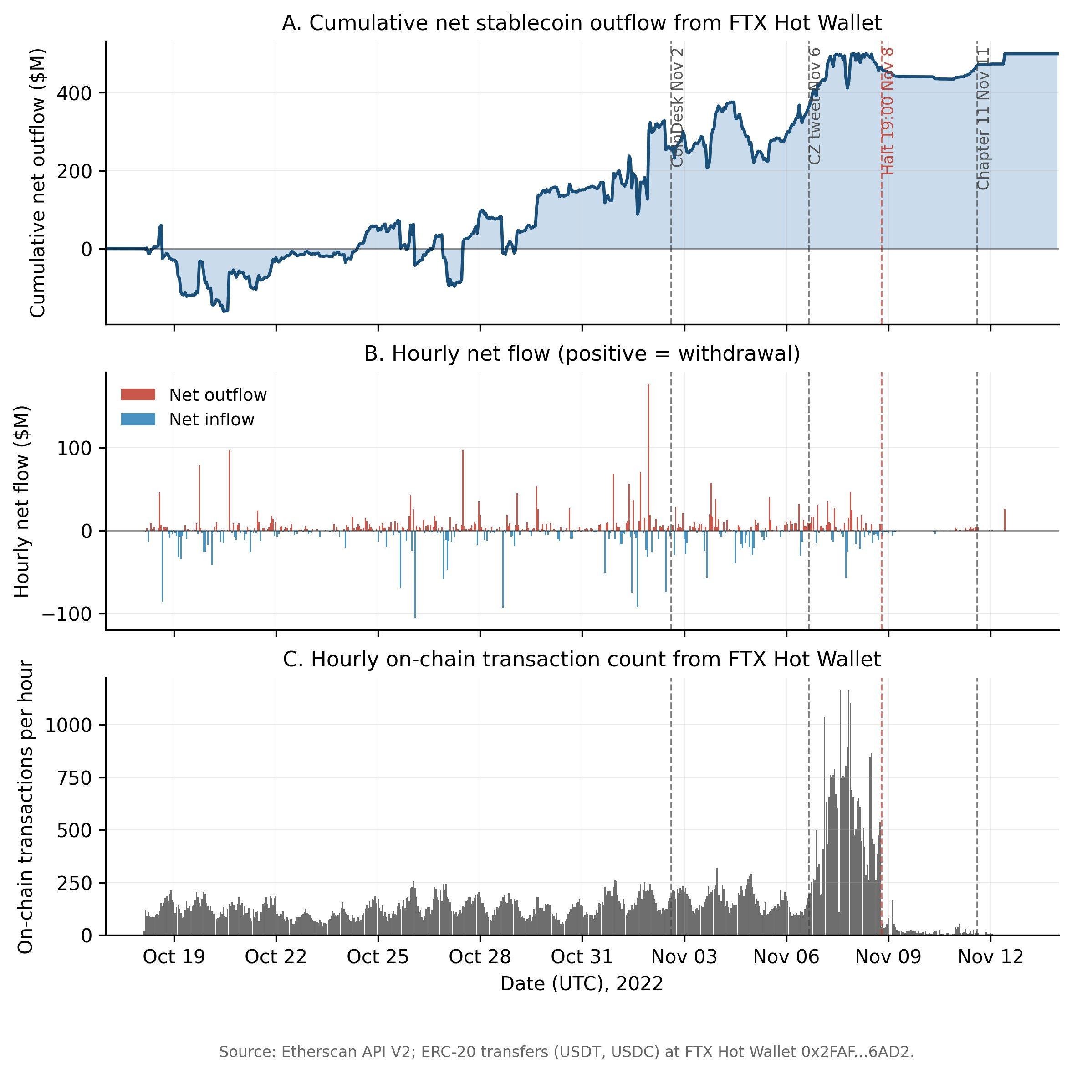
Figure 1. FTX Hot Wallet stablecoin outflows during the November 2022 collapse. Top panel: cumulative net outflow (positive values indicate net withdrawals). Middle panel: hourly net outflow. Bottom panel: hourly transaction count. Vertical dashed lines mark public events.
The cumulative net outflow series first turns positive on October 18, 2022 and increases approximately monotonically through November 8, reaching a peak of approximately $500 million. Three windows are useful for characterization: a pre-news period from October 15 to November 1, a news period from November 2 (CoinDesk publication) to November 9, and a post-halt period from November 10 onward. Table 1 summarizes flow characteristics across these windows.
Table 1. Net outflow by sub-window
Window | Hours | Total Net Outflow | Hourly Mean | Tx/Hour Mean
Pre-news (Oct 15 – Nov 1) | 432 | $304.2M | $0.70M | 107
News (Nov 2 – Nov 9) | 192 | $136.7M | $0.71M | 249
Post-halt (Nov 10–Nov 25) | 384 | $58.8M | $0.15M | 2

Two features of Table 1 deserve comment. First, the pre-news cumulative outflow of $304 million represents the majority of the total outflow observed across the entire window; the run was, in net flow terms, substantially complete by the time public attention focused on FTX. Second, the average hourly net outflow rate is essentially identical between the pre-news ($0.70M) and news ($0.71M) windows, despite a 2.33-fold increase in mean transaction count per hour over the same comparison. We return to this transaction-count surge, and its implications for the character of customer activity, in Section 4.2.
A natural counterfactual question is whether the pre-news outflow pattern is unusual relative to baseline FTX behavior in earlier periods. Our sample period does not contain a pre-stress baseline of comparable length, and we therefore do not make formal claims about anomaly detection. We document the pattern as observed.

4.2 Activity concentration and the panic phase
Hourly absolute flow magnitude across the study window is highly concentrated. Table 2 reports the share of total absolute flow accounted for by the most-active hours.
Table 2. Concentration of hourly absolute flow
Top N% of hours | Number of hours | % of total flow
Top 1% | 10 | 18.2%
Top 5% | 50 | 48.4%
Top 10% | 101 | 65.6%
Top 25% | 252 | 89.0%
Top 50% | 504 | 99.7%

The Gini coefficient of the hourly absolute flow distribution across the full study period (Oct 15 – Nov 25) is 0.806; the top 10% of hours account for 65.6% of total absolute flow and the bottom 50% for 0.3%. This concentration is partly mechanical — the post-halt window contains 384 hours during which median activity is essentially zero — but the inequality is also pronounced within the active periods alone. Either way, the picture is one in which operational activity at FTX was strongly episodic, with most flow concentrated in a relatively small number of hours.
Comparison of pre-news and news flow characteristics reveals a regime shift in the character of activity, even where average net outflow rate did not change. Table 3 reports moments of the hourly absolute flow distribution and transaction-count means across the two windows.
Table 3. Pre-news vs. news regime shift in flow characteristics
Metric | Pre-news | Post-news | Ratio
Mean hourly abs. flow ($M) | 8.05 | 9.41 | 1.17x
Median hourly abs. flow ($M) | 2.60 | 5.48 | 2.11x
Std hourly abs. flow ($M) | 17.52 | 12.01 | 0.69x
Skewness | 4.75 | 2.44 | 0.51x
Kurtosis | 29.33 | 7.41 | 0.25x
Mean transactions/hour | 106.8 | 248.7 | 2.33x
Max hourly abs. flow ($M) | 177.15 | 74.26 | 0.42x

Three patterns are visible. First, mean hourly absolute flow magnitude rose modestly (17%), but the median more than doubled (2.11x), indicating that hours of typical activity contained substantially more flow than before. Second, dispersion compressed sharply: standard deviation fell 31%, the maximum hourly flow fell 58% (from $177M to $74M), and both skewness and kurtosis declined materially. Third, mean transaction count per hour rose from 107 to 249, a 2.33-fold increase. Together these patterns describe a regime in which the distribution of hourly activity shifted upward and tightened: more transactions per hour, higher typical flow per hour, but fewer extreme single-hour spikes. One natural reading is that the news window was characterized by a flood of moderate-sized customer withdrawals replacing the prior regime of intermittent large transfers; we cannot distinguish customer from operational flows in the on-chain record alone, however, and offer this only as the most parsimonious interpretation of the observed distributional shift. Sub-hourly evidence reported in Appendix A.3 is consistent with this reading: the empirical distribution of transaction-level inter-arrival times tightens substantially during the news window relative to the pre-news baseline, a signature consistent with a withdrawal-processing pathway operating at or near a service-rate ceiling.

4.3 The on-chain visibility of the operational halt
Public reporting indicates that FTX began constraining withdrawals during the morning of November 8 UTC. Protos (2022) reported, citing on-chain observation, that the final processed ERC-20 user withdrawal occurred at approximately 11:00 UTC on November 8, with apparent cessation of on-chain withdrawal processing observable within hours thereafter. CoinDesk (2022) published "FTX Exchange Halts All Crypto Withdrawals" later the same day, describing the halt based on user reports, internal Telegram messages, and on-chain observation. FTX itself did not issue an explicit public confirmation of a halt; formal corporate acknowledgement came with the Chapter 11 bankruptcy filing on November 11. Subsequent regulatory characterization confirms the November 8 date (Federal Reserve Bank of Chicago, 2023).
The transaction count series in our hot-wallet data shows the operational halt at hourly resolution. From October 15 through the morning of November 8, hourly transaction count averages 107, with episodic excursions into the several-hundred range. Between November 6 and November 8 the series ramps to a sustained level of around 800–1,100 transactions per hour. At 19:00 UTC on November 8, transaction count drops from 540 (in the 18:00 UTC hour) to 38, and remains near zero or at zero for the rest of the day. Across the four-day window from November 8 19:00 UTC to November 13 00:00 UTC, twenty hours contain exactly zero on-chain transactions from the hot wallet, and the mean transaction count per hour over the post-halt sample (November 10 onward) is 1.7.
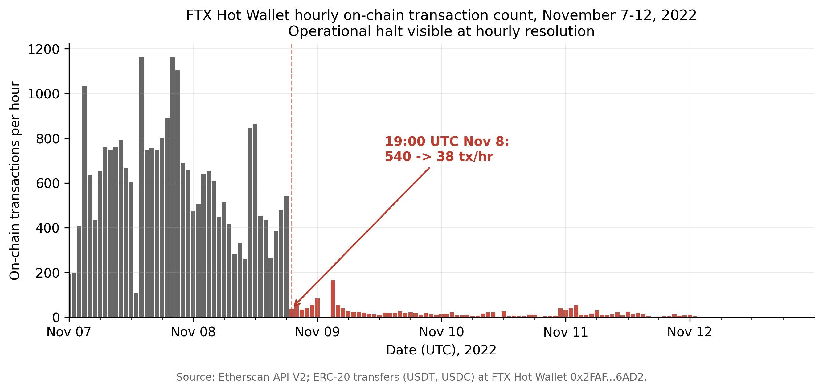
Figure 2. Hourly transaction count from FTX Hot Wallet, November 7-12, 2022. The vertical drop at 19:00 UTC on November 8 is visible without statistical inference.
Table 4 places the on-chain timestamps in the context of contemporaneous public reporting and the eventual official confirmation.
Table 4. Timeline of operational halt across data sources
Timestamp (UTC) | Event | Source
Nov 8, ~11:00 | Final ERC-20 user withdrawal processed | Protos (2022)
Nov 8, 16:15 | Binance LOI announced (CZ tweet) | Protos (2022)
Nov 8, 19:00 | Hot wallet transaction count drops from 540 to 38; sustained near-zero activity | This study
Nov 8 (later) | CoinDesk publishes "FTX Exchange Halts All Crypto Withdrawals" | CoinDesk (2022)
Nov 9 – Nov 13 | Twenty hours of zero on-chain transactions from hot wallet | This study
Nov 10, 15:50 | Partial hot wallet activity resumes | Cointelegraph (2022)
Nov 11, 14:30 | FTX Trading Ltd. files for Chapter 11 (formal corporate confirmation) | Public record

The on-chain record provides a precise hourly timestamp for the operational halt of the FTX Hot Wallet, more than 36 hours before the official confirmation. This is not a claim of unique informational advantage—observers including Protos identified the halt within hours of its occurrence using the same public data. Rather, it documents a property of public blockchain infrastructure: operational changes at venues whose primary wallets are publicly observable are visible at the resolution of the underlying chain, independent of the venue's disclosure decisions.

5. Discussion
The three findings together describe an empirical regularity: the FTX collapse, as it occurred operationally, was substantially visible in public on-chain data in advance of public disclosure. The pre-news outflow pattern was observable from approximately October 18 onward; the panic-phase intensification was observable as a surge in transaction count beginning November 6; the operational halt was observable as a transaction-count cliff at 19:00 UTC on November 8.
We do not claim that this visibility was actionable for market participants in the sense of predicting price movements—our prior analysis (available in Appendix A) finds no robust predictive relationship between on-chain flow magnitudes and Binance trading-volume changes after appropriate placebo and robustness testing. Rather, the findings characterize a property of the disclosure environment itself: customers, counterparties, regulators, and the general public had access to operational information about FTX at near real-time latency, mediated only by the work required to identify relevant wallets and parse the on-chain transaction record.
Three implications follow.

First, on-chain transparency complements rather than substitutes for traditional disclosure. The on-chain record showed when FTX stopped processing withdrawals, but did not show why, did not characterize the broader balance-sheet position, and did not include FTX-controlled wallets that were not publicly identified. The information available was mechanical and operational, not strategic or financial.

Second, the latency advantage of on-chain monitoring over self-disclosure is substantial during stress events. Where official disclosure may lag operational events by 24-72 hours, the on-chain record lags by minutes to hours. This is most relevant for events whose external consequences depend on timely identification: counterparty risk decisions, related-venue stress monitoring, regulatory triage.

Third, the value of on-chain visibility is bounded by wallet identification. Subsequent bankruptcy filings revealed FTX-controlled wallets that were not publicly tagged at the time of collapse. The visibility we document is the visibility that was actually available to contemporaneous observers; a more comprehensive on-chain footprint may have been visible to parties with private wallet identification.

Limitations.
Six limitations of the analysis warrant explicit mention. First, our wallet coverage is restricted to ERC-20 stablecoins on Ethereum; FTX operated across multiple chains and asset types, and Section 3.4 documents that the on-chain stablecoin channel observed here represents a small fraction of total customer outflows during the run. Findings about magnitudes should be read as lower bounds, while findings about timing and operational structure (the pre-disclosure outflow phase, the regime shift in flow characteristics, the operational halt) are preserved across the channel restriction since they concern when and how the channel behaved rather than how much total volume it represented. Second, we rely on publicly tagged wallet addresses; coverage of FTX-controlled addresses was incomplete at the time of collapse. Third, the analysis is descriptive rather than causal—we make no claims about whether on-chain visibility caused or could have caused different outcomes for any market participant. Fourth, this is a single-event study; the patterns we document may not generalize to other exchange failures with different organizational structures or operational arrangements. Fifth, our sample window does not contain a substantial pre-stress baseline. Without a comparable baseline period of normal-operation flows at the same wallet, we cannot make formal anomaly-detection claims about the October 18 inflection or the pre-news regime; the patterns are documented as observed, with the understanding that establishing their unusualness in a statistical sense would require a longer historical comparison series. Sixth, our hourly aggregation may obscure burst dynamics, queueing behavior, or sub-hourly clustering. We provide a sub-hourly robustness check at five-minute resolution in Appendix A.3, which preserves the qualitative findings reported in the main text.

6. Conclusion
We document three features of the November 2022 FTX collapse using public on-chain data: a pre-disclosure outflow phase beginning approximately October 18; a panic phase characterized by transaction-count surge rather than net flow acceleration; and a precisely datable operational halt at 19:00 UTC on November 8. Each finding rests on direct observation of the public blockchain record without inferential machinery.
The visibility we document was available to anyone monitoring public Ethereum data during the collapse. The findings suggest that public blockchain infrastructure provides a meaningful, though bounded, channel for operational transparency at centralized cryptocurrency exchanges, complementing rather than substituting for traditional disclosure.

References
Aramonte, S., Huang, W., & Schrimpf, A. (2021). DeFi risks and the decentralisation illusion. BIS Quarterly Review, December, 21–36. https://www.bis.org/publ/qtrpdf/r_qt2112b.pdf
Aramonte, S., Doerr, S., Huang, W., & Schrimpf, A. (2022). DeFi lending: Intermediation without information? BIS Bulletin, No. 57. https://www.bis.org/publ/bisbull57.pdf
Auer, R., Cornelli, G., Doerr, S., Frost, J., & Gambacorta, L. (2022). Crypto trading and Bitcoin prices: Evidence from a new database of retail adoption. BIS Working Papers, No. 1049. https://www.bis.org/publ/work1049.pdf
Azar, P. D., Baughman, G., Carapella, F., Gerszten, J., Lubis, A., Perez-Sangimino, J. P., Rappoport, D. E., Scotti, C., Swem, N., Vardoulakis, A., & Werman, A. (2024). The financial stability implications of digital assets. Federal Reserve Bank of New York Economic Policy Review, 30(2). https://www.newyorkfed.org/research/epr/2024/epr_2024_digital-assets_azar.html
Brunnermeier, M. K., & Pedersen, L. H. (2009). Market liquidity and funding liquidity. Review of Financial Studies, 22(6), 2201–2238. https://doi.org/10.1093/rfs/hhn098
CoinDesk. (2022, November 8). FTX exchange halts all crypto withdrawals. Retrieved from https://www.coindesk.com/business/2022/11/08/ftx-exchange-halts-all-crypto-withdrawals
Cointelegraph. (2022, November 10). Breaking: FTX appears to have resumed withdrawals, blockchain data shows. Original URL no longer accessible; archived copy retrieved from https://www.investing.com/news/cryptocurrency-news/breaking-ftx-appears-to-have-resumed-withdrawals-blockchain-data-shows-2940415
Cong, L. W., Li, Y., & Wang, N. (2021). Tokenomics: Dynamic adoption and valuation. Review of Financial Studies, 34(3), 1105–1155. https://doi.org/10.1093/rfs/hhaa089
Diamond, D. W., & Dybvig, P. H. (1983). Bank runs, deposit insurance, and liquidity. Journal of Political Economy, 91(3), 401–419. https://doi.org/10.1086/261155
Federal Reserve Bank of Chicago. (2023). A retrospective on the crypto runs of 2022. Chicago Fed Letter, No. 479. https://www.chicagofed.org/publications/chicago-fed-letter/2023/479
Goldstein, I., & Pauzner, A. (2005). Demand–deposit contracts and the probability of bank runs. Journal of Finance, 60(3), 1293–1327. https://doi.org/10.1111/j.1540-6261.2005.00762.x
Gorton, G. B., & Zhang, J. Y. (2023). Taming wildcat stablecoins. University of Chicago Law Review, 90(3), 909–970. https://lawreview.uchicago.edu/print-archive/taming-wildcat-stablecoins
Griffin, J. M., & Shams, A. (2020). Is Bitcoin really untethered? Journal of Finance, 75(4), 1913–1964. https://doi.org/10.1111/jofi.12903
Makarov, I., & Schoar, A. (2020). Trading and arbitrage in cryptocurrency markets. Journal of Financial Economics, 135(2), 293–319. https://doi.org/10.1016/j.jfineco.2019.07.001
Protos. (2022, November 8). FTX halts ERC-20, Solana, and Tron withdrawals. Retrieved from https://protos.com/ftx-halts-erc-20-solana-and-tron-withdrawals/
Vidal-Tomás, D., Briola, A., & Aste, T. (2023). FTX's downfall and Binance's consolidation: The fragility of centralized digital finance. Physica A: Statistical Mechanics and its Applications, 625, 129044. https://doi.org/10.1016/j.physa.2023.129044

Appendix A. Supplementary Empirical Analyses
In the course of this work, we tested a number of additional hypotheses that did not yield robust results and are therefore relegated to this appendix. We report them for completeness and to support replication.

A.1 On-chain flows and Binance trading volume
We tested whether absolute on-chain flow magnitude predicted Binance BTC/USDT trading volume at hourly horizons using ordinary least squares with Newey-West standard errors (lag = 24 hours). The pooled-stablecoin specification produced a small significant coefficient (β = 0.0072, t = 3.77 with HAC standard errors). However, this result did not survive robustness testing. Specifically: (i) splitting flows into USDT-only and USDC-only specifications produced individually insignificant coefficients in the post-news subsample (USDT t = 0.34, USDC t = 0.39); (ii) rolling 100-hour regression coefficients were highly unstable across the sample, with no visible strengthening around the November 2 information event; (iii) circular-shift placebo tests failed to reject the null of no genuine predictive relationship at any tested lag. We interpret the pooled-series result as likely an aggregation artifact and do not advance it as a substantive finding.

A.2 Reverse-direction test
We tested whether Binance trading volume predicted next-hour absolute on-chain flow. The coefficient was small and statistically insignificant (t = 0.75), supporting the absence of a robust contemporaneous relationship in either direction at hourly resolution.

A.3 Sub-hourly robustness
To verify that hourly bins do not obscure burst dynamics, queueing behavior, or sub-hourly clustering, we re-aggregated the raw transaction data at finer resolutions. The qualitative findings reported in the main text are preserved.
At five-minute resolution, the full sample contains 6,806 non-empty bins with a mean of 13.9 transactions per bin and a maximum of 154. The pre-news, news, and post-halt regime structure remains visible: the November 6–8 transaction-count ramp is sustained across many consecutive five-minute bins rather than concentrated in a small number of high-activity intervals, indicating elevated baseline activity rather than burst clustering. At one-minute resolution near the halt, the cliff structure is sharper than the hourly view suggests: the FTX Hot Wallet processed 29 transactions in the five minutes preceding 19:00 UTC on November 8 and 6 transactions in the five minutes immediately following, a 79% drop within ten minutes of the regime change.
The distribution of transaction-level inter-arrival times tightens during the news window relative to the pre-news baseline, then lengthens substantially after the halt. Specifically, mean (median) inter-arrival time is 42.9 (36.0) seconds during the pre-news window of October 15 to November 1, with a 90th percentile of 84 seconds. During the November 2 – November 8 19:00 UTC news window, mean inter-arrival time falls to 27.5 (median 24.0) seconds, and the 90th percentile compresses to 60 seconds. After the halt, mean inter-arrival time rises to 150.1 seconds, with the median at 72 seconds and the 90th percentile at 252 seconds. The pattern—faster and more regular spacing during the news window, sparser and more dispersed spacing afterwards—is consistent with a withdrawal-processing system operating at or near a service-rate ceiling during the run, then transitioning to intermittent residual activity once the customer-facing withdrawal pathway was closed.

Appendix B. Wallet and Token Contract Addresses
Full Ethereum addresses for the four FTX-affiliated wallets and the two stablecoin contracts used in this study are listed in Table B1 for replication purposes. All addresses are publicly identifiable on Etherscan as of the time of writing.
Table B1. Ethereum addresses used in the analysis
Label | Address
FTX Hot Wallet | 0x2FAF487A4414Fe77e2327F0bf4AE2a264a776AD2
FTX Cold Wallet | 0xC098B2a3Aa256D2140208C3de6543aAEf5cd3A94
FTX-tagged wallet (additional) | 0x83a127952d266A6eA306c40Ac62A4a70668FE3BD
Alameda Research-tagged | 0x3cD751E6b0078Be393132286c442345e5DC49699
USDT contract | 0xdAC17F958D2ee523a2206206994597C13D831ec7
USDC contract | 0xA0b86991c6218b36c1d19D4a2e9Eb0cE3606eB48

