DiAnne L. Sinn
Feb 25, 1949— Nov 8.2017

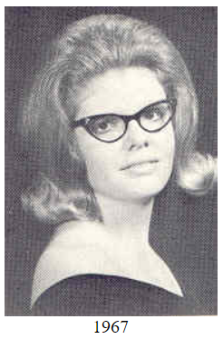
Preceded in death by father her Grant Sinn. Survived by her husband Terry Tomcsik, of Papillion, Neb.; mother Ival Sinn, of Boone; and her sister Kathryn Davies, of El Paso, Texas. DiAnne has resided in Papillion, Neb., for the last 6 years after her husband’s retirement from General Dynamics in Maryland. DiAnne retired in 2000 as a personnel specialist for Macro International in Laurel, Md., where she worked for 8 years. She lived for 30 years in the Washington, D.C.-Baltimore area and previous to that 2 plus years in Port Arthur, Texas. DiAnne graduated from Boone High School in 1967 and attended Iowa State University for a year. She then worked for the ISU telephone office for 10 years.

