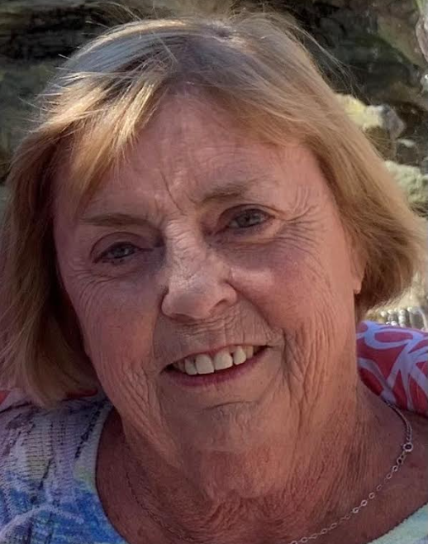
Houston - Linda Ward Rickertsen died peacefully, age 75 on September 29, 2024 at her home in Houston, TX.
She was perpetually optimistic, never letting chronic ailments, especially later in life, keep her down. She was a fiercely proud and loving mother and grandmother. She would say her outgoing nature came from Irish roots. She gathered with her tight-knit family often, travelling with them and with her many long-time friends to 30 countries around the world. As long as she was able, she loved to golf, bowl, and swim. She was a consummate dinner and bridge party hostess, always with long talks, excellent food, and big kitchen messes.
Linda Jeanne Ward was born to parents Paul and Marjorie (Allen) Ward in Cedar Rapids, IA on May 27, 1949. She grew up in Boone, IA, graduating from Boone High School in 1967. She attended the University of Iowa for two years, where she met and married fellow Hawkeye and avid bridge player Donald Leroy Rickertsen. In 1970 they moved to the dorms at the University of Chicago, where Don obtained his law degree.
To escape midwestern winters, they relocated to Atlanta in 1973. When her son Donald Ward ("J.R.") Rickertsen arrived in 1979, she returned to school, graduating with a B.B.A from Georgia State in 1981. Her daughter Marjorie ("Margie") Ward Rickertsen followed in 1982.
Linda held varied roles in finance over the years. She was one of very few women selling bonds at Drexel Burnham Lambert in the 1970s. In the early 1980s, she taught aspiring brokers including Archie Manning to pass licensing tests. She then encouraged women to invest when she founded Women Take Stock. She then served as chief financial officer for a succession of broker dealers. Linda shifted to compliance when what became Bank of America took her to Charlotte, NC from 1997-2002, before she returned to Atlanta and worked until retirement with SunTrust Robinson Humphrey.

She chose Boynton Beach, FL in 2016 as her base for exploring theworld, until her last year, when she lived in Houston to be close to her son.
Linda was predeceased by her parents, ex-husband Don, eldest sister and brother-in law Marcia & Joe Zachar. Linda is survived by son J.R. (wife Ashleigh and son Tom), daughter Dr. Margie Farris (children Alex and Anna), four siblings (Debbie Dogotch, Randy Ward, Daniel Ward, and Patty Ward), and a large extended family of in-laws, nieces and nephews.
A celebration of life will be held at 6PM Oct. 5 at Tin Roost, 840 W. Penn St. North Liberty, IA following interment at St. John's Cemetery in Cedar Rapids. In lieu of flowers, please send donations to the orphaned boys Linda supported at Highlands Bolivian Mission, PO Box 1358 Highlands NC 28741.

