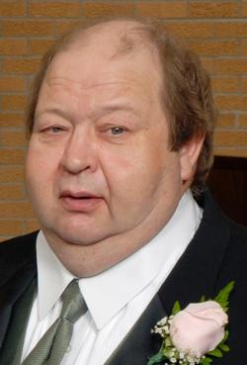

Birth: Jul. 30, 1950 Death: Jan., 2015
Boone, IA Ames, IA

Mark ‘Andy’ Anderson, age 64, of 1114-14th Street, died January 7, 2015, at the Mary Greeley Medical Center in Ames.

Bernard Mark Anderson was born in Boone on July 30, 1950, the son of Bernard Thomas and Gladys (Swanson) Anderson. Andy graduated from Boone High School in 1968.

On April 29, 2009, he married Beverly Jennings in Boone.

Andy was an auto body technician all of his working life, working in the body shops of Beneventi Chevrolet and Holmes Honda in Des Moines and Pat Clemons Chevrolet and Moffitt’s Ford in Boone. For a time, he also owned/operated Andy’s Body Shop in Boone.

He loved repairing and painting cars, playing pool, reading car magazines, cooking homemade soups, attending car shows, and assembling plastic model cars.

Andy is preceded in death by his father, a sister Barb Murphy, a brother Tom Anderson, a niece Angela Anderson, and a nephew Travis Anderson.

He is survived by his wife Beverly of Boone; two sons Kelly Anderson and wife Melissa of Boone and Shane Seil and wife Jodi of Lake City; daughter Michaelle Kirton and husband Bryant of Ogden; his mother Gladys Anderson of Madrid; two brothers Brian Anderson and wife Mary Kay of Boone and Kevin Anderson and wife Nancy of Ankeny; a sister Denise Laws of Lafayette, Indiana; a sister-in-law Janis Anderson of Boone; 12 grandchildren; six great grandchildren; and numerous nieces and nephews and other relatives.

