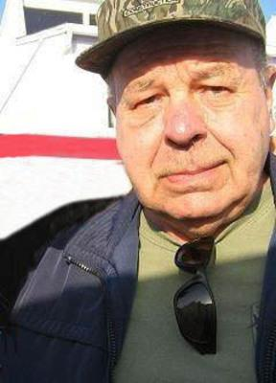
Roger Hubby (1949 - 2016)
Roger Hubby, 67, lifelong resident of Boone, Iowa passed at the St. Clare Health Center in Fenton, Missouri on Monday morning, February 1, 2016 of a second major stroke.
He was born on January 31, 1949 in Boone, Iowa the son of Donald and Jean (Ellsworth) Hubby.
Roger was a 1967 graduate of Boone High School. He served in the Iowa National Guard in Boone from 1970 to 1976 as an airframe structural repairman.
On June 23, 1979 he married Rose Zeets at Boone, Iowa.
Roger started working out of high school at the family business, Mid-States Steel. He loved working in steel fabrication and was especially proud of initiating the modernization of the shop and drafting department in the mid 1980's with a shop peddinghaus drill line and drafting department software. He retired as Vice President and Sales Manager in 2000. Roger enjoyed watching the Today Show and TV crime programs, following the Bears and Packer football teams and deep sea fishing in Florida.
His father Don in November of 1999; brother Ron in March of 2000; and mother Jean in July of 2013 preceded him in death.
He is survived by his wife Rose of Boone; 2 daughters Ann Anderson and husband David of Olathe, Kansas and Angela Hubby of St. Louis, Missouri; 1 son Gregory Hubby and wife Eleasha of Billings, Montana; 8 grandchildren Rand and Rowan Anderson, Jaden and Ian Waldman, and Gage, Grace, Wyatt and Morgan Hubby; 1 sister Claudia Ferry of Boone, Iowa; and 5 nieces.
Funeral services will be held on Saturday morning, February 6th at 10:30 a.m. at the Stark-Welin Chapel in Boone with Pastor Dianna Clark officiating.

Interment will be in the Bass Point Cemetery north of Boone.
Visitations will be held at the Stark-Welin Chapel on Saturday morning prior to the service from 9:00 a.m. until the time of service at 10:30 a.m. with the family present during that time to greet friends.
In memory of Roger, memorials may be directed to the Boone HOPE Foundation, P.O. Box 105, Boone, Iowa, 50036-0105.
On line condolences may be made at starkwelin.com.
Stark-Welin Funeral Directors in Boone, Iowa is in charge of arrangements.

