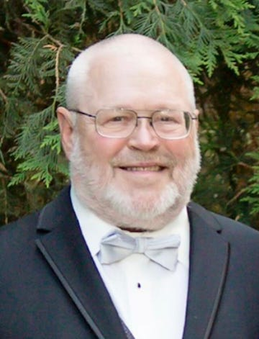

Russell Cline Brown of rural Cumming, Iowa passed away peacefully at his home on Saturday, July 22, 2023.
Russell was born on December 7, 1948 to Philip and Joye Brown of Bloomfield. He was the oldest of four boys. His family moved to Boone in 1964 where he attended school, graduating in 1967. He received his doctorate at Palmer College of Chiropractic and practiced in Mississippi and Boone.
Russ spent many years as the spa manager and massage therapist at the Savery Hotel and manager of Doc's Hunt Club.
He is preceded in death by his parents and brother Ronald.
Russ is survived by his daughters, Rishell Mallozzi (Chris), Sarah Pesek (Tom), and Emily Sisko (Adam); grandchildren Mason, Jacob, and Sadie Hessing, Sophia and Lydia Pesek, and Kaden Sisko; brothers Roger (Faye) and Ralph; companion Violeta Gettle, former spouses, Vicki Cero and Lori Brown, and his nieces.
A celebration honoring Russ will be held on Saturday, August 5th, 2023, from 1-4 pm at the farm.
Posted online on July 28, 2023
Published in Des Moines Register

