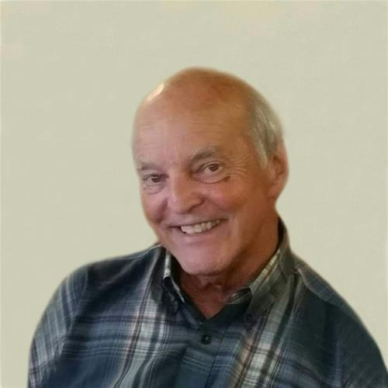

Thomas Long
Born on Jun 28, 1948
Departed on Aug 13, 2015

Memorial
Thomas Dale Long (Tom), 67, of Marion, died Thursday, August 13, 2015 after a courageous battle due to complications following heart bypass surgery. Memorial Service: 2:00 p.m. Wednesday, August 19, 2015 at Hope Lutheran Church in Cedar Rapids. A visitation will be held from 5-8 p.m. Tuesday, August 18, 2015 at Cedar Memorial Funeral Home.
Tom was born June 28, 1948 the son of Roy and June (Harker) Long of Boone, Iowa. He graduated in 1967 from Boone High School. He met Mary Fowler after moving to Cedar Rapids. They married December 12, 1970. Tom completed a Bachelor’s of Science in Sociology and Business from Mount Mercy College in 1975.
In 1979, they moved to Spirit Lake, IA, where he was a member of the Jaycees, very active in the community, and proponent for the Iowa Great Lakes. He loved adventure and seeing the United States. Tom and Mary moved back to the Cedar Rapids area in 1999 to be close to everyone. They eventually resided in Marion with their new dog, Chewy.
Tom is survived by wife Mary Long of Marion; daughter, Kristi and Micah of Atlanta, GA; son, Ryan and Erica of Hiawatha; three grandchildren, Paige, Zoey (Ryan) and Hayden Thomas (Kristi); sister, Beverly Long McAllister; several aunts, nieces, nephews and cousins.
Tom will be remembered as witty and hard-working. He was a loving and affectionate husband and an amazing, kind, and exceptional Dad. Tom was a loyal friend, neighbor and happy-go-lucky uncle and brother in-law. He was always sincere, pure, and best at whatever he touched. Tom will be deeply missed.
Memorials may be directed to the family in Tom’s memory.

