We got beat by the best 50 years ago in Iowa high school baseball

By CHUCK OFFENBURGER

DES MOINES, Iowa, Aug. 4, 2015 — Let’s talk baseball.

So last Friday morning, July 31, I started my drive to spend a fine day at the Iowa High School State Baseball Tournament here at beautiful Principal Park, where the State Capitol graces the view beyond the centerfield wall. Specifically I wanted to see the Class 3A semifinals — always good baseball — and to see if Boone could upset Waverly-Shell Rock and Harlan could upset Pella.

And when I thought of Boone right then, wow, it hit me like a haymaker! OMG, it was 50 years ago to the day when Boone, with its legendary pitcher Jack Mustapha, beat my Shenandoah Mustangs and me, 6-0, one game shy of the 1965 state championship game!

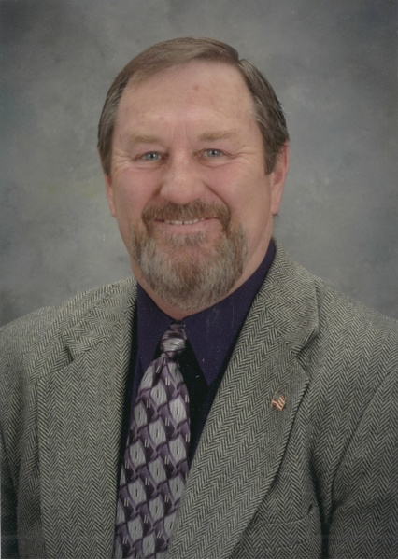

On an impulse, I pulled to the side of Iowa Highway 141, took out my smart phone and Googled for a Jack Mustapha in the east Des Moines suburb of Pleasant Hill, which is where he was living the last time I talked to him a half-dozen or more years ago. I punched in the number, and what-ho!

“Yes, this is Jack Mustapha,” he said.

“Mustapha, this is Chuck Offenburger,” I said. “Do you remember me?”

“Sure, I do, Chuck,” the old foe said, nice as could be. “How are you?”

“I’m fine, thanks,” I said. “And the reason I’m calling right now is to tell you just how damn broad-minded I’ve become.”

His answer: “Oh-oh. What’s up?”

HARD TO FORGET THIS. Then I erupted. “If I’m right, and I think I am, it was 50 years ago to this very day when you threw a no-hitter at my Shenandoah Mustangs and me, beat us 6-0 in a semifinals game, and then you went on to win the state championship in your next game against Burlington — with another no-hitter. And let me add that you struck me out three times in our game.”

Mustapha said his memory was the same as mine, although I don’t think he really recalls my three whiffs as clearly as I do.

“And do you want to guess what I’m doing now this morning, 50 years to the day after you did that to us?” I said to him. “I am driving down to the high school state baseball tournament in Des Moines, this time with full intent of cheering for your Boone Toreadors!”

Mustapha laughed out loud. “That,” he said, “is broad-minded!”

Then the old baseball stories started flowing, and next thing you know, we two old opponents were figuring out what day soon we can get together for lunch and continue the fun conversation. There’s a lot to talk about, including how the baseball tournament back in our era had all teams playing in one class, and how even most of the championship games were played on high school fields, rarely in fancy stadiums. For example, Boone beat us in Creston. And they won the state championship over Burlington in a game played in Williamsburg, of all places.

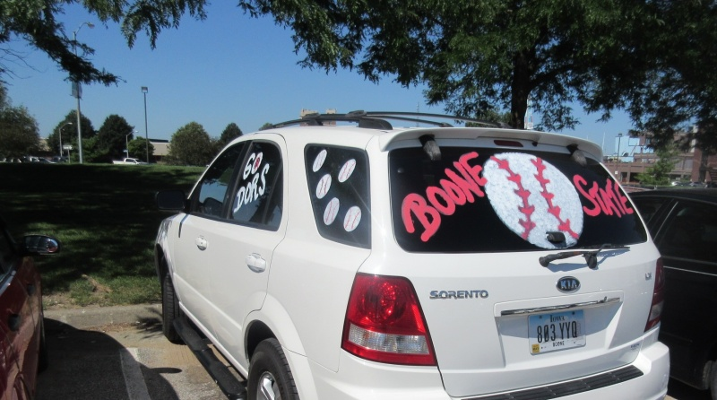

Boone High School fans were excited about baseball again this summer, as this vehicle showed last week while parked outside Principal Park in Des Moines, site of the state baseball tournament.

REMEMBER THAT OUTFIELDER FROM FOREST CITY? “So, when there were just the four teams of us left in the tourney, back in ’65, ” I said to Mustapha, “do you remember what team there was in addition to Boone, Burlington and Shenandoah?”

“No, I can’t come up with it,” he said. “We didn’t have to play them, whoever it was.”

Right, I said, “but that other team was Forest City. Want to guess who their most notable outfielder was?”

“No idea,” Mustapha said.

“Get ready for this,” I told Boone’s old star, “one of the Forest City outfielders was Terry Branstad. Ever heard of him since then? Maybe we can find him and invite him to lunch.”

There’s probably a lesson in all this for the high school ball players of today, some of whom had their hearts broken this past Friday and Saturday in the semifinals and championship games of the four-class state tournament. (That would include the boys from Mustapha’s alma mater, Boone, who got beat 12-2 in that semifinals game by the mighty Waverly-Shell Rock Go-Hawks, who cruised on to their school’s first-ever state baseball title.)

You might be so angry with your opponent, right after he puts a whoopin’ on you, that you think you’ll hate him for the rest of your life. But a few years go by — O.K. a few decades go by — and you’re on the phone with each other, or sitting at lunch, telling stories and laughing about it all.

WELL, WE GOT BEAT BY ONE OF THE BEST. In the case of our 1965 Shenandoah Mustangs and our feelings toward Jack Mustapha, it was abundantly clear to all of us that we had been beaten by someone really special. Fifty years later, we can say with certainty that he was one of the best high school pitchers ever in Iowa. And that’s high praise when you know the list would include Bob Feller, Stan Bahnsen, Bill Drummond, Dick McVay, Mike Boddicker, Cal Eldred, my great-nephew Tony Watson and other such legends.

You’ll probably want some statistics before you’ll accept my assessment of Mustapha, who was a right-hander. Here they are, thanks to the Boone News-Republican:

–His high school career pitching record was 31-2 with 430 strikeouts in 243 innings, seven no-hitters and four one-hitters.

–He was 10-0 as a sophomore, then was 12-2 as a junior with three no-hitters.

–His senior season of ’65 started with a scare. He got seriously sick with hepatitis and missed nine games early in the season. He came back frail — he’d lost 40 pounds — but began making pitching starts again about mid-season. But from then on, he was lights out, ending the senior year 9-0, with 135 strikeouts in 63 innings and had a 0.28 ERA. He started, finished and won eight of the team’s nine tournament games.

–And here’s perhaps the most convincing stat: In Boone’s last five tournament games, he threw four no-hitters, including three in a row to the championship!

Boone’s team, coached by Hall-of-Famer Bill Sapp, was phenomenal, needless to say. “You shouldn’t feel too bad about us beating you,” Mustapha told me last week. “We had four first-team All-Staters on that team when we were seniors in ’65, so that was going to be pretty tough for anybody to beat.”

His catcher back then was Rick Davis, who later became the Boone High School baseball coach. Davis has said he thinks Mustapha was throwing “in the low 90s” (that’s miles per hour) in high school, which even today would be great. Take it from somebody who batted against him — I wasn’t sure I saw the ball all the way from his hand to where it apparently crossed home plate.

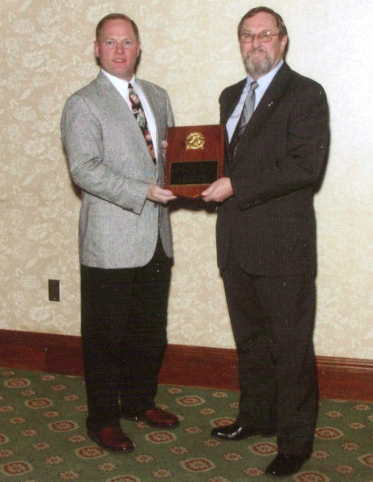

Jack Mustapha (right) is shown being inducted into the Iowa High School Baseball Coaches Association’s Hall of Fame in 2007. Making the presentation was Lee Toole, head coach at Lewis Central of Council Bluffs and the executive director of the baseball coaches group.

THE FUTURE LOOKED SO BRIGHT, AND THEN… So if Jack Mustapha was that good in high school 50 years ago, why didn’t you hear of him making it big later in college or professional baseball?

The story takes a sad turn here.

“Cap Timm, who was the baseball coach at Iowa State then, gave me a full ride scholarship,” Mustapha explained when we talked Friday. “This was back in the old days, remember, and freshmen were not eligible to play varsity ball. In that season in the spring of 1966, we only had three freshman games, and I pitched and won all three. But I got so frustrated about not getting to play more than that.”

He hadn’t enjoyed college life — at least the academic side of it — all that much and decided he’d already had enough of it. He signed a professional contract with the St. Louis Cardinals, who had wanted him all along, and went to spring-summer training with them.

“They were going to make an outfielder out of me, because I was always a pretty good hitter and I could run,” Mustapha said.

That seems almost crazy now, as good a pitcher as he was in high school. But on the other hand, if your big pitch is a sharp fastball — even if it had good movement on it like Mustapha’s did — it would probably be easy-pickings for professional hitters. The St. Louis Cardinals were probably right; they usually are, you may have noticed.

But in that Vietnam War era, Mustapha had no more student deferment. When he was about to be drafted, he decided instead to enlist in the U.S. Army. He wound up in Special Forces, and headed to combat in Southeast Asia.

Can he say what his assignment was?

“It’s been so long ago, I don’t think it matters anymore,” he said. “I was on a 9-man team, and we spent most of our time on assignments on borders that our military said didn’t exist, if you know what I mean. We were assigned to Khe Sanh when the Tet Offensive started.”

If I’m reading his records correctly, he had three tours in Vietnam. He had serious back injuries in a helicopter crash. He was wounded in firefights.

The good news was he survived. The bad news was his dream of having a professional baseball career was over.

YOU CAN’T STAY BITTER OR IT’LL KILL YOU. “I was really a bitter young man about that for a couple of years,” he said, “but you know, you just have to let that go if you’re going to go on and have any kind of life. Eventually I did let go of it.”

After a long recovery, and before he was discharged from the Army in 1975, he did have one more brief fling with the grand old game.

“For a time then, I was assigned at Fort Carson in Colorado,” he said. “It was the last time I played in a real baseball game, and it was only one inning. They had a baseball team out there, and I was talking to one of the young guys who was involved in running it. I was 25 years old then, which made me seem like an old man to a lot of those kids. So anyway, I told the guy I had played a little ball and asked if I could try to pitch an inning. He said, ‘Oh, Sarge, I’m not sure you want to do that. These guys are pretty good, and I don’t want you to get hurt.’ But I talked him into letting me give it a try.

“I got warmed up, went in and threw 12 pitches,” he recalled. “I gave up two foul balls, but struck out all three guys I faced. I came into the dugout, and the guy said, ‘Hey, Sarge, let’s talk about getting you on this team now.’ I said no (in a colorful way), that I just wanted to see if I could still do it.”

He knew, though, that the back injury and the tenderness in the arm made any return to baseball impossible.

After more recovery and back in civilian life, Mustapha waived his disability that he’d earned and joined the Iowa State Patrol. He was a trooper for 10 years before he was dismissed because he was in a car accident after drinking at a celebration of his birthday, a party attended mostly by his pals in law enforcement.

He then served as chief of police in the town of Madrid, just southwest of Boone. “I swear, the second worst job there is, is being a small town cop,” he said. “The absolute worst job there is, is being a small town police chief.”

MIDDLE-AGED AND BACK TO THE ARMY. But his misery there in Madrid ended when the U.S. military in the late 1980s began its build-up in the Middle East, leading to Desert Storm in 1990. Then in early 1991, the U.S. and its allies launched the Persian Gulf War against the Iraqi forces of Saddam Hussein.

“Because of my military specialty, I was asked to come back into the Army, and I did,” Mustapha said.

That second military hitch for him ended in 1993 when he had a heart attack and stroke. He returned home and was in a wheel chair for the next year.

He eventually went to work for Iowa Workforce Development in Des Moines, first as a representative working the cases of disabled veterans, then later as a program director battling unemployment fraud. He retired in the spring of 2010.

In recent years, Mustapha has had both shoulders and both knees operated on, and two years ago, he “nearly died” from a bout of intestinal bleeding.

“It’s been kind of tough physically,” he said. “I can’t rotate my shoulders anymore, so I can’t even play golf. But I’m just glad to be alive.

“The VA (Veterans Administration) has been tracking me pretty closely because when I was on that Special Forces team in Vietnam, we got into a bunch of chemical stuff, specifically Agent Orange. The eight other guys on that team have all died of cancer, but I’ve never had any sign of cancer at all, and they’re watching me to see if they can figure out why I haven’t had it.”

After hearing all that, I told Mustapha that long-ago high school baseball games seem pretty trivial.

And I thanked him for his public service — and his suffering, too.

But then, what the heck, I went ahead and also thanked him for the thrills he gave Iowa baseball fans in his high school years, even those of us who helped fatten his statistics.

“It was a lot of fun, wasn’t it?” Mustapha said.

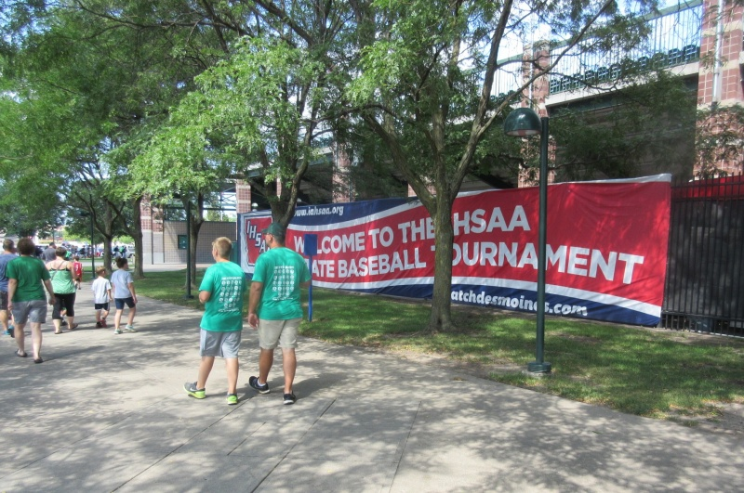

High school baseball, which is played in the summer in Iowa, is better and more popular than ever today. The state tournament draws good crowds to Principal Park, the beautiful stadium at the confluence of the Raccoon and Des Moines Rivers in downtown Des Moines.

IT AIN’T OVER UNTIL, WELL, UNTIL IT’S OVER. Now before I end this long, wandering baseball tale, let me point out that we Shenandoah Mustangs did not go down without a commendable or possibly foolish effort in that long-ago loss to the Boone Toreadors and Mustapha. We were trailing 6-0 going into the top of the seventh inning — our last chance at bat.

The inning opened with yet another strikeout, one of 15 he rang up on us that night. Then our scrappy Larry Cole came up and Mustapha walked him. Cole, who had good speed, stole second. Bruce Ketcham hit a ground ball and was thrown out at first base, but that put Cole on third base with two outs. Mustapha then walked Denny Howard. Our coach Tom England decided to challenge Mustapha, and signaled Howard to try to steal second.

“I thought Coach England had lost his mind when he gave me the steal sign,” recalled Howard, now a clothing & sporting goods store owner in Shenandoah. “Somehow I was able to beat the throw.”

Then Cole started agitating at third base.

“On a couple of Mustapha’s pitches, I’d gotten good distances off third base and made it back,” recalled for me from his home in Litchfield Park, Arizona, where he is retired after a career teaching high school and coaching. “Coach England was there in the coaching box, and I said, ‘Let me try to steal home! I think I can steal home!’ He was saying, ‘No, no, we’ve got two outs.’ I mean, we weren’t hitting Mustapha at all, and I don’t think anybody he’d faced in the tournament had scored on him. So I thought that if I could possibly score, it might rattle him, and who knows what might happen?”

So Cole says he asked our coach one more time if he could run, and whatever the answer was, Cole broke for home!

Does Mustapha remember that?

“Oh yeah,” he told me. “You know, not many teams scored on me. And during that senior season, I’d had a couple of them try to steal home on me late in games. In fact, I had a perfect game going — was it against Ames? — and a kid did steal home on me. So I was aware that base runners might be thinking that late in games. And I remember looking over at your guy on third base and getting a feeling that he might just try me. I was ready.”

When Cole did break for home, Mustapha threw a rocket to catcher Davis, who administered the tag. Third out. Game over. No-hitter for Mustapha.

After handshakes (this was before “high fives” or fist bumps), we were back in the dugout, awaiting a eulogy from Coach England. I remember finally saying quietly to Cole, “Two outs, we’re down 6 and you steal home? What were you thinking?”

He shrugged his shoulders and said, “Just trying to break-up the shut-out.”

Oh man, high school baseball was a great time back then.

And it’s even better now.

You can write the columnist (and 1965 Shenandoah Mustangs catcher) at chuck@Offenburger.com or comment using the handy for below here.

