Predicting Ad Clicks on A Website

Booorayan

26/10/2019

# importing required libraries  
library("aod")  
library("ggplot2")  
library(xgboost) # for xgboost  
library(tidyverse) # general utility functions

## -- Attaching packages ---------- tidyverse 1.2.1 --

## v tibble 2.1.1 v purrr 0.3.2   
## v tidyr 0.8.3 v dplyr 0.8.0.1  
## v readr 1.3.1 v stringr 1.4.0   
## v tibble 2.1.1 v forcats 0.4.0

## -- Conflicts ------------- tidyverse_conflicts() --  
## x dplyr::filter() masks stats::filter()  
## x dplyr::lag() masks stats::lag()  
## x dplyr::slice() masks xgboost::slice()

library(randomForest)

## randomForest 4.6-14

## Type rfNews() to see new features/changes/bug fixes.

##   
## Attaching package: 'randomForest'

## The following object is masked from 'package:dplyr':  
##   
## combine

## The following object is masked from 'package:ggplot2':  
##   
## margin

library(Metrics)  
library(caret)

## Loading required package: lattice

##   
## Attaching package: 'caret'

## The following objects are masked from 'package:Metrics':  
##   
## precision, recall

## The following object is masked from 'package:purrr':  
##   
## lift

# loading the dataset  
clickad <- read.csv("advertising.csv")  
head(clickad)

## Daily.Time.Spent.on.Site Age Area.Income Daily.Internet.Usage  
## 1 68.95 35 61833.90 256.09  
## 2 80.23 31 68441.85 193.77  
## 3 69.47 26 59785.94 236.50  
## 4 74.15 29 54806.18 245.89  
## 5 68.37 35 73889.99 225.58  
## 6 59.99 23 59761.56 226.74  
## Ad.Topic.Line City Male Country  
## 1 Cloned 5thgeneration orchestration Wrightburgh 0 Tunisia  
## 2 Monitored national standardization West Jodi 1 Nauru  
## 3 Organic bottom-line service-desk Davidton 0 San Marino  
## 4 Triple-buffered reciprocal time-frame West Terrifurt 1 Italy  
## 5 Robust logistical utilization South Manuel 0 Iceland  
## 6 Sharable client-driven software Jamieberg 1 Norway  
## Timestamp Clicked.on.Ad  
## 1 2016-03-27 00:53:11 0  
## 2 2016-04-04 01:39:02 0  
## 3 2016-03-13 20:35:42 0  
## 4 2016-01-10 02:31:19 0  
## 5 2016-06-03 03:36:18 0  
## 6 2016-05-19 14:30:17 0

tail(clickad)

## Daily.Time.Spent.on.Site Age Area.Income Daily.Internet.Usage  
## 995 43.70 28 63126.96 173.01  
## 996 72.97 30 71384.57 208.58  
## 997 51.30 45 67782.17 134.42  
## 998 51.63 51 42415.72 120.37  
## 999 55.55 19 41920.79 187.95  
## 1000 45.01 26 29875.80 178.35  
## Ad.Topic.Line City Male  
## 995 Front-line bifurcated ability Nicholasland 0  
## 996 Fundamental modular algorithm Duffystad 1  
## 997 Grass-roots cohesive monitoring New Darlene 1  
## 998 Expanded intangible solution South Jessica 1  
## 999 Proactive bandwidth-monitored policy West Steven 0  
## 1000 Virtual 5thgeneration emulation Ronniemouth 0  
## Country Timestamp Clicked.on.Ad  
## 995 Mayotte 2016-04-04 03:57:48 1  
## 996 Lebanon 2016-02-11 21:49:00 1  
## 997 Bosnia and Herzegovina 2016-04-22 02:07:01 1  
## 998 Mongolia 2016-02-01 17:24:57 1  
## 999 Guatemala 2016-03-24 02:35:54 0  
## 1000 Brazil 2016-06-03 21:43:21 1

# checking for dimensions of the dataframe  
  
cols <- dim(clickad)  
cols

## [1] 1000 10

# dataframe has 1000 rows and 10 columns

colnames(clickad)

## [1] "Daily.Time.Spent.on.Site" "Age"   
## [3] "Area.Income" "Daily.Internet.Usage"   
## [5] "Ad.Topic.Line" "City"   
## [7] "Male" "Country"   
## [9] "Timestamp" "Clicked.on.Ad"

strr <- str(clickad)

## 'data.frame': 1000 obs. of 10 variables:  
## $ Daily.Time.Spent.on.Site: num 69 80.2 69.5 74.2 68.4 ...  
## $ Age : int 35 31 26 29 35 23 33 48 30 20 ...  
## $ Area.Income : num 61834 68442 59786 54806 73890 ...  
## $ Daily.Internet.Usage : num 256 194 236 246 226 ...  
## $ Ad.Topic.Line : Factor w/ 1000 levels "Adaptive 24hour Graphic Interface",..: 92 465 567 904 767 806 223 724 108 455 ...  
## $ City : Factor w/ 969 levels "Adamsbury","Adamside",..: 962 904 112 940 806 283 47 672 885 713 ...  
## $ Male : int 0 1 0 1 0 1 0 1 1 1 ...  
## $ Country : Factor w/ 237 levels "Afghanistan",..: 216 148 185 104 97 159 146 13 83 79 ...  
## $ Timestamp : Factor w/ 1000 levels "2016-01-01 02:52:10",..: 440 475 368 57 768 690 131 334 549 942 ...  
## $ Clicked.on.Ad : int 0 0 0 0 0 0 0 1 0 0 ...

strr

## NULL

# Checking for the sum of missing values in each column  
miss <- colSums(is.na(clickad))  
miss

## Daily.Time.Spent.on.Site Age Area.Income   
## 0 0 0   
## Daily.Internet.Usage Ad.Topic.Line City   
## 0 0 0   
## Male Country Timestamp   
## 0 0 0   
## Clicked.on.Ad   
## 0

# Output reveals no column has missing values

# Checking for duplicate values   
dup_val <- clickad[duplicated(clickad),]  
dup_val

## [1] Daily.Time.Spent.on.Site Age   
## [3] Area.Income Daily.Internet.Usage   
## [5] Ad.Topic.Line City   
## [7] Male Country   
## [9] Timestamp Clicked.on.Ad   
## <0 rows> (or 0-length row.names)

# Dataframe has no duplicated values

library(tidyverse)  
clickad$Timestamp <- as.Date(clickad$Timestamp)  
clickad$Time <- format(as.POSIXct(clickad$Timestamp, format="%Y-%m-%d %H:%M:%S"), "%H:%M:%S")  
clickad$Date <- format(as.POSIXct(clickad$Timestamp, format="%Y-%m-%d %H:%M:%S"), "%Y:%m:%d")  
  
head(clickad)

## Daily.Time.Spent.on.Site Age Area.Income Daily.Internet.Usage  
## 1 68.95 35 61833.90 256.09  
## 2 80.23 31 68441.85 193.77  
## 3 69.47 26 59785.94 236.50  
## 4 74.15 29 54806.18 245.89  
## 5 68.37 35 73889.99 225.58  
## 6 59.99 23 59761.56 226.74  
## Ad.Topic.Line City Male Country  
## 1 Cloned 5thgeneration orchestration Wrightburgh 0 Tunisia  
## 2 Monitored national standardization West Jodi 1 Nauru  
## 3 Organic bottom-line service-desk Davidton 0 San Marino  
## 4 Triple-buffered reciprocal time-frame West Terrifurt 1 Italy  
## 5 Robust logistical utilization South Manuel 0 Iceland  
## 6 Sharable client-driven software Jamieberg 1 Norway  
## Timestamp Clicked.on.Ad Time Date  
## 1 2016-03-27 0 03:00:00 2016:03:27  
## 2 2016-04-04 0 03:00:00 2016:04:04  
## 3 2016-03-13 0 03:00:00 2016:03:13  
## 4 2016-01-10 0 03:00:00 2016:01:10  
## 5 2016-06-03 0 03:00:00 2016:06:03  
## 6 2016-05-19 0 03:00:00 2016:05:19

# library(tidyverse)  
library(lubridate)

##   
## Attaching package: 'lubridate'

## The following object is masked from 'package:base':  
##   
## date

#clickad$Date <- ymd(clickad$Date)  
#clickad$Time <- hms(clickad$Time)  
  
clickad = clickad %>%  
 mutate(Date = ymd(Date)) %>%  
 mutate_at(vars(Date), funs(year, month, day))

## Warning: funs() is soft deprecated as of dplyr 0.8.0  
## please use list() instead  
##   
## # Before:  
## funs(name = f(.)  
##   
## # After:   
## list(name = ~f(.))  
## This warning is displayed once per session.

head(clickad)

## Daily.Time.Spent.on.Site Age Area.Income Daily.Internet.Usage  
## 1 68.95 35 61833.90 256.09  
## 2 80.23 31 68441.85 193.77  
## 3 69.47 26 59785.94 236.50  
## 4 74.15 29 54806.18 245.89  
## 5 68.37 35 73889.99 225.58  
## 6 59.99 23 59761.56 226.74  
## Ad.Topic.Line City Male Country  
## 1 Cloned 5thgeneration orchestration Wrightburgh 0 Tunisia  
## 2 Monitored national standardization West Jodi 1 Nauru  
## 3 Organic bottom-line service-desk Davidton 0 San Marino  
## 4 Triple-buffered reciprocal time-frame West Terrifurt 1 Italy  
## 5 Robust logistical utilization South Manuel 0 Iceland  
## 6 Sharable client-driven software Jamieberg 1 Norway  
## Timestamp Clicked.on.Ad Time Date year month day  
## 1 2016-03-27 0 03:00:00 2016-03-27 2016 3 27  
## 2 2016-04-04 0 03:00:00 2016-04-04 2016 4 4  
## 3 2016-03-13 0 03:00:00 2016-03-13 2016 3 13  
## 4 2016-01-10 0 03:00:00 2016-01-10 2016 1 10  
## 5 2016-06-03 0 03:00:00 2016-06-03 2016 6 3  
## 6 2016-05-19 0 03:00:00 2016-05-19 2016 5 19

clickad = clickad %>%  
 mutate(Time = hms(Time)) %>%  
 mutate_at(vars(Time), funs(hour, minute))  
  
head(clickad)

## Daily.Time.Spent.on.Site Age Area.Income Daily.Internet.Usage  
## 1 68.95 35 61833.90 256.09  
## 2 80.23 31 68441.85 193.77  
## 3 69.47 26 59785.94 236.50  
## 4 74.15 29 54806.18 245.89  
## 5 68.37 35 73889.99 225.58  
## 6 59.99 23 59761.56 226.74  
## Ad.Topic.Line City Male Country  
## 1 Cloned 5thgeneration orchestration Wrightburgh 0 Tunisia  
## 2 Monitored national standardization West Jodi 1 Nauru  
## 3 Organic bottom-line service-desk Davidton 0 San Marino  
## 4 Triple-buffered reciprocal time-frame West Terrifurt 1 Italy  
## 5 Robust logistical utilization South Manuel 0 Iceland  
## 6 Sharable client-driven software Jamieberg 1 Norway  
## Timestamp Clicked.on.Ad Time Date year month day hour minute  
## 1 2016-03-27 0 3H 0M 0S 2016-03-27 2016 3 27 3 0  
## 2 2016-04-04 0 3H 0M 0S 2016-04-04 2016 4 4 3 0  
## 3 2016-03-13 0 3H 0M 0S 2016-03-13 2016 3 13 3 0  
## 4 2016-01-10 0 3H 0M 0S 2016-01-10 2016 1 10 3 0  
## 5 2016-06-03 0 3H 0M 0S 2016-06-03 2016 6 3 3 0  
## 6 2016-05-19 0 3H 0M 0S 2016-05-19 2016 5 19 3 0

clickad.nn <- subset(clickad, select = c(1,2,3,4,5,6,7,8,10,13,14,15,16,17))  
  
head(clickad.nn)

## Daily.Time.Spent.on.Site Age Area.Income Daily.Internet.Usage  
## 1 68.95 35 61833.90 256.09  
## 2 80.23 31 68441.85 193.77  
## 3 69.47 26 59785.94 236.50  
## 4 74.15 29 54806.18 245.89  
## 5 68.37 35 73889.99 225.58  
## 6 59.99 23 59761.56 226.74  
## Ad.Topic.Line City Male Country  
## 1 Cloned 5thgeneration orchestration Wrightburgh 0 Tunisia  
## 2 Monitored national standardization West Jodi 1 Nauru  
## 3 Organic bottom-line service-desk Davidton 0 San Marino  
## 4 Triple-buffered reciprocal time-frame West Terrifurt 1 Italy  
## 5 Robust logistical utilization South Manuel 0 Iceland  
## 6 Sharable client-driven software Jamieberg 1 Norway  
## Clicked.on.Ad year month day hour minute  
## 1 0 2016 3 27 3 0  
## 2 0 2016 4 4 3 0  
## 3 0 2016 3 13 3 0  
## 4 0 2016 1 10 3 0  
## 5 0 2016 6 3 3 0  
## 6 0 2016 5 19 3 0

#clickad$Time <- as.Date(clickad$Time)  
#str(clickad)

# dropping column 5 and 6 because they have a high number of unique values  
clickad.nn <- subset(clickad, select = c(1,2,3,4,7,8,10,13,14,15,16,17))  
  
head(clickad.nn)

## Daily.Time.Spent.on.Site Age Area.Income Daily.Internet.Usage Male  
## 1 68.95 35 61833.90 256.09 0  
## 2 80.23 31 68441.85 193.77 1  
## 3 69.47 26 59785.94 236.50 0  
## 4 74.15 29 54806.18 245.89 1  
## 5 68.37 35 73889.99 225.58 0  
## 6 59.99 23 59761.56 226.74 1  
## Country Clicked.on.Ad year month day hour minute  
## 1 Tunisia 0 2016 3 27 3 0  
## 2 Nauru 0 2016 4 4 3 0  
## 3 San Marino 0 2016 3 13 3 0  
## 4 Italy 0 2016 1 10 3 0  
## 5 Iceland 0 2016 6 3 3 0  
## 6 Norway 0 2016 5 19 3 0

#install.packages("plyr")  
library("dplyr")  
library("plyr")

## -------------------------------------------------------------------------

## You have loaded plyr after dplyr - this is likely to cause problems.  
## If you need functions from both plyr and dplyr, please load plyr first, then dplyr:  
## library(plyr); library(dplyr)

## -------------------------------------------------------------------------

##   
## Attaching package: 'plyr'

## The following object is masked from 'package:lubridate':  
##   
## here

## The following objects are masked from 'package:dplyr':  
##   
## arrange, count, desc, failwith, id, mutate, rename, summarise,  
## summarize

## The following object is masked from 'package:purrr':  
##   
## compact

count(clickad.nn$Country)

## x freq  
## 1 Afghanistan 8  
## 2 Albania 7  
## 3 Algeria 6  
## 4 American Samoa 5  
## 5 Andorra 2  
## 6 Angola 4  
## 7 Anguilla 6  
## 8 Antarctica (the territory South of 60 deg S) 3  
## 9 Antigua and Barbuda 5  
## 10 Argentina 2  
## 11 Armenia 3  
## 12 Aruba 1  
## 13 Australia 8  
## 14 Austria 5  
## 15 Azerbaijan 3  
## 16 Bahamas 7  
## 17 Bahrain 5  
## 18 Bangladesh 4  
## 19 Barbados 5  
## 20 Belarus 6  
## 21 Belgium 5  
## 22 Belize 5  
## 23 Benin 2  
## 24 Bermuda 1  
## 25 Bhutan 2  
## 26 Bolivia 6  
## 27 Bosnia and Herzegovina 7  
## 28 Bouvet Island (Bouvetoya) 5  
## 29 Brazil 5  
## 30 British Indian Ocean Territory (Chagos Archipelago) 1  
## 31 British Virgin Islands 3  
## 32 Brunei Darussalam 5  
## 33 Bulgaria 6  
## 34 Burkina Faso 4  
## 35 Burundi 7  
## 36 Cambodia 7  
## 37 Cameroon 5  
## 38 Canada 5  
## 39 Cape Verde 1  
## 40 Cayman Islands 5  
## 41 Central African Republic 2  
## 42 Chad 4  
## 43 Chile 4  
## 44 China 6  
## 45 Christmas Island 6  
## 46 Colombia 2  
## 47 Comoros 2  
## 48 Congo 4  
## 49 Cook Islands 3  
## 50 Costa Rica 6  
## 51 Cote d'Ivoire 4  
## 52 Croatia 6  
## 53 Cuba 5  
## 54 Cyprus 8  
## 55 Czech Republic 9  
## 56 Denmark 3  
## 57 Djibouti 2  
## 58 Dominica 5  
## 59 Dominican Republic 4  
## 60 Ecuador 5  
## 61 Egypt 5  
## 62 El Salvador 6  
## 63 Equatorial Guinea 4  
## 64 Eritrea 7  
## 65 Estonia 3  
## 66 Ethiopia 7  
## 67 Falkland Islands (Malvinas) 4  
## 68 Faroe Islands 3  
## 69 Fiji 7  
## 70 Finland 5  
## 71 France 9  
## 72 French Guiana 4  
## 73 French Polynesia 5  
## 74 French Southern Territories 5  
## 75 Gabon 6  
## 76 Gambia 2  
## 77 Georgia 4  
## 78 Germany 1  
## 79 Ghana 4  
## 80 Gibraltar 3  
## 81 Greece 8  
## 82 Greenland 5  
## 83 Grenada 4  
## 84 Guadeloupe 2  
## 85 Guam 4  
## 86 Guatemala 4  
## 87 Guernsey 3  
## 88 Guinea 3  
## 89 Guinea-Bissau 2  
## 90 Guyana 5  
## 91 Haiti 2  
## 92 Heard Island and McDonald Islands 3  
## 93 Holy See (Vatican City State) 3  
## 94 Honduras 5  
## 95 Hong Kong 6  
## 96 Hungary 6  
## 97 Iceland 3  
## 98 India 2  
## 99 Indonesia 6  
## 100 Iran 5  
## 101 Ireland 3  
## 102 Isle of Man 3  
## 103 Israel 4  
## 104 Italy 5  
## 105 Jamaica 5  
## 106 Japan 4  
## 107 Jersey 6  
## 108 Jordan 1  
## 109 Kazakhstan 4  
## 110 Kenya 4  
## 111 Kiribati 1  
## 112 Korea 5  
## 113 Kuwait 2  
## 114 Kyrgyz Republic 6  
## 115 Lao People's Democratic Republic 4  
## 116 Latvia 4  
## 117 Lebanon 6  
## 118 Lesotho 1  
## 119 Liberia 8  
## 120 Libyan Arab Jamahiriya 4  
## 121 Liechtenstein 6  
## 122 Lithuania 3  
## 123 Luxembourg 7  
## 124 Macao 3  
## 125 Macedonia 2  
## 126 Madagascar 6  
## 127 Malawi 4  
## 128 Malaysia 3  
## 129 Maldives 4  
## 130 Mali 4  
## 131 Malta 6  
## 132 Marshall Islands 1  
## 133 Martinique 4  
## 134 Mauritania 2  
## 135 Mauritius 4  
## 136 Mayotte 6  
## 137 Mexico 6  
## 138 Micronesia 8  
## 139 Moldova 6  
## 140 Monaco 3  
## 141 Mongolia 6  
## 142 Montenegro 2  
## 143 Montserrat 1  
## 144 Morocco 3  
## 145 Mozambique 1  
## 146 Myanmar 5  
## 147 Namibia 2  
## 148 Nauru 3  
## 149 Nepal 3  
## 150 Netherlands 4  
## 151 Netherlands Antilles 6  
## 152 New Caledonia 2  
## 153 New Zealand 4  
## 154 Nicaragua 3  
## 155 Niger 3  
## 156 Niue 3  
## 157 Norfolk Island 5  
## 158 Northern Mariana Islands 3  
## 159 Norway 2  
## 160 Pakistan 5  
## 161 Palau 4  
## 162 Palestinian Territory 3  
## 163 Panama 2  
## 164 Papua New Guinea 5  
## 165 Paraguay 3  
## 166 Peru 8  
## 167 Philippines 6  
## 168 Pitcairn Islands 2  
## 169 Poland 6  
## 170 Portugal 3  
## 171 Puerto Rico 6  
## 172 Qatar 6  
## 173 Reunion 2  
## 174 Romania 1  
## 175 Russian Federation 3  
## 176 Rwanda 5  
## 177 Saint Barthelemy 2  
## 178 Saint Helena 5  
## 179 Saint Kitts and Nevis 1  
## 180 Saint Lucia 2  
## 181 Saint Martin 4  
## 182 Saint Pierre and Miquelon 5  
## 183 Saint Vincent and the Grenadines 6  
## 184 Samoa 6  
## 185 San Marino 3  
## 186 Sao Tome and Principe 2  
## 187 Saudi Arabia 4  
## 188 Senegal 8  
## 189 Serbia 5  
## 190 Seychelles 3  
## 191 Sierra Leone 2  
## 192 Singapore 6  
## 193 Slovakia (Slovak Republic) 2  
## 194 Slovenia 1  
## 195 Somalia 5  
## 196 South Africa 8  
## 197 South Georgia and the South Sandwich Islands 2  
## 198 Spain 3  
## 199 Sri Lanka 4  
## 200 Sudan 2  
## 201 Suriname 2  
## 202 Svalbard & Jan Mayen Islands 6  
## 203 Swaziland 2  
## 204 Sweden 4  
## 205 Switzerland 4  
## 206 Syrian Arab Republic 3  
## 207 Taiwan 7  
## 208 Tajikistan 3  
## 209 Tanzania 3  
## 210 Thailand 4  
## 211 Timor-Leste 5  
## 212 Togo 3  
## 213 Tokelau 4  
## 214 Tonga 5  
## 215 Trinidad and Tobago 3  
## 216 Tunisia 4  
## 217 Turkey 8  
## 218 Turkmenistan 6  
## 219 Turks and Caicos Islands 5  
## 220 Tuvalu 4  
## 221 Uganda 4  
## 222 Ukraine 5  
## 223 United Arab Emirates 6  
## 224 United Kingdom 3  
## 225 United States Minor Outlying Islands 4  
## 226 United States of America 5  
## 227 United States Virgin Islands 4  
## 228 Uruguay 5  
## 229 Uzbekistan 2  
## 230 Vanuatu 6  
## 231 Venezuela 7  
## 232 Vietnam 3  
## 233 Wallis and Futuna 4  
## 234 Western Sahara 7  
## 235 Yemen 3  
## 236 Zambia 4  
## 237 Zimbabwe 6

length(unique(clickad.nn$Country))

## [1] 237

# Plotting a boxplot to check for outliers  
boxplot(clickad.nn[c(1,2,3,4,9,10)],col="blue",plot=TRUE)

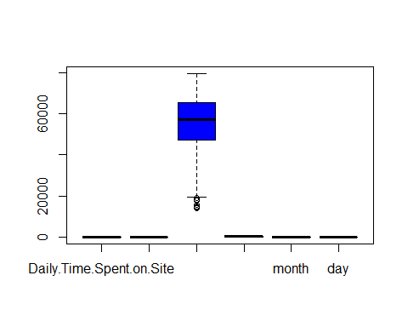

boxplot.stats(clickad.nn$Daily.Time.Spent.on.Site, coef = 1.5, do.conf = TRUE, do.out = TRUE)

## $stats  
## [1] 32.600 51.340 68.215 78.555 91.430  
##   
## $n  
## [1] 1000  
##   
## $conf  
## [1] 66.85523 69.57477  
##   
## $out  
## numeric(0)

columns <- c(colnames(clickad.nn))  
  
  
for (col in columns[1:4]) {  
 print(var(clickad.nn[col]))  
   
}

## Daily.Time.Spent.on.Site  
## Daily.Time.Spent.on.Site 251.3371  
## Age  
## Age 77.18611  
## Area.Income  
## Area.Income 179952406  
## Daily.Internet.Usage  
## Daily.Internet.Usage 1927.415

# checking for unique values in clicked on ad column  
unique(clickad.nn$Clicked.on.Ad)

## [1] 0 1

table(clickad.nn$Clicked.on.Ad)

##   
## 0 1   
## 500 500

# target variable is balanced as both outcomes have equal no. of observations

tab <- table(clickad.nn$Clicked.on.Ad)  
  
barplot(tab,main = "Countplot Showing Distribution of Ad Clicks",xlab = "Ad Clicks",col="darkgreen")

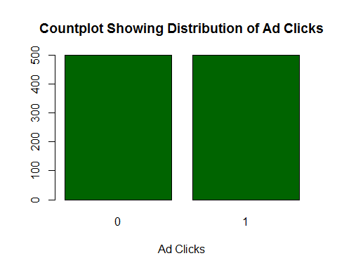

# Data Exploration & Cleaning   
  
  
# viewing a summary of the dataframe  
summary(clickad.nn[c("Daily.Time.Spent.on.Site", "Age", "Area.Income", "Daily.Internet.Usage")])

## Daily.Time.Spent.on.Site Age Area.Income   
## Min. :32.60 Min. :19.00 Min. :13996   
## 1st Qu.:51.36 1st Qu.:29.00 1st Qu.:47032   
## Median :68.22 Median :35.00 Median :57012   
## Mean :65.00 Mean :36.01 Mean :55000   
## 3rd Qu.:78.55 3rd Qu.:42.00 3rd Qu.:65471   
## Max. :91.43 Max. :61.00 Max. :79485   
## Daily.Internet.Usage  
## Min. :104.8   
## 1st Qu.:138.8   
## Median :183.1   
## Mean :180.0   
## 3rd Qu.:218.8   
## Max. :270.0

# according to output, there is need to normalize the data to reduce bias

age <- clickad.nn$Age  
  
age.freq <- table(age)  
barplot(age.freq,xlab = "Age", ylab = "Count", main = "Barplot Showing Age Distribution Clients",col = "darkorange")

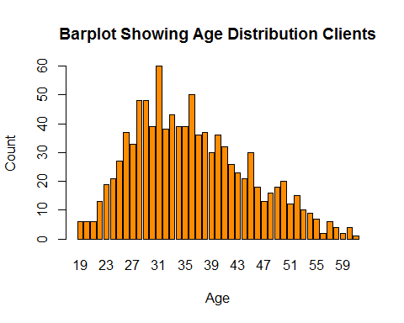

hist(clickad.nn$Daily.Time.Spent.on.Site, freq = T,col = "darkgray",xlab = "Daily Time Spent on the Site", main = "Histogram Showing Amount of Time Spent on Site")

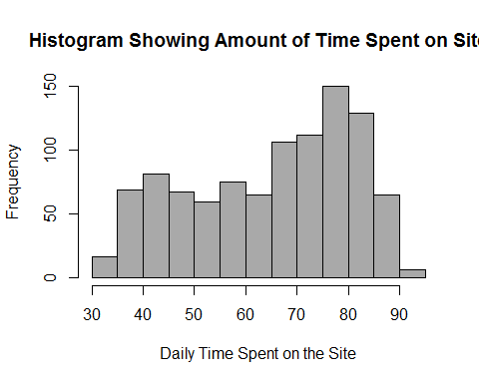

hist(clickad.nn$Age, freq = T,col = "blue",xlab = "Age", main="Histogram Showing Age Distribution of Clients")

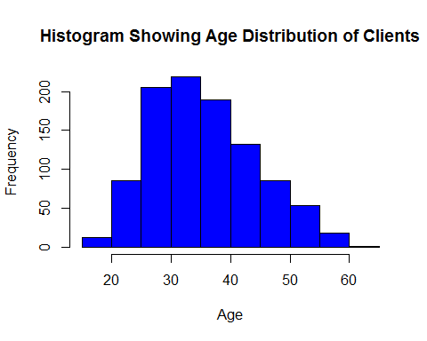

# most site's clients are between the ages of 25 and 40

hist(clickad.nn$Area.Income, freq = T,col = "darkgreen",xlab = "Area Income", main="Histogram Showing Area Income Distribution of Clients")

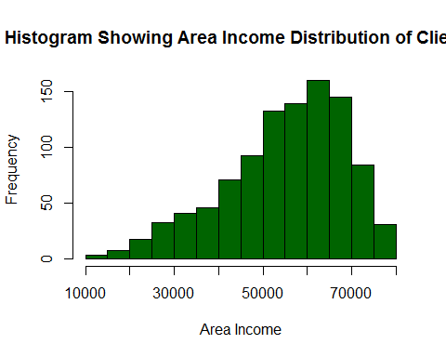

# most site's clients are between the ages of 25 and 40

#age <- clickad.nn$Age  
tsoin <- clickad.nn$Daily.Time.Spent.on.Site  
plot(age, tsoin, xlab="Age", ylab="Time Spent on the Site",main = "Scatterplot Showing Correlation Between Age and Time Spent on Site")

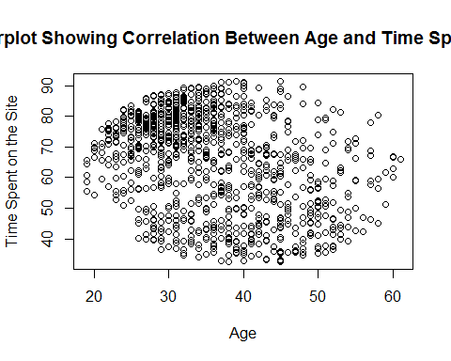

ar.income <- clickad.nn$Area.Income  
int.con <- clickad.nn$Daily.Internet.Usage  
plot(ar.income, int.con, xlab="Area Income", ylab="Daily Internet Usage", main = "Scatterplot Showing Correlation Between Area Income and Daily Internet Usage",)

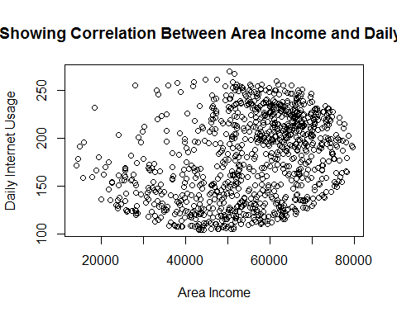

plot(tsoin, int.con, ylab="Internet Usage", xlab="Time Spent on Site", main = "Scatterplot Showing Correlation Between Time Spent on Site and Internet Usage")

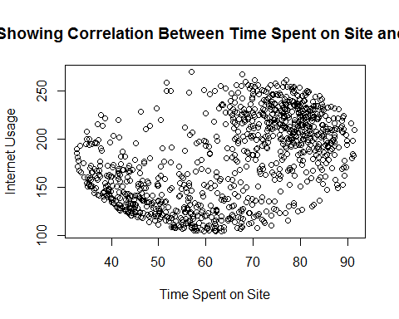

dat.cor <- cor(clickad.nn[c(1,2,3,4,5,7,9,10)], method = "pearson")  
palette = colorRampPalette(c("red", "orange", "white")) (20)  
heatmap(dat.cor,main = "Heatmap Showing Correlation Between Numeric Variables",symm=T )

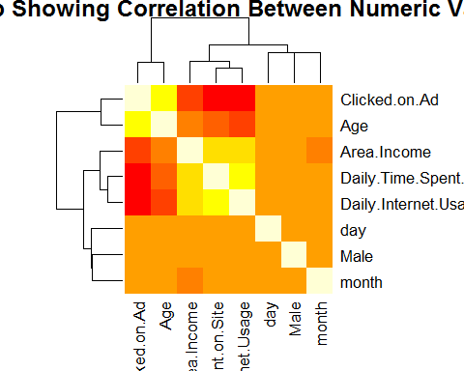

#install.packages("corrplot")

library(corrplot)

## corrplot 0.84 loaded

corrplot(dat.cor)

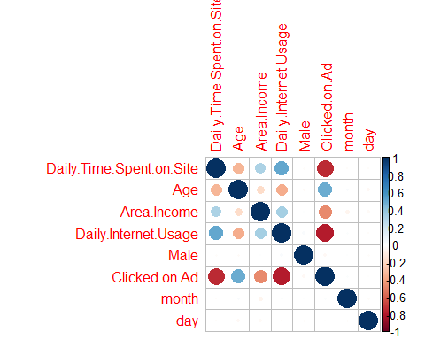

head(clickad.nn)

## Daily.Time.Spent.on.Site Age Area.Income Daily.Internet.Usage Male  
## 1 68.95 35 61833.90 256.09 0  
## 2 80.23 31 68441.85 193.77 1  
## 3 69.47 26 59785.94 236.50 0  
## 4 74.15 29 54806.18 245.89 1  
## 5 68.37 35 73889.99 225.58 0  
## 6 59.99 23 59761.56 226.74 1  
## Country Clicked.on.Ad year month day hour minute  
## 1 Tunisia 0 2016 3 27 3 0  
## 2 Nauru 0 2016 4 4 3 0  
## 3 San Marino 0 2016 3 13 3 0  
## 4 Italy 0 2016 1 10 3 0  
## 5 Iceland 0 2016 6 3 3 0  
## 6 Norway 0 2016 5 19 3 0

merged.frame <- clickad.nn  
head(merged.frame)

## Daily.Time.Spent.on.Site Age Area.Income Daily.Internet.Usage Male  
## 1 68.95 35 61833.90 256.09 0  
## 2 80.23 31 68441.85 193.77 1  
## 3 69.47 26 59785.94 236.50 0  
## 4 74.15 29 54806.18 245.89 1  
## 5 68.37 35 73889.99 225.58 0  
## 6 59.99 23 59761.56 226.74 1  
## Country Clicked.on.Ad year month day hour minute  
## 1 Tunisia 0 2016 3 27 3 0  
## 2 Nauru 0 2016 4 4 3 0  
## 3 San Marino 0 2016 3 13 3 0  
## 4 Italy 0 2016 1 10 3 0  
## 5 Iceland 0 2016 6 3 3 0  
## 6 Norway 0 2016 5 19 3 0

str(merged.frame)

## 'data.frame': 1000 obs. of 12 variables:  
## $ Daily.Time.Spent.on.Site: num 69 80.2 69.5 74.2 68.4 ...  
## $ Age : int 35 31 26 29 35 23 33 48 30 20 ...  
## $ Area.Income : num 61834 68442 59786 54806 73890 ...  
## $ Daily.Internet.Usage : num 256 194 236 246 226 ...  
## $ Male : int 0 1 0 1 0 1 0 1 1 1 ...  
## $ Country : Factor w/ 237 levels "Afghanistan",..: 216 148 185 104 97 159 146 13 83 79 ...  
## $ Clicked.on.Ad : int 0 0 0 0 0 0 0 1 0 0 ...  
## $ year : num 2016 2016 2016 2016 2016 ...  
## $ month : num 3 4 3 1 6 5 1 3 4 7 ...  
## $ day : int 27 4 13 10 3 19 28 7 18 11 ...  
## $ hour : num 3 3 3 3 3 3 3 3 3 3 ...  
## $ minute : num 0 0 0 0 0 0 0 0 0 0 ...

#merged.frame <- data.matrix(merged.frame)

#merged.frame[sapply(merged.frame, is.factor)] <- data.matrix(merged.frame[sapply(merged.frame, is.factor)])  
  
merged.frame = merged.frame %>% mutate_if(is.factor, as.numeric)

head(merged.frame)

## Daily.Time.Spent.on.Site Age Area.Income Daily.Internet.Usage Male  
## 1 68.95 35 61833.90 256.09 0  
## 2 80.23 31 68441.85 193.77 1  
## 3 69.47 26 59785.94 236.50 0  
## 4 74.15 29 54806.18 245.89 1  
## 5 68.37 35 73889.99 225.58 0  
## 6 59.99 23 59761.56 226.74 1  
## Country Clicked.on.Ad year month day hour minute  
## 1 216 0 2016 3 27 3 0  
## 2 148 0 2016 4 4 3 0  
## 3 185 0 2016 3 13 3 0  
## 4 104 0 2016 1 10 3 0  
## 5 97 0 2016 6 3 3 0  
## 6 159 0 2016 5 19 3 0

unique(merged.frame$year)

## [1] 2016

unique(merged.frame$hour)

## [1] 3

unique(merged.frame$minute)

## [1] 0

# dropping year, hour and minute columns because they are constant   
  
merged.fr <- subset(merged.frame, select = c(1,2,3,4,5,6,7,9,10))  
head(merged.fr)

## Daily.Time.Spent.on.Site Age Area.Income Daily.Internet.Usage Male  
## 1 68.95 35 61833.90 256.09 0  
## 2 80.23 31 68441.85 193.77 1  
## 3 69.47 26 59785.94 236.50 0  
## 4 74.15 29 54806.18 245.89 1  
## 5 68.37 35 73889.99 225.58 0  
## 6 59.99 23 59761.56 226.74 1  
## Country Clicked.on.Ad month day  
## 1 216 0 3 27  
## 2 148 0 4 4  
## 3 185 0 3 13  
## 4 104 0 1 10  
## 5 97 0 6 3  
## 6 159 0 5 19

tail(merged.fr)

## Daily.Time.Spent.on.Site Age Area.Income Daily.Internet.Usage Male  
## 995 43.70 28 63126.96 173.01 0  
## 996 72.97 30 71384.57 208.58 1  
## 997 51.30 45 67782.17 134.42 1  
## 998 51.63 51 42415.72 120.37 1  
## 999 55.55 19 41920.79 187.95 0  
## 1000 45.01 26 29875.80 178.35 0  
## Country Clicked.on.Ad month day  
## 995 136 1 4 4  
## 996 117 1 2 11  
## 997 27 1 4 22  
## 998 141 1 2 1  
## 999 86 0 3 24  
## 1000 29 1 6 3

# creating a function to normalize data to reduce bias   
normalize <- function(x) {  
 return((x - min(x)) / (max(x) - min(x)))  
}

feat.norm <- as.data.frame(lapply(merged.fr[c(1, 2, 3, 4, 5, 6, 8, 9)], normalize))  
summary(feat.norm)

## Daily.Time.Spent.on.Site Age Area.Income   
## Min. :0.0000 Min. :0.0000 Min. :0.0000   
## 1st Qu.:0.3189 1st Qu.:0.2381 1st Qu.:0.5044   
## Median :0.6054 Median :0.3810 Median :0.6568   
## Mean :0.5507 Mean :0.4050 Mean :0.6261   
## 3rd Qu.:0.7810 3rd Qu.:0.5476 3rd Qu.:0.7860   
## Max. :1.0000 Max. :1.0000 Max. :1.0000   
## Daily.Internet.Usage Male Country month   
## Min. :0.0000 Min. :0.000 Min. :0.0000 Min. :0.0000   
## 1st Qu.:0.2061 1st Qu.:0.000 1st Qu.:0.2288 1st Qu.:0.1667   
## Median :0.4743 Median :0.000 Median :0.4809 Median :0.5000   
## Mean :0.4554 Mean :0.481 Mean :0.4890 Mean :0.4695   
## 3rd Qu.:0.6902 3rd Qu.:1.000 3rd Qu.:0.7500 3rd Qu.:0.6667   
## Max. :1.0000 Max. :1.000 Max. :1.0000 Max. :1.0000   
## day   
## Min. :0.0000   
## 1st Qu.:0.2333   
## Median :0.4667   
## Mean :0.4828   
## 3rd Qu.:0.7333   
## Max. :1.0000

head(feat.norm)

## Daily.Time.Spent.on.Site Age Area.Income Daily.Internet.Usage Male  
## 1 0.6178820 0.3809524 0.7304725 0.9160310 0  
## 2 0.8096209 0.2857143 0.8313752 0.5387456 1  
## 3 0.6267211 0.1666667 0.6992003 0.7974331 0  
## 4 0.7062723 0.2380952 0.6231599 0.8542802 1  
## 5 0.6080231 0.3809524 0.9145678 0.7313234 0  
## 6 0.4655788 0.0952381 0.6988280 0.7383460 1  
## Country month day  
## 1 0.9110169 0.3333333 0.86666667  
## 2 0.6228814 0.5000000 0.10000000  
## 3 0.7796610 0.3333333 0.40000000  
## 4 0.4364407 0.0000000 0.30000000  
## 5 0.4067797 0.8333333 0.06666667  
## 6 0.6694915 0.6666667 0.60000000

merged.frm <- cbind(feat.norm, merged.fr[c(7)])  
  
head(merged.frm)

## Daily.Time.Spent.on.Site Age Area.Income Daily.Internet.Usage Male  
## 1 0.6178820 0.3809524 0.7304725 0.9160310 0  
## 2 0.8096209 0.2857143 0.8313752 0.5387456 1  
## 3 0.6267211 0.1666667 0.6992003 0.7974331 0  
## 4 0.7062723 0.2380952 0.6231599 0.8542802 1  
## 5 0.6080231 0.3809524 0.9145678 0.7313234 0  
## 6 0.4655788 0.0952381 0.6988280 0.7383460 1  
## Country month day Clicked.on.Ad  
## 1 0.9110169 0.3333333 0.86666667 0  
## 2 0.6228814 0.5000000 0.10000000 0  
## 3 0.7796610 0.3333333 0.40000000 0  
## 4 0.4364407 0.0000000 0.30000000 0  
## 5 0.4067797 0.8333333 0.06666667 0  
## 6 0.6694915 0.6666667 0.60000000 0

tail(merged.frm)

## Daily.Time.Spent.on.Site Age Area.Income Daily.Internet.Usage  
## 995 0.1886792 0.2142857 0.7502174 0.41306454  
## 996 0.6862145 0.2619048 0.8763103 0.62840538  
## 997 0.3178650 0.6190476 0.8213020 0.17944061  
## 998 0.3234744 0.7619048 0.4339587 0.09438189  
## 999 0.3901071 0.0000000 0.4264012 0.50351132  
## 1000 0.2109468 0.1666667 0.2424754 0.44539290  
## Male Country month day Clicked.on.Ad  
## 995 0 0.5720339 0.5000000 0.10000000 1  
## 996 1 0.4915254 0.1666667 0.33333333 1  
## 997 1 0.1101695 0.5000000 0.70000000 1  
## 998 1 0.5932203 0.1666667 0.00000000 1  
## 999 0 0.3601695 0.3333333 0.76666667 0  
## 1000 0 0.1186441 0.8333333 0.06666667 1

# split data into testing & training  
set.seed(1234)  
  
# 80-20 train/test split   
train.index <- createDataPartition(merged.frm$Clicked.on.Ad, p = .2, list = F)  
trainn <- merged.frm[train.index, ]  
test <- merged.frm[-train.index, ]  
head(test)

## Daily.Time.Spent.on.Site Age Area.Income Daily.Internet.Usage Male  
## 1 0.6178820 0.3809524 0.7304725 0.9160310 0  
## 2 0.8096209 0.2857143 0.8313752 0.5387456 1  
## 3 0.6267211 0.1666667 0.6992003 0.7974331 0  
## 4 0.7062723 0.2380952 0.6231599 0.8542802 1  
## 6 0.4655788 0.0952381 0.6988280 0.7383460 1  
## 8 0.5677375 0.6904762 0.1618126 0.1633370 1  
## Country month day Clicked.on.Ad  
## 1 0.91101695 0.3333333 0.8666667 0  
## 2 0.62288136 0.5000000 0.1000000 0  
## 3 0.77966102 0.3333333 0.4000000 0  
## 4 0.43644068 0.0000000 0.3000000 0  
## 6 0.66949153 0.6666667 0.6000000 0  
## 8 0.05084746 0.3333333 0.2000000 1

# get predictors  
predictor <- trainn %>%  
 select(-c(Clicked.on.Ad, Country)) %>%  
 as.matrix()  
  
output <- trainn$Clicked.on.Ad %>%  
 as.factor()  
  
str(output)

## Factor w/ 2 levels "0","1": 1 1 1 2 1 1 2 2 1 1 ...

class(output)

## [1] "factor"

# train a random forest model for Classification  
model <- randomForest(x = predictor, y = output,  
 ntree = 50) # number of trees  
  
# check out the details  
model

##   
## Call:  
## randomForest(x = predictor, y = output, ntree = 50)   
## Type of random forest: classification  
## Number of trees: 50  
## No. of variables tried at each split: 2  
##   
## OOB estimate of error rate: 3%  
## Confusion matrix:  
## 0 1 class.error  
## 0 97 3 0.03  
## 1 3 97 0.03

rfpred = predict(model, type="response", newdata= as.data.frame(predictor))  
  
summary(rfpred)

## 0 1   
## 100 100

table(output, rfpred)

## rfpred  
## output 0 1  
## 0 100 0  
## 1 0 100

#accracy <- (385 + 388) / (385 + 15 + 12 + 388) * 100  
#accracy

#use caret to pick a value for mtry  
  
#install.packages("caret")   
#install.packages('e1071', dependencies=TRUE)  
  
  
tuned_model <- train(x = predictor, y = output,  
 ntree = 10, # number of trees (passed on random forest)  
 method = "rf") # random forests  
  
tuned_model

## Random Forest   
##   
## 200 samples  
## 7 predictor  
## 2 classes: '0', '1'   
##   
## No pre-processing  
## Resampling: Bootstrapped (25 reps)   
## Summary of sample sizes: 200, 200, 200, 200, 200, 200, ...   
## Resampling results across tuning parameters:  
##   
## mtry Accuracy Kappa   
## 2 0.9517663 0.9029545  
## 4 0.9526285 0.9048145  
## 7 0.9465011 0.8923866  
##   
## Accuracy was used to select the optimal model using the largest value.  
## The final value used for the model was mtry = 4.

# plot the rmse for various possible training values  
ggplot(tuned_model)

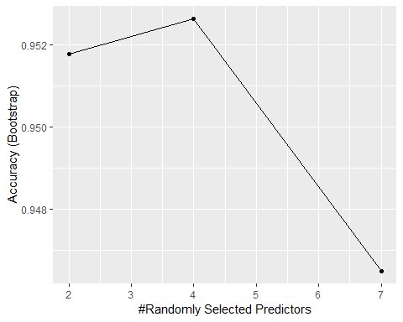

# plot both plots at once  
par(mfrow = c(1,2))  
  
varImpPlot(model, n.var = 5)  
varImpPlot(tuned_model$finalModel, n.var = 5)

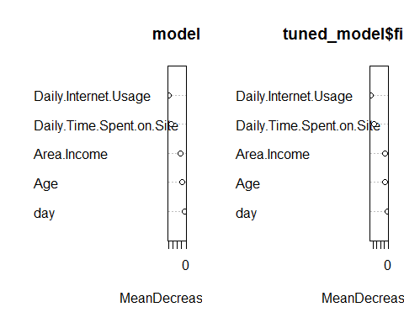

tuned_model$finalModel

##   
## Call:  
## randomForest(x = x, y = y, ntree = 10, mtry = param$mtry)   
## Type of random forest: classification  
## Number of trees: 10  
## No. of variables tried at each split: 4  
##   
## OOB estimate of error rate: 6.06%  
## Confusion matrix:  
## 0 1 class.error  
## 0 92 6 0.06122449  
## 1 6 94 0.06000000

logit <- glm(Clicked.on.Ad ~ Daily.Time.Spent.on.Site + Age + Area.Income + Daily.Internet.Usage + Male + month + day, family="binomial", data=merged.frm)  
summary(logit)

##   
## Call:  
## glm(formula = Clicked.on.Ad ~ Daily.Time.Spent.on.Site + Age +   
## Area.Income + Daily.Internet.Usage + Male + month + day,   
## family = "binomial", data = merged.frm)  
##   
## Deviance Residuals:   
## Min 1Q Median 3Q Max   
## -2.4797 -0.1330 -0.0286 0.0171 3.2371   
##   
## Coefficients:  
## Estimate Std. Error z value Pr(>|z|)   
## (Intercept) 16.33150 1.76494 9.253 < 2e-16 ***  
## Daily.Time.Spent.on.Site -11.37025 1.22143 -9.309 < 2e-16 ***  
## Age 7.21594 1.10187 6.549 5.80e-11 ***  
## Area.Income -9.01030 1.24807 -7.219 5.22e-13 ***  
## Daily.Internet.Usage -10.63548 1.14590 -9.281 < 2e-16 ***  
## Male -0.42762 0.40576 -1.054 0.292   
## month -0.04069 0.62821 -0.065 0.948   
## day -0.84912 0.72887 -1.165 0.244   
## ---  
## Signif. codes: 0 '***' 0.001 '**' 0.01 '*' 0.05 '.' 0.1 ' ' 1  
##   
## (Dispersion parameter for binomial family taken to be 1)  
##   
## Null deviance: 1386.29 on 999 degrees of freedom  
## Residual deviance: 180.43 on 992 degrees of freedom  
## AIC: 196.43  
##   
## Number of Fisher Scoring iterations: 8

predictTrain = predict(logit, type="response")  
  
summary(predictTrain)

## Min. 1st Qu. Median Mean 3rd Qu. Max.   
## 0.001706 0.008717 0.373276 0.500000 0.999850 0.999999

tapply(predictTrain, merged.fr$Clicked.on.Ad, mean)

## 0 1   
## 0.04770271 0.95229729

# Confusion matrix for threshold of 0.5  
table(merged.fr$Clicked.on.Ad, predictTrain > 0.5)

##   
## FALSE TRUE  
## 0 490 10  
## 1 18 482

acc <- (490 + 482) / (490 + 10 + 18 + 482) * 100  
acc

## [1] 97.2

predictorr <- test %>%  
 select(-c(Clicked.on.Ad, Country)) %>%  
 as.matrix()  
  
outputt <- test$Clicked.on.Ad %>%  
 as.factor()

predicted = predict(logit, type="response", newdata= as.data.frame(predictorr))  
   
summary(predicted)

## Min. 1st Qu. Median Mean 3rd Qu. Max.   
## 0.001706 0.008923 0.356660 0.498592 0.999824 0.999999

table(outputt,predicted >= 0.3)

##   
## outputt FALSE TRUE  
## 0 385 15  
## 1 12 388

accuracy <- (385 + 388) / (385 + 15 + 12 + 388) * 100  
accuracy

## [1] 96.625

#tapply(predicted, trainn$Clicked.on.Ad, mean)

Using XGBoost

predor <- trainn %>%  
 select(-c(Clicked.on.Ad, Country)) %>%  
 as.matrix()  
  
outut <- trainn$Clicked.on.Ad %>%  
 as.numeric()

predorr <- test %>%  
 select(-c(Clicked.on.Ad, Country)) %>%  
 as.matrix()  
  
oututt <- test$Clicked.on.Ad %>%  
 as.numeric()

# put our testing & training data into two seperates Dmatrixs objects  
dtrain <- xgb.DMatrix(data = predor, label= outut)  
dtest <- xgb.DMatrix(data = predorr, label= oututt)  
head(output)

## [1] 0 0 0 1 0 0  
## Levels: 0 1

# train a model using our training data  
xg.model <- xgboost(data = dtrain, # the data   
 nround = 2, # max number of boosting iterations  
 objective = "binary:logistic") # the objective function

## [1] train-error:0.030000   
## [2] train-error:0.030000

# generate predictions for our held-out testing data  
predd <- predict(xg.model, dtest)  
  
# get & print the classification error  
err <- mean(as.numeric(predd > 0.5) != oututt)  
print(paste("test-error=", err))

## [1] "test-error= 0.0775"

# train an xgboost model  
xg.model.tuned <- xgboost(data = dtrain, # the data   
 max.depth = 3, # the maximum depth of each decision tree  
 nround = 2, # max number of boosting iterations  
 objective = "binary:logistic") # the objective function

## [1] train-error:0.030000   
## [2] train-error:0.030000

# generate predictions for our held-out testing data  
preed <- predict(xg.model.tuned, dtest)  
  
# get & print the classification error  
errr <- mean(as.numeric(preed > 0.5) != oututt)  
print(paste("test-error=", errr))

## [1] "test-error= 0.0775"

# get the number of negative & positive cases in our data  
negative_cases <- sum(outut == FALSE)  
postive_cases <- sum(outut == TRUE)  
  
# train a model using our training data  
model.tuned <- xgboost(data = dtrain, # the data   
 max.depth = 3, # the maximum depth of each decision tree  
 nround = 10, # number of boosting rounds  
 early_stopping_rounds = 3, # if we dont see an improvement in this many rounds, stop  
 objective = "binary:logistic", # the objective function  
 scale_pos_weight = negative_cases/postive_cases) # control for imbalanced classes

## [1] train-error:0.030000   
## Will train until train_error hasn't improved in 3 rounds.  
##   
## [2] train-error:0.030000   
## [3] train-error:0.030000   
## [4] train-error:0.020000   
## [5] train-error:0.015000   
## [6] train-error:0.015000   
## [7] train-error:0.015000   
## [8] train-error:0.015000   
## Stopping. Best iteration:  
## [5] train-error:0.015000

# generate predictions for our held-out testing data  
prred <- predict(model.tuned, dtest)  
  
# get & print the classification error  
erro <- mean(as.numeric(prred > 0.5) != oututt)  
print(paste("test-error=", erro))

## [1] "test-error= 0.05875"

table(oututt,prred >= 0.3)

##   
## oututt FALSE TRUE  
## 0 362 38  
## 1 20 380

accuy <- (362 + 380) / (362 + 38 + 20 + 380) * 100  
accuy

## [1] 92.75

# train a model using our training data  
mdel.tuned <- xgboost(data = dtrain, # the data   
 max.depth = 3, # the maximum depth of each decision tree  
 nround = 10, # number of boosting rounds  
 early_stopping_rounds = 3, # if we dont see an improvement in this many rounds, stop  
 objective = "binary:logistic", # the objective function  
 scale_pos_weight = negative_cases/postive_cases, # control for imbalanced classes  
 gamma = 1) # add a regularization term

## [1] train-error:0.030000   
## Will train until train_error hasn't improved in 3 rounds.  
##   
## [2] train-error:0.030000   
## [3] train-error:0.030000   
## [4] train-error:0.020000   
## [5] train-error:0.015000   
## [6] train-error:0.015000   
## [7] train-error:0.015000   
## [8] train-error:0.015000   
## Stopping. Best iteration:  
## [5] train-error:0.015000

# generate predictions for our held-out testing data  
ppred <- predict(mdel.tuned, dtest)  
  
# get & print the classification error  
errr <- mean(as.numeric(ppred > 0.5) != oututt)  
print(paste("test-error=", errr))

## [1] "test-error= 0.06125"

table(oututt,ppred >= 0.3)

##   
## oututt FALSE TRUE  
## 0 363 37  
## 1 20 380

accy <- (363 + 380) / (363 + 37 + 20 + 380) * 100  
accy

## [1] 92.875

Using K Nearest Neighbors

# Defining train and test sets  
knnf.train <- merged.frm[1:500, 1:8]  
knnf.test <- merged.frm[501:1000, 1:8]  
knntes.train <- merged.frm[1:500, 9]  
knntes.test <- merged.frm[501:1000, 9]  
length(knntes.test)

## [1] 500

#fitting the model with data  
library(class)  
knn.mod <- knn(train=knnf.train, test=knnf.test, cl= knntes.train, k=10)

#creating a confusion matrix using table function  
tabo <- table(knn.mod, knntes.test)  
tabo

## knntes.test  
## knn.mod 0 1  
## 0 244 23  
## 1 5 228

akuracy <- function(x){sum(diag(x)/(sum(rowSums(x)))) * 100}  
  
akuracy(tabo)

## [1] 94.4

#install.packages("gmodels")  
library(gmodels)  
CrossTable(x = knntes.test, y=knn.mod, prop.chisq=F)

##   
##   
## Cell Contents  
## |-------------------------|  
## | N |  
## | N / Row Total |  
## | N / Col Total |  
## | N / Table Total |  
## |-------------------------|  
##   
##   
## Total Observations in Table: 500   
##   
##   
## | knn.mod   
## knntes.test | 0 | 1 | Row Total |   
## -------------|-----------|-----------|-----------|  
## 0 | 244 | 5 | 249 |   
## | 0.980 | 0.020 | 0.498 |   
## | 0.914 | 0.021 | |   
## | 0.488 | 0.010 | |   
## -------------|-----------|-----------|-----------|  
## 1 | 23 | 228 | 251 |   
## | 0.092 | 0.908 | 0.502 |   
## | 0.086 | 0.979 | |   
## | 0.046 | 0.456 | |   
## -------------|-----------|-----------|-----------|  
## Column Total | 267 | 233 | 500 |   
## | 0.534 | 0.466 | |   
## -------------|-----------|-----------|-----------|  
##   
##