**Schneider MMS Project development**

**Common User Login:**

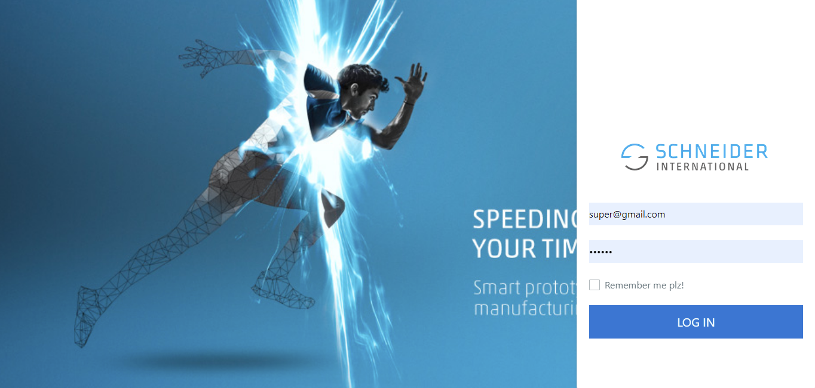

**Manager Dashboard:**

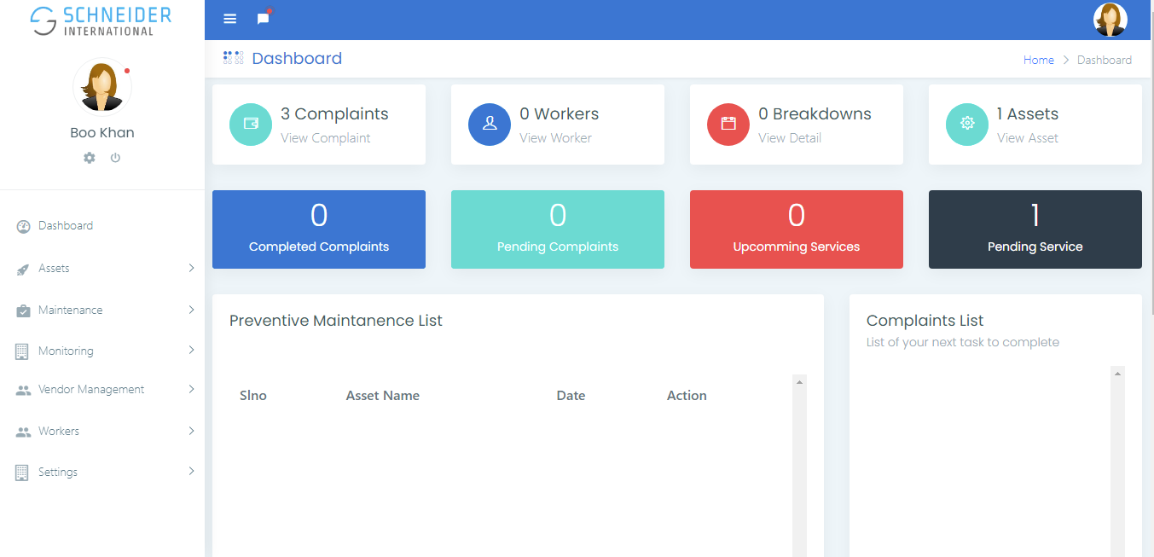

For PM also required, open, completed, scheduled.

Technician

**Plant Equipment’s List**

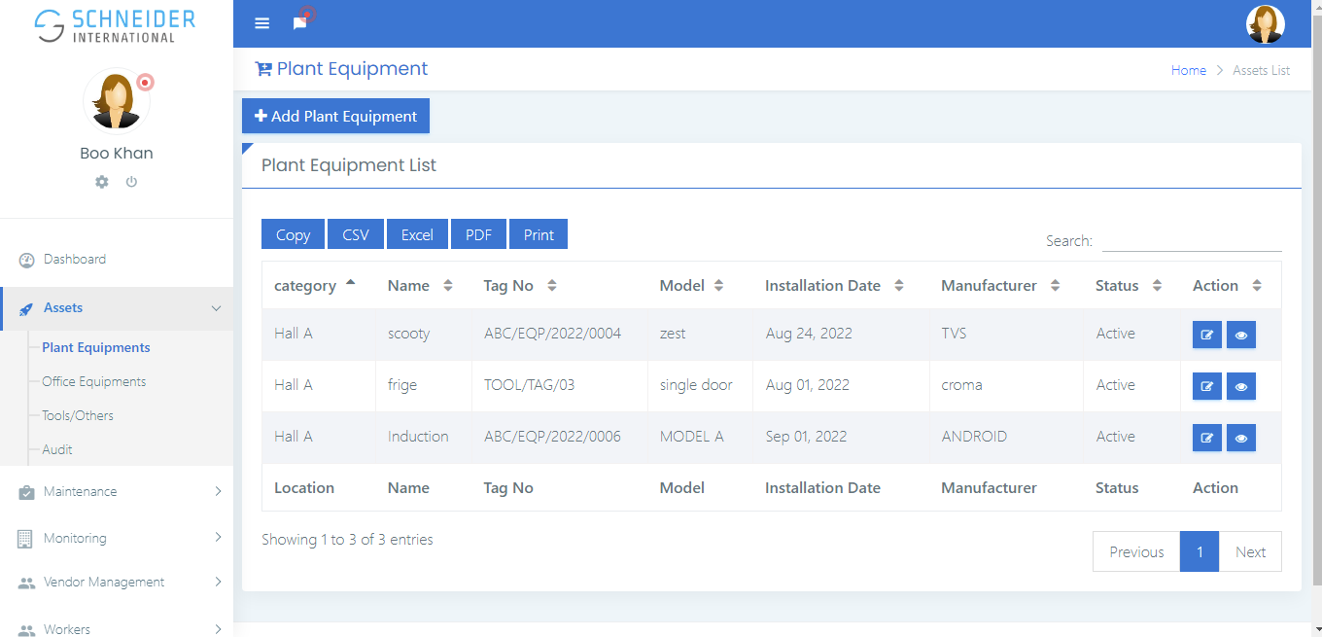

Asset Tag No. 

**Add Asset :**

Equipment Name

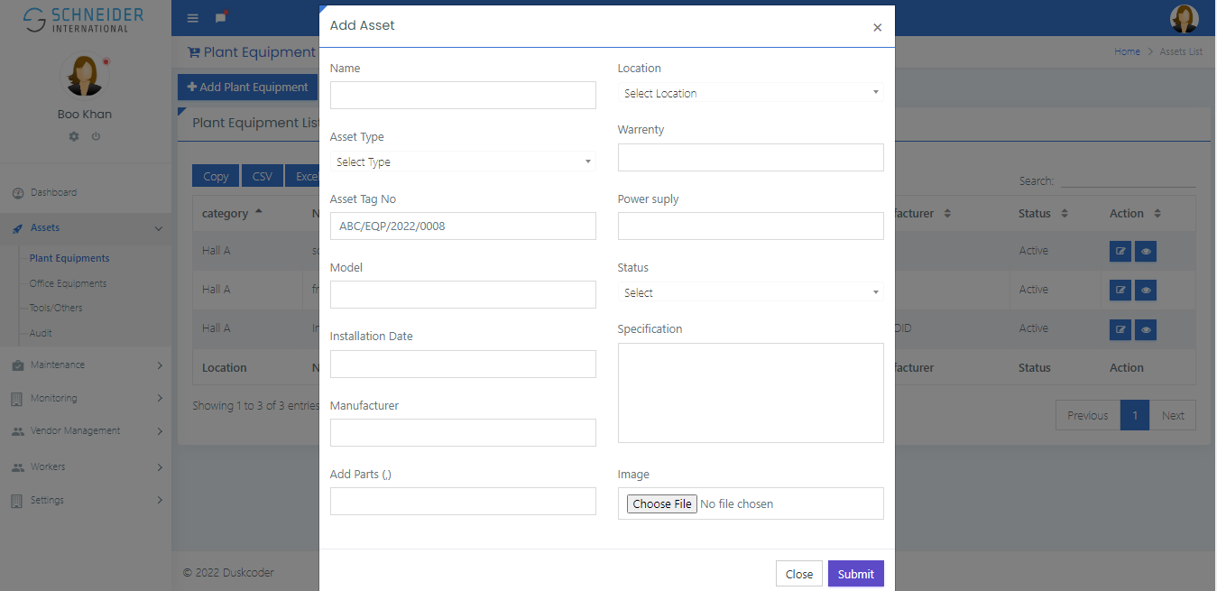

Sl.No:

Type also req.

**Update Asset:**

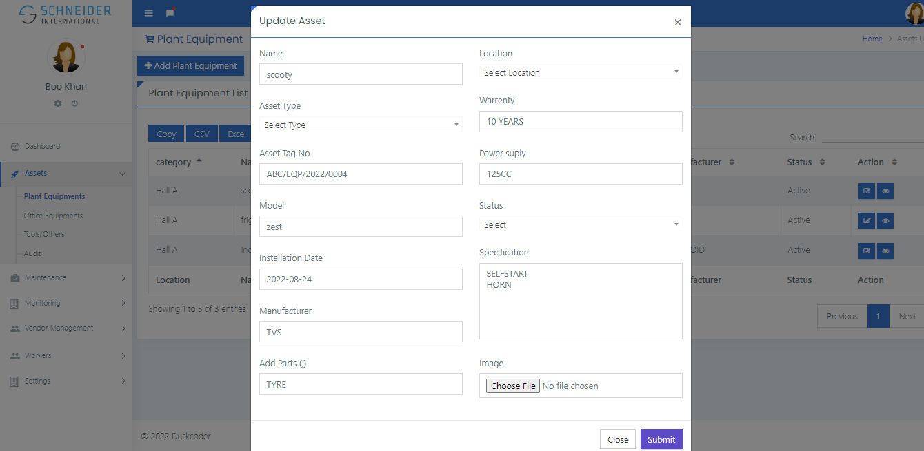

**View Asset Details:**

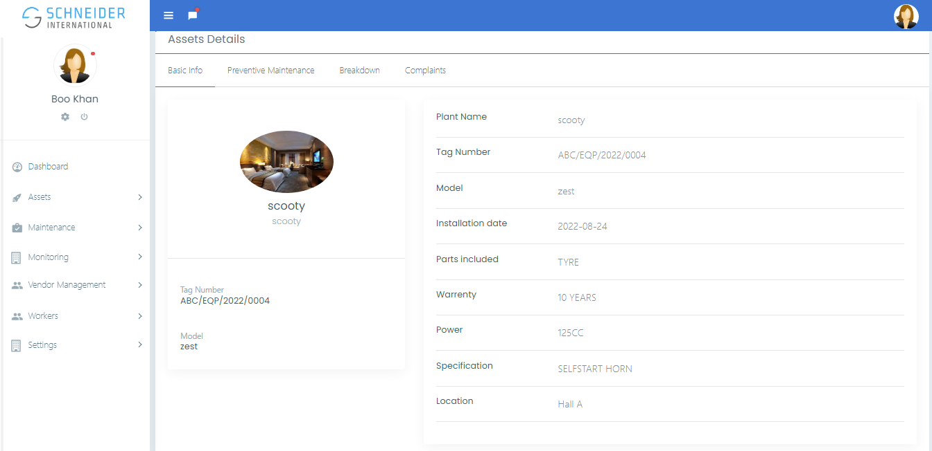

**Preventive Maintenance List:**

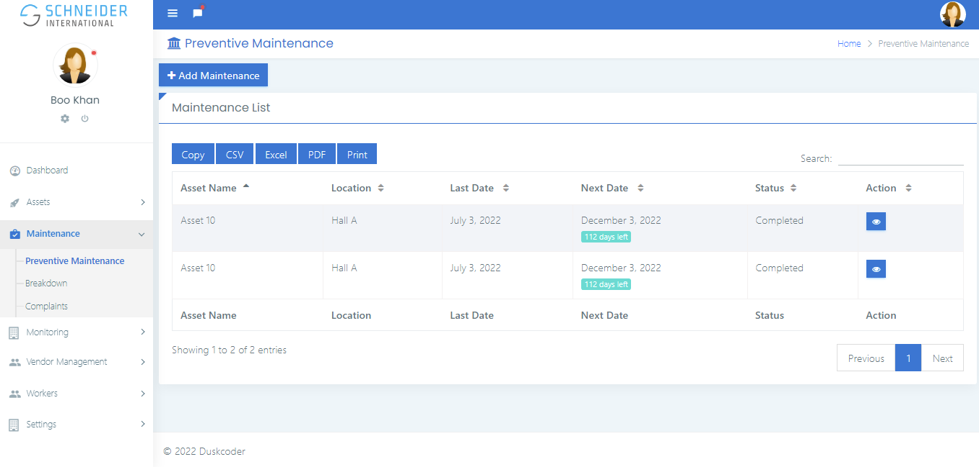

Equipment Name

**Add Maintenance:**

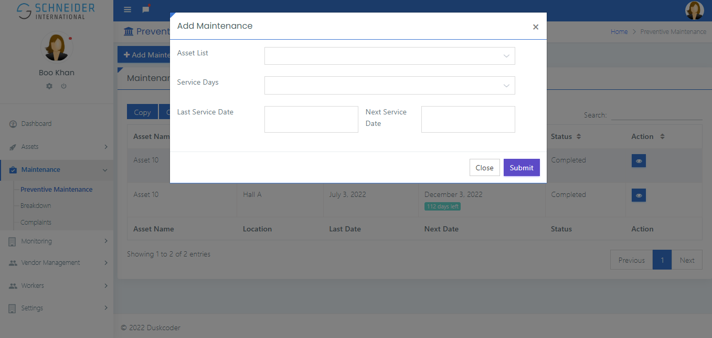

**Breakdown List:**

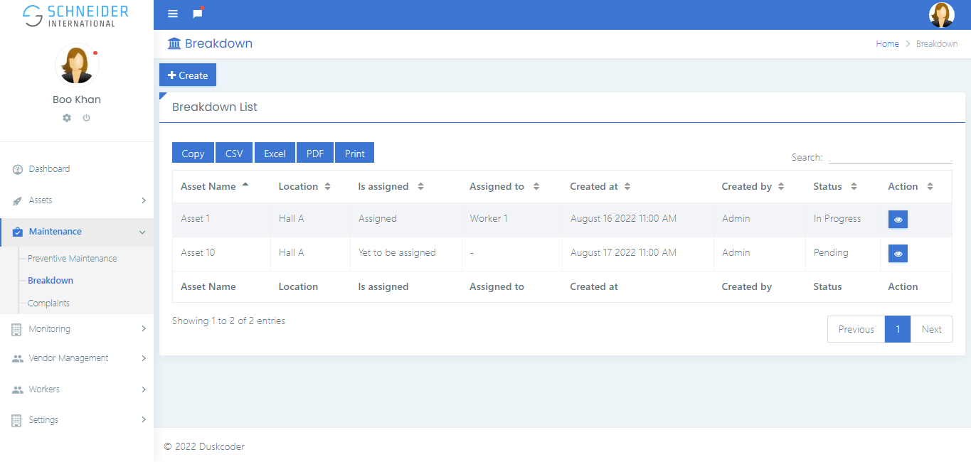

Equipment Name

**Complaints List:**

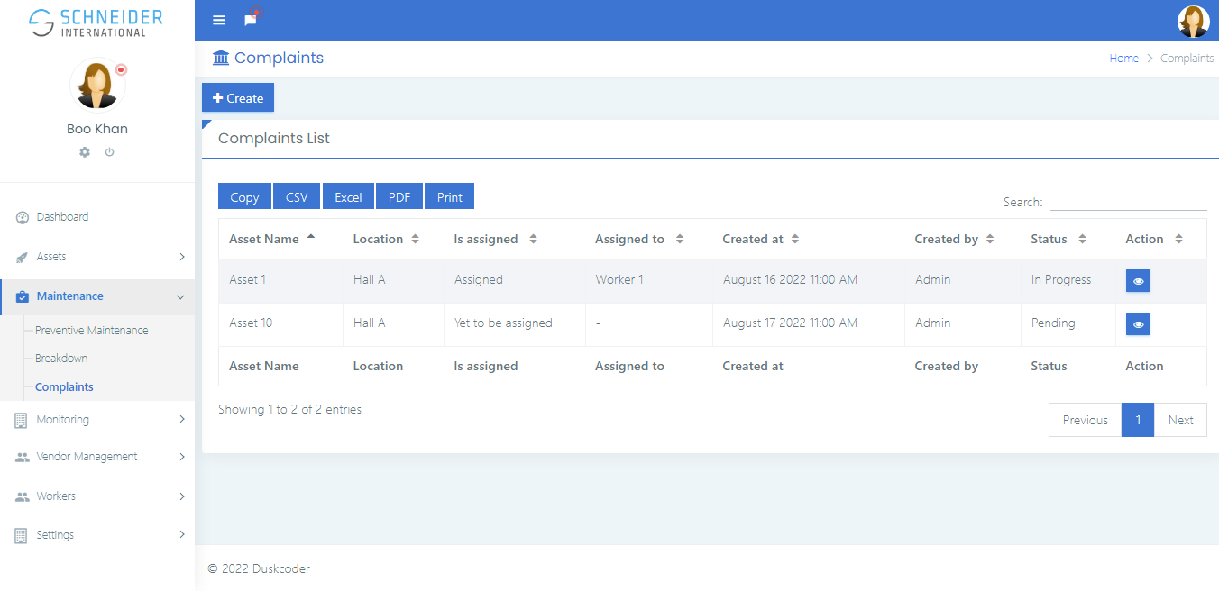

**Monitoring – ED**

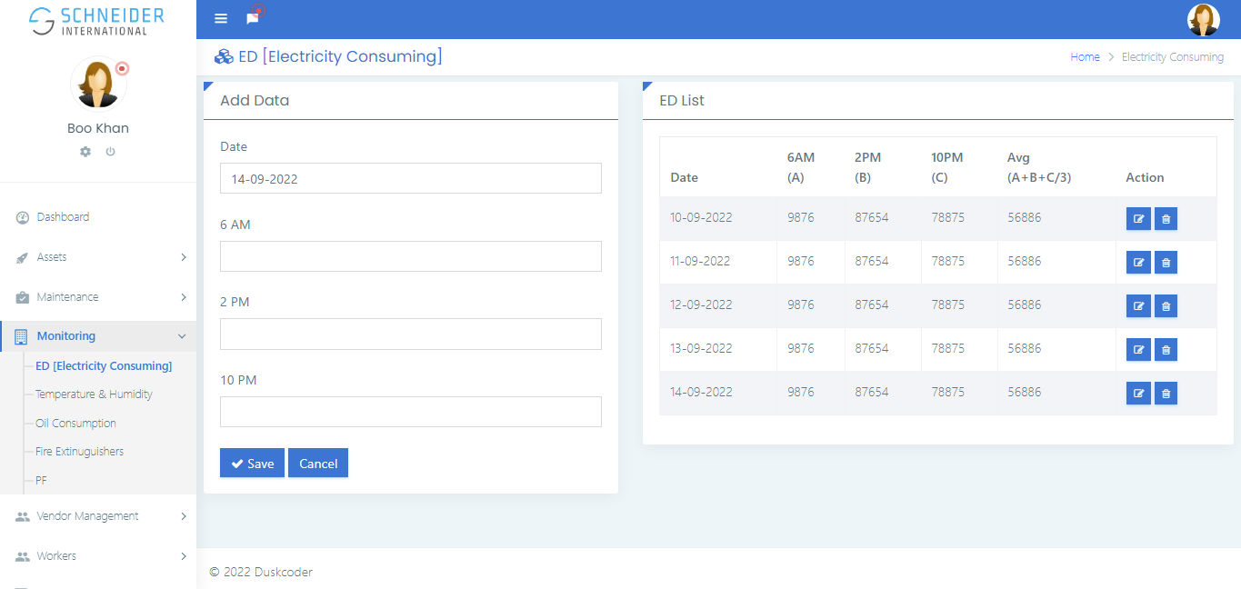

**Monitoring – Temperature**

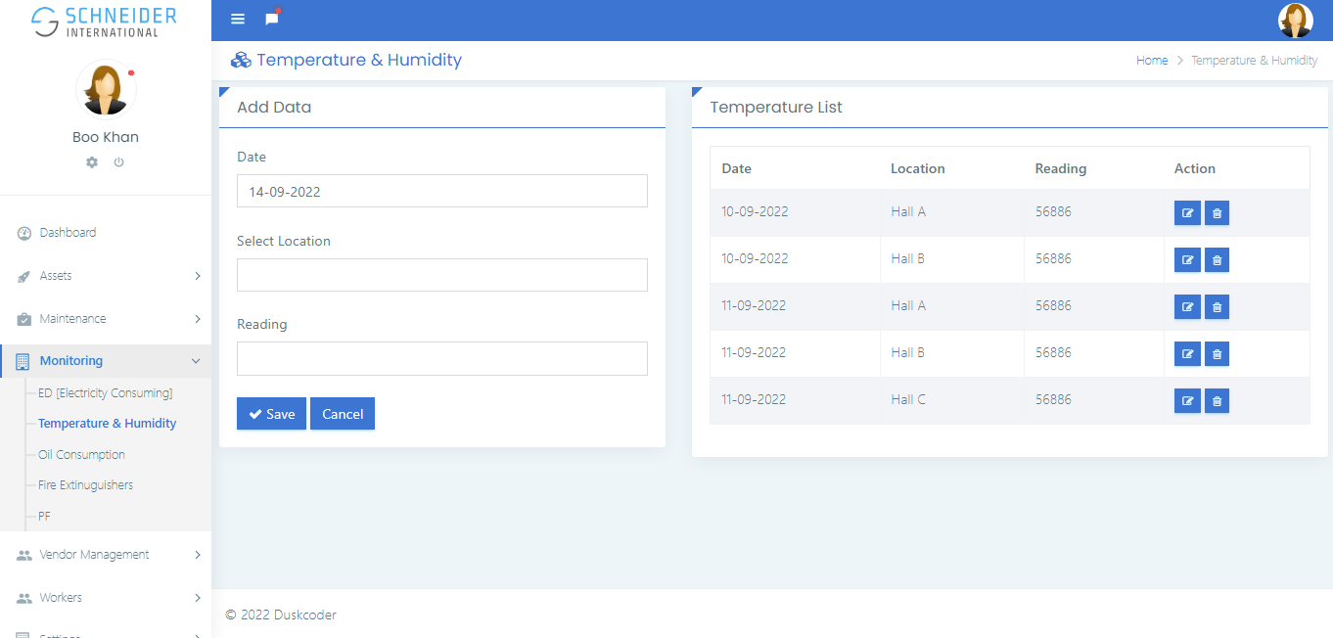

**Vendor Management**

**Vendor List :**

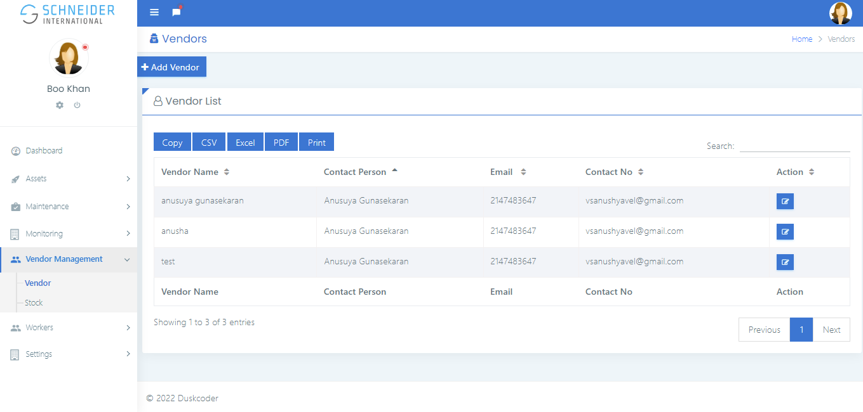

One more column for Nature of work

**Add Vendor:**

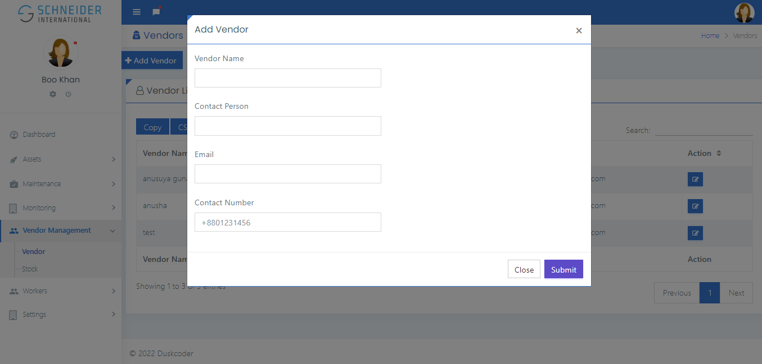

Nature of work

**Stock List**

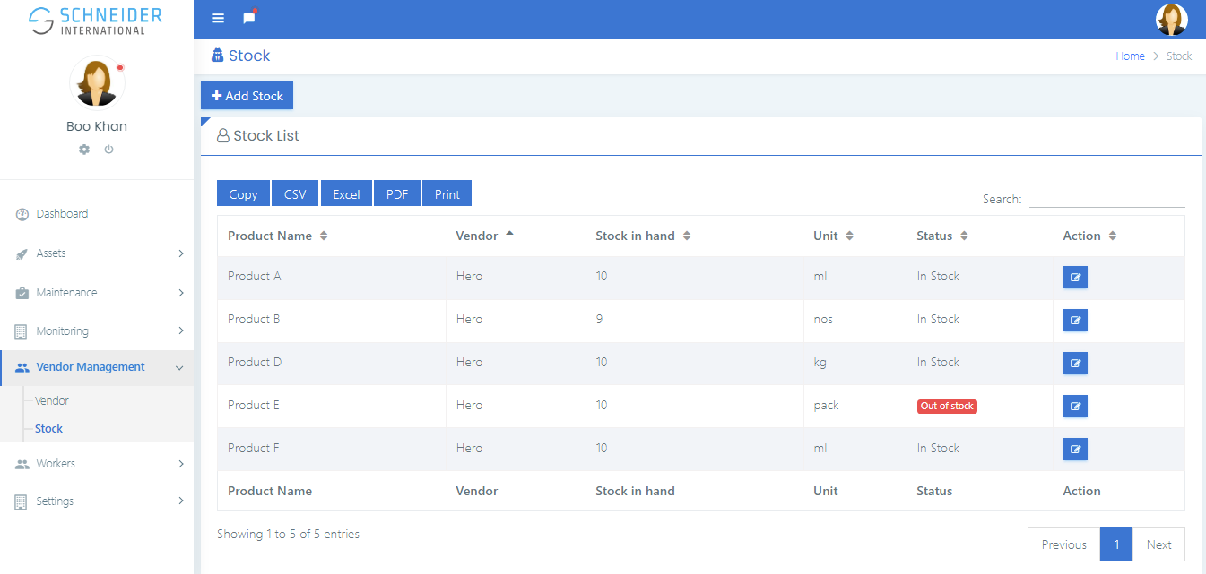

Update stock input need, Date, Month, Price, Expense category, Remarks

Technician

**Technician List:**

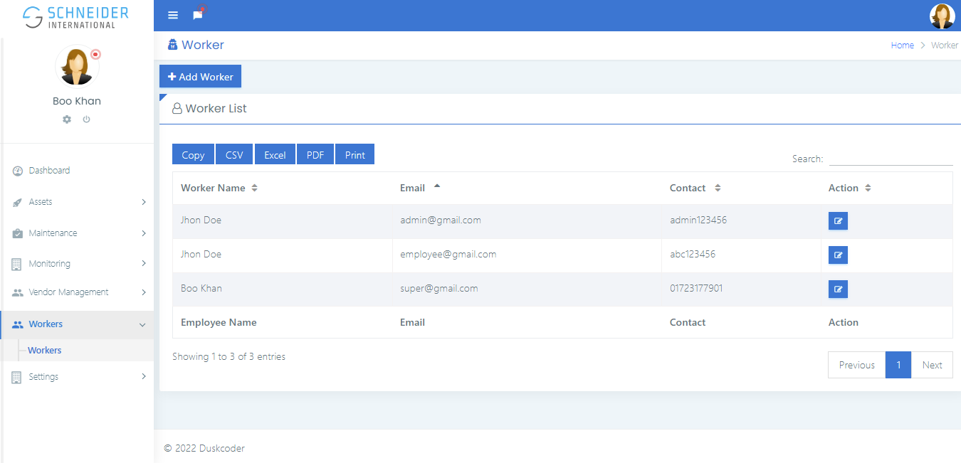

**Location:**

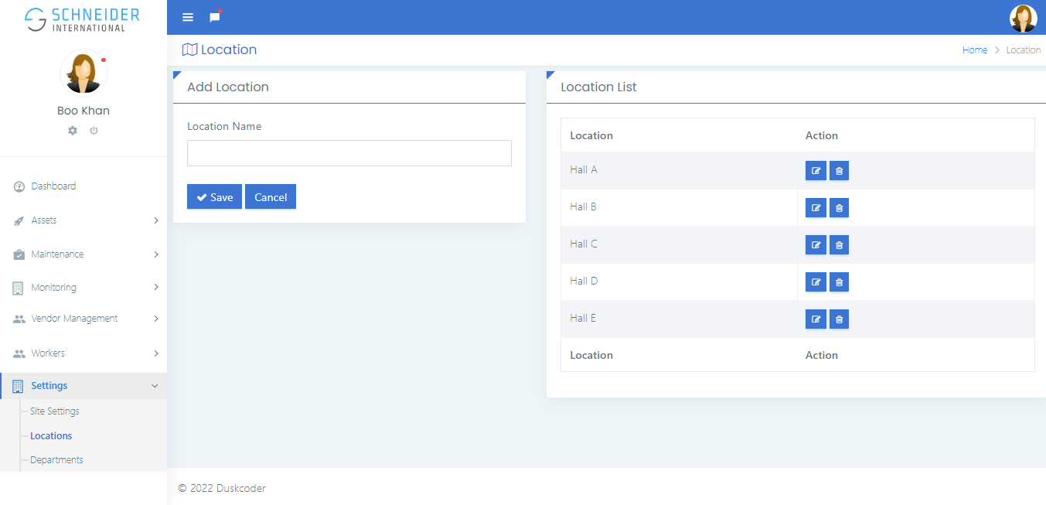

**Department**

