**ENSF-381**: **Full Stack Web Development Laboratory**

**Lab02**

**Section:** B02

**Group information:**

Stephen Ravelo (30213405)

Aaron Lauang (30216529)

**Exercise 1 Output:**

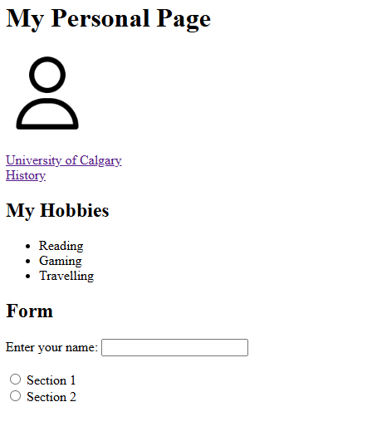

**Exercise 2 Answer:**

1. **The answer to Question 2.1:**

The table will be a fixed width of exactly 150px as opposed to a relative width of 100% where it will always span the entire width of the webpage.

1. **Output: An aerial view of a building

   Description automatically generated**

