INT404 – ARTIFICIAL INTELLIGENCE
FINAL REPORT

Topic: Sudoku solver
Registration number: 11807595
Name: Himanshu Borah
Roll number: 50



1. Abstract
Sudoku is a logic-based, combinatorial number-placement puzzle. The objective is to fill a 9 x 9 grid with digits so that each row, each column, and each of the nine 3x 3 sub grids that compose the grid contain all of the digits from 1 to 9. It is an NP-complete problem. For a human, it requires logic and possibly a lot of time to solve a sudoku puzzle. However, what would happen if a computer were to solve the same puzzle? With these things in mind, this project aims to do the same. It solves the sudoku puzzle using backtracking algorithm. However, the time taken to solve the puzzle increases as the difficulty level increases. But its efficiency can be increased by using some other algorithms which have proven to be faster than the backtracking approach.
2. Related existing projects
Before I started working on the project, I searched the internet if there are any existing projects which used the similar idea. Most of the projects were there which visualized, only the working of the backtracking algorithm using the path finding example. However, there were some projects which used the same sudoku applied some different algorithms and techniques and came up with the solution pretty quickly.
My project can solve sudoku puzzles of varying difficulties, however, the time taken to solve also varies with the same. However, there was one project which used Donald Knuth’s Dancing links algorithm to solve the problem. It reduces the sudoku puzzle to an exact cover problem and then applied the algorithm on it. The time taken was same, no matter how difficult the sudoku puzzle was.
Some of the projects didn’t focus on the speed but rather used computer vision in their implementations. They applied machine learning to detect the digits and the grid on a paper. And, then applied the suitable algorithm to solve the problem. Here’s one project.
3. Implementation
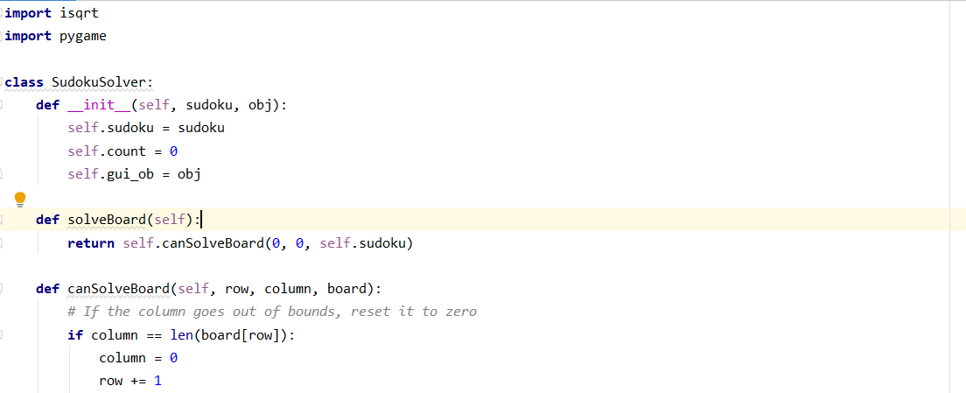

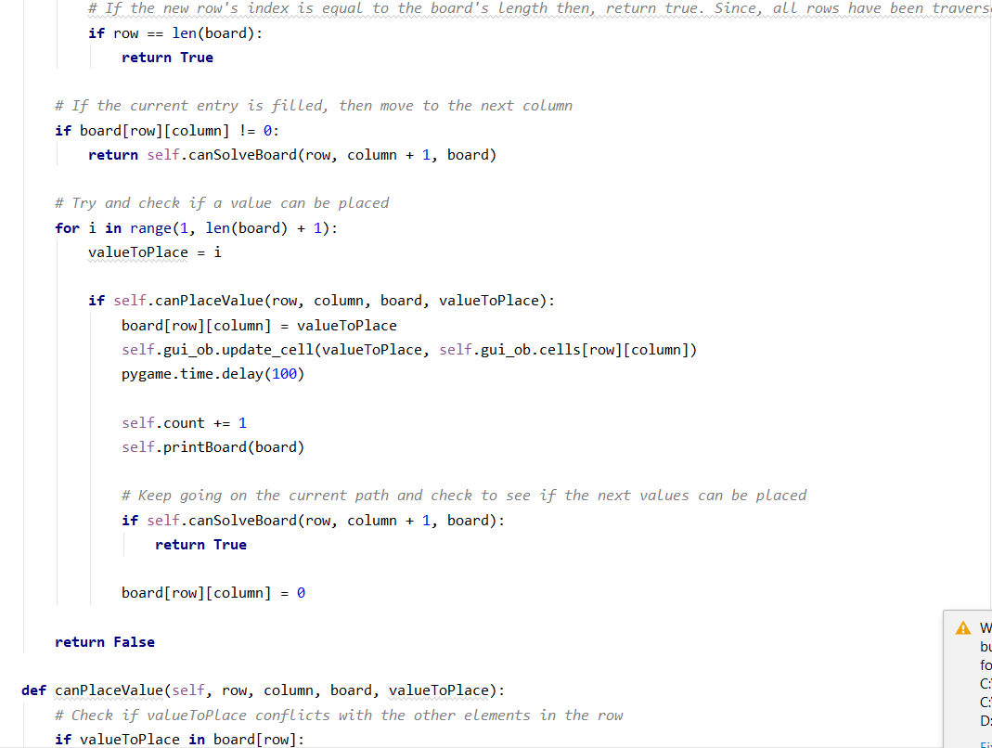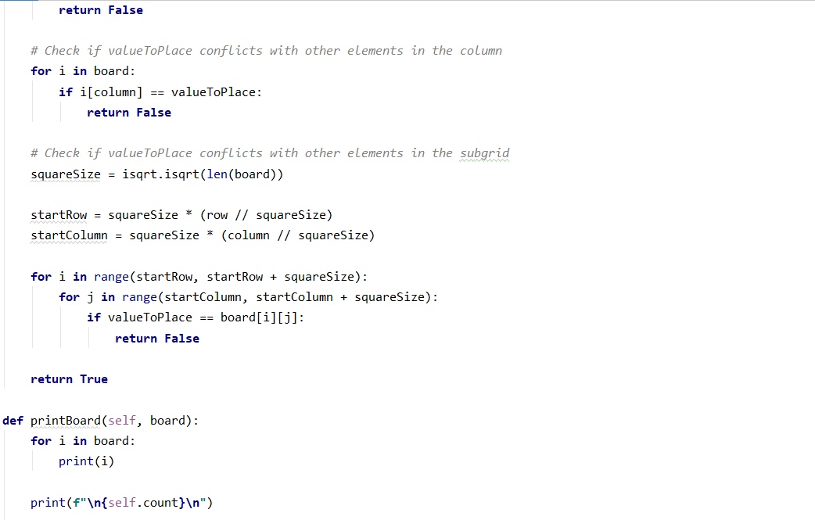

II. GUI
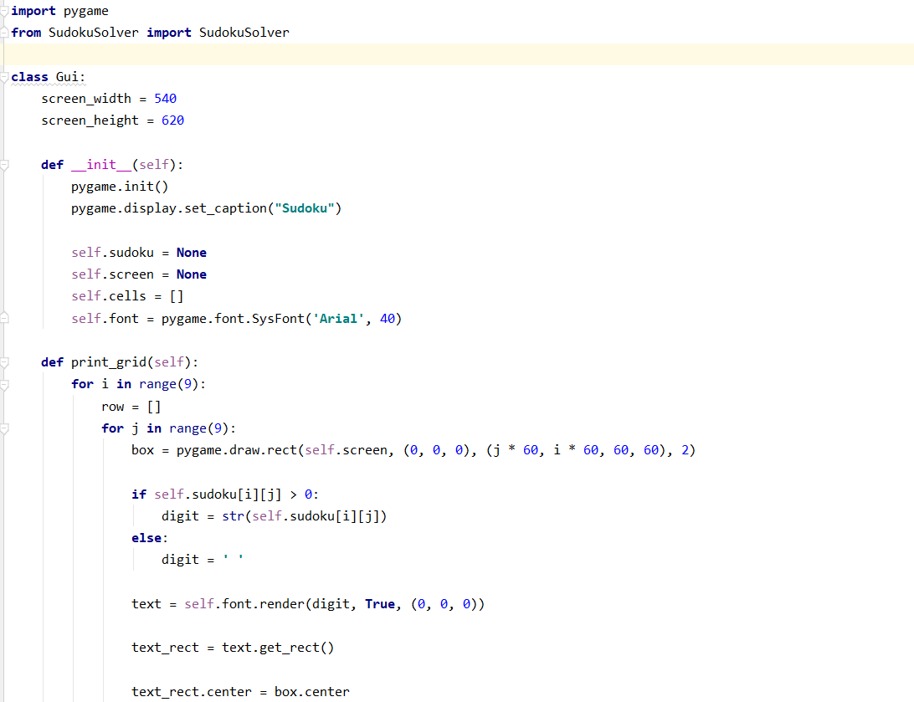
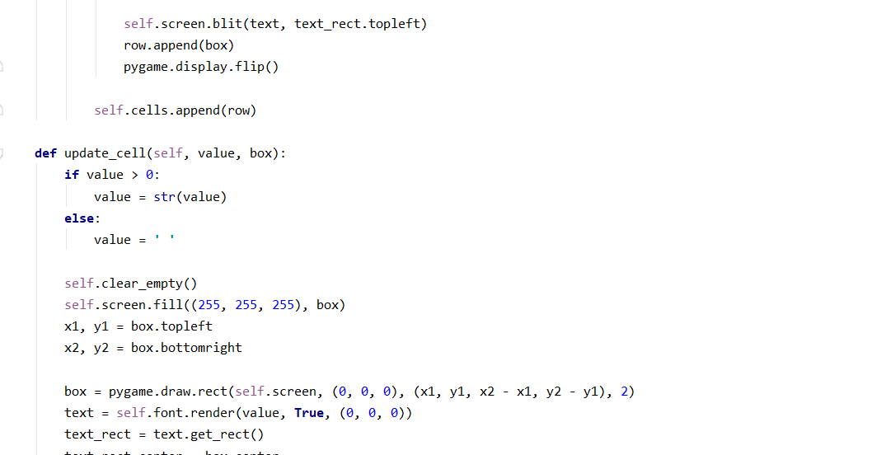

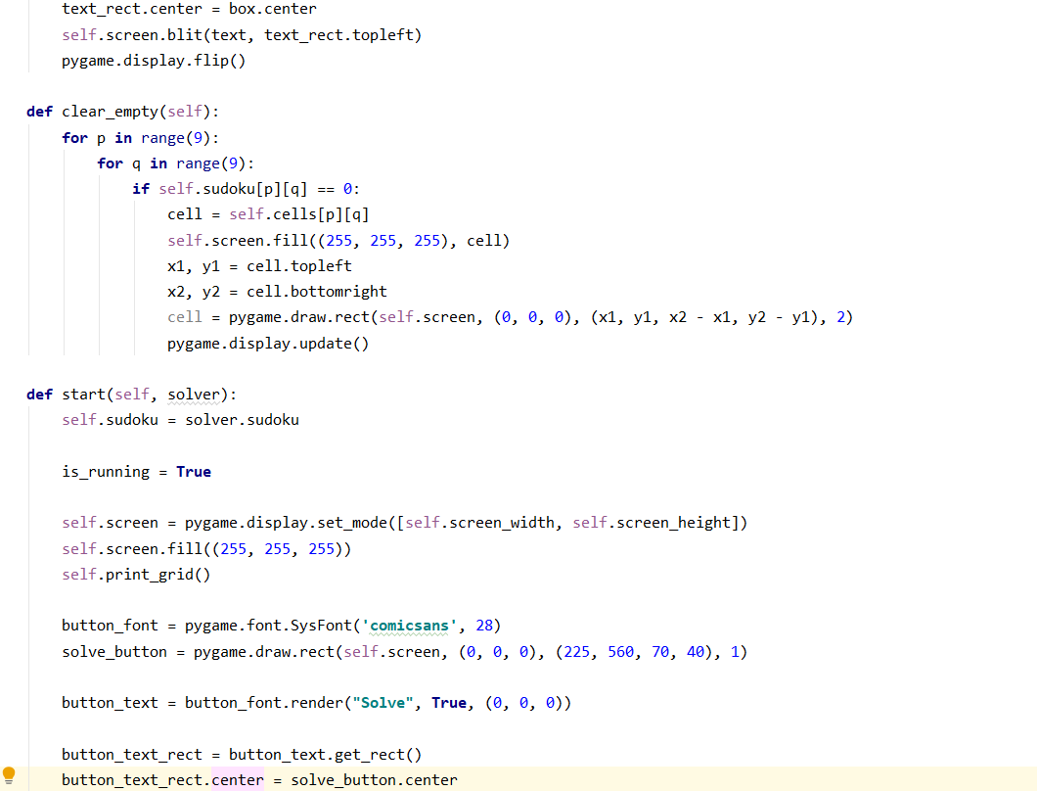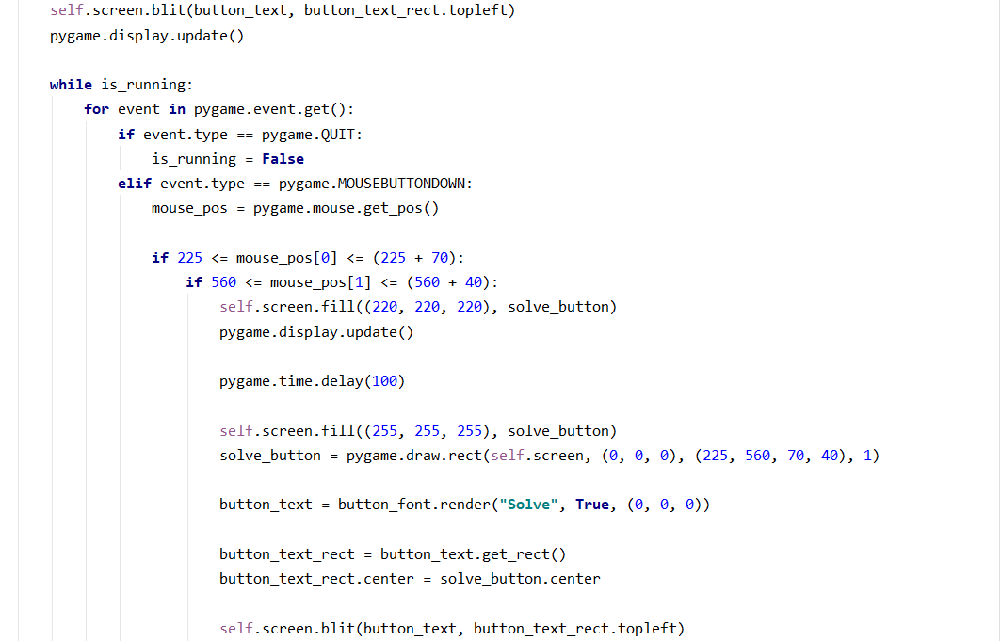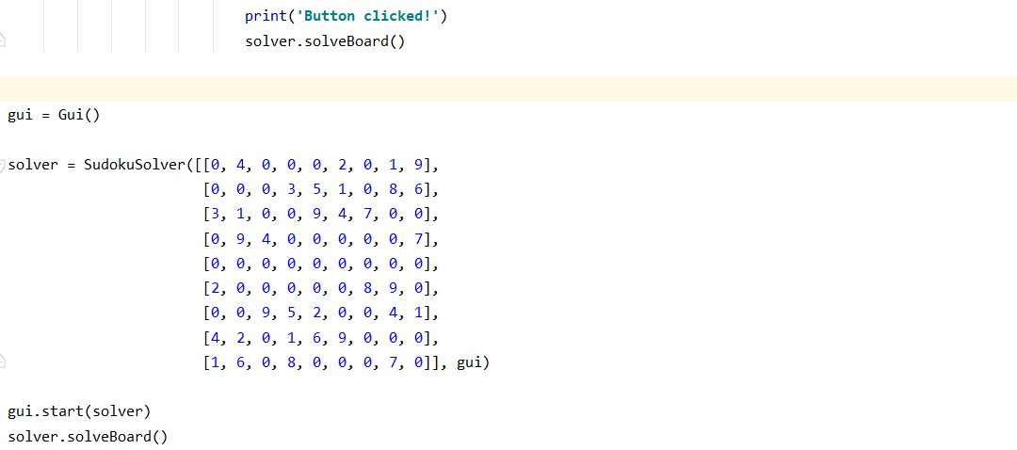

4. Result

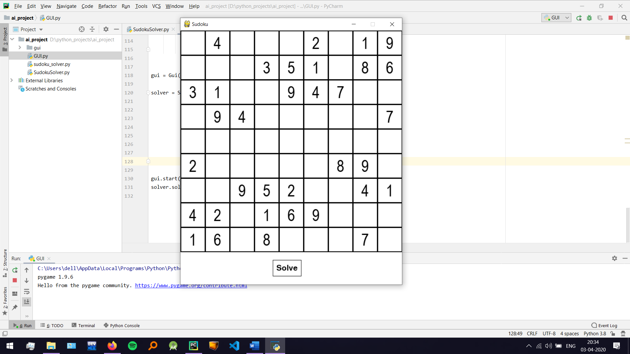

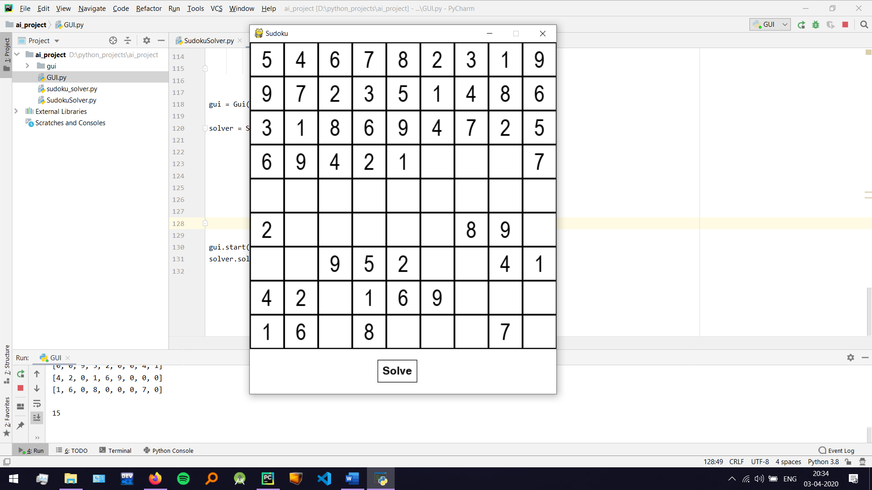

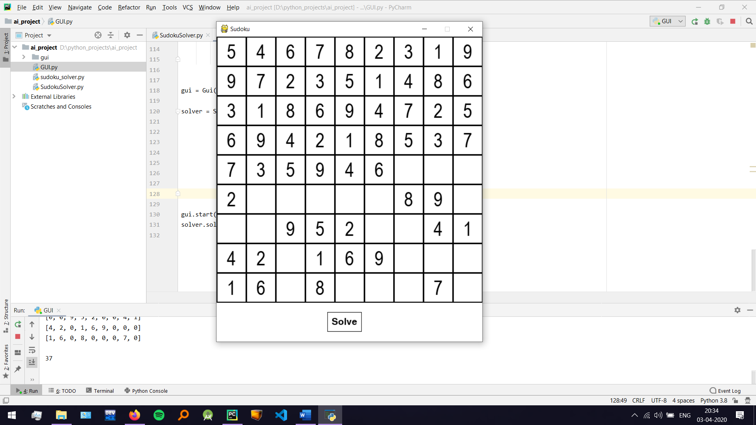

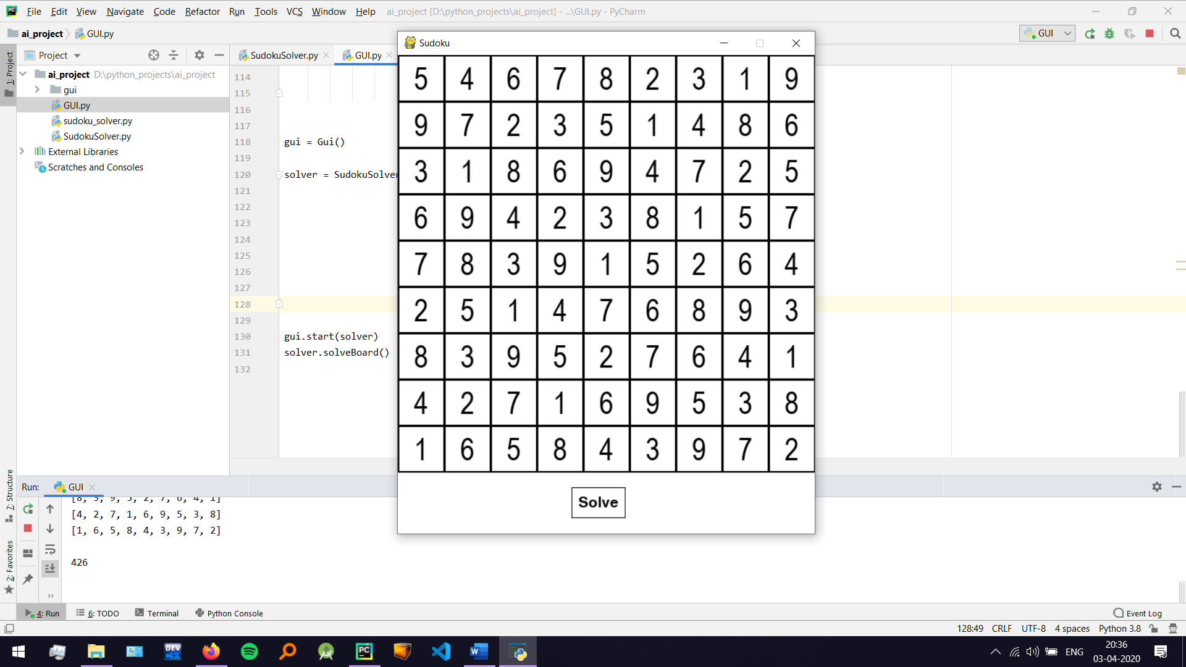

5. Libraries
I. PyGame
This library is used to make the GUI for the program.
II. isqrt
This library is used to find the integer square root of an integer.

References
I. https://www.youtube.com/watch?v=JzONv5kaPJM
I watched this YouTube video to get an idea on how to go about solving the sudoku and the rules that I need to implement.
II. https://www.pygame.org/docs/
I used the documentation for learning to create the GUI for my program.
III. https://www.stackoverflow.com/
Used for all the times that I got stuck while using PyGame.

