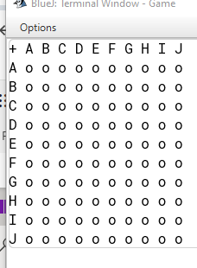

From Mr. Fairhall 14/05/24 if the user put the coordinate of e.g. [D][C] the user might not know which grid they interacted with (because there is two possibility DC or CD)

Solution: Change the vertical coordinate too number.

