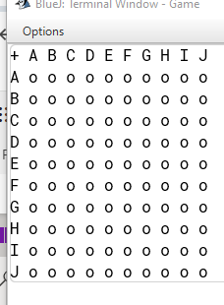

From Mr. Fairhall 14/05/24 if the user put the coordinate of e.g. [D][C] the user might not know which grid they interacted with (because there is two possibility DC or CD)

Solution: Change the vertical coordinate too number.

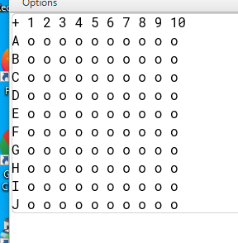

Make the square bigger and use the inner part of it.

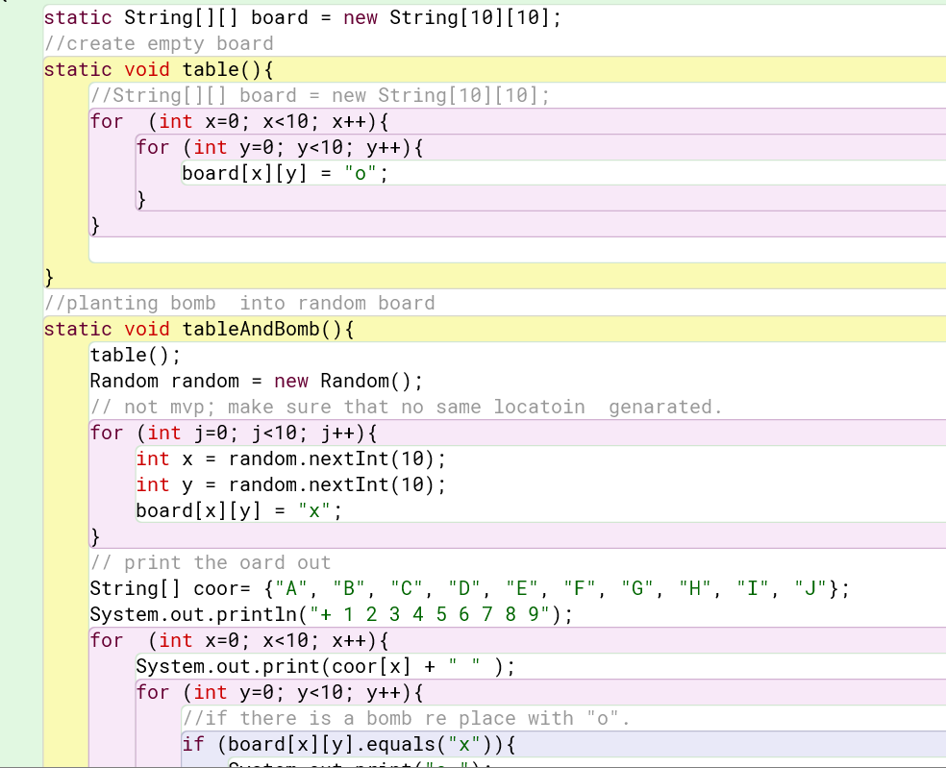

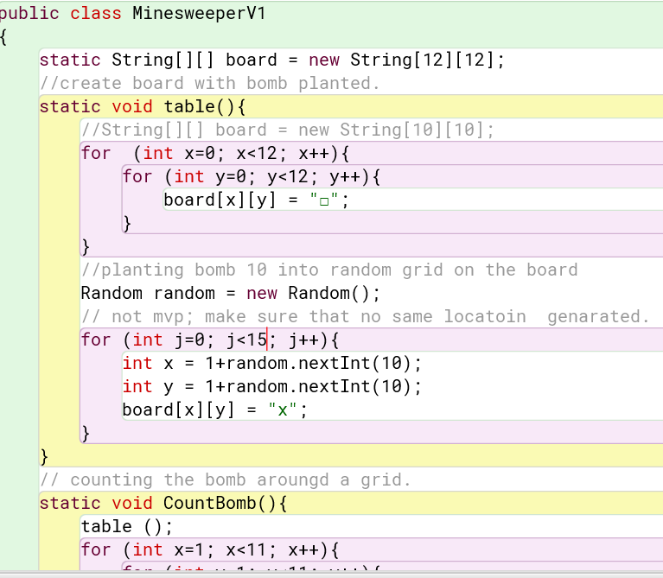

Adjust the table so it is easier to read.

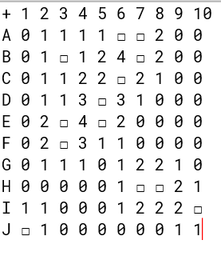

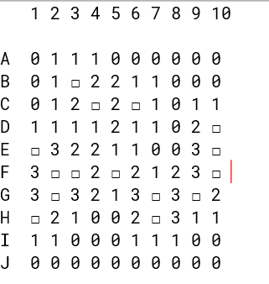

Testing

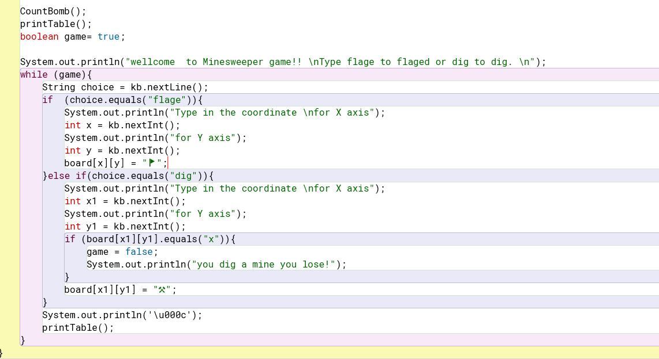

Need error checking for all the input to make it easier to use -= better user experience.

