Trialing Document

|  |  |
| --- | --- |
| Date | What is the thing I am trialing |
| 14/05/24 | GUI of the game. |

*Copy and paste the table above before filling it out*

### Version A

### Coordinate x and y have the same label which is hard to understand.

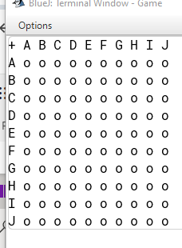

### Version B

X and y coordinates have different types of label (alphabet and number).

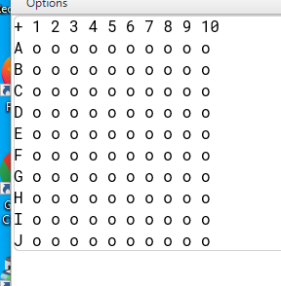

Person: Mr. Fairhall (my teacher)

Date: 14/05/24

Comment: From version A if the user puts the coordinate of e.g. [D][C] the user might not know which grid they interacted with (because there are two possibilities DC or CD)

Person:

Date:

Comment

### Evaluation and next steps

Based on this trialing and the feedback, I have decided to use version B because its easier to understand and use.

|  |  |
| --- | --- |
| Date | What is the thing I am trialing |
| 21/05/24 | Find out the Y coordinate as an integer for the arrays (because our y coordinate is alphabet) |

*Copy and paste the table above before filling it out*

### Version A

To find the y coordinate I use a for loop to loop through the arrays of y coordinate [a, b, c, d…] and keep track of how many times we loop through [ j ] then set it to equal to the y axis coordinate which over complicate it. The better way to do it is to use char.

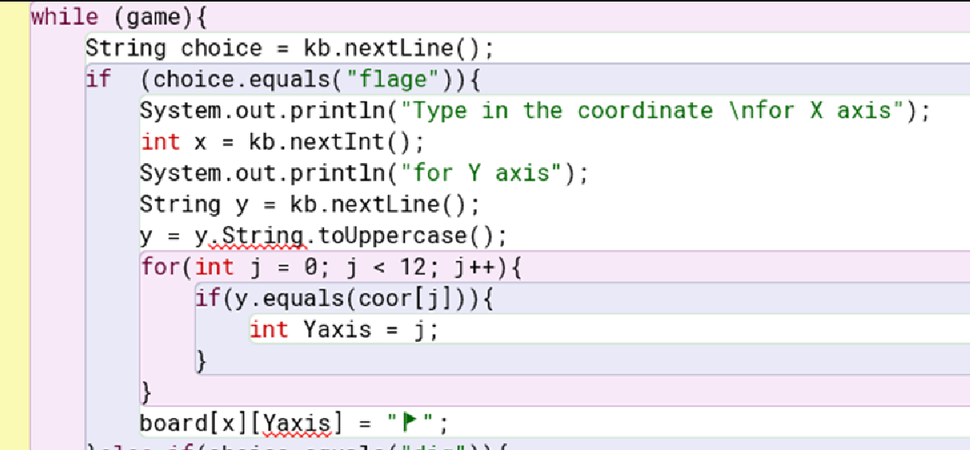

### Version B

Because char is an ASCII it has a value in int as well (A = 65) so I converted a string of y axis to char then minus it with 64 to get the y coordinate. Now it works fine with minimal code (compared with loop through the coordinate as string).

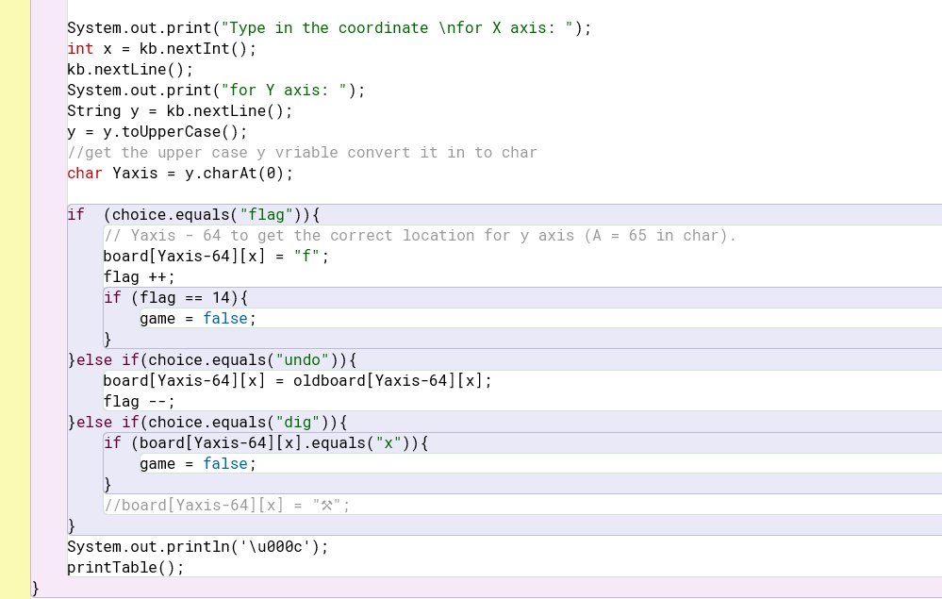

Evaluation and next steps

Based on this trial I decided to use version B because version B is faster, more efficient, and requires less code for the same output.

|  |  |
| --- | --- |
| Date | What is the thing I am trialing |
| 5/06/24 | Different ways of counting a bomb around each cell. |

### Version A

To count how many bombs are around a cell I created a method that takes the input of x and y coordinates then I ran a check on the cell around it ( [x-1, y-1] [x, y-1] [x+1, y+1]… ) if it contains a bomb or not but this will not work if the cell that we are checking is on the corner or at the rim of the board so what I do is create a bigger board (12x12) and only use the middle (10x10) part of it so if the cell that is being checked is at the edge of 10x10 board it will still works fine because the board is 12x12 so there will be no index out of range error.

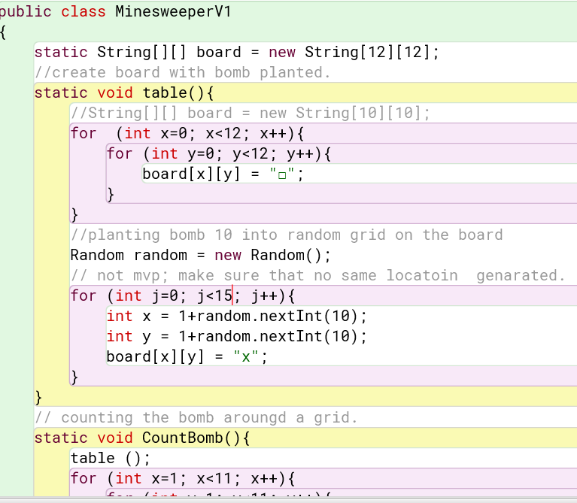

### Version B

I used a normal-size board (10x10) and passed the surrounding coordinates ( [x-1, y-1] [x, y-1] [x+1, y+1]… ) to another method called countbomb() which takes x and y coordinates as an argument. If the x and y coordinates are out of range the method will return 0 but if that cell is not out of range and contains a bomb the method will return 1 to the main Checkbomb method which will keep track of the amount of the bomb.

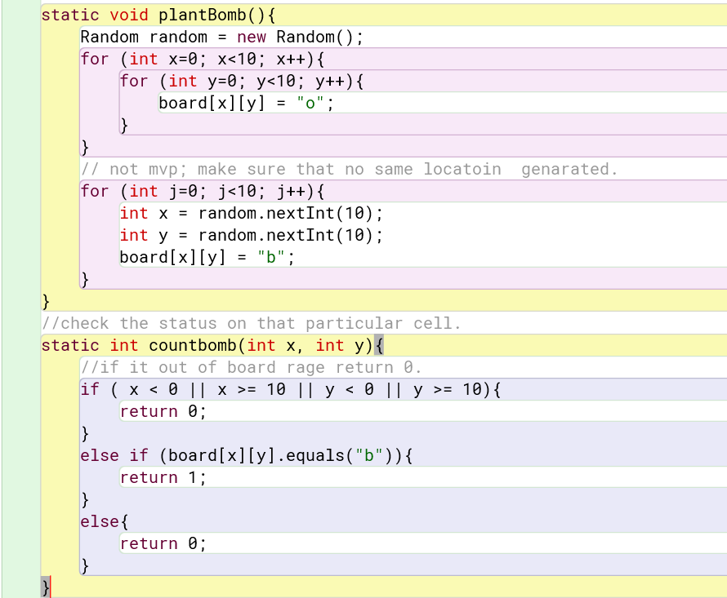

Evaluation and next steps

Based on this trial, I have decided to use version B because the board size of the board is being used throughout the entire game. If I use a size 12x12 board when I print the board out or generate a bomb inside the board the coordinates have to be in a range of 1 – 10 and the number of board lengths is not consistent throughout the game which made the game quite hard to deal with. Also, I think version B is easier to understand for everyone in case anyone wants to develop this project.

|  |  |
| --- | --- |
| Date | What is the thing I am trialing |
| 11/06/24 | User try the game 1 |

### Feedback

Person: Huy (my classmate)

Date: 11/06/24

Comment: According to Huy he says that the game is really hard to play because if the player type something wrong the game will end with error straight away.

I decided to put error checking into my game by passing every input into a method and will loop through until get the valid input. if the player types something wrong the program will loop through until it gets the valid input. This will also work for when user input a wrong case e.g. [fLaG] the program will still work fine.

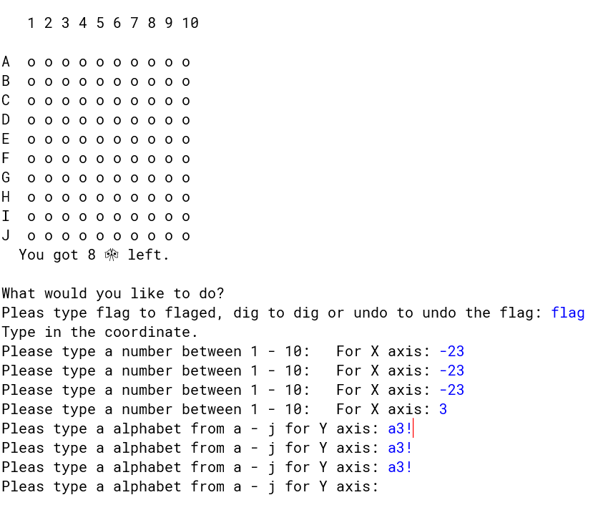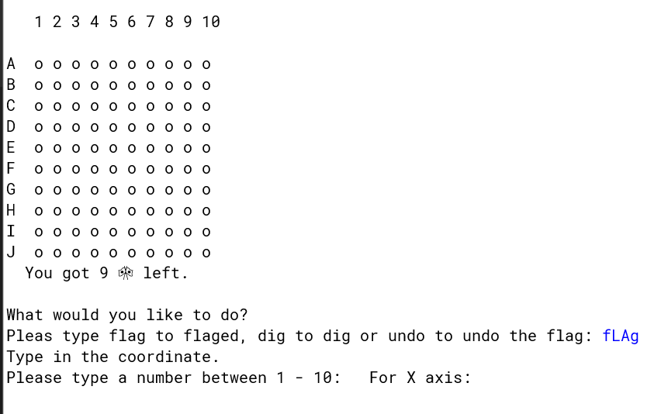

|  |  |
| --- | --- |
| Date | What is the thing I am trialing |
| 13/06/24 | User try the game 2 |

Person: Aksel (my friend that try the game)

Date: 3/05/24

Comment: According to Aksel he suggests that I put a undo flag option in the game because if the player accidentally place a flag at a wrong spot or place it wrong then find out later they cannot undo it.

I have decided to add an undo option to my game, now the player can undo the flag if they make any mistake.

