AIM:

Write a Python function to print missing characters to make string pangram.

PROGRAM:

a=input()

a=set(a.strip())

a.remove(chr(32))

b="abcdefghijklmnopqrstuvwxyz"

b=set(b)

b=b.difference(a)

b=list(b)

b.sort()

print("".join(b))

OUTPUT:

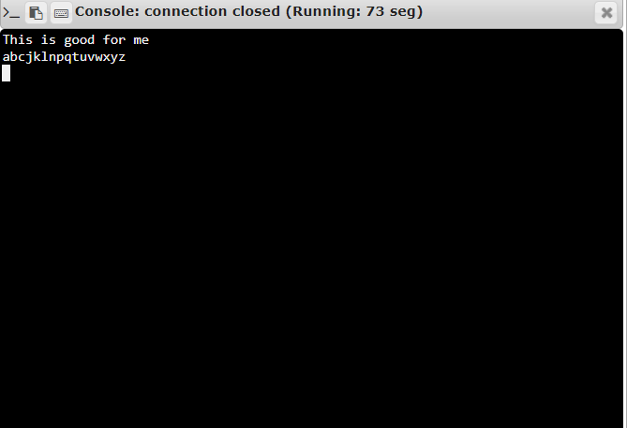

LINK:

<http://103.53.53.18/mod/vpl/forms/edit.php?id=235&userid=1700#>

RESULT:

Thus, the program was executed successfully.