AIM:

Write a Python class to find validity of a string of parentheses, '(', ')', '{', '}', '[' and ']. These brackets must be close in the correct order, for

example "()" and "()[]{}" are valid but "[)", "({[)]" and "{{{" are invalid.

PROGRAM:

class validity:

def f(str):

a=['()','{}','[]']

while any(i in str for i in a ):

for j in a:

str=str.replace(j,'')

return not str

s=input()

if(validity.f(s)):

print("valid")

else:

print("invalid")

OUTPUT:

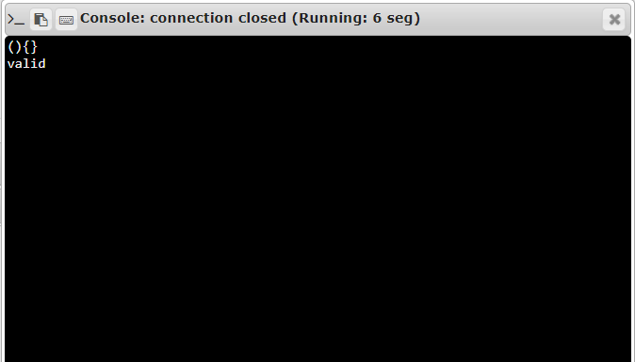

LINK:

<http://103.53.53.18/mod/vpl/forms/edit.php?id=327&userid=1700>

RESULT:

Thus, the program was executed successfully.

validty