Universes Whitepaper
Universes: Multiplayer Shooter game created by
Fishy Pug Bruh (Creator of this document):
Twitter: https://twitter.com/fakeobamalite
Youtube: https://www.youtube.com/channel/UC_fMmKaJ-Z7Nds2dOJt1pAA
VAKE333:
Youtube: https://www.youtube.com/channel/UCgKTz9EMQ1CPpCSJv5Lj2-g
Youtube Secondary:
https://www.youtube.com/channel/UChtPXL9JUNsBsMBTyVGh05w
Discord: Vake333#7323
Midas777 (AKA. Penny And Fishy):
Discord: Midas 777#5129
Youtube: https://www.youtube.com/channel/UCpH60hZ8iRGjIAjfqoD5qpQ
Arbereshflag:
Twitter: https://twitter.com/arbereshflag
Youtube: https://www.youtube.com/channel/UCxc7libVh8LtoIMXKarm_Vw
Introduction
The project vision is to create an enjoyable game with a great community. And allow the project to continue indefinitely, While resembling the feel of Valve’s Source Engine. The game is created with the Godot Engine, A feature rich Open-source game engine with multiplatform support. The game will be Open-source.
Digital Currency
The game will use the Solana blockchain for a digital currency. Playing the game will give you tokens. Tokens can be spent to buy characters, cosmetics and items or be sold at the swap.
The swap allows you to exchange different types of digital tokens. Cosmetics and items can be traded with other players at the market. The game is community driven using a DAO (Decentralized autonomous organization) system, developers can submit proposals and users can vote using tokens. The proposals with the most amount of tokens will be added into the game’s code. Proposals will be organised into categories. All profits earned from sales of items and cosmetics will be distributed among the DAO users. 20 billion tokens out of the 30 billion supply cap will be minted in the beginning 10 billion will go to developers and 10 billion will be added to the swap. The unminted tokens will be minted and given to players as a reword using a smart contract.
Proof of game round (POGR)
In order to reword players with tokens, All actions that a player preforms will be sent to multiple Game Verifiers that store the actions. At the end of the round the Game Verifiers will submit the round results to a smart contract. The smart contract has a short verifying period where a Game Verifier can only submit results once per period. At the end of the period, the submitted results for each round will be checked. If a round has less than 3 results submitted that round is ignored. If a round has at least 3 results submitted, the smart contract will count the votes in the round and pick the most submitted answer, then the smart contract mints new tokens and gives them to the best players in the round based on the picked results. Game Verifiers also get newly minted tokens as an incentive to keep everything secure.
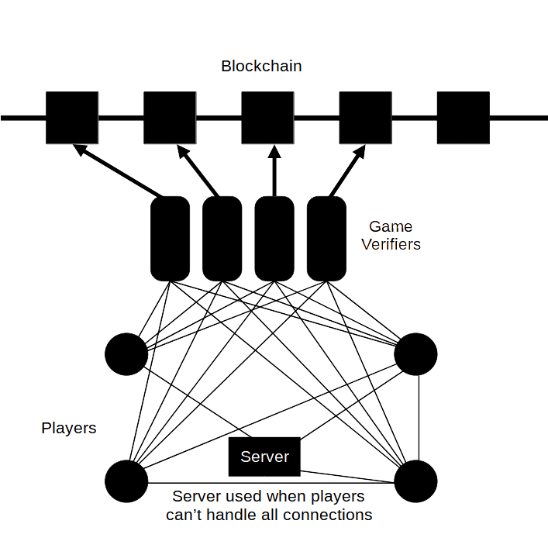

Trading System
In order to ensure secure trading of items between players a smart contract will be used to ensure that no scams can occur, however this is more limiting. The system works as fallows in order.
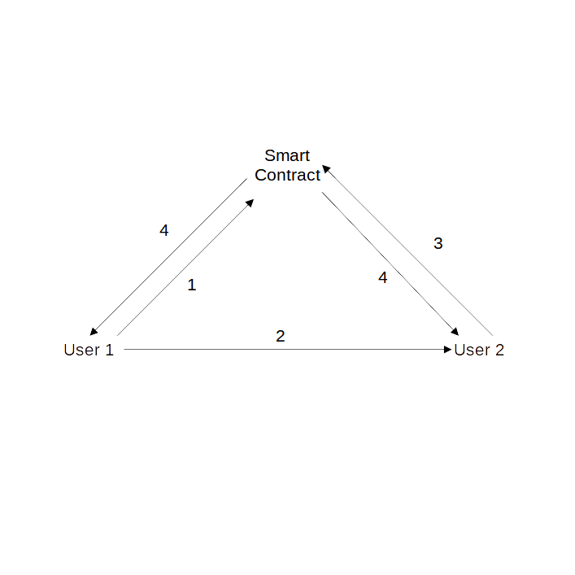
- User 1 creates a trade request With what they will like from user 2 and What they will give to User 2, then sends it to the Smart contract along with the items that are going to be sent to User 2
- User 1 notifies User 2 about the request
- If User 2 accepts the offer and sends the items that User 1 wants to the smart contract
- User’s items are sent to the other user
If user 2 declines the offer or User 1 wishes to remove the offer, Either users can cancel the offer, causing items to get sent back to there owner

Proof of feature
The proof of feature system allows for voting on witch features should be implemented in the future and rewords fast development. The system works by having a plan proposal. The plan proposal is like any other proposal, but when it’s accepted, all tokens
spent on the proposal are locked. If a new proposal with the features is not detected the some of the tokens spent will be returned to the original spenders. If a follow-up proposal is detected. A group of auditor nodes will verify if the proposal contains the feature stated in the plan proposal. Auditor nodes are users that have staked 400,000 tokens

