University of Stirling

Computing Science

Mobile App Development

Android Practical 6: Module Provider Database

Checkpoint at the End

In this practical you will learn about Android content providers. The aim is to create a content provider that translates module codes into names (e.g. CSCU9YH is translated into ‘Mobile App Development’). You will also create a client activity for this provider.
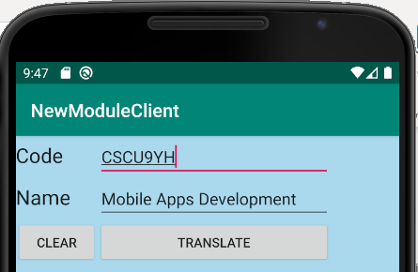

This lab consists of two applications (each with their own activity). So you will need two projects for this lab task. The first application contains the provider, and the second contains the client application.

Create the Module Provider
Create a new project Call your project ModuleProvider. We will need two classes here, one for the Activity which is automatically generated and a second class for the Provider class. So, to create a new class for the Provider, create a new Kotlin Class file (select java\uk.ac.stir.cs.provider and right-click New > Kotlin File/Class) and set the Name to ModuleProvider (that’s what is assumed in other code provided on this lab sheet). Open ModuleProvider.kt from the Explorer and start editing it.
The class ModuleProvider extends the standard ContentProvider. You will see that there are constants for the database table name, the provider name, the URI for accessing this, and URI codes corresponding to all modules or just one module. Later on, the onCreate method in the provider Activity establishes the link to the content provider object content and also creates a database reference.
In the Provider it is necessary to provide implementations for the insert, update, query, delete, getType, and onCreate database methods. These provide the interface between client apps and the content provider. So in structure there is similarity to the previous basic database practical code, but the content of these methods make use of Provider specific logic, namely using the URIMatcher to work out if the query is for a specific database record, or all. The SQLQueryBuilder class is another helper class to construct SQL queries.
package android.cs.stir.ac.uk.newmoduleprovider
import android.content.*
import android.database.Cursor
import android.database.SQLException
import android.database.sqlite.SQLiteDatabase
import android.database.sqlite.SQLiteOpenHelper
import android.database.sqlite.SQLiteQueryBuilder
import android.net.Uri
import android.text.TextUtils
class ModuleProvider : ContentProvider() {
lateinit private var contentResolver: ContentResolver
lateinit private var modulesDatabase: SQLiteDatabase
lateinit private var uriMatcher: UriMatcher
override fun onCreate(): Boolean {
uriMatcher = UriMatcher(UriMatcher.NO_MATCH)
uriMatcher.addURI(PROVIDER_NAME, "modules", ALL_MODULES)
uriMatcher.addURI(PROVIDER_NAME, "modules/*", ONE_MODULE)
val context = context
contentResolver = context!!.contentResolver
val databaseHelper = DatabaseHelper(context)
modulesDatabase = databaseHelper.writableDatabase
return modulesDatabase != null
}
override fun getType(uri: Uri): String? {
val mimeType: String
mimeType = when (uriMatcher.match(uri)) {
ALL_MODULES -> "vnd.uk.ac.stir.cs.cursor.dir/modules"
ONE_MODULE -> "vnd.uk.ac.stir.cs.cursor.item/modules"
else -> throw IllegalArgumentException("Invalid URI '$uri'")
}
return mimeType
}
override fun query(uri: Uri, projection: Array<String>?, selection: String?,
arguments: Array<String>?, sortOrder: String?): Cursor? {
var so = sortOrder
val sqlBuilder = SQLiteQueryBuilder()
sqlBuilder.tables = DATABASE_TABLE
if (uriMatcher.match(uri) == ONE_MODULE) {
val code = uri.pathSegments[1]
sqlBuilder.appendWhere("code = '$code'")
}
if (so == null || so === "") {
so = "code"
}
val cursor = sqlBuilder.query(modulesDatabase, projection, selection,
arguments, null, null, sortOrder)
cursor.setNotificationUri(contentResolver, uri)
return cursor
}
override fun insert(uri: Uri, values: ContentValues?): Uri? {
val newUri: Uri
val rowIdentifier = modulesDatabase.insert(DATABASE_TABLE, "", values)
if (rowIdentifier > 0) {
newUri = ContentUris.withAppendedId(CONTENT_URI, rowIdentifier)
contentResolver.notifyChange(newUri, null)
} else throw SQLException("Failed to insert row into '$uri'")
return newUri
}
override fun delete(uri: Uri, selection: String?, arguments: Array<String>?): Int {
var count = 0
when (uriMatcher.match(uri)) {
ALL_MODULES -> count = modulesDatabase.delete(DATABASE_TABLE, selection, arguments)
ONE_MODULE -> {
var code = uri.pathSegments[1]
code = "code = '$code'"
if (!TextUtils.isEmpty(selection)) code += " AND ($selection)"
count = modulesDatabase.delete(DATABASE_TABLE, code, arguments)
}
else -> throw IllegalArgumentException("Unknown URI '$uri'")
}
contentResolver.notifyChange(uri, null)
return count
}
override fun update(uri: Uri, values: ContentValues?, selection: String?,
arguments: Array<String>?): Int {
var count = 0
when (uriMatcher.match(uri)) {
ALL_MODULES -> count = modulesDatabase.update(DATABASE_TABLE, values, selection, arguments)
ONE_MODULE -> {
var code = uri.pathSegments[1]
code = "code = '$code'"
if (!TextUtils.isEmpty(selection)) code += " AND ($selection)"
count = modulesDatabase.update(DATABASE_TABLE, values, code, arguments)
}
else -> throw IllegalArgumentException("Unknown URI $uri")
}
contentResolver.notifyChange(uri, null)
return count
}
companion object {
const val DATABASE_TABLE = "modules"
const val PROVIDER_NAME = "android.cs.stir.ac.uk.newmoduleprovider.ModuleProvider"
@JvmField
val CONTENT_URI = Uri.parse("content://" + PROVIDER_NAME + "/" + DATABASE_TABLE)
private const val ALL_MODULES = 1
private const val ONE_MODULE = 2
}
}
internal class DatabaseHelper(context: Context?) : SQLiteOpenHelper(context, DATABASE_NAME, null, DATABASE_VERSION) {
override fun onCreate(database: SQLiteDatabase) {
database.execSQL(
"CREATE TABLE " + ModuleProvider.DATABASE_TABLE + "(" +
"id INTEGER PRIMARY KEY AUTOINCREMENT, " +
"code TEXT NOT NULL," +
"name TEXT NOT NULL" +
");"
)
}
override fun onUpgrade(database: SQLiteDatabase, oldVersion: Int,
newVersion: Int) {
database.execSQL("DROP TABLE IF EXISTS " + ModuleProvider.DATABASE_TABLE)
onCreate(database)
}
companion object {
val DATABASE_NAME = "courses"
val DATABASE_VERSION = 1
}
}

As in the previous lab, a separate DatabaseHelper class provides an interface to the built-in SQLite database. For each content provider URI, the getType method returns the resulting MIME type (Multipurpose Internet Mail Extensions). This names the type of data returned by the content provider when asked for module details; vnd stands for vendor (i.e. developer-defined). The onCreate method creates a content resolver (for accessing content) and creates a reference to the database.

Open AndroidManifest.xml and add the entry for the provider. This should go just after the activity (after its closing tag). The name of the provider will need to match the class name for the Provider class above. The authority needs to be the same whenever you reference the provider, e.g. in the Activity below and also in the client.

<provider
android:name="ModuleProvider"
android:authorities="android.cs.stir.ac.uk.newmoduleprovider.ModuleProvider"
android:enabled="true"
android:exported="true">
</provider>

Create the Module Provider Activity
Then edit the Layout file for the project to include a TextView which includes the text ‘Module Provider started’.

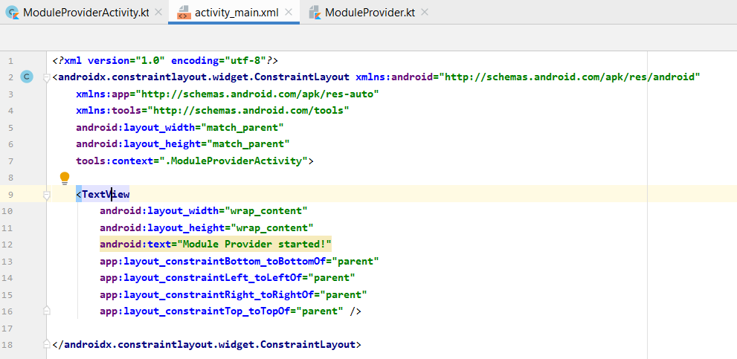
In the code that follows below for the provider Activity, the onCreate method sets up the database by calling the addModule method for each module. As marked by the code comment in bolt-red, add a number of modules (about 3-5).
Notice the use of method Log.v (short for verbose) which is called to log each module as it is added. This is a useful for debugging Android code (much like inserting print statements in a Java program). The log output appears under the Run tab. This should be visible, alternatively use ALT+6.

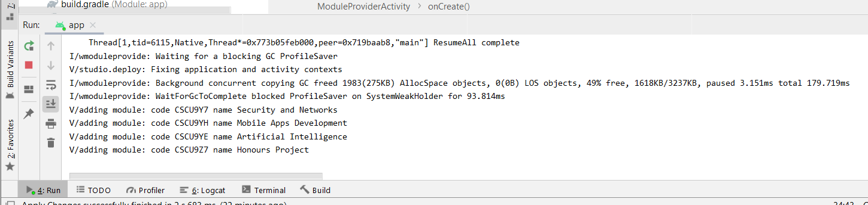

class ModuleProviderActivity : AppCompatActivity() {
private lateinit var cr: ContentResolver
fun addModule(code: String, name: String) {
Log.v("adding module", "code $code name $name")
val values = ContentValues()
var uri = Uri.withAppendedPath(ModuleProvider.CONTENT_URI, code)
values.put("code", code)
values.put("name", name)
val rows = cr.update(uri, values, "", null)
if (rows == 0) {
cr.insert(uri, values)
}
}
public override fun onCreate(savedInstanceState: Bundle?) {
super.onCreate(savedInstanceState)
cr = contentResolver
// delete any existing module table
cr.delete(ModuleProvider.CONTENT_URI, null, null)
// add modules
// addModule( string: code, string: title)
// report completion
setContentView(R.layout.activity_main)
}
}

Once the content provider has been created, run the Activity and check that it reports initialisation of the database.

Create the Module Client
Create an Android project much as you did before. Call your project ModuleClient. Then edit the following:
Open res\layout\activity_main.xml (or whatever your layout file is called) and edit this to look like the screenshot at the beginning of the practical. The layout is similar to the second practical, with the following rows in the table layout:
- In the first TableRow on the left hand side place TextView. In the next column place and EditText element and give it Id codeValue and give it a width of 250dp.
- In the second TableRow on the left hand side place a TextView. In the next column place a EditText and you may want to set the inputType attribute to textMultiLine. Give it the Id nameValue and set a width of 250dp.
- In the third row place a Button and give it Id clearButton with text ‘Clear’; and then place a second Button with Id translateButton with text ‘Translate’.
When the Translate button is clicked, the content provider is asked to translate the given module code into its name. A managed query is used as this keeps track of the database cursor automatically. If the module name is missing or invalid (one row is not returned in the cursor), and an error is displayed.

package android.cs.stir.ac.uk.moduleclient
import androidx.appcompat.app.AppCompatActivity
import android.net.Uri
import android.os.Bundle
import android.view.View
import android.widget.Button
import android.widget.EditText
import android.widget.Toast
class ModuleClientActivity : AppCompatActivity() {
lateinit var codeText: EditText
lateinit var nameText: EditText
val DATABASE_TABLE = "modules"
val PROVIDER_NAME = " android.cs.stir.ac.uk.newmoduleprovider.ModuleProvider"
val CONTENT_URI = Uri.parse("content://" + PROVIDER_NAME + "/" + DATABASE_TABLE)
public override fun onCreate(savedInstanceState: Bundle?) {
super.onCreate(savedInstanceState)
setContentView(R.layout.activity_main)
codeText = findViewById<View>(R.id.codeValue) as EditText
nameText = findViewById<View>(R.id.nameValue) as EditText
nameText.isFocusable = false
val clearButton = findViewById<View>(R.id.clearButton) as Button
clearButton.setOnClickListener {
codeText.setText("")
nameText.setText("")
}
val translateButton = findViewById<View>(R.id.translateButton) as Button
translateButton.setOnClickListener { view ->
try {
val moduleCode = codeText.text.toString()
val uri = Uri.parse(CONTENT_URI.toString() + "/" + moduleCode)
val cursor = contentResolver.query(uri, null, null, null, null)
if (cursor!!.count == 1) {
cursor.moveToFirst()
val moduleName = cursor.getString(cursor.getColumnIndex("name"))
nameText.setText(moduleName)
cursor.close()
} else {
nameText.setText("")
throw Exception("module code invalid")
}
} catch (exception: Exception) {
Toast.makeText(view.context, "Invalid data - " + exception.message, Toast.LENGTH_SHORT).show()
}
}
}
}

Edit the Client Manifest file
Since API level 30, Android applications are more restricted in terms of their “package visibility”, that is one application cannot, by default, see other packages from other applications. More information is available at https://developer.android.com/training/basics/intents/package-visibility.

In order for the client app to “see” the provider app we need to make a small change to the client's Manifest file. You need to add a queries tag at the beginning of the file to match the authorities tag of the provider to allow the client to "see" the content provider in the provider app:

<?xml version="1.0" encoding="utf-8"?>
<manifest xmlns:android="http://schemas.android.com/apk/res/android"
package="uk.ac.stir.cs.moduleclient">

<queries>
<provider android:authorities=" android.cs.stir.ac.uk.newmoduleprovider.ModuleProvider" />
</queries>

<application
…

Run your code and check that it behaves as expected (including error cases such as no module code or an invalid one).

You have now reached a checkpoint. Please record a short screen grab video and upload to Canvas for your checkpoint.

Consider the following questions:
- Why are different projects used for the provider and the client?
- Does the provider really need an associated activity?

