|  |  |
| --- | --- |
| **Computer Science 1** | **Lab 08C**  **Practice/Perform Major Python Assignment** |
| **The Random Graphics Program** | **50, 60, 70, 80, 90, 100 & 110 Point Versions** |
| **Assignment Purpose:**  The purpose of this program is to demonstrate knowledge of generating random integer values in specific ranges so they can manipulate graphics output. | |

For this lab assignment you are provided with a grid of two rows by four columns. Each cell in the grid needs some graphics object to be drawn. It will be necessary to use procedures from the **Graphics**library to complete this assignment. The use of the grid is intentional. One cell will be done for you as an example. In the other 7 cells you will need to display various graphics shapes that must stay within the boundaries of the cell. In most of these cells, the graphics shapes will be *random* in more than one way. Make sure to finish each cell with an **update** command as shown in line #27.

|  |  |
| --- | --- |
| **Lab 08C Student Version** | **Do not copy this file, which is provided.** |
| **1 # Lab08Cv110.py  2 # "Random Graphics"  3 # This is the student, starting version of Lab 08C.  4   5   6 from Graphics import *  7   8 beginGrfx(1300,700)  9  10 # Substitute your own name here. 11 drawHeading("John Smith","8C") 12  13 # Draw Grid 14 drawLine(325,50,325,700) 15 drawLine(650,50,650,700) 16 drawLine(975,50,975,700) 17 drawLine(1300,50,1300,700) 18 drawLine(0,375,1300,375) 19 drawLine(0,700,1300,700) 20  21 # Draw 1000 Random Points. 22 for k in range(1000): 23 setRandomColor() 24 x = randint(5,320) 25 y = randint(55,370) 26 drawPoint(x,y) 27 update() 28  29 # Draw 500 Random Lines. 30  31  32  33  34 # Draw 100 Random Rectangles. 35  36  37  38  39 # Draw 100 Random Triangles. 40  41  42  43  44 # Draw Your Initials 100 Times with random sizes. 45  46  47  48  49 # Draw 100 Random Stars with a constant radius  50 # of 50 and a random # of Points. 51  52  53  54  55 # Draw 100 Random Circles with random radii. 56  57  58  59  60 # Draw 100 Random Arcs with random horizontal radii, 61 # vertical radii, starting points and stopping points. 62  63  64  65  66  67**  **68 69 endGrfx() 70** | |

**Current Output of Lab08Cst.py**

At the beginning, the output is a 4 by 2 grid, with the “Draw Random Points” cell done for you.

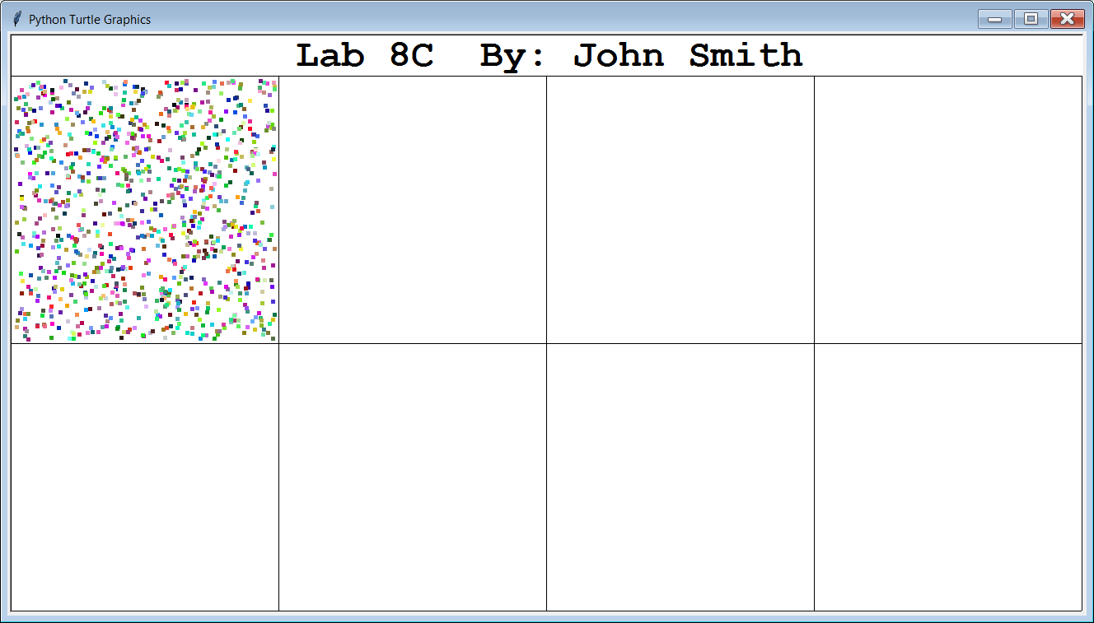

**50, 60, 70, 80, 90, 100 & 110-Point Version Specifics**

The 110-point version is shown on the next page and displays ALL 8 cells.

The 100-point version displays 7 of the 8 cells (Random Points, and 6 others).

The 90-point version displays 6 of the 8 cells (Random Points, and 5 others).

The 80-point version displays 5 of the 8 cells (Random Points, and 4 others).

The 70-point version displays 4 of the 8 cells (Random Points, and 3 others).

The 60-point version displays 3 of the 8 cells (Random Points, and 2 others).

The 50-point version displays 2 of the 8 cells (Random Points, and 1 other).

**110-Point Version Output**

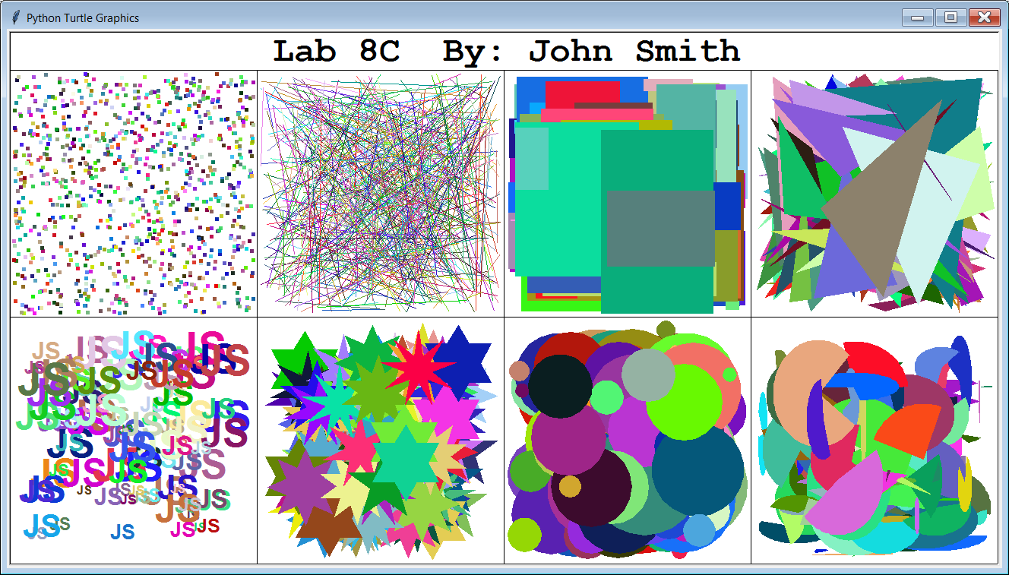

NOTE: Partial credit can be earned if some initials, stars, circles or arcs are partially outside of their cell. No credit is earned if any of its shapes are completely outside of their respective cell.

ALSO: The cells in the top row are easier. Do those cells first. The *Draw Random Arcs* cell is the most difficult. Do that cell last!

Specifics on Each of the 8 Cells

The cell with *Points* displays **1000** random colored points at random locations.

This part is provided to use as an example.

The cell with *Lines* displays **500** random lines.

The Lines have random colors.

Both ends of the line have random **x** and **y** coordinate locations.

The cell with *Rectangles* displays **100** random “filled-in” rectangles.

The Rectangles have random colors.

Both the upper-left-hand corner and the lower-right-hand corner of the rectangle have random **x** and **y** coordinate locations.

The cell with *Triangles* displays **100** random “filled-in” triangles.

The Triangles have random colors.

All 3 corners of the triangle have random **x** and **y** coordinate locations.

This means the triangles are scalene, NOT equilateral.

Make sure you use the command **fillPolygon**.

Do not use the command **~~fillRegularPolygon~~**!

The cell with *Initials* displays YOUR initials **100** times.

Your Initials have random colors.

You can also choose any font *name*, as long as it is readable. (No Wingdings!)

The *point size*should be a random number between **10** and **36**.

You can choose any *style* for your font.

The bottom-left-hand corner of your first initial has random **x** and **y** coordinate locations.

*It is possible that your initials are partially inside the grid cell, and partially outside.*

*If this happens, you will only get partial credit. To fix this, and get full credit,*

*you need to adjust the ranges of random numbers for your x and y values.*

The cell with *Stars* displays **100** random “filled-in” stars.

The Stars have random colors.

The Stars have a random number of points. (Between **5** and **10**)

All Stars have a **radius** of **50**.

The center of each Star has a random **x** and **y** coordinate location.

*It is possible that your initials are partially inside the grid cell, and partially outside.*

*If this happens, you will only get partial credit. To fix this, and get full credit,*

*you need to adjust the ranges of random numbers for your x and y values.*

The cell with *Circles* displays **100** random circles.

The Circles have random colors.

The Circles have a random **radius** which ranges from **1** to **75** pixels.

The center of each Circle has a random **x** and **y** coordinate location.

*It is possible that your initials are partially inside the grid cell, and partially outside.*

*If this happens, you will only get partial credit. To fix this, and get full credit,*

*you need to adjust the ranges of random numbers for your x and y values.*

The cell with *Arcs* displays **100** random “filled-in” arcs.

The Arcs have random colors.

The Arcs have a random **horizontal radius** and a random **vertical radius**.

Each of the random *radii* ranges from **1** to **75** pixels.

The “center” of each Arc has a random **x** and **y** coordinate location.

The **starting** and **stopping** degree values for each Arc are also random.

These means some arcs will look like a slice of pie. Some will look like PAC-MAN.

Some will be just a sliver. Some may even be a complete oval.

This is the most difficult cell in this lab assignment.

Make sure you do all of the other cells first before attempting this one.

*It is possible that your initials are partially inside the grid cell, and partially outside.*

*If this happens, you will only get partial credit. To fix this, and get full credit,*

*you need to adjust the ranges of random numbers for your x and y values.*