Implementing Formally Specified
Computational Science Software in C++

David Maley, Queen’s University of Belfast
d.maley@stmarys-belfast.ac.uk

Ivor Spence, Queen’s University of Belfast
i.spence@qub.ac.uk

Abstract
To date, much of the software written in Computational Physics has been produced with little regard paid to modern software engineering techniques; in addition, there is rarely an interface in the modern sense, and data sets are usually text files containing numbers, the meaning of which is only apparent to those who are familiar with the software (possibly only the authors).
This paper documents experiences in beginning to address these shortcomings for Config, a component of the Graphical R-Matrix Atomic Collision Environment (GRACE).
The work is based around a formal specification of the Config component. The principal focus of the paper will be on a non-intrusive mechanism for monitoring constraints such as class invariants and pre- and post-conditions for highly structured data types based on the containers and algorithms of the Standard Template Library (STL), a mechanism which can be extended to handle update and display prototyping.
Keywords: Computational Physics, C++, Standard Template Library, constraint monitoring.

Introduction
Software for generating electron distributions and couplings is available in the computation stage of an early version of the R-matrix program package []. However, the original package is written in FORTRAN 77 and is typical of many similar such large software systems, in that it has evolved over many years, through the efforts of numerous personnel, in a process of controlled iterative enhancement. Often the modification and extension of such large, complex and mature software systems is severely hampered because some components of the system are written in an implementation-dependent fashion, they are inadequately documented, their functionality is not precisely known, and under certain circumstances they fail to operate correctly.
Initial work to address these problems for Config [], a component of the Graphical R-Matrix Atomic Collision Environment, involved developing a formal specification of the problem of generating electron distributions and couplings []. The formal specification is reproduced in Appendix II. When an implementation of this specification was considered, and in particular when work began to design an interface to the component, problems became apparent to which an object-oriented approach offered the best prospect of a satisfactory solution. These problems centred around maintaining strict adherence of the implementation to the formal specification of the data types.
A data type defines, amongst other things, a range of acceptable values for a variable. Modern programming languages provide built-in data types, along with the facilities for the user to construct new types, using the built-in types as building blocks. Clearly the limits on the data that can be stored in built-in types impose limits on the individual components of any types constructed from them; more often it is required to restrict the range of values of a component to a subset of those provided by the built-in type.
A specification language such as VDM-SL [] allows these restrictions on component values to be stated in the form of constraints. Constraints involving multiple components are of course permitted also, and this provides the mechanism by which the form of the data within an application can be defined. A correct implementation will observe all these constraints, and formal methods exist that make it possible on occasions to prove the correctness of an implementation.
Use of formal methods in such circumstances relies heavily on the concept of refinement []. There can be a large number of refinements between the formal specification and the code. Methods to prove the equivalence of the various refinements exist, but are often difficult and lengthy, and an error at any stage will invalidate any subsequent proofs based on the conclusions of the erroneous statement. Therefore testing the final product is still essential even when proofs have been constructed. Other work has shown that tests can be generated from the specification [].
It is proposed that testing – at least with respect to the observance of constraints – is best undertaken in parallel to implementation, not as a subsequent phase. The basis for this is the belief that source of an error is easiest to identify if the error is detected immediately following its introduction into the system; also, if development is suspended until the error is removed, the problem does not become buried under layers of additional complexity.
The language chosen for the work was C++. Given the importance placed upon the formal approach, Eiffel [] might have seemed a more attractive candidate. However, some of the constraints stated in the specification of Config are not expressible in Eiffel’s Design by Contract [] support. Secondly, it is shown that adding Design by Contract support for the STL provides a platform for the provision of other services which are necessary to promote a faithful implementation of the specification.
The STL [] provides generic container classes, such as list and map, from which new types can be constructed without having to be concerned with the implementation of the container data structures. Likewise, many of the common operations upon these containers are provided in the form of parameterised algorithms. The container classes and their algorithms closely mirror the abstract data types used in a specification language; however, the STL does not provide mechanisms for checking the properties of the types created from it as they might be stated in a formal specification. A formal specification of the data types in a software component will specify not only data structure and permitted operations, but also constraints. In a language such as VDM-SL, for the data structures these will be in the form of invariants on the values of the data; for operations, they will be in the form of pre- and post-conditions on the execution of operations.
This paper describes a mechanism which automatically generates an object hierarchy (the objects are known as Managers) which parallels the data sub-structure of an existing object, and which can provide a platform from which to administer tasks such as constraint monitoring, object update and object display. The paper explores strategies for management of objects during (but also after) the implementation of a component, and aims to show how by adopting an object-oriented architecture, a versatile and reusable set of classes can be developed which provide a number of services in the implementation of a component, and its interface.
In the past, such mechanisms have usually been intrusive []: they have encroached on the code of the data type. This creates a trade-off situation. There are times when developers would like their code to consist of nothing but functional components. When installed on a client site, performance becomes paramount. Assertion checking slows the system, should not be necessary, and it may not be clear what should happen even if an assertion is found to be invalid. Prior to installation, code can be clearer if it is not peppered with assertions. Worse still is the possibility that the assertions themselves might actually alter the behaviour of the system. On the other hand, some would consider the assertions to be an inseparable part of the code, for documentation purposes if no other. Clearly there is no ideal resolution to this dilemma, but the mechanism proposed offers the developer more options.
Using inheritance and namespaces, it is shown that intrusive management is no longer necessary. For classes based on the STL, the mechanism can be utilised immediately, but the mechanism can also be used for classes not constructed from the STL, by non-intrusively adapting those classes and writing Managers for them. This was done in Config. The mechanism has been designed so that existing STL-based code can take advantage it of with the minimum of additional effort: for instance, to monitor constraints such as state validity and pre- and post-conditions, it merely requires the STL-based client to provide an implementation of the constraints to be monitored.
In the first section of the paper, the essential functionality of Config is outlined, and a sample problem motivating the discussion that follows is given. In order to illustrate the basic approach, a working example from a more familiar realm is put forward, and it is shown how constraint monitoring can be achieved by a simple non-intrusive scheme. A more versatile scheme is outlined in the following section, based on a small class hierarchy of Manager classes, and a class with which these Managers interact, CoManager. This section details the structure and behaviour of these classes, and shows how the Managers necessary to observe and report on the state of a highly-structured object can be automatically generated from the type structure of the object. The following section shows how the Manager scheme can be extended to do more than just provide information about the state of an object: it can be used to provide a structured approach to editing the object. An example is given of how the Manager structure can be utilised in data display prototyping. Finally, the limitations of the scheme are discussed.
It should be mentioned that not all C++ compilers can deal with the combination of standard language features utilised (and that there are some compilers which claim to handle these features but do not). The examples given were compiled using the experimental gnu compiler, egcs-1.1.1.

The motivation for Config
The essential operation of the Config component is shown in Figure 1.
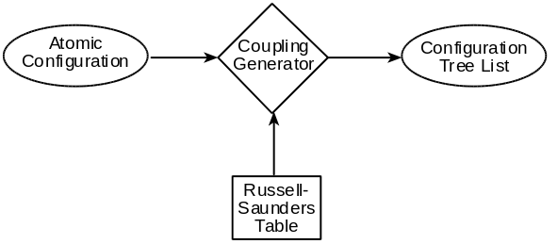
Figure 1. Config functionality.
The component takes an atomic configuration, provided by the client, and a data table, which is fixed, and uses them to generate the electron couplings. The resulting data is termed a configuration tree list. A simple configuration tree is shown in Figure 2.
5 o
G
|
+---+---+
| |
2 3 e 3 o
3d . F P
|
+---+---+
| |
1 2 o 2 e
2p . P S
|
+---+---+
| |
1 2 e *
1s . S

Figure 2. A Configuration Tree.
Configuration trees have two significant characteristics, the symmetry of their root term (⁵Gº in the example) and their electron distribution (1s¹2p¹3d² in the example, emboldened). Other components of the GRACE suite require a client to provide as input both the symmetry and the electron distribution of any trees being processed. However, it may or may not be possible to construct a tree exhibiting both a given symmetry and a given electron distribution. Config is used to prevent any inconsistencies of this nature arising: it can determine the symmetries of all the trees possible from a given atomic configuration and electron distribution, and all the electron distributions which give rise to a given symmetry from a given atomic configuration.
Figure 3 shows some components of the Config data hierarchy. The vast majority of data types in Config are derived from the STL containers vector, pair and map. One of the main concerns in implementing Config was to ensure that the data supplied by the client – primarily an atomic configuration – conformed to the specification. However, it was observed that if a more general mechanism for monitoring integrity could be devised, it could equally well be incorporated into a test phase to validate the data generated by the component itself.
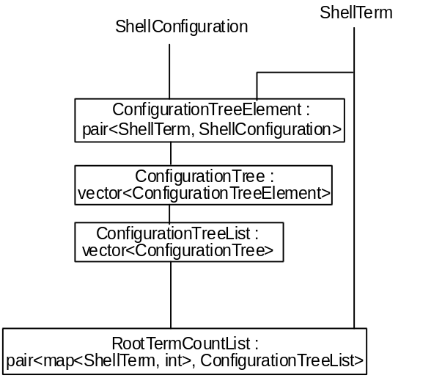
Figure 3. Example Components of the Config data hierarchy.
The structure of an atomic configuration object is considered in some detail below. Mention is made first of two of the other components of the system.
At the base of the data hierarchy are types that model the properties of atoms, such as principal quantum number and parity. These are mostly integer quantities with restrictions on their range of possible values, as captured in the specification. Using inheritance, a base class IntClass can be designed which displays the shared properties, and the properties that distinguish one type from another can be defined in derived classes. Alternatively, using (constrained) genericity, a single generic type IntClass<T> can be instantiated with different types T that supply the specific properties of each integer-based type (e.g. what constitutes a valid instance of the type, and how it should be displayed (some numeric atomic properties, e.g. orbital angular momentum, are traditionally represented by a character rather than an integer value)).
The one fixed item in the hierarchy is the Russell-Saunders table. This is effectively a constant (albeit a large one), and as such is implemented as an instance of the Singleton design pattern [].
An AtomicConfiguration is a list of ShellOccupancyRanges, together with a number of electrons. A ShellOccupancyRange is made up of a PrincipalQuantumNumber, an OrbitalAngularMomentum, a minimum Occupancy and a maximum Occupancy. The AtomicConfiguration editor, shown in Figure 4, offers increment and decrement operations for the four quantities that constitute a ShellOccupancyRange, plus the facility to add or delete ShellOccupancyRanges. The number of electrons is fixed.
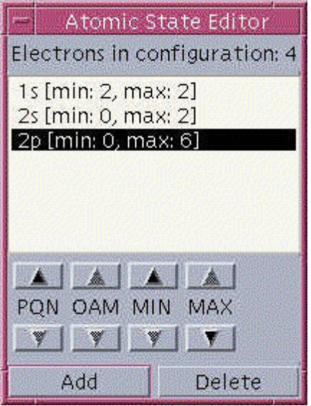
Figure 4. AtomicConfiguration Editor.
It was a design goal of Config that the user should not be able to use this editor to create an invalid AtomicConfiguration: one which violates the constraints given in the specification. This paper documents how this was achieved, and in a way which can be readily applied to any instance of highly structured data.

Supporting Design by Contract in C++
The most straightforward approach to supporting Design by Contract in C++ is to use Eiffel for those components for which monitoring constraints is most important. However, as was mentioned in the introduction, the expressivity of the Eiffel mechanism is not always sufficient.
There have been a number of different approaches to supporting Design by Contract in C++: use the existing language constructs to provide a support mechanism; use macros to support the inclusion and monitoring of constraints; effectively extend the syntax of the language by writing a pre-processor which converts non-C++ constraint expressions into C++ before compilation; and proposing language extensions [, ].
The Percolation pattern [] uses existing language constructs in a straightforward structure that yields the same checking as built-in assertion inheritance. It makes use of the GoF Template Method, which lets subclasses redefine certain steps of an algorithm without changing the algorithms structure. The Percolation pattern relies on the redefinitions observing a protocol in which they incorporate calls to base class functions and observe the Liskov Substitutability Principle [] in doing so (preconditions get weaker, invariants and postconditions are strengthened). The pattern requires discipline on the part of the programmer, which can have implications for maintenance.
A simulation of the Eiffel mechanism using macros has recently been put forward by Welch and Strong [Error: Reference source not found]. Macros are defined which serve the purpose of the corresponding Eiffel language constructs. The macros provided are REQUIRE, ENSURE, INVARIANT, LOOP_INVARIANT, CHECK.
App is an Annotation PreProcessor for C/C++ programs developed in UNIX environments. App recognises assertions that appear as annotations of the source text, written using extended comment indicators (/*@...@*/). It is designed on the premise that errors most often occur at function interfaces, and is intended primarily to monitor constraints at such points: it recognises three assertion constructs in this respect: assume (preconditions), promise (postconditions), return (specifies a constraint on the return value of a function), plus a fourth construct, assert, which specifies a constraint on a intermediate state of a function body. It also provides three constructs additional to C/C++ syntax to enhance the expressivity of constraints: all, some and in provide universal quantification, existential quantification and reference to the value of a variable prior to routine execution respectively.
Gnu’s Nana is a library that provides support for assertion checking and logging in a space and time efficient manner. The aim is to put common good practice into a library that can be reused. It was inspired by App. Assertion checking and logging code can be implemented using a debugger rather than as inline code with a large saving in code space. There is STL support, in that there a special version of the macros involved which use the iteration protocol to process containers.
None of the approaches outlined (except using Eiffel) save the user from having to explicitly deal with handling the consequences of inheritance on assertions.

A First Approach: Constraint Monitoring
Consider a simple example, in which the results of a player’s matches in a tennis tournament are being entered into an appropriate data structure. In this example the results may be input from a keyboard or a data file; more often in a non-trivial situation, the data to be monitored will be the result of an operation. A player’s results will be a series of Matches, each Match consisting of a series of Sets, and each Set consisting of two scores, the number of games won by each player in the Set. Clearly, there are potentially many instances of the class Results which would not in fact be a valid series of tennis scores. Using a formal specification language, the valid instances can be stated explicitly.
For example, this could be formalised in VDM-SL as follows. (VDM-SL is used since it was used to write the original specification of the Config system). An equivalent Eiffel-like version is given in Appendix I.

A Set is a pair of scores, e.g. a Set with one service break is represented by (6-4),
1.0 Set :: score1 :
score2 :

A Set is valid if one player won at least six games, and at least two more than her opponent (tie-breaks are discounted for simplicity)
1.1 inv (mk_Set(score1, score2 )) Δ |score1 - score2|>1 ∧ (score1>5 ∨ score2>5)

A Match is a sequence of Sets e.g. [(6-4), (4-6), (7-5), (6-1)]
1.2 Match = Set*

A Match is valid if one player won three games and the other player won 0, 1 or 2
1.3 inv L Δ (wins1(L)=3 ∨ wins1(L)= len L - 3) ∧ len L ≤ 5;

where the function wins1(Match) is defined by:
1.4 wins1 : Match →
wins1(M) Δ if len M = 0 then 0 else
if score1(hd M) > score2(hd M)
then 1 + wins1(tl M)
else 0 + wins1(tl M)

A Result is a sequence of Matches e.g. {[(6-4), (4-6), (7-5), (6-1)], [(6-4), (6-2), (6-1)], [(0-6), (0-6), (1-6)]}
1.5 Result = Match*

A Result is valid if it is not longer than the length of the tournament
1.6 inv L Δ len L ≤ TOURNAMENT_LENGTH;

The necessary structure could be modelled by the STL-based types Set, Match and Results:
typedef pair<int, int> Set;

class Match : public vector<Set>
{
public:
unsigned int wins1();
};

unsigned int Match::wins1()
{
unsigned int wins=0;
for (iterator p=begin(); p<end(); p++)
wins += p->first>p->second;
return wins;
}

typedef vector<Match> Result;

For an instance of the class Results to be valid, all the constraints of each of its components at all levels must be valid. For the Results instance given, there are fourteen constraints (Figure 5).

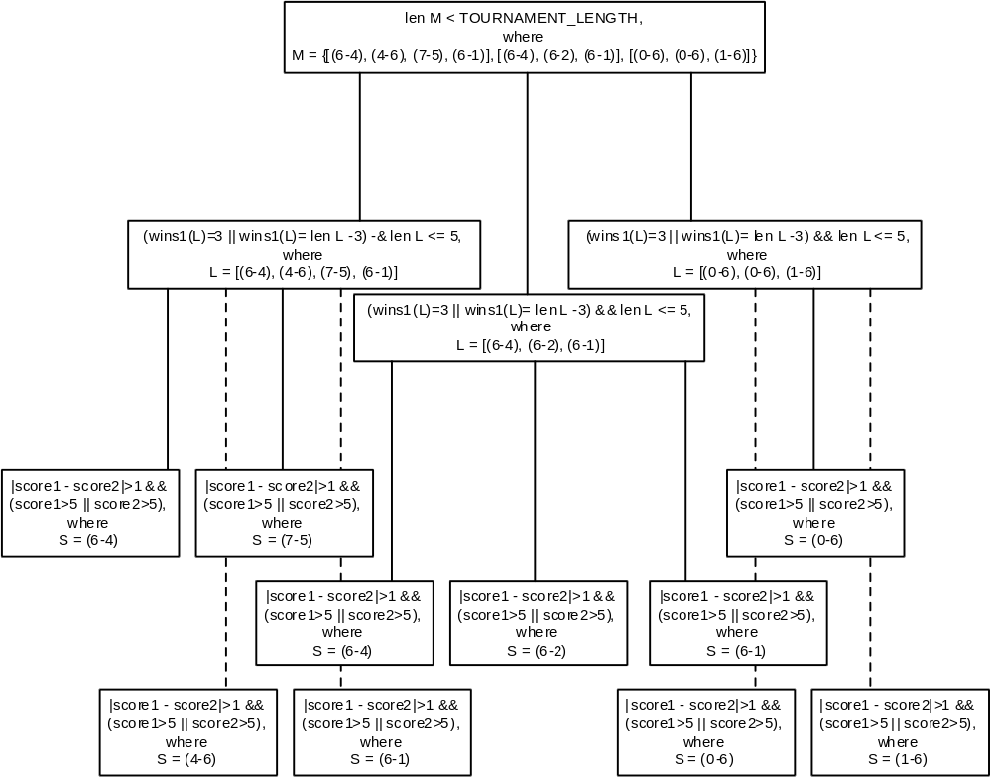
Figure 5. Constraints on a Tennis Result.

Current Options for Monitoring Assertions in C++

Enhancing STL Containers
In order to incorporate monitoring of these invariants into the Results objects themselves – without altering either the code of the STL, or the code shown above – the containers from which the Results class is built must inherit new behaviour, but without changing their names, and without altering their existing behaviour in any way. This can be done by using inheritance and namespaces. So, for example, given the namespace ‘stdpp’, in which the class stdpp::vector<T, Alloc> inherits from the class std::vector<T, Alloc> as follows
namespace stdpp {
//
template <class T, class Alloc = alloc>
class vector : public std::vector<T, Alloc>, public CoManager {
public:
virtual bool inv() { return true; }
bool determineInv();
//
};
//
} // end namespace stdpp

then within a second namespace which uses the definition of vector<T> from the namespace ‘stdpp’, (or simply within an extension of namespace stdpp)
namespace myNameSpace {
using stdpp::vector;
//
} // end namespace myNameSpace

any use of vector<T, Alloc> refers to stdpp::vector<T, Alloc>, which behaves exactly as the class std::vector<T, Alloc>, but also has additional behaviour. If monitoring for testing purposes is all that is required, a component can be developed within a namespace which uses the validated versions of the containers, in which it can be thoroughly tested, and released in a form which, removed from the scope of the development namespace, reverts to using the standard STL containers only.
The additional behaviour comes from inheriting the class CoManager. In this simple case, the CoManager class is defined as follows:
class CoManager {
public:
virtual bool inv()=0;
virtual bool determineInv()=0;
};

There are two members. The member function ‘bool inv()’ is for the client of the validated class to define what constitutes a valid instance of the class. So, in the tennis example, in order to provide validation, the client must supply definitions such as:
template <> bool Set::inv()
{
return abs(first-second)>1 && (first>5 || second>5);
}

Therefore this member must be declared virtual in each of the container classes within the validated namespace that inherits the CoManager class, in order that classes that derive from them can redefine it. The containers give a default definition which returns true, so it is therefore necessary that the compiler can handle explicit specialisation [] so that the specific definitions are used wherever they are given.
Note that the use of typedef in defining Set and Results is therefore not realistic for a non-trivial system, since the above definition of Set::inv() would apply to all pairs of ints: derivation must be used.
The second member function is defined for each validated container: it is not defined by the container client. The purpose of the function is to determine the validity of the object stored in that container, based on:
- the definition of inv() provided by the client for that container itself;
- knowledge of the elements of the container.
The two definitions of this function used in the current example are:
template <class S, class T>
bool pair<S, T>::determineInv()
{
_valid = true;
if (!(_valid = first->determineInv() && second->determineInv() && inv()))
throw pair<S, T>(*this);
return _valid;
}
template <class T, class Alloc>
bool vector<T, Alloc>::determineInv()
{
bool accum = accumulate(begin(), end(), true, detInvAcc<T>());
if (!(_valid = accum && inv()))
throw vector<T>(*this);
return _valid;
}

The routines simply make a recursive descent check of validity, and throw an exception when an invalid instance of a subtype is encountered. The implementation shown relies on the definition of a detInvAcc function object, shown below.
template <class T>
struct detInvAcc : public binary_function<bool, T, bool> {
bool operator()(bool valid, const T& t) const { if (!valid) return false; return t.determineInv(); }
};

The same effect can be achieved without the need for a function object or the use of the accumulate() algorithm.
template <class T, class Alloc>
bool vector<T, Alloc>::determineInv()
{
_valid = true;
for (iterator p=begin(); p<end(); ++p)
if (!(_valid = p->determineInv()))
break;
if (!(_valid = _valid && inv()))
throw vector<T>(*this);
return _valid;
}

However, this would not be in keeping with the philosophy behind the STL, one tenet of which is that explicit loops are potentially tedious and error prone.
There are four points to mention. Firstly, a trade off is necessary between requiring explicit specialisations of these functions, and requiring the encapsulation of built-in types. Unless all the built-in types are encapsulated before use, eventually the types instantiating one or more containers will be built-in types, not classes. Therefore they cannot be sent determineInv() messages, which are sent recursively to the elements of each container. Consequently explicit specialisations must be provided for these cases.
Secondly, note that the definition of stdpp::vector<T, Alloc>::determineInv() is written in terms of iterators, and uses no operation specific to vectors. It will be shown later, when CoManager becomes a generic class, how this definition could be placed at a more abstract level and be inherited by a number of containers, with explicit specialisations only being required for cases like pair<S, T> which do not have iterators.
Thirdly, determining the validity of the state of an object by recursive descent may not be desirable for a highly complex object structure about which certain information is already known: for example, that the object was valid before a particular component update. In such cases, for example if the invariant on a vector expresses an ordering, more efficient mechanisms can be employed which do not re-check what is already known.
Finally, throwing an exception may not be the choice of action in certain circumstances. Again, when the CoManager class later becomes a generic class, the action taken is made a member function of that class. There are various options for what action to take upon detecting a constraint violation. These are not the concern of this paper. The concern is automating non-intrusive detection to the greatest extent possible. The action taken is dependent on the circumstance; for example, it may be that the system creates invalid data in the course of adopting a ‘try-it-and-see’ approach to determining operation validity. Throwing an exception would not be appropriate in this situation.
With these definitions in place, if an object of class Results is constructed within a try block, the subsequent catch blocks can field the exception if one is thrown by determineInv().
However, in the example given, the Results object is likely to be declared empty and built incrementally. In this case there are two choices about monitoring validity. Firstly, a determineInv() message can be sent to the object once it is complete (i.e. all incremental steps have been undertaken). Secondly, the operations in validated container classes that modify the container can be adapted to check validity after they have made the modification so that an error, if one occurs, can be detected immediately. For example,
template <class Key, class Compare, class Alloc>
set<Key, Compare, Alloc>::iterator set<Key, Compare, Alloc>::insert(iterator pos, const value_type& value)
{
iterator newPos = std::set<Key, Compare, Alloc>::insert(pos, value);
determineInv();
return newPos;
}

The second approach is probably to be preferred, since the detection of the error immediately follows the operation that caused it, and does not require an enquiry for detection to take place. Indeed, with this approach the object may be considered to be self-monitoring.
The additional client code required to implement the constraint monitoring for the tennis example then amounts to:
bool Set::inv()
{
return abs(first-second)>1 && (first>5 || second>5);
}

bool Match::inv()
{
return wins1()==3 || wins1()==size()-3 && size()<=5;
}

bool Result::inv()
{
return size()<=TOURNAMENT_LENGTH;
}

Pre and Post Conditions
In addition to invariants on the values of a data type, specifications in languages such as VDM-SL state pre- and post-conditions on the operation of routines. If the pre-condition of a routine is not met, the result of the routine is not guaranteed to be valid. If the pre-condition is met, or if there is none, the routine guarantees that when execution is complete, the post-condition will be true. It is also implicit that the class invariant should hold after the operation.
The mechanism described thus far can be extended to handle operation pre and post conditions. For containers based on the STL, the necessary extension can be provided in library form. Containers not based on the STL require additional effort.
There are really two separate cases to consider. Firstly, there is the case of pre- and post-conditions which are inherent to a container operation because of the properties of the container. For example, it is an error to try to erase an element from an empty vector, so there should be a pre-condition on erasing from a vector stating that the vector is not empty. Secondly, there are the pre- and post-conditions which are specific to the instantiation of an operation for a particular type. Both can be accommodated.
The example redefinition of stdpp::set<T>::insert(..) in the previous section points the way. Each container operation for which a client may wish to define a pre- or post-condition (i.e. those that modify the container: no client is likely to want to stipulate a specific pre-condition for an operation such as size()) is redefined within the namespace ‘stdpp’ to check conditions which can be defined for specific instantiations by the client.
namespace stdpp {
//
template <class T, class Alloc = alloc>
class vector : public std::vector<T, Alloc>, public CoManager {
public:
virtual bool pre_erase(iterator) { return true; }
virtual bool post_erase(const vector<T>&, iterator){ return true; }
iterator erase(iterator);
//
};
//
} // end namespace stdpp

Thus, the definition of stdpp::vector<T>::erase(iterator) becomes
iterator stdpp::vector<T>::erase(iterator pos)
{
if (!size() || !pre_erase(pos))
throw vector<T>();
vector<T> old(*this);
iterator newPos = std::vector<T>::erase(pos);
if (!post_erase(old, newPos) || !inv())
throw vector<T>();
return newPos;
}

The client then has the option of supplying specific definitions of pre_erase() or post_erase() as necessary. Clearly granularity of control over which checks are employed can be introduced.
This section showed how a straightforward object management task - constraint monitoring - can be performed non-intrusively by taking advantage of object-oriented language features. More sophisticated developments are now considered.

Extending Management
In the previous section, it was demonstrated how a function to determine an object’s validity could be evaluated recursively over the internal structure of an object by defining two functions: one which dealt with the structure, and one which dealt with the evaluation. The first had to be defined for each type of container used (by the container-adaptation supplier), the second had to be defined for each class (by the container client).
In the development of Config, there were a number of other services required which were concerned with ensuring the integrity of the data. These required a more sophisticated mechanism than that required for constraint checking alone. This new mechanism provides an alternative mechanism for constraint checking to the one above. If constraint checking alone is all that is required, this new mechanism involves a lot more effort than the previous one. If that work is already done to provide other services, less effort is required to implement constraint checking.
A more comprehensive scheme for managing objects will therefore now be described. In this scheme, each object may be considered to be potentially self-managing, which it does by maintaining a pointer to a manager object. The make up of these managers is detailed below, and the uses to which they were put in the Config system are documented. One clear advantage of creating separate manager classes in this way is that the managers can be given a uniform structure. This eliminates the need to specialise constraint checking functions such as determineInv() for each type of container, reducing the work for the container-adaptation supplier. The existence of a separate Manager object is also vital in the broader picture because the Manager is required on occasion to be able to store a value of the type it is managing, other than the value it is managing (which it needn’t necessarily store since it is derivable).
Consider the type AtomicConfiguration. This is the type entered by the user from which a ConfigurationTreeList is constructed. In order to monitor the validity of this data structure, it is shadowed by a structure of managers (shown black in Figure 6).
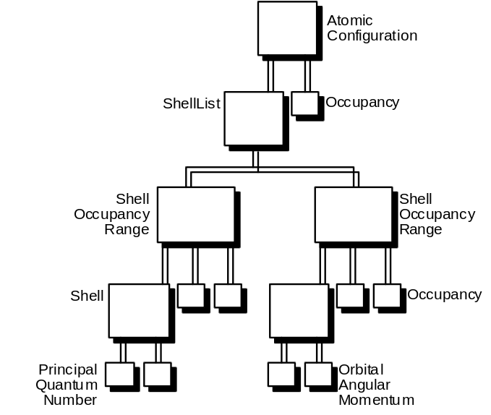
Figure 6. Atomic Configuration shadowed by Managers.
The Managers are all instantiations of the same generic class, Manager<T>. Use of partial specialisation means that it is possible to write generic managers for handling each container type. Thus, the Manager for an AtomicConfiguration is in fact the instantiation Manager<pair<ShellList, Occupancy>>; and the Managers for an AtomicConfiguration and a Shell are both instantitations of the same partial specialisation Manager<pair<T1, T2>>. The Manager structure for the above example is shown in Figure 7.

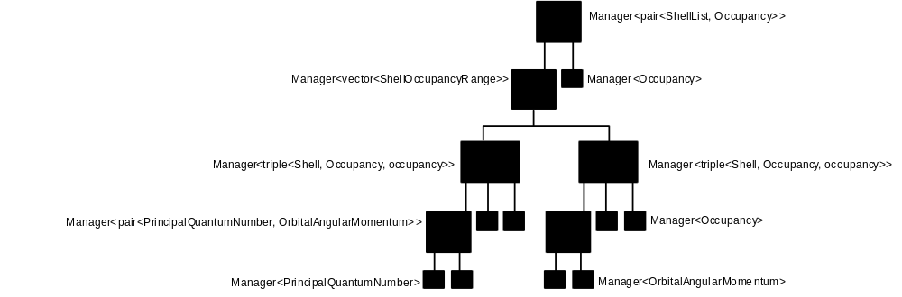
Figure 7. Managers for an AtomicConfiguration.

The Classes involved
The scheme is based on a small class hierarchy used to define the generic Manager class, and a class with which instantiations of Manager interact, CoManager. Although there are different Manager classes – one for each intrinsic type and one for each container class – each Manager object has a common ancestry. Most of the functionality of these Managers will be shown to be independent of the type that instantiates them, or automatically derivable from it. Consequently, there is little effort involved in writing Managers for non-STL classes.
At run-time, the Manager objects form a hierarchy which parallels the internal data structure of a managed object. This may appear to contravene Meyer’s principle of Knowledge Distribution. However, a method is demonstrated whereby the Manager hierarchy is generated automatically from the data structure.
Each Manager performs tasks appropriate to its position in the hierarchy, concerning itself only with the type that instantiated it, not with its components or with its parent. There are three layers of classes, which progressively diversify (Figure 8). The first layer, a single, non-generic class, is shared (inherited) by all Managers. The second layer is parameterised by the type it is validating, but the code is shared. The final layer is again essentially parameterised by the type it is validating, and is specialised for each basic type and container type.
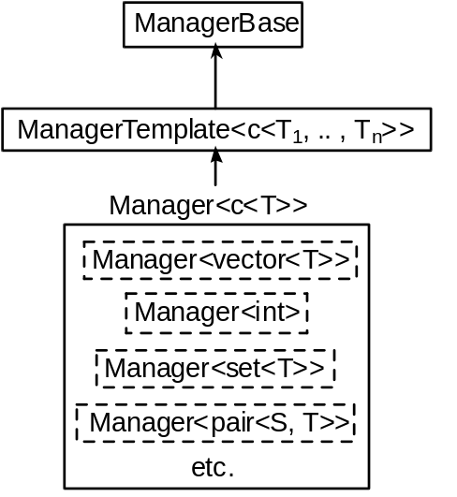
Figure 8. Manager Class Hierarchy.

CoManager
The key to automating the creation of the Manager object hierarchy paralleling the data structure of a given object is the CoManager class. This class must be inherited by all classes which it is desired to manage, and classes they are derived from or contain. The first important feature of this class is the function
template <class T> class CoManager {
//
virtual ManagerBase *newManager(ManagerBase *);
};

This function is the key to recursively decomposing a type into its Manager structure. An entire hierarchy of Managers can be created simply by declaring a single Manager. The definition of this function is:
template <class T>
ManagerBase *CoManager<T>::newManager(ManagerBase *parent)
{
return new Manager<T>(static_cast<T *>(this), parent);
}

Implementing this function within the CoManager<T> class is only possible if the different versions of the Manager class required for each type of container (described below) can be implemented by specialisation of a single class – the class returned by the call of new. In calling new Manager<T>(..), the CoManager<T>::newManager(..) function provides the link between the type and its Manager. Since the type being managed is the type parameter of the class CoManager<T>, new Manager<T>(..) creates a Manager specialised for type T.
The CoManager class can then be inherited by STL container classes as follows:
template <class T, class Alloc = alloc>
public:
class vector : public CoManager<vector<T, Alloc>>, public std::vector<T, Alloc> {
//
};

Referring back to the definition of CoManager<c<T>>::newManager(ManagerBase*), notice also the use of static cast of the object pointer ‘this’ in the call of the constructor for Manager<T>. The CoManager<..> class is intended to be inherited by container classes, and the current object pointed to by ‘this’ will therefore be a container, which has inherited from CoManager<..>, and therefore has CoManager<c<T>>::newManager(ManagerBase*) on its inheritance chain. CoManager<..> is an abstract class because of the inclusion of the pure virtual function inv(), and therefore there will never be an object of type CoManager<..> created, only objects derived from this class which provide definitions for this member. The object to which a CoManager<c<T>>::newManager(..) message is sent should in fact therefore be of type c<T>. The compiler needs to be informed of this via the static_cast. in order to reconcile the parameter type with that declared for the Manager constructor.
If it not possible to implement the different versions of the Manager class required for each type of container by specialisation of a single class, the function must be made a pure virtual function in CoManager (which then does not need to be a template class) and each container c<T1,..., Tn> must provide a definition of the form:
template <class T₁,..., class T_{n}>
Manager *c<T>::newManager(Manager *parent)
{
return new cManager<c<T>>(*this, parent);
}

where cManager<c<T>> is the version of Manager for the container c<T>. Therefore there are separate Manager classes for each type of container, rather than specialisations of the same class.
The second important feature of this class is the inclusion of a pointer to a Manager for an object of the instantiating type:
template <class T> class CoManager {
//
protected:
Manager<T> *manager;
};

Since the CoManager<T> class is inherited by each container type, any object based on a container has the potential to be self-managing.
Thirdly, CoManager<T> provides a member handleViolation(), which is called when a violation is detected. This can be redefined for specific containers or for specific instantiations of containers.
template <class T> class CoManager {
//
public:
virtual void handleViolation() { throw T(); }
};

The Manager Classes

ManagerBase
The Manager hierarchy for a given object forms a heterogeneous tree. All Managers share a common ancestor, ManagerBase, and the tree is connected by pointers to ManagerBase objects. Each ManagerBase stores a pointer to its parent, and pointers to its children. The children are implemented as an array of ManagerBase pointers.
class ManagerBase {
//
ManagerBase *_parent;
vector<ManagerBase*> _children;
};

Each Manager can therefore access its children in the same manner, irrespective of the type that instantiates it, and operations can therefore be defined at an abstract level. For instance, the routine determineInv() can be declared in ManagerBase and defined just once, in ManagerTemplate<T>.

ManagerTemplate<T>
ManagerTemplate<T> forms the second layer of the class hierarchy that makes up a manager object. It is templated because it maintains objects of the type it manages. It provides the following member access functions:
T& currentValue();
T& candidateValue();

These are used when the managers are adapted to deal with the question of determining which data editing operations on an object are currently legal and can be made available to the user, and are described later.
If determineInv() is defined in ManagerTemplate<T>, there is no need for separate definitions for pair<S, T>::determineInv() etc: all specialisations of Manager<T> inherit ManagerTemplate<T>, and therefore inherit determineInv(). Since all the Managers access their children in a uniform fashion, one definition works with all types of container manager specialisation.
template <class T>
bool ManagerTemplate<T>::determineInv()
{
_managerValid = true;
for (typename::vector<ManagerBase*>::iterator p=_children.begin(); p<_children.end(); ++p)
if (!(_managerValid = p->determineInv()))
break;
if (!(_managerValid = _managerValid && currentValue().validate()))
currentValue().handleViolation();
return _managerValid;
}

Inspection of this routine indicates that the generic class ManagerTemplate<T> displays constrained genericity; the type used to instantiate it must define the members
bool validate();
void handleViolation();

since these are called in the course of the routine. This is achieved by inheriting the class CoManager<c<T>>, which in addition to handleViolation() includes the members
bool _valid;
inline bool validate() { return _valid = inv(); }

It is useful for CoManager<c<T>> to maintain the value _valid: the example of container validity based on ordering of elements was mentioned earlier, and, for example, if an ordered container is known to be invalid (by checking _valid) prior to an insert(..) operation, there is no need to evaluate its validity afterwards: it will still be invalid.

Manager<c<T>>
When the monitoring of object validity is all that is required, writing a container manager simply involves writing the constructor. The purpose of the constructor is to create the children of the manager. This is where the knowledge of the class’s structure is made use of. If each container-specific version of the manager class is capable of constructing its children, the entire hierarchy required for an object with an arbitrarily complex type structure can be created automatically. Managers for built-in types have empty constructors, which are nonetheless important, since they include the call to the superclass of Manager<built-in>, ManagerTemplate<built-in>. The constructor for Manager<set<T>> is shown below.
template <class T>
Manager<set<T>>::Manager(set<T>* value, ManagerBase *parent)
: ManagerTemplate<set<T>>(*value, parent)
{
typename set<T>::iterator p=value.begin();
for (int i=0; i<value.size(); p++, i++)
_children.push_back(p->newManager(this));
}

Dereferencing the iterator yields an object of set member type, and sending a newManager(..) message will create a Manager for it based on that type, because the type parameter passed to CoManager<c<T>> determines which specialisation of the class Manager<T> is created. In this way, the constructor for a Manager<set<T>> creates a Manager<T> for every member of set<T>.

Self-Management
Depending on requirements, a client may or may not choose to make objects self-managing. Each object has the potential to maintain its own manager. Self-management can be instigated at object creation by supplying true as an additional parameter to the constructor (the default is false); it can instigated at a later point by sending the object a message. Alternatively, it may be preferred to declare a Manager for a particular object. It is conceivable but non-sensical to declare a Manager for a self-managing object.

Uses of Manager<c<T>>
Thus far a mechanism for automatically generating a manager structure that parallels the data structure of an object has been described, and mention has been made of how it can be used to monitor the validity of the state of, and operations on, an object. However, it was shown earlier that this can be achieved through a much simpler mechanism; and as well as its simplicity, the mechanism makes little demand on heap storage (indeed, its addition to a component merely expands the size of the virtual function dispatch table). Therefore there is a need to justify the additional complexity of the new mechanism.
In fact, the uses to which this new mechanism can be put are far from fully explored. It was stated earlier that a compiler that can deal with the range of language features employed has only recently become available. And of course, it is also an aim in designing reusable software that the uses to which a component can be put are not all envisaged by the designer. That said, this section shows some of the uses to which the mechanism has been put in the Config system.

Editing Structured Types
This section considers providing an editor for an AtomicConfiguration. Whether the user is permitted to enter values directly when editing a structured type, or whether the user must choose from a selection of pre-validated options, it is unlikely that an instance of the type in its entirety will be changed. It will be a component of the type that is under scrutiny. For instance, in order to change the AtomicConfiguration represented by
{1s[2, 2]2s[2, 2]2p[0, 6], n=4}

to
{1s[2, 2]2s[0, 2]2p[0, 6], n=4}

it is only necessary to alter the minimum Occupancy of the second ShellOccupancyRange in the ShellList. However, with the operations available for STL containers, this would require disassembly into subcomponents, incorporation of a new or changed subcomponent, and reassembly.
Providing a set of operations of this form is one of the purposes of the base adaptor component of the user interface. (A number of models have been proposed concerning the modularisation of the interface components in a software system. The model of Bass and Coutaz [] would be representative). Clearly, writing largely repetitive sets of routines akin to AtomicConfiguration:: replaceMin(..) is open to error and not readily amenable to change. What is required is an architecture which enables assembly and disassembly, alongside monitoring of constraints, to be implemented consistently, non-repetitively and at the appropriate level in the design.
It is therefore neither advisable nor necessary to provide base adaptor operations that are based explicitly on disassembly and reassembly. Instead, having created the Manager classes, the fact that they form a hierarchy that parallels the type structure of an object can be used to support the editing of the object. However, before this can be done, additional member functions must be added to the classes in the Manager cluster.
A new abstract member function constructValue(..) must be introduced to the ManagerBase class, along with some supporting functions.
public:
virtual bool constructValue(ManagerBase *)=0;
bool constructValues(ManagerBase *);
ManagerBase *descendant(int *, int);

The constructValue(..) abstract member function creates a new value for its data member _currentValue based a change to the value managed by one of its children. The parameter passed identifies which child – the message sender – has changed.
The scheme is that where appropriate Managers provide operations that change the value they manage. This change is propagated throughout the Manager hierarchy by a call to constructValues(). This calls constructValue() for the local value, and passes the call on to its parent. Disassembly and reassembly are modularised. The base adaptor writer does not have to consider how to provide an operation to update the PrincipalQuantumNumber of a given Shell of a given ShellOccupancyRange of a given ShellList of a given AtomicConfiguration (and then repeat the process for OrbitalAngularMomentum). The Manager writer encodes the assembly of an instance of the Managed type from the existing value and one amended component. This process of assembly propagates up the structure through the hierarchy of Managers.
In summary, the process of disassembly is undertaken by supplying the structure navigation information. The process of reassembly is undertaken by a single call to constructValues(..), which recurses up the Manager hierarchy.

Optimising Validation
In addition, validity is checked as the call progresses up the hierarchy. constructValues(..) returns the validity of the value it has constructed. This can be much more economical than a recursive descent check from the top. Only those parts of the hierarchy affected by the update need to have their validity re-evaluated.

Edit Operation Sensitivity
Considering again Figure 4, it is clear that some operations on the current AtomicConfiguration are sensitive - available to the user - and some are not. The button sensitivity reflects the constraints given in the specification: the user is not permitted to create an invalid instance of an AtomicConfiguration.
The sensitivity of a given button in the editor at a given time (i.e. in a given state) can be determined by fully stating the pre-condition of the operation. The pre-condition states for which values of the domain of the operation the post-condition is guaranteed – indeed, it is rare if ever that a meaningful pre-condition is not derivable from the post-condition (explicit or otherwise). An implicit part of any post-condition is that the class invariant holds after the operation. The complete class invariant of a container object is (recursively) made up of the conjunction of the invariants of its elements and the invariant specific to the container. Mathematically determining the pre-condition is a daunting task even in such a simple case.
A simpler approach is for the system to try the operation beforehand and see if an invalid object results. Of course, this is not an approach that can be adopted in all circumstances: ‘erase_hard_disc’, ‘fire_missiles’ are examples of operations where it would be undesirable to determine availability by this means. Clearly, it only works for readily-reversible operations, or when performed on a harmless copy of the object in question. This is possible in Config.

Display

Data Display with MOTIF
One of the aims of the GRACE project, which has been ongoing for a number of years, has been to provide a graphical user interface on UNIX workstations to computational physics software running on supercomputers. MOTIF [] was chosen from the outset for this purpose, and subsequently it has become necessary to develop ways to use it with C++. Encapsulation of graphics elements into reusable classes is dealt with by Young [] amongst others. The Manager and CoManager classes provide a platform for developing data display prototypes with interact well with MOTIF.
The MOTIF specifics needed to display each type of container class can be provided by classes such as VectorDisplay<T> and CompositeDisplay<T>. These classes can be used to display all types used within Config, although particular requirements at times require special adaptations to be written, such as that used to display large ConfigurationTrees.

Limitations

Applicability
The general question of monitoring constraints for C++ is unlikely to be made straightforward without language support. The Percolation pattern outlines the general approach, but there is a lot of work involved and plenty of scope for error. The mechanism outlined in this paper offers considerable benefits for monitoring highly structured data based on STL containers, but outside of this scope requires effort similar to that required for the Percolation pattern.

Encapsulating built-in Types
Function definitions are necessarily going to rely on recursive decompositions particular to each container. Messages are sent recursively to the elements of the container; however, the lowest-level containers will have elements of built-in type, to which messages cannot be sent. Consequently when container types which take built-in types as parameters are implicitly or explicitly instantiated or explicitly specialised, a compiler error will be generated. The two ways of avoiding this are to write explicit specialisations for each container that override the general definition for cases where a built-in type is a type parameter, or to require that all built-in types are encapsulated into a class before use. This inelegance is a consequence of the language, not of the method.
The more sophisticated the management mechanism becomes, the more work is involved in the specialisation approach.

Kick-starting Manager Generation
Most classes in the Config system are created by deriving from STL instantiations, in order to add functionality or to rename to better reflect the terminology of the problem domain (e.g. defining depth() as size() in the class ConfigurationTree).
In order for the mechanism to work when derivation is used it is necessary that the implementation language permits specific definitions of template functions. In this case, it is absolutely vital that the function
bool stdpp::pair<PrincipalQuantumNumber, OrbitalAngularMomentum>::inv();

(which is inherited from CoManager by stdpp::pair<PrincipalQuantumNumber, OrbitalAngularMomentum> when it is created as the Manager-savvy adaptation of std::pair<PrincipalQuantumNumber, OrbitalAngularMomentum>) is defined as a specific implementation of the pair<S, T> class and not in the derived class Shell. Thus
bool stdpp::pair<PrincipalQuantumNumber, OrbitalAngularMomentum>::inv()
{
return first()>second();
}

must be defined and not
bool Shell::inv()
{
return first()>second();
}

This is because the function Shell::inv() is never called. The Manager creation mechanism creates a Manager<pair<PrincipalQuantumNumber, OrbitalAngularMomentum>>: it does not create a specific ShellManager, since pair<PrincipalQuantumNumber, OrbitalAngularMomentum>::newManager(..) is the first definition of newManager(..) encountered on searching the inheritance chain of Shell.
This has a consequence if Managers of classes derived from containers are going to be declared.
If it is required that a client should be able to manage, for example, a Shell, without knowing its ancestry, it is necessary to provide a series of typedefs for the client of the class.
typedef Manager<pair<PrincipalQuantumNumber, OrbitalAngularMomentum>> ShellManager;

This is because the compiler does not perform type conversions on the type parameters of a specialisation (and so no definition of Manager<Shell> would be available to the compiler.

Implementing Implicit Specification
In a formal specification, list or set inclusion is often used, whereby a condition is given to identify list or set membership: the meaning of the statement is that all entities satisfying the condition are members of the list or set. For example, the generation of configuration trees from an atomic configuration is specified by list inclusion. The corresponding validity check can show that all trees generated are valid, but cannot show that all valid trees are generated. The monitoring as it stands will not detect this: if the algorithm produces a result which meets a stronger condition than the one given in the specification, the result will be passed as valid (which it is). The specification is complete, but it is difficult if not impossible to write a validity condition which accurately reflects the implicit condition given in the specification which uses list inclusion.

Creating a Manager Library
The manager templates suffer from the same difficulties that arise with ordinary template libraries, plus others besides. The main problem with template libraries is ensuring that the correct instantiations are made by the compiler. Various strategies are adopted by compiler writers to achieve this. Thus far, it has only been possible to compile Config using egcs1.1.1 by using the -alt-external-templates compiler option, which requires any template instantiations used to be explicitly declared in the translation unit where they are defined. In addition, a bug in the current release of egcs (fixed but not released at time of writing) means that compilation is only successful if the __STL_MEMBER_TEMPLATES flag is turned off in stl_config.h. This means, of course, that member function templates (which were utilised in a further development not documented here) cannot be used at the present time.

Conclusion
Implementers of software components who adopt an object-oriented architecture have to address a number of concerns with respect to the management of objects. In C++, object containers and algorithms that act on them are provided by the STL, but facilities to deal with other concerns are not: monitoring of class invariants and operation pre- and post-conditions must be added, as must textual and graphical renderings for the object data, mechanisms for object update, and indeed, mechanisms for determining the validity of update operations to prevent the user from creating invalid data.
It has been shown that all of these can be provided, in a non-intrusive fashion, for the containers of the STL. It is demonstrated how key features of the object-oriented paradigm such as inheritance and virtual functions, along with other language features such as generic programming and namespaces, make it possible to do this in such a way that practically all code is parameterised on the type of the object, code duplication is all but eliminated, and type-specific code is only written when absolutely necessary. The simplest implementation of constraint monitoring can be adopted for existing STL-based code simply by providing an encoding of the constraints to be monitored.

Appendix I. Specifying the tennis problem in Eiffel.

class Set creation
make
feature -- Initialisation
make(s1: INTEGER, s2: INTEGER) is
do
score1 := s1
score2 := s2
ensure
score1_set: score1 = s1
score1_set: score2 = s2
end
feature -- Access
score1 : INTEGER
score2 : INTEGER
invariant
at_least_six_to_win: score1>5 or score2>5
at_least_two_clear_games: score1-score2>1 or score2-score1>1
end -- class Set

class Match inherit
LIST[Set]
feature
wins1 : INTEGER is
-- number of Sets won by player one
do
local wins : INTEGER
from
start
until
after
loop
if item.score1>item.score2 then
wins := wins+1
end
forth
end
Result := wins
end
invariant
three_sets_to_win: (wins1=3 or wins1=count-3) and count<=5
end -- class Match

class Result inherit
LIST[Match]
feature
TOURNAMENT_LENGTH : INTEGER is 6
invariant
tournament_length: count<=TOURNAMENT_LENGTH
end -- class Result

Bibliography

The model of Bass and Coutaz partitions the interface into five modules: base functionality, base adaptor, dialogue controller, presentation component and interaction toolkit. This section is concerned with the Base Adaptor Component. The base adaptor takes the operations offered by the functional core and presents a subset - plus operations derived from them - to the dialogue controller. Thus although the base functionality only provides the mechanism to increment a 'free-standing' Occupancy, the user can issue a command to increment an Occupancy within a ShellOccupancyRange of an AtomicConfiguration without having to be concerned about the tasks of disassembly and reassembly because the base adaptor undertakes this task.
. V.M. Burke, P.G. Burke, N.S. Scott. Computer Physics Communications 69 (1992). Elsevier, North Holland.
David Maley, Ivor Spence. Config: A GRACE tool for generating configuration trees. Computer Physics Communications (1998). Elsevier, North Holland.
. Scott, Kilpatrick, Maley. The Formal Specification of Abstract Data Types and their Implementation in Fortran 90. Computer Physics Communications 84 (1994) 201-225. Elsevier, North Holland.
. Cliff Jones, Systematic Software Development using VDM. 2nd Edition. Prentice Hall. 1990.
. Carroll Morgan, Programming from Specifications. 2nd Edition. Prentice Hall. 1994.
. Christophe Meudec, Automatic Generation of Software Test Cases from Formal Specification. PhD thesis, Queen’s University of Belfast, 1998.
. Betrand Meyer. Object-Oriented Software Construction, 2nd Edition. Prentice Hall, 1997.
. Bertrand Meyer. Applying Design by Contract. Computer (IEEE) vol 25 no. 10 p40-51 October 1992.
. Alexaner Stepanov (Silicon Graphics Inc.) & Meng Lee (Hewlett Packard Laboratories). The Standard Template Library. 1995.
. David Welch & Scott Strong. An Exception-based Assertion Mechanism for C++. JOOP, July/August 1998.
. Erich Gamma, Richard Helm, Ralph Johnson, John Vlissides. Design Patterns for Object Oriented Software. Addison Wesley. 1994.
Sara Porat & Paul Fertig. Class Assertions in C++. JOOP, May 1995.
. Maurice Cline and Doug Lea. Using Annotated C++. Proceedings of C++ at Work. September 1990.
. Robert V. Binder. Testing Object-Oriented Systems: Models, Patterns and Tools. Addison Wesley, 1999.
. Barbara H. Liskov and Jeannette M. Wing. A behavioral notion of subtyping. ACM Transactions on Programming Languages and Systems, 16(6):1811-1841. November 1994.
. C++ Standard, Chapter 14. http://www.maths.warwick.ac.uk/cpp/pub
. Len Bass and Joelle Coutaz. Developing Software for the User Interface. Addison-Wesley. 1991.
. Marshall Brain. MOTIF - The Essentials and more. Digital Press. 1992.
. Douglas Young. Object-Oriented Programming with C++ and OSF/MOTIF. Prentice Hall, 1995.

