Agent Creation, Setup and Deployment

- Launch ‘Agent Creation’ screen, and Create a new agent from scratch.
  - Agent Name – “Procurement Bootcamp Lab” [You can use any name of your choice as well]
  - Agent Description - Get familiar with Agentic procurement flows [You can use any relevant description of your choice as well]
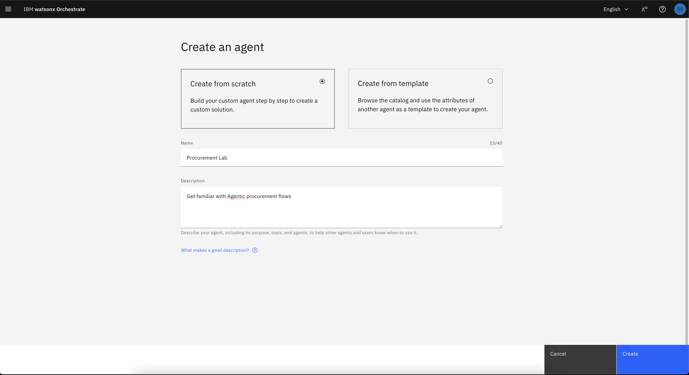
- Let’s add some knowledge to the agent. Using knowledge from direct files or external repository, one can enhance the Agent to respond to user utterance with organisation specific context like policies, and templates.
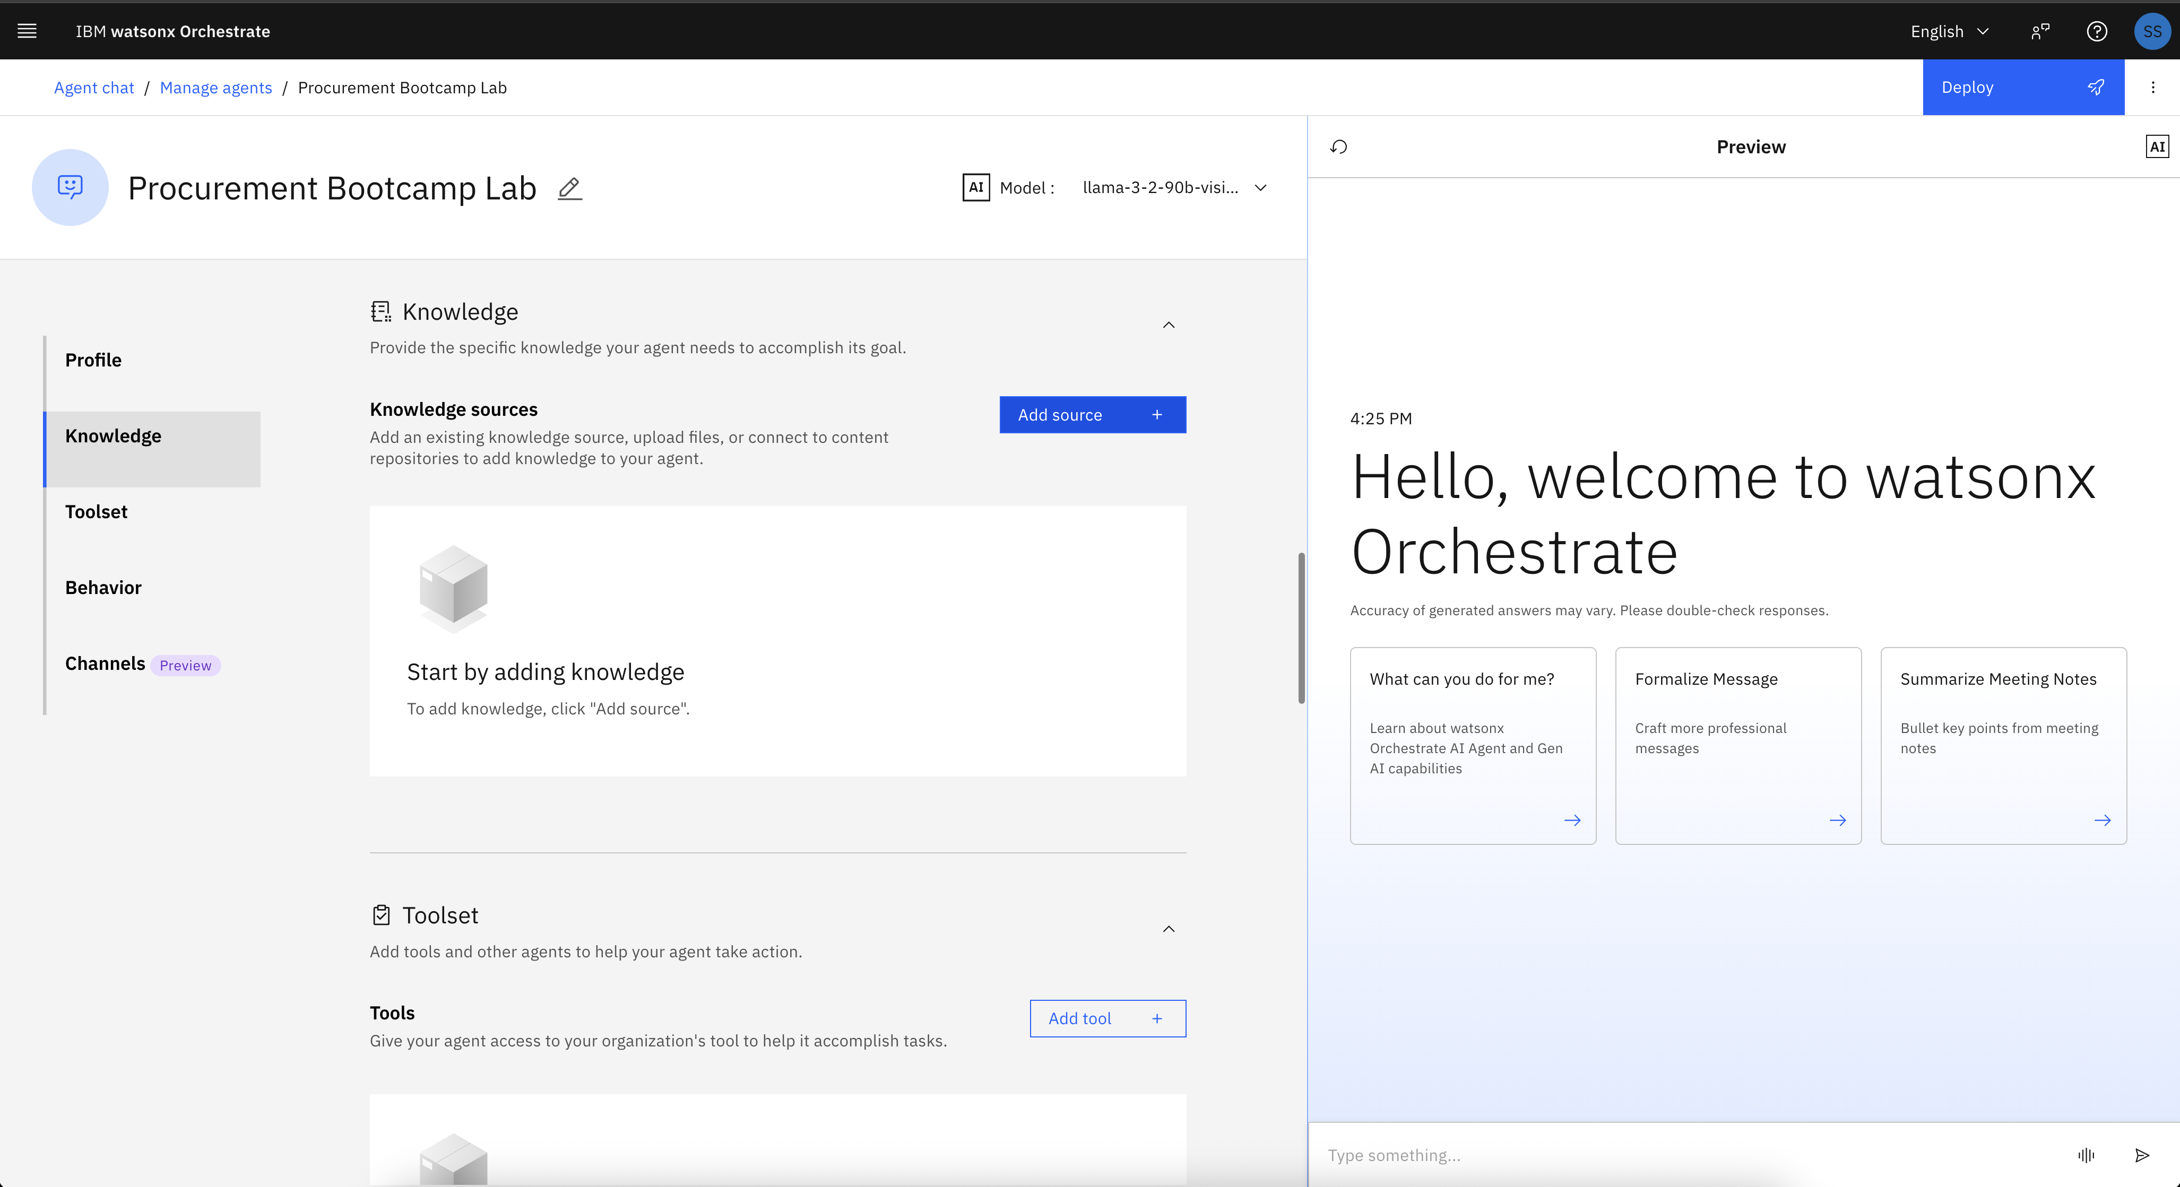

- Click Add Source -> New Knowledge -> Upload Files
  - Upload the file downloaded from repository: File Name - European Union Govt Procurement Guide
  - Description - European Union (EU) Government Procurement Guide (GPG) for Canadian Businesses. It contain overview of EU process, CETA government procurement commitment, challenges and expectations for bidders, guide to using TED, completing a BID, selection and award criteria, procurement procedures, thresholds, remedies, and background information about EU and EU legislation on procurement.
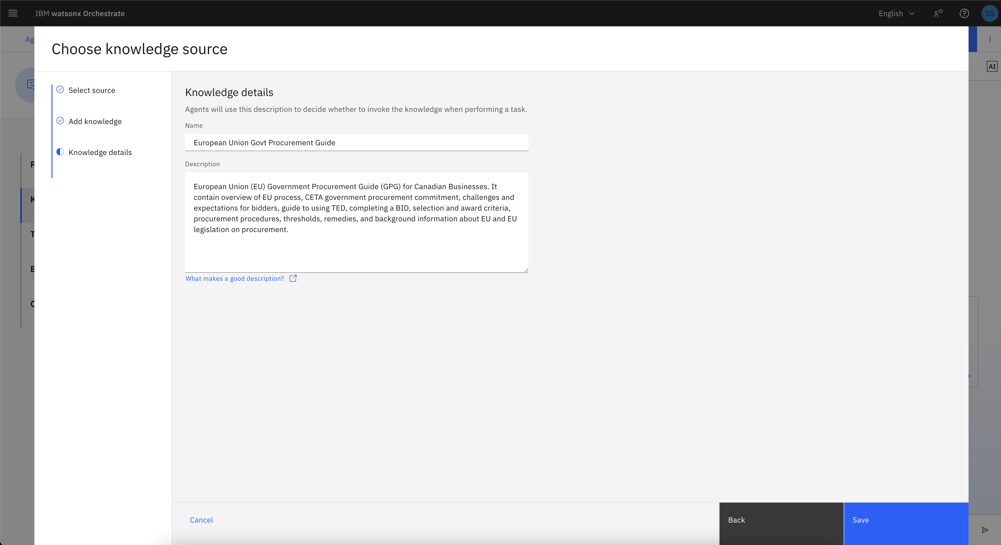

- Now time to add tools to the agent using which user will access/processes backend procurement platform data.
  - Under Toolset section, click Add tool -> OpenAPI
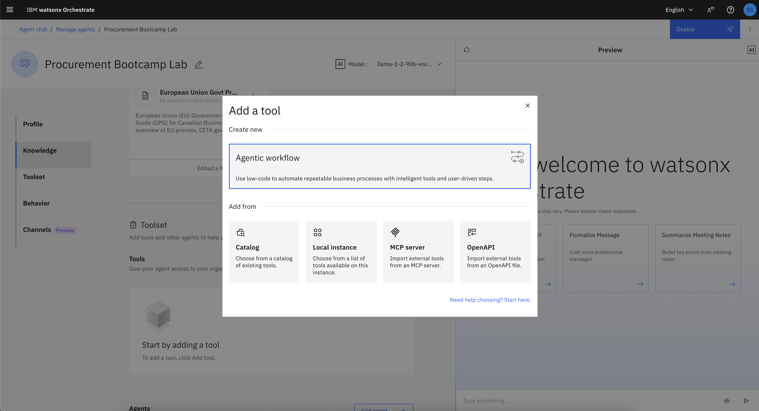

  - Locate the downloaded file (Procurement_App.yaml) from repository on your local PC, and upload it (ensure validation tick turns green as it checks file for any errors), and click next
  - Select all operations (these will be different tools) and click Done.
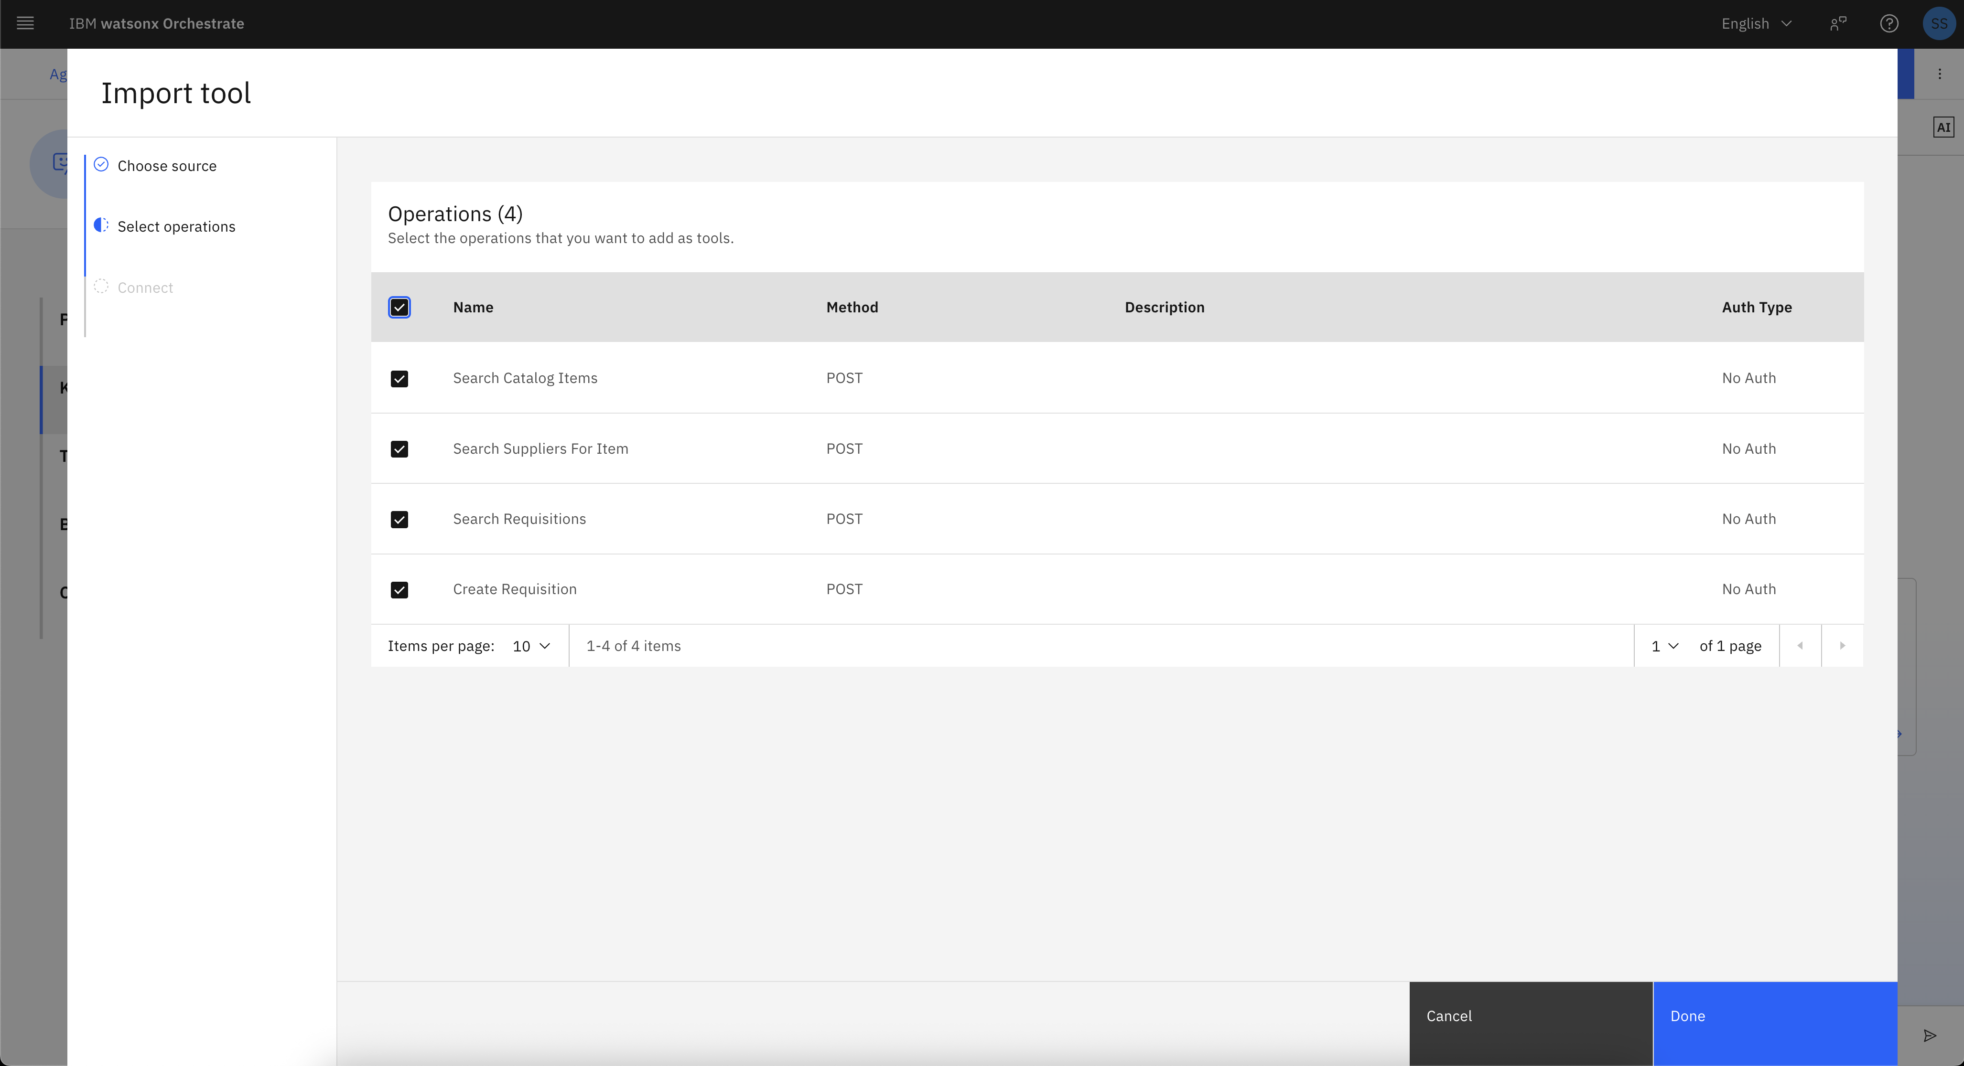

  - Now your agent should look like this with knowledge and tools added. Let’s try the agent in preview chat, before you deploy it and try via live chat. The goal of preview chat is for agent builders to try the agent functionality before deploying it for end users or business users.
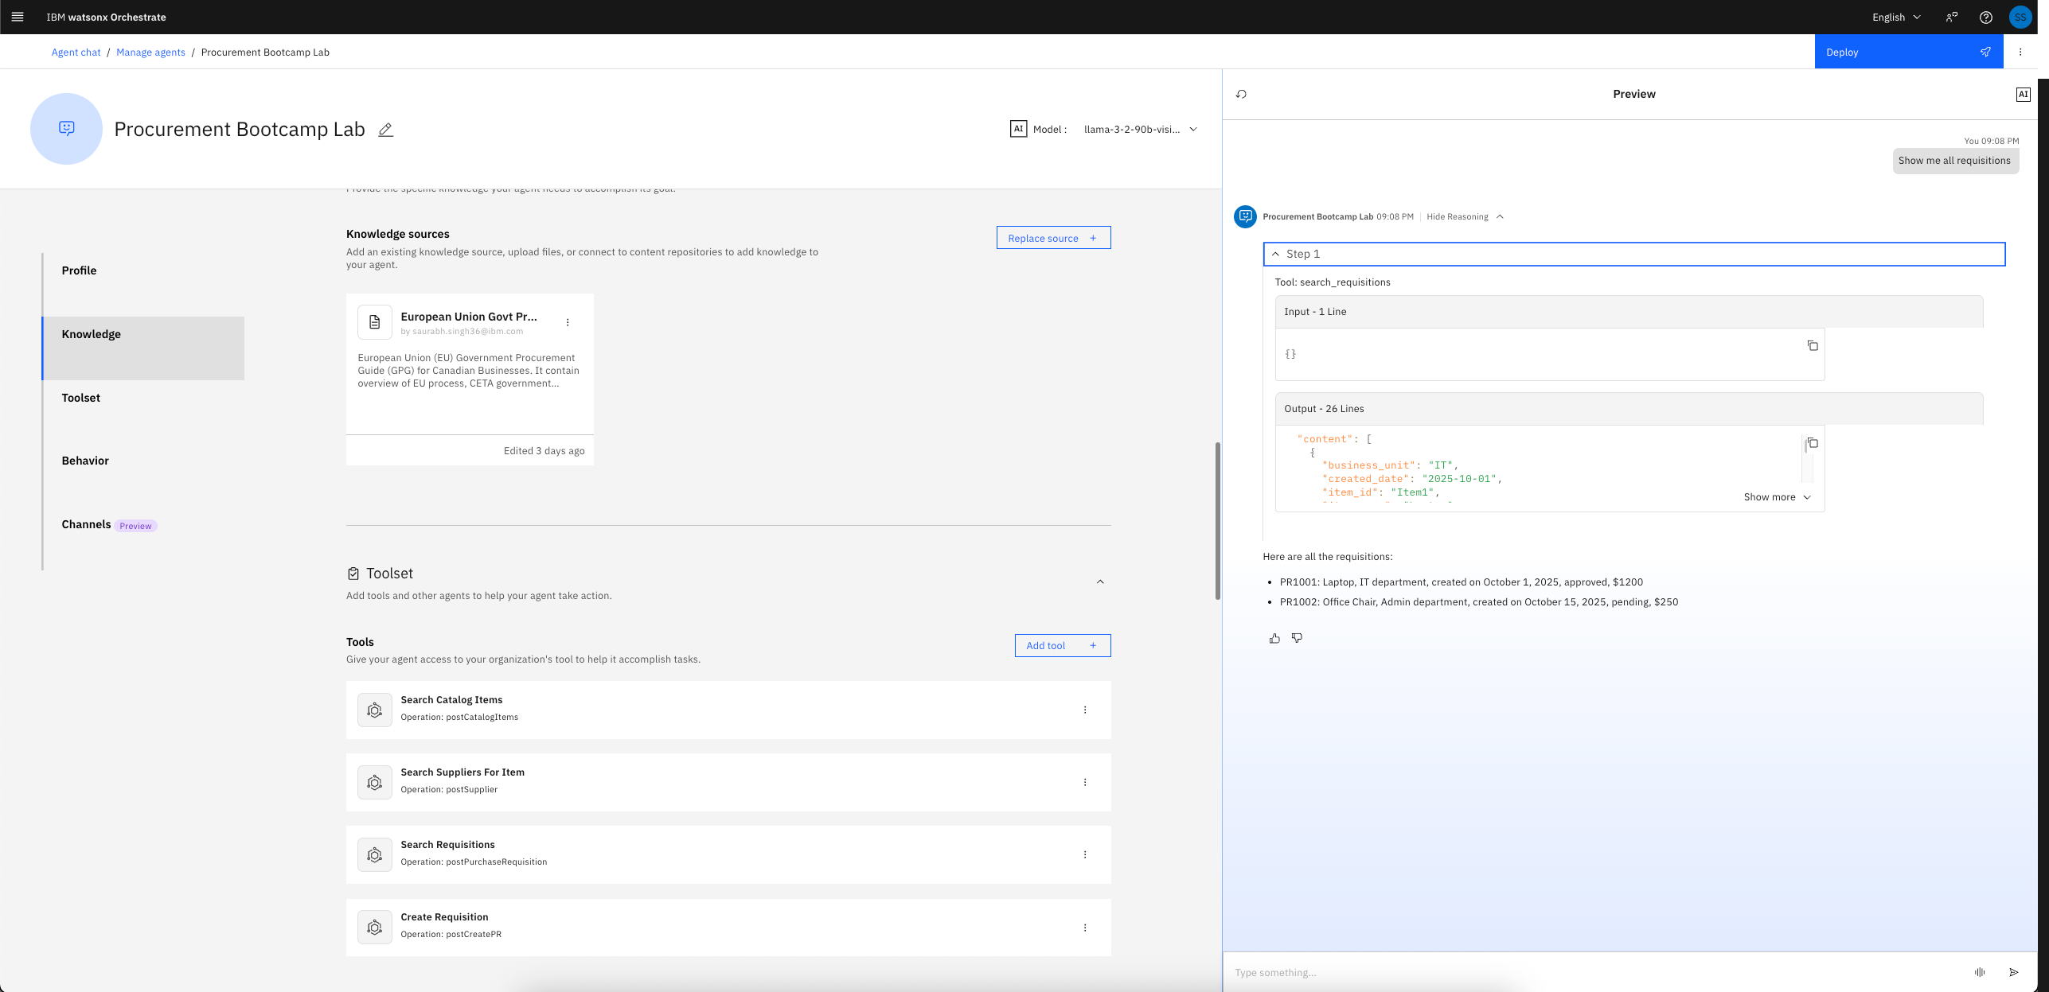
  - You can as well add some quick starter prompt based upon the agents/tools/knowledge added to the agent
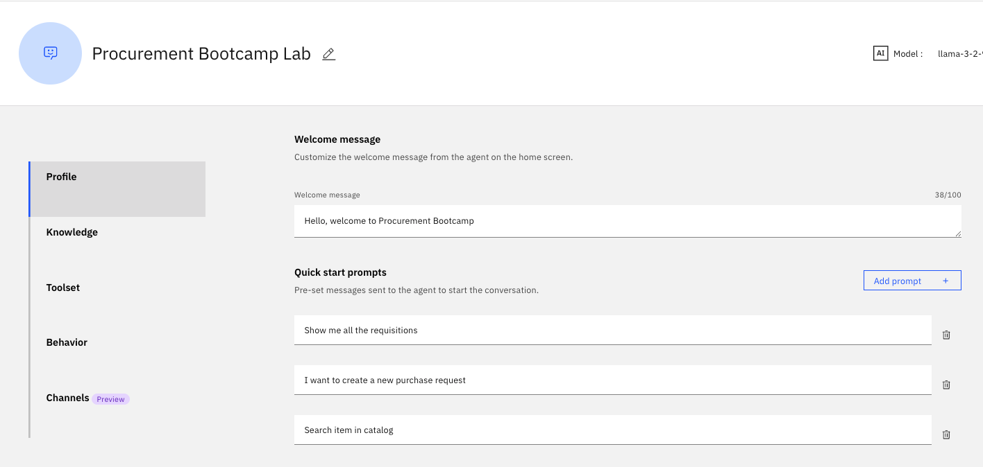

- Agent behaviour is the section which controls how the agent should behave. You can add some business logic here in simple natural language, like for a particular scenario how the tools be triggered, or in some complex implementations (say multiple agents added as collaborator to this agent) which agent can help what types of activities, and how to pass the context among them.
Let’s keep it simple for now, and ensure agent always respond with tabular format.
  - Just add to the instructions – “Always respond with markdown tables”, and try the same utterance again in preview chat.
  - 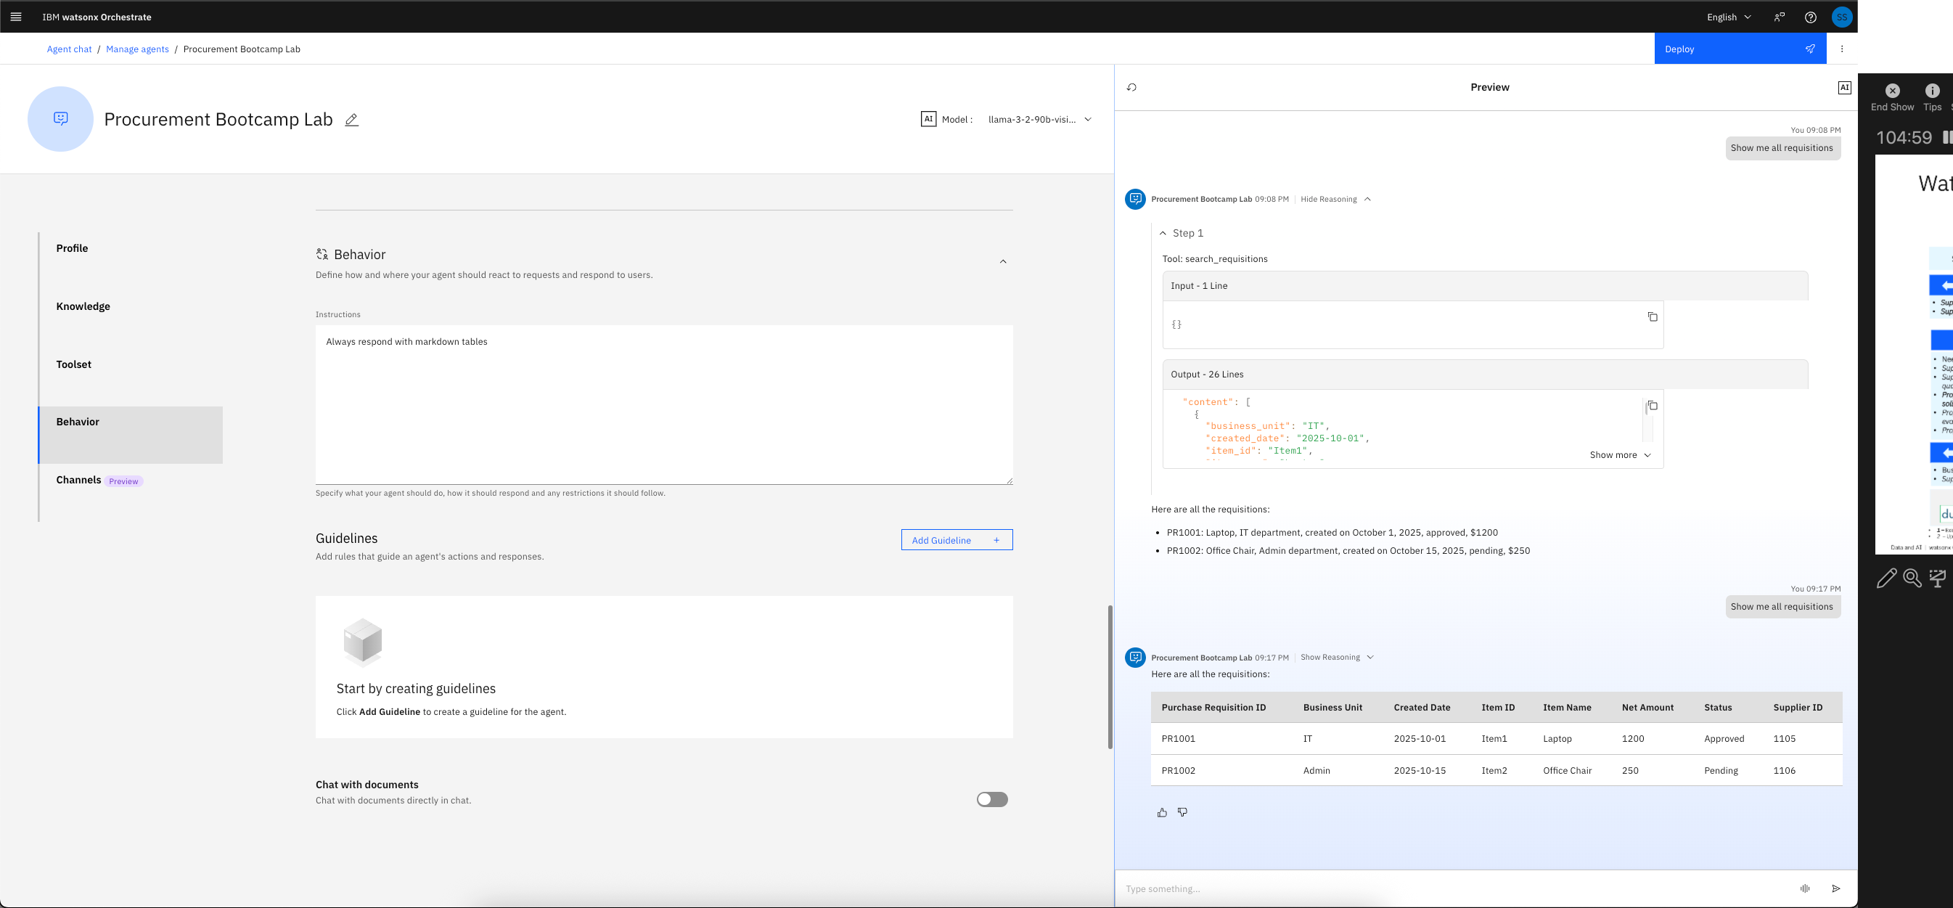
- You can see now the response is shown as a markdown table. Now you are good to deploy this agent.

Run the agent
- Select the deployed agent from Agents dropdown. In this case “Procurement Bootcamp Lab”
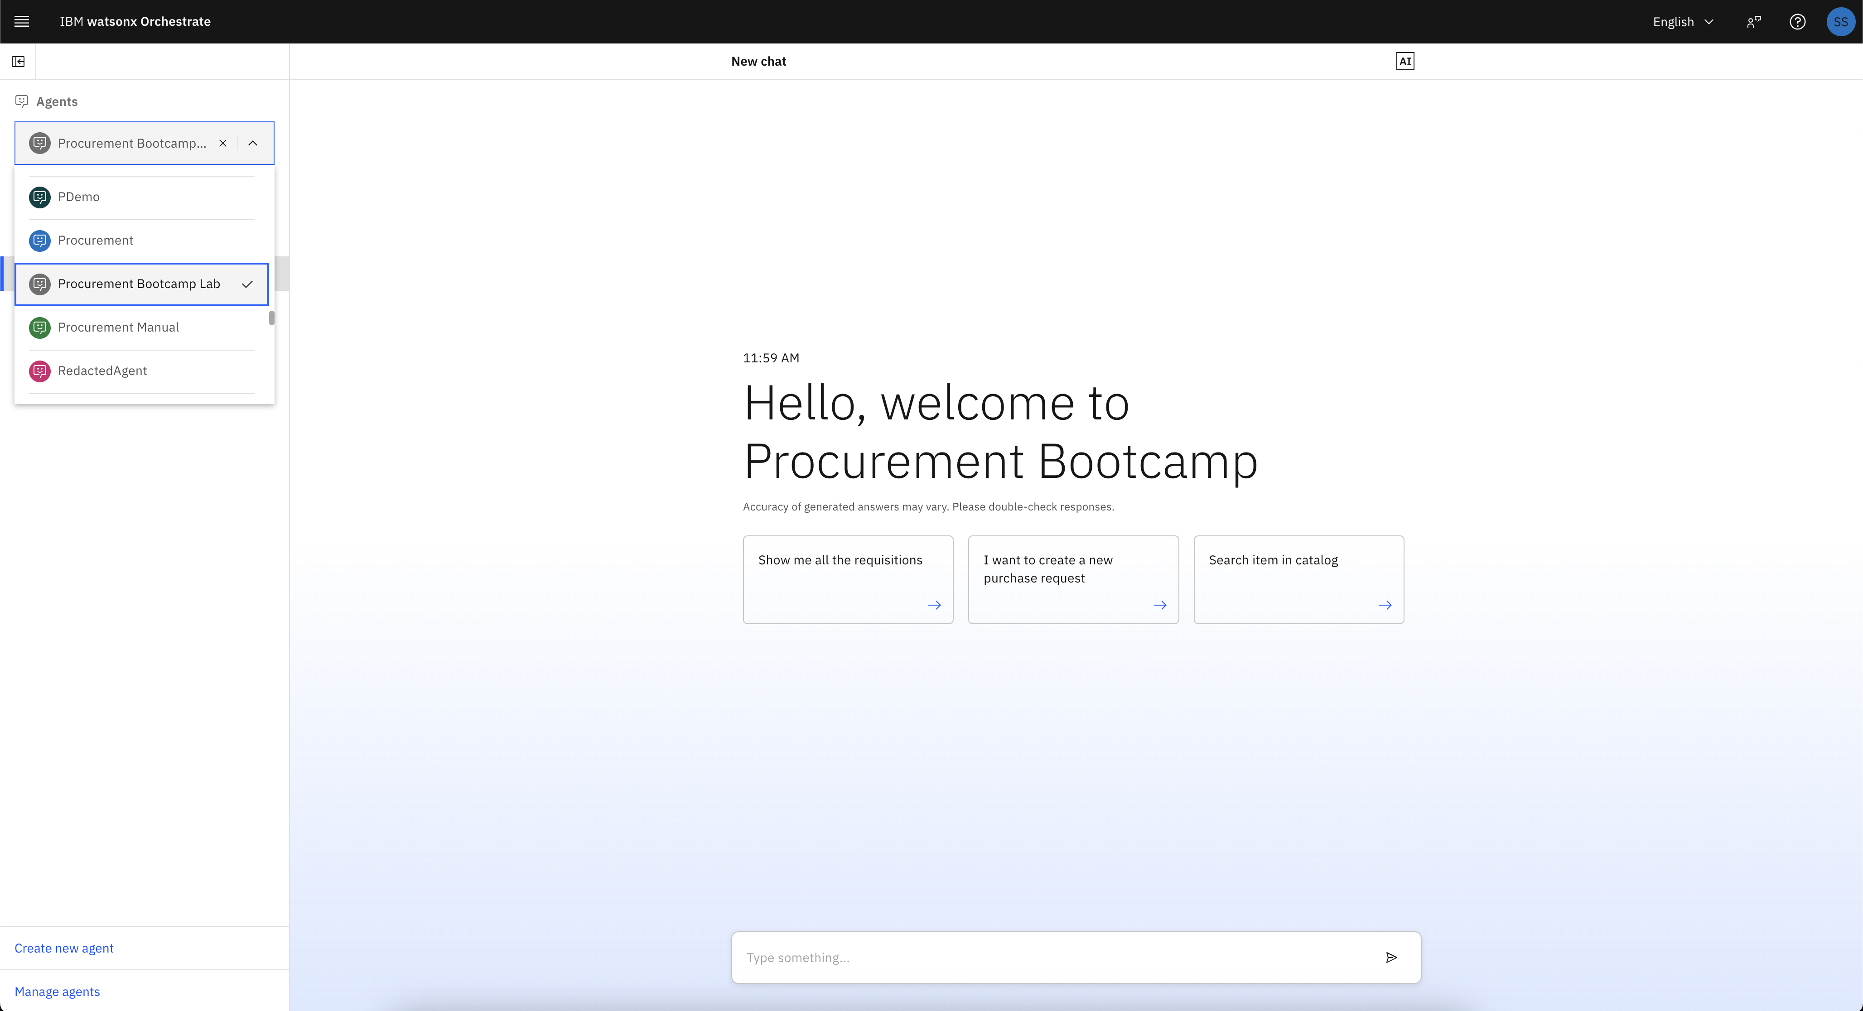
- You can click on few quick starter prompt tiles to start the conversation or even type your own.
  - Let’s click first tile – Show me all the requisition
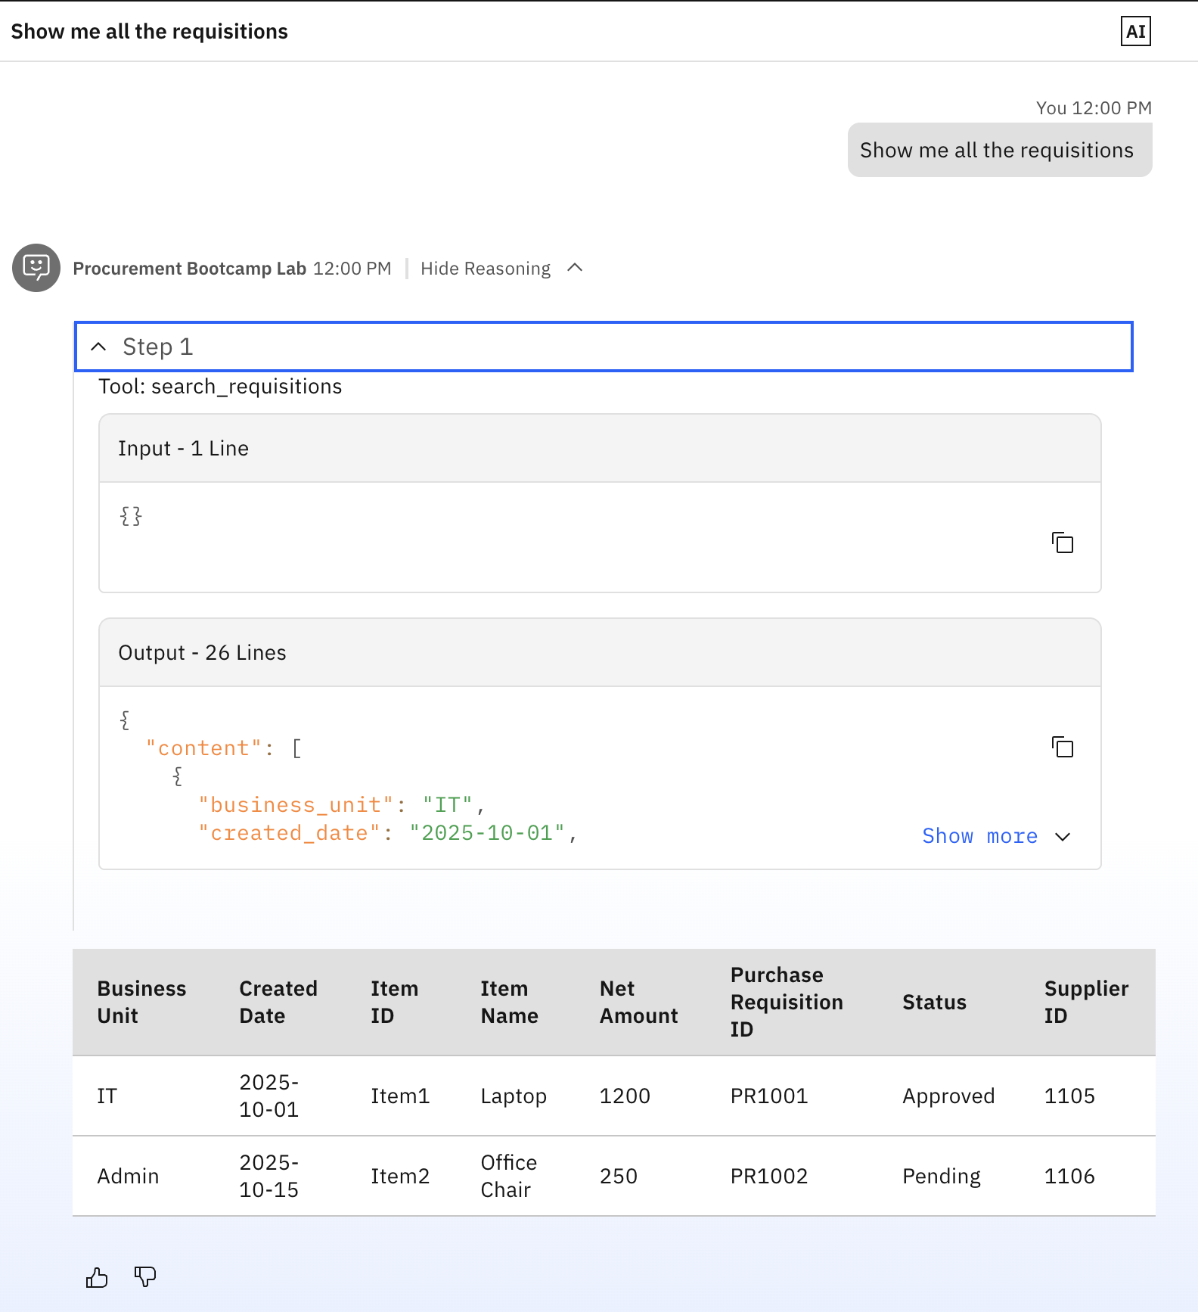
- You can see from reasoning, that relevant tool was called.
- Try below prompts and get the flavour of the agent.
  - I would like to buy a laptop. What is available in catalog?

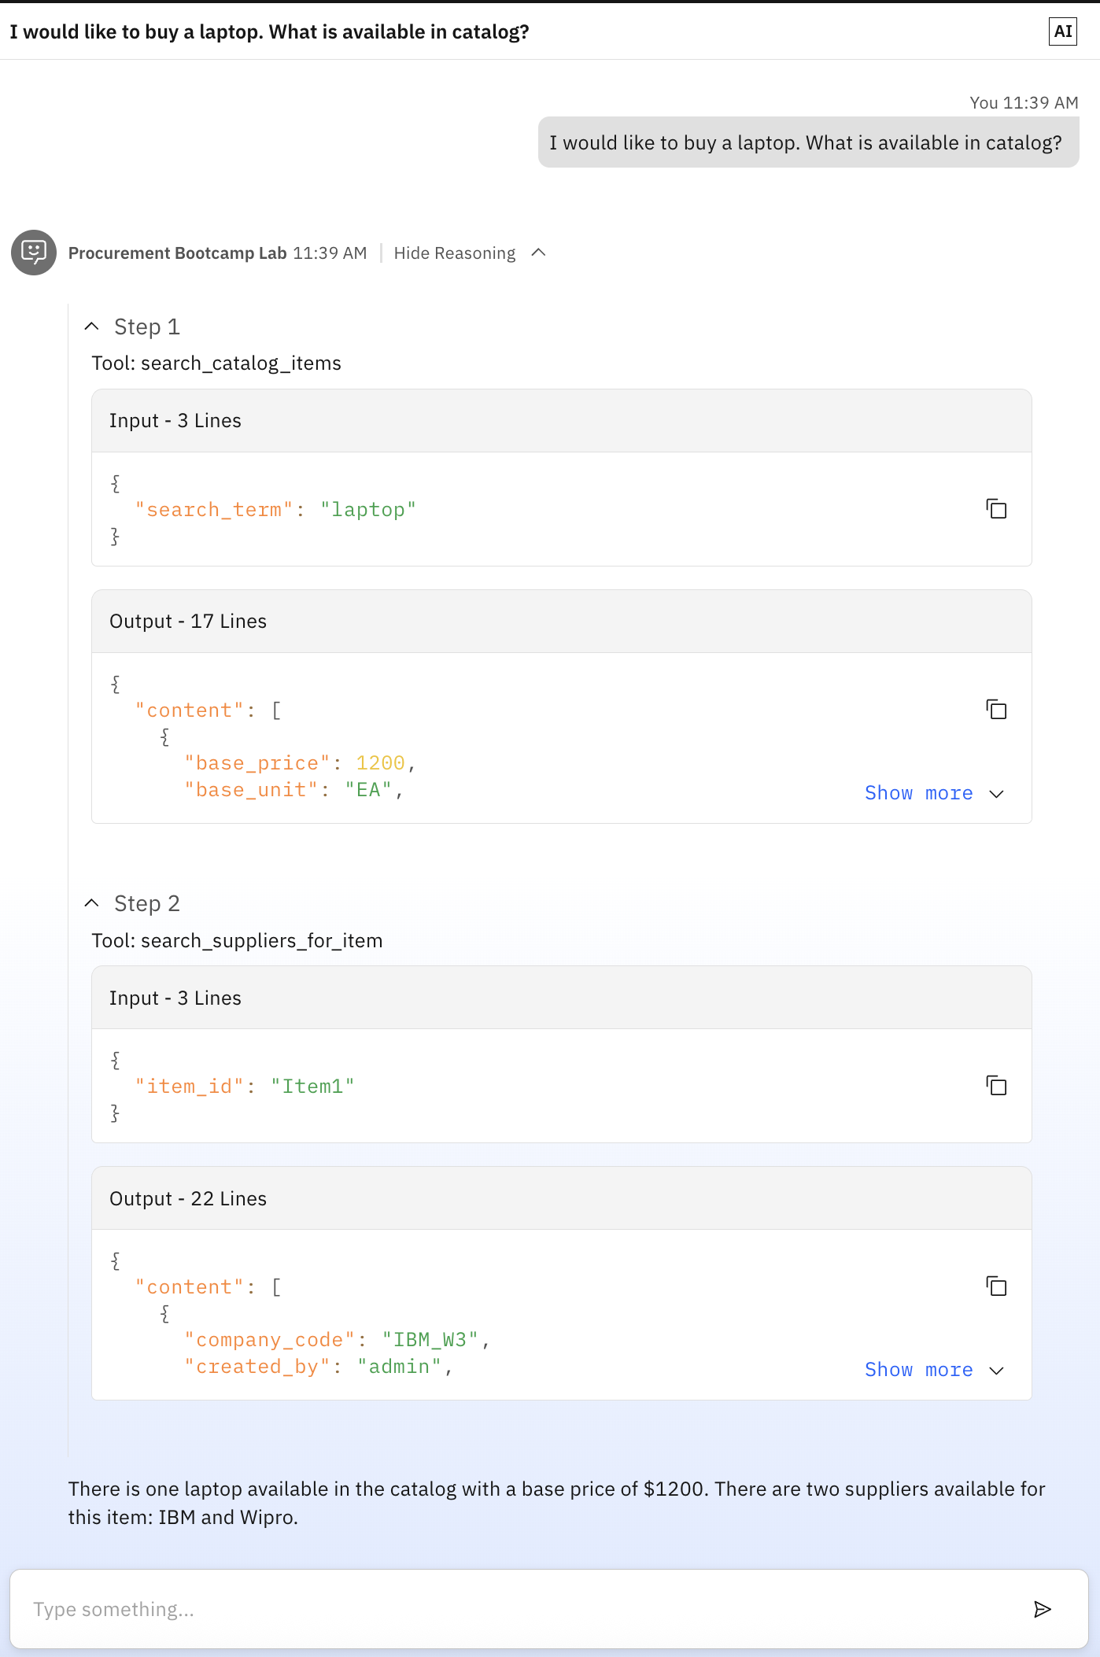
- You may notice multi-agent orchestration framework understood the intent and went ahead to search supplier for the item as well. Sometimes, it will just limit itself to search the item in catalog, and you need to explicitly ask –
  - who is the supplier for the item
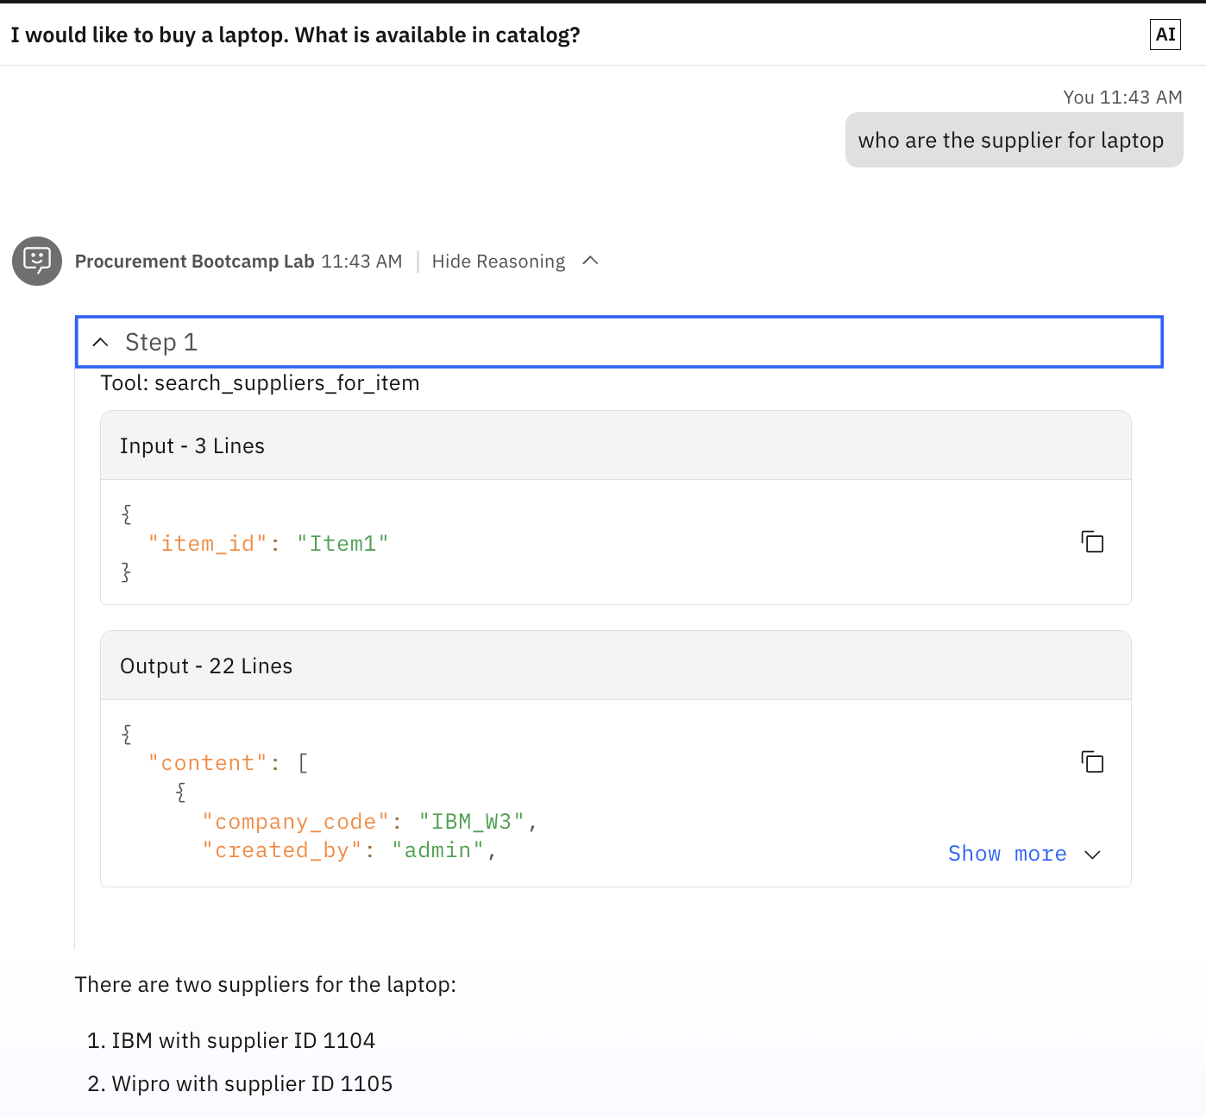
  - Show me what items are available in catalog
  - ok. Help me create requisition for the item 1 with supplier 1104
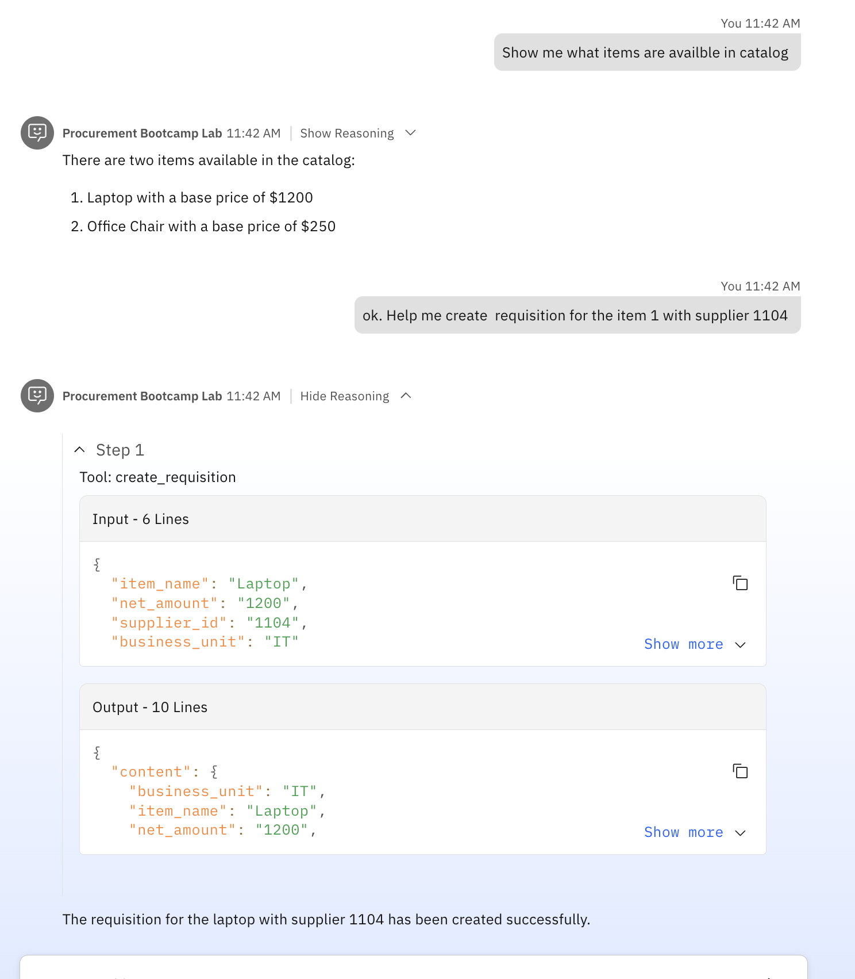
- Let’s see how does agent leverages the knowledge base to generate responses to user query.
  - what is the threshold for defence procurement?

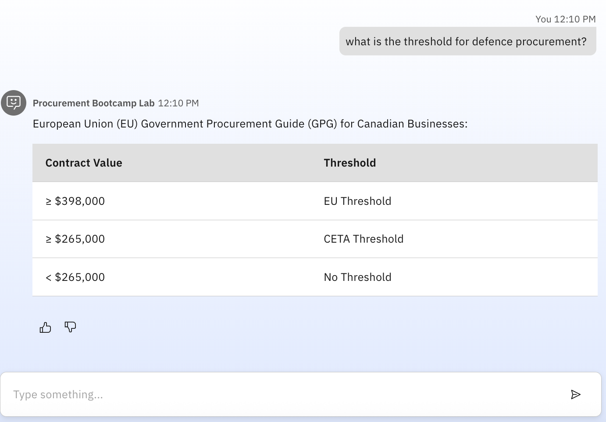
- Agent understands from the knowledge document ingested, and leverage RAG to answer the user query.

