Embedded Linux system development training

5 day session

Overview
Title | Embedded Linux system development training
Overview | Bootloaders. Kernel (cross) compiling and booting.  Block and flash filesystems. C library and cross-compiling toolchains. Lightweight building blocks for embedded systems. Embedded system development tools.  Embedded application development and debugging.  Implementing real-time requirements in embedded Linux systems.  Techniques to optimize system size, RAM, power, performance and cost.  Practical labs with ARM boards.
Duration | 5 days - 40 hours (8 hours per day)  40% of presentations and 60% of practical labs.
Trainer | One of the engineers listed on http://free-electrons.com/training/trainers/
Language | Oral lectures: English, French, German or Polish  Materials: English
Audience | People developing devices using the Linux kernel  People supporting embedded Linux system developers.
Prerequisites | Knowledge and practice of Unix or GNU/Linux commands  People lacking experience on this topic should get trained by themselves with our freely available on-line slides  (http://free-electrons.com/docs/command-line/)
Required equipment | For on-site sessions only.  Everything is supplied by Free Electrons in public sessions.  Video projector  PC computers with at least 2 GB of RAM, and Ubuntu Linux installed in a free partition of at least 20 GB. Using Linux in a virtual machine is not supported, because of issues connecting to real hardware.  We need Ubuntu Desktop 12.04 (32 or 64 bit, Xubuntu and Kubuntu variants are fine). We don't support other distributions, because we can't test all possible package versions.  Connection to the Internet (direct or through the company proxy).  PC computers with valuable data must be backed up before being used in our sessions. Some people have already made mistakes during our sessions and damaged work data.
Materials | Print and electronic copies of presentations and labs.  Electronic copy of lab files.

Training - Embedded Linux system development
See our training materials on http://free-electrons.com/doc/training/embedded-linux
This way, you can check by yourself that they correspond to your needs.

Hardware
Using the Atmel SAMA5D3 Xplained board in all practical labs
SAMA5D36 (Cortex A5) CPU from Atmel  USB powered  256 MB DDR2 RAM  256 MB NAND flash  2 Ethernet ports (Gigabit + 100 Mbit)  2 USB 2.0 host ports  1 USB device port  1 MMC/SD slot  3.3 V serial port (like Beaglebone Black)  Arduino R3-compatible header  Misc: JTAG, buttons, LEDs | 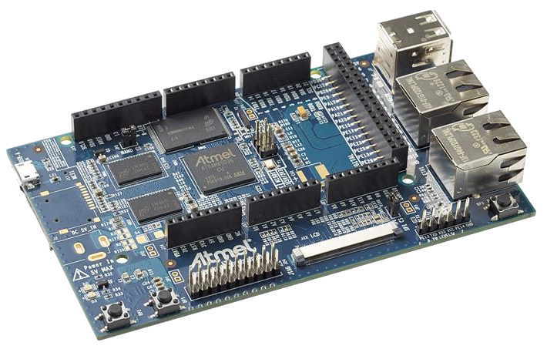

Day 1 - Morning
Lecture – Introduction to embedded Linux | Lecture – Embedded Linux development environment
Advantages of Linux versus traditional embedded operating systems. Reasons for choosing Linux.  Global picture: understanding the general architecture of an embedded Linux system.  Overview of the major components in a typical system.  The rest of the course will study each of these components in detail. | Operating system and tools to use on the development workstation for embedded Linux development.  Desktop Linux usage tips.

Lecture - Cross-compiling toolchain and C library
What's inside a cross-compiling toolchain
Choosing the target C library
What's inside the C library
Ready to use cross-compiling toolchains
Building a cross-compiling toolchain with automated tools.

Day 1 – Afternoon
Lab – Cross compiling toolchain | Lecture – Bootloaders
Configuring Crosstool-NG  Executing it to build a custom uClibc toolchain. | Available bootloaders  Bootloader features  Installing a bootloader  Detailed study of U-Boot

Lab – Bootloader and U-boot | Lecture – Linux kernel
Set up serial communication with the board.  Configure, compile and install the first-stage bootloader and U-Boot on the Xplained board.  Become familiar with U-Boot environment and commands.  Set up TFTP communication with the board. Use TFTP U-Boot commands. | Role and general architecture of the Linux kernel  Features available in the Linux kernel, with a focus on features useful for embedded systems  Kernel user interface  Getting the sources  Understanding Linux kernel versions.  Using the patch command

Day 2 - Morning
Lab - Kernel sources | Lecture – Configuring and compiling a Linux kernel
Downloading kernel sources  Apply kernel patches | Kernel configuration.  Useful settings for embedded systems.  Native compiling.  Generated files.  Using kernel modules

Lecture - Kernel cross-compiling | Lab - Kernel cross-compiling and booting
Kernel cross-compiling setup.  Using ready-made configuration files for specific architectures and boards.  Cross-compiling Linux. | Using the Xplained ARM board  Configuring the Linux kernel and cross-compiling it for the ARM board.  Downloading your kernel on the board through U-boot's tftp client.  Booting your kernel from RAM.  Copying the kernel to flash and booting it from this location.  Storing boot parameters in flash and automating kernel booting from flash.

Day 2 - Afternoon
Lecture – Root filesystem in Linux | Lecture - BusyBox
Filesystems in Linux.  Role and organization of the root filesystem.  Location of the root filesystem: on storage, in memory, from the network.  Device files, virtual filesystems.  Contents of a typical root filesystem. | Detailed overview. Detailed features.  Configuration, compiling and deploying.

Lab – Tiny root filesystem built from scratch with BusyBox
Now build a basic root filesystem from scratch for your ARM system
Setting up a kernel to boot your system on a workstation directory exported by NFS
Passing kernel command line parameters to boot on NFS
Creating the full root filesystem from scratch. Populating it with BusyBox based utilities.
Creating device files and booting the virtual system.
System startup using BusyBox /sbin/init
Using the BusyBox http server.
Controlling the target from a web browser on the PC host.
Setting up shared libraries on the target and developing a sample application.

Day 3 – Morning
Lab – Tiny root filesystem built from scratch with BusyBox
Continued from the previous afternoon.

Lecture - Block filesystems | Lab - Block filesystems
Filesystems for block devices.  Usefulness of journaled filesystems.  Read-only block filesystems.  RAM filesystems.  How to create each of these filesystems.  Suggestions for embedded systems. | Using the Xplained ARM board  Creating partitions on your block storage  Booting a system with a mix of filesystems: SquashFS for applications, ext3 for configuration and user data, and tmpfs for temporary system files.

Day 3 - Afternoon
Lecture - Flash filesystems | Lab – Flash filesystems
The Memory Technology Devices (MTD) filesystem.  Filesystems for MTD storage: JFFS2, Yaffs2, UBIFS.  Kernel configuration options  MTD storage partitions.  Mounting MTD filesystem images. | Using the SAMAD3 Xplained ARM board  Creating partitions in your internal flash storage.  Formating the main partition with JFFS2 in read-only mode.  Using JFFS2 for system data.

Lecture – Leveraging existing open-source components in your system
Reasons for leveraging existing components.
Find existing free and open source software components.
Choosing the components.
The different free software licenses and their requirements.
Overview of well-known typical components used in embedded systems : graphical libraries and systems (framebuffer, DirectFB, Gtk, Qt, etc.), system utilities, network libraries and utilities, multimedia libraries, etc.
Example of a typical consumer electronic product leveraging many open-source components.
System building: integration of the components.

Day 4 - Morning
Lecture – Cross-compiling applications and libraries | Lab – Cross-compiling applications and libraries
Configuring, cross-compiling and installing applications and libraries.  Details about the build system used in most open-source components.  Overview of the common issues found when using these components. | If enough time left  Building a system with audio libraries and a sound player application.  Manual compilation and installation of several free software packages.  Learning about common techniques and issues.

Day 4 - Afternoon
Lecture - Embedded system building tools | Lab - System build with Buildroot
Review of existing system building tools.  Buildroot example. | Building a system with a graphical system based on DirectFB, running in Qemu.  Using Buildroot to rebuild the same system as in the previous lab.  Seeing how easier it gets.  Optional: add a package to Buildroot.

Day 5 - Morning
Lecture - Application development and debugging
Programming languages and libraries available.
Overview of the C library features for application development.
Build system for your application, how to use existing libraries in your application.
Source browsers and Integrated Development Environments (IDEs).
Debuggers. Debugging remote applications with gdb and gdbserver. Post-mortem debugging with core files.
Code checkers, memory checkers, profilers.
Developing on Windows.

Lab – Application development and debugging
In Qemu and on the Xplained ARM board.
Develop and compile an application relying on the ncurses library
Using strace, ltrace and gdbserver to debug a crappy application on the remote system.
Do post-mortem analysis of a crashed application.

Day 5 - Afternoon
Lecture - Linux and real-time
Very useful for many kinds of devices, industrial or multimedia systems.
Understanding the sources of latency in standard Linux.
Soft real-time solutions for Linux: improvements brought by Linux 2.6.
Understanding and using the latest RT preempt patches for mainstream Linux.
Real-time kernel debugging. Measuring and analyzing latency.
Xenomai, a hard real-time solution for Linux: features, concepts, implementation and examples.

Lab - Linux latency tests
Tests performed on the Xplained ARM board
Latency tests on standard Linux.
Setting up Xenomai.
Latency tests with Xenomai.

