A rebuttal to Watters et al. ´2020 Long-term observations from Antarctica demonstrate that mismatched scales of fisheries management and predator-prey interaction lead to erroneous conclusions about precaution´
A bit long heading ?:
Shorter?: A Rebuttal to Watters et al. (2020): Misinterpretation of Predator-Prey Dynamics leading to erroneous Precautionary Management in Antarctic Krill Fisheries

2025-10-17
Abstract
Characterising the impact of human activities on wildlife is a key function of applied science. In the Antarctic Peninsula, the fishery for Antarctic krill has been operating for over half a century, and concerns that fishery-driven localised depletion of krill around pygoscelid penguin colonies could have deleterious effect on their performance and demographic trends have been raised. Watters et al. (2020) investigated 30 years of penguin foraging and reproductive performance at two colonies in the South Shetland Islands, comparing these data with acoustic measurements of krill biomass and catch metrics at the gSSMU scale. Herein, we critically assess of the efficacy of the approach and conceptual foundations, which has been cited as a basis for in drawing conclusions as representing sound scientific advice in fisheries management adviceWe demonstrate (/identify?) that several key assumptions in the Watters et al. 2020 study are contrary to the established scientific literature and not supported by the data provided by the authors themselves. By reformulating the modelling approach to address these issues,, we find that the impact on penguin performance of fishing activity is substantially reduced. Instead, our analyses highlights the Oceanic Niño Index as the dominant driver of penguin performance. These findings identify that the conclusions in Watters et al. (2020) should be treated with caution and not used uncritically to inform precautionary fisheries management decisions.

Introduction

Concerns over the potential impact of localised depletion of Antarctic krill (Euphausia superba) due to concentrated fishing effort, particularly on krill-dependent predators during sensitive life stages such as breeding, have been a longstanding topic of discussion within the Antarctic science community. Recently, Watters et al. (2020) suggested that local harvesting rates may impact predator performance to a degree comparable to that of adverse environmental conditions. Their analyses matched various performance indices of krill-dependent penguins with estimates of krill biomass, fishing pressure and broad scale climate variability.
The penguin performance indices were collected at two sites (Cape Shireff on Livingstone Island and Copacabana on King George Island, South Shetland Islands; Figure 1) over the period 1982 to 2016. Krill abundance data, representing the at-sea distributions of chinstrap, gentoo and Adélie penguins, were collected during summer seasons (1996 - 2011) and winter seasons (2012, 2014 and 2015). Monthly krill catches from Catch and Effort reports to CCAMLR, and climate variability was represented by the Oceanic Niño Index (ONI). Using a hierarchical analysis of variance approach, the authors estimated the variance in penguin performance indices as a function of Local Krill Biomass (LKB), Local Harvesting Rates (LHR; the ratio of krill catch to LKB) and the (ONI.

Watters et al., concluded that local harvesting levels of krill adversely impact penguin performance, with a degree of impact comparable to those of poor environmental conditions, and that these effects may be synergistic when high local harvesting coincides with unfavorable climate conditions. The conclusions of this paper, which as of this writing has accumulated (/received?) 162 citations and has been by CCAMLR in support of developing Marine Protected Area proposals, fisheries management strategies as well as being used in the review process of the Marine Stewardship Council fisheries certification process for the Antarctic krill fishery.
Given the influence of this study on policy and certification frameworks, it is essensial to ctitically assess its scientific foundations. In this paper, we identify six critical issues that undermine the validity of the conclusions presented by Watters et al. (2020). For each issue, we provide contextual background and a summary of the associated problem.

Issue #1: Continuing spatial and temporal mismatches predators and fishing activity
A key goal for Watters et al. (2020) was to highlight the consequences of mismatched spatial and temporal scales between the management of the Antarctic krill fishery and the ecological interactions between krill extractions and krill-dependent predators. . To address this, the authors created two strata composed of groups of Small-Scale Management Units(gSSMU); gSSMU #1 encompassing the Bransfield Strait (APBSE and APBSW) and gSSMU #2 covering areas north of the South Shetlands, including Elephant Island (APDPE, APDPW and APEI) (Figure 1). These strata were used to characterise both krill biomass and harvesting rates considered “local” to the penguin colonies for which performance data were available.
The reasoning behind scaling to gSSMU was linked to the foraging behaviour of the breeding adult pygoscelid penguins. The authors cite Hinke et al. (2017) as the justification for the use of these strata. However, pygoscelid penguins also exhibit staggered breeding phenology: with Adélie penguins commencing first, followed by chinstrap penguins then gentoo penguins (Black 2016). Adélie penguins are the first to fledge their chicks and thus cease to be centrally foraging, typically departing early February for their moulting grounds on the sea ice. chinstrap penguins depart for a pre-moult foraging trip towards the start of February and return to land in order to moult, before departing again for their overwinter trip mid-March (Hinke et al. 2015); Hinke et al. 2019). Conversely, gentoo penguins appear to remain near their breeding colonies throughout the winter (Korczak-Abshire et al. 2021).

Despite these differences in seasonal movement and spatial distribution, the model used by Watters et al. (2020) assumes that penguins occupy the entirety of their assigned gSSMU throughout the year. This assumption introduces a spatial and temporal mismatch between predator presence and fishing activity, potentially confounding the interpretation of local harvesting impacts on penguin performance.

Issue #2: Unsupported Ecological Assumptions
The conclusions presented by Watters at al. (2020) are further compromised by unvalidated ecological assumptions, particularly the claim that krill biomass at spatial scales relevant to penguin foraging varies systematically with the phase of the Southern Annular Mode (SAM). While SAM is known to influence large-scale atmospheric circulation and sea ice extent (REF), its direct relationship to local krill biomass, especially at the fine spatial scales relevant to penguin foraging, has not been empirically demonstrated.
The assumption that SAM-driven variability in krill biomass uniformly affects penguin performance across broad regions oversimplifies the complex interplay of local oceanographic and biological processes. Krill recruitment and aggregation are influenced by multiple factors, including local prey availability, predation pressure, and fine-scale hydrodynamic features, none of which are adequately captured by SAM alone (REF). Without robust empirical support for this relationship, the proposed mechanism linking climate variability, krill biomass, and penguin performance remains speculative.
Addressing this gap requires finer-scale data on krill distribution and environmental drivers to validate, or refute, the ecological assumptions underpinning the study’s conclusions.
KEY PROBLEM STATEMENT – JAVIER

Issue#3: Coding errors
A coding error further distorts the study’s findings: the “Worst Case” scenario is described in the text as having a neutral Oceanic Niño Index (ONI) but is incorrectly coded using a warm ONI parameter set (Supplementary Material 1, lines 661–663). This misclassification affects the interpretation of the model’s outputs, particularly the marginal probabilities associated with the “Worst Case” scenario.
Such structural coding errors results in misleading representations of the modeled relationships between environmental conditions, krill harvesting, and penguin performance. The presence of this error calls into question the robustness of the study`s conclusions

Issue#4: Omission of Competing Species
Another significant limitation of Watters et al. (2020) is its failure to account for competing krill-dependent predators. Recovering populations of baleen whales (Baines et al.2021; Biuw et al. 2024; Krafft et al., 2025) and migratory male Antarctic fur seals (Lowther et al.2020) forage in overlapping areas with penguins, particularly in key regions such as the Bransfield Strait and Gerlache Strait (e.g. Hückstädt et al. 2012; Johannessen et al. 2022).
By ignoring the presence and consumption demands of these predators, the study overestimates the relative impact of the krill fishery on penguin performance. For example, whales and seals may exacerbate the effects of fishing pressure by further depleting krill in shared foraging zones. The absence of these ecological interactions in the model undermines the completeness of the study`s conclusions.
A comprehensive assessment of fishery impacts on krill-dependent predators must incorporate the full suite of species competing for the same resource. Without doing so, evaluations of competition dynamics and their consequences for penguin populations remain incomplete and potentially misleading.
The model used by Watters et al. (2020) neglects the impact of recovering populations of large-bodied krill eating predators that overlap in time and space with penguins beyond a cursory discussion.

Issue#5: Model Bias
The analysis in Watters et al. (2020) suffers from two critical methodological flaws that undermine the reliability of its conclusions. First, the model includes both Local Krill Biomass (LKB) and Local Harvest Rate (LHR) as separate predictors, despite LHR being mathematically derived from LKB (LHR = Catch / LKB). This structural dependency introduces multicollinearity, which compromises the ability to disentangle the individual effects of krill availability and fishing pressure on penguin performance.
For example, areas with low LKB will inherently yield higher LHR values even under modest catch levels, thereby artificially inflating apparent impact of fishing pressure.
PROBLEM STATEMENT - ULF

Issue#6: Over-Reliance on Broad-Scale Climate Indices
A further limitation of Watters et al. (2020) is its reliance on macroscale climate indices, such as the Oceanic Niño Index (ONI) and the Southern Annular Mode (SAM), to explain variability in krill availability and penguin performance. While these indices are useful for characterizing large-scale atmospheric and oceanographic patterns, their application to ecological processes at fine spatial and temporal scales relevant to penguin foraging is problematic.

The Amundsen Sea Low (ASL) is the dominant climate feature for the western Antarctic Peninsula. The El Niño-Southern Oscillation (captured in the ONI predictor) modulates the ASL, with El Niño (La Niña) shallowing (deepening) its pressure, causing more northwesterly (southeasterly) winds and upwelling (restricted influx) of Circumpolar Deep Water onto the shelf. The SAM also influences the pressure of the ASL, with the current trend of negative SAM constructively (destructively) interfering with ASL when in phase with El Niño (La Niña) events (e.g. Clem et al. 2016).
The result is a set of above-surface climate conditions that drive changes in water mass intrusion that is in turn dependent on interactions between two climate processes as well as the geographical orientation of the coastline involved, all of which have been shown to impact the foraging trajectories and trip durations of Chinstrap penguins (Andrew D. Lowther et al. 2018). The bathymetry of the Antarctic Peninsula, which also influences the hydrographic conditions, is complex particularly at scales that are important to centrally-foraging predators such as penguins. The structuring of krill aggregations in time and space in the WAP have also been linked to mesoscale circulation processes (Santora et al. 2012), which are unlikely to be uniformly affected by broad-scale climate indices due to local variation in bathymetry and coastal orientation.

It is also worth noting that the study considers neither the impact of climate on the terrestrial breeding grounds, such as chick mortality due to rainfall-induced wetting (Chapman et al. 2011) nor does it unaccount for measurement inaccuracies in foraging trip durations (Lowther et al. 2015). While these indices provide useful insights into large-scale atmospheric and oceanographic patterns, they fail to capture the finer-scale processes that directly influence krill distribution and predator-prey interactions. For example, mesoscale oceanographic features, such as local upwelling, sea ice dynamics, and bathymetric influences, play a critical role in determining krill aggregation and accessibility to penguins (REF). However, these processes operate at spatial and temporal scales that are not adequately reflected by broad indices like ONI or SAM (REF). As a result, the study’s conclusions regarding climate impacts on penguin performance may be oversimplified or misrepresented, particularly in regions where local conditions deviate from broader climate patterns. This overreliance on coarse climate indices limits the study’s ability to accurately assess the true drivers of krill availability and, consequently, penguin responses to environmental change. As such, the general structure of the study does not appear to be appropriate for answering the research questions raised.

The model used by Watters et al. (2020) relies exclusively on ocean-scale climate indices as environmental predictors of LKB and penguin performance.

In the following,, we present quantitative analyses addressing Issues #1 to #3, demonstrating the limitations and inaccuracies in the study`s conclusions. Issues #4 to #6 are discussed qualitatively, highlighting their implications for understanding the drivers of penguin performance and the robustness of the study`s findings.

Materials and Methods

Continuing spatial and temporal mismatches
To assess the spatial overlap between krill-dependant predators and fishing activity, we utilzed Argos-CLS PTT telemetry data provided by the supporting studies referenced in Watters et al. (2020). These data were used to characterise the actual at-sea habitat use of breeding adult pygoscelid penguins, contextualized by species-specific breeding stages. Additional sources, including Warwick-Evans et al. (2018) and Lowther et al. (2018), were consulted to further quantify foraging behaviour in the study region.
For each species, we refrain from undertaking extensive state-space modelling of location errors and merely exclude locations with a “Z” error class, accepting the remaining locations had varying degrees of uncertainty around them. We then calculated the 99% Minimum Convex Polygon (home range) using the R package adehabitatHR and calculate their associated areas in , with the resulting MCP likely being larger than the area actually exploited, given the remaining inaccuracy in the underlying locations used.
We then scale the gSSMU LKB to the SSMU that the summer tracking data indicate penguins occupied. To do this, we calculate the area () of the SSMU for which the predator occupies and the gSSMU to which it is assigned, then create a scaling ratio. For example, we scale LKB for Cape Shireff chinstrap penguins solely to ADPDW (Figure 1) by multiplying the gSSMU LKB by the areal ratio of ADPDW/gSSMU #2. We then select the corresponding SSMU catch values provided in Watters et al. (2020) (Supplementary Info) to estimate SSMU-scale LHR. We also caution that while considering the gSSMU scale of harvesting as inappropriate for “local” effects, even the SSMU-scale catch levels likely do not accurately reflect pressures at the fine spatial scales relevant to breeding penguins
Watters et al. (2020) assigned LKB/LHR values in March into the “summer” period, thus effectively incorporating fishing pressure into the summer breeding season in the context of penguin performance metrics. However, fishing effort over the 30-year study period was not temporally uniform. In the last decade, catch rates have shown a nonlinear increase beginning in mid March, with the three years exhibiting rapid increases from early March (Figure 4). Given this variability, we conducted models runs that classified March as either part of the summer or winter season, based on the breeding phenology of Adélie and chinstrap penguins, both of which typically cease central-place foraging or migrate out of the area by March (Hinke et al., 2015, HINKE REFS GALORE, INCLUDING 2025 Scientific Reports).
Thus we reformulate the underlying assumptions above into a new model construct, in which performance indices from gentoo, chinstrap and Adélie penguins during the summer are included, but Adélie and chinstrap penguins cease to be centrally foraging species after breeding and migrate out of the area. The performance indices are matched in space and time but using SSMU level estimates of LKB and LHR. We re-run the model twice 1) using gappy survey data and 2) including imputed values for LKB in years where survey data are missing. We further consider two alternatives for considering March, either in a) summer or b) winter on each model run.
We present the outputs both in the same boxplot format as Figure 2 in the original manuscript, and as individual cases grouped and colour-coded as ONI “warm” ( 0.5; red), ONI “neutral” (-0.5 < ONI > +0.5; white) and ONI “cold” (< -0.5; blue). We also recreate the original marginal probabilities in Table 1 of Watters et al. (2020), and two additional tables in the same format with the probabilities extracted from our reformulated model, the difference between the latter two tables reflecting whether March is in summer or winter.

Unvalidated Ecological Assumptions

Model coding error
We also note an additional coding error that may influence how the original, unmodified results are interpreted. In summarising the model outputs into boxplots, the text in the paper seemingly classifies the “Worst Case” with “neutral” ONI ( oC < ONI < 0.5 oC; LKB > 1 Mt; and LHR 0.1) and the code relating to developing the original manuscript Figure 2 uses Parameter set 36 from the output dataframe, which actually reflects a “warm” ONI component (> 0.5 oC; LKB > 1 Mt; and LHR 0.1). Yet the discussion in Watters, Hinke, and Reiss (2020) also suggests that the likelihood of their “Worst Case” includes future warming (see Figure 3 below)
We agree that any “Worst Case” should reflect ENSO conditions into the future under a warming climate. However, climate change is likely to increase ENSO in amplitude - both El Niño (ONI “warm”) and La Niña (ONI “cold”) (Capotondi et al. 2015). How this increasing amplitude can be integrated appropriately into the presented modelling framework to match with long-term predicted mean performance of predators has not been explored yet. As such, and for the sake of comparison with the original study, we maintain the authors designation of ONI “neutral” when rendering the “Worst Case” boxplots, though caution that this is unlikely to be a realistic assumption

Omission of competing species
In order to provide numerical context on the potential role baleen whales and Antarctic fur seals may play in regulating penguin performance, we conduct two analyses. Firstly, we use published estimates of the time-evolving abundance and distribution of humpback whales (Megaptera novaeangliae) throughout the Bransfield Strait (Johannessen et al. 2022) to estimate the number of whales present in the SSMU occupied by penguins from Copacabana. We then use conservative per-capita consumption estimates (REF) to derive monthly krill consumption rates and compare these to the SSMU krill catch provided in Watters et al. (2020). Secondly, we use per-capita krill consumption rates for adult male Antarctic fur seals which are known to migrate into the region from as early as January until the beginning of the following summer breeding season (Lowther et al. 2020). The catch limit in the management unit in which the Watters et al. (2020) is conducted was 155,000tonnes/year, and we back-calculate the number of Antarctic fur seals that would need to be present to at least equal the krill removal rate of the fishery.
All analyses are conducted in the R statistical software environment (R 4.5.1), using the original data provided in Watters et al. (2020) or in the published articles cited as supporting evidence. To faciliate reproducibility, the Supplementary Material from the original Watters et al. (2020) article and the Supplementary Material from all necessary supporting articles are hosted in Zenodo repositories (record ID 5040114 and record ID 17347172). A dedicated R script allowing for these data and scripts to be downloaded directly from the repositories is provided in Appendix I. Fully annotated R code, highlighting the modifications and justifications, as well as the code needed to fully reproduce the figures and tables presented here, are also included in the Zenodo repositories.

Results

Continuing spatial and temporal mismatches
Comparing the original model outputs with ours, relative to the “Best Case”, the probability of negative impacts to penguins due to high LHR dropped precipitously from 93% to 37% (Table 3). In other words, when considering the migration of penguins in accordance with their known ecology (Figure 2), the relative probability of negative impact of LHR drops from a near-certainty to 1-in-3 (Table 2 and 3). At this point, we clarify that the probability of negative impact is not a measure of the scale of the expected impact (i.e. a measure of population decline), but a measure of whether any negative impact is likely to occur. Given the temporal separation between fishing and penguin breeding over the preceding decade, our results are unsurprising.

Unvalidated Ecological Assumptions

Model coding error

Omission of competing species
• Figure 1: Impact of Spatial and Temporal Adjustments on Expected Penguin Performance. Illustrate the combined effect of spatial and temporal corrections on model outputs. Highlight that LHR impacts are overestimated in the original model.
Content: • Boxplots comparing expected penguin performance under: ◦ Original model (gSSMU scales, Adélie/chinstrap penguins included in winter, March as summer). ◦ Revised model (SSMU scales, Adélie/chinstrap penguins excluded in winter, March as winter). • Color-coded by ONI conditions: ◦ Warm (≥0.5°C; red). ◦ Neutral (-0.5°C < ONI < 0.5°C; white). ◦ Cold (<-0.5°C; blue).
• Table 1: Marginal Probabilities of Negative Impacts on Penguin Performance
Content: • Comparison of marginal probabilities for: ◦ Original model (Watters et al., 2020). ◦ Revised model (spatial rescaling to SSMU, temporal adjustments, March as winter). • What to include: • Probability of negative impact from high LHR (original: 93%; revised: 37%). • Probability under “Worst Case” (neutral ONI, high LHR, high LKB). • Dominance of ONI effects in revised model.
Unvalidated Ecological Assumptions • Figure 1: Relationship Between SAM Phases and Local Krill Biomass (LKB). Visually confirm the lack of correlation between SAM and LKB. Support the argument that local processes (e.g., upwelling, bathymetry) are more influential than broad-scale climate indices. Content: • Scatter plots or regression plots showing: ◦ SAM index values (x-axis) vs. Local Krill Biomass (LKB) (y-axis). ◦ Data points for different SAM phases (positive, neutral, negative). ◦ Regression line with R² and p-values indicating no significant relationship (F < 0.975, p > 0.33). • Highlight: Visual demonstration that LKB does not vary predictably with SAM phases.
• Table 1: Statistical Tests for SAM-LKB and Low LKB-Small Krill Relationships
Content:

Discussion

Our reanalysis of Watters et al. (2020) reveals that the study’s conclusions are based on assumptions that lack empirical support. By addressing spatial and temporal mismatches, unvalidated ecological assumptions, and methodological biases, we demonstrate that the perceived impacts of krill fishing on penguin performance are significantly overestimated. Specifically, rescaling spatial units from gSSMUs to SSMUs and accounting for species-specific migration patterns reduced the estimated probability of negative impacts from high Local Harvest Rates (LHR) from 93% to 37%. Additionally, our findings highlight that broad-scale climate indices (ONI, SAM) are less influential than local oceanographic processes in determining krill availability and penguin performance.

Spatial and temporal mismatches undermine study conclusions
The spatial scales used in Watters et al. (2020) exceed the actual foraging ranges of penguins by a factor of 4 to 15 For example, Adélie penguins forage within 1,139 nm², yet the study used gSSMUs of 15,500–20,600 nm² to define “local” krill biomass and harvest rates. This mismatch leads to overestimated localized depletion effects, as the broad spatial units fail to capture the fine-scale interactions between penguins and their prey.
Similarly, the study’s temporal assumptions incorrectly associate winter fishing pressure with penguin performance, despite Adélie and chinstrap penguins migrating away from breeding colonies by late February. By excluding these species from winter analyses, we show that the original model’s conclusions about seasonal fishing impacts are misassigned.

Unvalidated ecological assumptions
Watters et al. (2020) assumes a direct relationship between krill biomass and the phase of the Southern Annular Mode (SAM), yet our statistical analyses reveal no significant correlation between SAM phases and Local Krill Biomass (LKB). Similarly, the assumption that low LKB (<1 Mt) corresponds to smaller krill is not supported by empirical evidence. These oversimplifications obscure the complex ecological processes that govern k krill-penguin dynamics.
Additionally, the study overlooks the role of krill life-stage dynamics in shaping prey availability and energetic value for predators. Krill populations consist of multiple size classes and age cohorts, each exhibiting distinct spatial distributions, seasonal behaviors, and nutritional profiles (REF). For instance, small juvenile krill, often dominate during recruitment pulses, are less energetically valuable to penguins than larger, mature individuals (REF). Seasonal and spatial variability in krill size structure driven by recruitment events and environmental conditions, can significantly influence predator foraging success and reproductive outcomes (REF), yet these dynamics are not explicitly considered in Watters et al. (2020).
By treating krill biomass as a homogeneous metric, the authors fail to account for critical variations in krill quality and availability that may drive penguin foraging success or failure. Addressing this gap requires life-stage-specific data on krill distribution and predator preferences to refine assessments of how fishing and environmental changes affect penguin populations.
Together, these oversights highlight the need for finer-scale ecological data to validate, or refute, the mechanisms proposed by Watters et al. (2020).

Model coding error
A structural coding error in Watters et al. (2020) further compromises the validity of the study’s conclusions. The “Worst Case” scenario is described in the text as having a neutral Oceanic Niño Index (ONI) but was incorrectly coded using parameters for a warm ONI. This misclassification inflates the perceived severity of neutral ONI conditions, leading to misinterpretation of the model’s outputs, particularly the marginal probabilities associated with the “Worst Case” scenario. The coding error reduces the probability of negative impacts from high LHR from 93% to 37% (Table 3). This adjustment underscores the dependency of perceived fishing pressure effects on krill abundance: low LKB amplifies the apparent impact of LHR, while high LKB mitigates it. Furthermore, the revised model clarifies that ONI excerts a stronger influence on penguin performance than LHR when structural biases are removed, challenging the original study`s emphasis on harvesting effects.

Omission of competing krill predators
A major limitation of Watters et al. (2020) is the omission of krill-dependent predators that compete with penguins for prey resources. Recovering baleen whale populations and migratory male Antarctic fur seals exert substantial predation pressure on krill, particularly in regions that overlap with penguin breeding and foraging activity. Using available abundance, distribution and consumption estimates for competing species, we show that humpback whales consume over five times the amount of krill than taken by the fishery per month. We show that the number of male Antarctic fur seals required to match the LHR of the fishery for each year of the study ranges from as few as zero to as many as 72,000 seals; given the number of seals that are recorded at only two sites in the South Orkney Islands (32,000 individuals) and their movements into the Antarctic Peninsula are well documented (Lowther et al. 2020), there are likely to be significant competitive interactions between migrating seals and breeding penguins. The consumption by whales also overlaps temporally with penguin breeding, unlike the fishery which since 2010 has shifted to a winter fishery (REF). Intuitively then, ignoring the vast amount more krill removed by whales at the same time as breeding penguins are foraging is likely to be greatly overestimating the relative impact of fisheries removal on penguin performance. Future assessments of krill fishery must incorporate multi-species interactions to accurately evaluate the cumulative pressures on krill-dependent predators.

Model Bias
The presence of structural model bias arising from the confounding relationship between covariates (LHR and LKB; LHR=Catch/LKB) was not explicitly explored in this study. This dependency, however, masks the isolated effects of krill availability (LKB) and fishing pressure (Catch) on penguin performance, potentially leading to misleading conclusions about the relative importance of these factors. This structural confounding in the model results in artificial inflation of fishing impacts in areas with low LKB, where even modest catches yield high LHR values, thereby exaggerating the perceived impact of fishing pressure on penguin performance. Conversely, in areas with high LKB, substantial catches may be masked because the same absolute catch results in a lower LHR, underestimating the true effects of fishing. This structural bias undermines the study’s ability to disentangle the true ecological drivers of penguin performance, necessitating a reevaluation of the model’s specifications and assumptions. These findings underscore the necessity for methodological rigor in ecological modeling. Future studies should avoid multicollinearity by using Catch and LKB as separate predictors instead of LHR to isolate the effects of fishing pressure and krill availability. Additionally, validating coding and assumptions is crucial to ensure that scenario classifications align with described conditions and prevent misinterpretation. Finally, reevaluating model specifications to account for structural biases will enable more accurate assessments of the impacts of fishing on predator performance. 6 Over-reliance on broad-scale climate indices Watters et al. (2020) relies on macroscale climate indices (ONI, SAM) to explain variability in krill availability, yet these indices fail to capture finer-scale oceanographic processes (e.g., local upwelling, sea ice dynamics) that directly influence krill aggregation. Our reanalysis shows that local environmental predictors (e.g., sea ice concentration, chlorophyll-a) explain more variance in penguin performance than ONI or SAM. This over-reliance on broad-scale indices limits the study’s ability to accurately assess the true drivers of krill availability and penguin responses to environmental change.

Implications for fisheries management
The real-world implications of Watters et al. (2020) are substantial, as its conclusions have influenced CCAMLR’s Marine Protected Area proposals and fisheries certification processes. However, our reanalyses suggest that key methodological limitations, including spatial and temporal mismatches, unvalidated ecological assumptions, and the omission of competiting predators, compromise the study`s validity as basis for management advice. We recommend that future assessments: 1. Use spatial scales aligned with penguin foraging ranges (such as SSMUs rather than gSSMUs to beter reflect ecological interactions). 2. Account for species-specific migration and seasonal variability in fishing effort, particularly in relation to breeding phenology. 3. Incorporate competing predators and local environmental drivers, including mesoscale oceanographic processes and krill life-stage dynamics. By addressing these issues, managers can develop more accurate and evidence-based strategies for balancing krill harvesting with the conservation of dependant predator populations.

Broader concerns and future directions
While Watters et al. (2020) raises important questions regarding the ecological impacts of krill fishery, its analytical framework, focused solely on fishing pressure and climate indices, is insufficient for disentangling the relative contributions of multiple stressors affecting krill-dependent predators. Over 20 years ago, CCAMLR acknowledged that its CEMP monitoring program was unable to distinguish between the effects of fishing and climate variability (REF), yet no substantive modifications have been implemented to address this limitation. Moving forward, integrated monitoring programs are needed to capture the complexity of predator-prey interactions in the Antarctic ecosystem. Such programs should incorporate data on interspecific competition, local oceanographic conditions, and fine-scale predator behavior. These elements are essential for developing a more accurate understanding of the cumulative pressures on krill-dependent species and for informing sustainable fisheries management under changing environmental conditions.

Conclusion

Our reanalysis of Watters et al. (2020) demonstrates thet the study`s conclusions are substantially influenced by methodlogogical limitations, including spatial and spatial/temporal mismatches, unsupported ecological assumptions, omission of competing krill predators and structural biases in model design.. While climate variability (ONI) remains a dominant driver of penguin performance, the impacts of krill fishing are considerable less severe when evaluated at ecologically relevant spatial and temporal scales.
To ensure that scientific advice provided to CCAMLR is both objective and robust, future assessments must adopt finer resolution spatial frameworks aligned with predator foraging ranges, account for species-specific seasonal dynamics, and incorporate multi-species interactions and local environmental drivers. Only through such integrative approaches can we accurately assess the cumulative impacts of fishing and environmental change on Antarctic krill-dependent predators in the Southern ocean ecosystem.
Summary Table showing what was bullshit, and where to find the analysis and data in our paper.
Statement/Question
Data Source
Support & Significance
Appendix Reference
Does LKB vary with SAM sign and strata ?
Appendix I
No; F < 0.975, p >0.33 all cases
LKB does not vary predictably with SAM
Is low LKB (<1Mt) correlated with small krill ?
Appendix II
No; F < 2.175, p >0.154 all cases
Low LKB in Best Case scenario is inappropriate
Are penguin indices related to ONI/SAM ?
Appendix III
No; see Appendix III Table 1
Penguin indices are not correlated to climate variability indices
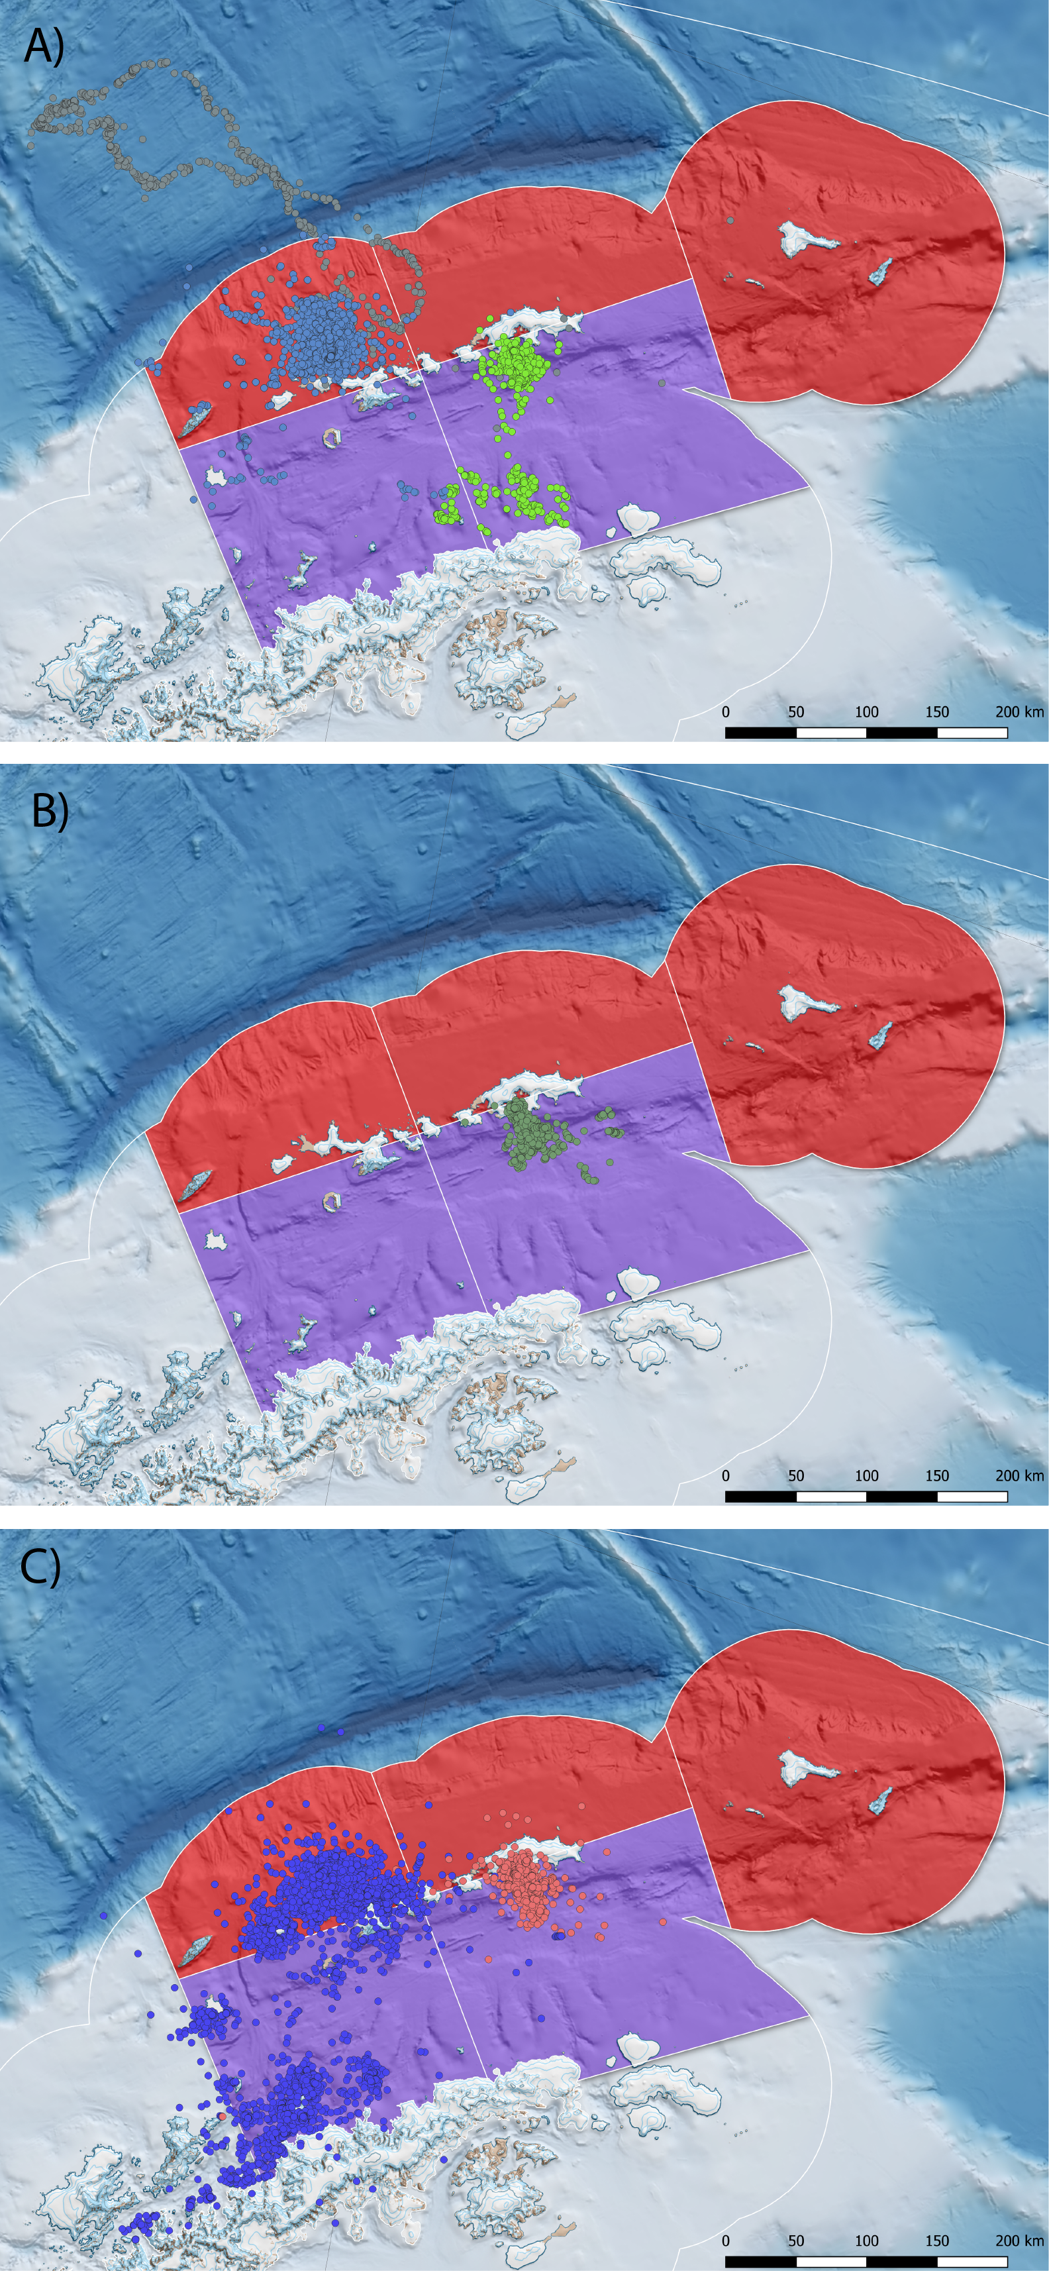
Penguin foraging behaviour during summer breeding, derived from available ARGOS-CLS PTT data presented in Hinke et al. 2017. A) Chinstrap penguins from Cape Shireff (blue) and Copacabana (green) truncated at ${10}^{th}$ March in line with known phenology (Black 2016; Lowther et al.(this meeting). Elongated grey track represents a single animal) B) Adélie penguins truncated to the end of January and C) gentoo penguins until August, representing all available PTT data provided. The SSMU are combined and coloured according to gSSMU (red; gSSMU 2, purple; gSSMU 1) with chinstrap and Adélie penguin 99% MCP home ranges occupying between 7-19% of the gSSMU to which they were assigned.
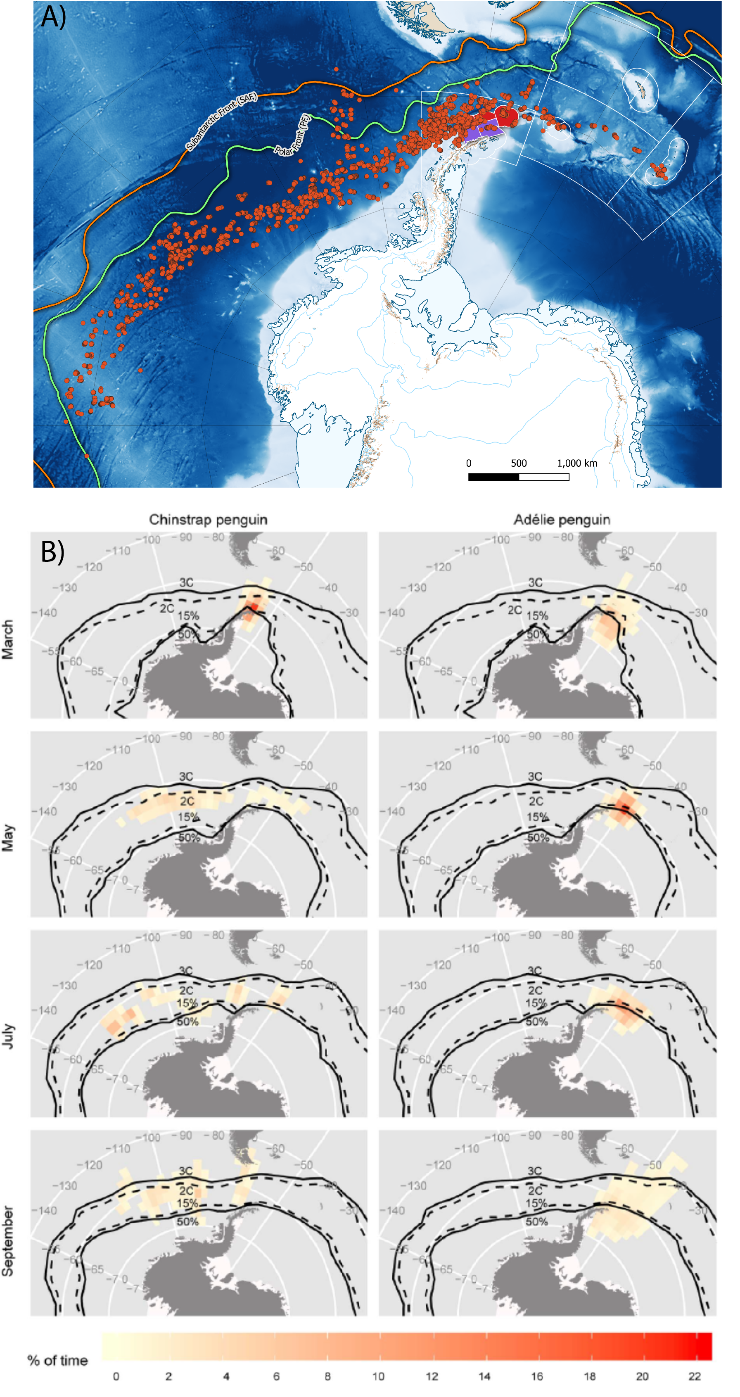
A) Distribution of overwinter movement for chinstrap penguins, relative to the gSSMU’s to which they were attributed, created from telemetry data available in Hinke et al. 2019. B) Adélie and chinstrap penguin movement recorded by light geolocators, highlighting the large longitudinal range both species disperse through at the end of breeding (taken from Hinke et al. 2015). In the original model formulation by Watters et al. 2020, the winter performance indices for both species are matched to macroscale levels of ONI variability but gSSMU-scale estimates of LKB and LHR.
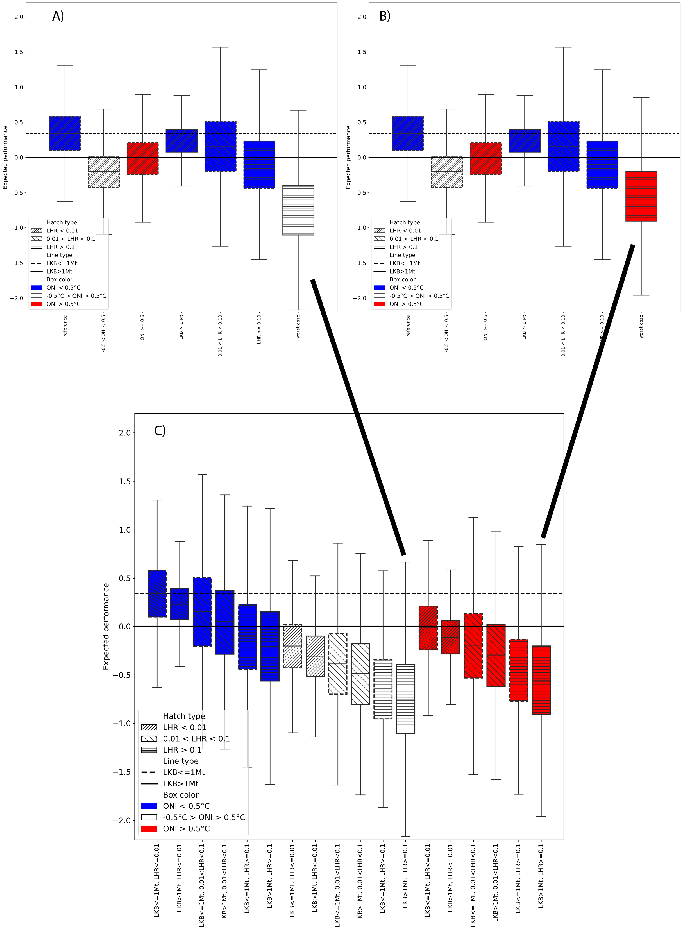
Original Figure 1 plot from Watters et al. 2020 with A) Neutral ONI and B) B) Warm ONI constituting the Worst Case selected. C) Displays the original case-by-case plots recreated from the paper, with Case 12 representing the intention while data from Case 18 was selected for rendering the boxplot. Note that the expected performance under neutral ONI Worst Case is poorer than under the warm ONI that was presented in the original paper. Henceforth, to facilitate comparison, we refer to the ONI Neutral plot however we consider this unrealistic if the intention is to portray a Worst Case of a continuing warming climate.
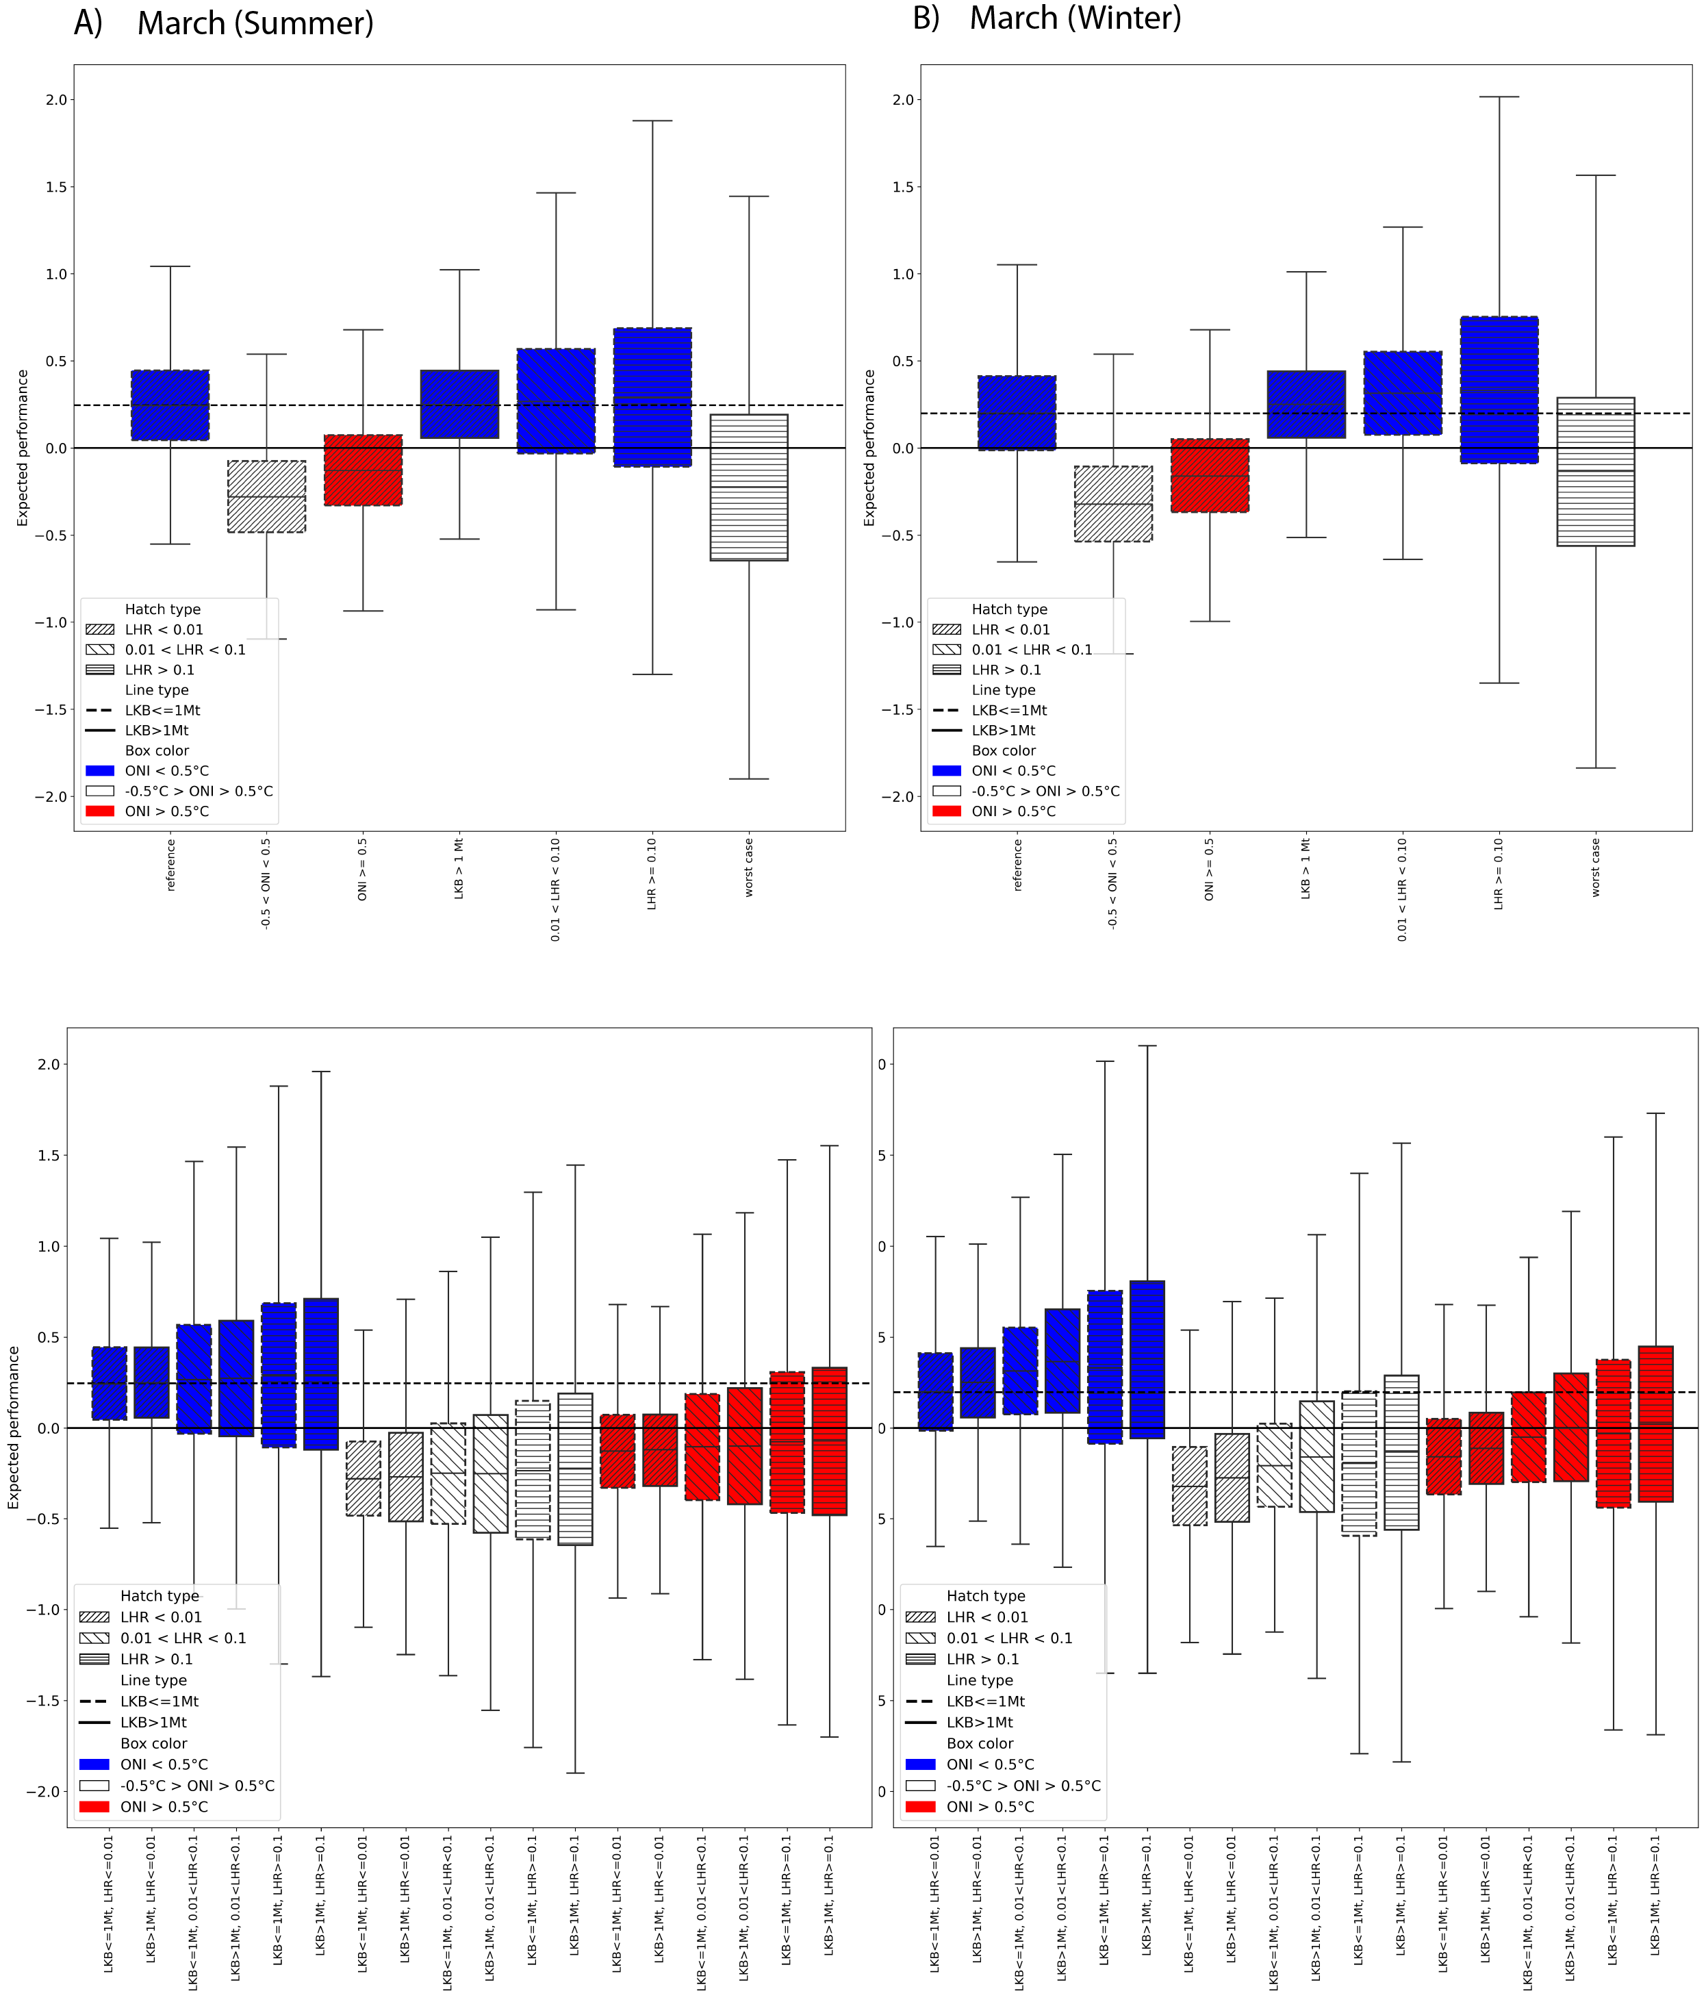
Model output for the alternatve Watters et al. 2020 scenario outlined above (all species initially present, Adélie and chinstrap penguins migrate out of the area after breeding, LKB and LHR rescaled to SSMU and March included in summer or winter). Selected cases as per Watters et al. 2020 for March in A) Summer and B) Winter are provided, with the corresponding case-by-case boxplots presented beneath. Boxplots are colour-coded by ONI state (red=warm, white=neutral, blue=cold). In all cases, the marginal effect of ONI dominated the expected performance of penguins against their long-term mean, irrespective of LKB or LHR.
Original table in Watters et al. 2020. In this and all subsequent tables below, the posterior and posterior predictive probabilities that the expected performance of penguins given the effects in the left hand column are less than the expected performance given the drivers in the column headings are provided. Worst Case is represented by neutral ONI; LHR $≥$ 0.1; and LKB $≥$ 1Mt. The Best Case is represented by La Niña conditions, low LKB and low LHR.
Effects
Best Case
-0.5 $​^{∘}$ C < ONI < +0.5 $​^{∘}$ C
ONI $≥+0.5$
Long-term $μ$
Long-term predicted $μ$
Best case
NA
NA
NA
0.04
0.36
ONI Neutral
1.00
NA
NA
0.89
0.59
ONI warm
0.99
NA
NA
0.52
0.51
LKB High
0.71
0.02
0.12
0.01
0.41
LHR medium
0.75
0.16
0.31
0.32
0.44
LHR high
0.93
0.39
0.61
0.64
0.54
Worst case
0.99
NA
NA
0.99
0.78
Posterior and posterior predictive probabilities extracted from the model output for alternatve Watters et al. 2020 scenario outlined above with March attributed to winter (Adélie and chinstrap penguins migrate out of the area after breeding, LKB and LHR rescaled to SSMU). Under this scenario, performance against the long term mean is worst for neutral and warm ONI conditions.
Effects
Best Case
-0.5 $​^{∘}$ C < ONI < +0.5 $​^{∘}$ C
ONI $≥+0.5$
Long-term $μ$
Long-term predicted $μ$
Best case
NA
NA
NA
0.04
0.40
ONI Neutral
1.00
NA
NA
0.97
0.62
ONI warm
0.99
NA
NA
0.81
0.56
LKB High
0.49
0.01
0.05
0.03
0.40
LHR medium
0.46
0.04
0.09
0.14
0.39
LHR high
0.45
0.10
0.16
0.23
0.39
Worst case
0.84
NA
NA
0.71
0.59
Posterior and posterior predictive probabilities extracted from the model output for alternatve Watters et al. 2020 scenario outlined above with March attributed to summer (Adélie and chinstrap penguins migrate out of the area after breeding, LKB and LHR rescaled to SSMU). Under this scenario performance against the long term mean is also worst for neutral and warm ONI conditions.
Effects
Best Case
-0.5 $​^{∘}$ C < ONI < +0.5 $​^{∘}$ C
ONI $≥+0.5$
Long-term $μ$
Long-term predicted $μ$
Best case
NA
NA
NA
0.10
0.42
ONI Neutral
1.00
NA
NA
0.98
0.63
ONI warm
0.99
NA
NA
0.86
0.56
LKB High
0.40
0.00
0.04
0.03
0.40
LHR medium
0.27
0.01
0.02
0.04
0.37
LHR high
0.37
0.08
0.13
0.21
0.38
Worst case
0.76
NA
NA
0.63
0.55

Supplementary material
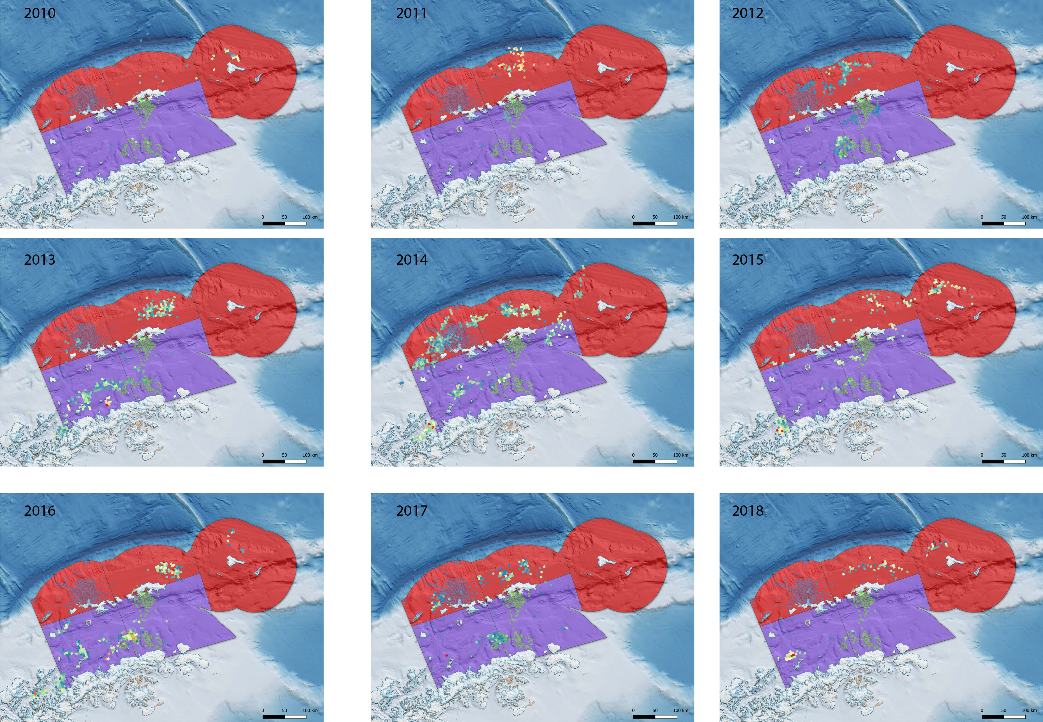
C1 Catch and Effort data for 2010 - 2018, for all catches during the period of the austral summer relating to Adélie and chinstrap penguins in Subarea 48.1 (i.e. up to ${10}^{th}$ March). The telemetry data presented in Hinke et al. 2017 for chinstrap penguins at both Cape Shireff and Copacabana and the gSSMU used in the Watters et al. 2020 paper are superimposed to highlight the extreme variability in actual catch, relative to the scale of LHR used to reflect interactions with penguins. Our reanalysis re-scaled LHR to the SSMU level, though we contend that for the purposes of matching predator data at appropriate spatial scales even this is too coarse a resolution.
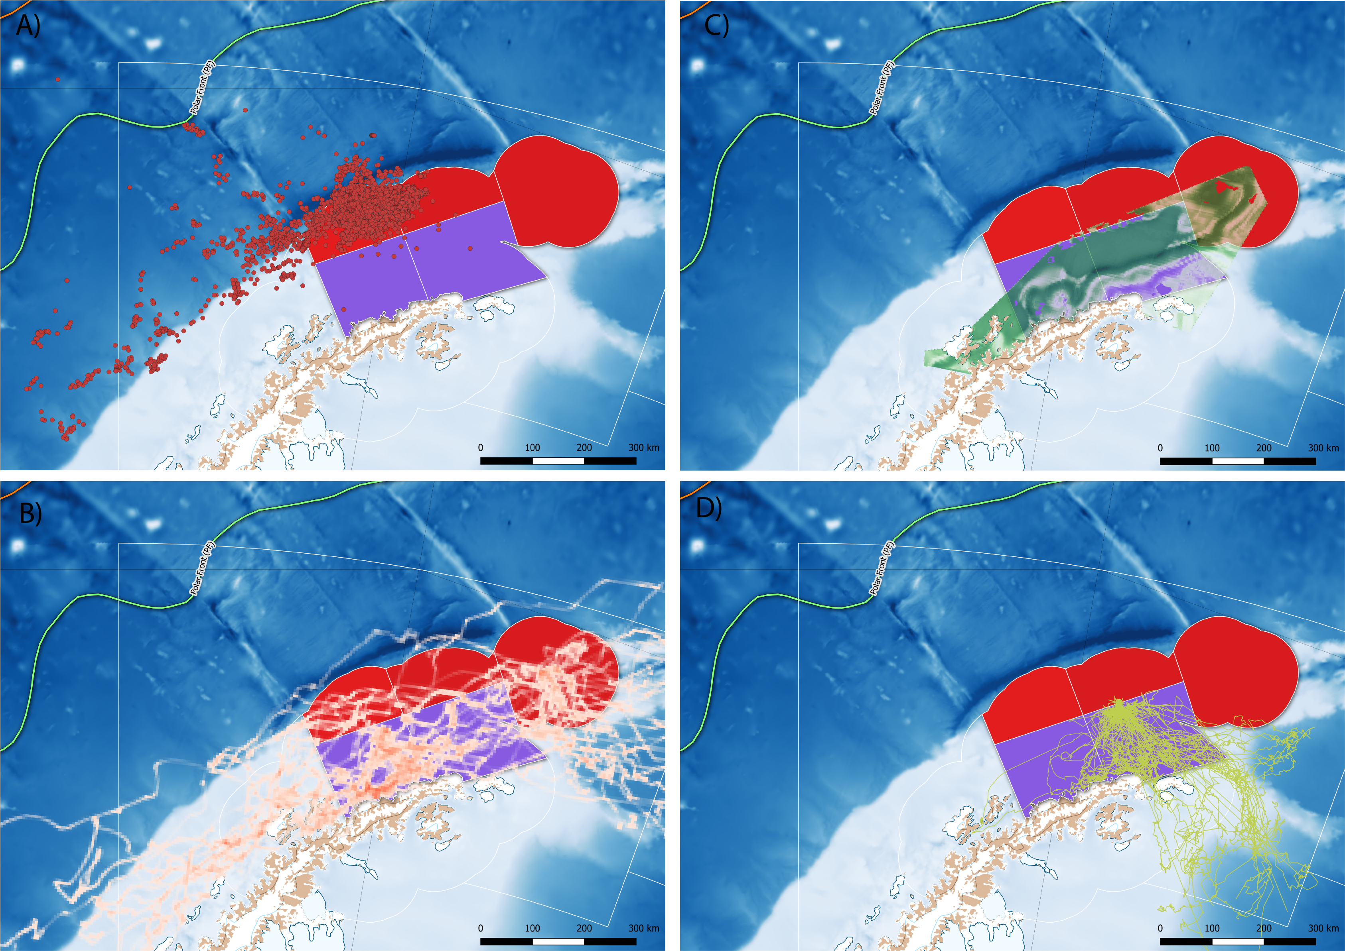
The summer distribution of foraging effort by A) adult female Antarctic fur seals (adapted from telemetry data available in Hinke et al. 2017), B) migratory adult male Antarctic fur seals (adapted from Lowther et al. 2020) C) humpback whales throughout December (adapted from Johannessen et al., this meeting) and D) nonbreeding adult Adélie penguins during the breeding season (adapted from data in Oosthuizen et al., this meeting). Potential effects of competitive overlap between pygoscelid penguins and other krill dependent predators, particularly those who have increased their abundance dramatically over the preceding 40 years, are excluded from both approaches, creating an unrealistic set of boundary conditions for interpreting the variance in penguin vital rates.

Citations
Watters, George M., Jefferson T. Hinke, and Christian S. Reiss. 2020. “Long-Term Observations from Antarctica Demonstrate That Mismatched Scales of Fisheries Management and Predator-Prey Interaction Lead to Erroneous Conclusions about Precaution.” Scientific Reports 10 (1). https://doi.org/10.1038/s41598-020-59223-9.

