A Rebuttal to Watters et al. (2020): Misinterpretation of Predator-Prey Dynamics leading to erroneous Precautionary Management in Antarctic Krill Fisheries
2025-11-19

A. Analysis of Survey Coverage
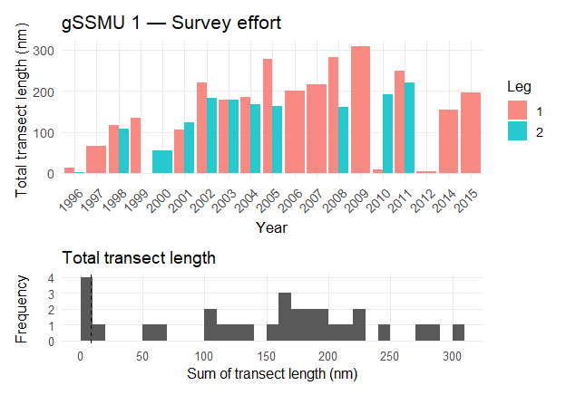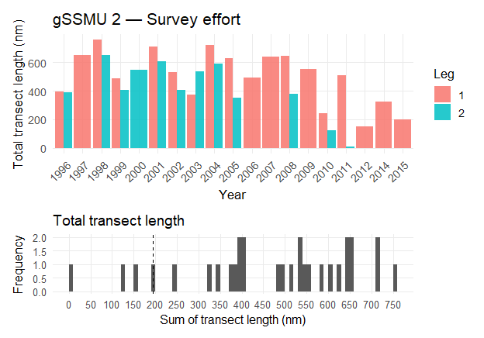
Figure S1. Survey coverage (total transect length surveyed) by gSSMU and year (up). Frequency distribution of total transect length, including the 10th percentile (dashed line) is shown below.

B. Imputed summer LKB values

Citations

