A rebuttal to Watters et al. ´2020 Long-term observations from Antarctica demonstrate that mismatched scales of fisheries management and predator-prey interaction lead to erroneous conclusions about precaution´
2025-12-04

Tables:
Table 1: Estimations of mean and sd of Ln(LKB), as per Equation (2) (Watters et al. 2020), and xx test between -/+ SAM values within each gSSMU. THe equivalent LKB value is given in ‘mean LKB’.
gSSMU | sam.sign | n | mu | sd | p-value | Mean_LKB
1 | Neg | 6 | 13.643 | 1.315 | 0.264 | 841401.3
1 | Pos | 10 | 14.315 | 0.994 | NA | 1647467.9
2 | Neg | 6 | 14.809 | 0.681 | 0.097 | 2701181.9
2 | Pos | 10 | 15.512 | 0.792 | NA | 5456188.0

Figures:
Figure 1. Location of the penguin colonies (COPA and SHIRREF), gSSMU # and #2, and SSMUs ().
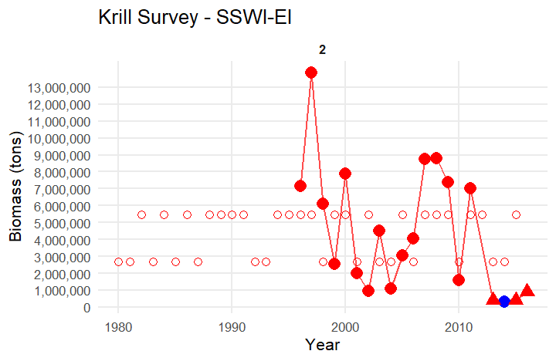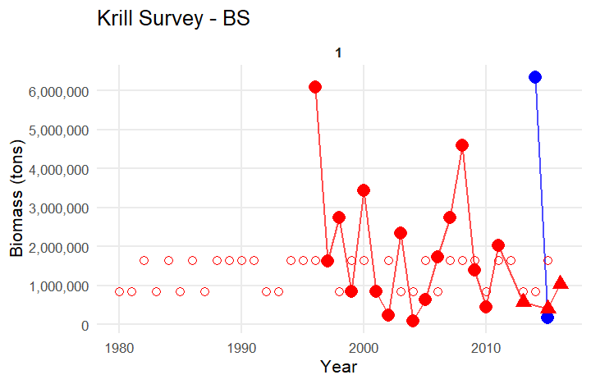
Figure 2. Krill survey estimates (LKB) for the study period. Top: gSSMU #2 (SSIW-EI); Bottom:gSSMU #1 (BS). Filled circles: Survey data from Watters et al. (2020); Open circles: mean imputed median LKB-value for -/+ SAM; filled triangles: survey data from Wang et al. (2025).
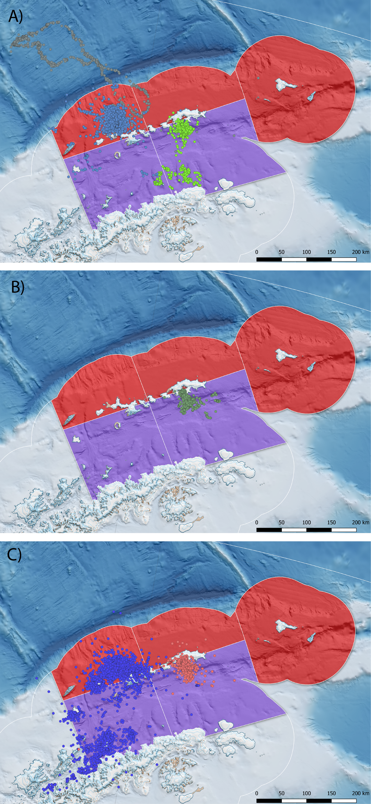
Penguin foraging behaviour during summer breeding, derived from available ARGOS-CLS PTT data presented in Hinke et al. 2017. A) Chinstrap penguins from Cape Shireff (blue) and Copacabana (green) truncated at ${10}^{th}$ March in line with known phenology (Black 2016; Lowther et al.(this meeting). Elongated grey track represents a single animal) B) Adélie penguins truncated to the end of January and C) gentoo penguins until August, representing all available PTT data provided. The SSMU are combined and coloured according to gSSMU (red; gSSMU 2, purple; gSSMU 1) with chinstrap and Adélie penguin 99% MCP home ranges occupying between 7-19% of the gSSMU to which they were assigned.
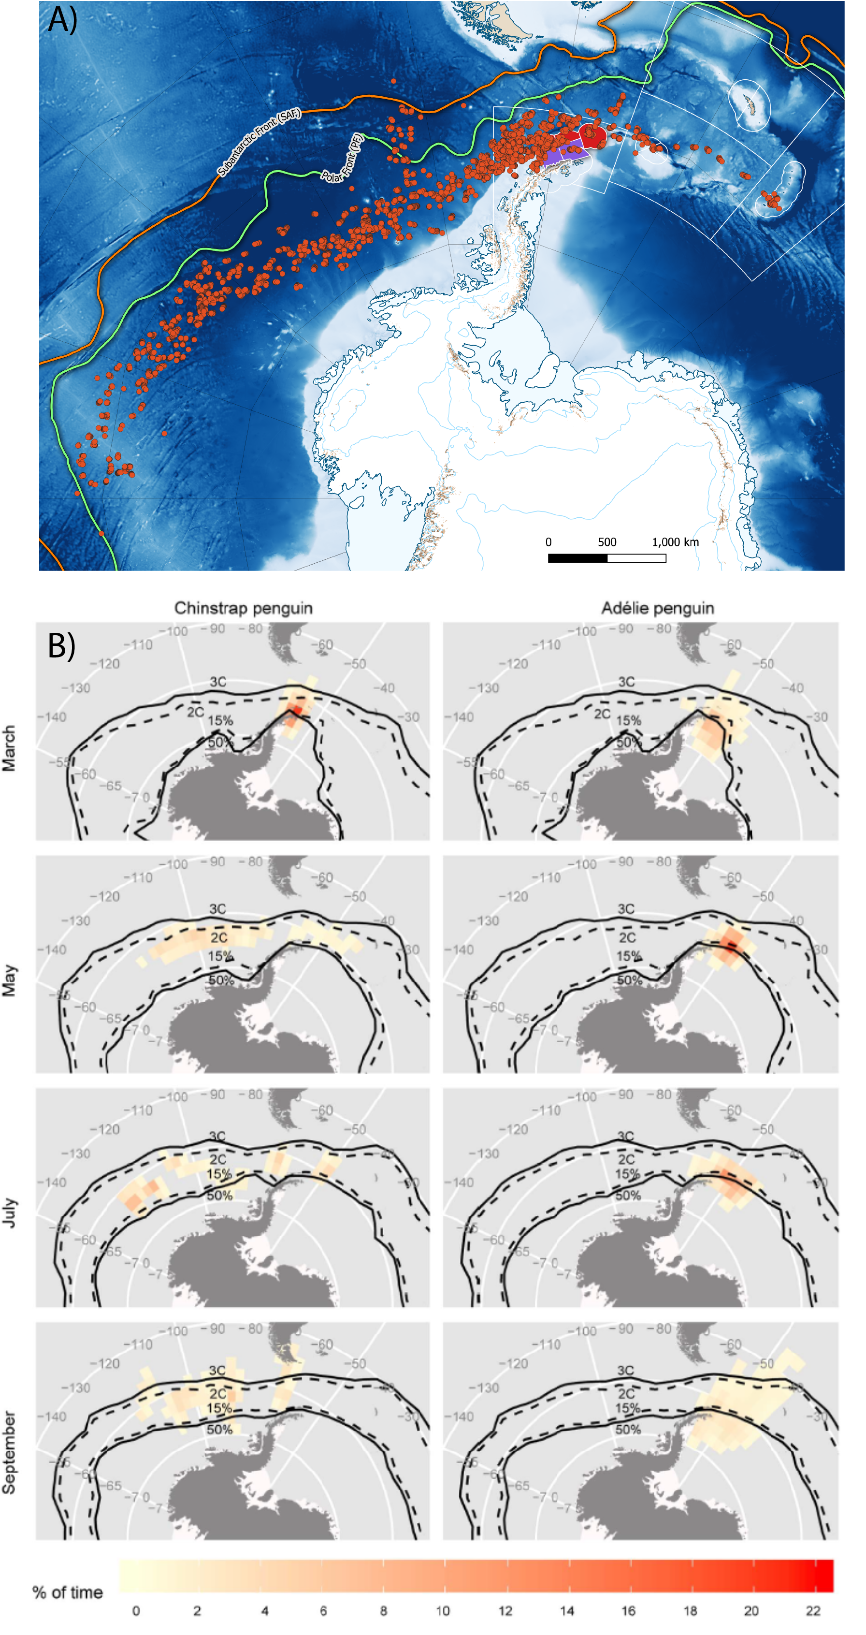
A) Distribution of overwinter movement for chinstrap penguins, relative to the gSSMU’s to which they were attributed, created from telemetry data available in Hinke et al. 2019. B) Adélie and chinstrap penguin movement recorded by light geolocators, highlighting the large longitudinal range both species disperse through at the end of breeding (taken from Hinke et al. 2015). In the original model formulation by Watters et al. 2020, the winter performance indices for both species are matched to macroscale levels of ONI variability but gSSMU-scale estimates of LKB and LHR.
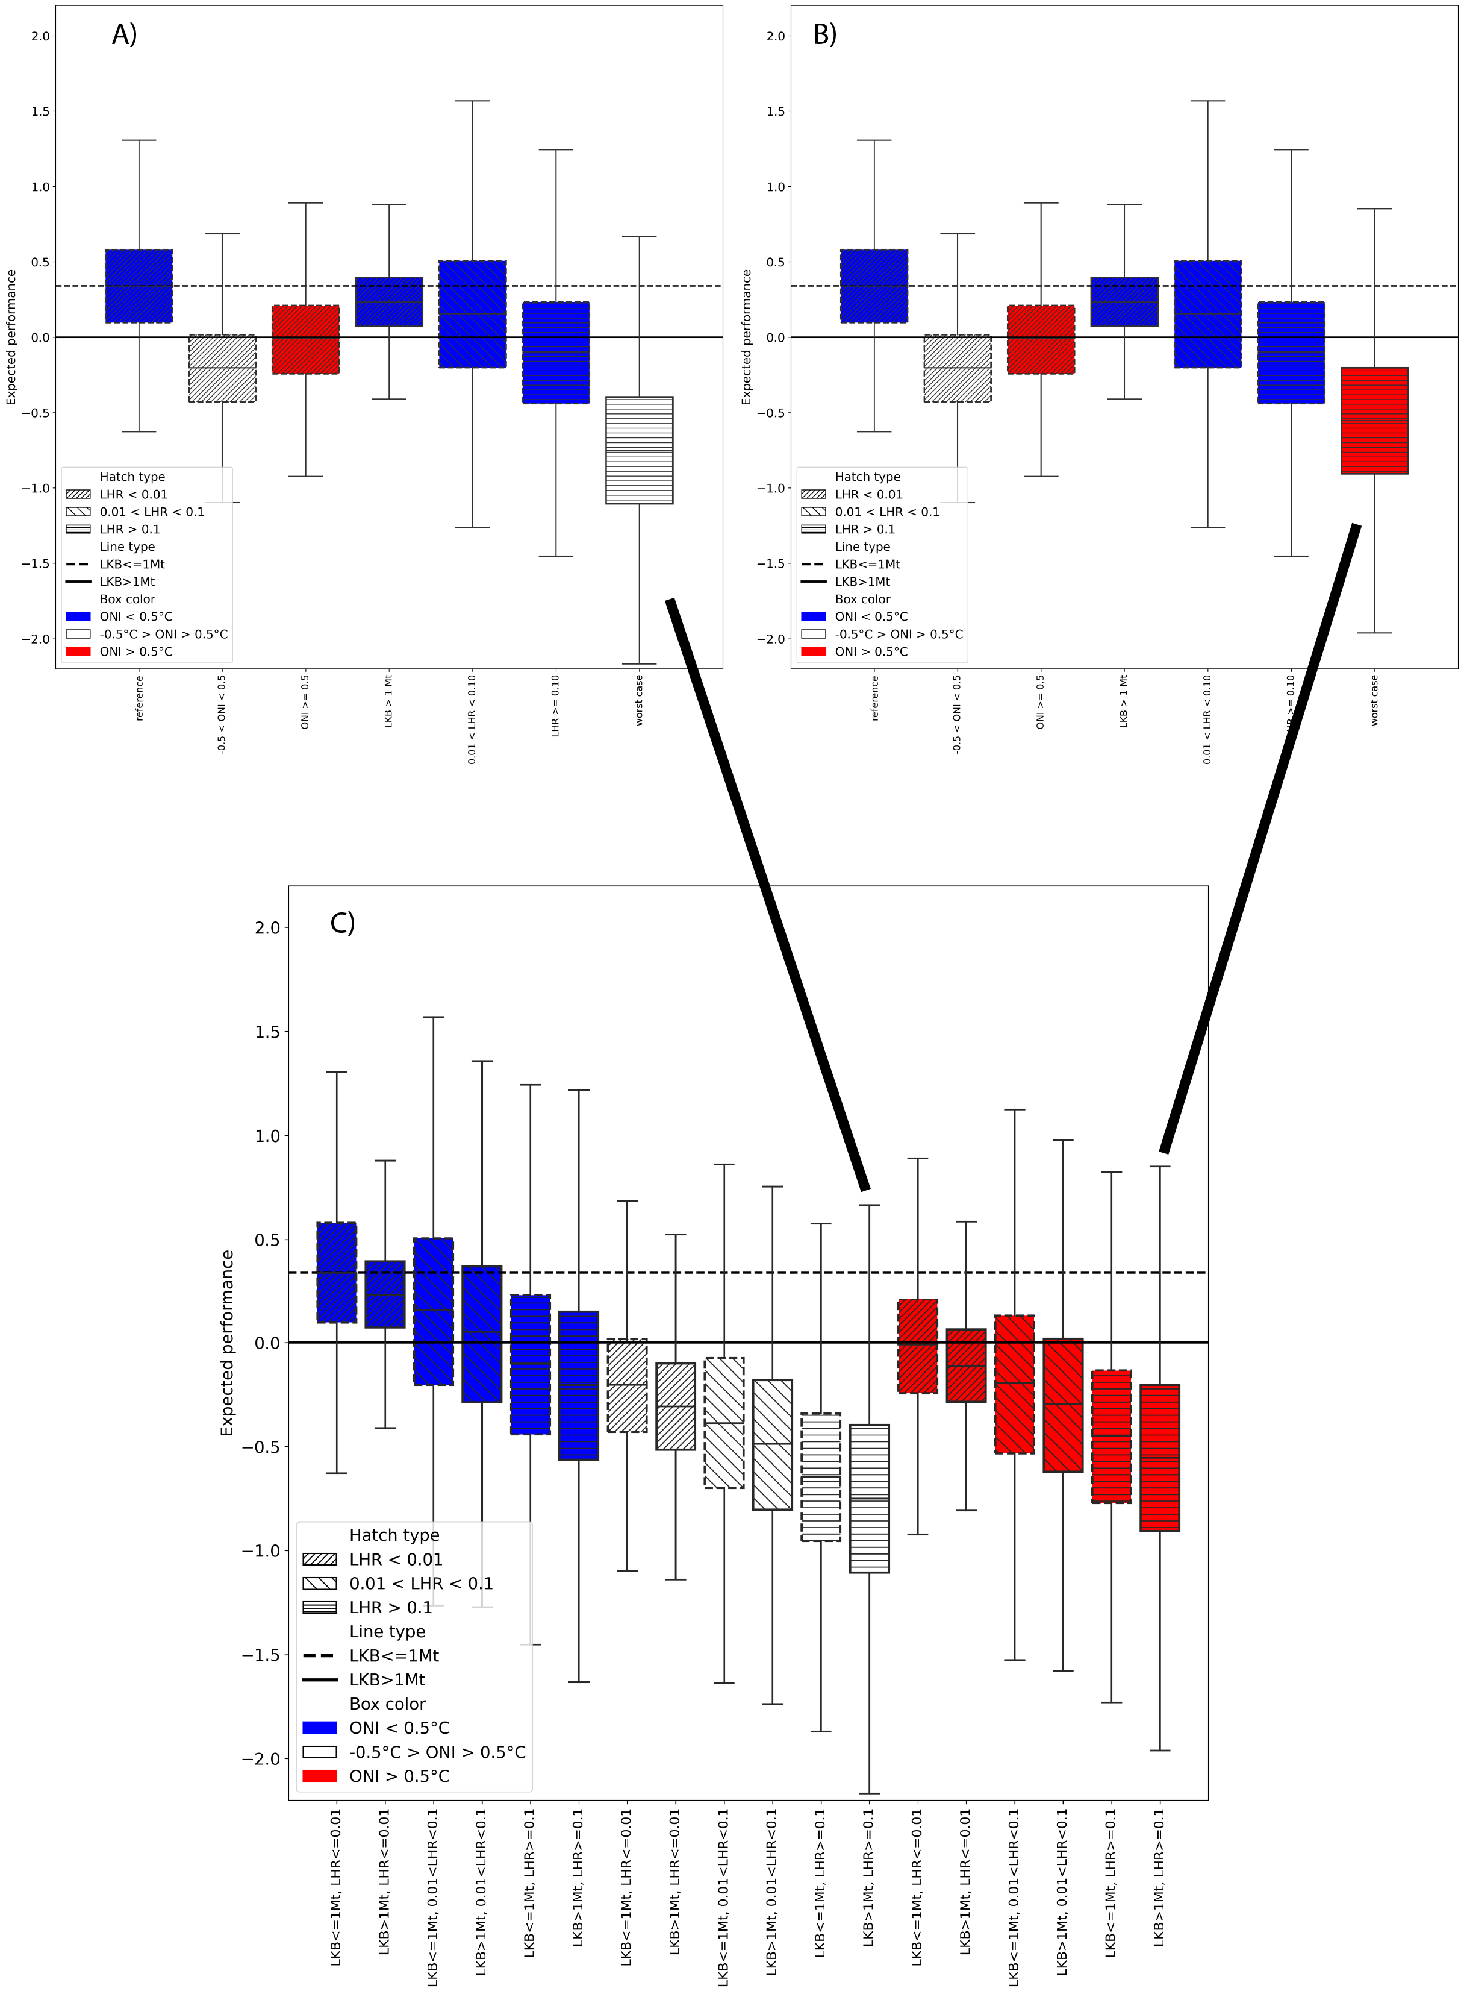
Original Figure 1 plot from Watters et al. 2020 with A) Neutral ONI and B) B) Warm ONI constituting the Worst Case selected. C) Displays the original case-by-case plots recreated from the paper, with Case 12 representing the intention while data from Case 18 was selected for rendering the boxplot. Note that the expected performance under neutral ONI Worst Case is poorer than under the warm ONI that was presented in the original paper. Henceforth, to facilitate comparison, we refer to the ONI Neutral plot however we consider this unrealistic if the intention is to portray a Worst Case of a continuing warming climate.
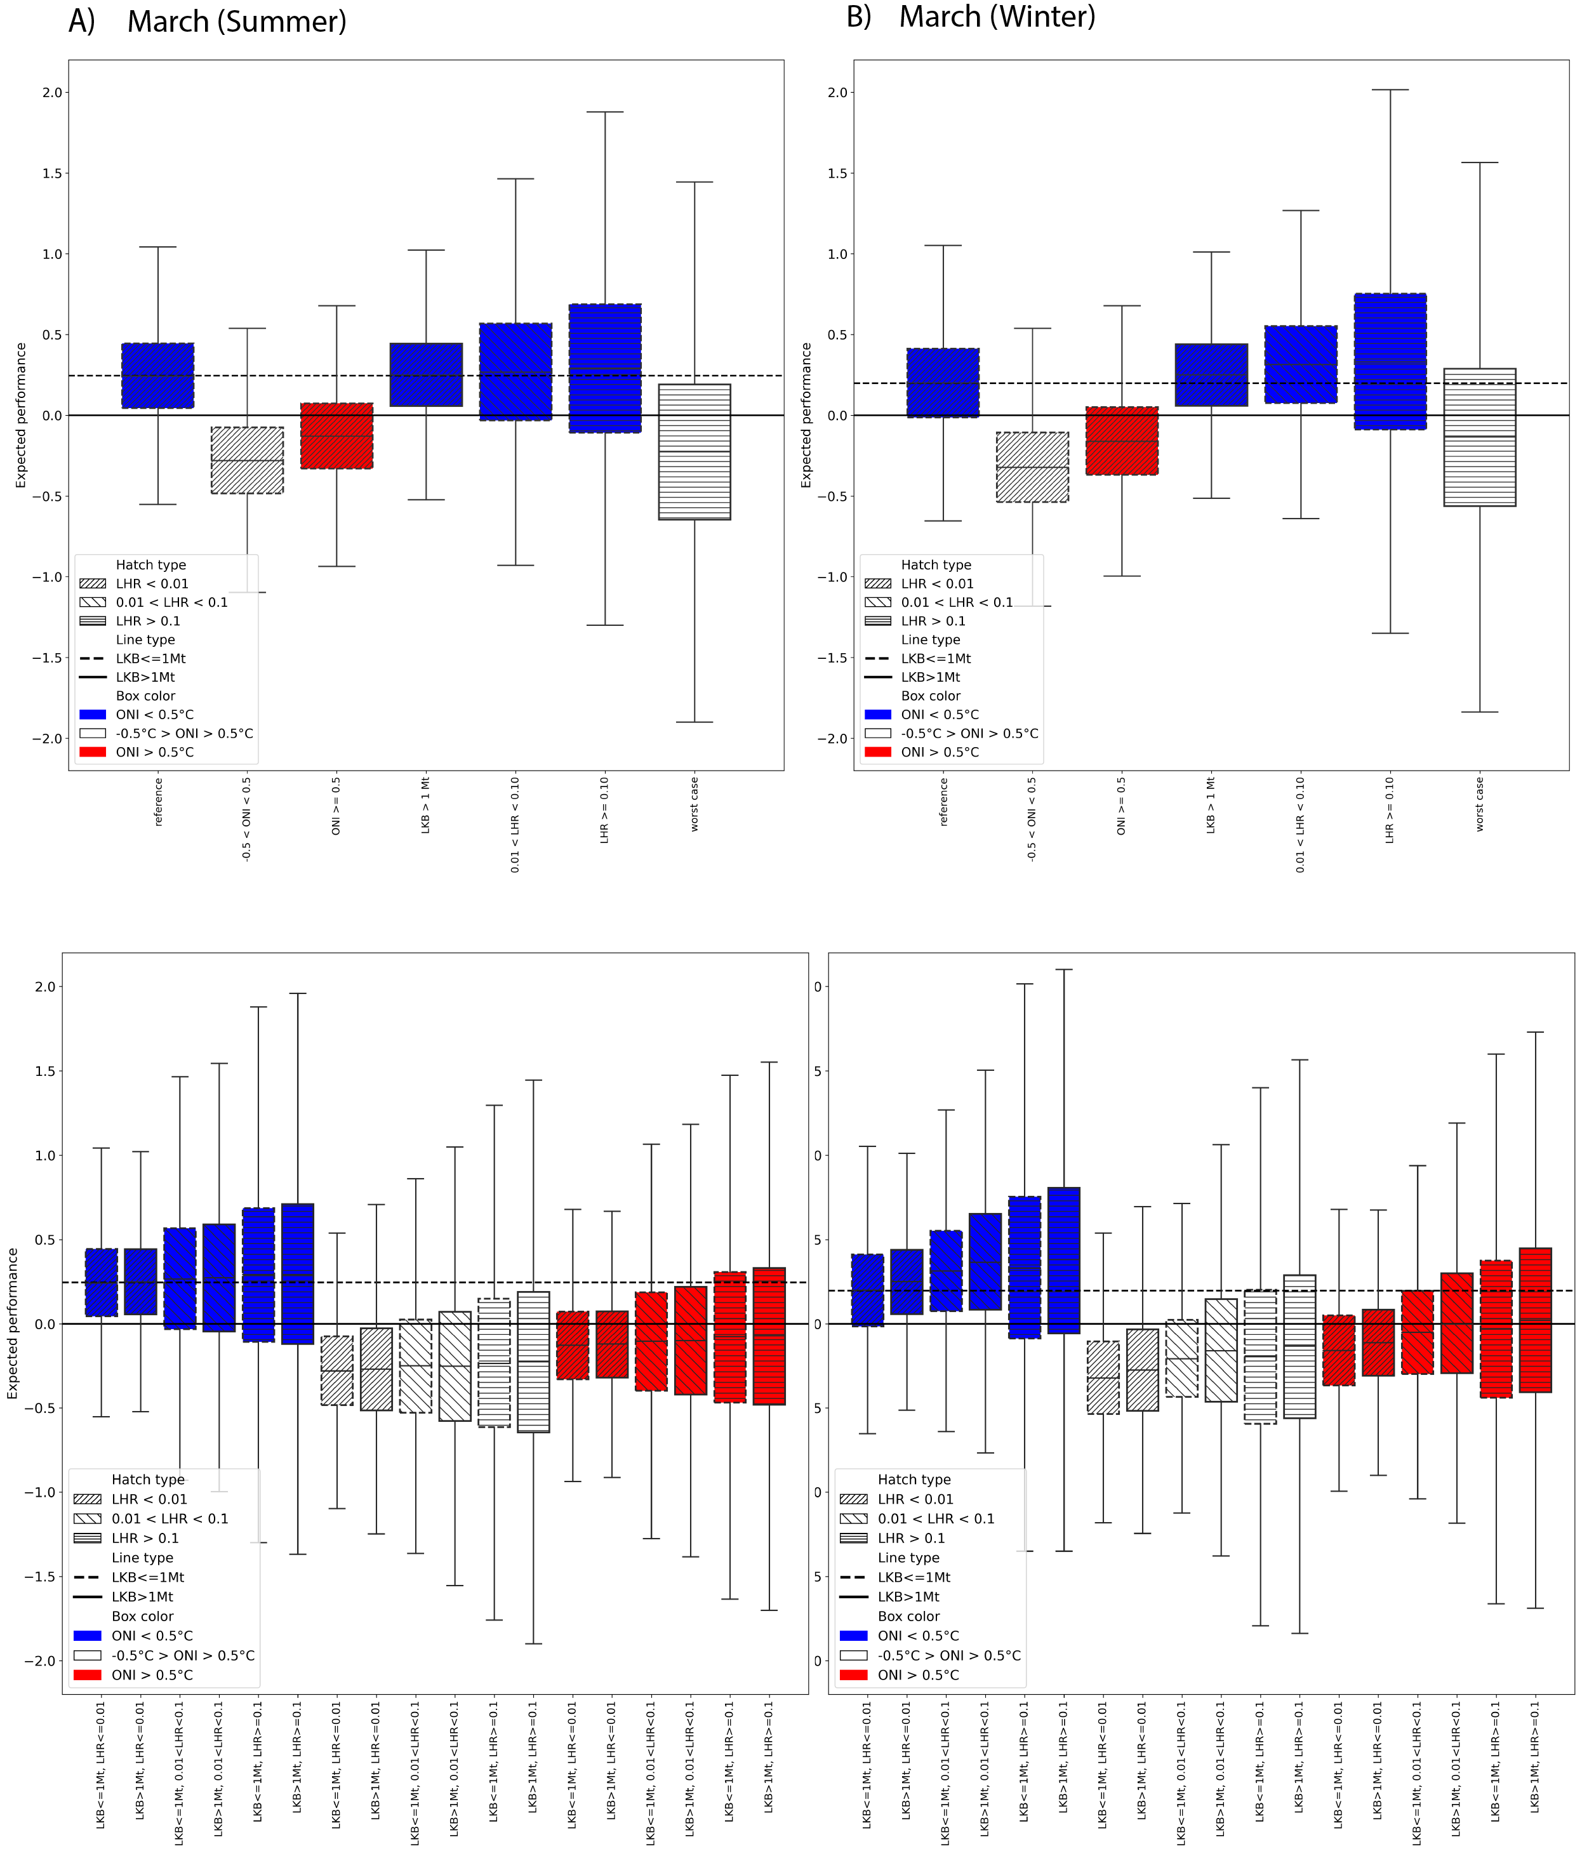
Model output for the alternatve Watters et al. 2020 scenario outlined above (all species initially present, Adélie and chinstrap penguins migrate out of the area after breeding, LKB and LHR rescaled to SSMU and March included in summer or winter). Selected cases as per Watters et al. 2020 for March in A) Summer and B) Winter are provided, with the corresponding case-by-case boxplots presented beneath. Boxplots are colour-coded by ONI state (red=warm, white=neutral, blue=cold). In all cases, the marginal effect of ONI dominated the expected performance of penguins against their long-term mean, irrespective of LKB or LHR.

Citations

