

Langendijk's localization model

Documentation

Vienna, September 2010

Robert Baumgartner
Acoustics Research Institute
Austrian Academy of Sciences
Contents
1 Introduction 3
2 Matlab functions (help texts) 4
2.1 langendijk 4
2.2 plotlangendijk 6
2.3 likelilangendijk 7
2.4 plotlikelilangendijk 8
3 Matlab scripts 9
3.1 demo_langendijk 9
3.2 spatstrat_langendijk 11

Introduction
Humans use spectral cues for localization on vertical plane and for high-frequency sources above 6kHz. These cues are coded in the directional part of the head related transfer function (DTF) which appears very individually mainly because of human's pinna.
In order to get some information about the modality of spectral cue analysis in auditory systems Langendijk et al. (2002) [Lang02] proved the effect of distorting different spectral information within a certain frequency band on localization skill. Interindividual spreads in response patterns let assume that each person uses different cues according to its DTF.
Thus Langendijk's localization model tries to predict individual response patterns in the median plane by comparing DTFs for target and response directions.
In this model the auditory system is assumed to compare the spectrum of the signal arriving at the eardrums with a template of stored DTFs as described in previous studies ([Mid92][Zaka93]). The following flow chart should explain which signal processing steps have to calculated for the simulation:

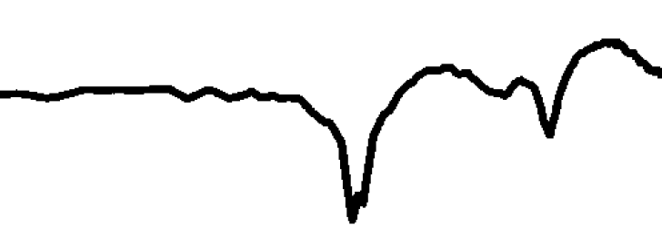

Figure 1: Flow chart for Langendijk's localization model
pdf of response distribution
DTF
of target position

Filter bank
(Basilar membran)
[bw]...bandwidth
Differentiator
(Zakarauskas)
[do]...diff. order
Comparison
process
[cp],[s]
Memory

Matlab functions (help texts)

langendijk

Usage:
- [ p ] = langendijk( ir1,ir2 )
- [ p ] = langendijk( ir1,ir2,stim )
- [ p ] = langendijk( ir1,ir2,bw,do,cp,s,bal,fstart,fend )
- [ p ] = langendijk( ir1,ir2,bw,do,cp,s,bal,fstart,fend,stim )

Input parameters:
- ir1: modified impulse responses of DTFs for all positions and both ears (sorted);
matrix dimensions: time x position x channel
- ir2: stored impulse responses of DTF-templates for all positions and both ears (sorted)
- bw: bandwidth of filter bands as partial of an octave; default: 6
- do: differential order; default: 0
- cp: comparison process; 'std' (default) or 'xcorr'
- s: standard deviation of transforming Gaussian function; default: 2
- bal: balance of left to right channel; default: 1
- fstart: start frequency of filter bank; min: 0,5kHz; default: 2kHz
- fend: end frequency of filter bank; default: 16kHz
- stim: applied stimulus for localization test (optional)

Output:
p = langendijk( ir1,ir2,... ) results to a two dimensional matrix p. The first dimension represents all possible response positions in increasing order and the second dimension all possible target respectively source positions. Consequently each column describes the probability density function of the response distribution for one special target position.
If you want to plot this matrix please use plotlangendijk.

Short description of integrated functions:
Langendijk executes the flow chart described in the introduction above for every target position in order to get a probability density function (pdf) for each possible source position.
Halvconv calculates a fast convolution if also a special auditory stimulus is given to locmodel. Because the modified input signal will be needed in frequency domain afterward no inverse Fourier transform takes place.
Averagingfb is a filter bank which simply averages single spectral lines and thus describes a filter bank with ideal rectangular filters. In order to get into frequency domain the built-in fft function was used. The discrete values of gain response (in dB) are averaged in 1/bw-octave bands using:
.
whereis the first bin in the jth 1/bw-octave band and the number of bins in that band .
In addition to the parameter bw defining the filter bandwidth also the start and end frequencies can be diversified.
Furthermore averagingfb recognizes whether the input signal is already in frequency domain by observing the imaginary part of it.
The built-in function diff differentiates input signals according to:
.
The differential order is defined in parameter do.
Langecomp describes the comparison process cp and distinguishes between two kinds of comparing a input spectrum with a template of stored DTFs.
The first one is called standard deviation method ('std') and evaluates the standard deviation of the spectral difference according to:
.
Afterward this standard deviation will be transformed by a Gaussian normal distribution function because it is accepted that smaller errors are more probable than greater ones.

In this case parameter s defines the standard deviation of the transforming function.
In order to get real pdfs the cumulative sum needs to be set to one by:
.
The second kind of comparison process is called crosscorrelation method ('xcorr').
In this case the height of similarity is evaluated by the correlation coefficient. In order to get values between 0 and 1 the result has to be added with 1 and divided by 2.

plotlangendijk

Usage:
- plotlangendijk( p,rang,tang )
- plotlangendijk( p,rang,tang,name )
- plotlangendijk( p,rang,tang,name,latang,delta,deltat,cond )
- plotlangendijk( p,rang,tang,name,latang,delta,deltat,cond,colbar )

Input parameters:
- p: pdf-matrix for all target and response positions
- rang: polar angles of possible response angles
- tang: polar angles of possible target angles
- name: string for title OR
commit also latang, delta, deltat and cond to generate title automatically
- colbar: switch for plotting colorbar-legend, use string 'colorbar' for switching on

Output:
The simulation result p of Langendijk's localization model will be plotted in a gray colored map.
In order to get comparable results to [Lang02] a special colormap called LangendijkColormap was generated and will be loaded during calculation process.
If you want to compare the model's prediction with actual response patterns plot it while holding on, e.g.:
plotlangendijk(p,rang,tang,'P6; baseline');
hold on; h=plot( target, response, 'ko'); set(h,'MarkerFaceColor','w')

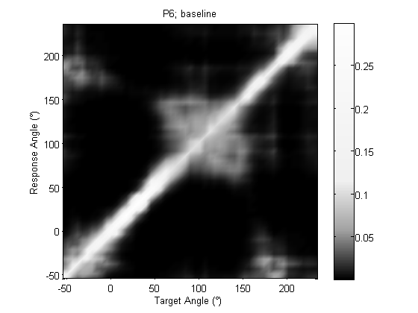Figure 2: Example for localization prediction
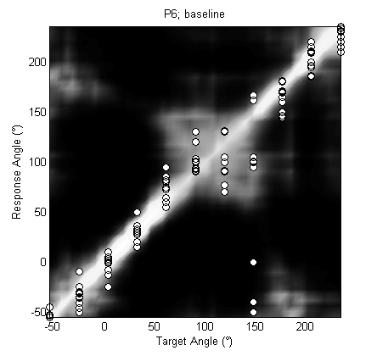Figure 3: Prediction and actual response pattern

likelilangendijk

Usage:
[ la,le,ci ] = likelilangendijk( p,rang,tang,target,response )

Input parameters:
- p: pdf-matrix for all target and response positions
- rang: polar angles of possible response angles
- tang: polar angles of possible target angles
- target: target angles of localization test
- response: actual response angles of localization test

Output parameters:
- la: actual likelihood
- le: expected likelihood
- ci: 99% confidence interval

Description:
Likelilangendijk proofs the model performance by the following log-likelihood estimation:
.
Moreover two kinds of estimations will be calculated. The first one is called actual likelihood la and evaluates Langendijk's prediction matrix on points of actual response patterns.
For the second one equivalent response patterns will be generated randomly according to the pdfs calculated before. This likelihood estimation will be done 100 times and averaged at the end. As result likelihood provides the mean value as estimated likelihood le and the 99% confidence interval.

plotlikelilangendijk

Usage:
- plotlikelilangendijk( la,le,ci )
- plotlikelilangendijk( la,le,ci,tit )

Input parameters:
- la: actual likelihood
- le: expected likelihood
- ci: 99% confidence interval
- tit: set to 'spatstrat' optionally (adapted for ARI's spatstrat project)

Description:
Plotlikelilangendijk plots the resulting likelihood statistic in a bar graph with errorbars. The bars represent the actual likelihoods and the smaller errorbars with the dot in between describe the estimated likelihood and its 99% confidence interval.
Furthermore four lines are visible behind the bars which represent the likelihood estimation for a flat response distribution (uniform chance) and a uni-, bi- or trimodal Gaussian response distribution (sigma of 17°).

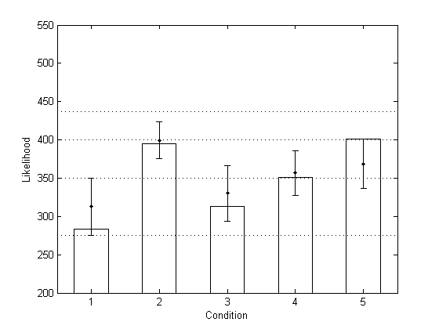Figure 4: Likelihood statistics for P6

Matlab scripts

demo_langendijk
demo_langendijk2002 contains the validation of Langendijk's simulation results for two of his listeners P3 and P6. The DTF data of these two probands could be reconstructed by the two figures (F.11) given in [Lang02] and the response patterns were extracted out of figures F.7 and F.9.
In order to digitize the DTF data the functions bmp2gr and gr2ir were used. If you do not have the bitmaps of the JASA paper the function data_langendijk2002 commits the calculated mat-files hrtf_M_langendijk2002 P3 and hrtf_M_langendijk2002 P6 containing the DTF data converted to ARI format. Moreover data_langendijk2002 also contains the reconstructed response patterns for both probands.
Because the calculations take too much time the reconstructed results for all conditions are saved in two further mat-files called langendijk2002 P3 and langendijk2002 P6 and will be loaded in demo_langendijk2002.
Unfortunately only left-ear DTFs are published in Langendijk's paper with an inaccuracy of 5dB. Consequently it is not possible to reconstruct his results exactly which can be seen at the following pictures comparing some results of the implementation with the images published in [Lang02].

Baseline condition of P6:
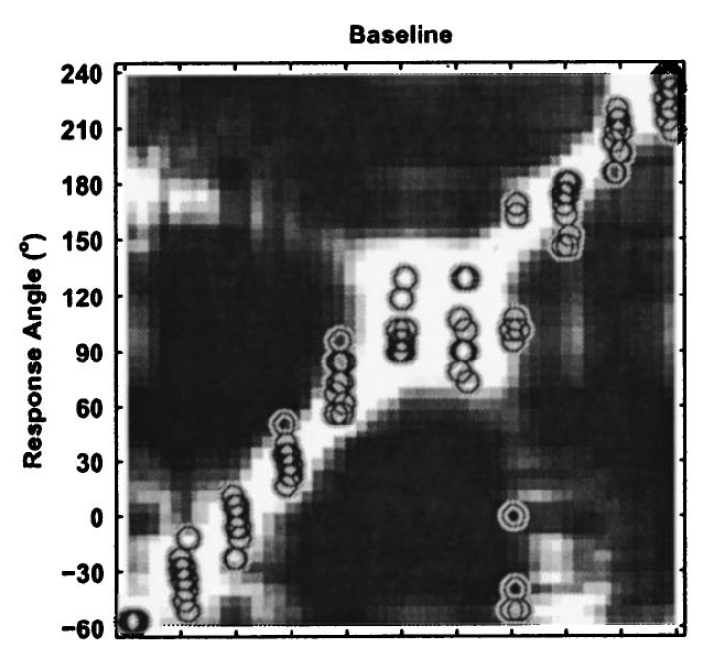
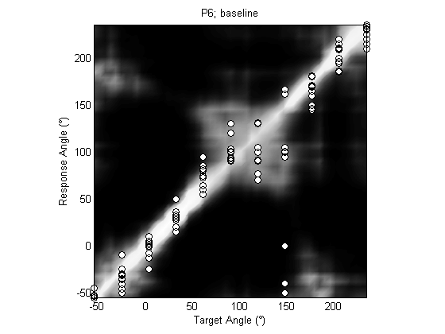

Figure 5: Baseline condition of P6, [Lang02]
Figure6: Baseline condition of P6, Implementation

2-octave condition of P6:
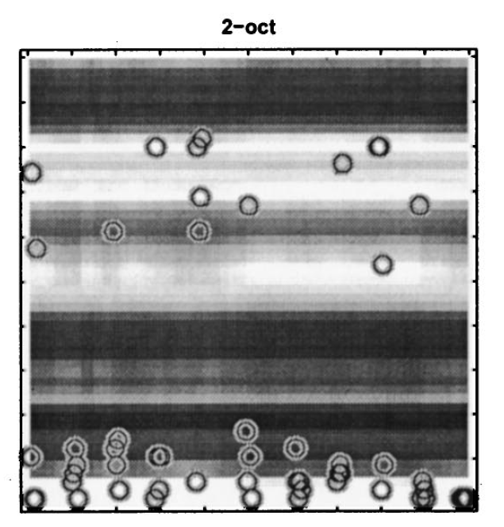
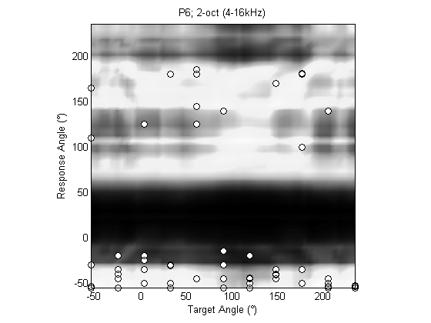

Figure 7: 2-octave condition of P6, [Lang02]
Figure8: 2-octave condition of P6, Implementation
1-octave (middle) condition of P6:
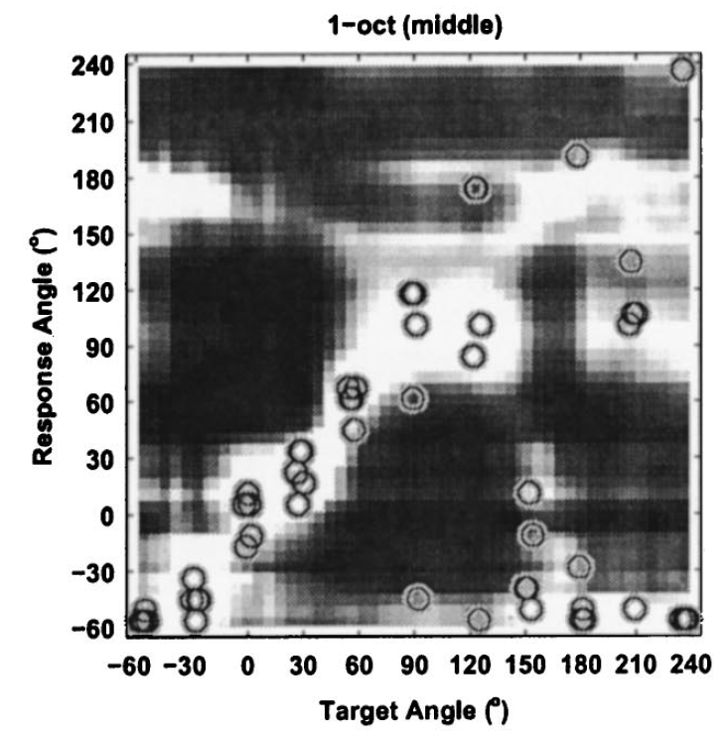
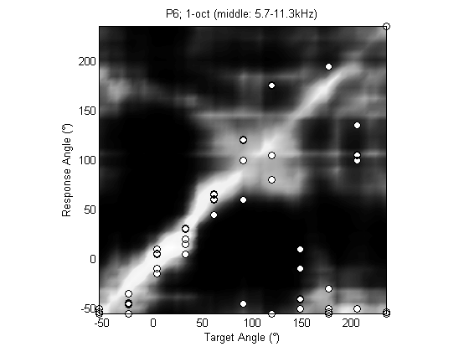
Figure 9: 1-oct (mid) condition of P6, [Lang02]
Figure10: 1-octave (middle) condition of P6, Implementation
likelihood statistics of P6:
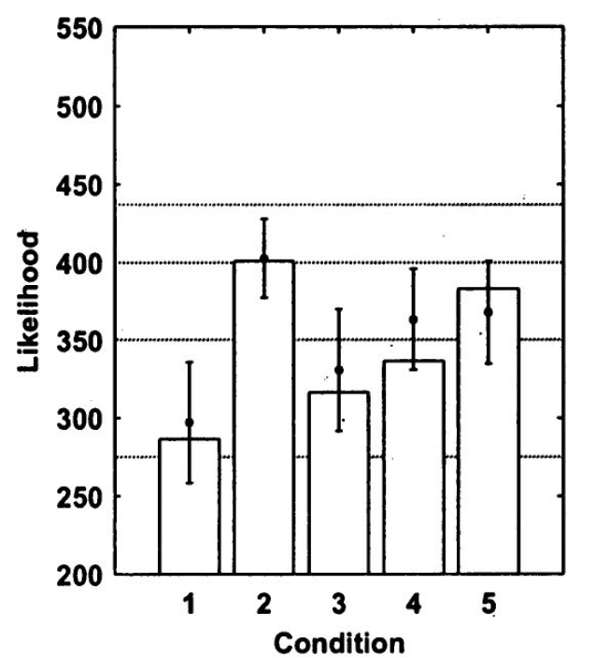
Figure 11: Likelihood statistics of P6, [Lang02]
Figure 12: Likelihood statistics of P6, Implementation

spatstrat_langendijk
spatstrat_langendijk contains an appliance of Langendijk's localization model on ARI's “Spatstrat” experiments and examines the “PreTest” response patterns.
The following pictures show the results for one proband:

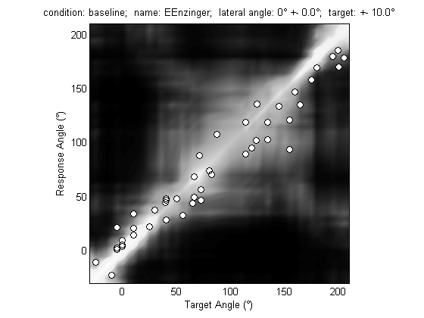

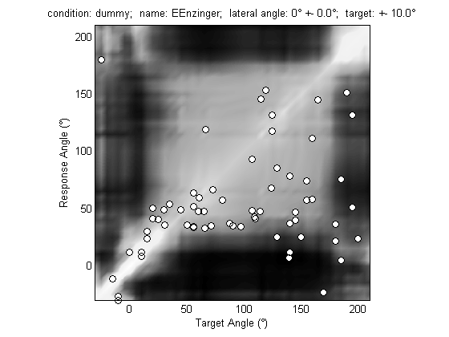
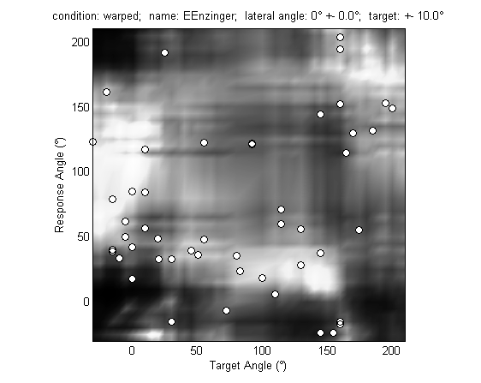

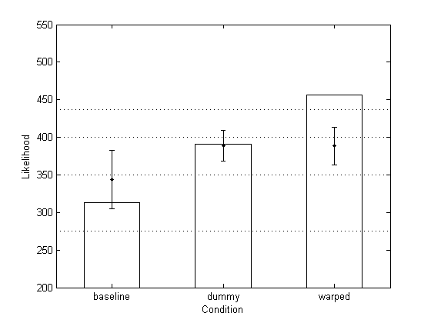
References
Lang02: Erno H. A. Langendijk and Adelbert W. Bronkhorst, Contribution of spectral cues to human sound localization, 2002
Mid92: John C. Middlebrooks, Narrow-band sound localization related to external ear acoustics, 1992
Zaka93: Pierre Zakarauskas and Max S. Cynader, A computational theory of spectral cue localization, 1993

