Wii RetroPad Adapter User Manual
Rev. 1.1 - 10/12/2011

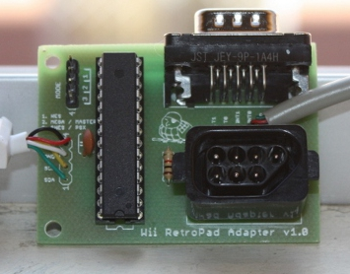

Connecting the adapter to the Wiimote:

- Disconnect the adapter from the Wiimote before plugging in any joystick or changing the mode jumper;
- Select the desired joystick port from the mode jumper. Available modes are: 1 - NES to select the NES port and using a NES joystick, 2 - MEGA/MASTER to select the DB9 port and using a Sega Genesis/MegaDrive, Sega Master System or Atari 2600 joystick or 3 - SNES/PSX to select the extension cable for using either a SNES or a PS2 joystick, depending on your adapter’s model;
- Plug your classic joystick in the selected port. DO NOT plug more than one joystick in the adapter!
- Plug the adapter in the Wiimote. It will be recognized as a Wii Classic Controller by the Wiimote
- Play! :)

Button Mappings:

Old-school  Joystick | Wii Classic Controller button mapping
Old-school  Joystick | D-Pad | Y | B | X | A | + | - | HOME | Left  Analog | Right  Analog | L | R | ZL | ZR
NES | D-Pad | - | B | - | A | START | SELECT | UP+START | - | - | - | - | - | -
Super NES | D-Pad | Y | B | X | A | START | SELECT | UP+START | - | - | L | R | - | -
Sega Genesis | D-Pad | A | B | Y | C | START | MODE | UP+START | - | - | X | Z | - | -
PS2 | D-Pad | [ ] | X | /\ | O | START | SELECT | UP+START | Left  Analog | Right  Analog | L1 | R1 | L2 | R2

Additional information:

- There are currently two models for the Wii RetroPad Adapter: PS2 and SNES. Both are 3-in-1 adapters (i.e., they have a DB9 connector, a NES 7-pin connector and an extension cable). The difference between them is that the PS2 model has an extension that supports PS2 joysticks and the SNES model has an extension that supports Super Nintendo joysticks.
- As of today, the adapter only supports the analog stick if using a PS2 controller (supported only in the PS2 model, not supported in the SNES model).
- PS2 joystick rumble is not supported.
- For additional information, please go to http://www.brunofreitas.com/?q=node/35

