

Lesson 1

Circles Competition Time: 5 minutes
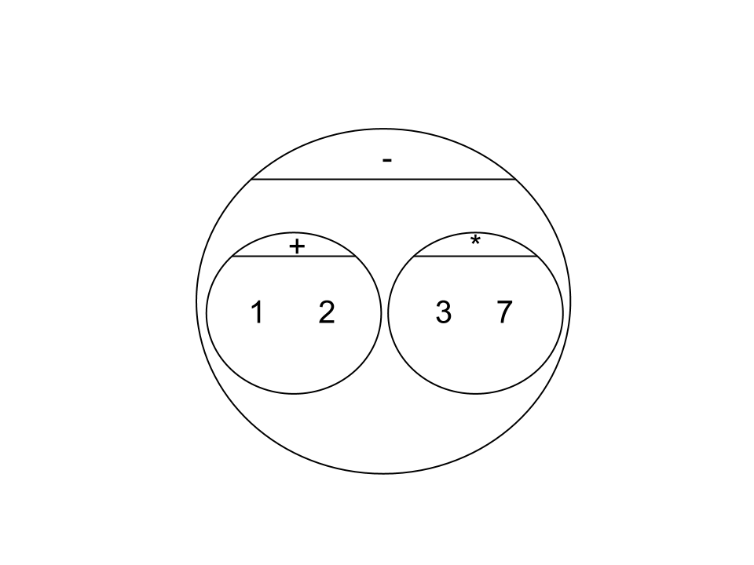 | Math | Circle of Evaluation | Scheme Code
Round 1 | 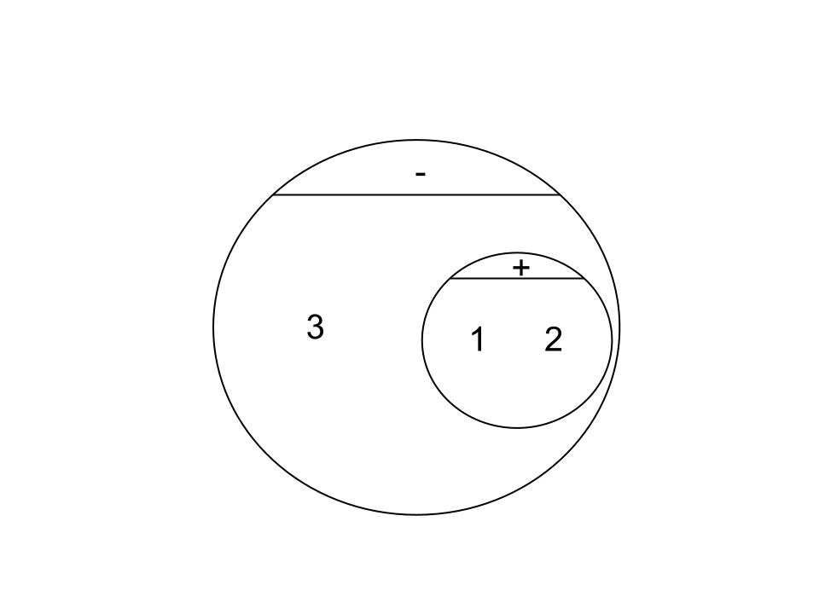  (1 + 2) - (3 * 7) |  | (- (+ 1 2) (* 3 7))
Round 2 | 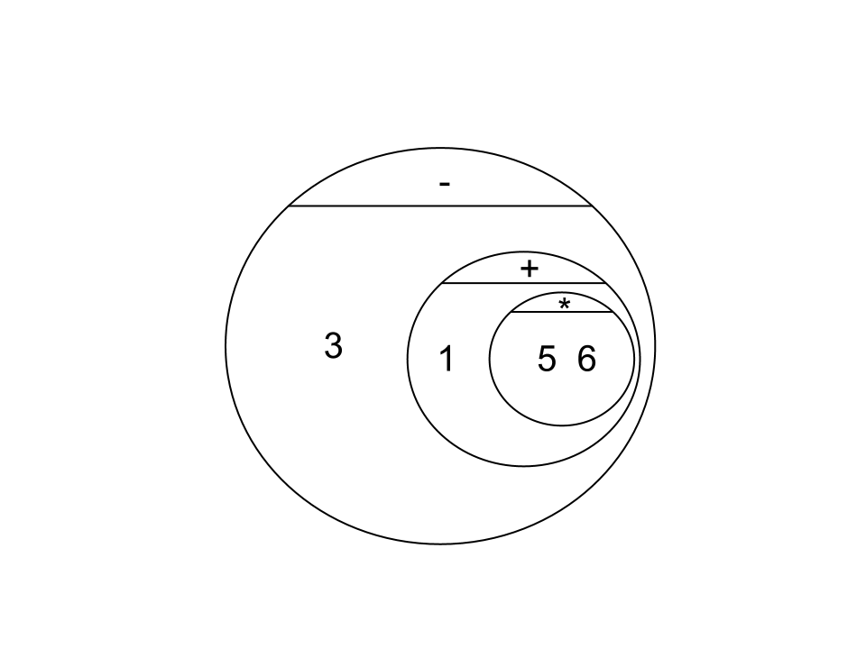  3 - (1 + 2) |  | (- 3 (+ 1 2))
Round 3 | 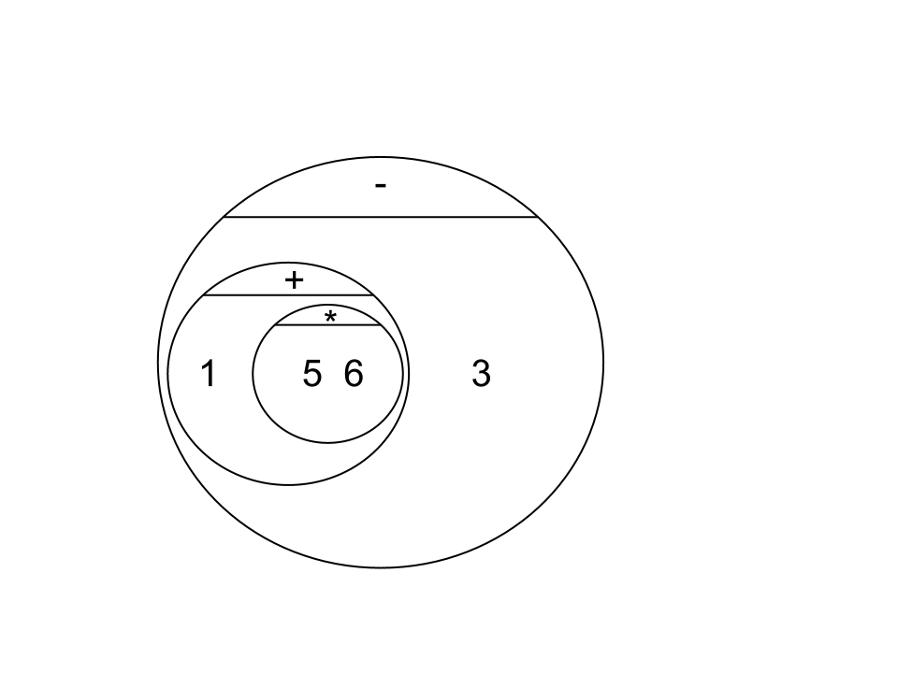  3 - (1 + (5 * 6)) |  | (- 3 (+ 1 (* 5 6)))
Round 4 | (1 + (5 * 6)) - 3 |  | (- (+ 1 (* 5 6)) 3)


Fast Functions!
Fill out the contract for each function, then try to write two examples and the definition by yourself.
; _double____________:__Number________ -> _Number________
name domain range
(EXAMPLE (_double_ __5__) _( * 2 5 )_____________)
(EXAMPLE (_double_ __7__) _( * 2 7 )_____________)
(define (__double_ _n____) _( * 2 n )________________)
; _triple_________ : __#____________ -> __#______________
name domain range
(EXAMPLE (triple_ 7____) __(* 3 7)______________)
(EXAMPLE (triple_ 9____) __(* 3 9)______________)
(define (_triple_ _n__) ___(* 3 n)________________)
; __plus1__________:__#______________ -> ___#_____________
(EXAMPLE (plus1__ _4_____) _(+ 1 4 ) ___________________)
(EXAMPLE ( plus1 __13______) (+ 1 13 ) ____________________)
(define (_plus1_ __n_____) _(+ 1 n) ___________________)
; __mystery_______:___#______________ -> ___#_____________
(EXAMPLE (_mystery_ _5_) _(- 7 4 )_______________)
(EXAMPLE (_mystery_ _8_) _(- 7 8 )_______________)
(define (_mystery_ _x_) _(- 7 x)_______________)

Lesson 2

Design Recipe: SAMPLE

State the problem:

Make a circle (spot) of size 100, with the provided color

Contract+Purpose Statement
Every contract has three parts:

; ___spot100____ : String -> Image
name Domain Range

; Makes a size 100 circle in a color What does the function do?

Give Examples

On the computer, write an example of your function in action, using EXAMPLE.

(EXAMPLE ( spot100 “green” )(circle 100 “solid” “green” ))
the user types… ...which should become
color

(EXAMPLE ( spot100 “blue” )(circle 100 “solid” “blue” ))
the user types… ...which should become

Function
Circle the changes in the EXAMPLEs, and name the variables.
Write the code, copying everything that isn't circled, and using names where you find variables!

(define (spot100 color ) (circle 100 “solid” color ))
function name variable names ...and the computer does this

Design Recipe: double-radius

State the problem:
Write a function, double-radius, which takes in a radius and color, and makes an outline circle of the same color, but double the size

Contract+Purpose Statement
Every contract has three parts:

; __double-radius________ : __Number String______ -> __Image_________
name Domain Range

; Doubles the radius, and draws a circle of that new size and color
What does the function do?

Give Examples
On the computer, write an example of your function in action, using EXAMPLE.
EXAMPLE (double-radius 6 “blue”) (circle (* 2 6) “outline” “blue”) )
the user types… ...which should become

(EXAMPLE (double-radius 10 “red”) (circle (* 2 10) “outline” “red”) )
the user types… ...which should become

Function
Circle the changes in the EXAMPLEs, and name the variables.
Write the code, copying everything that isn't circled, and using names where you find variables!

(define (double-radius radius color) (circle (* 2 radius) “outline” color) )

Design Recipe: double-width

State the problem:
Write a function, double-width, which takes in a height and a color, and makes a solid rectangle, where the width is twice the height

Contract+Purpose Statement
Every contract has three parts:

; __double-width__ : __Number String___________ -> __Image__
name Domain Range

; draws a rectangle where the width is twice the height, of the given color
What does the function do?

Give Examples
On the computer, write an example of your function in action, using EXAMPLE.

(EXAMPLE (double-width 3 “green”) (rectangle 3 (* 2 3) “solid” “green”))
the user types… ...which should become

(EXAMPLE (double-width 7 “yellow”) (rectangle 7 (* 2 7) “solid” “yellow”))
the user types… ...which should become

Function
Circle the changes in the EXAMPLEs, and name the variables.
Write the code, copying everything that isn't circled, and using names where you find variables!

(define (double-width h color) (rectangle h (* 2 h) “solid” color))

Design Recipe: paint-job

State the problem:
Write a function called paint-job that takes an auto and changes its color

Contract+Purpose Statement
; _paint-job_______ : __auto string____________________ -> __auto__________
name Domain Range
; takes in an auto and a color, and returns an auto with that color
What does the function do?

Give Examples
(EXAMPLE (_paint-job____ ___car1 “green”___________________)
(make-auto (auto-model car1)_______________________
____________(auto-hp car1)_______________________
____________(auto-rims car1)_______________________
____________”green”_______________________
____________(auto-value car1)___________)____________)
(EXAMPLE (_paint-job____ ___car2 “black”___________________)
(make-auto (auto-model car2)_______________________
____________(auto-hp car2)_______________________
____________(auto-rims car2)_______________________
____________”black”_______________________
____________(auto-value car2)___________)____________)

Function
(define (_paint-job____ ___auto color___________________)
(make-auto (auto-model auto)_______________________
____________(auto-hp auto)_______________________
____________(auto-rims auto)_______________________
____________color_______________________
____________(auto-value auto)___________)____________)

Design Recipe: turbo-charge

State the problem:
Write a function called turbo-charge that takes an auto and adds 20 hp

Contract+Purpose Statement
; _turbo-charge______ : _auto___________________________ -> __auto________
name Domain Range
; takes in an auto and returns the same auto, with twenty more hp_____________
What does the function do?

Give Examples
(EXAMPLE (_turbo-charge___ __car1_____________________________)
(make-auto _(auto-model car1)___________________________
_(+ 20 (auto-hp car1))___________________________
_(auto-rims car1)___________________________
_(auto-color car1)___________________________
_(auto-value car1) )___________________________)
(EXAMPLE (_turbo-charge___ __car2_____________________________)
(make-auto _(auto-model car2)___________________________
_(+ 20 (auto-hp car2))___________________________
_(auto-rims car2)___________________________
_(auto-color car2)___________________________
_(auto-value car2) )___________________________)

Function
(define (_turbo-charge___ __auto_____________________________)
(make-auto _(auto-model auto)___________________________
_(+ 20 (auto-hp auto))___________________________
_(auto-rims auto)___________________________
_(auto-color auto)___________________________
_(auto-value auto) )___________________________)

Lesson 3

Design Recipe: pimp

State the problem:
+100 hp, red, +10000 value, 30” rims

Contract+Purpose Statement
; ___pimp_________ : __auto________________________________ -> __auto____________
name Domain Range
; takes in an auto and makes it red, 30” rims, +100 hp and +10000 value
What does the function do?

Give Examples
(EXAMPLE (__pimp______ __car1________________________________)
_(make-auto (auto-model car1)________________________
____________(+ 100 (auto-hp car1))____________________
____________30_____________________________________
____________”red”___________________________________
____________(+ 10000 (auto-value car1)))_______________)
(EXAMPLE (__pimp______ __car2________________________________)
_(make-auto (auto-model car2)________________________
____________(+ 100 (auto-hp car2))____________________
____________30_____________________________________
____________”red”___________________________________
____________(+ 10000 (auto-value car2)))_______________)

Function
(define (__pimp______ __auto________________________________)
_(make-auto (auto-model auto)________________________
____________(+ 100 (auto-hp auto))____________________
____________30_____________________________________
____________”red”___________________________________
____________(+ 10000 (auto-value auto)))_______________)

define-struct

Autos:

; an auto is a (make-auto string number number string number)

(define-struct auto (model_____________
hp_______________
rims______________
color______________
value______________))

; a party is a _string string number___________________

(define-struct party (location____________
theme______________
guests______________))

Design Recipe: RSVP

State the problem:
Add 1 to the # of guests

Contract+Purpose Statement

; __RSVP___________ : __party_______________________________ -> _party_____________
name Domain Range
; __Add 1 to the number of guests in the party______________________________________
What does the function do?

Give Examples
(EXAMPLE (__RSVP_____ ___Halloween__________________________)
__(make-party (party-location Halloween)_________________
_____________(party-theme Halloween)___________________
_____________(+ 1 (party-guests Halloween)))____________________)
(EXAMPLE (__RSVP_____ ___Summer__________________________)
__(make-party (party-location Summer)_________________
_____________(party-theme Summer)___________________
_____________(+ 1 (party-guests Summer)))____________________)

Function

(define (__RSVP_____ ___party__________________________)
__(make-party (party-location party)_________________
_____________(party-theme party)___________________
_____________(+ 1 (party-guests party)))____________________)

Design Recipe: relocate

State the problem:

Move the party to a new location

Contract+Purpose Statement

; __relocate___________ : ___party string______________________ -> ___party___________
name Domain Range
; ___ moves the party to a new location_______________________________________________
What does the function do?

Give Examples
On the computer, write an example of your function in action, using EXAMPLE.

(EXAMPLE (__relocate____ ___birthday “movie theater”__________________)
(make-party ____”movie theater”___________________
________________(party-theme birthday)___________
________________(party-guests birthday)___________)
(EXAMPLE (__relocate____ ___summer “beach”__________________)
(make-party ____”beach”___________________
________________(party-theme summer)___________
________________(party-guests summer)___________)

Function

(define (__relocate____ ___party location__________________)
(make-party _____location______________________
________________(party-theme party)___________
________________(party-guests party)___________)

Dissecting a Demo: Ninja World
What changes?
____dogX________________________________________
_______________________________________________
_______________________________________________
_______________________________________________

Ninja World:
; a world is a __number_________________________________

(define-struct world (__dogX_______________))

My constructor function is:
1) (How do you make a world?)__make-world________________
What is its contract? __; make-world : number → world_____________
2) My accessor function is:
(How do you get the dogX out of the world?)
_world-dogX_________________________________________
What is its contract? _; world-dogX : world → number_____________

Design Recipe: update-world (Ninja World)

State the problem:

Contract+Purpose Statement

; _update-world_______ : __world_________ -> ___world________
name Domain Range
;_Adds 50 to the current dogX___________________________________
What does the function do?

Give Examples
On the computer, write an example of your function in action, using EXAMPLE.

(EXAMPLE (_update-world__ _START_____________)
__(make-world (+ 50 (world-dogX START) ) )________)
(EXAMPLE (_update-world__ _NEXT_____________)
__(make-world (+ 50 (world-dogX NEXT) ) )_________)

Function

(define (_update-world__ _w_____________________)
__(make-world (+ 50 (world-dogX w) ) )______________)

Lesson 4

Review: define-struct
Last week we talked about a function that created new structs. For the structs below, what function would you use for each of the following?

; an auto is a String _Number___ Number _String____ Number
(define-struct auto (model hp rims color value))
Make an auto? __make-auto______________________
Get the model out of an auto? __auto-model__________
Get the hp out of an auto? __auto-hp___________

; a party is a __String___ String Number
(define-struct team (location theme guests))
Make a party? ___make-party___________________________
Get the location out of the party? __party-location___________
Get the theme out of the party? ____party-theme____________
Get the guests out of the party? ____party-guests____________
; a world is a Number
(define-struct world (dogX))
What function would you use to:
Make a world? __make-world__________________________
Get the dogX out of the world? ____world-dogX___________

Game Design
“Start Simple, Get Complex”

Draw a rough sketch of your game in action

What images will you need for your game?
Background | Cave
Player | Archer
Projectile | Arrow
Danger 1 | Wumpus
Danger 2 | Bats

List everything that has changed, and the datatype you will use to represent it
Changed (position? score? color? costume?) | Datatype (number? string? image? boolean?)
wstatus (status of wumpus) | string
archerY | Number
wumpusX | Number
batX | Number
arrowX | Number

; a world is a _String Number Number Number Number______
(define-struct world (__wstatus_______________
__archerY_______________
__wumpusX_______________
__batsX_______________
__arrowX_______________))

My constructor function is…

; make-world : ____String Number Number Number Number____ → World

My accessor functions are…
;_world-wstatus : world → string ___________________________
;_world-archerY : world → number ___________________________
;_world-wumpusX : world → number ____________________________
;_world-batsX : world → number ____________________________
;_world-arrowX : world → number ____________________________

Lesson 5

(0, 480) START (640,480)
(0, 0) (640, 0)
At the start of my game, this is where everything is:
Object (top to bottom of stack) | Position (x, y)
FLOCK | (620, 210)
PLAYER | (50, 40)
ARROW | (800, 65)
DANGER | (210, 210)
Background
(define START(make-world _ “asleep”________
__40_____________
__210____________
__620____________
__800____________))
(0, 480) NEXT (640,480)
(0, 0) (640, 0)
A split second later, this is where everything is:
Object (top to bottom of stack) | Position (x, y)
FLOCK | (5800, 210)
PLAYER | (50, 40)
ARROW | (820, 65)
DANGER | (210, 210)
Background
(define NEXT (make-world _ “asleep”________
__40_____________
__210____________
__580____________
__820____________))

draw-world

Contract

; _draw-world__________ : ____world__________________________ -> ____image__________

Using put-image

(define (_draw-world______ __w__________________________)
(put-image __FLOCK_______
_(world-batX w)__210_____________
(put-image _PLAYER_________
_50__(world-archerY w)_____________
(put-image __ARROW______________
__(world-arrowX w)__(+ 25 (world-archerY w)_
(put-image _DANGER_____________
_(world-wumpusX w)__210____________
BACKGROUND _)))))__

Design Recipe: update-world

State the problem (What changes?):
Move arrow 20 pixels right and move bats 10 pixels left

Contract+Purpose Statement

; _update-world________ : ___world_____________________________ -> ___world___________
name Domain Range
; __returns a new world where batX is 10 less and arrowX is 20 more_______________________
What does the function do?

Give Examples
On the computer, write an example of your function in action, using EXAMPLE.

(EXAMPLE (_update-world____ __START______________________)
_(make-world (world-wstatus START)_____________________________
____________(world-archerY START)_____________________________
____________(world-wumpusX START)____________________________
____________( - (world-batX START) 10)__________________________
____________(+ (world-arrowX START) 20))_______________________)
(EXAMPLE (_update-world____ __NEXT______________________)
_(make-world (world-wstatus NEXT)_____________________________
____________(world-archerY NEXT)_____________________________
____________(world-wumpusX NEXT)____________________________
____________( - (world-batX NEXT) 10)__________________________
____________(+ (world-arrowX NEXT) 20))_______________________)

Function

(define (_update-world____ __w______________________)
_(make-world (world-wstatus w)_____________________________
____________(world-archerY w)_____________________________
____________(world-wumpusX w)____________________________
____________( - (world-batX w) 10)__________________________
____________(+ (world-arrowX w) 20))_______________________)

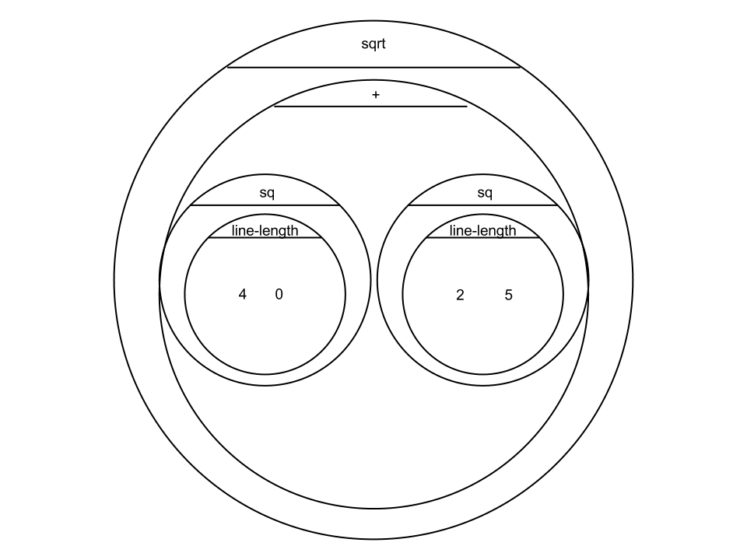
Lesson 6
When the user presses… | this part... | Changes by…
up | archerY | +10
down | archerY | -10
space | wstatus | Becomes “awake”

Design Recipe

State the Problem
For each keypress in the Ninja World game, show how (keypress START <key>) should change your world.

Contract+Purpose Statement
; keypress : world string -> world
name Domain Range

Give Examples

(EXAMPLE (keypress START _ “up” ________________________________)

(make-world _(world-dogX START)___________________

_(world-rubyX START)__________________

_(+ (world-catY START) 10) ___________

_____________________________________

_____________________________________))

(EXAMPLE (keypress START _ “down” ________________________________)

(make-world _(world-dogX START)___________________

_(world-rubyX START)__________________

_(- (world-catY START) 10) ___________

_____________________________________

_____________________________________))

(define (_keypress__ __w key______________________)
(cond
[(__string=? key “up” _________________________________)

(make-world _(world-dogX START)___________________

_(world-rubyX START)__________________

_(+ (world-catY START) 10) )_____________

_____________________________________

_____________________________________]

[(__string=? key “down” _______________________________)

(make-world _(world-dogX START)___________________

_(world-rubyX START)__________________

_(- (world-catY START) 10) )_____________

_____________________________________

_____________________________________]))

Design Recipe

State the Problem
For each keypress in your game, show how (keypress START <key>) should change your world.

Contract+Purpose Statement
; keypress : world string -> world
name Domain Ranges

Give Examples

(EXAMPLE (keypress START __ “up” ________________________________)

(make-world ___(world-wstatus w)________________________

___(+ (world-archerY w) 10)__________________

___(world-wumpusX w)______________________

___(world-batX w)___________________________

___(world-arrowX w) )________________________

(EXAMPLE (keypress START _ “down” _________________________________)

(make-world ___(world-wstatus w)________________________

___(- (world-archerY w) 10)__________________

___(world-wumpusX w)______________________

___(world-batX w)___________________________

___(world-arrowX w) )________________________

(EXAMPLE (keypress START __ “ ” ________________________________)

(make-world ___ “awake” _______________________________

___(world-archerY w)________________________

___(world-wumpusX w)______________________

___(world-batX w)___________________________

___(world-arrowX w) )________________________
___________________________________________________________________________________________________
(define (_keypress_______________ ___w key_______________________________)
(cond
[(_string=?__key ____ “up” __________________________________________)

(make-world ___(world-wstatus w)________________________

___(+ (world-archerY w) 10)__________________

___(world-wumpusX w)______________________

___(world-batX w)___________________________

___(world-arrowX w) )________________________]

[(_string=?__key ____ “down” __________________________________________)

(make-world ___(world-wstatus w)________________________

___(- (world-archerY w) 10)__________________

___(world-wumpusX w)______________________

___(world-batX w)___________________________

___(world-arrowX w) )________________________]

[(_string=?__key ____ “ ” __________________________________________)

(make-world ___ “awake” _______________________________

___(world-archerY w)________________________

___(world-wumpusX w)______________________

___(world-batX w)______________________

___(world-arrowX w) )________________________]))

Lesson 7

Extended update-world:
; __off-right?___:__number_______ -> __boolean______________
name domain range
(EXAMPLE (__________ ______) _______________________)
(EXAMPLE (__________ ______) _______________________)
(define (__________ ______) _______________________)
; _off-left?___:__number_________ -> ___boolean______
(EXAMPLE (__________ ______) _______________________)
(EXAMPLE (__________ ______) _______________________)
(define (__________ ______) _______________________)
; ________________:_________________ -> ________________
(EXAMPLE (__________ ______) _______________________)
(EXAMPLE (__________ ______) _______________________)
(define (__________ ______) _______________________)
; ________________:_________________ -> ________________
(EXAMPLE (__________ ______) _______________________)
(EXAMPLE (__________ ______) _______________________)
(define (__________ ______) _______________________)

TEST | RESULT
(off-left (world-batX w)) | (make-world (world-wstatus w)  (world-archerY w)  (world-wumpusX w)  800  (world-arrowX w))
(off-left (world-wumpusX w)) | (make-world (world-wstatus w)  (world-archerY w)  800  (world-batX w)  (world-arrowX w))
(make-world ___________________________________
___________________________________
___________________________________
___________________________________
___________________________________)
(make-world ___________________________________
___________________________________
___________________________________
___________________________________
___________________________________)

Lesson 8

Design Recipe: line-length
Write a function called line-length, which takes in two numbers and returns the difference between them. It should always subtract the smaller number from the bigger one.

Contract+Purpose Statement
Every contract has three parts:

; __line-length_________ : _____number number_________ -> ____number__________
name Domain Range

Give Examples

(EXAMPLE ( _line-length___4 6______) _( - 6 4 ) )

(EXAMPLE ( _line-length 7 1 ) ( - 7 1 ) )

Function Header
Write the Function Header, giving variable names to all your input values that change.

(define (__line-length___ _a__b________________)
function name variable names

__(cond______________________________

[(> a b) | ( - a b )]
[else | ( - b a )]

))

Distance:

The Player is at (4, 2) and the Target is at (0, 5).
Distance takes in the player-x, player-y, character-x and character-y.

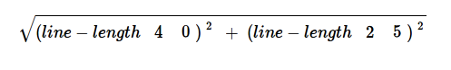
Use the formula below to fill in the EXAMPLE:

Convert it into a Circle of Evaluation. (We've already gotten you started!)

Convert it into Racket code:
(EXAMPLE (_distance______ __4 2 0 5________)

( sqrt ( + ( sq (line-length 4 0) ) ( sq (line-length 2 5) ) ) )

Design Recipe: distance
Write a function distance,which takes FOUR inputs:
- px: The x-coordinate of the player
- py: The y-coordinate of the player
- cx: The x-coordinate of another game character
- cy: The y-coordinate of another game character

It should return the distance between the two, using the Distance formula:
Distance = ((line-length px cx)² + (line-length py cy)² )

Contract+Purpose Statement

; __distance___________ : ___number number number number___ -> ___number_______
name Domain Range

; ___determines the 2d distance between two points___________________________________
What does the function do?

Give Examples

(EXAMPLE
(_distance______ __4 2 0 5________)

( sqrt ( + ( sq (line-length 4 0) ) ( sq (line-length 2 5) ) ) )

(EXAMPLE
(_distance______ __1 2 3 4________)

( sqrt ( + ( sq (line-length 1 3) ) ( sq (line-length 2 4) ) ) )

Function Header

(define (_distance___ _px py cx cy___________)
function name variable names

( sqrt ( + (sq (line-length px cx) ) (sq (line-length py cy) ) ) )

Design Recipe: collide?

Write a function collide?,which takes FOUR inputs:
- px: The x-coordinate of the player
- py: The y-coordinate of the player
- cx: The x-coordinate of another game character
- cy: The y-coordinate of another game character
It should return true if the coordinates of the player are within 75 pixels of the
coordinates of the other character. Otherwise, false.

Contract+Purpose Statement

; __collide?___________ : ___number number number number___ -> ___boolean_______
name Domain Range

; ____determines whether two objects have collided (are within 75 px)___________________
What does the function do?

Give Examples

(EXAMPLE (_collide? 1 2 3 4________________________)

_(> (distance 1 2 3 4) 75)___________________________)

(EXAMPLE (_collide? 5 6 8 3________________________)

_(> (distance 5 6 8 3) 75)___________________________)

Function Header

(define (collide? px py cx cy________________________)

_(> (distance px py cx cy) 75)________________________)

TEST | RESULT
(collide?  (world-wumpusX w)  210  50  (world-archerY w)) | (make-world (world-wstatus w)____________________  0_________________________________  1000______________________________  (world-batX w)_____________________  (world-arrowX w)__________________)
(collide?  (world-batX w)  440  50  (world-archerY w)) | (make-world (world-wstatus w)___________________  0_________________________________  (world-wumpusX w)_________________  1500______________________________  (world-arrowX w)___________________)
(collide?  (world-wumpusX w)  210  (world-arrowX w)  (+ 25 (world-archerY w))) | (make-world "asleep"___________________________  (world-archerY w)_________________  800_____________________________  (world-batX w)____________________  900_____________________________)
(make-world ___________________________________
___________________________________
___________________________________
___________________________________
___________________________________)

Supplemental

Design Recipe

State the problem:

Contract+Purpose Statement
Every contract has three parts:

; __________________ : _________________________________________ -> ______________
name Domain Range

; _______________________________________________________________________________
What does the function do?

Give Examples
On the computer, write an example of your function in action, using EXAMPLE.

(EXAMPLE (_______ _____________) _________________________________)
the user types… ...which should become

(EXAMPLE (_______ _____________) _________________________________)
the user types… ...which should become

Function
Circle the changes in the EXAMPLEs, and name the variables.
Write the code, copying everything that isn't circled, and using names where you find variables!

(define (_______ _____________) _________________________________)

Design Recipe

State the problem:

Contract+Purpose Statement
Every contract has three parts:

; __________________ : _________________________________________ -> ______________
name Domain Range

; _______________________________________________________________________________
What does the function do?

Give Examples
On the computer, write an example of your function in action, using EXAMPLE.

(EXAMPLE (_______ _____________) _________________________________)
the user types… ...which should become

(EXAMPLE (_______ _____________) _________________________________)
the user types… ...which should become

Function
Circle the changes in the EXAMPLEs, and name the variables.
Write the code, copying everything that isn't circled, and using names where you find variables!

(define (_______ _____________) _________________________________)

TEST | RESULT
(make-world ___________________________________
___________________________________
___________________________________
___________________________________
___________________________________)
(make-world ___________________________________
___________________________________
___________________________________
___________________________________
___________________________________)
(make-world ___________________________________
___________________________________
___________________________________
___________________________________
___________________________________)
(make-world ___________________________________
___________________________________
___________________________________
___________________________________
___________________________________)

