**Unit 1 - Qualitative Energy Storage and Transfer**

**Table of Contents**

**Instructional Goals** 4

**Student Learning Objectives** 4

**Acknowledgements** 4

**Energy: An Overview** 5

I. An Operational Definition of Energy 5

II. System Identification and States 5

III. Energy Storage 6

IV. Energy Transfer 7

V. The Conservation of Energy and the 1st Law of Thermodynamics 7

VI. Representational Tools 8

**Sequence** 10

Activity 1 — Write It, Do It 11

Resources 11

Overview 11

Apparatus & Materials 11

Pre-Activity Discussion Notes 11

Activity Performance Notes 12

Post-Activity Discussion Notes 12

Worksheet 1 — Data Types and Expressions in Pyret 12

Resources 12

Overview 13

Discussion Notes 13

Activity 2 — Observation Stations 14

Resources 14

Overview 14

Apparatus & Materials 15

Pre-Activity Discussion Notes 17

Activity Performance Notes 18

Post-Activity Discussion Notes 18

Activity 3 — State Diagram Flipbook 19

Resources 19

Overview 19

Pre-Activity Discussion 19

Activity Notes 19

Post-Activity Discussion 20

Worksheet 2 — System Schemas and State Diagrams 20

Resources 20

Overview 20

Reading 1 — System Schemas and State Diagrams 20

Resources 20

Overview 20

Class Discussion — Communicating to Draw a Shape 21

Resources 21

Overview 21

Discussion Notes 21

Worksheet 3 — Working with Images in Pyret 21

Resources 21

Overview 21

Activity 4 — Flags of the World 22

Resources 22

Overview 22

Worksheet 4a — One-Argument Functions 22

Resources 22

Overview 22

Discussion Notes 22

Worksheet 4b — Two-Argument Functions 23

Resources 23

Overview 23

Reading 2 — Writing Custom Functions in Pyret 23

Resources 23

Overview 23

Activity 5 — Dynamic State Diagrams with Pyret 23

Resources 23

Activity 6 — Energy Storage Modes and Transfer Mechanisms 24

Overview 24

Discussion Notes 24

Reading 3 — Telling A Story of Energy 26

Resources 26

Overview 26

Discussion Notes 26

Activity 7 — Skate Park 2 27

Resources 27

Worksheet 5 — Energy Bar Graphs 27

Resources 27

Overview 27

Discussion Notes 28

Reading 4 — Creating Energy Bar Graphs 28

Resources 29

The Model So Far — Energy Storage & Transfer 29

Overview 29

**Resource Index** 30

Unit 1 Activity 1: Write It, Do It 30

Unit 1 Activity 1 Teacher Resource: Write It, Do It Shape Cards 32

Unit 1 Worksheet 1: Data Types & Expressions in Pyret 33

Unit 1 Activity 2: Observation Stations 36

Unit 1 Activity 2 Teacher Resource: Observation Station Instructions 41

Unit 1 Activity 3: State Diagram Flipbooks 52

Unit 1 Worksheet 2: System Schemas and State Diagrams 54

Unit 1 Reading 1: System Schemas and State Diagrams 57

Unit 1 Worksheet 3: Working with Images in Pyret 61

Unit 1 Activity 4: Creating Flags 66

Unit 1 Worksheet 4a: One-Argument Functions 67

Unit 1 Worksheet 4b: Two-Argument Functions 71

Unit 1 Reading 2: Writing Custom Functions in Pyret 75

Unit 1 Activity 5: Dynamic State Diagrams with Pyret 79

Unit 1 Reading 3: Telling A Story of Energy 80

Unit 1 Worksheet 5: Energy Bar Graphs 82

Unit 1 Reading 4: Creating Energy Bar Graphs 85

# Instructional Goals

**1. Communicate information with intention and specificity**

* Establish the importance of using clear language and directions to achieve a task
* Employ appropriate syntax to communicate successfully with Pyret
* Adjust both spoken and computational language for clarity in response to feedback

**2. Identify systems and relate changes in conditions of a system to energy transfer**

* Develop the concepts of systems and the state of a system
* Develop the concept of energy storage modes, as evidenced by the conditions inherent in the system
* Develop the concept of energy transfer among storage modes, as evidenced by the change in the conditions of a system
* Develop the concept of the conservation of energy in closed systems

**3. Use multiple representational tools for describing changing systems**

* Identify and represent systems using a System Schema to represent the objects in a system, objects in the surrounding environment, and the interactions of objects within a system or between the system and objects outside the system.
* Represent change in a system over time as a succession of State Diagrams
* Represent changes in energy storage modes and energy transfers, using Energy Bar Graphs to display the modes of energy storage present in a system at any given moment

**4. Develop basic skills for using Pyret to model physical phenomena**

* Recognize multiple data types in Pyret
* Create working expressions in Pyret
* Create functions with one or multiple arguments in Pyret
* Produce complex images in Pyret

# Student Learning Objectives

QE.1 - I can use specific and intentional language to communicate with my peers and Pyret.

QE.2 - I can identify a system in any given situation.

QE.3 - I can differentiate between an open and closed system.

QE.4 - I can describe and represent the transfer of energy within a closed system.

QE.5 - I can describe and represent the transfer of energy into and/or out of a system.

QE.6 - I can construct programs in Pyret that evaluate simple functions.

QE.7 - I can construct scaffolded programs in Pyret to model physical phenomena.

# Acknowledgements

The AMTA would like to acknowledge the contributions of Jennifer Adams, Gabriel de la Paz, Robert Laux, Kathy Malone, Deborah Rice, Rex Rice in the development of this unit. Many of the activities, worksheets and assessments are adapted from their work in Freshman Physics.

# Energy: An Overview

Students begin by defining a system and studying the conditions present in the system (the state of the system), identifying the changes in the state of the system between two moments in time, and then identifying the mechanisms by which these changes occur. This pedagogical progression results in the development of an operational definition of energy - a quantifiable measurement of the ability of a system to change - and a knowledge of energy storage modes, transfer mechanisms, and, in some systems, conservation.

Key representational tools (e.g., system schemas, state diagrams, energy bar graphs, and computational simulations) are developed throughout the unit. By the end of Unit 1, students are able to describe a number of complex systems and are prepared to dive deeper into many of the phenomena introduced - specifically those involving motion.

### I. An Operational Definition of Energy

A robust conceptual model of energy is central to a full understanding of all known science. Although it is often treated as a straightforward and easily defined quantity, energy is notoriously difficult to understand; it is often confused with the concepts of force, power, momentum, and even speed.

Energy is sometimes defined as “the ability to do work.” This is often problematic, though, as the term *work* is itself often misunderstood and misused. A more general and useful definition of energy is simply “the ability to cause a change.” With this in mind, students begin by identifying and describing change within a system as a starting point for the development of their conceptual model of energy.

There are two things that can be done with energy: it can be stored, and it can be transferred. By identifying what changes during an event or process (i.e., changes in motion, position, shape, temperature, etc.), we can identify changes in how energy is stored. When we examine the mechanism(s) by which this change occurs, we specify how energy is being transferred.

### II. System Identification and States

The notion of a system is fundamental to the concept of energy. Specifying a system of interest defines the spatial bounds within which we will look at change, and the elements (or objects) within that system that “count” in terms of the change we are observing. We must identify which objects are part of the “system,” and which are part of the “surroundings,” and how these objects interact, either within the system or across the system boundary.

Change within a system happens over time. It is therefore necessary to have a way to describe the *state* of the system at different instants in time during that change. Visually, this description becomes a series of *state diagrams*, a series of snapshots each showing the state of the system at a given clock reading.

A system may be *closed* (in other words, energy may be transferred from one storage mode to another, but it all remains within the system) or *open* (energy is transferred into or out of the system). The identification of a system and its boundaries is arbitrary but critical for accurate analysis of change. The larger the scope of the system, the more likely that energy transfers will be internal. If objects in the system interact with the surroundings, external energy transfers into or out of the system must be considered.

### III. Energy Storage

Energy is stored in a system as internal energy. This internal energy IS a property or *state variable* of the system: it is due to the microscopic and macroscopic energies of the particles that make up the system. These energies cannot be measured directly. A *change in internal energy* is all that can be measured, since a change in internal energy results in a change in one or more state variables of the system (position, velocity, pressure, temperature, etc.). Stored energy is therefore represented using ∆ notation.

There are two ways that energy can be stored in a system:

1. Energy can be stored in the *position* (or *configuration* or *arrangement*) of the constituent parts of an object or system of objects, and
2. Energy can be stored in the *motion* of an object or a system of objects, or in the system’s constituent parts.

Examples of energy of position or configuration are the energy of an object suspended above the ground, the energy of a compressed spring, or the energy of a molecule that has its atoms in a particular geometric configuration. These are traditionally referred to as ‘potential’ energies. In Modeling Instruction, we try to eliminate the use of the word ‘potential’ and focus more on the actual modes in which energy is stored in a system. This is discussed further on in the Teacher Notes below.

Examples of the energy of motion would be the energy of an object traveling at some velocity *v*, or the energy of an object with molecules vibrating or moving at a particular average speed (a measure of this average energy is also known as an object’s “temperature”). These energies of motion are sometimes called kinetic or molecular kinetic energy. An object’s temperature (a measure of its average molecular kinetic energy) is sometimes also called its thermal energy.

We use “E-subscript” notation to indicate that all modes of energy storage do just that, store Energy. The mode just helps us keep track of how energy is stored. Here are some examples of “E-subscript” notation:

* Energy in gravitational field: Eg
* Energy in springs or “stretchy” elastic things: Eel
* Energy in electric field due to physical state: Eph
* Energy in electric field due to chemical bonding: Ech
* Energy in moving object, Ek
* Energy in a collection of moving particles (as measured by temperature), Eth

It is important to note that although we may use different names for energy storage (e.g., kinetic, gravitational, chemical), ***energy is energy***, regardless of the way it manifests. The names we have for energy storage simply tell us something about how some element of a system’s energy was measured and allow us to separate a system’s total energy into different accounts, so that we can more easily account for changes in one category or another.

### IV. Energy Transfer

Energy transfer will be addressed in terms students are familiar with during Unit 1. We will encourage students to use terms like “pushing,” “pulling,” “heating up,” “cooling off,” etc. until we have encountered multiple phenomena and developed a need to group these into formal categories (i.e., working, heating and radiating) used in the study of thermodynamics.

There are, broadly, three mechanisms of energy transfer:

* **Working (W)** involves the transfer of energy by external forces acting on an object across some displacement. Working is introduced in this unit through the process of pushing and pulling. Eventually students will be able to quantify the amount of energy transferred via Working as the product of the component of the input force in the direction of the object’s motion and the displacement the object.
* **Heating (Q)** involves the transfer of energy due to differences in temperature. Higher temperature objects in contact with lower temperature objects transfer energy via particle collisions. Eventually students will be able to quantify the amount of energy transferred via Heating using observed temperature changes in the system and developing a concept of ‘heat capacity.’
* **Radiating (R)** involves the transfer of energy by photons or electromagnetic waves. Early on, students will observe different ways that waves and light may be involved in energy transfer. Eventually they will be able to examine the relationships between different properties of light and waves and the ability of waves to transfer energy.

These transfers are NOT properties of the system. They do not represent changes in the state of the system (hence we do not use the ∆ notation to describe them). Since they are processes, and not intrinsic properties of the system, we use the gerund form of each of these words (e.g., heat*ing*, work*in*g, radiat*ing*); otherwise, students may come to view W, Q, and R as a synonym for energy, or as an actual part of the system. For example, we would not want to say that a system possesses “heat”. Rather, we would say a high temperature system stores thermal energy which it can transfer to another system through the process of heating.

### V. The Conservation of Energy and the 1st Law of Thermodynamics

According to the Law of Conservation of Energy, the algebraic sum of changes in internal energy in the system must equal the energy transfers across the system boundary. In terms of our energy storage accounts, the total energy change in a system is equal to the sum of the system’s internal energy changes:

∆Esystem = ∆Eg + ∆Eel + ∆Eph + ∆Echem + ∆Ek + ∆Eth

In this unit, we designate all processes that *increase the energy of the system* as *positive*: transferring energy into the system by heating it, working on the system (energy transferred in by forces), etc.

Energy that *decreases the energy of the system* is designated as *negative*, such as energy leaving by cooling a system, or work done by a system (energy transferred out by forces).

Thus the 1st Law of Thermodynamics can be stated as:

∆Esystem = W + Q + R

where ∆Esystem is the sum of all the changes in a system’s energy storage modes, using the same sign convention stated above. When expanded to include energy transfer mechanisms, this comprehensive statement of the 1st Law of Thermodynamics is sometimes referred to as “The Equation of Everything”:

W + Q + R = ∆Esystem = ∆Eg + ∆Eel + ∆Eph + ∆Echem + ∆Ek +∆Eth

To use the 1st Law in this form, one must first identify the system, and then determine the appropriate modes of internal energy storage which undergo changes, and which energy transfer mechanisms are involved.

### VI. Representational Tools

In our study of energy, we use several representational tools, which are listed here according to their increasing levels of complexity. Their use will be explained in detail in later sections:

1. System Schema

* qualitative and simple tool for identifying the objects in a system
* identifies the interactions between objects in the system
* establishes a system boundary
* identifies if interactions are occurring with the surroundings across a system boundary
* helps in deciding if energy transfers into or out of the system during a change, or if energy transfers take place within the system

2. State Diagram

* illustrates the state of a designated system at time “*t”* (e.g., initial and final)
* can be used in a series to visualize change in the state of a system while energy transfer is occurring
* most useful in representing change in events where observable motion occurs

3. Computational Representation (e.g., function, simulation, computer program)

* identifies Data Types
* uses Function Design to illuminate the contract, examples and function definitions.
* entails the writing of functions - A function is a model -- a mathematical or computational model with elements, operations, relations and rules
* utilizes simulations to allow us to test our understanding of physics concepts at a deeper level

4. Energy Bar Graph

* illustrates the idea of internal energy as a property of a system
* illustrates the concept of changes in internal energy of the system
* specifies various energy storage modes
* allows for internal energy to be seen as a sum of energies:

∆Esystem = ∆Eg + ∆Eel + ∆Eph + ∆Echem + ∆Ek +∆Eth

* shows means of energy transfer across system boundary
* makes distinction between changes in internal energy and energy transfer as a process
* shows how macroscopic energy transfer W, Q, R can affect microscopic energy storage ∆Esystem (system’s internal energy)
* Allows for 1st law of Thermodynamics as the sum of energy transfers:

∆Esystem = W + Q + R

* useful for representing Conservation of Energy and 1st Law of Thermodynamics
* can be used in series to represent change in energy storage modes (e.g., states) in a dynamic system
* can be used in conjunction with state diagrams in systems where the event involves observable motion

When we develop computational representations, we will explicitly build, test and refine them, and then deploy them in a variety of contexts. The*Pyret* code and the simulations we build with it are representations of the function model. In physics, we regard a function as a representation of a structure in a model, but in math, it *is* a model. We engage in a Modeling Cycle that enables students to build, test and refine functions, and then have opportunities to deploy them.

Once we have these computational representations, we can circle back to use them as opportunities arise. We can use them to diagnose problems with student thinking about mathematizing the model. Typically, we ask students to represent a model “algebraically” by developing an equation in the form *y = mx + b*. For computational modeling in Pyret we make the small but significant shift in our use of language to having them represent the model ‘*functionally*’ (rather than saying ‘algebraically’) --*as a function* (of which an equation is a particular expression). The words we use matter, as you are coming to realize, and this is an opportunity to begin to use the word ‘*function*’ purposefully.

The development of the concept of *function* is significant in math education research. It turns out that one reason it is hard for students to develop a coherent concept of *function* is because in math it is often taught free of context. Students end up with a procedural knowledge of functions and how to manipulate them, but no conceptual model that enables them to derive functions within a particular context and generalize them to other contexts. If we can help students build a robust function model at the start of 9th grade physics, not only will they be better computational modelers, but they will also be better mathematical thinkers and learners as well.

# 

# Sequence

1. Activity 1 — Write It, Do It
2. Worksheet 1 — Data Types and Expressions in Pyret
3. Activity 2 — Observation Stations
4. Activity 3 — State Diagram Flipbook
5. Worksheet 2 — System Schemas and State Diagrams
6. Reading 1 — System Schemas and State Diagrams
7. Class Discussion — Communicating to Draw a Shape
8. Worksheet 3 — Working with Images in Pyret
9. Activity 4 — Flags of the World
10. Worksheet 4a — One-Argument Functions
11. Worksheet 4b — Two-Argument Functions
12. Reading 2 — Writing Custom Functions in Pyret
13. Activity 5 — Dynamic State Diagrams with Pyret
14. Activity 6 — Energy Storage Modes and Transfer Mechanisms
15. Reading 3 — Telling A Story of Energy
16. Activity 7 — Skate Park 2
17. Worksheet 5 — Energy Bar Graphs
18. Reading 4 — Creating Energy Bar Graphs
19. The Model So Far — Energy Storage & Transfer

## 

## Activity 1 — Write It, Do It

### Resources

* Unit 1 Activity 1: Write It, Do It
* Unit 1 Activity 1 Teacher Resource: Write It, Do It Shape Cards

### Overview

This activity introduces students to several important science and computer science concepts. They will experience the importance of **intentional language** and specificity in the descriptions of objects and directions they give to each other, and the problems that can come about when interpreting directions with not enough information. Students will also learn the importance of asking clarifying questions as a form of **feedback**.

This experience of **crafting detailed instructions** is a direct lead-in to Worksheet 1 - Data Types and Expressions. In speaking with a computer using Pyret, students will need to be exact with both their instructions and their syntax.

The pre-activity discussion around drawing a circle is important to setting norms in the classroom about clarifying instructions, even from the teacher. It also points to the need for specificity in instructions, and the natural feedback loop when those instructions are not specific enough. This will mirror the feedback loop from Pyret in the next activity and throughout the course.

### Apparatus & Materials

A printable template for shape cards, which can be handed out to students, is included in the Resources linked to above. A blank table can also easily be made in Google Docs or any other word processor, if you would prefer to create your own custom shapes.

### Pre-Activity Discussion Notes

Students begin this activity with the teacher asking them to simply “draw a circle.” Any requests for clarification should be deferred until after they have drawn their circles, which should not take more than a minute. The teacher should also draw a circle at this time.

Some students may draw it on paper, others on a whiteboard, with a pen or pencil or marker, any with varying sizes, colors, and circleness. After comparing results with the teacher, students may complain that with such vague instructions, “draw a circle” produces as many different circles as there are students. If the teacher’s goal was to have them produce a circle of specific size, color, location, material, etc., more detailed instructions would have needed to be given.

### Activity Performance Notes

Students are paired up, and each student is given a card with shapes and lines of different sizes and colors drawn on them. They have five minutes to write a set of instructions for how to draw this figure, only using words. Once the time is up, they will give their instructions to the other student, who will have three minutes to attempt to draw the shape in question from their partner’s instructions. They will then return the paper, and compare the picture drawn from their instructions with the original picture on the card.

### Post-Activity Discussion Notes

Students should be encouraged to share their results, noting any discrepancies (large or small) between their produced work and the original. After sharing, students should reflect with their partner and the whole class, and give feedback on which instructions were helpful, and which instructions were too vague or misleading.

Some sample student responses about examples of helpful instructions:

*“Telling us what the final picture should look like.”*

*“Specific language - like an ‘equilateral triangle’ instead of just ‘a triangle.’”*

*“He gave us a coordinate system!”*

Some sample student responses about examples of vague or misleading instructions:

*“I didn’t know if the shape was filled in or just an outline.”*

*“Using the word ‘it’ was too vague - I didn’t know which shape she was talking about.”*

*“Some of the instructions were overly complicated - I couldn’t follow what he meant.”*

After the discussion, another round can be played, if time permits. Many students may find this second round easier as they learn to communicate more effectively and combine other students’ communication strategies with their own.

## 

## Worksheet 1 — Data Types and Expressions in Pyret

### Resources

* Unit 1 Worksheet 1: Data Types & Expressions in Pyret
* Pyret editor: <http://code.pyret.org/editor>
* Student code for working with expressions: <https://tinyurl.com/U1expressions>

* [Minute Physics: The Order of Operations is Wrong](https://www.youtube.com/watch?v=y9h1oqv21Vs)

### Overview

Building on the theme of the previous activity, this worksheet is designed to further the idea of the importance of using **intentional language** when conveying information. In particular, to communicate with our computers, we need to use an appropriate language - in this case, we must learn to speak with the computer through the Pyret interpreter.

Terms which are defined throughout the worksheet and discussion include:

* **Data Type** - Building blocks of the programming language. *In this exercise, we will confine our data types to Number and String. Note that all data types are proper nouns.*
* **Value** – Information that can be categorized as being of one of the data types.
* **Number** – The data type of numbers.
* **String** – The data type of letters/words/characters. Grouped by quotation marks.
* **Operator** – A symbol representing a mathematical operation such as +, -, * or /
* **Operands** – The values on which the operators are operating.
* **Expression** – A phrase containing values (operands) and one or more operators.
* **Feedback** - Information provided to the user by the programming language when communication is unclear. *See the important note on “error” vs. “feedback” below.*

### Discussion Notes

As with most lessons in this course involving programming, the ideal setup is for students to be “pair programming” - that is, working in pairs on a single laptop, with one student typing and the other reviewing the code, periodically switching roles.

This worksheet and the discussion surrounding it lay the foundation of many computational ideas and concepts that will be returned to throughout the course. It also introduces some syntax and language norms specific to Pyret, which will be important to focus on at this time to help students avoid unnecessary difficulties on future assignments.

Question 1 asks students to identify the data type of various values and predict what Pyret will return if the value is typed into the Interactions window, and “Enter” is pressed. Many of these are intuitive (e.g., typing 5 and pressing Enter returns 5), but important exceptions and special rules are highlighted by the choice of values entered (e.g., decimals requiring a leading 0, decimal and fraction equivalency, etc.). Two common issues students have are 1) typing these values into the Definitions window (not the Interactions window), and 2) clicking “Run” instead of “Enter” after typing in the Interactions window, which will reset the Interactions window.

Question 2 deals with expressions in Pyret. A number of important Pyret norms are introduced here as well, specifically the required whitespace surrounding operators (excluding the ‘/’ operator, which also identifies fractions), and Pyret’s lack of knowledge of PEMDAS (the conventional order of operations). The Minute Physics video linked to above is a helpful extension in explaining why students should hard-code operator precedence into their code (to ensure that Pyret evaluates expressions as we intended - a reinforcement of the importance of **intentional language** when communicating an idea). In the expressions table, students will receive feedback when evaluating expressions that contain two different operators but no parentheses.

Question 3 links to a Pyret program template with a number of pre-written expressions in the Definitions window, and an explanation of how *comments* work in Pyret, and what they are for (instructions meant for the programmer, not Pyret). This code is available in the Resources section above.

Students should predict what value each expression will return when evaluated, then test each one by uncommenting the line and clicking `run`. For this question, student instructions are given at the top of the definitions window in comments, rather than on the worksheet. This will be common throughout the course, so it is important that students build this habit of reading the comments at the top of every script. Emphasize to students that good comments communicate to humans what the program should be doing.

Throughout this worksheet, students should be encouraged to explore and try out new things beyond what is listed. Anything interesting should be shared and discussed with the entire class.

*An important note on “errors” in Pyret:* It is very important that the messages produced by Pyret when invalid code is run are not called “error messages.” Teachers and students should instead call these messages feedback. The pedagogical benefits of this are self-evident; feedback is expected as part of the programming cycle and shouldn’t be something feared or seen as a discouraging event. Students should learn to read feedback closely to determine what is needed for effective communication with the Pyret interpreter.

## 

## Activity 2 — Observation Stations

### Resources

* Unit 1 Activity 2: Observation Stations
* Unit 1 Activity 2 Teacher Resource: Observation Station Instructions

### Overview

These “observation stations” give students the opportunity to refine their skills of making precise descriptions of objects (building on Activity 1), recording scientific observations, and engaging in classroom discourse. All of these are foundational skills for doing science.

This paradigm lab activity allows students to experience, note and discuss many interactions and changes in a way that foreshadows the discussion of energy storage and transfer later. It also provides the entire class with a large set of shared experiences that will help facilitate discussions throughout the entire course. These particular experiences will be returned to multiple times throughout this unit and referenced afterwards throughout the course.

### Apparatus & Materials

There is no set list of “required” observation stations that you should pick; it is, however, recommended that you choose events that represent a variety of energy storage modes and all three mechanisms of energy transfer (see the Unit Overview for an in-depth discussion of these modes and mechanisms). A list of ten stations that are appropriately varied, but require a minimal amount of equipment, is provided below.

|  |  |  |
| --- | --- | --- |
| **Station** | **Primary Energy Transfer(s)** | **Directions for Students**  **(Modify for Specific Classroom Setup)** |
| Flaming Cheetos | Ech→Eth  (Radiating) | Place one Cheeto onto a paper clip taped to the table. Using a lighter, light the bottom of the Cheeto. Once the Cheeto is on fire, remove the lighter. Make observations. |
| **Reason for Inclusion:** A demonstration which students practice group observations on. | | |
| Tumble Buggy | Ech → Ek→Eint  (Working) | Using the switch on the bottom of the buggy, turn the buggy on. Place the buggy on the floor. Make observations. |
| **Reason for Inclusion:** The tumble buggy is the object of interest for much of Unit 2. | | |
| Wind-Up Toys | Eel → Ek→Eint  (Working) | Using the winding dial, gently wind the toy. Place the toy on the table and release the dial. Make observations. |
| **Reason for Inclusion:** A simple event with quantifiable observations and a variety of energy storage modes. | | |
| Popper Toys | Eel →Ek/g→Eint  (Working) | Turn the popper inside out, and quickly place it on the table. Make observations. |
| **Reason for Inclusion:** A simple event that highlights a variety of storage modes, with continuous changes throughout. | | |
| Ball Drop | Eg →Ek/el→Eint  (Working) | Put on the goggles. Drop the smaller ball from chest height. Make observations. Drop the larger ball from chest height. Make observations. Now, stack the smaller ball on top of the larger ball. Hold the stack at chest height, and release both balls at the same time. Make observations. |
| **Reason for Inclusion:** A simple but unexpected event for many students, highlighting gravitational and elastic energy and, later, momentum transfer. | | |
| Mass on a Spring | Eg→Eel  (Working) | Gently pull the mass down 2-3 inches. Release the mass. Make observations. |
| **Reason for Inclusion:** The introduction of a spring as an important object for visualizing elastic energy storage and restorative forces. | | |
| Melting Ice | Eph→Eth  (Heating) | Place one ice cube on each of the two blocks. Make observations. One block should be plastic (or some other thermal insulating material), the other block should be metal (or some other thermal conductor). |
| **Reason for Inclusion:** A thermal reaction which causes a phase change, provoking good discussions in physics and setting up deeper discussions in chemistry. | | |
| Airzooka | Eel → Ek  (Working) | Hold the Airzooka handle in one hand and pull back the elastic launcher knob with the other. Aim the Airzooka at the suspended piece of paper and release the air launcher. Make observations. |
| **Reason for Inclusion:** Requires the introduction of air into the system schema and can also seem like “action at a distance” to students. | | |
| Fizz, Fizz, Pop | Ech → Ek  (Working) | Place a tablet of Alka-Seltzer in a film canister. Pour water into the film canister so it is half full, and then quickly place the lid on the canister, turn it over, and set it on the table. Make observations. |
| **Reason for Inclusion:** A dramatic event highlighting chemical energy as a mode of energy storage, which students may have trouble explaining. | | |
| Rubbing Hands | Ech → Ek→Eth  (Working) | Press your palms and fingers together. Rub your hands together, alternating forward and backward for several seconds. Make observations. |
| **Reason for Inclusion:** Foreshadows discussions on thermal energy and frictional forces. | | |

* **Air Puck (Ech → Ek)** - Using the switch underneath the air puck, turn the air puck on. Place the air puck on the floor. Make observations. Give the air puck a gentle push with your hand. Make observations. Turn the air puck off.
* **Carts on a Track (Ek → Ek)** - Place one cart on the track and give it a gentle push. Make observations. Place both carts on the track, so that each is about 20 cm from the end stops. Give one cart a gentle push towards the other. Make observations.
* **Compass and a Magnet (Emag → Ek)** - Bring the bar magnet close to the compass. Make observations.
* **Current Through a Wire (Ee → Ek)** - Flip the switch to ‘on’ and bring the compass close to the wire. Make observations. Flip the switch to ‘off’ and bring the compass close to the wire. Make observations.
* **Glow Sticks (Ech → Eem)** - Take one glow stick out of the package. Gently bend the glow stick until you hear a cracking sound. Make observations.
* **Hammer Paper** **(Ek → Eint)**- Hold a hammer in each hand. Tap the heads together, with a piece of paper suspended between them. Make observations.
* **Hand Warmers (Ech → Eth)** - Pick up a hand warmer and hold it in your hands. Make observations. Bend the metal circle until you hear a “crack” noise, then set it back down. Make observations. After about thirty seconds, pick the hand warmer back up. Make observations.
* **Nose Cruncher (Eg → Ek → Eg)** - Pull the bowling ball up to your nose, with the cable taut. Release the ball, allowing it to swing smoothly away from your nose. (NOTE: It is VERY important to “let go” of the ball, and not push the ball in any way.) Stand still as the ball swings away from you, and then back - DO NOT MOVE. Make observations.
* **Tuning Fork (Ek → Ek)** - Grasp the single end of the tuning fork. Strike the tines of the tuning fork with the rubber mallet, the palm of your hand, or the edge of the table. Make observations. Strike the tines of the tuning fork again and place the tines of the tuning fork so they just touch the surface of the water in the shallow dish. Make observations.

*Note: It is important that common experiences are created using these observation stations. Should you add any of these additional stations, the same ones will need to be added to Worksheet 2.

### Pre-Activity Discussion Notes

Before class begins, set up the chosen lab stations in the classroom, spread out in such a way that groups can rotate through them with ease.

As a class, the students and teacher should discuss the meaning of the word **observation**. In common terms, an observation is *something you can see, hear, taste, smell, touch, or otherwise feel (as through proprioception)* - in essence, something we can experience with any of our senses. Another way to make an observation is to make a measurement with a **tool**, like a ruler, stopwatch, or other device. Observations made by our senses are usually **qualitative** - focusing on the *qualia* of an object (size, color, relative “hotness,” etc.), while tools can usually provide measurements which are **quantitative** - observations involving counting or numerical measurement (length, wavelength, temperature, etc.).

It is also useful to discuss at this point the difference between **observation** and **inference** and provide examples of each. A demonstration like [the edible candle](https://www.youtube.com/watch?v=0Gu-NyD-6AQ) is a good focus for this discussion, if time permits.

After defining observations, students should be directed to describe the initial conditions of the station. Conditions are ‘noun’ terms such as ‘motion’, ‘separation’, ‘extension’, ‘contraction’, etc. These should be able to be identified in a binary operation… something is either ‘in motion’ or ‘not in motion’; objects are either ‘in separation’ or ‘not in separation’; an object is ‘in extension’ or ‘not in extension’ (aka, stretched); or ‘in contraction’ or ‘not in contraction’, etc.

Students should then be invited to participate in a group Observation Station - usually the Flaming Cheeto or the Edible Candle. Afterwards, students will be split into small groups (no more than 3-4) and go to different stations. At each station, students should do three things:

1. Describe the **initial conditions** of the station. This may include location of objects, motion of objects, deformation in shape, height from a surface, temperature, etc.
2. Describe the **final conditions** of the station. These may include the same conditions from the initial state or conditions which have changed or were not previously observed.
3. Describe **changes** in the conditions of the system.

### Activity Performance Notes

Rotating through the stations will take between 5-10 minutes per station. Monitor students’ groups for safety and cleanliness as they work.

Depending on your school’s schedule, this may take multiple days to work through the labs and subsequent discussions. This lab should not be unnecessarily rushed - students need time to explore each station fully. Some teachers perform all lab stations in a single day and use the next day(s) for whiteboarding and discussion; others choose to only perform 2-3 lab stations a day and discuss those events that same day before moving onto the next stations. Whatever order is chosen, make sure the groups have time for both careful observation and for reflection, discussion, and consensus-making with peers.

### Post-Activity Discussion Notes

At some point after an observation station is completed (either the same day or in the following class), students should participate in a **whiteboard meeting**. Since this is the first whiteboard meeting of the year, careful attention should be paid to classroom and discourse norms. Advice on leading whiteboard discussions can be found in many articles on the Modeling Instruction website.

On their whiteboard, each group should represent their findings from the station; this includes the initial and final conditions of the station and the changes observed to these conditions. They should be able to clearly articulate their list of conditions and any constraints that apply to them.

*Note*: The concepts of energy, systems, and states have not been introduced at this point in the unit, and therefore should NOT be mentioned at this stage. The focus of this whiteboard meeting is primarily on setting norms for discourse, precise language, and argumentation from evidence. They will revisit these stations multiple times in the unit and will have ample opportunity to describe them again in the language of systems, states, and energy.

After each meeting, give students time to make any necessary corrections or alterations to their notes for the station.

## 

## Activity 3 — State Diagram Flipbook

### Resources

* Unit 1 Activity 3: State Diagram Flipbooks
* Energy Skate Park - <https://phet.colorado.edu/en/simulation/energy-skate-park-basics>

### Overview

The state diagram is a useful representation of a system that is changing. It gives a visual idea of what is changing and what is not. It is also important to have an understanding of these changes when modeling the interactions in Pyret. In this activity we will use the PhET simulation entitled Energy Skate Park as a way to have a common experience that our students can share. There is an html version available, so you don’t have to worry about Java permissions, and it runs on chromebooks and tablets.

### Pre-Activity Discussion

The skate park simulation has a large drawback in that it refers to gravitational potential energy as just potential energy. You may need to clarify that for students.

### Activity Notes

The skate park activity has several modes. They need the “Intro” one for this activity.

They don’t really need to use any of the functions of the simulation other than the ability to pause the simulation which sort of stops time for them to decide what is in their system and when they choose to make state diagrams.

Give students clear guidelines for the first and last states of the simulation. One suggestion would be to denote “A” when the skater is at the top left of the half-pipe, and “H” when the skater is at the top right of the half-pipe. Students can then choose the location of the skater for “B” through “G.” They are simulating one run from the left to the right, not multiple back and forth motions.

Questions to be thinking about as the activity goes on. Do all kids pick evenly spaced moments for the state diagrams? Should they? How does time affect the state of the skater? These sorts of questions could lead to a richer discussion afterwards.

### Post-Activity Discussion

Some ideas for a post discussion/ whiteboard activity:

* There was consensus that between every picture "flip" was about the same amount of time.
* Each “flip” defines a new “state” of the system.
* We can treat the skater and the skateboard as one "item" - those are the things we can include in our "system.” From this idea the system schema representation should be introduced.

Students will likely find this very tedious. It may be worth pulling out how this would be much easier if we could automatically create these state diagrams or make a ton of them. This introduces the *need* for the computer (and Pyret!).

We have set up a *need* for a tool that can make these “flipbooks” for us - the computer!

## 

## Worksheet 2 — System Schemas and State Diagrams

### Resources

* Unit 1 Worksheet 2: System Schemas and State Diagrams

### Overview

Continuing from the previous Skate Park activity, students now try to practice their system schema diagrams and state diagrams using their observation stations (Activity 2). It might be helpful to assign a few of the observation stations for them to work through and compare with each other so they have multiple viewpoints for one station. They will do the remainder in the worksheet.

This worksheet revisits the Observation Stations activity, asking students to use what they have learned to create system schemas and state diagrams for each station.

*Note: The stations on this worksheet should be the same stations examined in Activity 2.

## 

## Reading 1 — System Schemas and State Diagrams

### Resources

* Unit 1 Reading 1: System Schemas and State Diagrams

### Overview

The first portion of this reading gives a rationale for choosing what belongs in a *system* and illustrates the process of choosing and representing the system of interest when observing a change. The second portion illustrates the use of state diagrams. These concepts should first be introduced during class discussion, with the reading serving as a second reference.

## Class Discussion — Communicating to Draw a Shape

### Resources

* Pyret editor: <http://code.pyret.org/editor>

### Overview

This activity builds on the intentional language idea introduced in Activity 1. Start by asking students to draw a circle, purposely refraining from providing any additional information such as size, shading, or color. Once students have completed their circle, ask them to share their drawing. It is expected that there will be a wide variation of circles drawn throughout the class.

### Discussion Notes

Ask students to reflect back to the Write It, Do It activity:

* What information did you need to tell your partner to draw the shape?
* What information would you need to tell the computer to draw a shape?

Repeat the process, asking students to draw a square, then a triangle. They will now ask for more detail to ensure they are drawing the expected shape, with size, shading and color. These three pieces of information (size, shading or mode, and color) are the three inputs needed to communicate instructions clearly using the image functions circle( ), square( ), and triangle( ) in Pyret, as students will discover.

Instruct students to open the Pyret editor. Provide students with the three function names, circle( ), square( ), and triangle( ), and the knowledge that these functions consume the same three pieces of information they require to draw an accurate shape. Students will then experiment to determine the correct order for these three inputs.

Emphasize using the feedback message(s) as a guide. When students receive a feedback message, they should read this and interpret to determine what guidance they are being given. The goal is to use this guidance to modify their code and produce an image of the desired shape.

## 

## Worksheet 3 — Working with Images in Pyret

### Resources

* Unit 1 Worksheet 3: Working with Images in Pyret

### Overview

This worksheet builds on the previous discussion and has students writing multi-argument functions to produce images. Questions are scaffolded to help students with syntax.

Some important lessons involve creating identifiers for easily referencing an image, and appreciation for the variety of ways to solve a particular problem. Sharing of code and trying to figure out how it works makes for interesting discussions.

## 

## Activity 4 — Flags of the World

### Resources

* Unit 1 Activity 4: Creating Flags
* Pyret editor: <http://code.pyret.org/editor>

### Overview

This activity gives students more practice using the image functions by trying to recreate state and country flags. Only flags which contain geometric shapes are used so that students should be able to reproduce them using only the simple shape functions and functions like overlay, beside, above, and overlay-align. The Cuban flag also requires the rotate function be used on a triangle.

It may be helpful to have students create a plan for creating these flags first, whether by whiteboard the steps or even cutting shapes from construction paper and placing them to create the flag. It is after they have a plan that giving them the functions mentioned above would be useful.

## 

## Worksheet 4a — One-Argument Functions

### Resources

* Unit 1 Worksheet 4a: One-Argument Functions

### Overview

This worksheet has students writing single-argument functions to find the perimeter and area of a square. This is the first custom function that students will write in Pyret, and so they will need to learn the proper syntax. The function designs included in the worksheet scaffold the syntax for contracts, examples, and function definition. Make sure students complete the function design before opening Pyret.

### Discussion Notes

Sharing the answers to each question and comparing as a group is a good way to work through this. Full whiteboard meetings may not be necessary.

“What changed in our calculation [of perimeter]?” is a good leading question to determine the input of the function on the second page.

You can sound out the contract: “sq-per is of type Number producing Number.”

Some questions from the group:

“Can I type num instead of Number, since it’s shorter?”

“What does # mean? Is it a comment?”

What do you think a contract means?

“If I do this, it will do that.”

“I have to hold up my end of the contract (the Domain), and it will hold up its end (the Range)”

Students breakout for the area of a square function - they must defend their function design to each other. Students grilling and defending other students. The answer to “where did you get that?” has to come from ABOVE the thing in question.

## 

## Worksheet 4b — Two-Argument Functions

### Resources

* Unit 1 Worksheet 4b: Two-Argument Functions

### Overview

The second worksheet has students writing two-argument functions to find the perimeter and area of a rectangle. Again, the function designs are scaffolded to help students with syntax.

## 

## Reading 2 — Writing Custom Functions in Pyret

### Resources

* The student code can be found at <https://tinyurl.com/U1-Reading2>
* Unit 1 Reading 2: Writing Custom Functions in Pyret

### Overview

This reading reinforces data types and the syntax of contracts, examples, and function definitions in Pyret with a few examples.

## 

## Activity 5 — Dynamic State Diagrams with Pyret

### Resources

* The student code can be found at <https://tinyurl.com/U1-StateDiagrams>
* Unit 1 Activity 5: Dynamic State Diagrams with Pyret

Activity 3 used hand-drawn flipbooks to create a set of multiple state diagrams, all representing the same sequence of motion. Since students now have the ability to create images using Pyret, this activity challenges them to write a function that takes in an image, its x- and y-coordinates, and a background image and produces a state diagram for that image.

Students could be challenged to show horizontal, vertical, or diagonal motion by creating multiple state diagrams.

## 

## Activity 6 — Energy Storage Modes and Transfer Mechanisms

### Overview

Up until now, the term *energy* has not been introduced with students. In this discussion, students should not only identify *modes/conditions* in which energy is stored but connect these modes/conditions with the Observation Stations activity.

### Discussion Notes

Begin by referring back to the Observation Stations activity, this time focusing on the changes that take place in each one. In the activity, students answered the questions, “What are the initial conditions of the station?”; “What are the final conditions of the station?”; and “What changes occurred?”

It is suggested to start with a relatively ‘simple’ observation station and focus on that first as individual groups. For example, the wind-up toy might be considered. In either state (moment in time), the wind-up toy seems lifeless and boring. But once you wind the toy up… it has now *changed* its conditions. It is ready to be played with. The change that took place might be called ‘*winding’,* resulting in the spring inside the toy now beingin a *condition of torsion* or a condition of ‘twistedness’ (focusing on a *noun*, -‘ion’ ending or -‘ness’). So, the act of *winding* produced a *change in condition* to the spring and the spring now possesses *different qualities* than it did before.

The *winding* is a transfer which moves *something* from the person who does the *winding* to the spring that has been *wound.*

Once students have discussed the changes in state and why they occur, ask them to group these changes into categories. Changes in state could be grouped as *burning*, *heating*, *stretching*, *falling*, *melting*, *crunching*, *bending*, *burning*, *glowing*, *fizzing*, *shaking*, etc. Have students create a whiteboard with these categories and place the changes seen into one of their categories. For example, “Alka-Seltzer” might be written under the term ‘fizzing’; “spring” might be written under the term ‘stretching’, etc. These are all examples of ‘transfers’ of this *something*.

(*Moving* is a tricky one, and one that students will want to include in a ‘change’ as the object has changed its position, but the motion itself is not the important part of that. An object that is experiencing constant velocity motion is *not* changing that *condition*. It is under a *condition* of motion, and maintains its *condition* of motion, *until* something else interacts with it, causing a change to that *condition*. This will be further explained as we move into the units on motion and dynamics.)

The ability to cause a change is what we often refer to as “energy.” An operational definition for energy early in this stage is “the ability to cause a change.” Energy then, is not a thing itself, but a property of the objects in a system. The changes in the Observation Stations can now all be viewed through the lens of changes in energy… where the energy is stored, and how the energy is transferred.

**Why not *types* of energy?**

To this point, students may be accustomed to describing energy as being one of many “types.” The difficulty with this is that it furthers the idea that energy is *transformed* from one type to another instead of treating energy as a single conserved quantity. We will instead refer to *modes of energy storage*, or energy storage conditions. Emphasize with students that this is all energy, with only the storage conditions being changed.

At this point, you can encourage students to use “E-subscript” notation. We want to emphasize that *all energy is the same, all energy is energy, no matter how the energy is stored*. The “E” with a subscript notation represents modes of energy **storage,** rather than discussing “types” of energy. For example, with the tumble buggy station, they may note that the car is able to move because it has a battery, which means energy is stored in the car’s battery. We could write this as Ebattery. The buggy is also moving and has energy of motion, and we could write that as Emotion. If students need evidence that moving objects “store” energy, ask them if they remember getting hit with a moving playground ball in Dodgeball or some other suitable examples. As students work through the other stations, encourage them to use their System Schemas from Worksheet 2 and their observations from the Activity 2 Observation Stations to help them. They should again include State Diagrams where applicable. Have students review their categories and add possible notations to each.

After discussing all the different ways that energy is stored in these objects, we can now come to consensus on what we call these storage modes. Make a list of all the different energy storage modes students came up with. This list should allow you and the class to find similar methods and discuss agreed on terms for the energy storage modes.

Try to get the students to agree on the following main concepts:

* Energy stored in *movement*:
  + Energy in moving object, **Ek**(stored in *motion* of large objects*)*
  + Energy in a collection of moving particles (temp), **Eth** (stored in *motion* of tiny particles)
* Energy stored in *position* (or arrangement) of particles:
  + Energy in gravitational field, **Eg** (stored in *separation* of objects)
  + Energy in springs or “stretchy” things, **Eel** (stored in *extension/compression/torsion***)**
  + Energy in electric field due to physical phase (solid, liquid, or gas), **Eph**
  + Energy in electric field due to chemical bonding, **Ech** (stored in *organization* of particles)
  + Energy in magnetic field, **Emag** (stored in *separation/proximation*)
* Energy stored in the internal system:
  + Internal energy, **Eint**, is stored in changes to the structure and/or temperature of the system and can no longer be used for change. You may point out the examples of “friction” from the Observation Stations. There is no need for a full analysis here, ideas of friction and energy transfer will continue to be discussed as we progress through future units.

**“Why aren’t we using the term ‘Potential Energy’? That’s what I learned! It’s in all the books!”**

In Modeling Instruction for high school, we do not use the adjective “potential” for energy storage accounts. This is because the term 'potential' carries everyday meanings that cause misconceptions, for both teachers and students. Also, the term is not needed since the energy storage model used in the Modeling Instruction treatment of energy provides a simple unambiguous way of representing energy.

That said, we understand that teachers and students will have to wrestle with this somewhat, as the term ‘potential’ has been in use for centuries and will take a while to become antiquated - especially when textbook authors and some in higher education insist on retaining that term. As teachers, we must deal with this if our textbook uses the term ‘potential’. We believe student minds are flexible enough to handle using the clearer ideas and models we are developing over the fuzzier term of ‘potential’ seen in textbooks (in high school or later). Just because a term is traditionally used doesn't mean the word is meaningful. As teachers, we need to provide a clear rationale for using a different convention. *An alternative locution of ‘positional’ energy can be substituted.*

## 

## Reading 3 — Telling A Story of Energy

### Resources

* Unit 1 Reading 3: Telling an Energy Story

### Overview

The purpose of this reading is to give students practice using energy storage modes through a Feynman-type story. Students begin by reading one of the famous excerpts from the Feynman Lectures on the conservation of energy.

### Discussion Notes

After students read this “Story of Energy”, instruct them to work in their groups to create their own “Story of Energy.” The summary of their story should fit on one whiteboard and be large enough to be seen from across the room.

If student groups struggle with coming up with a story or analogy on their own, you may offer some help by suggesting one of the following analogies for energy: money, information, music, laundry, etc. As each group prepares and presents their story, try to engage in probing questions and discussions about how the energy is stored, transferred, and conserved. Their stories are likely not perfect at this point; we just want students to engage in the thought of energy transfer and conservation. Initiating the discussion and ideas here will allow us to revisit the concepts of energy transfer and conservation as we proceed through the remaining units.

After preparing their stories, you can either have groups present to neighboring groups, or each group can take turns presenting to the class as a whole.

## 

## Activity 7 — Skate Park 2

### Resources

* Energy Skate Park - <https://phet.colorado.edu/en/simulation/energy-skate-park-basics>

This activity uses the same PhET simulation as before, with students examining the graphical representations available in the simulation. Students switch on the bar graph option and compare its readings to observations on the state of the system. The simulation uses the word “potential” when referring to gravitational energy, so it is important that students identify which energy storage mode is represented by the “potential” bar.

Students should whiteboard their observations and any inferences regarding the connections between the state of the system and the energy bar graph representation. This will lead into Worksheet 5, in which students use energy bar graphs to represent energy storage and transfer in the Observation Stations.

## Worksheet 5 — Energy Bar Graphs

### Resources

* Unit 1 Worksheet 5: Energy Bar Graphs

### Overview

Students will now have an opportunity to revisit the Observation Stations one last time. This time, students will be focusing on how to draw Energy Bar Graphs for each station, as well as demonstrating energy transfers into or out of the chosen system.

Students should begin by drawing state diagrams of an event to be investigated at some ‘initial’ time and some ‘final’ time. Focusing student attention on specific moments in time will lead to greater consensus about the scope of the event and limit the ambiguity that is inherent.

Any of the previous Observation Stations *can* be used, but the recommendation is that the focus be on the stations that will be referenced later in the course (e.g., Tumble Buggy, Ball Drop, Mass on a Spring, etc.).

After the state diagrams, students must draw a system schema, and then re-create their system schema in the circle on the Energy Bar Graph. The objects in the system dictate which modes of energy storage must be shown on the energy bar graph.

Finally, to draw the energy bar graphs for the initial and final states, students should consider the energy stored in the system in any modes discussed by the class earlier in the unit (e.g., Kinetic energy is stored in the motion of an object), and whether or not any objects outside the system adds or removes energy from the system.

### Discussion Notes

Students should whiteboard their initial and final state diagrams, their system schema, and their energy bar graphs. A whiteboard discussion comparing and contrasting student approaches should end in a general consensus of what representations are correct, even if those representations are expressed differently across groups.

An example of a whiteboard with a completed system schema, state diagram, and energy bar graph is on the following page. Students could also add a ‘condition’ statement to each state diagram: Object in motion, batteries at full ‘charge’ - initially… Object in motion (constant), batteries at lower ‘charge’, car and table have become hotter, with both energy storage modes labeled under Eint.

## 

## Reading 4 — Creating Energy Bar Graphs

### Resources

* Unit 1 Reading 4: Creating Energy Bar Graphs

This reading provides students with steps for creating an energy bar graph, including using the system schema as a guide and making connections to state diagrams. The reading could also precede Worksheet 4.

## 

## The Model So Far — Energy Storage & Transfer

### Overview

The end of each unit is an excellent time for review and reflection on the representations used to form “the model so far.” This unit review should include representations of the system, representations of the state of the system, and representations of energy storage and transfer. An accompanying summary of computational representations (data types, expressions, functions, images) should be interwoven to show when these were used. The goal is to show the *development* of the model in addition to the model itself.

# Resource Index

Unit 1 Activity 1: Write It, Do It

Unit 1 Activity 1 Teacher Resource: Write It, Do It Shape Cards

Unit 1 Worksheet 1: Data Types & Expressions in Pyret

Unit 1 Activity 2: Observation Stations

Unit 1 Activity 2 Teacher Resource: Observation Station Instructions

Unit 1 Activity 3: State Diagram Flipbooks

Unit 1 Worksheet 2: System Schemas and State Diagrams

Unit 1 Reading 1: System Schemas and State Diagrams

Unit 1 Worksheet 3: Working with Images in Pyret

Unit 1 Activity 4: Creating Flags

Unit 1 Worksheet 4a: One-Argument Functions

Unit 1 Worksheet 4b: Two-Argument Functions

Unit 1 Reading 2: Writing Custom Functions in Pyret

Unit 1 Activity 5: Dynamic State Diagrams with Pyret

Unit 1 Reading 3: Telling A Story of Energy

Unit 1 Worksheet 5: Energy Bar Graphs

Unit 1 Reading 4: Creating Energy Bar Graphs

#### Unit 1 Activity 1: Write It, Do It

In the box below, write instructions for creating the object/shape your instructor has given you. Then, without showing your partner the object, give them this paper and let them attempt to recreate it from your instructions. You should do the same with their instructions.

|  |
| --- |
| **Instructions for creating your object/shape:** |

Your Partner: ___________________________

|  |  |
| --- | --- |
|  |  |

Could your partner recreate your object? Why or why not? What difficulties did they encounter?

Could you recreate your partner’s object? Why or why not? What difficulties did you encounter?

What are some guidelines for writing clear instructions?

#### Unit 1 Activity 1 Teacher Resource: Write It, Do It Shape Cards

|  |  |  |
| --- | --- | --- |
| TOP  BOTTOM | TOP  BOTTOM | TOP  BOTTOM |
| TOP  BOTTOM | TOP  BOTTOM | TOP  BOTTOM |
| TOP  BOTTOM | TOP  BOTTOM | TOP  BOTTOM |

#### Unit 1 Worksheet 1: Data Types & Expressions in Pyret

**Data Types in Pyret**

To communicate with your neighbor, you can use words, gestures, pictures, body language, etc. All of these transmit information, or data, from you to your neighbor. They are the *data types* of a human language. To communicate using Pyret, there are several data types that we may use. To start, we will use the data types *Number* and *String*. Note the capitalization. These names are ‘proper nouns’, and as such must be capitalized to be recognized as data types by Pyret.

A *value* can be placed into one of the categories of data types. For example, 25 is of data type *Number*. A series of letters grouped by quotation marks, “physics” for example, would be of data type *String*.

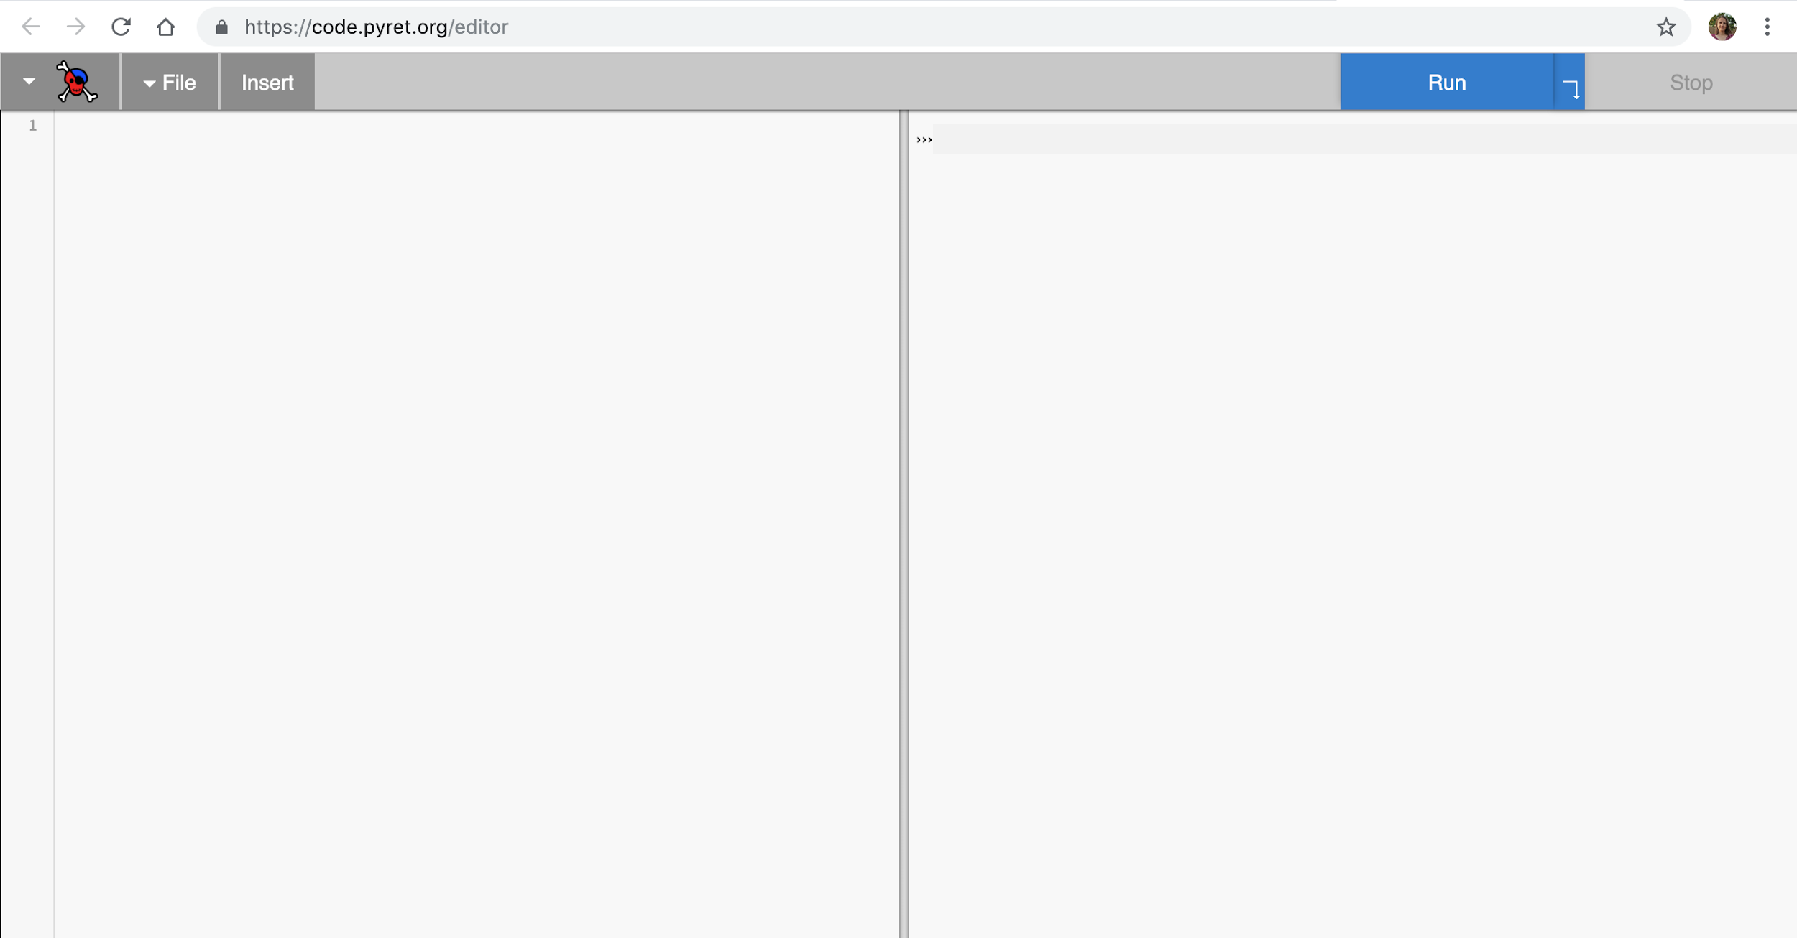

Definitions

Side

Interactions Side

In your browser, go to:

[code.pyret.org/editor](http://code.pyret.org/editor)

For the first few questions we will work only on the right side (*Interactions Side*) of the Pyret screen.

1. What happens when you type values into the interactions window of Pyret and press *‘enter’*? Fill in the table below. Name the data type for each value. Predict what Pyret will return when you type these values into the interactions window. Try each and record your observations. If you receive feedback, what is the feedback telling you?

|  |  |  |  |
| --- | --- | --- | --- |
| **Value** | **Data Type** | **Predict what Pyret will return** | **What does Pyret return? What does the feedback tell you?** |
| **5** |  |  |  |
| **5.00** |  |  |  |
| **3.14** |  |  |  |
| **.3** |  |  |  |
| **Value** | **Data Type** | **Predict what Pyret will return** | **What does Pyret return? What does the feedback tell you?** |
| **"a"** |  |  |  |
| **a** |  |  |  |
| **a = 2** |  |  |  |
| **a** |  |  |  |
| **a = 3** |  |  |  |
| **“a = 3”** |  |  |  |
| **a** |  |  |  |

**Expressions in Pyret**

In Algebra, an *expression* is a mathematical phrase that can include numbers, operators, and symbols. An *operator* is a symbol we use to show the *operation* to be performed, + for addition, for example. The order of operations is important, as it can change the solution to an expression.

An expression in Pyret is similar to an algebraic one. We use an operator to show the operation that must be performed. The values in the operation are called *operands*, and the operands in a Pyret expression can be of data type *Number* or *String*.

1. What happens when you *type* the following expressions into the interactions window of Pyret and press *‘enter’*? Fill in the table below. Predict what Pyret will return when you type these expressions into the interactions window. Try each and record your observations. If you receive feedback, what do you think it is telling you?

|  |  |  |
| --- | --- | --- |
| **Expression** | **Predict what Pyret will return** | **What does Pyret return? What does the feedback tell you?** |
| **5 + 6**  ***(with spaces)*** |  |  |
| **Expression** | **Predict what Pyret will return** | **What does Pyret return? What does the feedback tell you?** |
| **5+6**  ***(without spaces)*** |  |  |
| **5 * 6** |  |  |
| **3.14 - 2.1** |  |  |
| **1 / 2**  ***(with spaces)*** |  |  |
| **1/3**  ***(without spaces)*** |  |  |
| **(2 + 7) * 3** |  |  |
| **2 + 7 * 3** |  |  |
| **3 + 2 + 7** |  |  |
| **3 - 9 + 4** |  |  |
| **4 * 2 * 10** |  |  |
| **1 + "physics"** |  |  |
| **"Hi" + "neighbor"** |  |  |
| **"Hi" * "neighbor"** |  |  |

**More Practice**

1. Open the following code and predict what will happen when you enter each expression into the interactions window. Read the instructions at the top of the definitions window to evaluate each expression. <https://tinyurl.com/U1expressions>

#### Unit 1 Activity 2: Observation Stations

At each station, you will perform an activity and respond to the following prompts:

1. Describe the **initial conditions** of the station.
2. Describe the **final conditions** of the station.
3. Describe the **changes** to the conditions of the station.

|  |
| --- |
| **Station Name:** ______________________  **I.** What are the “**initial” conditions** of the station?  **II.** What are the **“final” conditions** of the station?  **III.** What **changes** did you observe to these conditions? |

|  |
| --- |
| **Station Name:** ______________________  **I.** What are the “**initial” conditions** of the station?  **II.** What are the **“final” conditions** of the station?  **III.** What **changes** did you observe to these conditions? |

# 

|  |
| --- |
| **Station Name:** ______________________  **I.** What are the “**initial” conditions** of the station?  **II.** What are the **“final” conditions** of the station?  **III.** What **changes** did you observe to these conditions? |

|  |
| --- |
| **Station Name:** ______________________  **I.** What are the “**initial” conditions** of the station?  **II.** What are the **“final” conditions** of the station?  **III.** What **changes** did you observe to these conditions? |

# 

|  |
| --- |
| **Station Name:** ______________________  **I.** What are the “**initial” conditions** of the station?  **II.** What are the **“final” conditions** of the station?  **III.** What **changes** did you observe to these conditions? |

|  |
| --- |
| **Station Name:** ______________________  **I.** What are the “**initial” conditions** of the station?  **II.** What are the **“final” conditions** of the station?  **III.** What **changes** did you observe to these conditions? |

# 

|  |
| --- |
| **Station Name:** ______________________  **I.** What are the “**initial” conditions** of the station?  **II.** What are the **“final” conditions** of the station?  **III.** What **changes** did you observe to these conditions? |

|  |
| --- |
| **Station Name:** ______________________  **I.** What are the “**initial” conditions** of the station?  **II.** What are the **“final” conditions** of the station?  **III.** What **changes** did you observe to these conditions? |

# 

|  |
| --- |
| **Station Name:** ______________________  **I.** What are the “**initial” conditions** of the station?  **II.** What are the **“final” conditions** of the station?  **III.** What **changes** did you observe to these conditions? |

# 

#### Unit 1 Activity 2 Teacher Resource: Observation Station Instructions

The following pages contain instructions for the stations you can use in the Unit 1 Observation Stations Lab.

**Observation Station: Cheetos on Fire**

(**goggles required**, one trial per group).

**[1]**

Directions:

* Place one piece of Cheeto into an aluminum pie pan.
* Using the lighter wand, attempt to ignite the Cheeto. You may find it easier by maneuvering the flame to an internal surface of the Cheeto.
* Once the Cheeto is ignited, remove the lighter.
* Make observations

**Observation Station:** **Tumble Buggy**

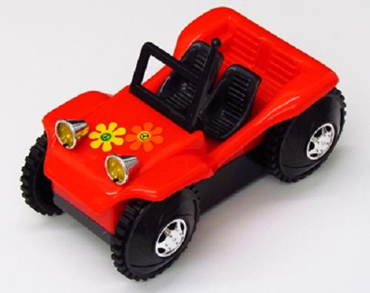[2]

Directions:

* Using the switch on the bottom of the buggy, turn the buggy on.
* Place the buggy on the floor.
* Make observations.
* Turn the buggy off.

# Observation Station: Wind-Up Toys

**[3]**

Directions:

* Using the winding dial, gently wind the toy. Be gentle. It only takes a few twists.
* Place the toy on the table and release the toy.
* Make observations.

**Observation Station: Popper Toy**

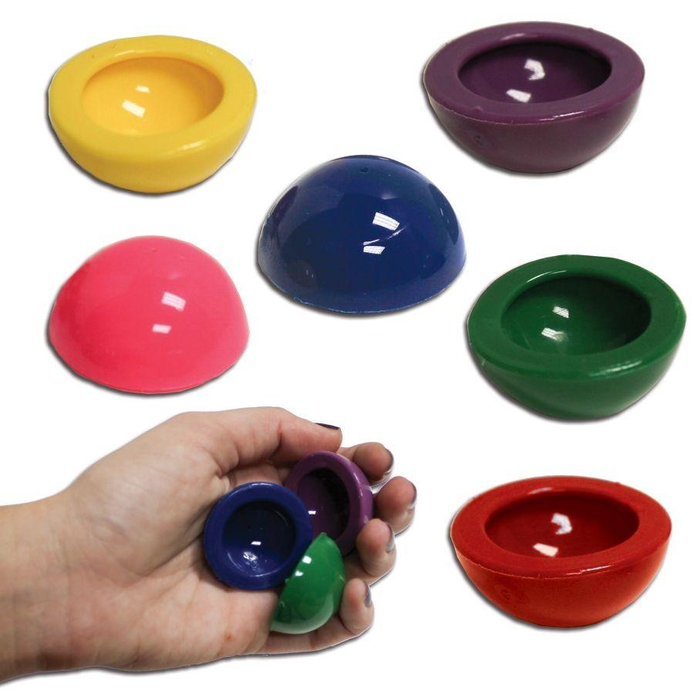**[4]**

Directions:

* Turn the popper inside out and quickly place it on the table.
* Release and watch.
* Make observations.

**Observation Station: Ball Drop**

**(goggles required)**



[5]

Directions:

* Drop the smaller ball from chest height.
* Make observations.
* Drop the bigger ball from chest height.
* Make observations.
* Now stack the smaller ball on top of the bigger ball. Release the balls at the same time so that they fall together.
* Make observations.

**Observation Station: Mass on a Spring**

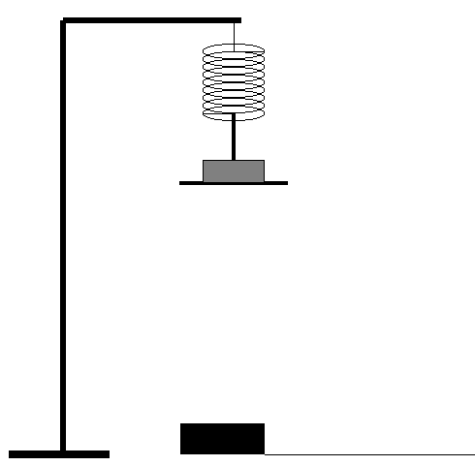**[6]**

# 

Directions:

* Gently pull the mass down 2-3 inches.
* Release the mass.
* Make observations.

**Observation Station: Watching Ice Melt**

**[7]**

Directions:

* Place one piece of ice on each of the two blocks.
* Make observations.

**Observation Station: Airzooka**

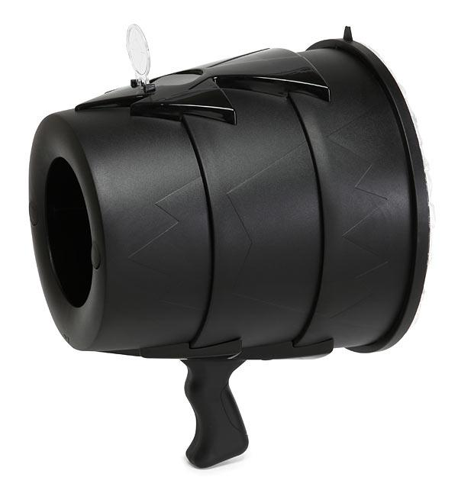**[8]**

Directions:

* Hold the Airzooka handle in one hand and pull back the elastic air launcher knob with the other.
* Aim the Airzooka at the suspended piece of paper and release the air launcher.
* Make observations.

**Observation Station: Pop, Pop, Fizz, Fizz. . .**

(**goggles required**, one trial per group).

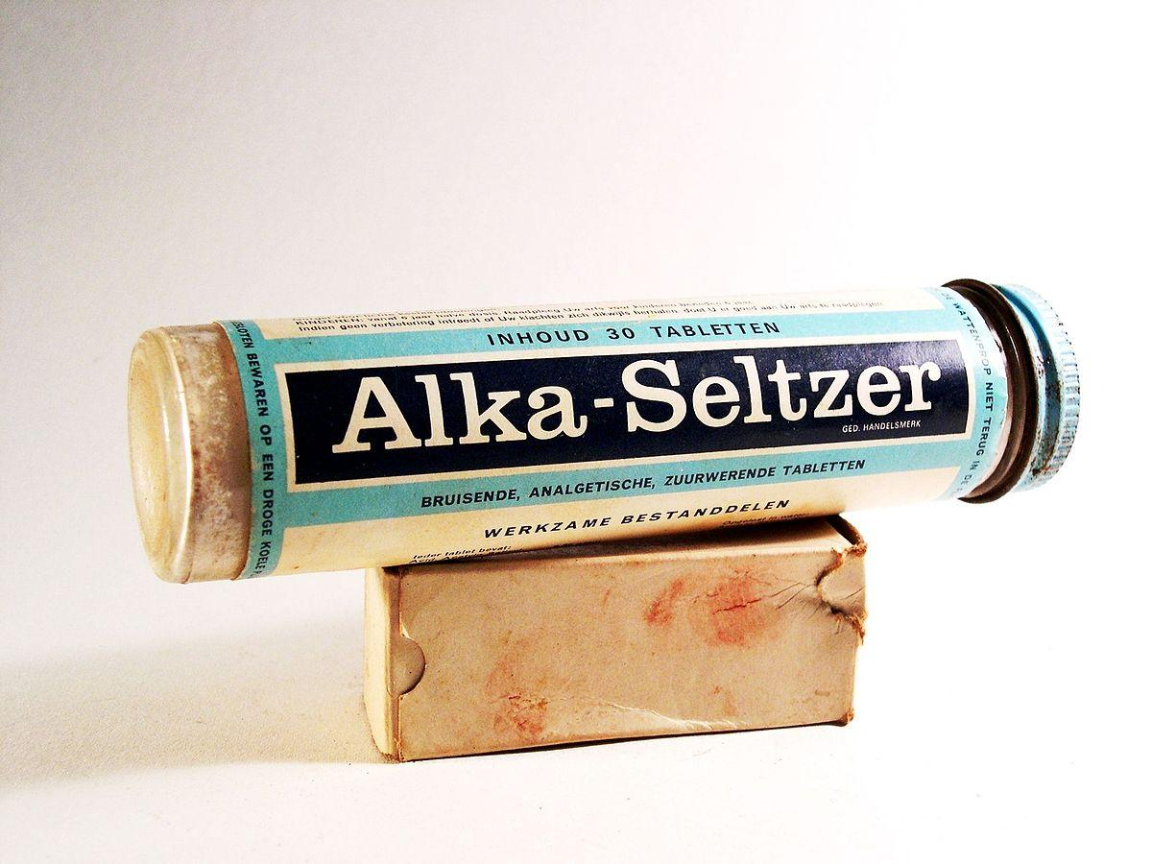**[9]**

# 

Directions: *Please read all directions before beginning*.

* Place ½ tablet of Alka Seltzer in a film canister.
* Have the film canister cap ready. Pour 1 test tube of water into the film canister and quickly replace the cap.
* Quickly place the closed film canister, lid side down, into the clear jar. You need to move quickly on this one.
* Stay clear of the canister opening! Please view from the *side*!
* Make observations.

**Observation Station: Rubbing Hands**

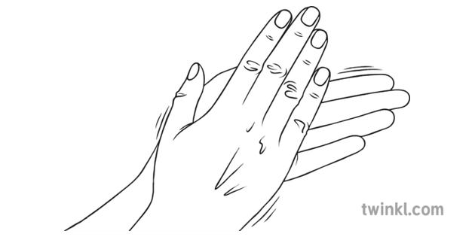**[10]**

# 

Directions:

* With your palms together, compress your palms and fingers.
* Rub your hands together, alternating forward and backward for several seconds.
* Make observations.

#### Unit 1 Activity 3: State Diagram Flipbooks

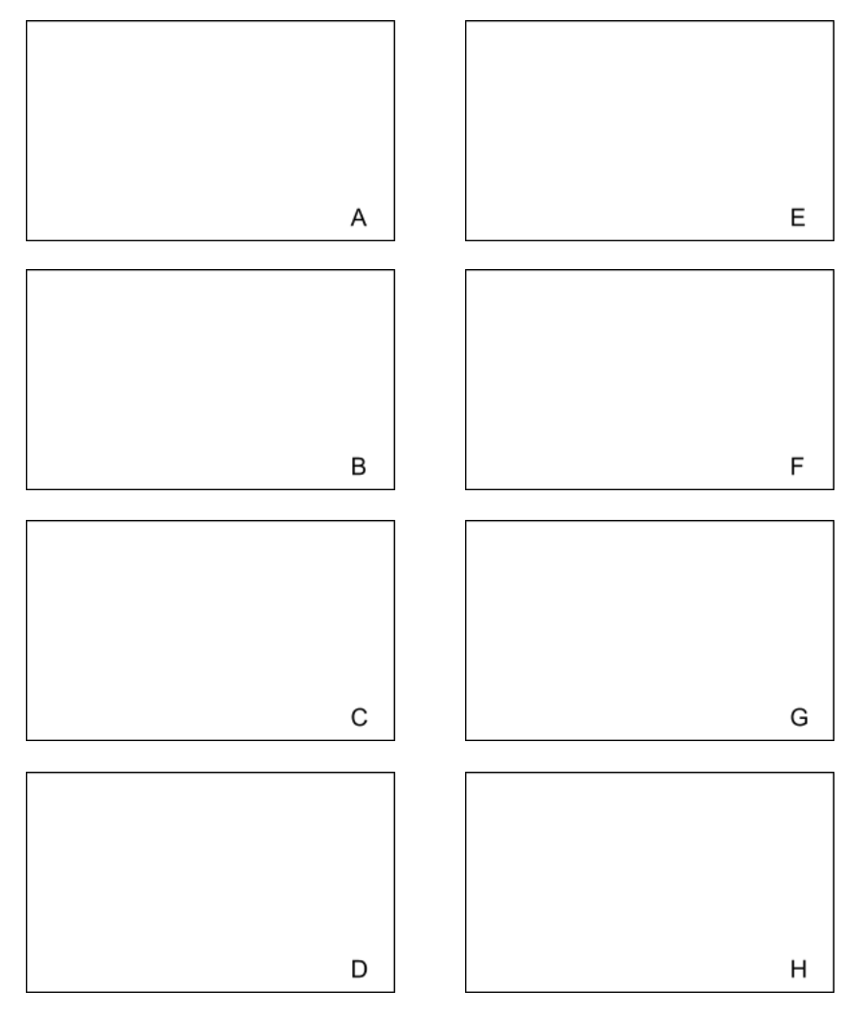

#### Unit 1 Worksheet 2: System Schemas and State Diagrams

*Refer to your notes on the Activity 2 Observation Stations to help you recall and analyze each of these events.*

**Directions: For each Observation Station listed…**

1. Construct a system schema
2. If useful, construct a state diagram. If you do not construct a state diagram, give the rationale for your conclusion that a state diagram is not useful in this situation.
3. Wind-Up Toys



1. Tumble Buggy
2. Ball Drop
3. A picture containing holding, hand

   Description automatically generatedPopper Toy
4. Watching Ice Melt

1. Mass on a Spring
2. Cheetos on Fire
3. 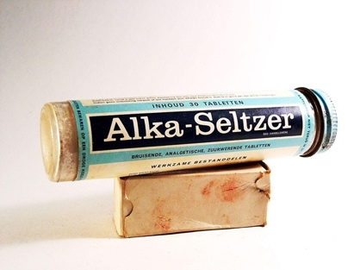Pop Pop, Fizz Fizz
4. Airzooka
5. Rubbing Hands

#### 

#### Unit 1 Reading 1: System Schemas and State Diagrams

**What is a System?**

In order to meaningfully discuss changes, we observe in some phenomenon, we need to establish what the boundaries are within which the change is occurring - in other words, which objects we care about (and which we do not). The objects that are of interest to us can be described as “inside the **system**” - a fictitious “border” around the objects we care about. The definition of a system is, to physicists, simply *the objects of particular interest to us*. Every object we feel is important may be placed inside the system; every object which is not important is “outside the system”, and is in what we call the **environment**, or more simply the **surroundings**.

To help us define a system, scientists draw diagrams called **system schemas**. A system schema helps us to, in as simple and abstract a manner as possible, represent objects that are interacting during a process or change. By *identifying the system* and *all interactions between objects*, we can determine if which interactions are occurring *within* the system, or if objects in the system are interacting with objects in the surroundings, across the system boundary. This may seem unimportant now, but it has far-reaching implications!

**Constructing a System Schema**

You can follow the steps below to create a system schema for any phenomenon:

1. Start making your System Schema by drawing circles to represent objects in and around the phenomenon you are observing. All objects are represented without any details of their shape or structure. Circles can be included on the schema that represent the object(s) of interest, or other objects that interact with the object(s) of interest. Each circle in the diagram should be labeled clearly with the name of the object.
2. Think about the event you have observed. Identify the objects that are interacting with each other. *(How do you know if objects interact? Most interactions occur when there is direct and obvious contact between them. A few types of interactions, such as magnets or the Earth, can happen even when the objects are not in direct contact!).*
3. Lines are drawn between circles to represent the interaction between the two objects. Whenever an interaction line ends on a circle, this means that the object represented by that circle experiences an interaction with the object at the other end of the line. If Object A and B share a line, for instance, then Object A is interacting with B, and Object B with A.
4. Finally, draw a dashed line around the object(s) you are interested in analyzing. This is your **system**. Any objects outside of the dashed line are part of the environment/surroundings.

**Example 1:**

A brick is sitting on top of a book which is sitting on top of a table:

How would you define the System? Sketch out an answer, then compare your answer with the answer drawn below.

**System Schema Example 1:**

We could define the system to include the Brick, the Book, the Floor and the Earth.

Here is a representation of this system, with all interactions drawn:

In this case, all the interactions between objects are *inside* the system. This type of system is called an **isolated system**, meaning there are no interactions between the system and the environment.

**System Schema Example 2:**

How would Example 1 change if the system were only the Brick and the Book? Look at this representation below:

In this case, some interactions of objects cross the system boundaries. This means the system is **non-isolated** - it has objects which interact with the environment/surroundings (in this case, the Floor and the Earth). In fact, there is only one interaction fully inside the system — the one between the Book and the Brick.

**Why Use System Schemas?**

We can use system schema to help us talk about phenomena — we can answer questions like:

1. What is/What are the object(s) in the system?
2. How do objects within the system interact with each other?
3. How do objects within the system interact with objects in the surroundings?
4. Which interactions change conditions of a system?

**Constructing State Diagrams**

The phenomenon illustrated above is *static*—it is not changing. However, most of the observation stations you observed were *dynamic* events—there was an observable change that occurred between the beginning and the end of each event. There is another tool you should use for these events—the **state diagram**.

Instead of a brick and book sitting on the floor, let’s imagine they are placed on a ramp and allowed to begin sliding. To help us track what conditions are changing in this system, we will draw **state diagrams**—pictures that illustrate the conditions of (at least) all the objects in the system at one moment. This moment is called a **state**, and for dynamic events, scientists will identify at least two states - the **initial state** and the **final state** (in some cases, there may be diagrams of **intermediate states** as well).

Below is a picture of the sliding brick+book, and two state diagrams (initial and final):

          Initial State     Final State

Note that the dot represents both the brick AND the book—since these two objects are both moving in the same manner, you can draw them as one dot in your diagrams.

You may choose to illustrate the system at intermediate states—for example, these four:

         Initial State                                                                                                         Final State

Both system schemas and state diagrams are useful tools for identifying systems and illustrating the state of a system at any moment, and as the system changes over time.

#### Unit 1 Worksheet 3: Working with Images in Pyret

**The Image Data Type**

In addition to the *Number* and *String* data, Pyret can also work with a third type of data: the *Image* data type. While both numbers and strings can be created using a computer keyboard, to create images requires the use of stored Pyret instructions called **image functions**.

**The Pyret Image Function Library**

**Calling the Image Function Library**

Images are created using **built-in functions** in Pyret, which are pre-made instructions, written by the creators of Pyret and stored in a function **library**.

Image functions, and really all functions in Pyret, work by taking in one or more inputs (or **arguments**) and producing an output. One example is the circle() function, which consumes three arguments and produces the image of a circle, with attributes determined by those three arguments.

Some common image functions are below.

|  |  |  |
| --- | --- | --- |
| **Function** | **Contract** | **Example** |
| circle | Number, String, String -> Image | circle(15, “outline”, “red”) |
| square | Number, String, String -> Image | square(25, “solid”, “blue”) |
| triangle | Number, String, String -> Image | triangle(30, “outline”, “green”) |
| star | Number, String, String -> Image | star(35, “solid”, “yellow”) |

**Creating Images**

**Basic Shapes**

1. Open the Pyret editor. Save a copy of your code.
2. Predict what will happen if you type circle(30, “solid”, “red”). What do you expect the output will be?
3. Type circle(30, “solid”, “red”) in the Definitions window, then click Run. Was your prediction correct? If not, what was different from your prediction? What should you change? Repeat until you can successfully produce a solid red circle of size 30.
4. In the Definitions window…
   1. Create a solid red circle of size 10. Store it under the **identifier** red-circle by typing red-circle = ____ with your code in the blank.
   2. Create a solid white circle of size 30. Store it under the identifier white-circle.
   3. Create a solid blue circle of size 50. Store it under the identifier blue-circle.
5. Click Run. What happens?
6. How could you tell Pyret to return all three circles in the Interactions window? Find as many ways as you can to do this.

**Combining Shapes**

Some functions create images by combining two or more images into one new Image. One of these functions is overlay(), which places one image on top of another.

|  |  |  |
| --- | --- | --- |
| **Function** | **Contract** | **Example** |
| overlay | Image, Image -> Image | overlay(image-1, image-2) |
| above | Image, Image -> Image | above(image-1, image-2) |
| beside | Image, Image -> Image | beside(image-1, image-2) |

1. Type overlay(blue-circle, white-circle) and click Run.
   1. What do you see?
   2. Which circle is on top? How could you change your code so that the other circle is on top? Change your code and run it again.
2. Using what you have learned, create the following Image in Pyret. Save the image in an identifier, and then save your file.



**Importing Images**

Sometimes, you may want to use an image found on the Internet, instead of making one using the image library. Pyret can do that, using the function image-url().

|  |  |  |
| --- | --- | --- |
| **Function** | **Contract** | **Example** |
| image-url | String -> Image | image-url("http://bit.ly/3AhLIm8") |

1. Import a picture from the Internet into Pyret using image-url().

**Resource: The Pyret Image Library**

Below is a curated list of Pyret image functions. For a list of ALL functions, go here! <https://www.pyret.org/docs/latest/image.html>

|  |  |  |
| --- | --- | --- |
| **Function** | **Contract** | **Example** |
| circle | Number, String, String -> Image | circle(15, “outline”, “red”) |
| square | Number, String, String -> Image | square(25, “solid”, “blue”) |
| triangle | Number, String, String -> Image | triangle(30, “outline”, “green”) |
| rectangle | Number, Number, String, String -> Image | rectangle(20, 50, “outline”, “green”) |
| star | Number, String, String -> Image | star(35, “solid”, “yellow”) |
| overlay | Image, Image -> Image | overlay(image-1, image-2) |
| above | Image, Image -> Image | above(image-1, image-2) |
| beside | Image, Image -> Image | beside(image-1, image-2) |
| put-image | Image, Number, Number, Image -> Image | put-image(circle-1, 20, 45, square-1) |
| scale | Number, Image -> Image | scale(0.2, rectangle-1) |
| rotate | Number, Image -> Image | rotate(40, star-1) |
| image-url | String -> Image | image-url("http://bit.ly/3AhLIm8") |
|  |  |  |
|  |  |  |
|  |  |  |

|  |  |  |
| --- | --- | --- |
| **Function** | **Contract** | **Example** |
|  |  |  |
|  |  |  |
|  |  |  |
|  |  |  |
|  |  |  |
|  |  |  |
|  |  |  |
|  |  |  |
|  |  |  |
|  |  |  |
|  |  |  |
|  |  |  |
|  |  |  |
|  |  |  |
|  |  |  |
|  |  |  |

#### 

#### Unit 1 Activity 4: Creating Flags

Use what you’ve learned about manipulating images in Pyret to try to reproduce the following national flags. Open up a new program at [code.pyret.org](http://code.pyret.org). Use the built-in image library to create the flags shown below.

|  |  |  |
| --- | --- | --- |
| russia =  C:\Users\jrutt\AppData\Local\Microsoft\Windows\INetCache\Content.MSO\90A21FDA.tmp | italy =  C:\Users\jrutt\AppData\Local\Microsoft\Windows\INetCache\Content.MSO\9D04C472.tmp | japan =  C:\Users\jrutt\AppData\Local\Microsoft\Windows\INetCache\Content.MSO\95C80D50.tmp |
| sweden =  C:\Users\jrutt\AppData\Local\Microsoft\Windows\INetCache\Content.MSO\DF72EFDE.tmp | chile =  C:\Users\jrutt\AppData\Local\Microsoft\Windows\INetCache\Content.MSO\3BBD879C.tmp | panama =  C:\Users\jrutt\AppData\Local\Microsoft\Windows\INetCache\Content.MSO\3B13FC0A.tmp |
| mauritania =  C:\Users\jrutt\AppData\Local\Microsoft\Windows\INetCache\Content.MSO\370E60A8.tmp | cuba =  C:\Users\jrutt\AppData\Local\Microsoft\Windows\INetCache\Content.MSO\C01394F6.tmp | myanmar =  C:\Users\jrutt\AppData\Local\Microsoft\Windows\INetCache\Content.MSO\865F2474.tmp |

Once you have made all nine of these national flags, try to make up a flag of your own.

#### Unit 1 Worksheet 4a: One-Argument Functions

1. Draw a square with side lengths 2 cm.

1. Determine the perimeter of the square. Show your work.

1. Draw a square with side lengths 3 cm.

1. Determine the perimeter of the square. Show your work.

1. Draw a square with sides of length ‘L’.
2. Determine the perimeter of the square. Show your work.

|  |
| --- |
| **Function Design** |

The purpose of this function is to compute the perimeter of a square.

|  |
| --- |
| **Physical Interpretation** |

What will the input(s) of your function be?____________________________(ex: length)

What will the units of each input be?______________________________(ex: meters)

What will the output be?__________________________________(ex: density)

What will the unit of the output be?_____________________________(ex: grams/meter3)

|  |  |  |  |  |  |  |
| --- | --- | --- | --- | --- | --- | --- |
| **Contract & Purpose Statement** | | | | | | |
| sq-per | | :: | Number | -> | Number | |
|  | Name |  | Domain (type of input(s)) |  | Range (type of output) | |
| # |  | | | | | |
|  | What does the function do? (The function consumes ______ and produces _______.) | | | | | |
| **Examples** | | | | | |

Write examples of your function in action

**examples:**

|  |  |  |  |  |
| --- | --- | --- | --- | --- |
| sq-per | | ( | 2 | ) |
| Name | |  | Example input(s) |  |
| **is** |  | | | | |
|  | What calculation must be performed? | | | | |

|  |  |  |  |  |
| --- | --- | --- | --- | --- |
|  | | ( |  | ) |
| Name | |  | Example input(s) |  |
| **is** |  | | | | |
|  | What calculation must be performed? | | | | |

**end**

|  |
| --- |
| **Function Definition** |

Circle the changing quantities in your examples and name them (consider the names used for the

physical quantities above).

|  |  |  |  |  |
| --- | --- | --- | --- | --- |
| **fun** | sq-per | ( | L | ): |
|  |  | | | |
|  |
| **end** |  |  |  |  |

1. Draw a square with sides of length 5 cm.

1. Determine the area of the square. Show your work.

1. Draw a square with sides of length 7 cm.

1. Determine the area of the square. Show your work.

1. Draw a square with sides of length ‘L’.

1. Determine the area of the square. Show your work.

|  |
| --- |
| **Function Design** |

|  |
| --- |
| **Physical Interpretation** |

What will the input(s) of your function be?____________________________(ex: length)

What will the units of each input be?______________________________(ex: meters)

What will the output be?__________________________________(ex: density)

What will the unit of the output be?_____________________________(ex: grams/meter3)

|  |
| --- |
| **Contract & Purpose Statement** |

|  |  |  |  |  |  |  |
| --- | --- | --- | --- | --- | --- | --- |
|  | | :: |  | -> |  | |
|  | Name |  | Domain (type of input(s)) |  | Range (type of output) | |
| # |  | | | | | |
|  | What does the function do? (The function consumes ______ and produces _______.) | | | | | |
| **Examples** | | | | | |

Write examples of your function in action

**examples:**

|  |  |  |  |  |
| --- | --- | --- | --- | --- |
|  | | ( |  | ) |
| Name | |  | Example input(s) |  |
| **is** |  | | | | |
|  | What calculation must be performed? | | | | |

|  |  |  |  |  |
| --- | --- | --- | --- | --- |
|  | | ( |  | ) |
| Name | |  | Example input(s) |  |
| **is** |  | | | | |
|  | What calculation must be performed? | | | | |

**end**

|  |
| --- |
| **Function Definition** |

Circle the changing quantities in your examples and name them (consider the names used for the

physical quantities above).

|  |  |  |  |  |
| --- | --- | --- | --- | --- |
| **fun** |  | ( |  | ): |
|  |  | | | |
|  |
| **end** |  |  |  |  |

#### Unit 1 Worksheet 4b: Two-Argument Functions

1. Draw a rectangle with sides of length 2 cm and 3 cm.

1. Determine the perimeter of the rectangle. Show your work.

1. Draw a rectangle with sides of length 1 cm and 5 cm.

1. Determine the perimeter of the rectangle. Show your work.

1. Draw a rectangle with sides of length ‘L’ and ‘W’.

1. Determine the perimeter of the rectangle. Show your work.

|  |
| --- |
| **Function Design** |

The purpose of this function is to compute the perimeter of a rectangle.

|  |
| --- |
| **Physical Interpretation** |

What will the input(s) of your function be?____________________________(ex: length)

What will the units of each input be?______________________________(ex: meters)

What will the output be?__________________________________(ex: density)

What will the unit of the output be?_____________________________(ex: grams/meter3)

|  |  |  |  |  |  |  |
| --- | --- | --- | --- | --- | --- | --- |
| **Contract & Purpose Statement** | | | | | | |
| rec-per | | :: | Number, Number | -> | Number | |
|  | Name |  | Domain (type of input(s)) |  | Range (type of output) | |
| # |  | | | | | |
|  | What does the function do? (The function consumes ______ and produces _______.) | | | | | |
| **Examples** | | | | | |

Write examples of your function in action

**examples:**

|  |  |  |  |  |
| --- | --- | --- | --- | --- |
| rec-per | | ( | 2, 3 | ) |
| Name | |  | Example input(s) |  |
| **is** |  | | | | |
|  | What calculation must be performed? | | | | |

|  |  |  |  |  |
| --- | --- | --- | --- | --- |
|  | | ( |  | ) |
| Name | |  | Example input(s) |  |
| **is** |  | | | | |
|  | What calculation must be performed? | | | | |

**end**

|  |
| --- |
| **Function Definition** |

Circle the changing quantities in your examples and name them (consider the names used for the

physical quantities above).

|  |  |  |  |  |
| --- | --- | --- | --- | --- |
| **fun** | rec-per | ( | L, W | ): |
|  |  | | | |
|  |
| **end** |  |  |  |  |

1. Draw a rectangle with sides of length 2 cm and 4 cm.

1. Determine the area of the rectangle. Show your work.

1. Draw a rectangle with sides of length 7 cm and 3 cm.

1. Determine the area of the rectangle. Show your work.

1. Draw a rectangle with sides of length ‘l’ and ‘w’.

1. Determine the area of the rectangle. Show your work.

|  |
| --- |
| **Function Design** |

|  |
| --- |
| **Physical Interpretation** |

What will the input(s) of your function be?____________________________(ex: length)

What will the units of each input be?______________________________(ex: meters)

What will the output be?__________________________________(ex: density)

What will the unit of the output be?_____________________________(ex: grams/meter3)

|  |
| --- |
| **Contract & Purpose Statement** |

|  |  |  |  |  |  |  |
| --- | --- | --- | --- | --- | --- | --- |
|  | | :: |  | -> |  | |
|  | Name |  | Domain (type of input(s)) |  | Range (type of output) | |
| # |  | | | | | |
|  | What does the function do? (The function consumes ______ and produces _______.) | | | | | |
| **Examples** | | | | | |

Write examples of your function in action

**examples:**

|  |  |  |  |  |
| --- | --- | --- | --- | --- |
|  | | ( |  | ) |
| Name | |  | Example input(s) |  |
| **is** |  | | | | |
|  | What calculation must be performed? | | | | |

|  |  |  |  |  |
| --- | --- | --- | --- | --- |
|  | | ( |  | ) |
| Name | |  | Example input(s) |  |
| **is** |  | | | | |
|  | What calculation must be performed? | | | | |

**end**

|  |
| --- |
| **Function Definition** |

Circle the changing quantities in your examples and name them (consider the names used for the

physical quantities above).

|  |  |  |  |  |
| --- | --- | --- | --- | --- |
| **fun** |  | ( |  | ): |
|  |  | | | |
|  |
| **end** |  |  |  |  |

#### Unit 1 Reading 2: Writing Custom Functions in Pyret

**Functions and Computation**

Computers are powerful tools used by scientists. The instructions we will write for a computer that tell it how to transform one or more inputs into a certain output are called *a function*.

**Function Contracts**

Before we can start writing our function, we must be sure of what exactly the function is supposed to accomplish. For this, we first need to be able to express in plain English a) what problem we want to solve, and b) what steps we will use to solve it.

Then we can decide *what we will call our function*, what *inputs* we will need to supply, and what kind of *output* we should get after the computer runs our function.

We organize this information into the function’s **contract**, and we write it as follows:

|  |
| --- |
| function-name :: Domain(type of input) -> Range(type of output) |

Remember that :: means “is of type” in Pyret. Let’s look at some examples of function descriptions and the contracts we would write for those functions.

1. We want to write a function called cm-to-meters which consumes a single Number as an input and produces a new Number which converts the number of centimeters an object is to the number of meters.

Contract

|  |
| --- |
| cm-to-meters :: Number -> Number |

This can be read as “cm-to-meters is of type Number producing Number.”

1. We want to write a function called grams-to-kilograms which consumes a Number and produces a Number that converts the number of grams input to the number of kilograms.

Contract

|  |
| --- |
| grams-to-kilograms :: Number -> Number |

This can be read as “grams-to-kilograms is of type Number producing Number.”

1. We want to write a function called name-of-shape which consumes a Number and produces a String which is the name of a polygon with that number of sides.

Contract

|  |
| --- |
| name-of-shape :: Number -> String |

This can be read as “name-of-shape is of type Number producing String.”

1. We want to write a function called red-circle which consumes a Number and a String and produces a circle with a certain radius and color.

Contract

|  |
| --- |
| red-circle :: Number, String -> Image |

This can be read as “red-circle is of type Number, String producing Image.”

**Choosing your Inputs**

One important aspect of writing a new function is deciding what information needs to be included as an input to your function. Take the following situation as an example:

|  |
| --- |
| A student working a part time job makes $11 an hour. They want to write a function to determine how much money they will make if they work various numbers of hours. |

1. The problem they want to solve is: given an hourly rate of pay of $11, how much will I earn if I work some number of hours?
2. The steps to solve the problem are to multiply the number of hours they work in a given pay period by $11/hr.

The student writes the following contract for their function, which they will call amount-earned.

Contract

|  |
| --- |
| amount-earned :: Number -> Number |

Where the Number input is the number of hours she worked.

Now, imagine this student wants to be able to use their amount-earned function to predict how much money all their friends will make from their jobs, which all pay somewhere between $10 and $15 an hour. In this case it’s not just the number of hours worked, but also the hourly pay that will change each time they use their function. Thus, they would have to use the following function contract:

Contract

|  |
| --- |
| amount-earned :: Number, Number -> Number |

Where the first input is the number of hours she worked and the second is the hourly rate of pay.

From this we can see that the intended use of a function can determine what values in the calculation are constants and which are variables. *The variables must be inputs to the functions.*

**Writing Examples**

Once we have written a contract for our function, the next step is to come up with a few examples of our function working properly. These examples serve two purposes:

1. They serve as a visual test to see whether our finished function behaves the way we expect it to.
2. They allow the Pyret program to tell us whether our function matches our examples.

Let’s say we want to write a function called find-sum which consumes two Numbers, x and y, and produces a Number which is the sum of the two. Below is the contract and some examples for this function.

|  |  |
| --- | --- |
| 1.  2.  3.  4.  5.  6.  7. | find-sum :: Number, Number -> Number  **examples:**  find-sum(0, 5) **is** 5  find-sum(-5, 5) **is** 0  find-sum(5, 5) **is** 10  **end** |

These examples tell us (and Pyret) how we want our function to behave.

**Writing Functions**

Once we have our examples written, we are ready to write the actual instructions that the computer will follow every time we use our function. Let’s take the function above and see what it looks like in Pyret:

|  |  |
| --- | --- |
| 1.  2.  3.  4.  5.  6.  7.  8.  9.  10.  11. | find-sum :: Number, Number -> Number  **examples:**  find-sum(0, 5) **is** 5  find-sum(-5, 5) **is** 0  find-sum(5, 5) **is** 10  **end**  **fun** find-sum(x, y):  x + y  **end** |

The instructions for carrying out this function are found on lines 9-11 in the previous block. Notice the notation we use to tell Pyret we are giving it instructions for how to carry out a function:

|  |
| --- |
| **fun** function-name(input-identifiers):  instructions  more-instructions (if necessary)  **end** |

Notice the words **examples**,**end**,**is** and **fun** in the boxes above. They are words that have *special meaning* to the Pyret program.

These words are Pyret “reserved words” and must be written exactly as shown in your program.

Once we have written the instructions that tell Pyret how to carry out a specific function, we are free to use it as many times as we want.

**Function Design**

One tool we will use as programmers when designing new functions is the **function design**. This prompts us through some of the steps we saw in this reading: Writing a contract, coming up with examples, then writing a function.

You should always complete a function design prior to writing a new function. Think of a function design as a ***function proposal***, which must be approved before construction of a new function can begin. Look over the sample function design included at the end of this reading.

**Try for Yourself**

Open the Pyret program link below and work your way through the sample functions. Fill in any missing information (denoted by a … in the code). Once you’ve worked your way through all the examples, try writing a function of your own from scratch, including its contract and examples.

Code: <https://tinyurl.com/U1-Reading2>

#### Unit 1 Activity 5: Dynamic State Diagrams with Pyret

What if we wanted to have 20 pages in our flipbooks? 100? Some of you may think 8 was already too many. With Pyret we can make unlimited flipbooks very easily! In this activity we will build a state diagram using our new skills

Student code: <https://tinyurl.com/U1-StateDiagrams>

#### Unit 1 Reading 3: Telling A Story of Energy

The passage that follows is from a book which chronicles a set of lectures presented by Nobel Prize winning physicist Richard Feynman during the 1961-1962 academic school year. This passage was chosen as an introduction to the concept of energy because it gives a clear view of the concept through a simple and effective analogy.

**From The Feynman Lectures on Physics: *What is Energy?***

There is a fact, or, if you wish, a *law*, governing all natural phenomena that are known to date. There is no known exception to this law—it is exact, so far as we know. The law is called the *conservation of energy*. It states: “There is a certain quantity (which we call energy) that does not change [throughout the many] changes which nature undergoes.”

That is a most abstract idea, because it is a mathematical principle; it says that there is a numerical quantity which does not change when something happens. It is not a description of a mechanism, or anything concrete; it is just a strange fact that we can calculate some number, and when we finish watching nature go through her tricks and calculate the number again, it is the same... Since it is an abstract idea, we shall illustrate the meaning of it by an analogy.

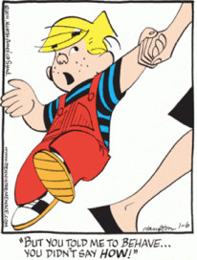

Imagine a child - perhaps “Dennis the Menace” - who has blocks which are *absolutely indestructible* and cannot be divided into pieces. Each is the same as the other. Let us suppose that he has 28 blocks. His mother puts him with his 28 blocks into a room at the beginning of the day. At the end of the day, being curious, she counts the blocks very carefully, and discovers a phenomenal law—no matter what he does with the blocks, there are always 28 remaining!

This continues for a number of days, until one day there are only 27 blocks. But a little investigating shows that there is one under the rug — she must look everywhere to be sure that the number of blocks has not changed.

One day, however, the number appears to change — there are only 26 blocks. Careful investigation indicates that the window was open, and upon looking outside, the other two blocks are found.

Another day, a careful count indicates that there are 30 blocks! This causes considerable consternation, until it is realized that Bruce came to visit, bringing his blocks with him, and he left a few at Dennis’ house.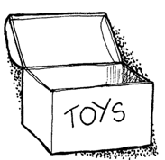

After she has disposed of the extra blocks, she closes the window, does not let Bruce in, and then everything is going along all right, until one time she counts and finds only 25 blocks. However, there is a box in the room, a toy box, and the mother goes to open the toy box, but the boy says, “No, do not open my toy box!” and screams. Mother is not allowed to open the toy box.

Being extremely curious, and somewhat ingenious, she invents a scheme! She knows that a block weighs three ounces, so she weighs the box at a time when she sees 28 blocks, and it weighs 16 ounces. The next time she wishes to check, she weighs the box again, subtracts sixteen ounces and divides by three. She discovers the following:

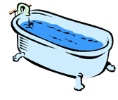

[The next day], there appear to be some new deviations - but careful study indicates that the dirty water in the bathtub is changing its level. The child is throwing blocks into the water, and she cannot see them because it is so dirty, but… since the original height of the water was 6 inches, and each block raises the water a quarter of an inch, this new formula would be:

In the gradual increase in the complexity of her world, she finds a whole series of terms representing ways of calculating how many blocks are in places where she is not allowed to look. As a result, she finds a complex formula for a *quantity* which *has to be computed*, which always stays the same.

What is the analogy of this to the conservation of energy? First, when we are calculating the energy, sometimes some of it leaves the system and goes away, or sometimes some comes in. In order to verify the *conservation of energy*, we must be careful that we have not put any in or taken any out of the system. Second, energy has a large number of different storage modes, and there is a formula for each one. These are: gravitational energy, kinetic energy, heat energy, elastic energy, electrical energy, chemical energy, radiant energy, nuclear energy, and many more. If we total up the formulas for each of these contributions, it will not change except for energy going in and out.

It is important to realize that in physics today, we have no knowledge of what energy *is*. We do not have a picture that energy comes in little blobs of a definite amount. It is not that way. However, there are formulas for calculating some numerical quantity, and when we add it all together it gives… always the same number.

Excerpt adapted from "Conservation of Energy;" The Feynman Lectures on Physics; Feynman, Leighton and Sands; Addison-Wesley Publishing Company, 1963.

***It’s time for your Story of Energy***

Can you tell your own “story” of energy — how it is stored and transferred?

#### 

#### Unit 1 Worksheet 5: Energy Bar Graphs

Re-observe (or review your notes for) the observation stations from the beginning of this unit. For each station,

* Draw the initial state and the final state diagrams.
* Draw the system schema *(be sure to identify your system!)* and transfer your system and any important objects external to the system to the LOL chart.
* Finally, draw the energy bar graphs for the initial and final states.

|  |
| --- |
| **Station Name: _______________**  Initial State  Diagram  Final State  Diagram  System Schema  E__ E___ E____  E___ E___ E___ E___  Initial state  Final state  System |

|  |
| --- |
| **Station Name: _______________**  Initial State  Diagram  Final State  Diagram  System Schema  E__ E___ E____  E___ E___ E___ E___  Initial state  Final state  System |
| **Station Name: _______________**  Initial State  Diagram  Final State  Diagram  System Schema  E__ E___ E____  E___ E___ E___ E___  Initial state  Final state  System |
| **Station Name: _______________**  Initial State  Diagram  Final State  Diagram  System Schema  E__ E___ E____  E___ E___ E___ E___  Initial state  Final state  System |
| **Station Name: _______________**  Initial State  Diagram  Final State  Diagram  System Schema  E__ E___ E____  E___ E___ E___ E___  Initial state  Final state  System |

#### Unit 1 Reading 4: Creating Energy Bar Graphs

**Why do we need to use energy bar graphs?**

Another tool to help us represent energy is an energy bar graph. A bar graph can help us to represent energy storage and transfer quantitatively. Alongside the system schema and state diagram, energy bar graphs will represent how energy storage changes when energy is transferred within a system, or even into or out of a system.

**What does an energy bar graph look like?**

Below is an example of an energy bar graph:

Initial state

Final state

System/Flow

**Start with a system schema and state diagrams**

Before making an energy bar graph, define your system and make a system schema and state diagrams. Remember, the system schema identifies the objects that interact during a process or change. State diagrams represent the positions or configurations of objects in your system at the instants that you choose. The instants for your state diagrams will become the instants represented in the energy bar graphs (include the initial and final states, and sometimes intermediate states, too). An energy bar graph will help us track changes in how the system stores and transfers energy during the process or change.

**Important features of an energy bar graph**

Each “bar” or “block” in the initial or final graph of an energy bar graph represents how the system is storing energy. The circle in the middle is used to represent the system and is also used to show energy flow. We can use ‘quantified arrows’ (like the bars on the bar graph) that point into or out of the system circle to represent the amount of energy being transferred into or out of the system. A system with a quantified arrow would be considered an *open system*. If no energy transfers into or out of the system, no arrow would be needed, and we call this a *closed system*. In this instance, the initial and final bar graphs must have an equal number of “blocks” or “bars” distributed among the different energy storage modes.

**Steps in constructing an energy bar graph**

1. *Identify the system*.
2. *Draw the system schema.*
3. *Draw state diagrams for each state you will represent with an energy bar graph.*
4. *Identify the initial energy storage* *modes* and represent them with bars that depict relative amounts of energy in each storage mode.
5. *Identify the resulting final energy storage modes* with final quantified bar graphs.
6. *Identify energy transfer(s).* If any energy transfer occurs across the system boundary, represent this transfer with arrows pointing into or out of the system schema to make the energy flow diagram.

In summary, you will use energy bar graphs to represent the initial and final energy storage, and the system schema and energy flow diagram to represent the intermediate processes. The difference in the initial and final energy storage is the system’s change in energy, ∆E, since

∆E = Efinal - Einitial

The energy bar graph and energy flow diagram help us represent the conservation of energy. Scientists call this concept of energy conservation the “First Law of Thermodynamics,” which states that the total energy of a system stays the same unless energy is transferred into or out of the system.

**Examples of bar graphs and energy flow diagrams**

**Example 1:** A skater is at rest at the top of the half-pipe and moves to the bottom of the half-pipe.

**

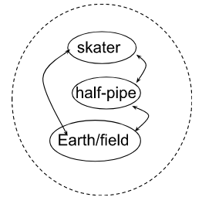 Initial Final

**System** = skater, Earth/field, half-pipe

The system schema shows that energy cannot be transferred into or out of the system, since none of the object interactions cross the system boundary. Therefore, in the energy flow diagram no energy transfers in or out of the system. This is a closed system; therefore, energy within the system remains unchanged.

**Corresponding energy bar graph and energy flow diagram:**

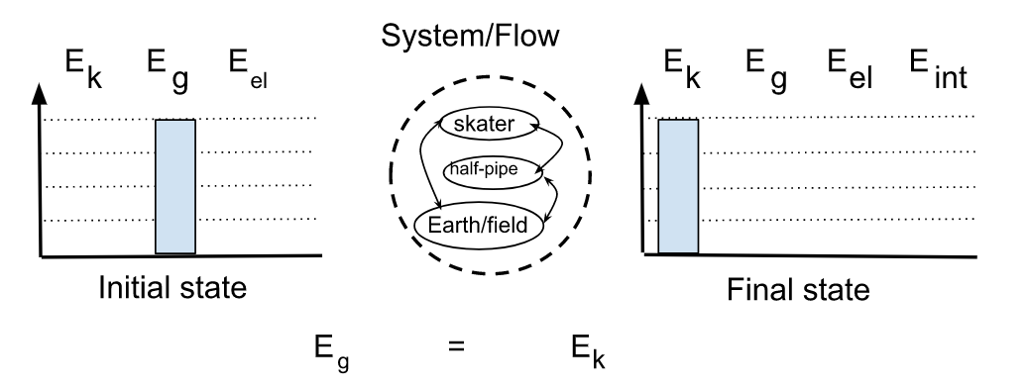

**Corresponding State Diagrams**

**Analysis**

1. The skater and Earth are separated, therefore there is energy stored in the arrangement of those two objects (Eg).

2. Energy is transferred from the energy of arrangement stored as Eg to Ek as the skater comes down the half-pipe and the skater moves faster. Positional energy is transferred to motion energy.

3. At the final state, the energy is now stored as kinetic energy, as the separation is now gone, and the energy is stored exclusively in the motion of the skater.

*Note, in this scenario, if friction (rubbing) takes place some of the energy moves into Eint, so when the skater reaches the bottom, the skater is moving slower, and the Ek is smaller, such that the Ek and Eint sum to the initial amount of Eg.

**Example 2:** A spring pushes a box from a 0 position up a ramp.

Initial

Final

**System** = box + ramp + Earth/field

**System Schema diagram**

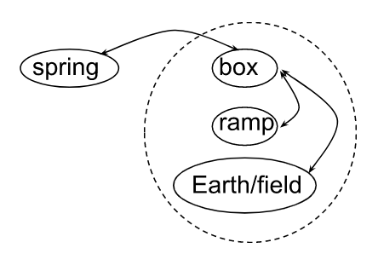

**Corresponding energy bar graph and energy flow diagram:**

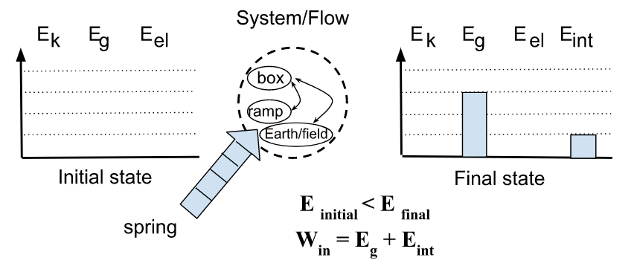

**Corresponding State Diagrams:**

**Analysis**

1. Assuming the box starts at a 0 (“zero”) reference point, it has no initial energy.

2. Energy is transferred to the system via the push provided by the spring that is outside the system. We call this energy transferred by pushing “Working” and give it the symbol “W”. If the spring transfers 4 blocks of the Eel into the system by pushing, then the ‘Working’ energy flow arrow is 4 blocks long.

3. In the final state, the energy transferred into the system by Working has been stored in the arrangement of the box and Earth and some has been transferred into Eint.

**Note that Eg and Eint add up to 4 blocks since the energy stored in the final state is equal to the energy transferred into the system through Working. 4 blocks (Win) = 3 blocks (Eg) + 1 block (Eint).

**Example 3:** A bucket is slowly lowered into a well by a person and sits motionless in the water.

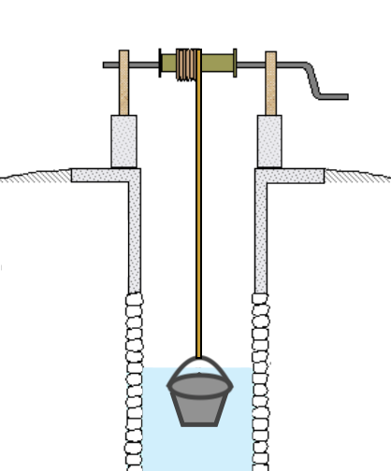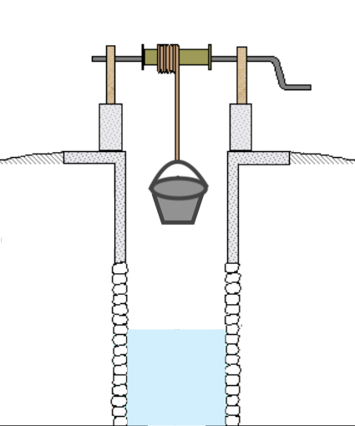

Initial

Final

**System** = bucket + water + Earth/field

**System Schema diagram:**

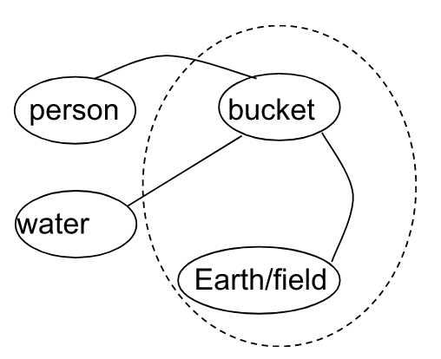

The system schema shows that energy can be transferred into the system by the person or water. Energy can also be transferred out of the system to the person or water.

**Corresponding State Diagrams: Corresponding bar graphs and energy flow diagram**

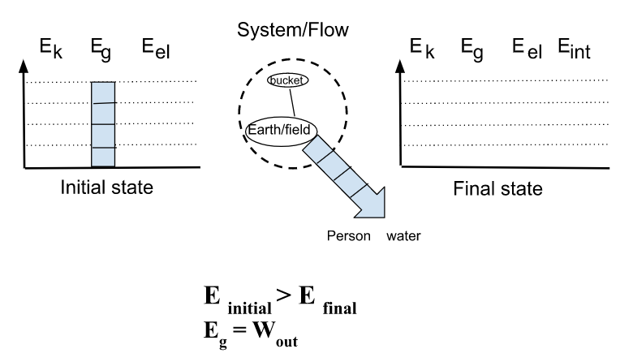

**Analysis:**

1. Initially, the system has only Eg energy, due to the bucket’s vertical position (separating it from the Earth).

2. Afterwards, the box-Earth/field system has no energy! The box sits motionless in the water, at such a low vertical position that we can define that location as the point where h = 0.

It might be tempting to say that the energy Eg was “lost” to Eint.However, it’s difficult to imagine the temperature of the bucket or its internal structure undergoing significant change in this process. Friction is minimal as the box is lowered, and we assume it was lowered gently so it doesn't slam into the water. Therefore, the energy had to be transferred out of the system by the interaction of the bucket with the person who lowered the bucket to the water (by ‘pulling’ or ‘working’)! This is a case where the analysis is actually more complicated if the person is included in the system (that situation would be beyond the scope of this course).

**Example 4:** A person pushes a box that was initially at rest across a floor; friction exists.

**System** = box + surface + Earth/field

The system schema shows that energy can be transferred into the system by the person or even out of the system to the person.

**System schema diagram:**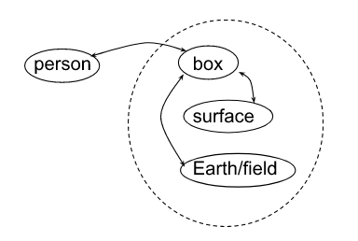

**Corresponding energy bar graph and energy flow diagram:**

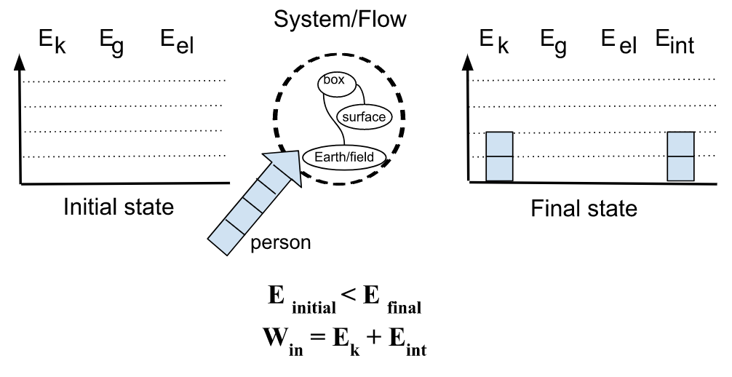

**Analysis**

1. The box has no initial energy.

2. Energy is transferred to the system (Win) via the external pushing provided by the person. The ‘Working’ arrow is 4 blocks long.

3. At the final state, the energy transferred to the system is stored partially as kinetic energy and partially as internal energy, since the box and surface has warmed during the process.

**Notice that Ek and Eint add up to 4 blocks since the energy in the final state is equal to the energy transferred into the system through the process of Working.

1. <https://www.flickr.com/photos/theimpulsivebuy/5878178681>
2. Image Source: <http://underscoopfire.com/wp-content/uploads/2014/03/tumble-buggy.jpg>
3. Public Domain [CC-0 <https://pixabay.com/en/toy-animal-yellow-wind-up-eyes-576488/> ]
4. <https://www.windycitynovelties.com/rubber-1-1-2-poppers-12-pack.html?gclid=CK37xc-Bv9MCFQSQaQodLP8AVQ>
5. <http://sirius.ucsc.edu/demoweb/mechan/collis.php>
6. http://www1.lasalle.edu/~blum/p106wks/massonspring.gif
7. Public Domain [CC-0 <https://pixabay.com/en/ice-cube-melting-ice-frozen-295036/> ]
8. <http://www.thinkgeek.com/product/60b6/>
9. By Henk Albert de Klerk - Own work, CC BY-SA 4.0, <https://commons.wikimedia.org/w/index.php?curid=36708118>
10. https://images.twinkl.co.uk/tr/image/upload/illustation/hands-rubbing-together-friction-black-and-white-1.png