**Unit 5 — More About Forces**

**Table of Contents**

Instructional Goals 3

Student Learning Objectives 3

Overview 3

Sequence 5

Activity 1 — Human Dynamics Cart 6

Apparatus 6

Pre-Activity Discussion 6

Activity Performance Notes 6

Post-Activity Discussion 7

Lab 1 — Modified Atwood’s Machine 7

Apparatus 7

Pre-Lab Discussion 7

Option 1: Force Probe 8

Option 2: “Megadot” System 9

Performance Notes 9

Post-Lab Discussion 10

Worksheet 1 — Practice with Unbalanced Forces 12

Resources 12

Worksheet 2 — Finding Individual Forces 12

Resources 12

Activity 2 — Forces During an Elevator Ride 12

Resources 12

Apparatus 12

Pre-Lab Discussion 13

Performance Notes 13

Post-Lab Discussion 13

Worksheet 3 — Elevator Ride Data Analysis 14

Resources 14

Worksheet 4 — Elevator Practice 14

Resources 14

Worksheet 5 — Forces in Two Dimensions 14

Resources 14

Lab 2 — Air Resistance 14

Resources 14

Apparatus 14

Pre-Lab Discussion 14

Performance Notes 15

Post-Lab Discussion 15

Activity 3 — Air Resistance Simulation 16

Resources 16

Activity 4 — Drag Race Simulation 17

Resources 17

Student Goal 17

Instructional Goal 17

Worksheet 6 — Two-Body Problems 19

Resources 19

Activity 5 — Rocket Lander Game 19

Resources 19

The Model So Far 21

Resource Index 22

Unit 5 Worksheet 1: Practice with Unbalanced Forces 23

Unit 5 Worksheet 2: Finding Individual Forces 25

Unit 5 Worksheet 3: Elevator Ride Data Analysis 27

Unit 5 Worksheet 4: Elevator Practice 29

Unit 5 Worksheet 5: Forces in Two Dimensions 32

Unit 5 Lab 2: Air Resistance 33

Unit 5 Activity 3: Air Resistance Simulation 37

Unit 5 Activity 4: Drag Race Simulation 39

Unit 5 Worksheet 6: Two-Body Problems 43

Unit 5 Activity 5: Rocket Lander 45

# **Instructional Goals**

1. **Newton’s 2nd Law**

* Apply force diagrams and system schemas to systems of multiple objects
* Use to calculate unknown forces exerted upon a system

1. **Resistive forces**

* Use collected data to form representations for air resistance

**3. Computational Representations**

* Modify and create programs that represent the application of force to an object as incremental changes in its velocity
* Use displays of dynamic images of arrows to represent force vectors
* Create conditionals to represent the motion of an object as a piecewise function
* Construct functions that take key commands as input

# **Student Learning Objectives**

MF1: I can use Newton’s second law to calculate an unknown force acting on an object.

MF2: I can use Newton’s 2nd Law to calculate the acceleration of an object, when I know all the force values acting on it.

MF3: I can relate the forces acting on an object to its motion using representations such as mathematical expression, motion maps, and free body diagrams.

MF4: I can produce a simulation of a moving object that takes air resistance into account.

# **Overview**

In this unit, we build on the understanding of Newton’s 1st Law developed in Unit 4 to include the motion of an object experiencing unbalanced forces. In Unit 4, we had developed the idea that *constant velocity* is the result of *balanced forces* (𝛴F = 0), and ***non****-constant velocity* is the result of ***un-****balanced forces* (𝛴F ≠ 0). In this unit we will develop a more robust expression, that can explain both the balanced and the unbalanced force situation for both constant and non-constant acceleration, culminating in the commonly used equation to model Newton’s 2nd Law.

We will model air resistance as well, such that students can use Pyret to model a realistic situation involving that interaction. Through a lab investigation, students will come to recognize that air resistance is a function of the speed of the object moving through the air. Students will have the opportunity to simulate a situation involving air resistance to deepen their understanding.

Conditionals will be used to simulate motion as a piecewise function, allowing for a much larger subset of forces, behaviors and phenomena to be simulated. Students will create more realistic motion by controlling the conditions under which objects move.

# **Sequence**

1. Activity 1 — Human Dynamics Cart
2. Lab 1 — Modified Atwood’s Machine
3. Worksheet 1 — Practice with Unbalanced Forces
4. Worksheet 2 — Finding Individual Forces
5. Activity 2 — Forces During an Elevator Ride
6. Worksheet 3 — Elevator Ride Data Analysis
7. Worksheet 4 — Elevator Practice
8. Worksheet 5 — Forces in Two Dimensions
9. Lab 2 — Air Resistance
10. Activity 3 — Air Resistance Simulation
11. Activity 4 — Drag Race Simulation
12. Worksheet 6 — Two-Body Problems
13. Activity 5 — Rocket Lander Game
14. The Model So Far

## Activity 1 — Human Dynamics Cart

### **Apparatus**

* Human Dynamics Cart, rolling chair, or cart (See diagram below)
* Heavy-duty spring scale
* Stopwatch
  + *Alternate apparatus: Dynamics carts, masses, and spring scales* 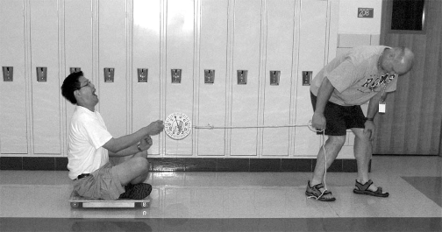

### **Pre-Activity Discussion**

The purpose of this activity is to provide a common physical experience for students to commence their study comparing balanced and unbalanced forces on systems.

To avoid any situations in which students might be singled out due to mass, it is important to ask for volunteers for this activity. Students who ride on the “dynamics cart” should be of varying mass so as to see that a relationship exists between force, mass and acceleration.

Discuss with the class what variables they think would affect the acceleration of the cart. Make a list of these on the board. When the students have an idea of what variables might affect the acceleration of the cart, have them go in the hall and test these variables.

### **Activity Performance Notes**

You will need to provide students with spring scales so that they can make rough measurements of force. They will also need stopwatches in order to get an idea whether the acceleration of the cart is increasing or decreasing as the pulling force on or mass of the system is changed. The stopwatch and spring scale are not meant to take quantitative measurements at this point, they are only for reference so that students can gauge the effects of their changes on acceleration.

### **Post-Activity Discussion**

Ask the students to devise qualitative rules that describe how mass and net force affect the acceleration of the cart. Allow each lab group to whiteboard their findings and explain to the class the rules that they have discovered during the exploratory activity.

## Lab 1 — Modified Atwood’s Machine

### **Apparatus**

* Dynamics Lab Cart
* Dynamics Track
* Pulley
* Hanging masses
* Motion sensor
* String
* Balance
* *Option 1: Add force sensor and interface*

### **Pre-Lab Discussion**

The purpose of this lab is to determine the relationship between acceleration and unbalanced force *for a system*.

* Show the class a cart attached to a string, with a mass hanging over a pulley. The cart and hanging mass will both accelerate.
* Release the cart and ask the students:
  + “What motion do you see for the cart?”
  + “What motion do you see for the hanging mass?”
  + “What conclusions can we draw based on previous investigations?”
* Ask the students what they can measure. The students now have experience with measuring velocity and time for uniformly accelerated motion, so these quantities will occur to them readily. They should also recognize that they can measure the masses of the cart and hanging masses.
* Have the students draw a system schema for the situation, as well as force diagrams for both the cart and hanging masses separately. This is especially important when using the second, “Megadot,” option.
* The schema and force diagrams should appear as follows:
  + The tension forces on both the cart and the hanging masses are the same.
  + The tension force is smaller than the force of gravity on the hanging mass.

Regardless of the option you decide to do, proper prep must be done ahead of time to prepare the students for the conceptual challenge of this lab.

**Option 1: Force Probe**

A force sensor is secured on the cart, and the string attached to this, allowing students to easily measure the unbalanced force acting on the cart. The force diagram for the cart only is sufficient for this case. A force sensor will directly measure the unbalanced force on the cart if the track is level. Using a wireless force sensor (options are available now from both PASCO Scientific and Vernier) will allow students to get data without the complication of wires getting in the way.

|  |  |
| --- | --- |
| Unbalanced Force  (Force of tension on the cart) | Acceleration  (Slope of the velocity vs. time graph) |
|  |  |
|  |  |
|  |  |

|  |  |
| --- | --- |
| System Mass  (Mass of the cart plus added masses) | Acceleration  (Slope of the velocity vs. time graph) |
|  |  |
|  |  |
|  |  |

A second experiment comparing the mass of the system and the unbalanced force exerted on it can be conducted using Option 1. In this experiment, mass is added to the cart while the unbalanced force remains constant. Students should find an inverse relationship between these variables.

Split the class so that some groups explore the acceleration vs. unbalanced force relationship while the others explore the acceleration vs. mass relationship. This will allow for more rich discussion, and a full exploration of the relationships, in the post-lab discussion.

### **Option 2: “Megadot” System**

* The key here is that the directions need to be aligned. Rotate the hanging mass force diagram to align the positive ‘parallel’ directions for both force diagrams. This removes the role of the pulley, as the pulley’s only purpose in this scenario is to redirect the direction of the string. We are in essence ‘straightening’ the string.
* Now, since both objects move together ‘as one’, we can consider them as a single system. This should be easier for them to consider after having dealt with the colliding cars in Unit 2 as a single system.
  + We identify the system with the bold orange dotted line on both the system schema and the force diagram.
  + Finally, we draw the system as the ‘megadot’ in the final force diagram and note that the ‘unbalanced’ force in this scenario is the Force of gravity from the Earth acting on the hanging mass, and this force diagram has the same basic structure as in Option 1.

### **Performance Notes**

At this point, we can determine the acceleration of our system using the motion sensor (slope of velocity vs. time graph) and the unbalanced force by determining the gravitational force by the Earth on the hanging mass. We will directly control the unbalanced force, but for our purposes it will serve us better to graph it with the acceleration on the independent (horizontal) axis and unbalanced force on the dependent (vertical) axis.

One final hurdle to this is that the mass of the *system* will change, *unless* the extra mass added to the hanging mass during the lab comes from the ‘cargo’ on the cart. This would allow the mass of the system to remain the same, and we are merely redistributing it within the system.

Students should be directed to record the amount of the mass of their system (including the cart, extra masses and hanging mass).

|  |  |
| --- | --- |
| Unbalanced Force  (Force of gravity on hanging mass) | Acceleration  (Slope of the velocity vs. time graph) |
|  |  |
|  |  |
|  |  |
|  |  |

### **Post-Lab Discussion**

Once the data is collected, students will have two representations:

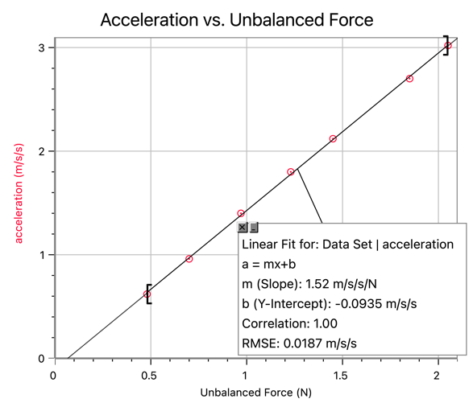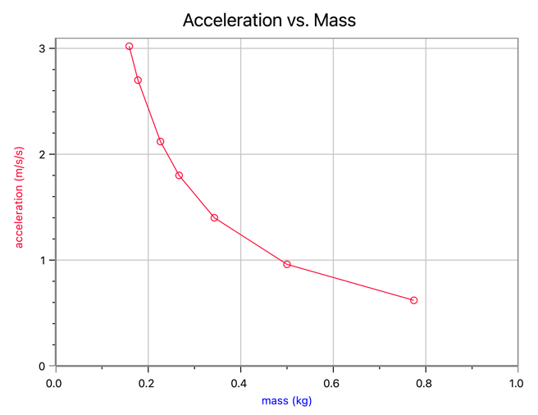

**How Force Affects Acceleration**

The acceleration vs. unbalanced force graph shows a linear relationship with a constant of proportionality represented by the slope of the line. A small vertical intercept may be due to friction. (This can be alleviated by elevating the back end of the ramp so that the car rolls towards the pulley with a constant speed, but even if this doesn’t happen your students’ results should be close enough.)

Explore the proportionality by having students include their data table on their whiteboards. “If your unbalanced force doubled, what happened to the acceleration? Tripled? etc.” The relationship shows a constant that has no obvious meaning at first. Unit analysis of the constant will lead students to the unit of m/s/s for every Newton of force added. This is not a unit we have seen before so we can move on in the discussion and come back to this relationship later.

The relationship they should get from this graph:

**How Mass affects Acceleration**

The acceleration vs mass graph shows an inverse relationship. Students may need help to see this relationship if you have not explored similar relationships before. Many students will assign this graph a negative linear slope, but exploration of what happens after the line crosses an axis will help them see that is not the best representation of their data. “If you add enough mass does the acceleration become negative? What would that mean?”

The relationship from this graph is:

This constant is not a slope but some constant of proportionality. Analysis of the data table should show that if you double the mass the acceleration should change by a factor of 1/2, etc.

It is important that students use a wide range of masses to really see the curviness of the data.

When prompted to consider what was kept constant in this experiment, students should see that the value of the constant is very similar to the unbalanced force used to pull the carts.

When students see this, they are then ready to look back at both relationships together.

If constant2 is the same as the unbalanced force, what would make sense for constant1? Students should see that if they calculate the inverse of their system mass, the result is very close to the value of constant1. At this point challenge the students to come up with a unified equation and they should figure out that the relationship is:

The last step is to further examine this unbalanced force. In Unit 4, we established that forces are balanced when the sum of the forces is equal to zero and unbalanced when the sum of the forces is not zero. Students should be encouraged to use other representations such as a system schema or force diagram to verify that the sum of the forces on the cart is, in fact, equal to the unbalanced force used in this experiment. SO, one last re-write yields:

## Worksheet 1 — Practice with Unbalanced Forces

### **Resources**

* Unit 5 Worksheet 1: Practice with Unbalanced Forces

Students will have the opportunity to practice deploying the model (Newton’s 2nd law) developed in the modified Atwood’s machine lab. Instructions direct them to construct system schemas and force diagrams for each situation to make the connections between these representations.

## Worksheet 2 — Finding Individual Forces

### **Resources**

* Unit 5 Worksheet 2: Finding Individual Forces

Students will have the opportunity to practice utilizing Newton’s 2nd Law to find an individual force in a given situation. Again, system schemas and force diagrams should be included to emphasize the connections between representations.

## Activity 2 — Forces During an Elevator Ride

### **Resources**

* Elevator ride video with measurements: <https://drive.google.com/open?id=1XscWdjbRjjVy81xuXL72Pju3vI7yoOXl>
* Free fall ride (Disneyland’s “Mission Breakout”): <https://www.youtube.com/watch?v=k0F2aLwt2d8>

The notion that the perpendicular (aka, normal) force is always equal to the force of gravity is a deeply rooted idea. This needs to be unmasked as an erroneous conception. This is only possible through actively confronting the idea in a lab setting. Even after confronting it, we will often see this crop back up when forces act on angles; objects are placed on a ramp, etc. This idea is not easily quenched in the minds of students and efforts must be made to continually cycle back to this activity in the minds of the students.

### **Apparatus**

* Force sensor or spring scale
* Mass set
* Interface *or video capture device w/slow-motion mode*

*Alternate Apparatus: Access to an elevator and bathroom scale or force plate*

For this activity, we will repeat the apparatus used in the gravitational force vs. mass lab from Unit 4, adding motion.

### **Pre-Lab Discussion**

Discuss the motion of an elevator. Ask:

* How does the motion of the elevator change as it moves from a lower floor to a higher one?
* How does the motion of the elevator change as it moves from a higher floor to a lower one?
* What clues can you use to detect the motion of the elevator?

### **Performance Notes**

Students should begin by holding the force sensor in such a way that the masses are suspended above the table. They start the masses at this “floor.” Start the data collection (force sensor or slow-motion video) and raise the masses, coming to a stop at a higher “floor.”

### **Post-Lab Discussion**

Students should begin by discussing what the graph of force vs. time shows about the force on the hanging masses. After discussing what their data is showing, have students draw a motion map for the situation on their whiteboard. The students should identify three distinct sections of the motion: Speeding up while moving up, moving up at a constant velocity and slowing down while moving up. Identify these sections as “A,” “B,” and “C.”

C

B

A

Continued discussion about what the motion map is describing to them about their forces should be undertaken at this time. Clearly the forces are not ‘balanced’ the entire time. A reason for this must exist!

Students should then be directed to draw a force diagram for each of the 3 situations for “A,” “B,” and “C.”

This establishes that the perpendicular force changes during the course of the ride. How would a passenger in the elevator *feel* during each section of the motion? Do they feel ‘normal,’ ‘heavier than normal’ or ‘lighter than normal?’ Students should then look for a link about ‘how they feel’ and the force diagrams they have drawn.

Finally, extend them to the hypothetical situation of what they would ‘feel’ if the elevator cable were to break while they were on the elevator. An alternate to this question would be to ask about popular amusement park rides that lift passengers then “drop” them quickly. A video of Disneyland’s “Guardians of the Galaxy: Mission Breakout” ride can be found in the Resources section above.

As a segue into the next activity, students could watch the elevator ride with measurements video or reproduce this activity should they have access to an elevator and force plate or bathroom scale.

## Worksheet 3 — Elevator Ride Data Analysis

### **Resources**

* Unit 5 Worksheet 3: Elevator Ride Data Analysis

This worksheet offers students the opportunity to analyze data from an elevator ride and interpret it to determine the motion that is occurring at the various times. This will also give students the opportunity to reason beyond the obvious plug and chug.

## Worksheet 4 — Elevator Practice

### **Resources**

* Unit 5 Worksheet 4: Elevator Practice

This worksheet provides students extra practice with unbalanced forces and vertical acceleration.

## Worksheet 5 — Forces in Two Dimensions

### **Resources**

* Unit 5 Worksheet 5: Forces in Two Dimensions

Students often confuse the sum of the forces to mean adding all forces, regardless of direction. This worksheet allows the instructor to separate the horizontal and vertical forces into separate summation statements. In all situations that we investigate in this unit, there will only ever be an acceleration in one dimension, either horizontal or vertical, not both.

## Lab 2 — Air Resistance

### **Resources**

* Unit 5 Lab 2: Air Resistance

### **Apparatus**

* Paper coffee filters
* Camera and video analysis software (Vernier Video Analysis, VideoPhysics app)

### **Pre-Lab Discussion**

The purpose of this experiment is to develop a mathematical representation to describe the effect of air resistance on the motion of a falling object.

* Hold a coffee filter in the air and drop it. Ask students to describe the motion of the filter. Most will state that it appears to float, that it does not continue to accelerate toward the floor.
* Ask students to create a force diagram for the coffee filter. They should state that two forces act on the filter: gravity and air resistance. At some point these two forces should be equal in magnitude. We already know that when the sum of the forces on an object is zero, that object experiences no change in motion.
* Ask students what evidence we will need to determine the filter is not accelerating. Acceptable evidence will include a linear position vs time graph, a slope of zero on a velocity vs time graph and equal intervals on a motion map. All three of these representations are available through video analysis.
* If your students have not yet used video analysis software, it will be important to model the process. See the performance notes below for suggestions.

### **Performance Notes**

* Students will film the motion of the coffee filter as it falls. The camera must remain stationary. Placing a meter stick in the background of the video will allow students to set scale on the video.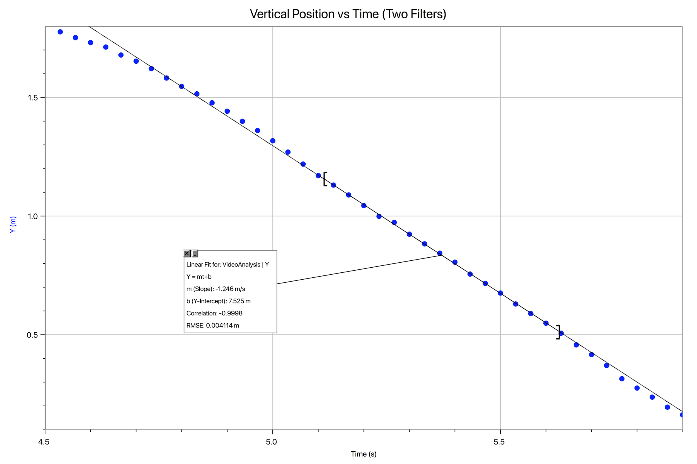
  + Using a marker to draw a large dot on the side of the coffee filter can give students a focus for video analysis when the filter becomes blurry.
  + An alternative would be to have students use the vertical position of the coffee filter and the video timestamp to collect data points.
* Groups will generate graphs of **vertical position vs time.**
* As an extension, groups should obtain data using different numbers of coffee filters. A larger mass will result in a higher terminal velocity.
  + The number of filters should not exceed six as it will become increasingly difficult for the filters to reach terminal velocity during the time of the video.

### **Post-Lab Discussion**

* The graph will show an increasing speed for a short period of time followed by a period of constant velocity. Students can interpret each portion of the graph as evidence of the behavior of the falling coffee filter.
* Students can compare the slopes of the linear portion to determine a pattern. Those groups that used a larger number of filters will see a larger negative slope as the terminal velocity is higher.
* An additional graph of **Fg vs vt (terminal velocity)** can be constructed using class data to show a direct linear relationship. This relationship will be used in the Pyret simulation that follows.
  + Depending on the number of coffee filters used, the graph may become closer to a quadratic relationship (which is the correct relationship) but this affects the speed of the animation in the next simulation. To avoid this, limit the number of filters dropped to a maximum of six, and guide students toward the linear fit for this data.
  + When the filter moves at a constant velocity, the vertical forces on the filter are balanced.
  + Using the graph, and substituting for , the equation for the graph becomes

with the negative sign telling us that the air resistance on the filter is in a direction opposite to that of the velocity.

* + This slope is the “drag factor” for the coffee filter and shows the proportionality between and the velocity of the coffee filter. Since the mass of the coffee filter is very small, this drag factor should be very small as well.

## Activity 3 — Air Resistance Simulation

### **Resources**

* Student Code: <https://tinyurl.com/U5-Coffee-Filter>
* Unit 5 Activity 3: Air Resistance Simulation

This activity has students completing a simulation of the falling coffee filters they explored in Lab 3. This will be the first simulation with non-constant acceleration, so students will need to write a new function called find-a. Notice that this function is not called next-a. That is because the function does not use the acceleration at the current tick to calculate the acceleration in the next tick. Instead, it uses the velocity at the current tick to calculate the acceleration at that same tick. Students should be encouraged to use the values they found in Lab 3 to complete this simulation, then compare the simulated results to their experimental results.

Students will create a find-drag-force function that consumes the current velocity and produces the force of drag as a number. This output will then be sent to a find-sum-of-forces function that consumes drag and produces the sum of the forces as a number. The Fg of the earth on the filter does not need to be an input to this function because it will be constant for this particular situation. The drag factor found in Lab 2 can be defined at the top of the code, along with the gravitational field strength needed for the force by the Earth on the filter. In the example below, these have been defined as drag-factor and gfs. Students will need to be careful with the directions for the forces on the filter(s). Start by having students draw a force diagram for the coffee filter as it falls. The gravitational force is downward so it must be negative, and the drag force is upward so it must be positive.

**fun** find-drag-force(v):

-1 * drag-factor * v

**end**

**fun** find-sum-of-forces(drag):

(mass * gfs) + drag

**end**

The find-a function consumes the sum of the forces and produces the acceleration by computing the quotient of the sum of forces and the mass of the coffee filter. In this example, the sum of the forces has been locally defined as sum-F. This local definition can be changed to match the consensus of the classroom. To reinforce the relationship between the sum of the forces and acceleration found in the Modified Atwood’s Machine lab, this function computes the acceleration as the sum of the forces divided by the mass.

**fun** find-a(sum-F):

sum-F / mass

**end**

In question 1, make sure that students choose two frames where the coffee filter is still accelerating and one frame where it has reached terminal velocity.

## Activity 4 — Drag Race Simulation

### **Resources**

* The student code can be found at <https://tinyurl.com/U5-Drag-Race>
* Unit 5 Activity 4: Drag Race Simulation

### **Student Goal**

The students will write code to reach the finish line in the shortest time possible and then stop the car in the shortest distance possible, for the sake of safety.

### **Instructional Goal**

In order to meet the objective, they need to write an on-key function to start the thrust from the engine using one key and stop the thrust at the appropriate position using any other key. They will also write a function to deploy the chute and bring the car to a stop.

Students are responsible for writing the functions:

* next-x (a function of position and velocity)
* next-v (a position of velocity and acceleration)
* thrust-from-key (a function of key)
* drag-force (a function of velocity)
* chute-force (a function of position and velocity)
* sum-of-forces (a function of thrust, drag, and chute
* find-a (a function of ForceSum)

Students will need to apply the following programming skills to successfully implement this simulation:

* Conditionals (applying the proper forces under the appropriate conditions to determine the acceleration)
* Key controls for the simulation

In the starter code, three identifiers are defined as values in the background code, meaning that students can use these in their functions.

* mass
* delta-t
* max-thrust

To control the thrust using the thrust-from-key function, students will write a conditionals block with two conditions:

* Pressing one selected key will start the thrust
* Pressing any other key will stop the thrust

This requires an on-key function with the contract

thrust-from-key :: String -> Number

To indicate that the keypress needs to equal one specific key, the == operator should be used in the condition. The function consumes a keypress and produces a value for the thrust.

**fun** thrust-from-key(key):

**if** key == “right”: max-thrust

**else**: 0

**end**

**end**

Students will use an on-key function again in the Rocket Lander to control the vertical thrust of the rocket.

**Sample student code:**

|  |  |
| --- | --- |
| The drag force is a function of the speed of the car. Students control the drag coefficient. | **fun** drag-force(v):    -5 * v  **end** |
| The chute (parachute) force is a function of the position and the speed of the car. The position controls *when* the chute is deployed. Students control the drag coefficient of the chute. | **fun** chute-force(x, v):  **if** x < 1000: 0  **else**: -50 * v  **end**  **end** |

|  |  |
| --- | --- |
| The sum-of-forces function consumes the output of the three force functions and outputs one number that is sent to the find-a function. | **fun** find-sum-of-forces(  thrust, drag, chute):  thrust + drag + chute  **end** |
| The find-a function is a function of the three forces that act on the car from start to finish. | **fun** find-a(sum-F):  sum-F / mass  **end** |

## Worksheet 6 — Two-Body Problems

### **Resources**

* Unit 5 Worksheet 6: Two-Body Problems

This worksheet is designed to force students to navigate between large systems (‘megadots’) and smaller systems (single object systems). The first problem is designed to focus on the difference in the tension in a string in an equilibrium situation, versus an accelerated one. Most students will not see the tension as having changed from one scenario to the other.

The last problem is open to teacher interpretation, based on your students’ ability level. It is sufficiently robust that students can solve for a numerical answer to the question, yet the question is sufficiently vague that it can be dealt with merely as a discussion based on students’ thinking and can be dealt with qualitatively.

## Activity 5 — Rocket Lander Game

### **Resources**

* Students should use their saved Rocket Lander game
* Unit 5 Activity 5: Rocket Lander

At this point students can add three additional pieces to their Rocket Lander game. They will add a function sum-of-forces that consumes the thrust acting on the rocket and computes the sum of the forces. They will then take this sum and use it to determine the acceleration of the rocket using the function a-from-f. The final function will be a thrust-from-key function that takes in the current vertical thrust and a keypress and produces the new vertical thrust.

The first two functions use Newton’s 2nd Law, adding two forces together then taking that sum and dividing by the mass of the rocket to compute acceleration.

**fun** sum-of-forces(Fth):

Fg = mass * gfs

Fg + Fth

**end**

Mass and gravitational field strength are both defined in the initial parameters of the simulation.

**fun** a-from-f(sum-F):

sum-F / mass

**end**

The function a-from-f does not require that students compute the sum of the forces in their code, but instead *automatically* takes in the value computed by sum-of-forces and divides this by the mass to determine the current acceleration of the rocket.

The final function for Unit 5 is thrust-from-key which is similar to the function written for the drag race simulation.

**Notes on this function:**

When the player presses the "up" key, this should increase the current upward thrust on the rocket. Pressing "up" multiple times will increase the thrust multiple times. This will slow downward motion and/or cause upward motion, depending on the current velocity of the rocket and how the thrust compares to the force due to gravity.

Handled by the game: Displaying the flames when the thrust is non-zero. Keeping track of the current thrust.

Handled by the player: Calculating the sum of forces. Deciding how much thrust is applied per press of the "up" button, and how much lost for "down". Using the sum of forces to calculate acceleration.

The thrust is calculated in the background in multiples of half the weight of the rocket. An addition of 1 to the thrust, for example, will add 0.5 * mass * gfs to the current thrust. Students will observe an increase to the size of the flames beneath the rocket each time the thrust is increased, and a decrease each time the thrust is decreased.

thrust-from-key :: Number, String -> Number

# Consumes the current thrust and a key press

# and produces the new thrust value

**examples:**

thrust-from-key(10, "up") **is** 10 + 1

thrust-from-key(10, "down") **is** 10 - 1

**end**

**fun** thrust-from-key(Fth, key):

**if** key == "up": Fth + 1

**else if** key == "down": Fth - 1

**else:** Fth

**end**

**end**

Following the completion of these functions, students will now have a complete game in which they can control the thrust, keep the rocket flying, and land it safely on the surface of the planet.

## The Model So Far

As with the previous units, finish this unit by constructing a “Model So Far” to include unbalanced forces.

# **Resource Index**

1. Unit 5 Worksheet 1: Practice with Unbalanced Forces
2. Unit 5 Worksheet 2: Finding Individual Forces
3. Unit 5 Worksheet 3: Elevator Ride Data Analysis
4. Unit 5 Worksheet 4: Elevator Practice
5. Unit 5 Worksheet 5: Forces in Two Dimensions
6. Unit 5 Lab 2: Air Resistance
7. Unit 5 Activity 3: Air Resistance Simulation
8. Unit 5 Activity 4: Drag Racer Simulation
9. Unit 5 Worksheet 6: Two-Body Problems
10. Unit 5 Activity 5: Rocket Lander

#### **Unit 5 Worksheet 1: Practice with Unbalanced Forces**

*For each problem, draw a system schema for the physical system. Define the system in your diagram with a dotted line around the object or objects that are in your system. Draw a well-labeled force diagram. Show all general equations in your solution.*

1. A 2.00 kg cart on a frictionless track is pulled horizontally with a force of 3.00 N. What is the acceleration of the cart?
2. A box filled with books has a mass of 15.0 kg. It is pushed across the floor with a constant force of 60.0 N. If the frictional force by the floor on the box is 15.0 N, what is the acceleration of the box?
3. A shuffleboard player applies a horizontal force of 10.0 N to the shuffleboard puck (400. g). If the puck accelerates at 24.5 m/s/s as the player continues to push it, what is the frictional force on the puck?
4. The player releases the puck. Using the same frictional force as above, what is the acceleration of the puck now?
5. If the puck must travel 10.5 meters to make its goal, what initial velocity should it have?
6. To accelerate the puck to this needed initial velocity, for how long did the player need to apply the force mentioned in question 3?

#### **Unit 5 Worksheet 2: Finding Individual Forces**

*For each situation, be sure to sketch a physical diagram, a system schema and a force diagram.*

1. A parent pushes their child in a grocery cart. The total mass of the cart and child is 30.0 kg. If the force resisting this cart's motion is 15.0 N, how hard does the parent have to push so that the cart accelerates at 1.50 m/s/s?
2. A 3.00 kg cart on a track is pulled by a string so that it accelerates at 2.00 m/s/s. The force of tension in the string is 10.0 N. What is the force of friction on the cart?
3. A 2000 kg SUV accelerates from rest at a rate of 3.00 m/s/s. The total amount of force resisting its motion is 1500 N. How much force is applied by the ground to the SUV’s tires to make it accelerate?
4. The 2000 kg SUV from problem 4 now drives at a constant 18.0 m/s. The total amount of force resisting its motion is 2500 N. How much force is now applied by the ground to the SUV’s tires?
5. A shopping bag’s handles can provide a maximum force of 65.0 N before breaking. A shopper puts 5.00 kg of groceries in the bag. If the shopper tries to lift the bag with an upward acceleration of 2.00 m/s/s, will the bag break?
6. A 900 kg helicopter accelerates downwards at a rate of 2.50 m/s/s. What is the magnitude of the lifting force by the air on the helicopter?
7. A 0.500 kg model rocket is initially pushed upwards by a thrust force of 8.00 N. If the force of air resistance is 1.00 N, what is the initial acceleration of the rocket?
8. A 70.0 kg skydiver falls towards the Earth. If the force due to air resistance is 500. N, what is the acceleration of the skydiver?
9. The skydiver in the previous problem opens their chute. The force due to air resistance is now 1200 N. What is the acceleration of the skydiver? (What happens to the motion of the skydiver?)

#### **Unit 5 Worksheet 3: Elevator Ride Data Analysis**

After watching the video of the elevator ride, analyze the data illustrated by the graphs. The person was ***at rest*** on the 15th floor at the beginning of the elevator ride. The person was standing on a force plate (scale) which measured the amount of force exerted on the plate by the person, and therefore also the amount of upward force on the person by the plate. In the exercises below, consider the motion and forces on the person for each labeled section of the graph.

Draw a *qualitative* force diagram for a person on an elevator: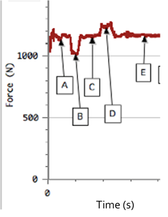

|  |  |  |
| --- | --- | --- |
| **Moving w/ constant velocity** | **Accelerating upward** | **Accelerating downward** |
|  |  |  |

1. Based on the graph above, what is the approximate *weight* of the person riding the elevator? Explain how you know this.
2. Based on your answer to question 1, what is the *mass* of the person? Explain how you know this.
3. What can you infer about the motion of the elevator during sections ‘C’ and ‘E’ of the graph?
4. Based on the graph and information above, give a *possible* description of the motion of the elevator.

The graph to the right is from the same elevator ride – assume that the elevator is at rest before the motion shown in section ‘F’.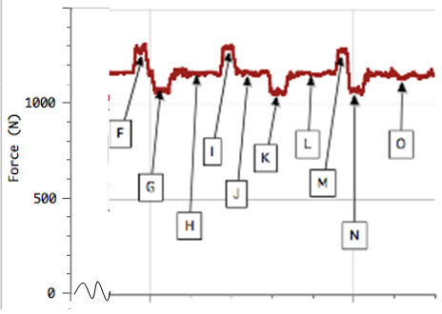

1. What do you believe is happening at section ‘H’? Explain your reasoning.

1. During which interval do you suppose the elevator traveled the greatest distance?

1. Draw a possible motion map for the motion from point H to point L.

#### **Unit 5 Worksheet 4: Elevator Practice**

1. An elevator is moving up at a *constant velocity* of 2.50 m/s, as illustrated in the diagram below: The person has a mass of 85.0 kg.

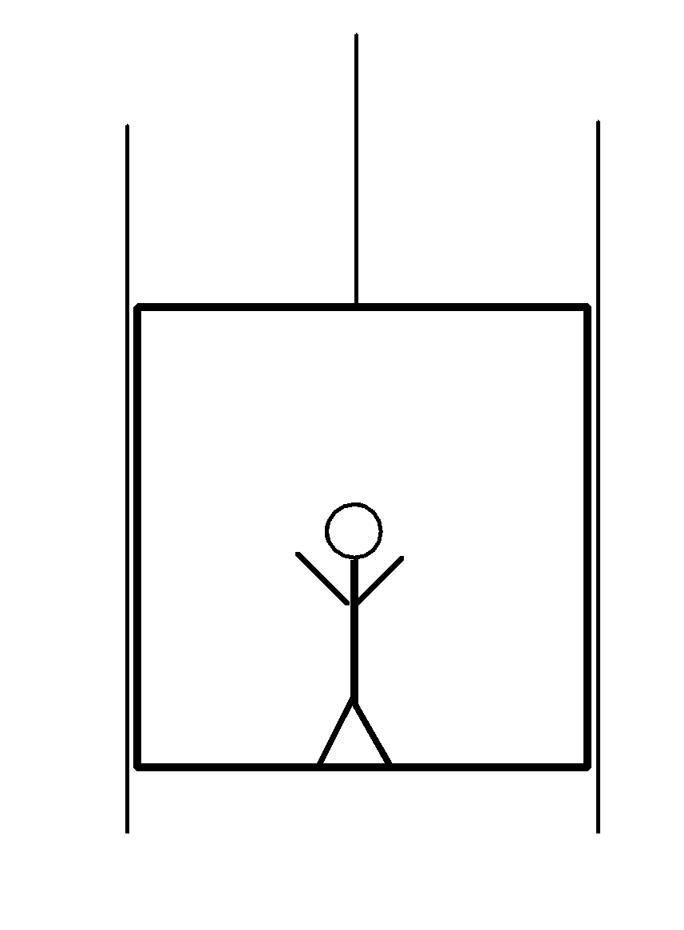

* 1. Construct a system schema for the person.
  2. Construct a force diagram for the person.
  3. How large is the force that the floor exerts on the person? How large is the force the person exerts on the floor?

1. The elevator now *accelerates* *upward* at 2.00 m/s2.
   1. Construct a new force diagram for the person.
   2. How much force does the floor of the elevator now exert on the person?
2. Upon reaching the top of the building, the elevator accelerates downward at 3.00 m/s2.
   1. Construct a force diagram for the person.
   2. How much force does the floor now exert on the person?
3. While descending in the elevator, the cable suddenly breaks. What is the force of the floor on the person?
4. Consider the situation where a person that has a mass of 68.0 kg is descending in an elevator at a constant velocity of 4.00 m/s. At some time "t", the elevator starts to slow to a stop at the rate of 2.00 m/s2.

a. Construct a qualitative motion map indicating the relative positions, velocities and accelerations of the elevator as it descends.

b. Construct **quantitative** force diagrams (include sizes) for the person in the elevator as it descends at (a) constant speed and (b) during the times it was accelerating.

1. If the person in the elevator were standing on a bathroom scale calibrated in ‘Newtons’, what would the scale read while the elevator was (a) descending at constant speed and (b) while slowing to a stop? Show your work and explain your answers.

#### **Unit 5 Worksheet 5: Forces in Two Dimensions**

1. An applied force of 25 N pushes on a 5.0 kg block resting on a frictionless horizontal surface. The force is directed parallel to the surface.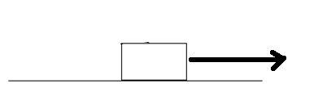

1. Draw a force diagram for the block.
2. Determine the force of gravity on the block.
3. Determine the normal force on the block.
4. Determine the acceleration of the block.

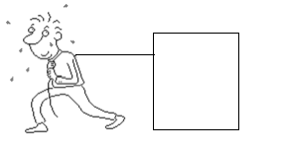

1. A 75.0 kg box is pulled by a 400. N force parallel to the horizontal flat surface. If the block is accelerated at 2.00 m/s/s, determine the force of friction on the block.
2. If the string snapped… what would happen?

#### **Unit 5 Lab 2: Air Resistance**

#### 

**Pre-lab Questions**

1. Draw a system schema and force diagram for a coffee filter falling to the floor.
2. Describe the motion of the coffee filter as it falls.
3. What evidence would you need to collect to support your description? How would you collect this?

**Equipment**

* Paper coffee filters
* Meter stick
* Camera and video analysis software (LoggerPro or VideoPhysics app)

**General Procedure**

You will be using video analysis software to analyze the motion of a coffee filter as it falls to the floor. Some things to remember:

* keep the camera stationary
* place a meter stick in the background so it can be used for scale

This software will give you data for horizontal and vertical position, and horizontal and vertical velocity based on the points you mark. We only need to analyze the vertical motion of the filter.

Since we know that mass and gravitational force are related, you should measure the mass of the coffee filter. You may collect multiple data sets using a different number of coffee filters for comparison.

**Data**

On the axes below, label and sketch the collected graph of vertical position vs. time. What does this graph tell you?

**Discussion Questions**

1. How many coffee filters were used to obtain the previous data set? What was the total mass of these coffee filters? What would the force of gravity be for these coffee filters?
2. What does the graph tell you about the motion of the coffee filter as it falls? How do you know?
3. What does your answer to question 2 tell you about the air resistance acting on the coffee filter as it falls?
4. Compare your data with that of another lab group who used a different number of coffee filters. What is similar? What is different?
5. Collect data for several numbers of coffee filters. This may require you to record more video to analyze. Use this data to complete the following table.

|  |  |  |
| --- | --- | --- |
| **Mass of Coffee Filters (kg)** | **Fg (N)** | **Terminal Velocity (m/s)** |
|  |  |  |
|  |  |  |
|  |  |  |
|  |  |  |
|  |  |  |
|  |  |  |

1. Construct and label a graph of Fg vs Terminal Velocity on the axes below. What does this graph tell you?

#### **Unit 5 Activity 3: Air Resistance Simulation**

In this activity you will create a simulation to replicate your experimental results from Lab 3. This will be the first time you have simulated motion with a non-constant acceleration, so you will need to write an additional function to calculate the acceleration of the coffee filter each tick.

1. Draw a 3-frame flipbook of the coffee filter falling in the space below. Then, underneath each frame, draw the force diagram showing all of the forces acting on the coffee filter at that moment in time.

|  |  |  |
| --- | --- | --- |
| **Flipbook** |  |  |
| **Force Diagrams** |  |  |

1. Using the force diagrams you drew above, write a mathematical expression for the sum of the forces acting on the coffee filter at any moment in time. If this were a computer function, what input(s) would it need to take?
2. Complete a Function Design for the function find-drag-force which will calculate the drag on the coffee filter at each tick. Write the final function body in the space below.
3. Complete a Function Design for the function find-sum-of-forces which will calculate the sum of the forces acting on the coffee filter at each tick. Write the final function body in the space below.
4. Complete a Function Design for the function find-a which will calculate the coffee filter’s acceleration at each tick. Write the final function body in the space below.
5. Once your teacher has approved your function design, open the code found here: <https://tinyurl.com/U5-Coffee-Filter>. Use the numbers (mass and slope) from Lab 2 to finish the simulation.

1. Compare the graphs produced by the simulation to those you found in the lab. How well does your simulation match what you observed?

#### **Unit 5 Activity 4: Drag Race Simulation**

In this activity you will create a simulation of a drag racer trying to drive 1,000 meters as quickly as they can. We will make this simulation more realistic by accounting for the air resistance acting on the car.

1. Answer the following questions as you get started.
   1. When should the car start to ‘thrust’ forward?
   2. When should the parachute be deployed to slow the car down?
   3. When should the ‘thrust’ be stopped?
2. Consider the 3 sections of motion that might occur during a drag race. For this simulation, we will consider the drag force by air on the front of the car and the ‘chute’ force by the parachute on the car to be two separate forces.

Draw a motion map for the motion of the drag racer. (*Hint: Remember to include the times while the light is red, yellow and green.*)

|  |  |  |
| --- | --- | --- |
| Before the car starts to move | While the car is speeding up | While the car is slowing down |
| Force Diagram: | Force Diagram: | Force Diagram: |
| Write an expression for the acceleration, based on the force diagram above: | Write an expression for the acceleration, based on the force diagram above: | Write an expression for the acceleration, based on the force diagram above: |

1. What factor(s) will affect the acceleration calculation? What should be the inputs of this function?
2. Complete two Function Designs, one for the find-sum-of-forces function and one for the find-a function. Write the bodies of these functions here.
3. Open the simulation<https://tinyurl.com/U5-Drag-Race>and add your find-a function. Copy the next-x and next-v functions from one of your previous simulations into the appropriate lines in the drag race code. Include the contract and an examples block.
4. The car experiences a drag force from the air as it moves. What factor(s) influence the drag force?
5. Complete a Function Design for the find-drag-force function and write the body of the function here. Add your find-drag-force function to the starter code.

You have two goals in this drag race:

* Reach the finish line in the shortest time possible.
* Stop the car as close to the finish line as possible.

In this simulation, **you** are the driver.

* To apply the parachute, you will be writing a conditional to automate when the chute is deployed.
* To apply thrust you will be writing a function to use one key on the keyboard to turn on the thrust, and any other key to turn off the thrust.

1. Under what condition(s) should the chute be deployed?
2. Complete a Function Design with Conditionals for the find-chute-force function and write the body of the function here. Add your find-chute-force function to the starter code.

To apply thrust to the car you will write a function thrust-from-key that takes in a keypress and produces the amount of thrust to give the car. The contract for this function is

thrust-from-key :: String -> Number

10. What key will you be using to apply thrust to the car? How would this be written as a string?

11. How much thrust should be given to the car when this key is pressed?

12. If any other key is pressed, how much thrust should be given to the car?

13. Complete a Function Design with Conditionals for the thrust-from-key function and write the body of the function here. Add your thrust-from-key function to the starter code. When you have done so, press “Run.”

14. Did you receive feedback? Read each feedback message individually, make adjustments to your code, and press “Run” again. What did you need to do to address this feedback?

15. You had two goals in this drag race:

* Reach the finish line in the shortest time possible.
* Stop the car as close to the finish line as possible.

Make changes to the code to achieve these goals. What was your shortest time? How close did you come to the finish line? Which factors did you change?

#### **Unit 5 Worksheet 6: Two-Body Problems**

#### 

1. Consider a situation similar to the lab set-up, as shown to the right: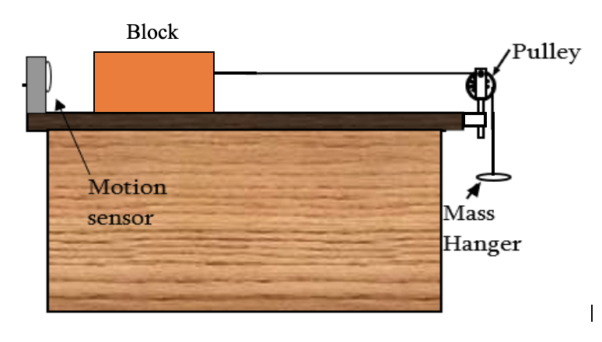
2. Draw a system schema and force diagram for the situation.
3. If the block on the table (4 kg) is stationary, *but on the verge of moving*, determine the mass of the hanging object. Assume the coefficient of *static* friction to be 0.25.
4. Determine the tension in the string.
5. Moments later, another mass equal to the amount you calculated in part b is added to the mass hanger, effectively doubling the hanging mass. Determine the acceleration of the mass on the table.
6. Determine the tension in the string after the addition of the extra mass.

1. If a 50-gram mass were hanging as shown above, what minimum mass would be required to hold the system in equilibrium? Assuming the coefficient of static friction remains 0.25.
2. What happens to the force of friction on the mass sitting on the table, if the mass of the hanging object were decreased?

15 kg

5 kg

F = 50 N

1. In the situation to the right, the coefficient of kinetic friction between the bottom block and the floor is 0.25. The coefficient of kinetic friction between the blocks is 0.20, and the coefficient of static friction between the blocks is 0.40.

What happens to the top block? *Hint: Draw force diagrams for the blocks before proceeding.* Defend your answer.

#### **Unit 5 Activity 5: Rocket Lander**

In the previous units, you wrote functions to control the motion of the rocket, to keep it on the screen, and to change the game’s status as you attempt to land it on the surface of the planet.

For this unit, your goal is to write three functions:

* sum-of-forces computes the total force on the rocket.
* a-from-f computes the acceleration of the rocket.
* thrust-from-key allows the player to change the rocket’s thrust by pressing a key.

**Part I — sum-of-forces**

1. Open your copy of the Rocket Lander code. Find the following comment block:

############

# Unit 5 #

####################################################################

# Design a function called sum-of-forces that consumes the rocket #

# thrust, and produces the total force on the rocket due to both #

# the thrust and the gravitational field. #

# #

# THEN, in the make-lander function at the end of the code, #

# change default-sum-of-forces to sum-of-forces. #

####################################################################

2. Draw a force diagram for the rocket a) when the thrust is zero, b) when the thrust is pointed upwards, and c) when the thrust is pointed downwards.

3. Write an expression for the sum of the forces acting on the rocket.

4. Complete a function design for the function sum-of-forces. When you have done so, add this to your Rocket Lander game. Don’t forget to change default-sum-of-forces to sum-of-forces in the inputs to the `make-lander` function at the end of the code and then run the program.

5. Did you receive feedback? Did the code highlighted by the feedback message include your mistake? What did you need to do to make the program run as you intended?

**Part II — a-from-f**

6. Next, find the following comment block:

####################################################################

# Design a function called a-from-f that consumes a Number #

# (the current sum of the forces on the rocket), and produces #

# the rocket's current acceleration. #

# #

# THEN, in the make-lander function at the end of the code, #

# change default-a-from-f to a-from-f. #

####################################################################

7. Write an expression that uses the sum of the forces on an object to find its acceleration.

8. Complete a function design for the function a-from-f, which follows the instructions in the comment above. When you have done so, add this to your Rocket Lander game. Don’t forget to change default-a-from-f to a-from-f in the inputs to the `make-lander` function and then run the program.

9. Did you receive feedback? Did the code highlighted by the feedback message include your mistake? What did you need to do to make the program run as you intended?

**Part III — thrust-from-key**

10. Find the following comment block:

####################################################################

# Design a function called thrust-from-key that consumes the #

# current thrust and the name of a key pressed by the player, #

# and, depending on the key pressed, produces a positive change #

# in the thrust, a negative change in the thrust, or no change in #

# the thrust at all. #

# #

# THEN, in the make-lander function at the end of the code, #

# change default-thrust-from-key to thrust-from-key. #

# Confirm the game works the way you intend. #

####################################################################

11. Which key do you want the player to press to create a positive change in thrust? Which key do you want the player to press to create a negative change in thrust?

12. Complete a function design for the function thrust-from-key, which follows the instructions in the comment above. When you have done so, add this to your Rocket Lander game. Don’t forget to change default-thrust-from-key to thrust-from-key in the inputs to the `make-lander` function at the end of the code and then run the program.

13. Did you receive feedback? Did the code highlighted by the feedback message include your mistake? What did you need to do to make the program run as you intended?