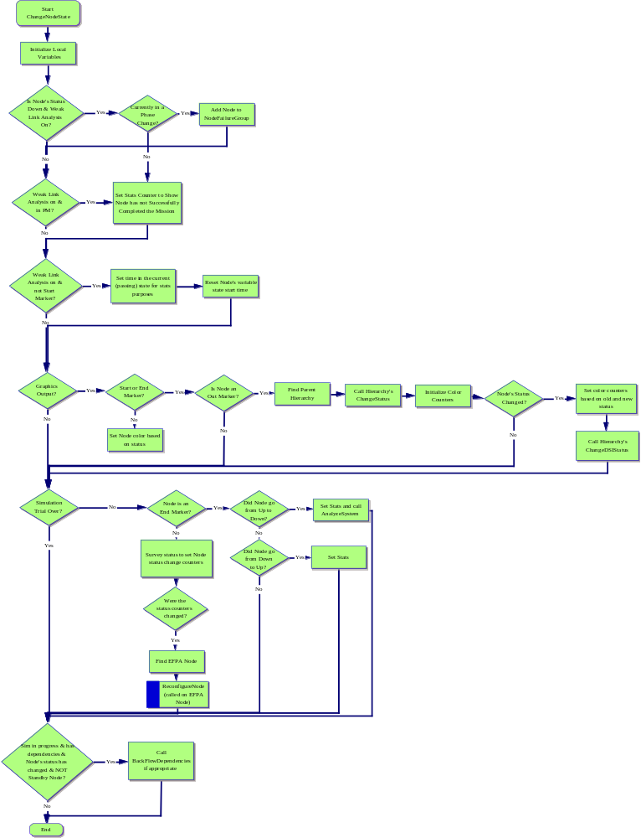

Start
ChangeNodeState
I. Initialize Local Variables
A. Is Node's Status Down & Weak Link Analysis On?
1. Currently in a Phase Change?
a. Add Node to NodeFailureGroup
b. Set Stats Counter to Show Node has not Successfully Completed the Mission
(1) Weak Link Analysis on & not Start Marker?
(a) Set time in the current (passing) state for stats purposes
i) Reset Node's variable state start time
(b) Graphics Output?
i) Simulation Trial Over?
(1) Node is an End Marker?
(a) Did Node go from Up to Down?
i) Did Node go from Down to Up?
(1) Set Stats
ii) Set Stats and call AnalyzeSystem
(b) Survey status to set Node status change counters
i) Were the status counters changed?
(1) Find EFPA Node
(a) ReconfigureNode
(called on EFPA Node)
(2) Sim in progress & has dependencies & Node's status has changed & NOT Standby Node?
(a) Call BackFlowDependencies if appropriate
(b) End
ii) Start or End Marker?
(1) Set Node color based on status
(2) Is Node an Out Marker?
(a) Find Parent Hierarchy
i) Call Hierarchy's ChangeStatus
(1) Initialize Color Counters
(a) Node's Status Changed?
i) Set color counters based on old and new status
(1) Call Hierarchy's ChangeDSIStatus
2. Weak Link Analysis on & in PM?

