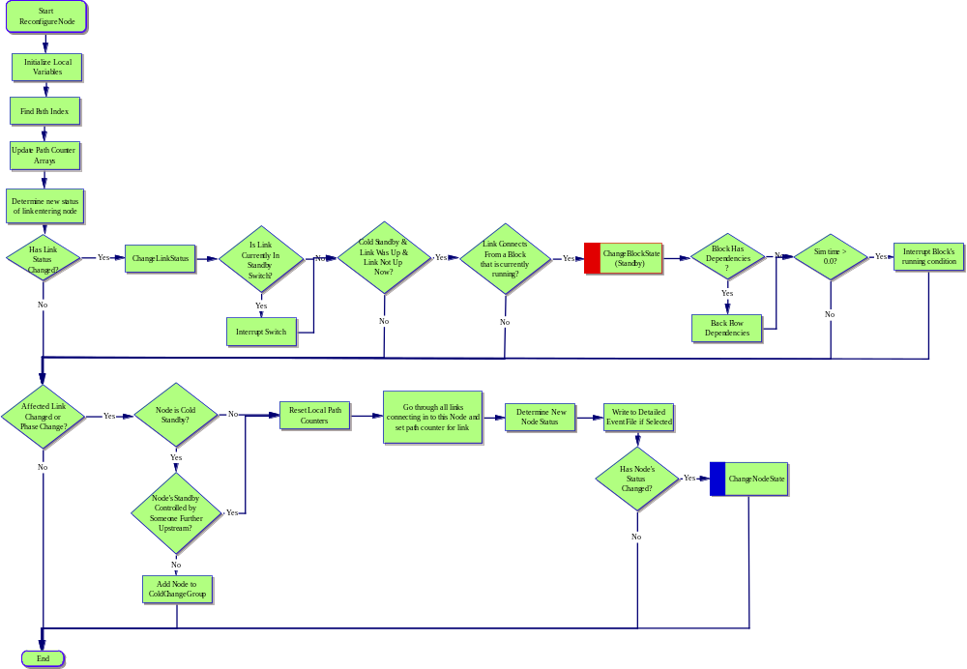

Start
ReconfigureNode
I. Initialize Local Variables
A. Find Path Index
1. Update Path Counter Arrays
a. Determine new status of link entering node
(1) Has Link Status Changed?
(a) ChangeLinkStatus
i) Is Link Currently In Standby Switch?
(1) Interrupt Switch
(2) Cold Standby & Link Was Up & Link Not Up Now?
(a) Link Connects From a Block that is currently running?
i) ChangeBlockState
(Standby)
(1) Block Has Dependencies?
(a) Back Flow Dependencies
(b) Sim time > 0.0?
i) Interrupt Block's running condition
(b) Affected Link Changed or Phase Change?
i) Node is Cold Standby?
(1) Reset Local Path Counters
(a) Go through all links connecting in to this Node and set path counter for link
i) Determine New Node Status
(1) Write to Detailed Event File if Selected
(a) Has Node's Status Changed?
i) ChangeNodeState
(2) Node's Standby Controlled by Someone Further Upstream?
(a) Add Node to ColdChangeGroup
ii) End

