Robot Writer 2025 – System Manual

Program Overview
This program controls a robotic writing system, driving actuators via serial communication to draw characters based on text input.
- Initializes encoder state machines
- Reads sensor inputs based on input text and font files
- Sends commands to actuators via serial communication with RS232 port
- Returns pen to origin position upon writing completion
With the surrounding elements (e.g. extra printed text) removed to only contain the G code, an emulator provides the following image when attempting to draw a basic square shape. Had to be edited from main code to produce basic suitable shape – create new text file, comment out font and scaleFactor related functions to trial.
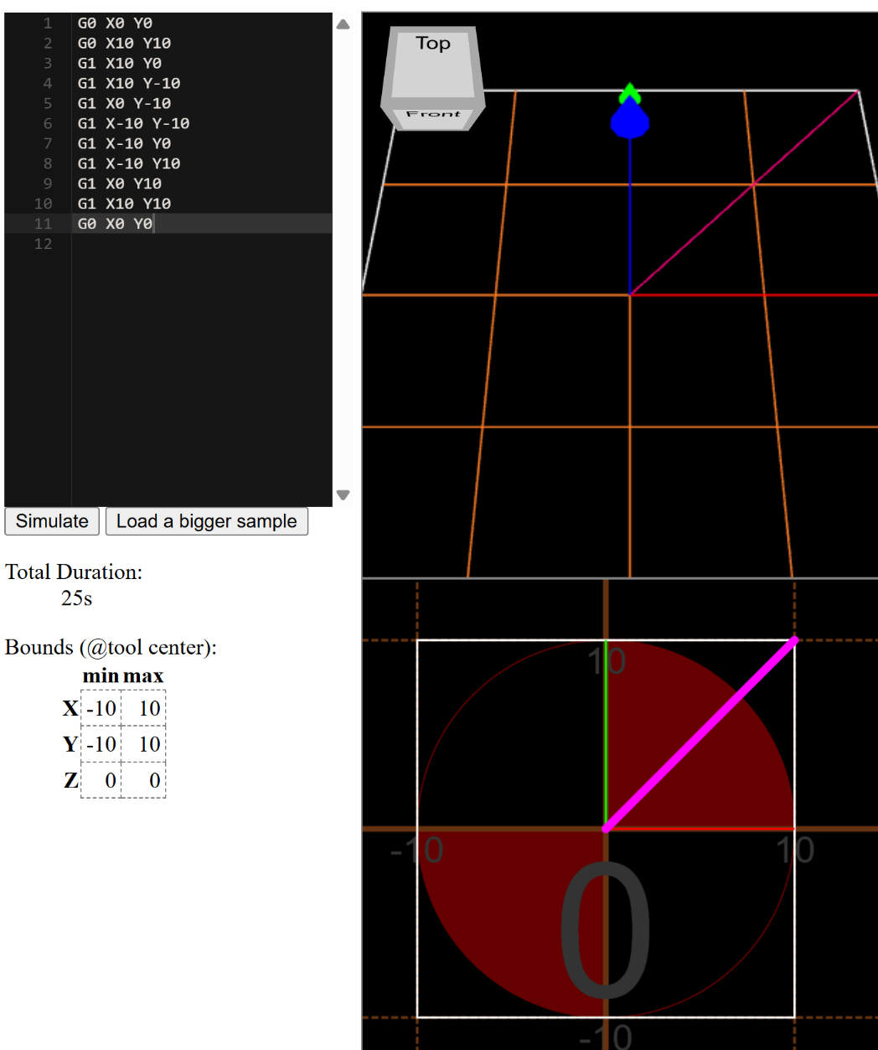

Key Files Contained in Program
- main.c
  - Contains main program loop and initializes the hardware used, setting up serial communication with the RS232 port.
  - Config change – baud rate or loop timing, expand textHold array if required for larger file sizes
- serial.c
  - Implements all key functions, including provided functions for sending/receiving data over UART, developed functions for sending G code commands from text/font data and user input scaling.
- serial.h
  - Header for serial communication functions. Contains all function prototypes and constants
  - Config change – update buffer size, define correct com port depending on USB input
- rs232.c
  - Provides low-level implementation of RS232 serial communication across different platform (in this case Windows, Linux and Mac also available)
- rs232.h
  - Header file declaring the RS232 API functions, including platform-specific headers
  - Update RS232_PORTNR if more ports required (should only be 16 in most cases)

Key Developed Functions and Descriptions

int openText(const char* filePath, char* textHold, int maxLength)
- Description: Opens a text file and loads its contents into a buffer for processing.
- Parameters:
  - filePath (const char*, input): Path to the text file.
  - textHold (char*, output): Buffer to hold the file contents.
  - maxLength (int, input): Maximum number of characters to read.
- Return: int — number of characters successfully read, or error code.

int fetchFont(int asciiValue, FontChar* fontSet)
- Description: Retrieves font data for a given ASCII character.
- Parameters:
  - asciiValue (int, input): ASCII code of the character.
  - fontSet (FontChar*, output): Structure holding font vector data.
- Return: int — success/failure status.

int applyScaleFactor(FontChar* fontSet, float scaleFactor)
- Description: Scales font vector data to adjust character size.
- Parameters:
  - fontSet (FontChar*, input/output): Font data to be scaled.
  - scaleFactor (float, input): Scaling multiplier.
- Return: int — success/failure status.

int newPosition(float* currentX, float* currentY, float *x, float *y, int numberMovements)
- Description: Updates current drawing position based on movement vectors.
- Parameters:
  - currentX (float*, input/output): Current X coordinate.
  - currentY (float*, input/output): Current Y coordinate.
  - x (float*, input): Array of X movements.
  - y (float*, input): Array of Y movements.
  - numberMovements (int, input): Number of movements to apply.
- Return: int — success/failure status.

int checkWidth(float currentX, int maxWidth)
- Description: Checks if the current X position exceeds the maximum allowed width.
- Parameters:
  - currentX (float, input): Current X coordinate.
  - maxWidth (int, input): Maximum permitted width.
- Return: int —0 = fits, 1 = exceeds

int applyLineBreak(float* currentX, float* currentY)
- Description: Moves drawing position to the start of a new line.
- Parameters:
  - currentX (float*, output): Reset X coordinate.
  - currentY (float*, input/output): Updated Y coordinate for new line.
- Return: int — success/failure status.

int generateGcode(int asciiValue, float *x, float *y, int *penState, int numberMovements, int lastPenState)
- Description: Generates G-code instructions for a character.
- Parameters:
  - asciiValue (int, input): ASCII code of the character.
  - x (float*, output): X movement array.
  - y (float*, output): Y movement array.
  - penState (int*, output): Pen up/down states.
  - numberMovements (int, input): Number of movements to generate.
  - lastPenState (int, input): Previous pen state for continuity.
- Return: int — success/failure status

int applyCharacterSpacing(float* currentX, float charSpacing, float wordSpacing, int asciiValue)
- Description: Adjusts X position for spacing between characters and words.
- Parameters:
  - currentX (float*, input/output): Current X coordinate.
  - charSpacing (float, input): Space between characters.
  - wordSpacing (float, input): Space between words.
  - asciiValue (int, input): ASCII code of current character.
- Return: int — success/failure status.

int penStateOrigin(float* currentX, float* currentY, int* penState)
- Description: Resets pen state and drawing position to origin.
- Parameters:
  - currentX (float*, output): Reset X coordinate.
  - currentY (float*, output): Reset Y coordinate.
  - penState (int*, output): Reset pen state (e.g., pen up).
- Return: int — success/failure status.

int checkWordFit(const char *textHold, int startIndex, float currentX, int maxWidth)
- Description: Checks if the next word fits within the remaining line width.
- Parameters:
  - textHold (const char*, input): Text buffer.
  - startIndex (int, input): Index of word start in buffer.
  - currentX (float, input): Current X coordinate.
  - maxWidth (int, input): Maximum permitted width.
- Return: int — 0 = fits, 1 = exceeds

Key Data Items

Name | Data type | Rationale
asciiValue | int | Required for storing characters’ ASCII values
numberMovements | int | Number of steps taken for the drawing process
x | float* | Dynamic allocation of array of x position
y | float* | Dynamic allocation of array of y position
penState | int* | Sets pen position – 0 for up, 1 for down (as pen should be up when starting). Int* with dynamically allocated array to allow for variable length and code flexibility.
currentX | float | Current x position as decimal
currentY | float | Current y position as decimal
FontChar | struct | Encapsulates font vector data, e.g. coords and pen state. struct chosen to logically group related fields.
textHold[] | char* | Stores the current character being processed from the input text file. Dynamic allocation allowing flexibility in buffer size without wasting memory.
textHeightmm | int | Sets text height in mm according to the user input
scaleFactor | float | Once height input is set, font units are scaled to a height between 4-10mm using scaleFactor
maxWidth | int | Allows maximum width of writing space of 100mm to be set
charSpacing | float | Sets horizontal spacing between characters at 2.0mm
wordSpacing | float | Sets greater spacing between complete words when program identifies ASCII 32 (space)

Testing Information

The following testing methods can be used to validate the code throughout and ensure all functions are working correctly.

Function | Test Case | Test Data | Expected Output
openText | Checking file is opened correctly, no errors in opening | File containing “HELLO WORLD” | textHold[] set to hold characters “H”, “E”, “L”, “L”, “O”, “ “, “W”, “O”, “R”, “L”, “D”.  If error present, returns 0 and textHold[] is empty  If TestData.txt is empty, program completes without drawing.
fetchFont | Check font data for character | asciiValue = 65 (A) | numberMovements, x[], y[], penState[] correctly populated
applyScaleFactor | Check scaling factor application | scaleFactor = 2 | x[] and y[] coordinates all doubled
newPosition | Check pen position updates correctly | currentX = 0, currentY = 0 | currentX and currentY update to final position
checkWidth | Check line break is triggered only when needed | currentX >= maxwidth  maxwidth = 100mm | Return 1 if line break required  Else return 0
applyLineBreak | Check line break application | currentX = 110  currentY = 10 | currentX becomes 0, currentY increases by 5
generateGcode | Check G-code generation | asciiValue = 65 (A) with date filled | Produced G-code commands set pen up and down positions, correct X and Y movements for A.
applyCharacterSpacing | Check correct spacing between characters and words | Text “HELLO WORLD” | Correct spacing of 2mm between characters, and 5mm between “HELLO” and “WORLD”.
penStateOrigin | Check that the pen returns to the origin point at completion | currentX = 10, currentY=10, penState=1. Test with empty .txt file. | Pen should return to currentX = 0, currentY = 0, penState = 0.
checkWordFit | Check if word fits on the current line | “HELLO” at currentX = 90, maxWidth = 100 | Return 0, line break must be applied
checkWordFit | “ | “HELLO” at currentX = 10, maxWidth = 100 | Return 1, no line break needed
main() | Check SingleStrokeFont.txt opens correctly | No SingleStrokeFont.txt present | Program error, terminates.
main() | Check correct beginning-to-end function | File “HELLO WORLD”, set textHeightmm = 6 | End product shows HELLO WORLD with correct spacing between letters, fitting within 100mm width, line breaks where required, returns to 0,0 with pen in “up” position.

