**Origins and vernacular architecture**

*Main article:* [*Vernacular architecture*](https://en.wikipedia.org/wiki/Vernacular_architecture)

Vernacular architecture in Norway

Building first evolved out of the dynamics between needs (shelter, security, worship, etc.) and means (available [building materials](https://en.wikipedia.org/wiki/Building_material) and attendant skills). As human cultures developed and knowledge began to be formalized through oral traditions and practices, building became a [craft](https://en.wikipedia.org/wiki/Craft), and "architecture" is the name given to the most highly formalized and respected versions of that craft.

It is widely assumed that architectural success was the product of a process of trial and error, with progressively less trial and more replication as the results of the process proved increasingly satisfactory. What is termed [vernacular architecture](https://en.wikipedia.org/wiki/Vernacular_architecture) continues to be produced in many parts of the world. Indeed, vernacular buildings make up most of the built world that people experience every day. Early human settlements were mostly [rural](https://en.wikipedia.org/wiki/Rural). Due to a surplus in production the economy began to expand resulting in urbanization thus creating [urban areas](https://en.wikipedia.org/wiki/Urban_area) which grew and evolved very rapidly in some cases, such as that of [Çatal Höyük](https://en.wikipedia.org/wiki/%C3%87atal_H%C3%B6y%C3%BCk) in [Anatolia](https://en.wikipedia.org/wiki/Anatolia) and [Mohenjo Daro](https://en.wikipedia.org/wiki/Mohenjo-daro) of the Indus Valley Civilization in modern-day [Pakistan](https://en.wikipedia.org/wiki/Pakistan).

**Asian architecture**

Early Asian writings on architecture include the *Kao Gong Ji* of China from the 7th–5th centuries BCE; the [Shilpa Shastras](https://en.wikipedia.org/wiki/Shilpa_Shastras) of ancient India and [Manjusri Vasthu Vidya Sastra](https://en.wikipedia.org/wiki/Manjusri_Vasthu_Vidya_Sastra) of [Sri Lanka](https://en.wikipedia.org/wiki/Sri_Lanka).

The architecture of different parts of [Asia](https://en.wikipedia.org/wiki/Asia) developed along different lines from that of Europe; Buddhist, Hindu and Sikh architecture each having different characteristics. Buddhist architecture, in particular, showed great regional diversity. Hindu temple architecture, which developed around the 3rd century BCE, is governed by concepts laid down in the Shastras, and is concerned with expressing the macrocosm and the microcosm. In many [Asian](https://en.wikipedia.org/wiki/Asia) countries, pantheistic religion led to architectural forms that were designed specifically to enhance the [natural landscape](https://en.wikipedia.org/wiki/Natural_landscape).

**Renaissance and the architect**[[edit](https://en.wikipedia.org/w/index.php?title=Architecture&action=edit&section=10)]

*Main article:* [*Renaissance architecture*](https://en.wikipedia.org/wiki/Renaissance_architecture)

In [Renaissance](https://en.wikipedia.org/wiki/Renaissance) Europe, from about 1400 onwards, there was a revival of Classical learning accompanied by the development of [Renaissance Humanism](https://en.wikipedia.org/wiki/Renaissance_Humanism) which placed greater emphasis on the role of the individual in society than had been the case during the Medieval period. Buildings were ascribed to specific architects – [Brunelleschi](https://en.wikipedia.org/wiki/Filippo_Brunelleschi), [Alberti](https://en.wikipedia.org/wiki/Leone_Battista_Alberti), [Michelangelo](https://en.wikipedia.org/wiki/Michelangelo), [Palladio](https://en.wikipedia.org/wiki/Palladio) – and the cult of the individual had begun. There was still no dividing line between [artist](https://en.wikipedia.org/wiki/Artist), [architect](https://en.wikipedia.org/wiki/Architect) and [engineer](https://en.wikipedia.org/wiki/Engineer), or any of the related vocations, and the appellation was often one of regional preference.

A revival of the Classical style in architecture was accompanied by a burgeoning of science and engineering which affected the proportions and structure of buildings. At this stage, it was still possible for an artist to design a bridge as the level of structural calculations involved was within the scope of the generalist.

**Modernism**[[edit](https://en.wikipedia.org/w/index.php?title=Architecture&action=edit&section=12)]

*Main article:* [*Modern architecture*](https://en.wikipedia.org/wiki/Modern_architecture)

The [Bauhaus](https://en.wikipedia.org/wiki/Bauhaus) Dessau architecture department from 1925 by [Walter Gropius](https://en.wikipedia.org/wiki/Walter_Gropius)

Around the beginning of the 20th century, a general dissatisfaction with the emphasis on revivalist architecture and elaborate decoration gave rise to many new lines of thought that served as precursors to Modern Architecture. Notable among these is the [Deutscher Werkbund](https://en.wikipedia.org/wiki/Deutscher_Werkbund), formed in 1907 to produce better quality machine made objects. The rise of the profession of industrial design is usually placed here. Following this lead, the [Bauhaus](https://en.wikipedia.org/wiki/Bauhaus) school, founded in [Weimar](https://en.wikipedia.org/wiki/Weimar), Germany in 1919, redefined the architectural bounds prior set throughout history, viewing the creation of a building as the ultimate synthesis—the apex—of art, craft, and technology.

<https://www.fastcodesign.com/3042937/sector-forecasting/5-trends-shaping-the-future-of-architecture>

<https://en.wikipedia.org/wiki/Architecture#Origins_and_vernacular_architecture>

<https://en.wikipedia.org/wiki/Sustainable_architecture>

<http://www.architectmagazine.com/aia-architect/aiafeature/the-coming-decade-for-residential-design_o>

The Coming Decade for Residential Design

**Sustainable architecture** is [architecture](https://en.wikipedia.org/wiki/Architecture) that seeks to minimize the negative environmental impact of buildings by efficiency and moderation in the use of materials, energy, and development space and the ecosystem at large. Sustainable architecture uses a conscious approach to energy and ecological conservation in the design of the built environment.[1]

The idea of sustainability, or [ecological design](https://en.wikipedia.org/wiki/Ecological_design), is to ensure that our actions and decisions today do not inhibit the opportunities of future generations

**Housing Progress and the Housing Bust**

• **Outdoor living expanded in popularity.**

• **Changing work patterns encouraged growth of home offices.**

• **Residential projects were integrated into mixed-use facilities.**

• **Technology was incorporated into kitchens and baths.** The

**Emerging Influences on Home Design**

• **Continued expansion of universal design and accessibility features throughout the home.**

• **Increased focus on a healthy home environment.**

• **Infill development promotes smaller, better designed homes.**

• **Kitchens remain a focus of household activities.**

**Beyond Your Front Door**

**Technology enhancements increase efficiency.**

**Heightened focus on conservation.**

**New design and construction methods change the building process.**

**Innovation in materials allows for expanded design options.**

Photos:

<https://www.pexels.com/> free stock pictures.

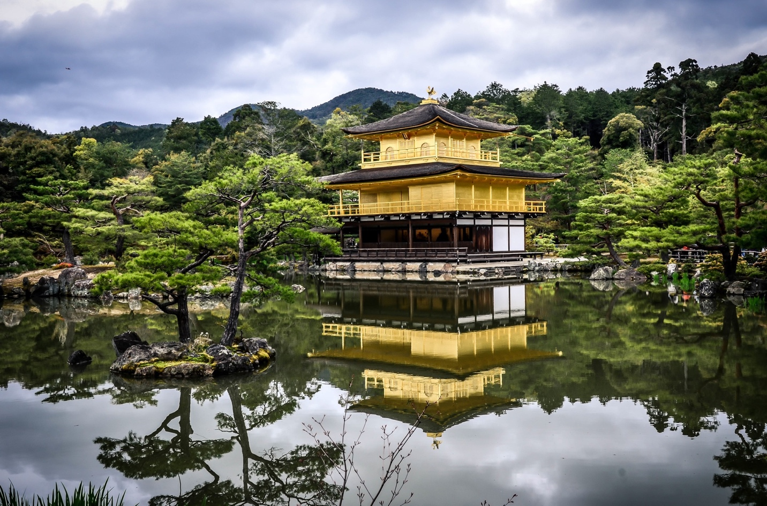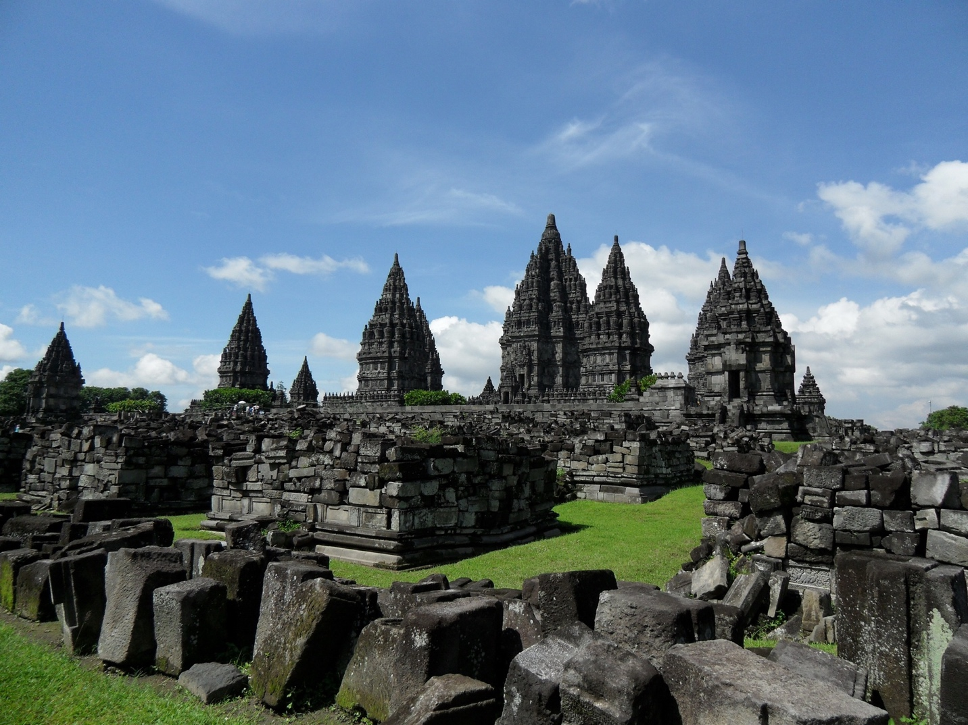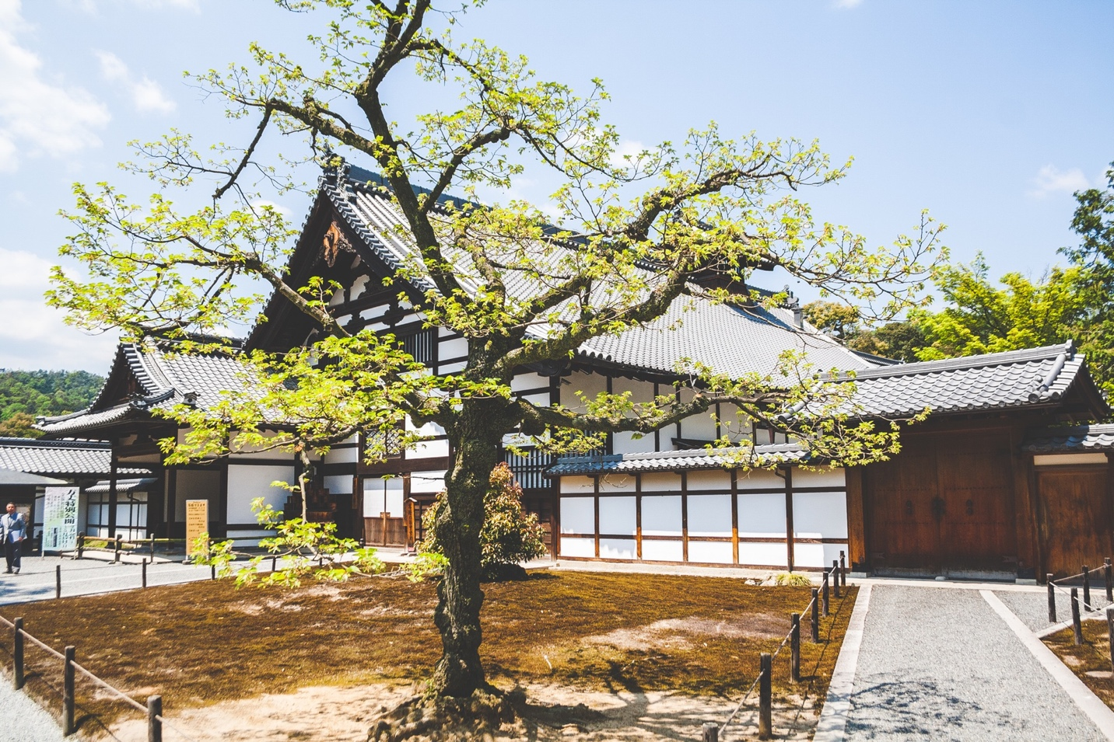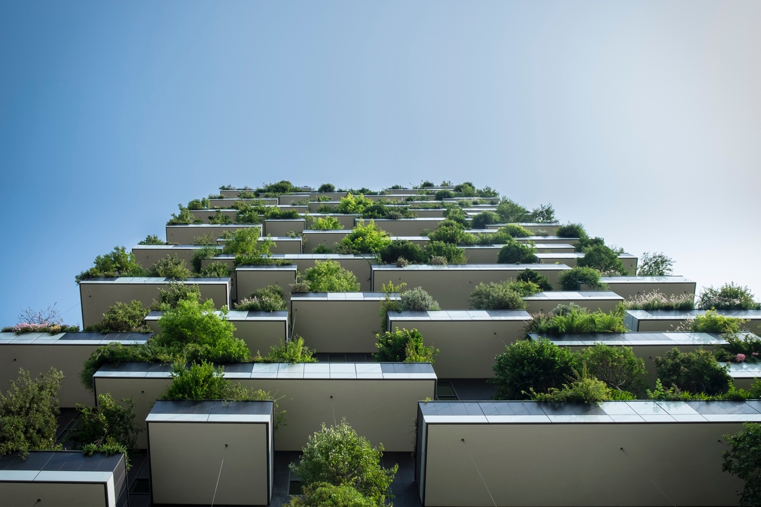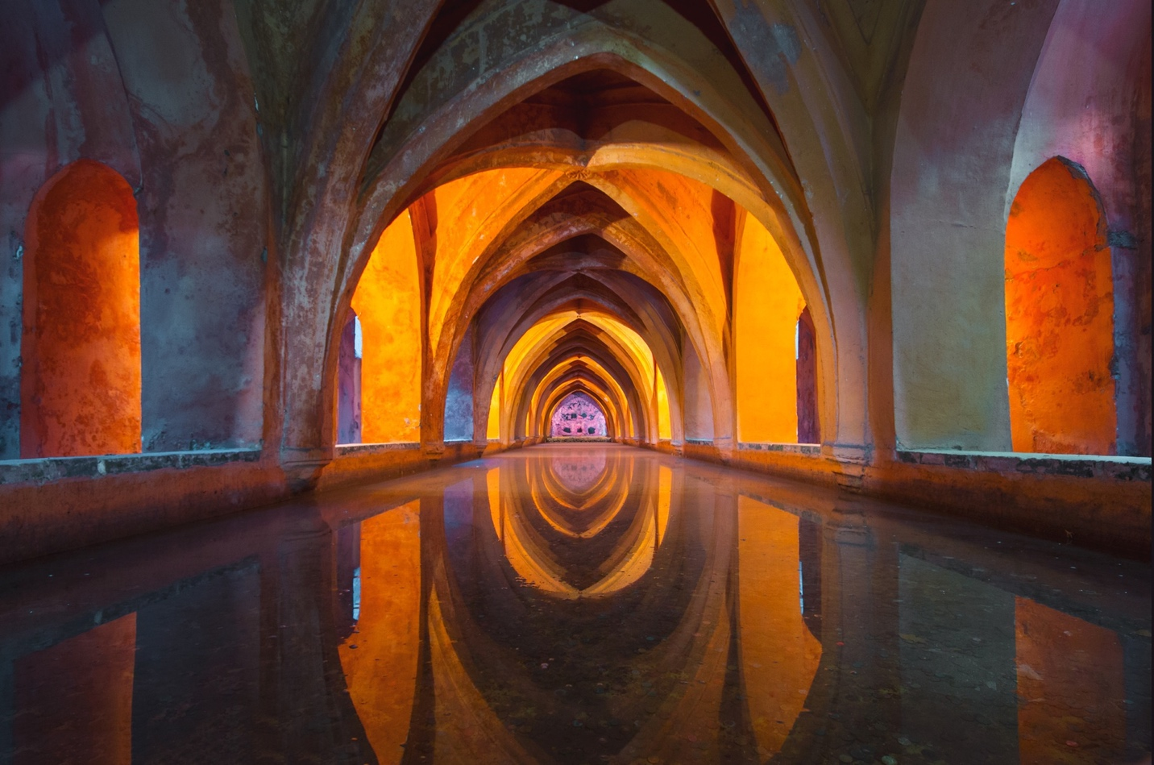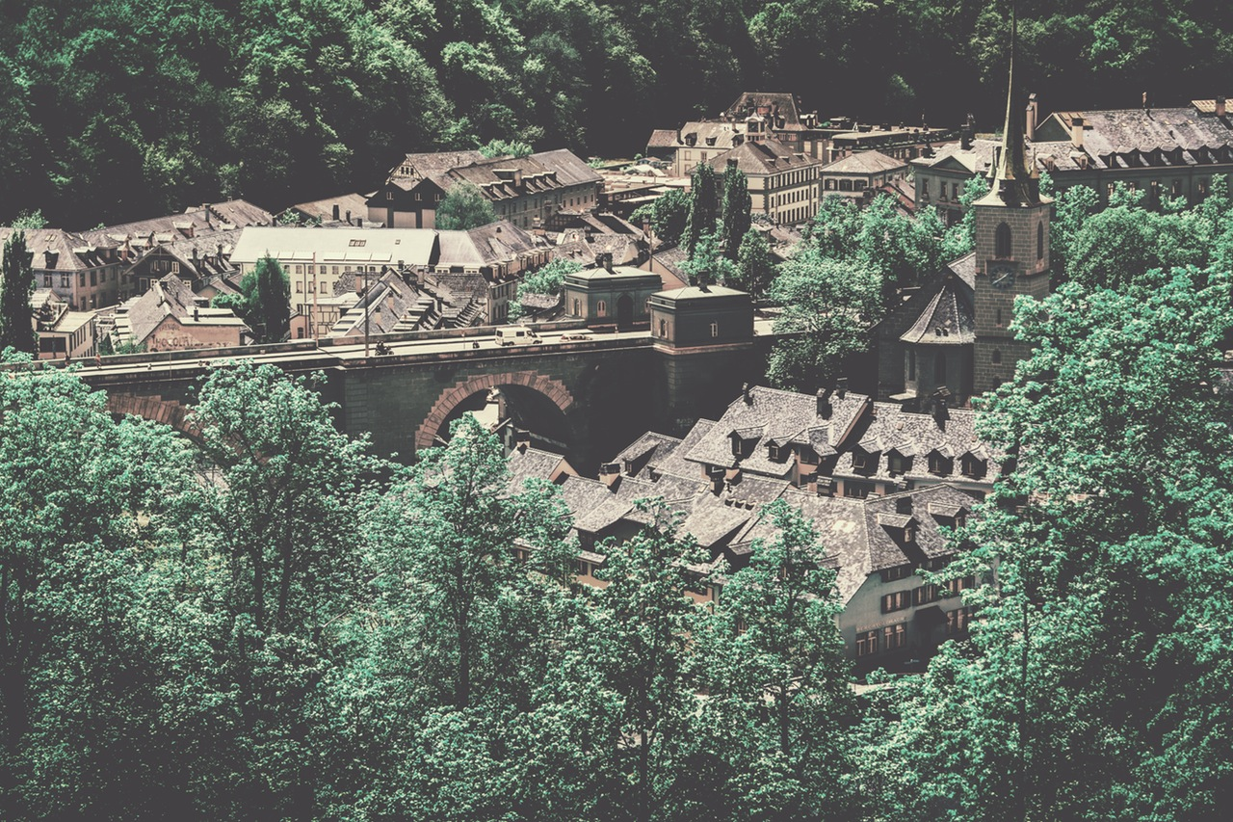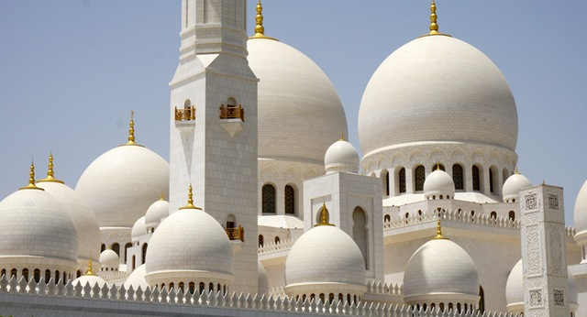

[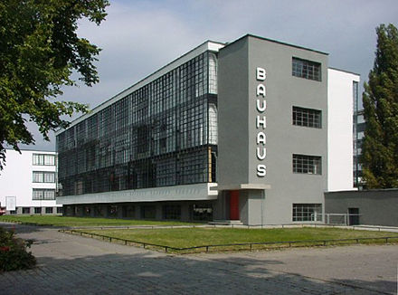](https://en.wikipedia.org/wiki/File:Bauhaus.JPG)