Power supply for Seebo Combi

Seebo Mini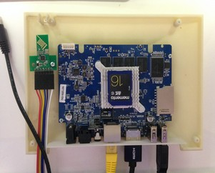

Class D Amplifier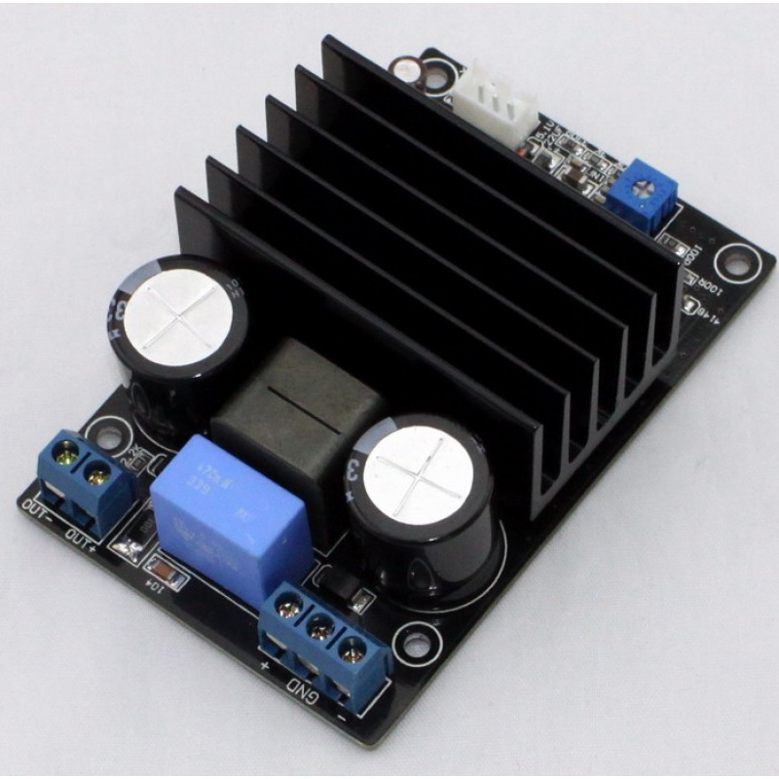

USB DAC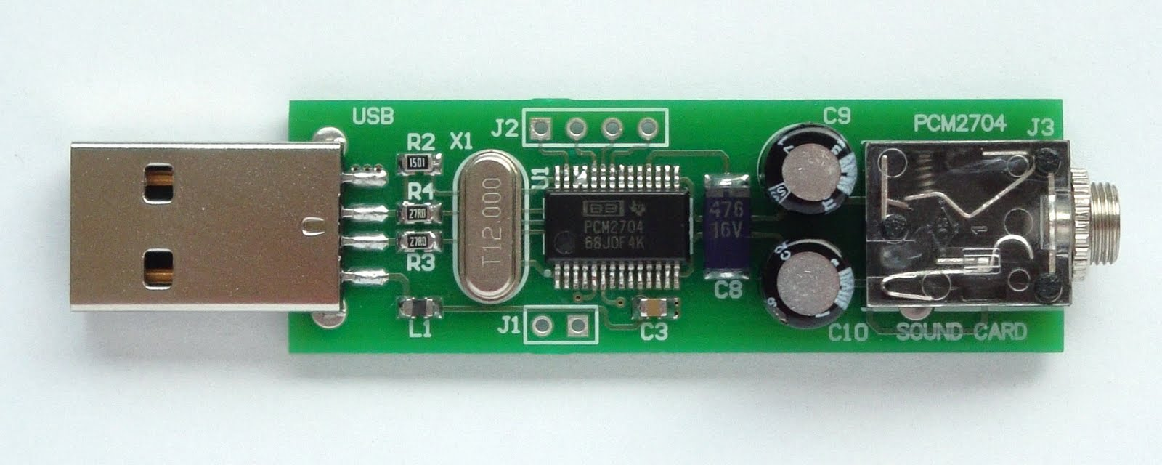

Concept of SMPS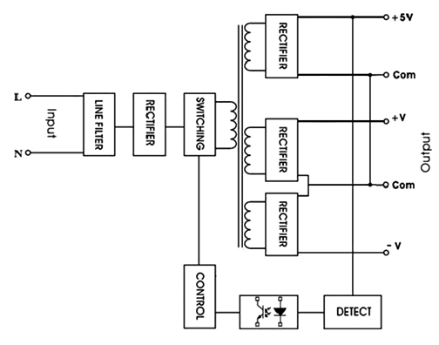

Similar to above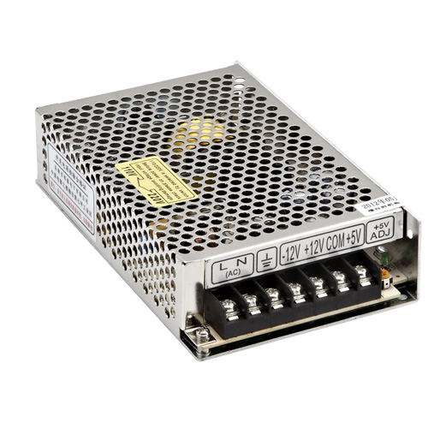

Input Power : AC 210 ~ 240 Volts / 50 Hz

Output Power

For Combi : DC +48V / GND / -48V 3[A]

For Mini : DC +5V 2[A]