Seebo Mini project
12 November 2014
Jin Kim

1. Development Goal
When SeeboMini system boot up, direct load xbmc 12.2 without Androiod UI

2. Target board : Amlogic M8
2.1 CPU - Amlogic s802, Quad core cortex A9
2.2 GPU- Mali-450
2.3 RAM - 2G
2.4 ROM - 8G
2.5 OS - Android 4.4.2
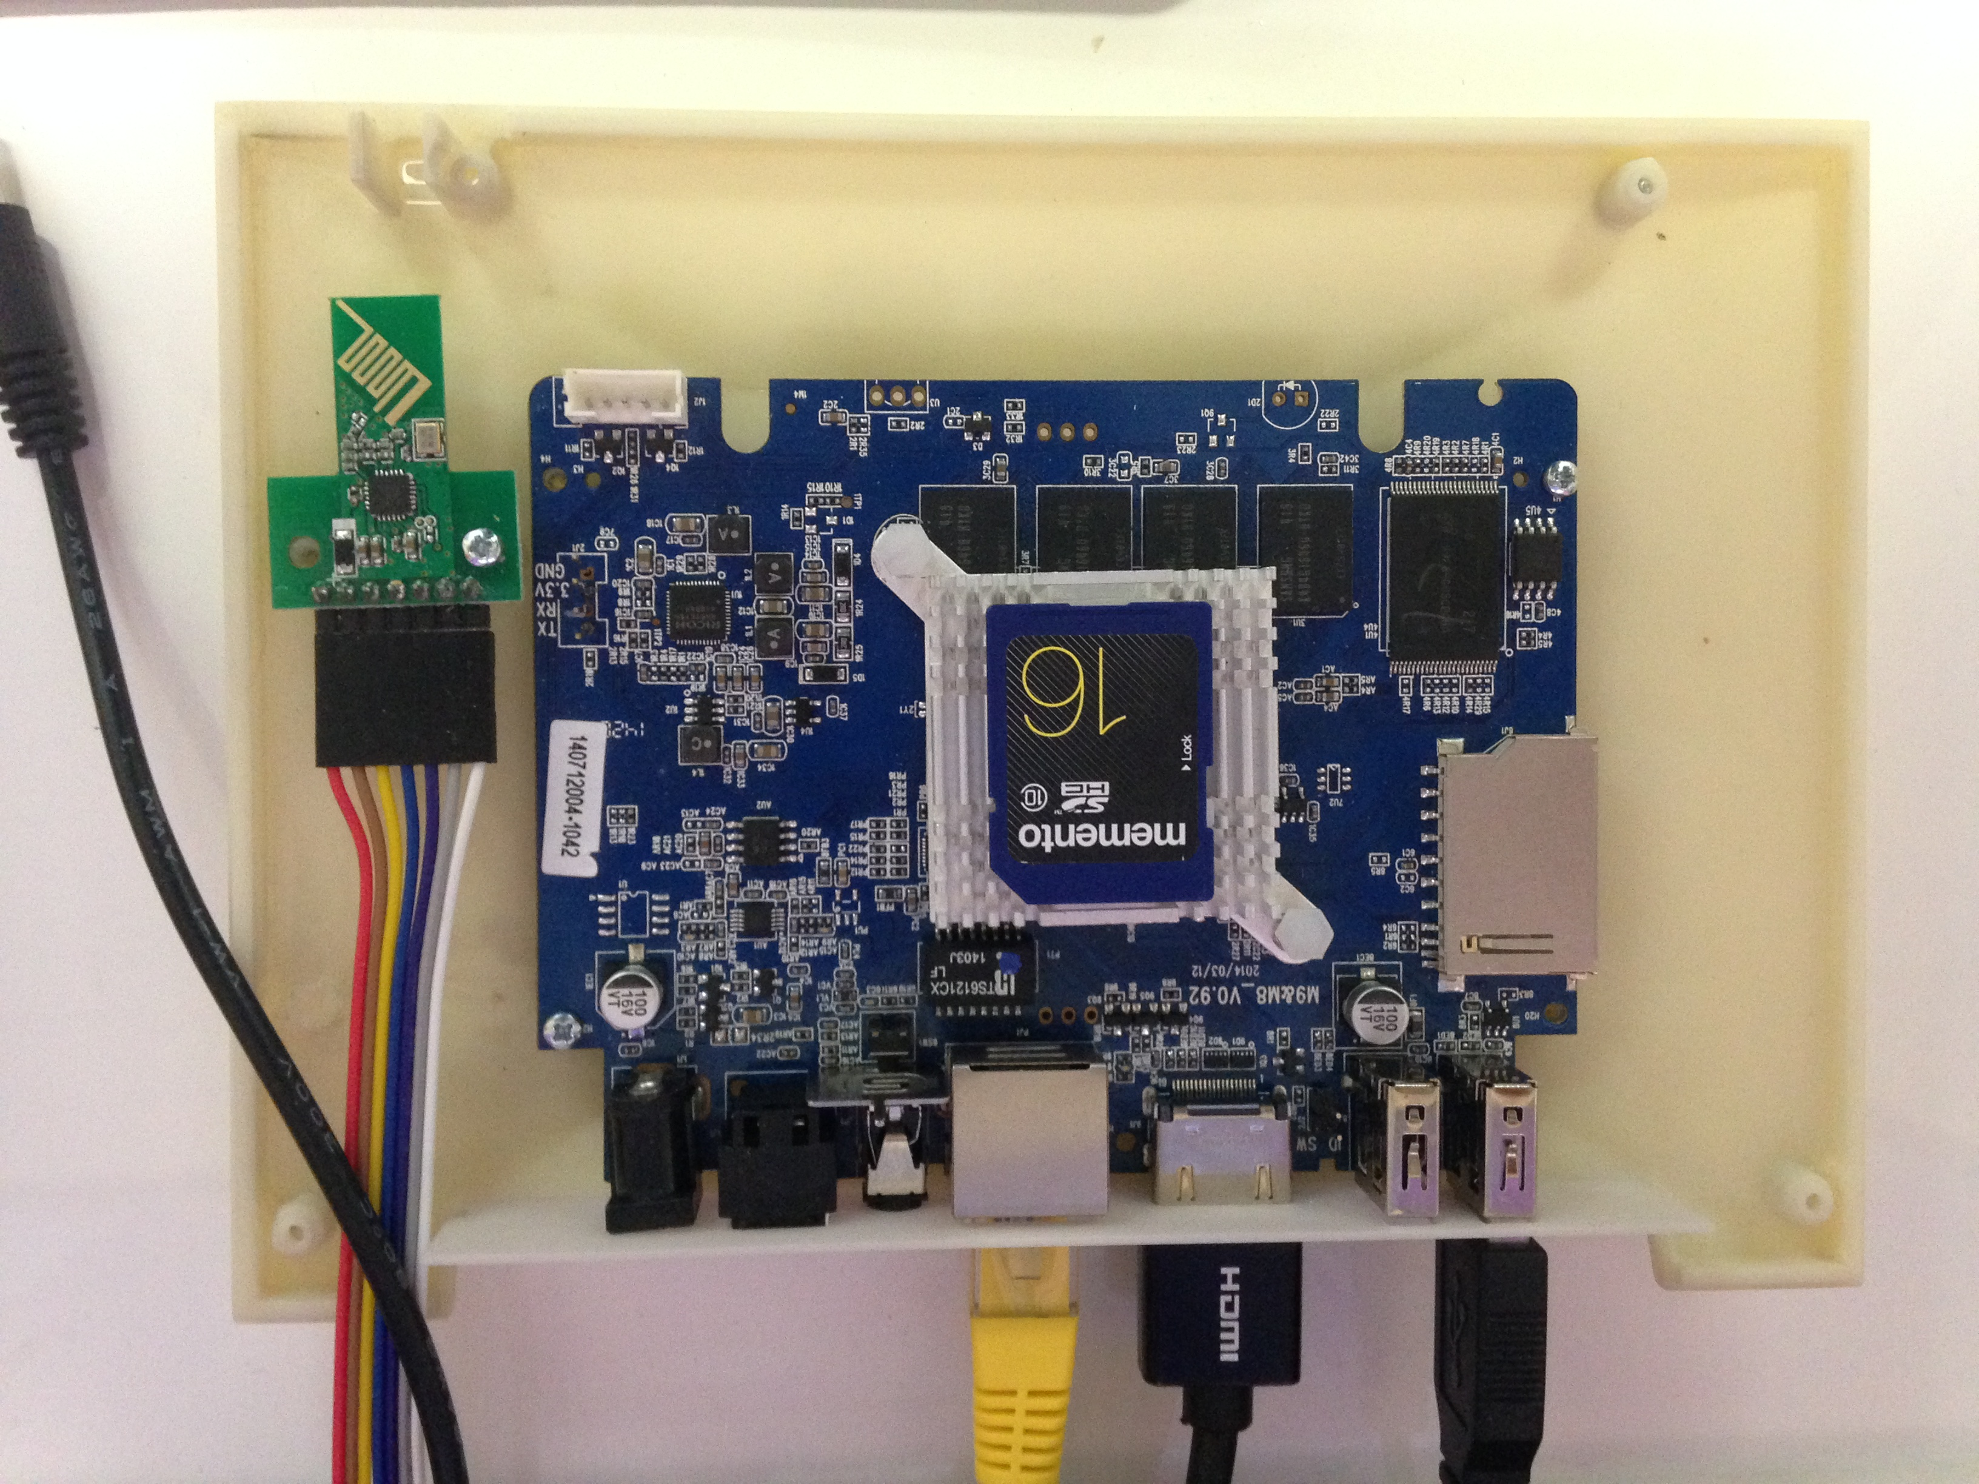
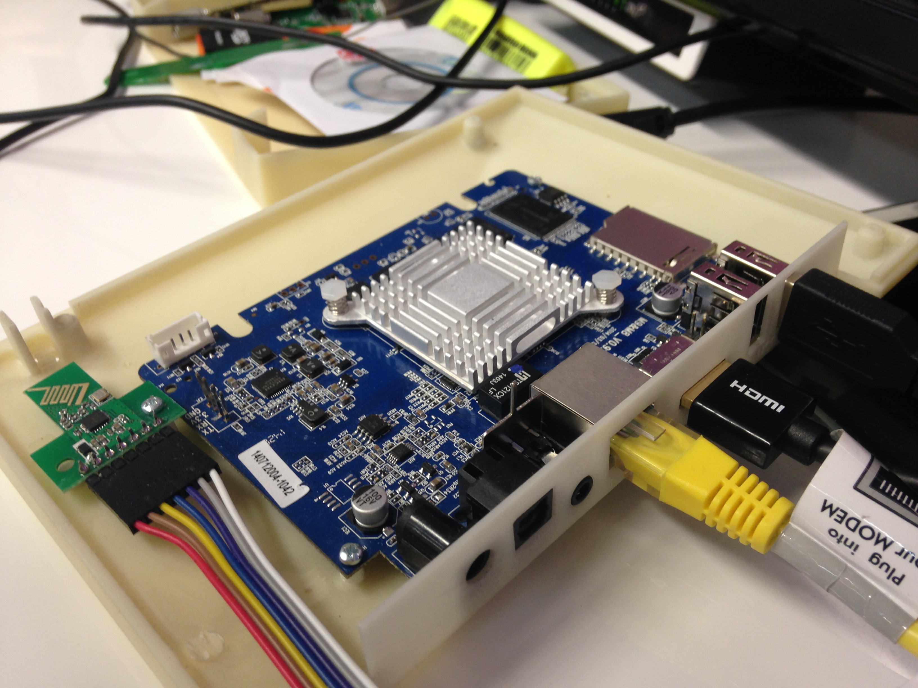

3. Compare Firmware
 | Factory f/w | Amlinux | Openelec | SeeboMini
ROM type | Static(commercial) | Custom | Custom | Custom
Code  Based on | Amlogic  M8-k200 | Amlogic  M8-k200 | Amlogic  M8-k200 | Amlogic  M8-k200
OS | Android 4.4.2 | Android 4.4.2 | Openelec 4.0.2 | Android 4.4.2
Linux kernel | 3.10.54 | 3.10.58 | 3.10.33 | 3.10.33
XBMC | 13.1(apk type) | 13.1 / 13.2 | 13.2 | 12.3
Distributor | Default | Stane's 1983 | Codesnake | N/A
Source | N/A | N/A | N/A | Yes
Firmware | Yes | Yes | Yes | No
Update  Method | OTA package  (Update.zip) | OTA package  (Update.zip) | OTA package  (Update.zip)

* OTA(Over The Air) package Directory tree
Dir: META-INF # updater-script
Dir: system # root file system
file: bootloader.img # bootloader image file
file: logo.img # booting logo
file: boot.img # kernel + ramdisk file + device tree file

4. Development Schedule

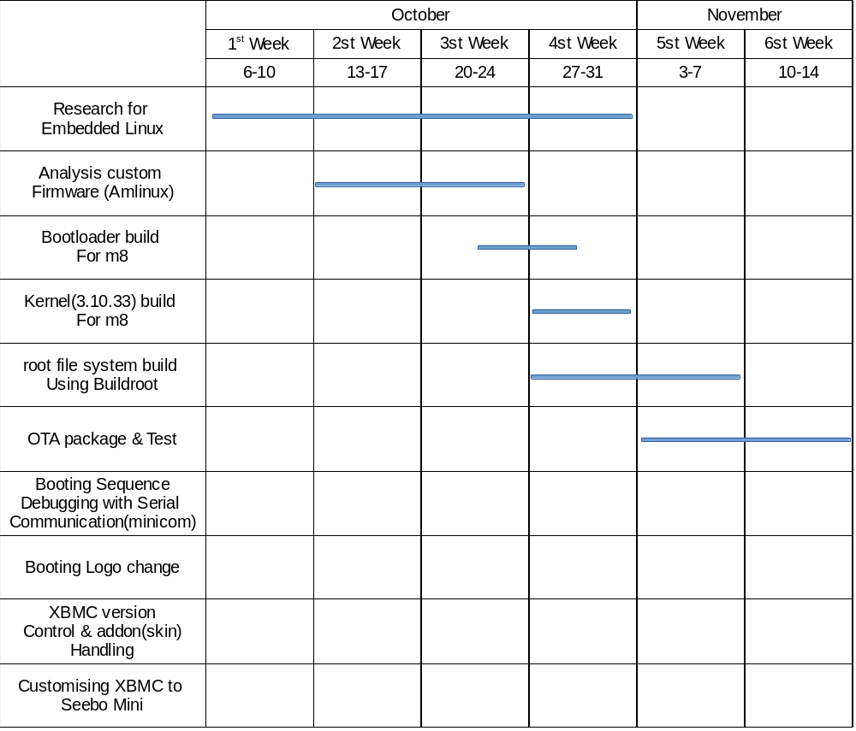

5. How to compile – Meson8-k200 : board name
5.1. Download sources file from http://openlinux.amlogic.com:8000/download/ARM/
5.2. Kernel build with meson8_defconfig ---------------------------> uImage
5.3. Bootloader build (uboot) -----------------------------------------> u-boot.bin
5.4. Filesystem build with Buildroot
----------> rootfs.cpio : ramdisk
m8.dtb : device tree file
rootfs.tar : root file system (+ xbmc)
5.5. make OTA package for updating using recovery-aml.mk
5.6. Copy to SD card and insert SD card to the target board
5.7. Reboot in recovery mode

* Buildroot - Buildroot is a set of Makefiles and patches that makes it easy to generate a complete embedded Linux system. Buildroot can generate any or all of a cross-compilation toolchain, a root file system, a kernel image and a bootloader image. Buildroot is useful mainly for people working with small or embedded systems, using various CPU architectures (x86, ARM, MIPS, PowerPC, etc.) : it automates the building process of your embedded system and eases the cross-compilation process.
* recovery-aml.mk – This is makefile script for OTA package for Android device

6. The result until now
Currently, I have made OTA package(Update.zip) and test many time with SD card, but the result was not successful. The update.zip I built is closely similar in structure but not a same with Amlinux's one. When my firmware is updated to the target, the screen is shown anything. I am analysing Android script generator codes to figure out what's different with Stane's one and I am modifying other source for Amlogic MX_m6 which was distributed by stane's 1983 in order to change to Meson8-k200(Amlogic M8) configures.

