Power supply for Seebo Combi

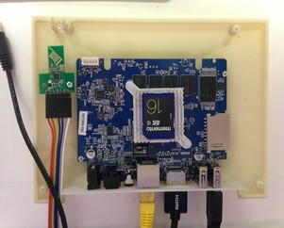Seebo Mini
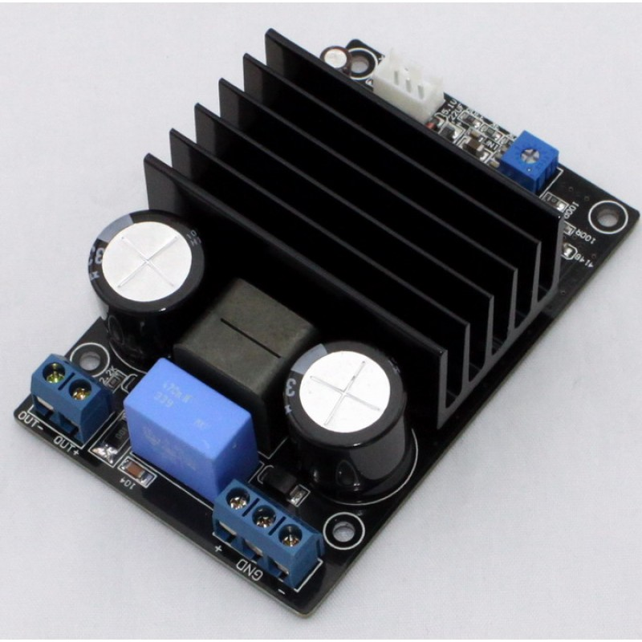Class D Amplifier

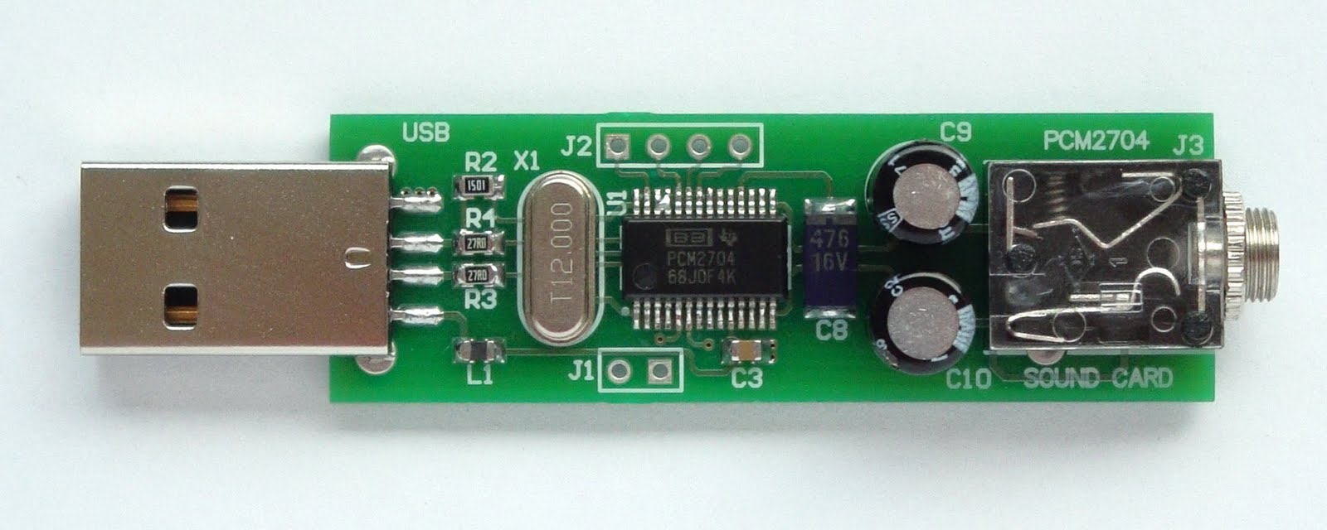USB DAC

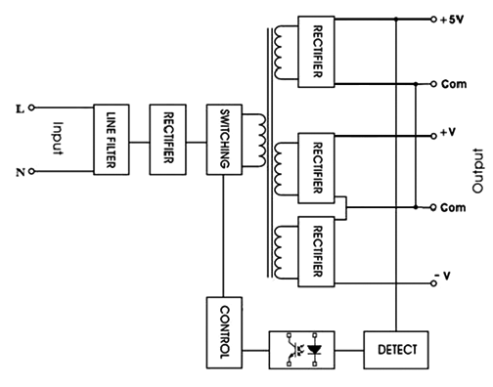Concept of SMPS

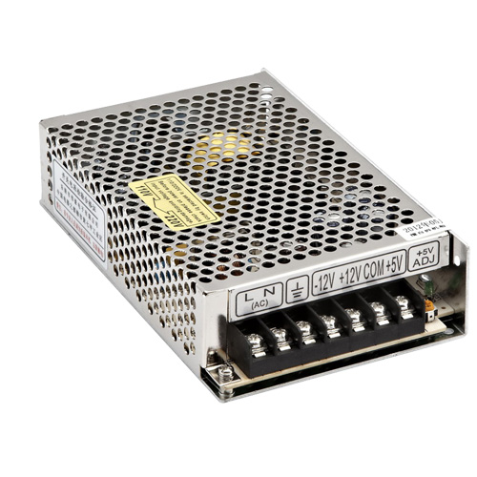Similar to above

Input Power : AC 210 ~ 240 Volts / 50 Hz
Output Power
For Combi : DC +48V / GND / -48V 3[A]
For Mini : DC +5V 2[A]

