1. INTRODUCTION
India’s Ration Distribution System is the largest retail system in the world. Public distribution system provides a ration card issued under an order or authority of the State Government for the purchase of essential consumer materials like rice, wheat, kerosene and oil. State Government issues distinctive ration cards like yellow ration card, saffron ration card, and white ration card depending on family annual income. The consumer material is supplied to ration card holders in the first week of every month by ration shopkeeper. Ration Distribution System is one of the widely controversial issues that involve malpractice. The manual intervention in weighing of the materials leads to inaccurate measurements and/or it may happen, the ration shop owner illegally uses consumer materials without prior knowledge of ration card holders.
The proposed system aids to control malpractices which are present in ration shop by replacing manual work with automatic system based on RFID and IoT. Every consumer i.e. family head provided RFID card which acts as ration card. RFID based programmed rationing shop is novel approach out in the RDS valuable for more effective, precise and mechanized method of distribution of ration. The present RDS framework has disadvantages like low processing speed, imprecise quantity of goods, material theft, large waiting time in rationing shop. The proposed rationing system replaces the manual work in the existing rationing shop. The main goal of the proposed system is automatic distribution of ration to give straightforwardness. The proposed automated rationing system depends on RFID innovation that replaces regular ration cards. RFID tag is given rather than ration cards. Customer’s database is already saved centrally which can be given by Government Authority. Customer has to scan the RFID tag to RFID card reader and after that microcontroller checks detail of customer which are stored already in the system to distribute material in rationing shop. After effective check, customer has to enter material type and also amount of material with the help keypad. Each customer has provided a RFID tag which goes about as the ration card. This RFID tag has all the data of the customer, required for taking the ration in required quantity from the rationing shops. The customer needs to demonstrate this RFID tag to the RFID reader, which is connected to a microcontroller, which peruses the data in the tag and in like manner instruct the consumer to give required amount of ration to the card holder.
Thus this system could be useful in increasing the transparency between people and government of India. It will be helpful to increase transparency at each level of ration distribution system. Mainly this system can be useful in reduction of corruption and forgery of ration.This system proposes a new method of implementing a scheme of Rationing System which is managed by government from last many years.
2. LITERATURE REVIEW
[1] Civil Supply distribution system in today's scenario faces loads of challenges as lots of controversial issues like illegal smuggling of goods, corruption and adulterations in goods happens here in the distribution centers in both rural and urban parts of India. These controversies include irregular measurement of the goods, wrong entries in the manual stock register of centers containing wrong stock information of the commodities that are supplied or delivered to the consumers, other times the actual goods provided by the government for distribution does not reach the common people effectively as the information or data regarding the goods received by the ration centers and their availability in the centers for distribution can be altered by the workers of the ration centers which cannot be noted or recognized by the consumers as they have no access to the manual record of data. In our project we have replaced the manual work done in the distribution centers by smart measuring automated electronic device with the help of Arduino microcontroller which measures the goods accurately and updates it in data base periodically about the availability of goods and information regarding the transactions done in a digitalized manner. Here, to have access to the information and data regarding the stock a main data base is created which can be access by both common consumers of that particular locality and by the government main stream invigilators for distribution centers from their head office. Therefore, this project ensures corruption free ration centers working system which will also enhance the direct communication of the consumers with the government and will defiantly provide transparency. [2] In the present days many immoral activities are taking place in ration shops, which are meant to distribute the commodities to the people who are in below the poverty line, as the distribution process is manually operated and due to which it consumes a lots of time. To overcome this problem we one can use RFID technology. In this paper RFID tags are introduced, The RFID cards are instead of ration cards, which consist of all the details about the card holder like family details, type of card and its validity etc. In this paper we are going to discuss different types of automatic ration distribution system implemented for the automatic ration distribution. [3]The Government of India in an effort to ensure fair supply of food items under PDS to the targeted underprivileged sections as per the eligibility fixed by the Government of India. In spite of the best efforts by Government officials at various levels, there are a few bottle-necks and inconveniences to the targeted citizens in availing the services provided. All these happen because every job in the ration shop involves manual work. Because of intervention of manual work there are lots of illegal activity occurs. As solution to this problem the proposed system proposes a transparent and highly scalable Ration Distribution (Food Distribution) system with biometric authentication. The conventional paper based ration card is replaced by smart card. The system is placed at each ration shop which is connected to the server through web. Every time before ration collection each user has to login into the system. The user need not to pay the cash money as theappropriate balance is deducted from users bank account, so there is no direct involvement of ration shop owner in transaction. The transaction details are send to users mobile The government can have overall control and monitoring at each ration shop through web. In addition user as well as ration distributor will get SMS based alert about arrival of commodities. As a result, this new e-PDS system can reduce possible human errors and provide accurate information of public distribution system at any point. [4] The Rationing distribution system also called public distribution system distributes food items to the poor. Major commodities include rice, wheat, sugar and kerosene. In this system QR codes will be provided instead of current ration cards. Users database is stored which is provided by Government. The Smart Card must be scanned by the customer to show the details of items allocated by government, and then it checks customer details with stored data to distribute material in ration shop. Biometric i.e. Fingerprint scanning will be done for security and authentication purpose.

3. PROJECT ARCHITECTURE

3.1. BLOCK DIAGRAM:
RFID Module
ARM(LPC1768)
Keypad
USB to Serial
Converter
Node-MCU
(ESP8266)
Serial
Monitor
Server
Database

Fig. 3.1: Block Diagram
3.2. PROJECT DESIGN:
The system primarily contains 2 major components i.e. the controller board LPC1768 and Node MCU. The controller and Node MCU are connected to each other through UART. The RFID reader module also provides output via serial communication. Hence in this system 2 UARTs are used. The LPC1768 provides 4 UARTs. 2 out of the 4 that are being used are UART3 and UART0. UART0 is used for communication between LPC1768 and Node MCU. UART3 is used for taking input from RFID reader and showing User Interface to user over Serial Monitor.The keypad has 8 pins that are connected to the 8 GPIO pins of LPc1768.
As shown above the block diagram shows how different elements of the system are interconnected. Physically they are connected as follows:
- UART3 Rx pin is connected to Tx pin of RFID Reader Module.
- UART3 Tx pin is connected to Rx pin of Serial to USB converter.
- UART0 Tx pin is connected to Rx pin Node MCU.
- P0, P1, P2 GPIOs for connecting keypad pins.

3.3. DESCRIPTION:
It is proposed that each user gets a ration card that will be an rfid card. This card will be the unique identity of the user. When user scans the card, the rfid reader module detects it. The 12-digit tag value will be read by the receiver, and sent to the controller. The Reader transmits this value through serial port, that is received by the controller over UART. The controller checks if this values is present in the list that is predefined. If the user is present in the list, the user is authenticated. If the user is not present in the already existing list, the system prompts the user to scan an authenticated card.
Once the user is authenticated, the system will show the options to user to select the amout of quantity he/she wants. The UI will be shown on Serial Monitor indicating the type of commodity the user may want. If the user wants to take some amount of it, he/she must enter a valid value in the speciafied and allowed range NodeMCU accepts all the values and gathers them in a JSON format.
The server is Python Flask Appication running on the server machine. The Server also accepts the values in JSON format. This transfer occurs through Iot protocol. The NodeMCU connect to the same network over which the Server is running. It sends the data over network to the server.
The Server inspects the incoming request and the data in it. Depending upon the routes assigned in it, it gets the data and performs the corresponding function. When data is sent to server, the server pushes it accordingly into database.

3.4. FLOWCHART:
No
Dispaly Commodity/
Ration material
Is ID matched?
Start
Scan the RFID tag
Compare ID with predefined user
Enter the quantity
Is specified quantity
within limit?
A

Yes
No
Yes
Stop
Dispense material
Send data to the database
A

Fig. 3.2: Flowchart

4. HARDWARE DESCRIPTION
Hardware Components used in the project are :
1. Microcontroller ARM Cortex M3 (LPC 1768).
2. Node MCU (ESP 8266).
3. EM-18 RFID Reader Module.
4. 4X4 Matrix Keypad.
5. USB-to-TTL Convertor.

4.1. ARM Cortex M3 (LPC 1768):

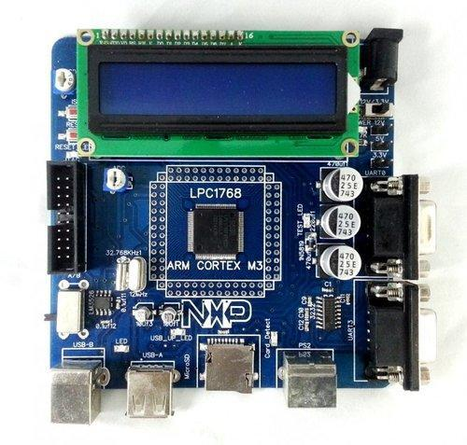
Fig. 4.1: ARM Cortex M3 LPC1768 Development Board

The LPC1768 is an ARM Cortex-M3 based microcontroller for embedded applications requiring a high level of integration and low power dissipation. The ARM Cortex-M3 is a next generation core that offers system enhancements such as modernized debug features and a higher level of support block integration.

The peripheral complement of the LPC1768 includes:
- 512 kB of flash memory
- 64 kB of data memory
- Ethernet MAC
- USB interface that can be configured as either Host, Device, or OTG
- 8 channel general purpose DMA controller
- 4 UARTs
- 2 CAN channels
- 2 SSP controllers
- SPI interface
- 3 I 2 C interfaces
- 2-input plus 2-output I 2 S interface
- 8 channel 12-bit ADC
- 10-bit DAC
- motor control PWM
- Quadrature Encoder interface
- 4 general purpose timers
- 6-output general purpose PWM
- ultra-low power RTC with separate battery supply
- 70 general purpose I/O pins.

The ARM Cortex-M3 is a general purpose 32-bit microprocessor, which offers high performance and very low power consumption. The Cortex-M3 offers many new features, including a Thumb-2 instruction set, low interrupt latency, hardware divide, interruptible/continuable multiple load and store instructions, automatic state save and restore for interrupts, tightly integrated interrupt controller with Wake-up Interrupt Controller, and multiple core buses capable of simultaneous accesses. Pipeline techniques are employed so that all parts of the processing and memory systems can operate continuously. Typically, while one instruction is being executed, its successor is being decoded, and a third instruction is being fetched from memory.
The LPC1768contains up to 512 kB of on-chip flash memory. A flash memory accelerator maximizes performance for use with the two fast AHB-Lite buses. This memory may be used for both code and data storage. Programming of the flash memory may be accomplished in several ways. It may be programmed In System via the serial port. The application program may also erase and/or program the flash while the application is running, allowing a great degree of flexibility for data storage field firmware upgrades, etc.
The LPC1768 contains up to 64 kB of on-chip static RAM memory. Up to 32 kB of SRAM, accessible by the CPU and all three DMA controllers are on a higher-speed bus. Devices containing more than 32 kB SRAM have two additional 16 kB SRAM blocks, each situated on separate slave ports on the AHB multilayer matrix. This architecture allows the possibility for CPU and DMA accesses to be separated in such a way that there are few or no delays for the bus masters.

4.2. Node MCU (ESP 8266):
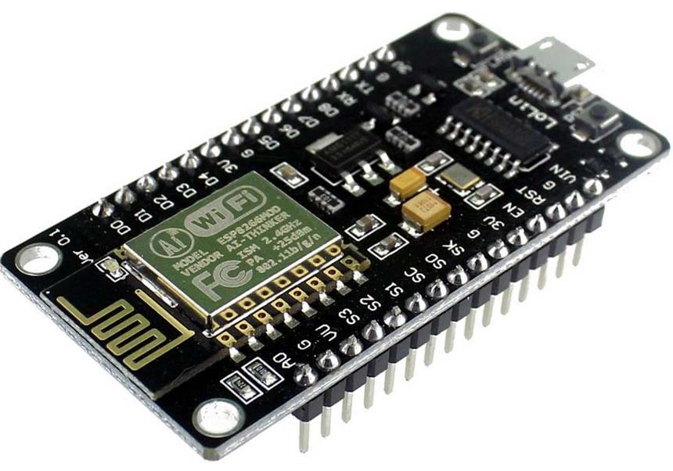

Fig. 4.2: ESP 8266
ESP8266 is the name of a micro controller designed by Espressif Systems. The ESP8266
itself is a self-contained WiFi networking solution offering as a bridge from existing micro controller to WiFi and is also capable of running self-contained applications. This module comes with a built in USB connector and a rich assortment of pin-outs. With a micro USB cable, you can connect NodeMCU devkit to your laptop and flash it without any trouble, just like Arduino. It is also immediately breadboard friendly.

Specifications:
• Voltage:3.3V.
• Wi-Fi Direct (P2P), soft-AP.
• Current consumption: 10uA~170mA.
• Flash memory attachable: 16MB max (512K normal).
• Integrated TCP/IP protocol stack.
• Processor: Tensilica L106 32-bit.
• Processor speed: 80~160MHz.
• RAM: 32K + 80K.
• GPIOs: 17 (multiplexed with other functions).
• Analog to Digital: 1 input with 1024 step resolution.
• +19.5dBm output power in 802.11b mode
• 802.11 support: b/g/n.
• Maximum concurrent TCP connections: 5.

Pin Diagram:
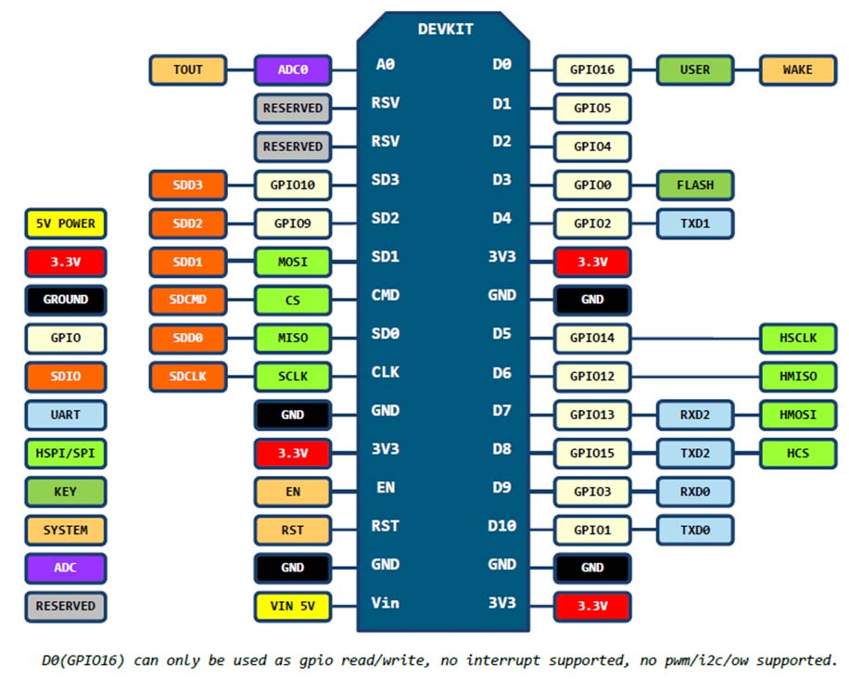

Fig. 4.3: Pin Diagram of ESP 8266
4.3. EM-18 RFID Reader Module:
RFID:
Basically, RFID systems categorised as active and passive based on how they are powered and their range.
1. Active RFID system
Active RFID tags have their own transmitter and power source (Mostly battery operated). They operate at 455 MHz, 2.45 GHz, or 5.8 GHz, and they typically have a read range of 60 feet to 300 feet (20 meters to 100 meters).
2. Passive RFID system
Passive RFID tags do not have a transmitter, they simply reflect energy (radio waves) back coming from the RFID reader antenna. They operate in Low frequency (~125 KHz) as well as High frequency (~13 MHz) band and have limited read range of up to ~1m.
There are two modes of coupling for communication used in RFID as:
- Inductive coupling, in which RFID reader emits magnetic field and whenever RFID tags enters the magnetic field which creates energy response from RFID tags and is detected by RFID reader. As the magnetic field drops sharply with distance, it is used for short distance applications.
- Capacitive coupling, where reader emits electromagnetic waves and whenever that waves encounters RFID tags, RFID tag reflects signal containing information of ID.

How RFID system works?
RFID Reader has transceiver which generates a radio signal and transmits it through antenna. This signal itself is in the form of energy which is used to activate and power the tag.
When RFID tag comes in range of signal transmitted by the reader, transponder in the tag is hit by this signal. A tag draws power from the electromagnetic field created by reader. Then, the transponder converts that radio signal into the usable power. After getting power, transponder sends all the information it has stored in it, such as unique ID to the RFID reader in the form of RF signal. Then, RFID reader puts this unique ID data in the form of byte on serial Tx (transmit) pin. This data can be used or accessed by PC or microcontroller serially using UART communication.

EM18 RFID Reader Module:

EM18 is a RFID reader which is used to read RFID tags of frequency 125 kHz. After reading tags, it transmits unique ID serially to the PC or microcontroller using UART communication or Wiegand format on respective pins. EM18 RFID reader reads the data from RFID tags which contains stored ID which is of 12 bytes. EM18 RFID reader doesn’t require line-of-sight. Also, it has identification range which is short i.e. in few centimetres.

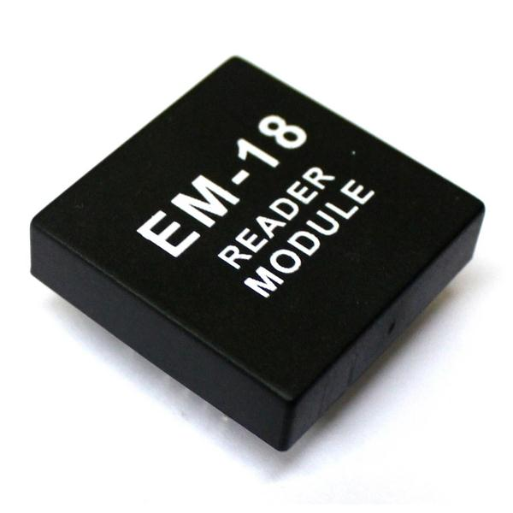

Fig. 4.4: EM-18 RFID Reader Module
There are various RFID readers available according to their frequency are shown as follows,
Frequency | Range | Different modules | Applications
120-150 kHz | 5-20 cm | EM-18, ILA-12, etc. | Factory data collection, identifying animals etc.
13.56 MHz | 10 cm – 1m | MFRC522, SM130 | Smart cards
Table 4.1: RFID Frequency ranges, distance, modules and applications.

RFID reader EM-18 features:
1. Serial RS232/TTL output
2. Operating Frequency is 125KHz.
3. Range is 5-8 cm.

RFID Reader to PC/Laptop communication
We can see RFID reader output on serial terminal of PC/Laptop.

RFID Serial Interface
When we bring RFID tag near to the reader, it reads the data from the tag and immediately transmits 12-byte unique ID on the serial port.12 Byte Unique Identification Number.
RFID Tags contain 12 Byte unique ID.
These checksum bytes will be the XOR result of 1st 10 bytes, i.e. Tag no.

4.4. 4X4 Matrix Keypad:
An alphanumeric keypad is a keyboard that contains both numbers and letters on the same keys. Typically, they are found on telephones and cellular phones. They also can appear on laptops, ATMs or any device where both numbers and letters are equally necessary. On phones, the number "1" is typically devoid of any letters; each of the other keys contain only three letters in alphabetical order.

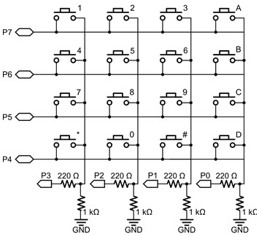  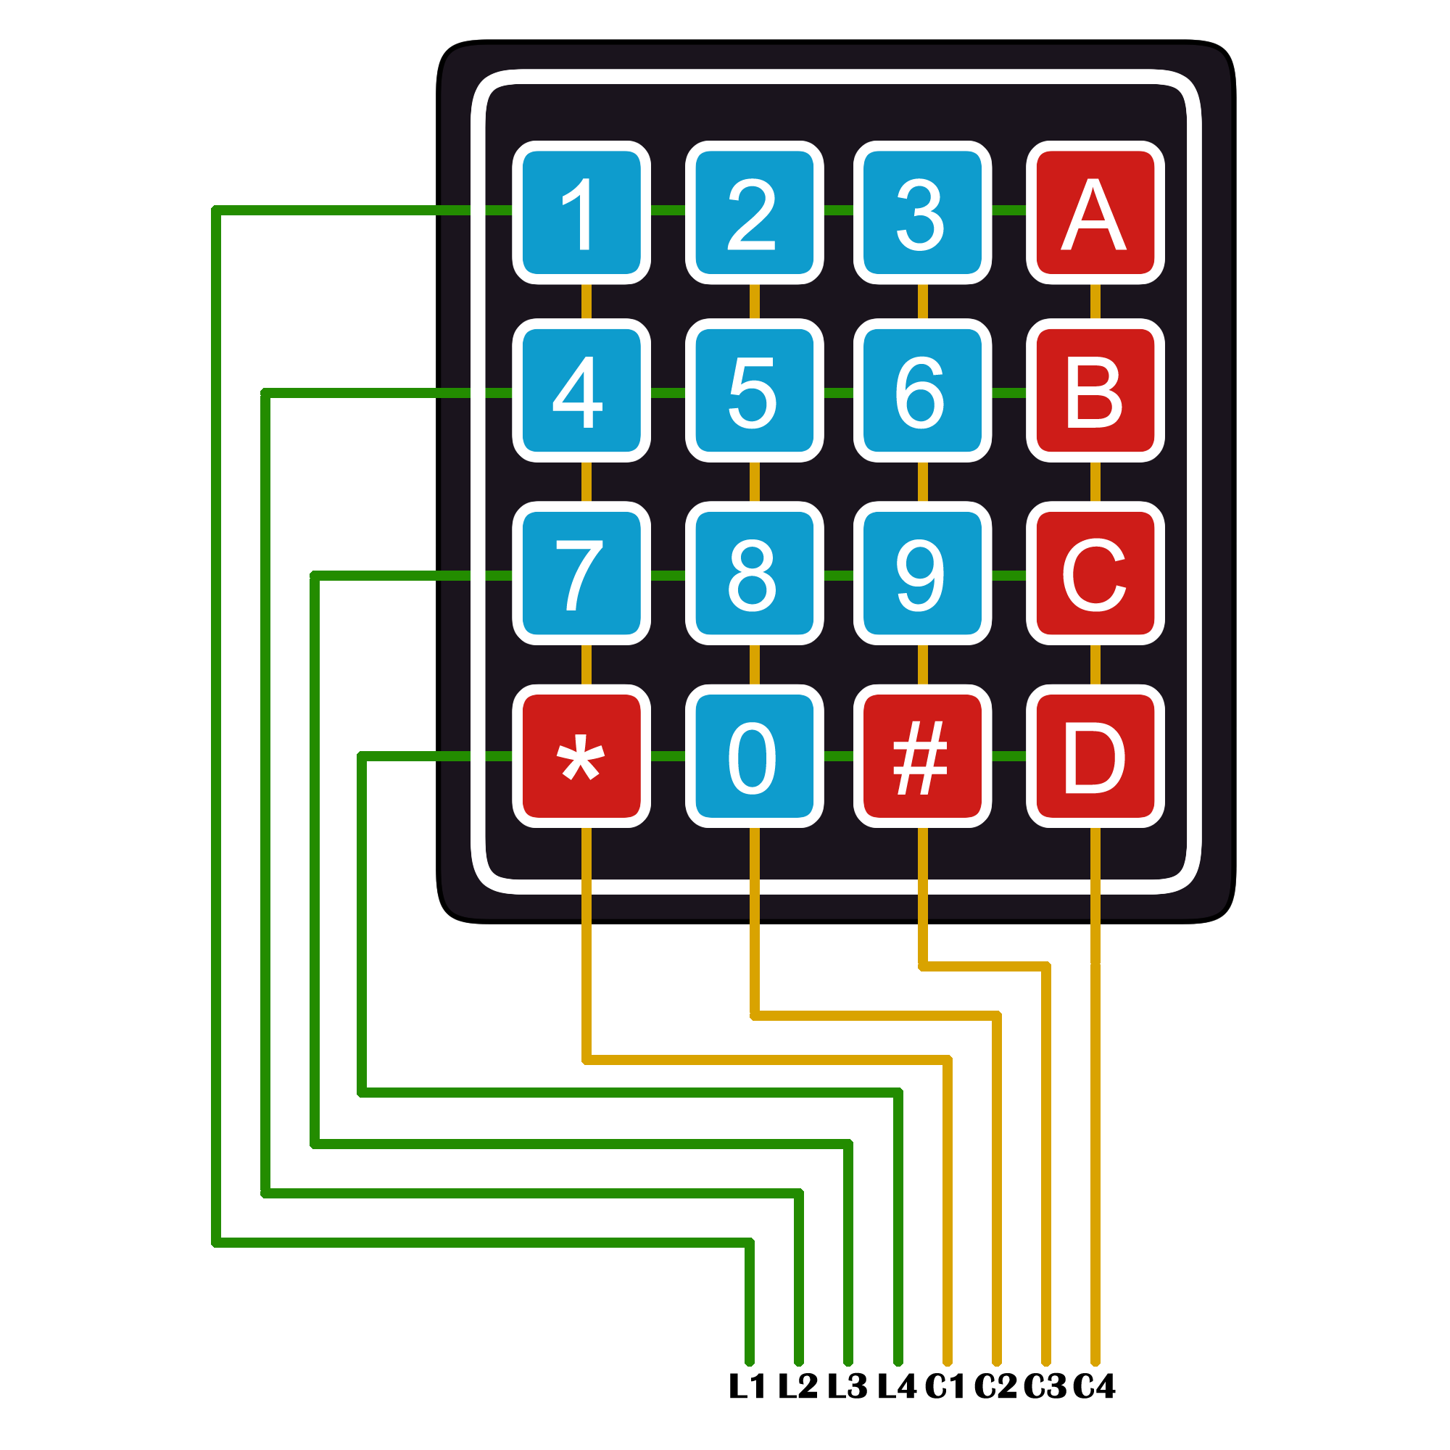  Fig. 4.5: 4X4 Matrix Keypad | Fig. 4.6: Keypad row-column intersection

4.5. USB-to-TTL Convertor:
The USB -232 Converter is an intelligent module which connects to a PC Universal Serial Bus port providing a high-speed asynchronous RS232 serial port. The USB-232 Converter provides easy connectivity between the PC and standard communication ports.
The USB-232 Converter is equipped with a USB cable and a USB type A connector for connection to a PC USB port and a male DB -9 for connection to a RS232 equipped data or communication terminal.
DB -9, Male PIN ASSIGNMENTS:
PIN# | SIGNAL
1 | DCD
2 | RXDATA
3 | TXDATA
4 | DTR
5 | GND
6 | DSR
7 | RTS
8 | CTS
9 | RI
Table 4.2 : DB-9 Pin Assignments
5. SOFTWARE REQUIREMENTS AND SPECIFICATIONS
Softwares used for the development of the project as:
- Vim Editor.
- Arduino IDE.
- Pycharm IDE.
- MySQL(Database).

5.1. Vim Editor:
Vim is a highly configurable text editor for efficiently creating and changing any kind of text.
Vim is rock stable and is continuously being developed to become even better. Among its features are:
- persistent, multi-level undo tree
- extensive plugin system
- support for hundreds of programming languages and file formats
- powerful search and replace
- integrates with many tools
5.2. Arduino IDE:
The Arduino Integrated Development Environment (IDE) is a cross-platform application (for Windows, MacOS, Linux) that is written in functions from C and C++. It is used to write and upload programs to Arduino compatible boards, but also, with the help of 3rd party cores, other vendor development boards.
The source code for the IDE is released under the GNU General Public License, version 2. The Arduino IDE supports the languages C and C++ using special rules of code structuring. The Arduino IDE supplies a software library from the Wiring project, which provides many common input and output procedures. User-written code only requires two basic functions, for starting the sketch and the main program loop, that are compiled and linked with a program stub main() into an executable cyclic executive program with the GNU Toolchain also included with the IDE distribution. The Arduino IDE employs the program avrdude to convert the executable code into a text file in hexadecimal encoding that is loaded into the Arduino board by a loader program in the board's firmware.
In October 2019 the Arduino organization began providing early access to a new Arduino Pro IDE with debugging and other advanced features.

5.3. PyCharm:
PyCharm is the most popular IDE used for Python scripting language. PyCharm offers some of the best features to its users and developers in the following aspects:
- Code completion and inspection
- Advanced debugging
- Support for web programming and frameworks such as Django and Flask.

5.4.MySQL:
MariaDB is an enhanced, drop-in replacement for the MySQL database server and is available under the GPL v2 license. It is developed by the MariaDB community with the MariaDB Foundation as its main steward. The project maintains its own set of security patches on top of MySQL. Indeed many of the security issues found in MySQL and MariaDB have been found and reported by the MariaDB team.
MariaDB is kept up to date with the latest MySQL release from the same branch and in most respects MariaDB will work exactly the same as MySQL. All commands, interfaces, libraries and APIs that exist in MySQL also exist in MariaDB.
There is no need to convert databases to switch to MariaDB. MariaDB is a true drop in replacement of MySQL! Additionally, MariaDB has many nice new features that you can take advantage of.
MariaDB uses the same architecture and the same code structure as MySQL, this is why it can mantain compatibility. There is however, a long list of improvements to the original MySQL code including more storage engines, speed improvements, extensions & new features, better testing, fewer warnings and bugs and truly open source.
6. SOURCE CODE EXPLANATION
6.1 ARM Programming:
Most of the communication between the devices takes place through UART. The main functions used for uart communication are:
- To put data on Tx pin of UART:

void uart_puts(char str[])
{
uart_puts_busy_wait();
wr_flag = 0;
wr_index = 0;
wr_string = str;
LPC_UART3->THR = wr_string[wr_index++];
}

The string that has to be written to uart is passed into uart_puts() function as argument 1. Inside this function uart_puts_busy_wait() function is called.

void uart_puts_busy_wait(void)
{
while(wr_flag == 0);
}
In this function we check if any other uart_puts() function is writing data to avoid collisions. Here we monitor a flag that is made equal to 1 when writing function is completed. Thus in uart_puts_busy_wait() function we monitor whether this flag is made 0. When flag becomes 0 further data can be written to uart.

LPC_UART3->THR = wr_string[wr_index++];
UI showing the system waiting for card
This statement writes actual data byte-by-byte into the uart register THR. When data is transmitted the IIR bits corresponding to transmission operation are set indicating that the data is sent. Once a byte of data is sent the next bytes can be transmitted further. Thus on indication of transmission, isr for tranmission is called that triggers next transmission.

2. To receive data on Rx pin of UART:

void uart_gets(char str[])
{
uart_gets_busy_wait();
rd_flag = 0;
rd_string = str;
rd_index = 0;
}
The string that is read on uart is catched into uart_gets() function in argument 1. Inside this function uart_gets_busy_wait() function is called.

void uart_gets_busy_wait(void)
{
while(rd_flag == 0);
}
In this function we check if any other uart_gets() function is reading data to avoid collisions. Here we monitor a flag that is made equal to 1 when reading function is completed. Thus in uart_gets_busy_wait() function we monitor whether this flag is made 0. When flag becomes 0 further data can be read from uart.

ch = LPC_UART3->RBR;
This statement reads the uart register RBR. When data is received the IIR bits corresponding to reception operation are set indicating that the data is received. Once a byte of data is read the next bytes can be received further. Thus on indication of reception, isr for receiving the next data is called that triggers next operation.

6.2 ESP8266 Programming:
Initially the connection between nodeMCU and the server is built. When nodeMCU gets connected to the network, the serial port is checked continuously to monitor if any data is present on it.
if(Serial.available() > 0)
{
ch = char(Serial.read());
if(ch != '\r')
{
str = str + ch;
}
}

The data received on Serial port is captured in a string.
user_id = str[9];
sugar = str[16];
wheat = str[23];
oil = str[28];
rice = str[34];

Once the data is obtained, it is sent to server in the json format.
http_send(user_id, sugar, wheat, oil, rice);

This function collects the data and puts in json format.
String body = "{ \"user_id\" : " + String(user_id) +","+ "\"sugar\" : " + String(sugar)+ "," + "\"wheat\" : " + String(wheat) + "," + "\"oil\" : " + String(oil) + "," "\"rice\" : " + String(rice) +"}";

This data is now sent to server.
httpClient.begin("http://172.18.5.210:4000/update_data");
httpClient.addHeader("Content-Type", "application/json");
int statusCode = httpClient.POST(body);

6.3 Server Programming:
Server is the Python Flask application. This application contains routes for mapping requests with functions.
@app.route("/update_data", methods=["POST"])
def post_data():

This function collects data in json format and pushes it into database.
user_id = request.json.get("user_id")
sugar = request.json.get("sugar")
wheat = request.json.get("wheat")
oil = request.json.get("oil")
rice = request.json.get("rice")

Here we update the database with the following query:
statement = f"update data set sugar={sugar},wheat={wheat},oil={oil},rice ={rice} where(user_id={user_id})"

This statement is further executed with the help of cursor to commit final changes in database.
cursor.execute(statement)
connection.commit()

7. TESTING
1. The UI shows that the system is waiting for the user to scan the card.
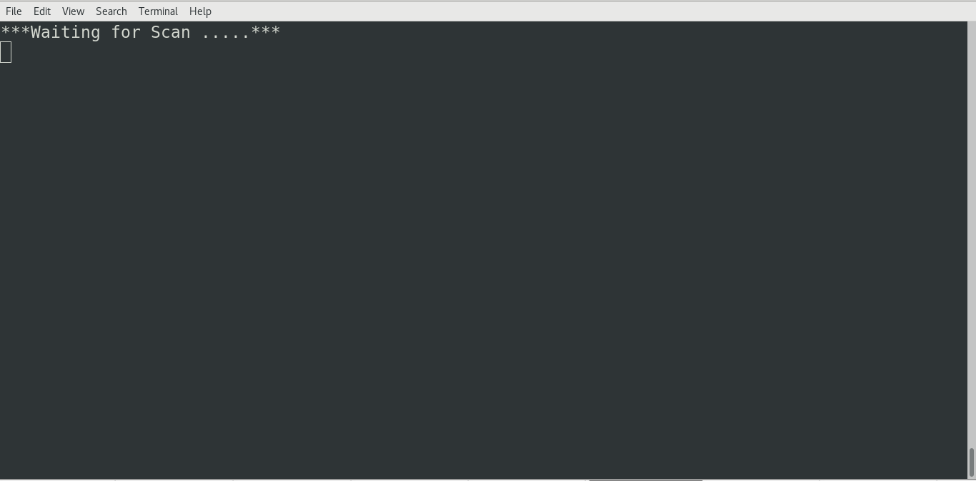
Fig. 7.1: UI showing the system waiting for card

2. Once the user scans the card, system will show the options to select the quantity.
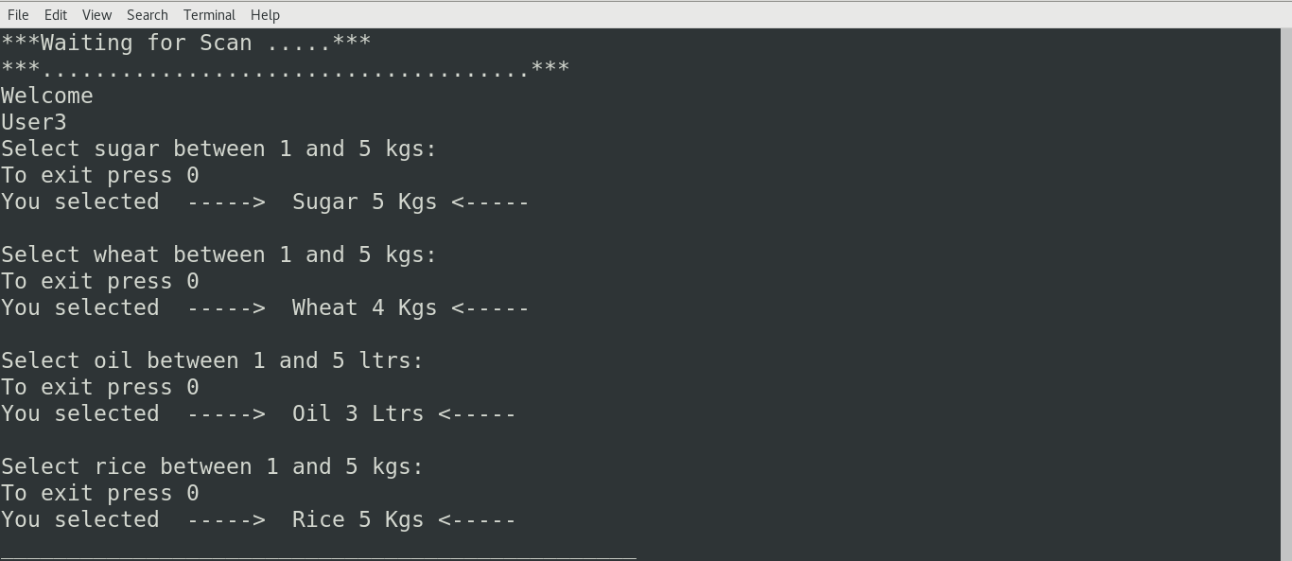
Fig. 7.2: UI showing options for selecting quantity

3. The data gets sent to the NodeMCU and it further sends data to server.
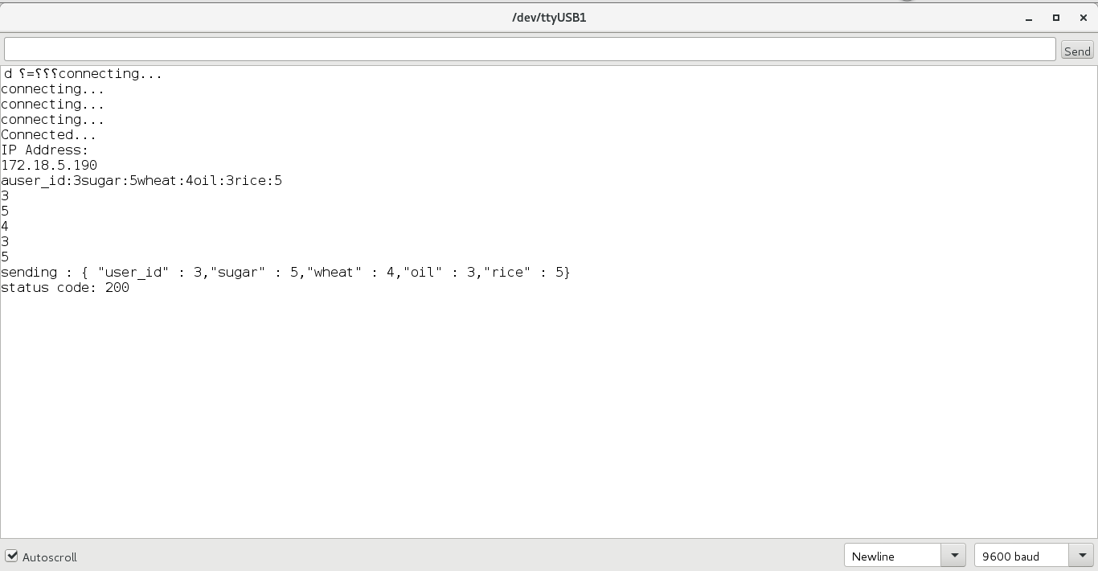
Fig. 7.3: Serial Monitor at NodeMCU shows the received data and status code of the data transmission to server.

4. The initial status of database.
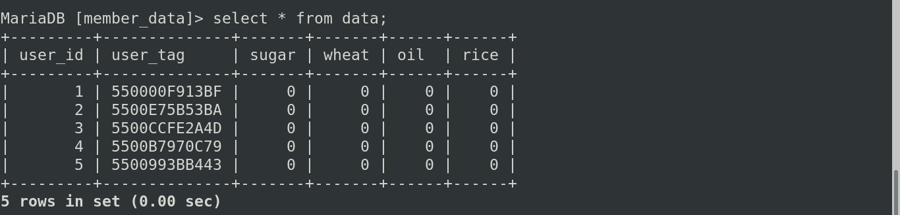
Fig. 7.4: Initial status of the database.

5. The status of database after updating data.
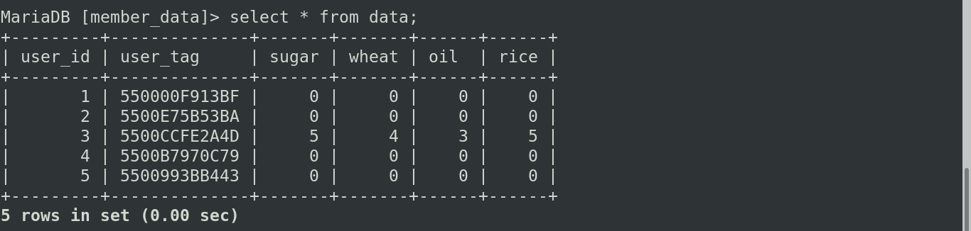
Fig. 7.5: Status of the database after updating a value.
8. FUTURE SCOPE
Ration Distribution System means distribution of essential commodities to a large number of people. It is done by the government. Public distribution system is one of the widely controversial officers that involves corruption and illegal smuggling of goods. All these happen because every job in the ration shop involves manual work and there are no specific high-tech technologies to automate the job. Our main objective here is to automate the process of the distribution. The classical method involves customer to tell the person handling the ration shop outlet, the amount of the commodity he/she needs and the type too. The person working then measures the commodity and gives it to the customer. In our version of the system, we will develop an embedded system project where we will have the customer to input the amount he requires and the system made will automatically collect that much amount in a container. It is a new concept which takes into account the various social, economic and general aspects relating to technical as well as day to day disciplines.
The application of this particular improvement is the present working of the ration shops has a lot of scope in various other areas apart from being introduced only to this particular domain. This particular system can be scaled up to for a large number of items which can be selected from one controller itself. Also the technology introduced can be used in various places like malls, supermarkets, etc. As there is ease of access, it can remove the constraint on time for various types of applications. So the users have 24x7availability.This can prove to be a profit to some organizations and they may opt for installing such a system.
This system has greater scope in future. As there is no manual data stored and all information is stored in database, the in higher authority can check the details as and when it’s necessary through the use of servers. We can preserve the privacy of the data through data mining technique based approach for distribution of products and services. Also, induces better security and transparency in the distribution of the goods.

9. CONCLUSION
The conventional system has drawbacks like malpractices, low processing speed, long waiting time at ration shop to get material and material theft in ration shop without any acknowledgement to Government and consumer. To overcome above problems, automatic ration shop played important role. The automatic ration shop involved RFID as well as IoT technology to distribute the kerosene or grain material. Ration card is replaced by RFID and information is sent to database for future use. The proposed system creates the transparency in public distribution system as the work becomes automatic. With the help of this system, it is possible to make public distribution system efficient and free from malpractices. The proposed system has advantages like it is helpful to prevent malpractices at ration shop, maintain data properly, reduces paper work, time saving approach and cost effective.
The proposed framework is for the benefit of government as well as common people. The proposed system will find its application in the rationing shops which are run by government. Also, this project includes an electronic device which can be used in the distribution centers and rationing shops.
10. REFERENCES
[1] M. Pallikonda Rajesekaran, R. Arthi, D. Balaji, P. Daniel “Automatic smart ration distribution system for prevention of civil supplies hoarding in India” Advanced Computing and Communication Systems (ICACCS), 2017 4th International Conference on 6-7 Jan. 2017, 10.1109/ICACCS.2017.8014593
[2]Swapnil R. Kurkute, Chetan Medhe, Ashlesha Revgade, Ashwini Kshirsagar “Automatic ration distribution system — A review” Computing for Sustainable Global Development (INDIACom), 2016 3rd International Conference on 16-18 March 2016.
[3]Sana A. Qader Perampalli, Dr. R.R. Dube “Smart Card based e-Public Distribution System” International Journal of Advanced Research in Computer and Communication Engineering Vol. 5, Issue 5, May 2016.
[4]Golden Bagul , Brendon Desouza, Tejaswini Gaikwad , Ankush Panghanti, Trupti Kumbhare “A Survey on Smart Ration Card System” nternational Journal Of Engineering And Computer Science ISSN: 2319-7242, Volume 6 Issue 1 Jan. 2017, Page No. 20096-20098, DOI:10.18535/ijecs/v6i1.42.

