

Курсов проект по Управление на проекти на тема

“Система за онлайн курсове”

Изготвили:

Манол Джермански

Росица Деянова

Волен Димитров

Виктор Симеонов

# 1.Харта на проекта. Заинтересовани лица.

Манол Джермански

| **Project Name** | Information System for Online Courses | | | |
| --- | --- | --- | --- | --- |
| **Project Charter Author** | Manol Dzhermanski | | | |
| **Project Manager** | Manol Dzhermanski | | | |
| **Project Sponsor** | Madhav Khandelwal (Project Director of Coursera) | | | |
| **Project Start Date** | 4.12.2023 | | | |
| **Estimated Period for Completion** | 11.07.2024 | | | |
| **Last Revision Date** | 20.12.2022 | | | |
| **Project Description** | To create an information system for online courses on different topics which can aid in the education of healthy individuals but also people with hearing and seeing difficulty. | | | |
| **Project Scope** | The goal of the project is to create a web-based information system for online courses on different topics. People can freely apply for permission to create courses.It is mandatory for the content creator to prove that he has knowledge and experience in the field in which he makes courses(CV, diploma, certificates etc.). Courses will go through a submission and review process. If they meet a series of standards, they will be adapted for people with disabilities by adding translations to materials, text and live captions etc. When ready, the course will be visible to the public. Users will gain access to the course material by buying a desired course. | | | |
| **Project Objectives** | * Provide up to 50 courses on different topics in English by 7 months since the start of the project * Allow professionals to help out in the education of healthy individuals and ones with hearing and seeing difficulty by allowing them to create online courses in the information system in 5 months since the start of the project. * Assure the courses’ materials are of high quality and meet the needs of the targeted demographic by introducing a course review process in 6 months since the start of the project * Support the education of individuals with hearing difficulty by providing live caption in ASL for the materials of 15 courses of different topics by 5 months since the start of the project and all up to 7 months since the start of the project * Support the education of individuals with hearing difficulty by providing verified text caption and translation for all 50 courses in English and Spanish up to 6 months after launch * Support the education of individuals with seeing difficulty by providing font size increasing and magnification to all documents in text format by 5 months since the start of the project * Support the education of individuals with seeing difficulty by providing additional color contrast such as “Blue text on yellow background”, “Yellow text on black background” and “Green text on black background” to all documents in text format by 5 months since the start of the project | | | |
| **Budget** | **150 000$** | | | |
| **Success criteria** | The project will be considered as successful when the following objectives are achieved:   * The information system’s interface is build * To offer 50 available courses at the launch of the information system * The information system has grabbed the attention of 2 universities from the top 10 best universities in the world * To offer adapted courses in ASL at the launch of the information system * Functionalities for people with hearing difficulty are implemented * Functionalities for people with sight difficulty are implemented * The information system has gained a positive reviews from the general public | | | |
| **Project Deliverables** | Key deliverables of the project:   * Stakeholder Analysis * Cost Management Plan * Communication Plan * Risk Management Plan * Results of marketing research * Mockup of the website’s design and features * Course which is used to training the content creators on how to use the information system * 50 online courses in English, adapted in ASL and translated in Spanish * The information system’s website * Documented result of the performed tests with control groups * Software documentation | | | |
| **Project Milestones** | **Milestone** | | **Expected time of completion** | |
| Finalized project charter | | by 2 weeks since start of the project | |
| Signed contract with 15 independent content creators and 2 universities for creating 50 courses | | by 2 months since the start of the project | |
| Finalized the website’s mockup | | by 3 months since the start of the project | |
| Signed contract with translators | | by 3 months since the start of the project | |
| Signed contract with sign language interpreters | | by 3 months since the start of the project | |
| Adapted 15 courses in ASL | | by 6 months since the start of the project | |
| Completed the color contrast filters | | by 6 months since the start of the project | |
| Completed font size increasing functionality | | by 6 months since the start of the project | |
| Completed text caption functionality | | by 6 months since the start of the project | |
| Tested features with control groups | | by 7 months since the start of the project | |
| Tested features with special needs devices | | by 7 months since the start of the project | |
| Deploy the information system’s website | | by 7 months since the start of the project | |
| Released the 50 initial courses to the public | | by 8 months since the start of the project | |
| Completed the translation in Spanish | | by 8 months since the start of the project | |
| Adapted and released all 50 courses in ASL | | by 8 months since the start of the project | |
| **Key Stakeholders** | **Name** | **Role** | **Interest** | **Power-Interest Grid Quadrant** |
| Project Sponsor | Provide resources, guidance, and support to the project manager and team | Ensure the project goals are met  Provide a link between senior management and the project team | Manage Closely |
| Project Manager | Oversee the entire project - planning, development, launch and post-launch support. | Manage the project scope, timeline, budget, resources, and stakeholders  Ensure the project goals are met | Manage Closely |
| Healthy individual | User | Complete courses  Keeps statistics on how many courses are bought, grades etc.  Being kept accountable to finish their work at certain deadlines  Flexibility to work on their coursework on their own schedule.  Easily communicate with staff - content creators | Manage Closely |
| Person with hearing difficulty | User | Complete courses  Keeps statistics on how many courses are bought, grades etc.  Being kept accountable to finish their work at certain deadlines  Flexibility to work on their coursework on their own schedule.  Use the live and text caption functionality.  Easily communicate with staff - content creators, sign language interpreters, customer support | Manage Closely |
| Person with seeing difficulty | User | Complete courses  Keeps statistics on how many courses are bought, grades etc.  Use color filter functionality.  Use font increasing functionality  Easily communicate with staff - content creators | Manage Closely |
| Content creator | User; Professional who creates courses | Teach students real life knowledge  Have freedom on how to structure the courses  Easily create and edit courses  Promote created courses  Compete courses | Keep satisfied |
| Sign language interpreter | Provides live captioning for the course videos and aid in live classes | Have communication with content creators  Easily join live session to help out with the interpretation  Easily navigate throughout video timestamps | Keep informed |
| Translator | Translates the course materials in other languages | Have communication with content creators  Easily write and correct translations  Easily navigate throughout video timestamps | Keep informed |
| Quality Control moderators | Verifies that the course materials are of high quality by checking if all best practices are used when recording videos;  Assists in live classes by attending and checking if all best practises are being used; | Easily notify content creators, translators, sign language interpreters if there are flaws  Easily moderate student’s questions and reactions and help out in live classes | Keep informed |
| Developer | Creates the information system and website | Ensure the other stakeholders are satisfied  Provide feedback on the development process  Ensure that they are creating a quality product | Manage Closely |
| QA | Tests the information system and website | Ensure that the product is of high quality  Ensure that the project is completed according to the customer's specifications and requirements.  Reduce the risk of project failure by identifying potential issues | Manage Closely |
| UI designer | Creates the design of the system’s website, decides which colors to be used for the color contrast filters | Еnsure the product is accessible to all users, including those with disabilities.  Testing the designs  Optimize the user experience by creating intuitive and efficient designs | Manage Closely |
| Team Lead | Manages the tasks done by the development/testing teams; Helps solve problems within the team; | Ensuring the successful completion of the project within the timeline, budget, and scope.  Providing guidance and direction to team members  Building and maintaining relationships with stakeholder  Monitoring progress | Manage Closely |
| HR | Reviews the applications for content creator rights;  Think of strategies to keep the stakeholders engaged | Recruiting the right personnel  Developе project culture  Analyze feedback from stakeholders to optimize the work process  Ensure the organization meets compliance and legal requirements | Keep informed |
| Universities | Provide courses of higher education to the information system’s students | Improve academic standards  Expand student enrollment  Gain more flexibility in delivering courses in higher education | Manage Closely |
| Customer support | Provide help to the students, content creators with any questions that may occur | Help students with resolving common problems  Report about errors and bugs found by the students | Monitor |
| **Assumptions** | * The demand for educational courses for people with hearing and seeing difficulty is increasing. * There aren’t many platforms which combine all of the planned for development functionalities in one place * There are plenty of sign language interpreters in the labor market * The courses will be useful for many people thus it’s beneficial to translate them * The provided product will be affordable to the general public * There are plenty of motivated content creators willing to create courses * The scope of the project will not change during the project lifecycle * The project’s budget will be sufficient | | | |
| **Constraints** | * Creating content and materials takes time * Ensuring that the courses are accessible to all students, regardless of their technological abilities or physical limitations will require several user experience tests with control groups. | | | |
| **Risks** | * Courses may not be viewed * High demand for new content in a short period of time * The system won’t handle the web traffic * Cannot attract content creators * Little experience with people with disabilities * Cannot keep student’s attention * Can’t predict how many translators and sign language interpreters are needed * Developing and maintaining the project will require a certain amount of money. * Courses may be subject to external threats such as hacking, data theft and other malicious activities. * Special needs hardware isn’t compatible with the information system * The integrated payment system may not be reliable | | | |

* **High power, highly interested people (Manage Closely)**: you must fully engage these people, and make the greatest efforts to satisfy them.
* **High power, less interested people (Keep Satisfied)**: put enough work in with these people to keep them satisfied, but not so much that they become bored with your message.
* **Low power, highly interested people (Keep Informed)**: adequately inform these people, and talk to them to ensure that no major issues are arising. People in this category can often be very helpful with the detail of your project.
* **Low power, less interested people (Monitor)**: again, monitor these people, but don’t bore them with excessive communication.

# 2. Спецификация на изискванията към всички продукти. Обхват на проекта.

Росица Деянова

| **Priority** | M | Must have |
| --- | --- | --- |
| S | Should have |
| C | Could have |
| W | Would be nice to have |

| **Application functionality** | | | | | |  |
| --- | --- | --- | --- | --- | --- | --- |
|  |  |  |  |  |  |  |
| **REQUIREMENT LIST** | | | | | **REQUIREMENTS ANALYSIS** | |
| **ID** | **REQUIREMENT DESCRIPTION (USE CASE)** | **USE CASE**  **DESCRIBTION** | **PRIORITY** | **ACCEPTANCE CRITERIA** | **COMPLEXITY** | **TEST OR VERIFICATION** |
| 1 | New user registration | The client opens the form and enters their data. If the data is valid, they log into the system. If the data is not valid an error messege is showed. | M | To create a new account the user should enter a username, email and password. The username and email should be unique. | Medium | Enter faulty emails:  - without "@"  testregex1.prm.com  -without domain part  testregex2@  testregext3@prm  -without username part  @prm.com  @.com  Write a correct email  correct.email@pm.com  Check if email is unique  Check that the password is strong  Check if username is unique |
| 2 | Registered user login | The client opens the login form and enters their data. If the data is valid, they log into the system. If the data is not valid an error messege is showed. | M | A user should be able to log in in already existing acount with an email and password. | Medium | Test if the user is redirected to the main page if their credentials are correct and if an error messege is shown when their credentials are incorrrect. |
| 3 | A registered user wants to change their password | The client opens the login form and chooses "Forgotten password option". After entering the username or email, they will receive a mail allowing them to change their password. | M | The users's password in the database is changed. | Low | The user should be able to log in with their new password |
| 4 | User wats to see the course's content | A logged in user can see the course's content only if they have purchased it. | M | The videos must be able to open, the test have to be able to be taken and retaken and provide visualized answers | High | - test if text files can displayed  - test if image files can be displayed  - test if video files can be displayed  - test if other files can be downloaded  - test if test can be taken  -test if test can be retaken and if they show the answers |
| 5 | User wants to submit an assignment | After login, if the user is taking the course, they can submit their assignment. | М | The user should be able to submit image files, video files, text files and archives. | High | test if:  - image files can be submitted and saved  - video can be submitted and saved  - text files can be submitted and saved  - archives can be submitted and saved |
| 6 | User wants to resubmit an assignment | If a user is logged in, taking the course and has submitted an assignment they can reopen the assignment task again and upload a new file. | S | The user should be able to resubmit image files, video files, text files and archives. | Medium | test if:  - the resubmitted images, videos, text files or archives are correctly saved in the database |
| 7 | The content creator wants to open an assignment | After login the content creator can open all submitted assignments for their courses and leave a feadback or a mark. | S | When the content creator clicks on an assignment a form for feedback is visualized. | High | test if:  - all types of assignments are visualized  - the content creator can write a feadback and a mark in a custom form. |
| 8 | The content creator wants to start a live session | After login the content creator can start a live session | W | The lector should be able to start a live lecture | Medium | - test if the lecturer can start a live session  - test if the user who bought the course receive a notification when the live session starts  - test if the users can join the live session  - test if the comment during the live session are being shown |
| 9 | Content Creator wants to create a new course or edit existing one | If a user wants to become a content creator they need to fill put the application form. If they are accepted they can start uploading content to their course. Course editing also has to be approved first. | M | A registered user may apply to create a course. If it is their first time creating a course they will be asked to submit some personal information. If they already have created a course, they will skip the persional information phase and directly upload they course content. | High | - test if the appliction form can be filled out correctly  - test if the application form is being sent  Google forms may be used for this functionality |
| 10 | Approve or reject course application | The platform admins can approve or reject applications for course creations. | M | The course application may be approved or rejected. The content creator will receive feedback in their profile. | Medium | - test if the button for approving visualizes the course for the users  - test if the lecturer receives a notifications for their approved course  - test if reject button sends a course back for edits  - test if the lecturer receives a notificationfor their rejected course |
| 11 | Unregistered user wants to see the available courses | All users registered or unregistered can | S | A user may see the available courses | Medium | - test if all approved courses are visible on the main page |
| 12 | User wants to buy a course | After a successful payment a registered user can enroll in the chosen course and see it's contents. | M | A registered user may buy a course. | High | - test if a course displays the Buy button  - test if a course visualizes it's prise  - test if when clicked the Buy button sends you to the integrated payment system  - test if when payed the course is visualized in the user's profile  - test if when payed the user can access all the materials in the course |
| 13 | User wants to save payment information | After successfull payment the user may choose to add the payment details to their profile for later use. | S | The used card's number and expiration date will be saved for future use. | High | - test if after the user clicks the save button their data is saved in the database |
| 14 | User wants to delete payment information | The user may delete the already saved payment details form their profile. | S | The user should be able to delete he details for saved payment information. | Low | - test if after the user clicks the delete button their data is deleted from the database |
| 15 | Support option | Both registered and unregistered users can be able to use the chat feature to chat directsly to Customer Support. | S | The platform should have a contact page where users can directly contact support through chat regarding any difficutly operating the site | Medium | -TEST IF CHAT POPUP OPENS  Click on the chat button and check if the user can click on the category of problems are displayed for clicking. Assure that the user can be contacted to a person and can type messages.  -TEST IF USER MESSAGES ARE SENT TO SUPPORT  Send several texts as a user  -test if support message is being sent to user  - test if sent texts between the user and support are saved  - test if when browser is reopen the chat session is still showing if the problem isn't resolved |
| 16 | View profile | Registered user should be able to go to their profile to see which courses they are currently taking, their submitted assignments and grades and general profile information. | W | The user is able to open their profile. There they can see their courses and statistics. | Medium | - test if personal information is displayed  - test if courses information is displayed  - test if analytics are displayed  - test if the user is able to change their username and photo |
| 17 | Upload content in your course | Approved content creator can upload image files, video files, text files and archives to their course. | M | If the course hasn't been approved yet, the uploaded content won't be visible to the users. If the course has been approved before, the old version of the content will be visible, until the new one gets approved. | High | - test if text files can be uploaded and displayed  - test if image files can be uploaded and displayed  - test if video files can be uploaded and displayed  - test if other files can be uploaded and displayed |

# 

| **User Interface** | | | | | |
| --- | --- | --- | --- | --- | --- |
|  |  |  |  |  |  |
| **REQUIREMENT LIST** | | | | | **REQUIREMENTS ANALYSIS** |
| **ID** | **REQUIREMENT DESCRIPTION** | **PRIORITY** | **ACCEPTANCE CRITERIA** | **COMPLEXITY** | **TEST OR VERIFICATION** |
| *18* | Additional color contrast | S | Providing additional color contrast for all text files. Using certain color combinations for different disabilities | Meduim | - test if there is a contrast changing button on every text document- test if the button changes the color of the text and background on click |
| *19* | Font size and magnification | S | Font size increasing and magnification to all documents in text files | Meduim | - test if there is a magnification icon on every text document, letting you change the font size |
| *20* | Live caption videos | S | Add live caption videos for the hearing impared | Meduim |  |
| *21* | Create course subtitiles | *S* | Creating subtitiles for the hearing impared | High | Test if every lecture has a good quality subtitles using a control group |

# 

| **Functional and non-functional requirements** | | |
| --- | --- | --- |
|  |  |  |
| **Category** | **Priority** | **Details** |
| **usability** | M | The system has to behave the same with all browsers |
| **usability** | S | The system has to be available on mobile |
| **usability** | S | Friendly oriented design and easy navigation |
| **usability** | C | The content has to be in many different languages |
| **usability** | W | The system has to have functions for video and audio editing |
| **usability** | W | The system has to support a “Text to speech” functionality |
| **monitoring** | M | When system changes are made the system should save logs of those changes |
| **monitoring** | S | The system should be able to monitor the traffic |
| **performance** | M | The system should load for not more than 1 second |
| **performance** | М | The system has to support 5000 requests at the same time |
| **performance** | W | The system has to have a few servers in important places around the world |
| **availability** | M | The system has to be able to process the requests correctly 95% of the time |
| **availability** | M | There should be a second copy of the database |
| **availability** | M | The system should be supported from at least 2 centers |
| **security** | М | Use the OWASP recommendations for security |
| **security** | M | Use the local requirements for data storing (like GDPR) |
| **security** | C | Adding a two factor authentication |
| **security** | S | Ending the user sessions after 12 hours |
| **security** | S | The system has to have as many profile recovering options as possible |
| **scalability** | S | The system has to be scalable and unscalable |

# 

| PROJECT DELIVERABLES | | |  |
| --- | --- | --- | --- |
| **DATE:** | *15.11.2022* | *Platform for online courses* |  |
|  |  |  |  |
| **DELIVERABLES LIST** | | | |
| **ID** | **DELIVERABLE NAME** | **DESCRIPTION** | **OWNER** |
| 1 | Demo course | Course which is used to training the content creators | Developer |
| 2 | Information system guide | Work breakdown structure on the information system’s creation | Developer |
| 3 | Website | The information system’s website | Developer |
| 4 | Software documentation |  | Developer |
| 5 | Мarketing research | Results of marketing research | Marketing |
| 6 | User feedback document | Document on the user experience from people with hearing and seeing difficulties | Marketing |
| 7 | Gantt chart | Gantt chart to determine the project’s timeline | Project Manager |
| 8 | Stakeholder Analysis |  | Project Manager |
| 9 | Cost Management Plan | Plan of all the budget that will go in the project | Project Manager |
| 10 | Demo video | Demo video showing the best practises for creating a video lecture | Video Editor |
| 11 | Best video practises | Document on best practises when recording video | Video Editor |
| 12 | Website logo | A logo that will be displayed on the top of the web site | Web Designer |
| 13 | Mockup of the website’s design | A pdf that displays the planned pages | Web Designer |
| 14 | Color contrast filters | Mockup of the additional color contrast filters with the specific RGB codes to be applied | Web Designer |

## Scope

The scope of the project is to develop an online platform that allows visually and hearing-impaired individuals to access and participate in educational courses. The platform will allow users to create profiles, browse and watch available courses, and apply to become lecturers. The courses will be created and presented by reputable and knowledgeable lecturers.

The scope of the project includes the following:

* Developing a user-friendly interface that is accessible to visually and hearing-impaired individuals, including the use of alternative text and audio descriptions for images and videos.
* Implementing a course management system that allows lecturers to create and upload their courses, and allows users to browse and watch available courses.
* Implementing a system for accepting and reviewing applications from individuals who wish to become lecturers on the platform.
* Implementing a secure payment system for users to purchase courses.
* Testing and debugging the platform to ensure it is functional and user-friendly.
* Launching the platform and maintaining it on an ongoing basis.

# 3. Структура на работните пакети (WBS). WBS речник.

Волен Димитров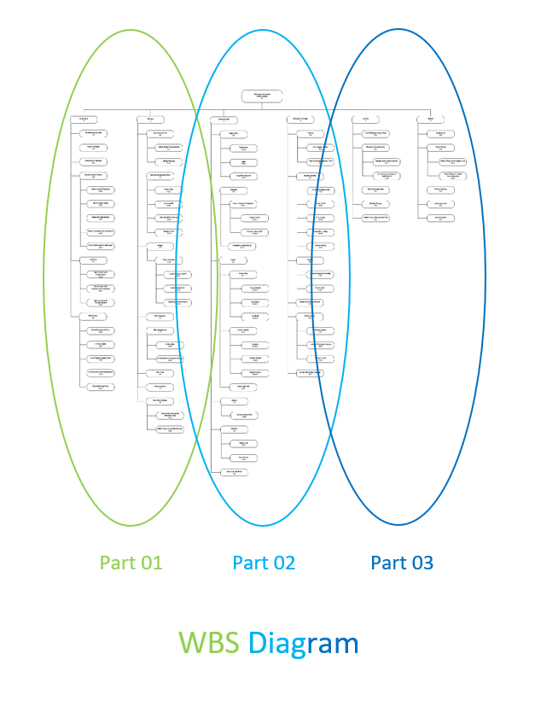

# Part 01:

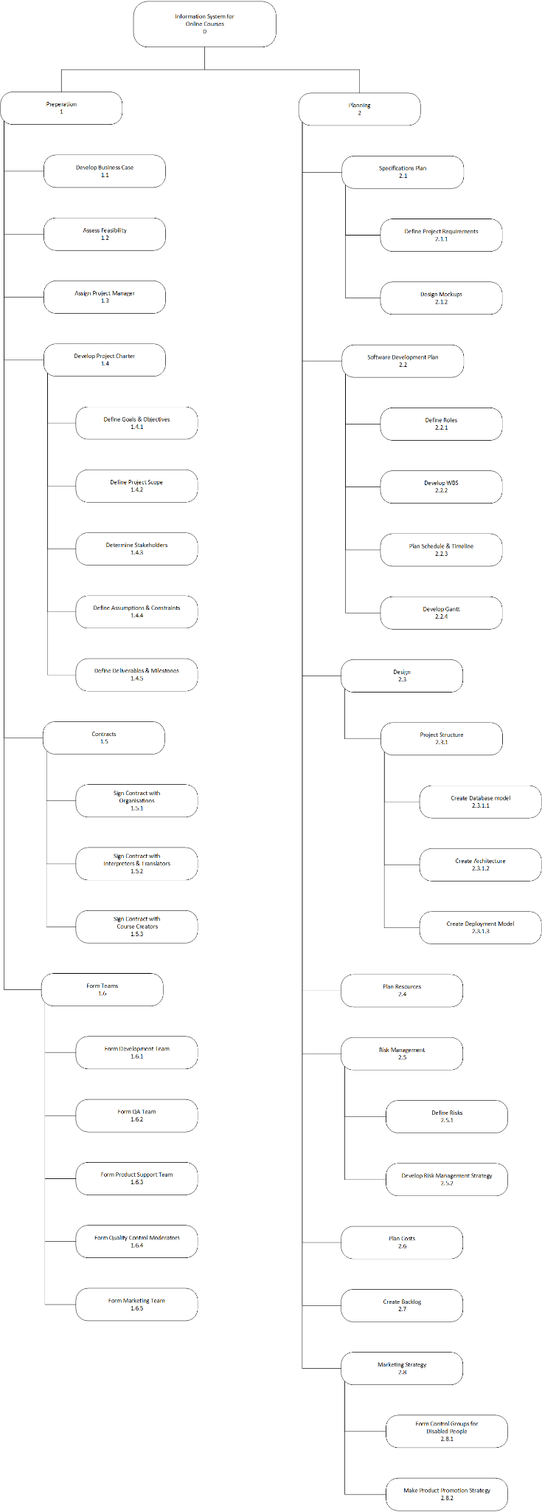

Part 02:

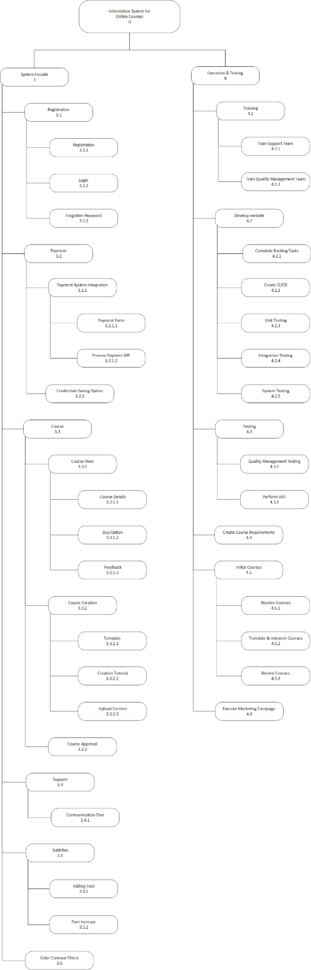

Part 03:

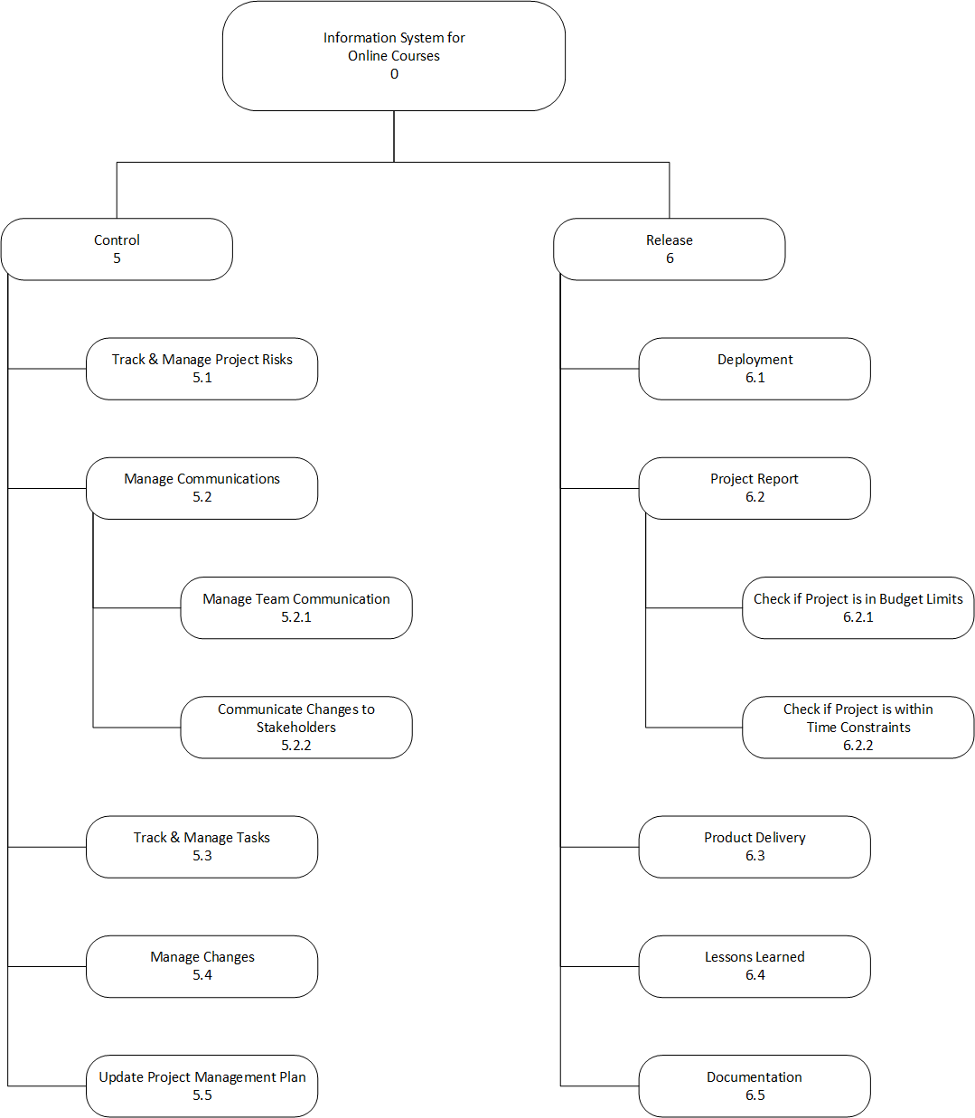

WBS Dictionary

(Work-Packages Description)

0. Information System for Online Courses

1. Preparation

1.1 Develop Business Case – Early stage outlining the project’s why, what, how and who.

1.2 Assess Feasibility – Study to determine if it is worthwhile continuing the project.

1.3 Assign Project Manager - Somebody that has knowledge about project management must be engaged from the time where the idea came.

1.4 Develop Project Charter

1.4.1 Define Goals & Objectives – Goals are the outcomes you intend to achieve, whereas objectives are the specific actions and measurable steps that you need to take to achieve the goals.

1.4.2 Define Project Scope – The part of project planning that involves determining and documenting a list of specific project goals, deliverables, tasks, costs and deadlines.

1.4.3 Determine Stakeholders – Stakeholder is either an individual, group or organization that’s impacted by the outcome of the project.

1.4.4 Define Assumptions & Constraints - An assumption is what you believe to be true. These are expected events or circumstances during your project’s life cycle. Constraints are limitations, like the budget, schedule, or resources imposed on the project.

1.4.5 Define Deliverables & Milestones - A deliverable is a measurable and tangible outcome of the project. They are developed by project team members in alignment with the goals of the project. Milestones on the other hand are checkpoints throughout the life of the project. They identify when one or multiple groups of activities have been completed thus implying that a notable point has been reached in the project.

1.5 Contracts

1.5.1 Sign Contract with Organisations – Find, negotiate and contract with the organisations that will have a part in the project.

1.5.2 Sign Contract with Interpreters & Translators - Interpreters and translators convert information from one language into another language. Interpreters work in spoken or sign language, translators work in written language. They are the people that will transcribe the courses in the system.

1.5.3 Sign Contract with Course Creators – Course creators are the content creators that will upload the courses for our customers. They are approved upon prove/demonstration of their significant success/knowledge in a certain area.

1.6 Form Teams

1.6.1 Form Development Team – The recruitment team of our organisation will find the suitable people responsible for planning, testing, analysis, programming throughout the course of the project.

1.6.2 Form QA Team - The recruitment team of our organisation will find the suitable people responsible for providing the overall quality of the project - test planning, test development, test environment and data setup, test execution (manual or automated), and bug reporting.

1.6.3 Form Product Support Team - The recruitment team of our organisation will find the suitable people responsible for education of current and prospective customers about the company's product and services. They will present informative pitches and demonstrations to leads and answer any questions.

1.6.4 Form Quality Control Moderators - The recruitment team of our organisation will find the suitable people responsible for the checking and correcting courses content according to the guidelines.

1.6.5 Form Marketing Team - The recruitment team of our organisation will find the suitable people responsible for coordinating and producing all materials representing the product and reach out to prospects, customers, investors and/or the community, while creating an overarching image that represents the organisation in a positive light.

2. Planning

2.1 Specifications Plan

2.1.1 Define Project Requirements - The features, functions, and tasks that need to be completed for the project to be deemed successful.

2.1.2 Design Mock-ups - High-fidelity render of the product's design that showcases how the finished product will look.

2.2 Software Development Plan

2.2.1 Define Roles – Assign more specific roles to the different teams’ members.

2.2.2 Develop WBS – WBS (Work breakdown structure) takes the project and breaks it down into smaller components till we have work packages that describe the bigger tasks in our project in order to develop our product.

2.2.3 Plan Schedule & Timeline - A schedule focuses on dates, as opposed to a timeline's list of tasks.

2.2.4 Develop Gantt - Gantt charts visualize the tasks that occur simultaneously within a project, and how far along they have progressed.

2.3 Design

2.3.1 Project Structure

2.3.1.1 Create Database Model – The type of model that determines the logical structure of our database.

2.3.1.2 Create Architecture - Architectural aspects of the development of a design and production of the construction documents, plans and specifications.

2.3.1.3 Create Deployment Model - Identifying the environment that will house the IT infrastructure based on ownership, accessibility and scale.

2.4 Plan Resources – Plan the necessary hardware and software for our project.

2.5 Risk Management

2.5.1 Define Risks – The uncertain events that may or may not occur during a project.

2.5.2 Develop Risk Management Strategy – The approach for addressing, monitoring and managing risks.

2.6 Plan Costs – Outline the project’s estimated costs.

2.7 Create Backlog – Determine and arrange the set of tasks which a project team has yet to do to complete the project.

2.8 Marketing Strategy

2.8.1 Form Control Groups for Disabled People – The group of people necessary for examining/suggesting the product’s features for people with disabilities.

2.8.2 Make Product Promotion Strategy – The plan and tactics to increase the product demand.

3. System Encode

3.1 Registration

3.1.1 Registration – The system component for registering customers and creators

3.1.2 Login – The system component for authenticating users.

3.1.3 Forgotten Password – The system component for user password recovery.

3.2 Payment

3.2.1 Payment System Integration

3.2.1.1 Payment Form – The system component for processing payments.

3.2.1.2 Process Payment API – The API we need to integrate to correspond with for processing our payments.

3.2.2 Credentials Saving Option – An option to save user’s preferred way of payment and payment details.

3.3 Course

3.3.1 Course View

3.3.1.1 Course Details – The course information on the course page.

3.3.1.2 Buy Option – An option on the course page offering the user to buy the course they’re currently on.

3.3.1.3 Feedback – Area on the course page to leave a feedback for the respective course only if the course is purchased.

3.3.2 Course Creation

3.3.2.1 Template – A template for all the content creators to make the process of creating a course the right way easier.

3.3.2.2 Creation Tutorial – A tutorial to give them a visual understanding of how a course should be created.

3.3.2.3 Upload Content – An option to upload materials to the course you’re creating.

3.3.3 Course Approval – A page for moderators to review the new non-published courses.

3.4 Support

3.4.1 Communication Chat – A chat implementation for customers and creators to contact the support team .

3.5 Subtitles

3.5.1 Adding Tool – A tool for manually adding subtitles at different timestamps to your course.

3.5.2 Font Increase – A tool to change the font to your liking.

3.6 Color Contrast Filters – A tool offering different color combinations for people with different kinds of disabilities.

4. Execution & Testing

4.1 Training

4.1.1 Train Support Team – Educate the Support Team via role-playing scenarios.

4.1.2 Train Quality Management Team – Educate the Quality Management Team about different client expectations, requirements and guidelines.

4.2 Develop Website

4.2.1 Complete Backlog Tasks – The development team completion of the list of tasks required to implement the website via several sprints.

4.2.2 Create CI/CD - Continuous Integration and Continuous Delivery/Deployment (CI/CD) is the process of creating pipelines for automating updates and testing.

4.2.3 Unit Testing – The smallest testable parts of the website are being tested for their proper operation.

4.2.4 Integration Testing – Testing of several components interacting with each other.

4.2.5 System Testing – High-level QA testing of all integrated components and the way they work together.

4.3 Testing

4.3.1 Quality Management Testing – Testing the full website on different environments scenarios.

4.3.2 Perform UAT – End-user acceptance testing.

4.4 Create Course Requirements – Create the requirements for course creation.

4.5 Initial Courses

4.5.1 Receive Courses – Receive the courses from the creators signed with.

4.5.2 Translate & Interpret Courses – All received courses should be prepared for disabled people.

4.5.3 Review Courses – Final stage of checking if the courses match the requirements.

4.6 Execute Marketing Campaign – After the website is implemented and ready for deployment, the marketing strategy should be executed.

5. Control

5.1 Track & Manage Project Risks – Re-evaluate risks.

5.2 Manage Communications

5.2.1 Manage Team Communication – Resolve conflicts, encourage engagement, schedule 1:1 meetings, provide feedback.

5.2.2 Communicate Changes to Stakeholders – Present different reports.

5.3 Track & Manage Tasks – Prioritize tasks, focus on one task at a time.

5.4 Manage Changes – Establish and communicate the changes that occur during the project.

5.5 Update Project Management Plan – Assess changes impact on budget, schedule, scope and resources.

6. Release

6.1 Deployment – Process of making the product to work on a production environment.

6.2 Project Report

6.2.1 Check if Project is in Budget Limits – Estimate costs and analyse the cost efficiency of the project.

6.2.2 Check if Project is within Time Constraints – Compare the final estimated time to the planned schedule.

6.3 Product Delivery – Finding great product-market fit.

6.4 Lessons Learned – The gained knowledge from conducting the project, positive and negative experience of the project.

6.5 Documentation – All documents regarding the project – including plans, reports, instructions on how to use the product, recommendations, etc.

# 4.Дейности, ключови моменти, Gantt диаграма, критичен път.

Виктор Симеонов

Gantt Diagram:

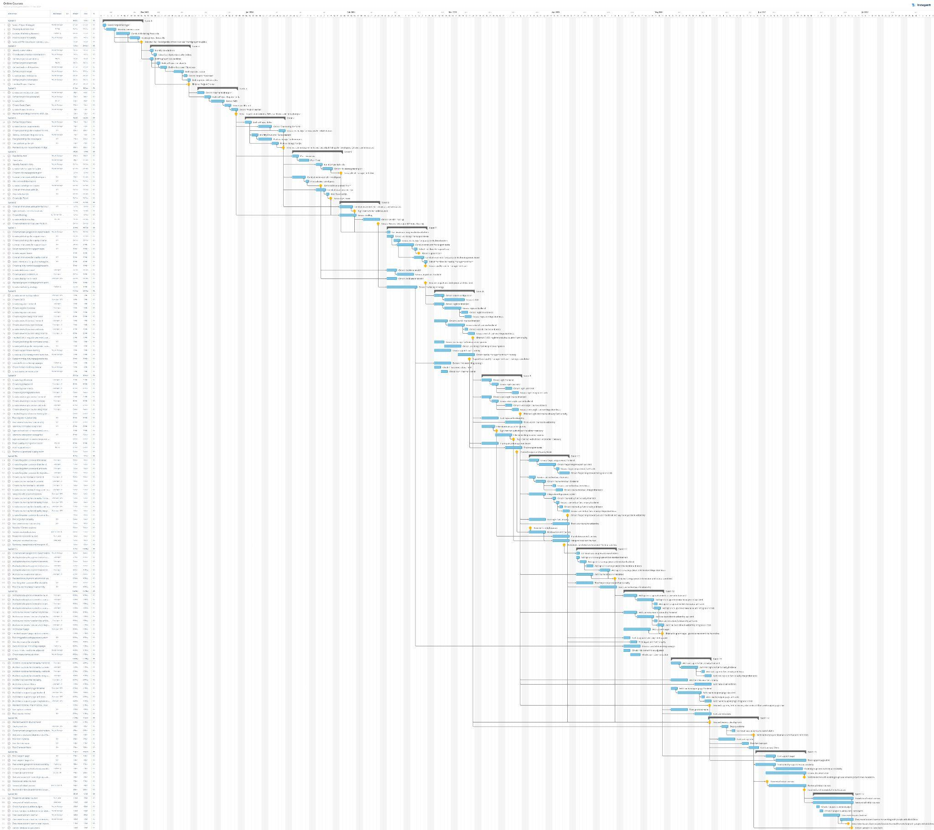

# Източници:

Works Cited

1. Aston, Ben. “Complete Project Charter Guide: Template, Examples, & How-To.” *The Digital Project Manager*, https://thedigitalprojectmanager.com/project-charter/. Accessed 15 November 2022.
2. “Choosing High Contrast Color Schemes For Low Vision.” *Veroniiiica*, 25 October 2019, https://veroniiiica.com/2019/10/25/high-contrast-color-schemes-low-vision/. Accessed 15 November 2022.
3. *Project Charter*. 2018. *Igor American River College*, ARC ONLINE 2.0, https://igor.arc.losrios.edu/Content/docs/ProjectCharters/2018-2019/ARC%20Online%202.0%20Project%20Charter.pdf.
4. “Project Deliverables Template Download | Project Management Templates.” *Techno-PM*, 24 April 2018, https://www.techno-pm.com/2018/04/project-deliverables-template.html. Accessed 20 December 2022.
5. “Project Requirements Gathering Template | Excel Template FREE.” *Stakeholdermap.com*, https://www.stakeholdermap.com/project-templates/requirements-template.html. Accessed 20 December 2022.
6. “Project Scope: Overview & Template | Adobe Workfront.” *Adobe Experience Cloud*, 18 March 2022, https://business.adobe.com/blog/how-to/project-scope. Accessed 20 December 2022.
7. Spagnola, Whitney. “Making online learning accessible for deaf students.” *Hearing Like Me*, 17 March 2020, https://www.hearinglikeme.com/online-learning-for-deaf-students/. Accessed 15 November 2022.
8. “The What, Why, and How of Project Requirements.” *Project Risk Coach*, https://projectriskcoach.com/the-what-why-and-how-of-project-requirements/. Accessed 20 December 2022.
9. Windsor, Grace. “How to Identify and Gather Project Requirements.” *BrightWork.com*, 21 February 2022, https://www.brightwork.com/blog/project-requirements. Accessed 20 December 2022.
10. Zabala, Ignacio. “Stakeholder Analysis using the Power Interest Grid.” *ProjectManagement.com*, https://www.projectmanagement.com/contentPages/wiki.cfm?ID=368897&thisPageURL=/wikis/368897/Stakeholder-Analysis--using-the-Power-Interest-Grid#_=_. Accessed 20 December 2022.