2010-6-4 Geometry Quickie by kmh

Let c be a circle and P be some point outside of it. The two tangents from P on c, touch c in A and B and |PA|=|PB|=10 cm. Now let C be an arbitrary point on the arc AB (the smaller arc close to P). The tangent on c at C intersects the tangent segments PA and PB in Q and R. Determine the perimeter of the triangle  PQR.

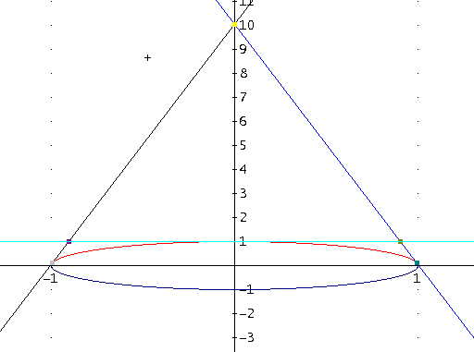

We define two points that lie on the circle, A and B:

$$A\left(\cos\left(π-a\right),\sin\left(π-b\right)\right) \\ B\left(\cos\left(a\right), sin⁡(b)\right)$$

We also define another point P that is outside the circle, and such that |PA|=|PB|=10 cm

$$P(?, ?)$$

Because the tangent is $0<x<π$ we are free to work with a semi-circle. The function for a full circle is $x^{2}+ y^{2}=1$. From this, we derive the upper half of the circle which is $f\left(x\right)= sqrt(1-x^{2})$.

The equation of a tangent of a line at a given point $Z\left(x_{0},y_{0}\right)$ is given by $y-y_{0}=f^{'}\left(x_{0}\right)\left(x-x_{0}\right).$

We can now use this function for both A and B and solve the system to find where the 2 tangents intercept (i.e. find P).

$$\left\{\begin{aligned}y-\sin\left(π-b\right)=f^{'}\left(\cos\left(π-a\right)\right)(x-\cos\left(π-a\right)) \\ y-\sin\left(b\right)=f^{'}\left(\cos\left(a\right)\right)(x-cos⁡(a))\end{aligned}\right.$$

By solving this system of 2 equations with 2 unknowns, we arrive at the following result:

$$x=0 ∧y=\frac{{\cos\left(a\right)}^{2}}{\left|sin⁡(a)\right|}+\sin\left(b\right)$$

This is our point P and its coordinates.

The reason why we need another system of 2 equations is that $d\left(A,P\right)= d\left(B,P\right)= 10$.

So we have:

$$\left\{\begin{aligned}\sqrt{{\left(\frac{cos{\left(a\right)}^{2}}{\left|sin⁡(a)\right|}\right)}^{2}+ {cos⁡(a)}^{2}}=10 \\ \sqrt{{\left(\frac{cos{\left(a\right)}^{2}}{\left|sin⁡(a)\right|}\right)}^{2}+{\cos\left(π-a\right)}^{2}}=10\end{aligned}\right.$$

The system gives out 6 solutions total:

$$a = - \tan^{-1}{(1/10)} - π$$

$$a = \tan^{-1}{(1/10)} - π$$

$$a = - \tan^{-1}{(1/10)}$$

$$a = \tan^{-1}{(1/10)}$$

$$a = π- \tan^{-1}{(1/10)}$$

$$a = \tan^{-1}{(1/10)}+ π$$

I picked $a =\tan^{-1}{(1/10)}$ to work with. So it follows that $b =\tan^{-1}{(1/10)}$ from the previous definition of f(x). To get the points Q and R, plug in the variables to get the points where the slopes (equation of tangent lines) intercept with y=1:

$$Q(\frac{1}{10} -\frac{\sqrt{101}}{10}, 1)$$

$$R(\frac{\sqrt{101}}{10} -\frac{1}{10}, 1)$$

$$C(0, \sqrt{101})$$

By applying Pythagorean’s distance formula $\sqrt{ {\left(x_{1}-x_{0}\right)}^{2}+ {\left(y_{1}-y_{0}\right)}^{2}}$ on QR, QC, and RC, and summing all three equations, we get **20** as the final answer.

Solved by Sitnikovski Boro 15.06.2010