Level | Experience Table
1 to 8 | 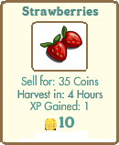  Strawberries Stats: 2.50 Gold/h, 0.50 XP/h
8 to 17 | 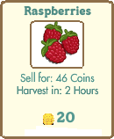  Raspberries Stats: 5.50 Gold/h, 0.50 XP/h
17 to 29 | 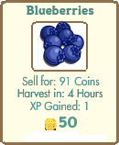  Blueberries Stats: 6.50 Gold/h, 0.50 XP/h
29 to end | 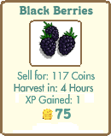  Black Berries Stats: 6.75 Gold/h, 0.50 XP/h

Level | Gold Table
1 to 7 | Strawberries Stats: 2.50 Gold/h, 0.50 XP/h
7 to 8 | 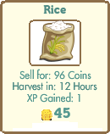  Rice Stats: 3.00 Gold/h, 0.17 XP/h
8 to 17 | Raspberries Stats: 5.50 Gold/h, 0.50 XP/h
17 to 20 | Blueberries Stats: 6.50 Gold/h, 0.50 XP/h

20 to 31 | 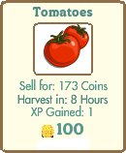  Tomatoes Stats: 7.25 Gold/h, 0.25 XP/h
31 to 34 | 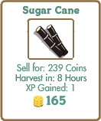  Sugarcane Stats: 7.38 Gold/h, 0.25 XP/h
34 to 37 | 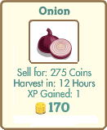  Onion Stats: 7.50 Gold/h, 0.17 XP/h
37 to end | 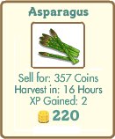  Asparagus Stats: 7.63 Gold/h, 0.19 XP/h

Seed Price and Experience Listing
Written by Sitnikovski Boro (Ситниковски Боро)
(http://www.facebook.com/sitnikovski/, bornull@hotmail.com)
If you would like to contact me please use the e-mail address above. If you want to know how I calculated these numbers - very simple. The formulas are as follows:
Experience Formula: Experience for Plowing (1) plus XP Gain from the Seed (a), divided by Hours.
E(a)=(1+a)/h
Gold Formula: Gold Gain (a) minus the Seed Cost (b) minus 15 for plowing, divided by Hours.
G(a,b) = (a-b-15)/h
How did I determine which seed is useful for which level? Simple, I created a C program where you can enter the price of many seeds. The program will then use the formulas above to calculate the XP/Gold gain from each seed and will then display the results. After this the program will do some sorting which will tell you which is the best seed to use. The program (which includes the source code and this document) can be downloaded from http://boro.dcmembers.com/farmville.zip.
I started playing on 07.09.2009, and by following my very own guide, for just 4 days I am level 21, have the greatest possible farm in size, I have about 50 Lime Trees, and many other trees and animals.
11.09.2009 (UPDATE: 14.09.2009, 18.10.2009)

