Atakan Yılmaz - 0078906

Bora Aktaş - 0071461

**INDR 422/522 HOMEWORK 1**

**1.a.**

The figure of the time series data and the corresponding autocorrelation plot is given below.

By a simple visual inspection on the time series data seems to be no apparent trend. We inspected the autocorrelation plot to identify whether the data has any seasonality. It appears there exists significant decaying autocorrelation at lag 1,2,3,4 and 5.

**1.b.**

The following figure presents the error measurements and forecasts for naive one-month ahead model. The error measurements will be used as a benchmark in the following questions.

**1.c.**

The following figure presents the error measurements and forecasts for 5-period moving average (one-month ahead) model.

For every month of 2022, %95 prediction intervals (using RMSE) for 5-period moving average were calculated. The following figure depicts that the data is between the prediction intervals for every month of the year.

**1.d.**

An exhaustive search for the best smoothing constant (α) has been performed (for every α values between 0 and 1). The following figure depicts the comparison of several α values with respect to MAE, MAPE, MSE, RMSE measurements.

α = 1.00 has shown the best performance according to MSE values. As α=1 implies that the model is the same as naive-method, the error measurements are exactly the same with the forecasts in naive model. Yet, according to RMSE measurements, this model outperforms the 5-period moving average model. In the later parts of the question the comparison between this model will not be provided separately as it implies the naive method. The error measurements and forecasts for exponential smoothing with α=1 (one-month ahead) model is presented in the following figure.

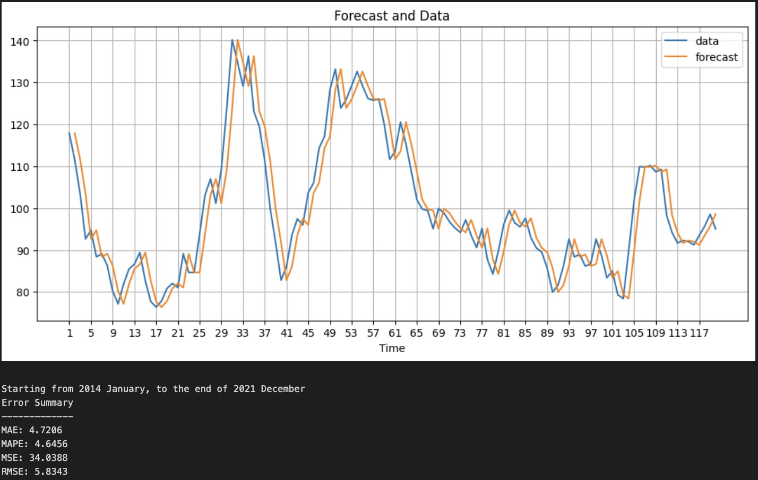

For every month of 2022, %95 prediction intervals (using RMSE) for exponential smoothing with α=1 (one-month ahead) model were calculated. The following figure depicts that the data is between the prediction intervals for every month of the year.

**1.e.**

The following figure presents the error measurements and forecasts for naive model that includes trends.

For every month of 2022, %95 prediction intervals (using RMSE) for naive model that includes trends were calculated. The following figure depicts that the data is between the prediction intervals for every month of the year.

RMSE figures seem to be higher than the benchmark (naive method). However, it performs better than the 5-period moving average model.

**1.f.**

The following figure presents the error measurements and forecasts for double exponential smoothing (one-month ahead) method with α = 0.5 and β = 0.1.

For every month of 2022, %95 prediction intervals (using RMSE) for double exponential smoothing (one-month ahead) method were calculated. The following figure depicts that the data is not between the prediction intervals for every month of the year. The model failed to produce the correct prediction intervals for 2 of the months.

RMSE figures seem to be higher than the benchmark (naive method) and naive method that includes trends. However, it performs better than the 5-period moving average model.

**1.g.**

An exhaustive search for the best smoothing constants (α, β) of double exponential smoothing (6-months ahead) method has been performed (for every α and β values between 0 and 1). The following figure depicts the comparison of several α, β values with respect to MAE, MAPE, MSE, RMSE measurements.

α = 0.79, β = 1.00 has shown the best performance according to RMSE value for the data between 2014-2021.

The following figure shows the predictions of the best double exponential smoothing (α = 0.79 , β = 1.00) for the next six months.

**1.h.**

The following figure depicts the comparison of several forecast methods with respect to MAE, MAPE, MSE, RMSE measurements.

As seen above, the naive method gives the best (minimum) RMSE value for the tea price index time series.

**2.a.**

500 time series data points are generated using AR-1 process with the given parameter settings. The following plot shows the data.

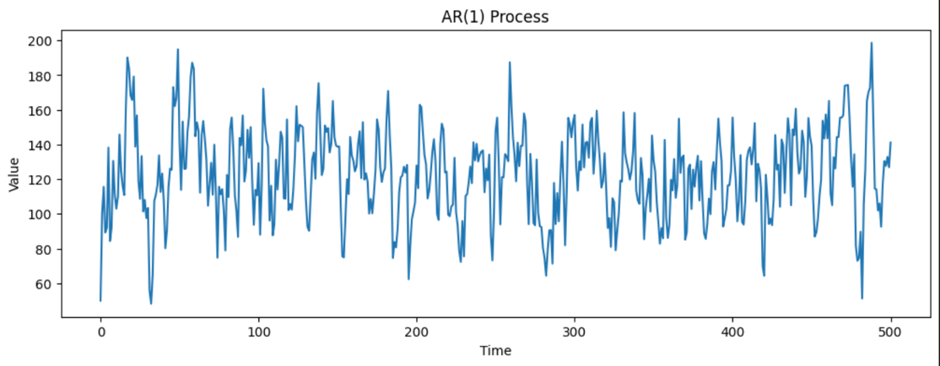

**2.b.**

The following plot shows the autocorrelation plot of the time series data. Positive autoregressive term in the first lag is apparent from the ACF plot. This is due to the decaying spikes starting from the first lag.

**2.c.**

Naive method has been applied to the data and RMSE is calculated. The following figure depicts both the forecasts vs. observations and the RMSE value (21.59).

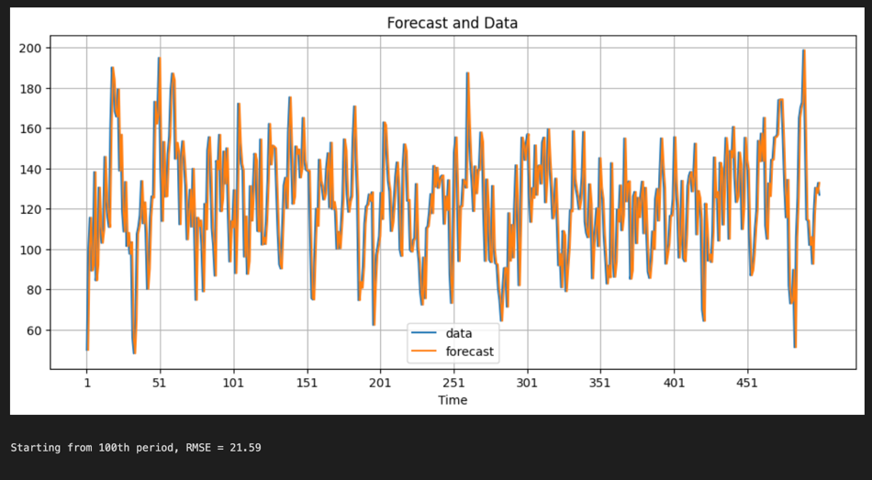

**3.a.**

The following plots show the autocorrelation plot and partial autocorrelation plot of the time series data.

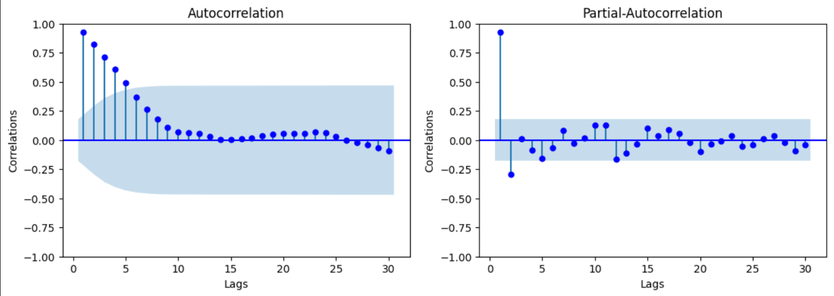

AR-1 process seems to be a valid hypothesis for the data. This is because the only significant spike at PACF is at lag 1 and in ACF spikes are decaying starting from lag 1.

**3.b.**

One level of differencing has been applied to the data. The following plots show the autocorrelation plot and partial autocorrelation plot of the differenced data.

Although the spikes at lags 1 are not as high as the original data (in both plots), one can try to fit MA-1 to the differenced data.

**3.c.**

Since ACF and PACF plots of the original data resembles a typical AR-1 process, ARIMA(1,0,0) model appears to be the best model. If we have enough computational power to try different models, we can try to fit ARIMA(0,1,1) as well.