
Practical Programming Assignment
Introduction to Programming IY499


Student Id:P444218
Student Name: Bora Bayrakci
Tutor: Marzieh Farahani
Table of Contents
Introduction 1
Requirements 2
Design Flowchart Diagram 3
Appendix A (Code listing) 8
Appendix B (ReadMe file) 12

Introduction
The Grouped Data Analysis program is a Python application designed to help users input a series of continuous numerical data values and analyze them by grouping into classes. The primary purpose of the program is to organize raw data into equal-width intervals (classes) and provide a statistical summary of the data distribution. The program’s main features include collecting data from the user, saving this data to a file, grouping the data into specified class widths, calculating key statistics (such as mean, median, mode, variance, etc.), and visualizing the distribution with a histogram. It is an interactive, menu-driven console application, which guides the user through each step of the analysis.
This program demonstrates several fundamental programming skills and concepts. It involves user input handling (with validation for numeric data), file handling (writing to and reading from CSV files), data processing and grouping (using loops and library functions to bin continuous data into classes), and computing statistical measures (leveraging Python’s statistics module for mean, median, mode, variance, etc.). Additionally, the program uses external libraries like pandas and NumPy for data manipulation, and matplotlib for generating a histogram. The use of a menu system and modular functions illustrates structured programming practices, making the code organized and maintainable.

Requirements
The functional requirements of the Grouped Data Analysis program are outlined as follows in plain language:
- User Data Input: The program shall prompt the user to input numerical data (a series of continuous numeric values, e.g. measurements or scores).
- Saving Data to CSV: The program shall save the user-entered data into a CSV file named data.csv for persistent storage of the raw data.
- Loading Data from CSV: The program shall be able to read the data back from data.csv, allowing the user to reload previously entered data for analysis.
- Grouping Data into Classes: The program shall group the numeric data into classes (intervals) for frequency distribution analysis, where the class width (the size of each interval) is specified by the user. Each class groups data values that fall into a specific range, enabling further statistical calculations.
- Visual Histogram: The program shall show from what has been saved on CSV file.
(Additional context: Beyond these core requirements, the program also computes summary statistics for the grouped data (mean, median, mode, modal class, variance, standard deviation) and displays the grouped data in a tabular form. It saves the results in separate CSV files and generates a histogram for visualization. These features are integral to the program’s objective but are implicitly covered by the broader requirement of data analysis.)*

Design Flowchart Diagram

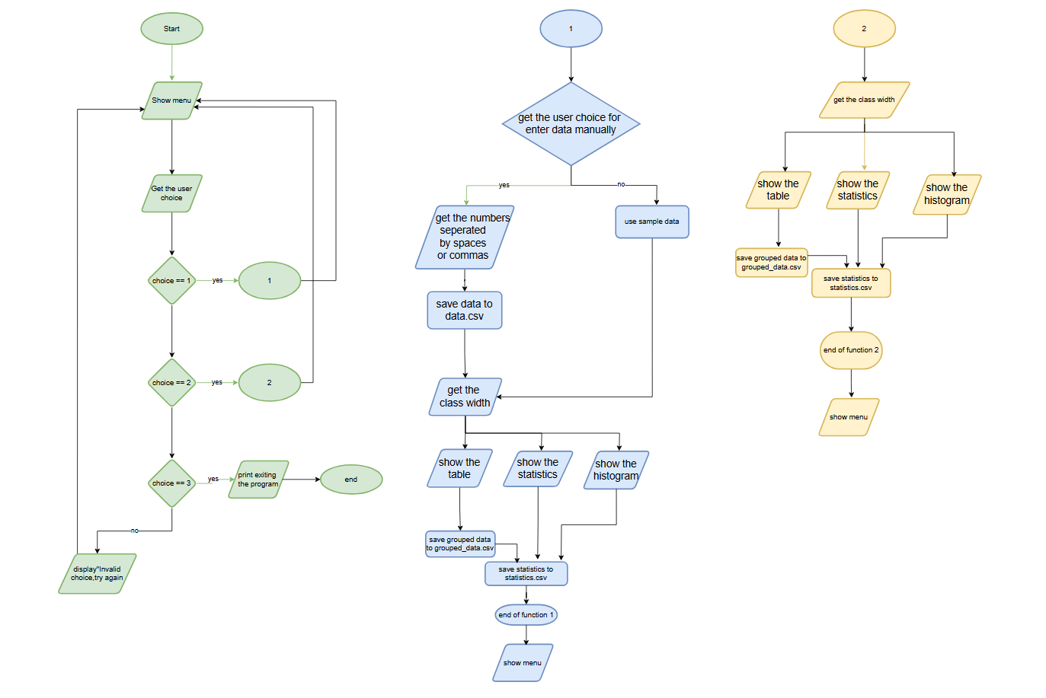
Testing Guide (User Manual Style)
This section provides a step-by-step testing guide for key features of the program. Each subsection below presents a scenario in a user-oriented manner, including the objective of the test, the steps to perform, the expected outcome, and a placeholder for a screenshot of the program’s output in that scenario. The testing is done in a console environment (terminal or command prompt), as the program is text-based and interactive.
1.Library Installation: Install the required libraries using pip. Open a terminal and run:
(The statistics module is included in Python’s standard library, so no separate installation is needed for it.)

2. Running the Program
Objective: Verify that the program launches correctly and presents the main menu to the user. This ensures the application is installed properly and ready to accept commands.
Steps:
- Open a terminal or command prompt on your system.
- Navigate to the directory containing the dataCollector.py program file.
- Run the program by typing the command:
(If Python 3 is required explicitly, use python3 dataCollector.py.)
- Press Enter to execute the command.
Expected Result: The program should start without errors and display a welcome banner or title (e.g., “=== Grouped Data Analysis ===”) followed by a main menu with options. The menu should list options such as 1. Enter Data, 2. Load Data from CSV, and 3. Exit. The console will be waiting for the user to input one of these option numbers.
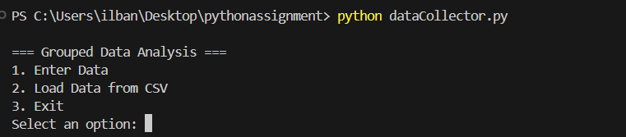
Screenshot: The console displaying the program’s title and main menu options upon launching.
3. Getting Data from the User
Objective: Test the program’s ability to accept numerical input from the user and handle the input correctly. This confirms that the data entry function works and that validation is in place for empty or invalid inputs.
Steps:
- At the main menu prompt (after running the program, as in the previous test), type 1 and press Enter to select “Enter Data”.
- The program will ask: “Do you want to enter data manually? (yes/no):” – Type yes and press Enter to indicate you will input data.
- When prompted “Enter numbers separated by spaces or commas:”, input a series of numerical values. For example, type:
(You can enter any set of numbers, separated by commas or spaces. In this example, five sample numbers are provided.)
- Press Enter to submit the numeric data input.
- If the input is not empty and all values are valid numbers, the program will accept the data. (If the input was empty or contained non-numeric text, the program would display an error message and prompt again, but that is not the case in this valid input scenario.)
Expected Result: The program should display a confirmation that the data has been received and stored. Specifically, it should print a message indicating the data was saved (e.g., “Raw data appended to raw_data.csv” or similar confirmation). The list of numbers entered may also be echoed or mentioned. After this, the program will proceed to the next step, usually asking the user to “Enter class width:” for grouping the data (which leads into the data grouping functionality). At this stage, we have confirmed that the user input is successfully captured.
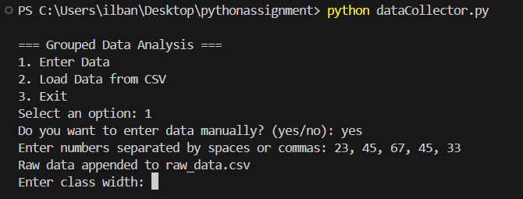
Screenshot: After entering a series of numbers, the program confirms the data is recorded and prompts for the class width for grouping.
4. Saving Data into a CSV File
Objective: Ensure that the program correctly saves the user’s input data into a CSV file, and subsequently performs grouping of data into classes as expected. This test confirms file-writing functionality and data persistence, as well as the grouping operation triggered by specifying a class width.
Steps:
- Perform the data entry as in the previous test (enter option 1, confirm manual input, provide numerical values). Use a sample dataset if needed (e.g., 23, 45, 67, 45, 33 as before).
- After confirming the data is accepted, the program asks for a class width. Enter a suitable numeric value for the class width (for example, type 10 and press Enter, to group the data in intervals of size 10).
- The program will now group the data into classes of width 10 and proceed to save the results. It will create or update a file named data.csv (the raw data file) with the values entered, and generate a grouped data table along with statistics. The grouped frequency distribution is typically saved to grouped_data.csv, and the statistical measures are saved to statistics.csv.
- To verify the saving, you can open the file data.csv in a text editor or use a quick command (such as type data.csv in Windows or cat data.csv in Linux/Mac terminal) to view its contents. Also, checking for the existence of grouped_data.csv and statistics.csv after running the grouping will confirm that results were saved.
Expected Result: The original data file (data.csv) should contain the numbers that were entered, each value recorded (typically one per line under a “Data” column, since it’s a CSV format). The program should also display a frequency distribution table in the console, showing the classes (interval ranges) and the frequency of data points in each class, along with the midpoint of each class and the frequency multiplied by midpoint. A message like “Grouped data saved to grouped_data.csv” will be printed, indicating that the grouped results have been written to file. Similarly, the console will list the descriptive statistics (Mean, Median, Mode, Modal Class, Variance, Standard Deviation) computed from the data, and a message “Statistics saved to statistics.csv” confirms that these are saved. Finally, a histogram will pop up in a window, illustrating the frequency distribution of the data (each bar centered at class midpoints). After reviewing, the user can close the histogram window. All entered data and results are now safely stored in CSV files for further reference.
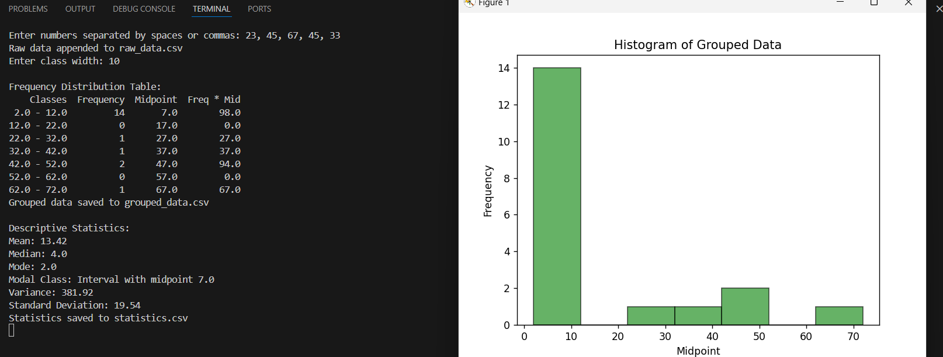
Screenshot: The program outputs the frequency distribution table and statistics after grouping the data (with class width 10), and confirms that CSV files have been saved. The histogram window (not shown in text) would display the distribution graphically.

Appendix A (Code listing)
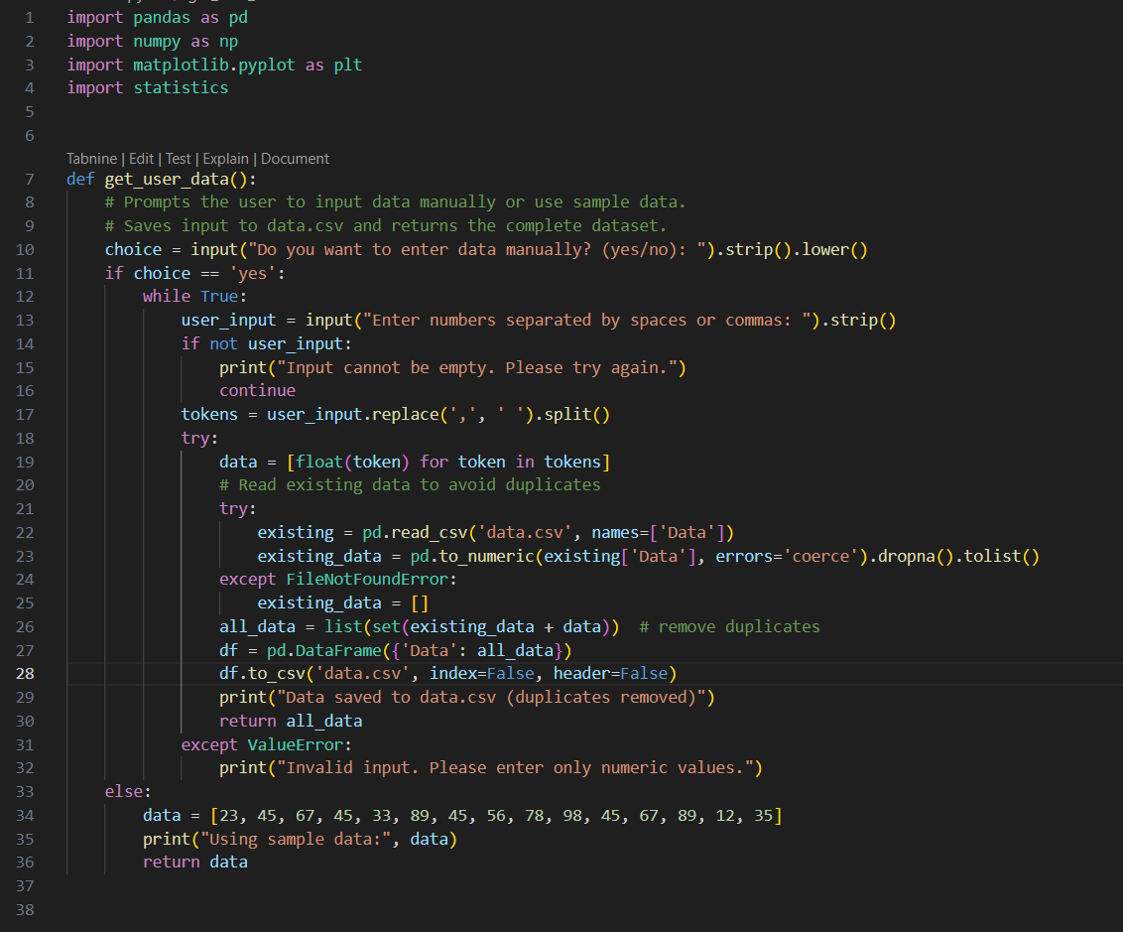
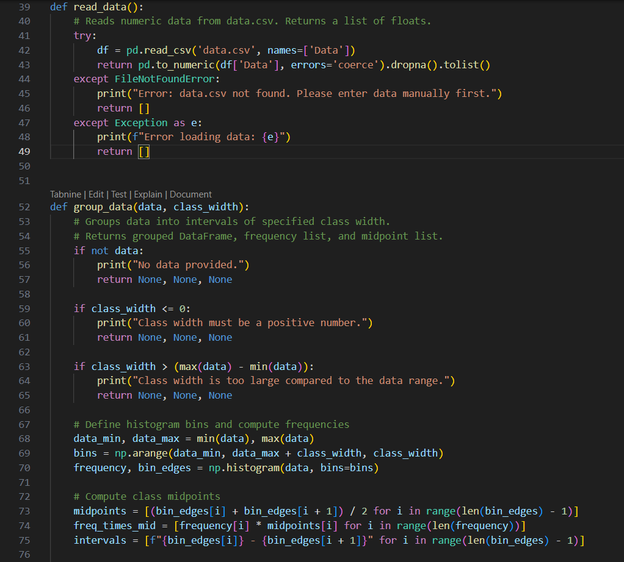
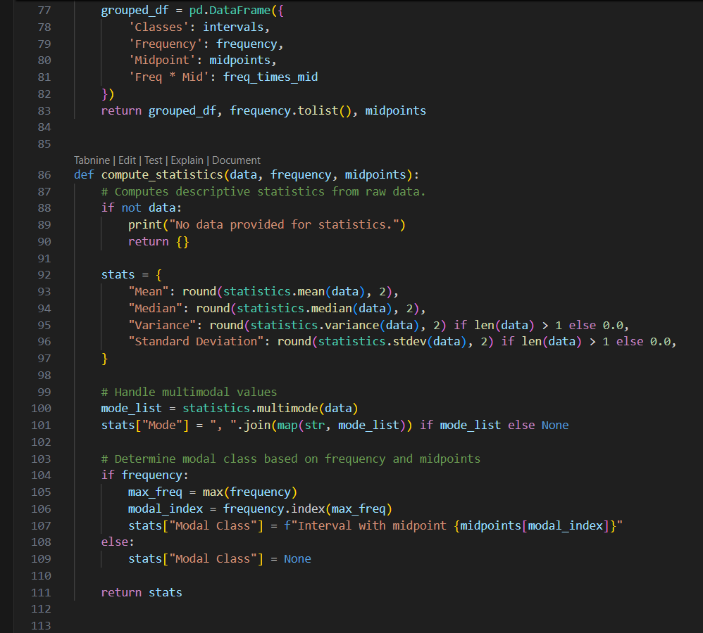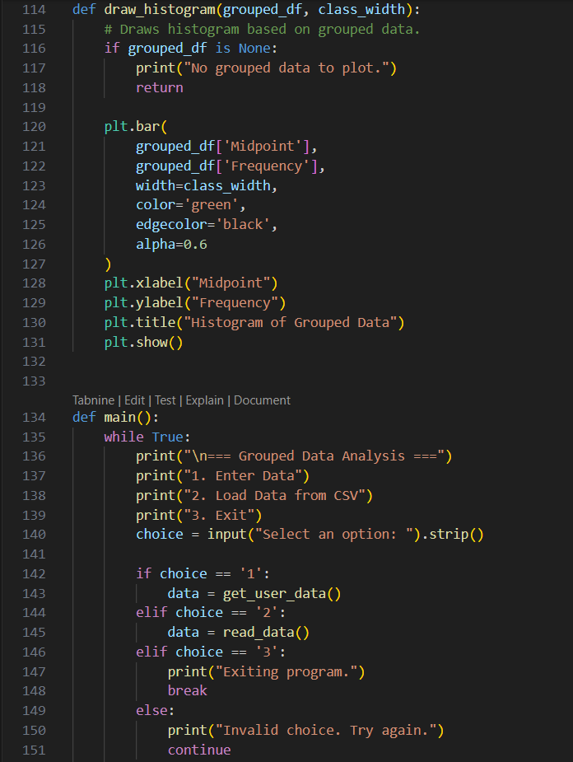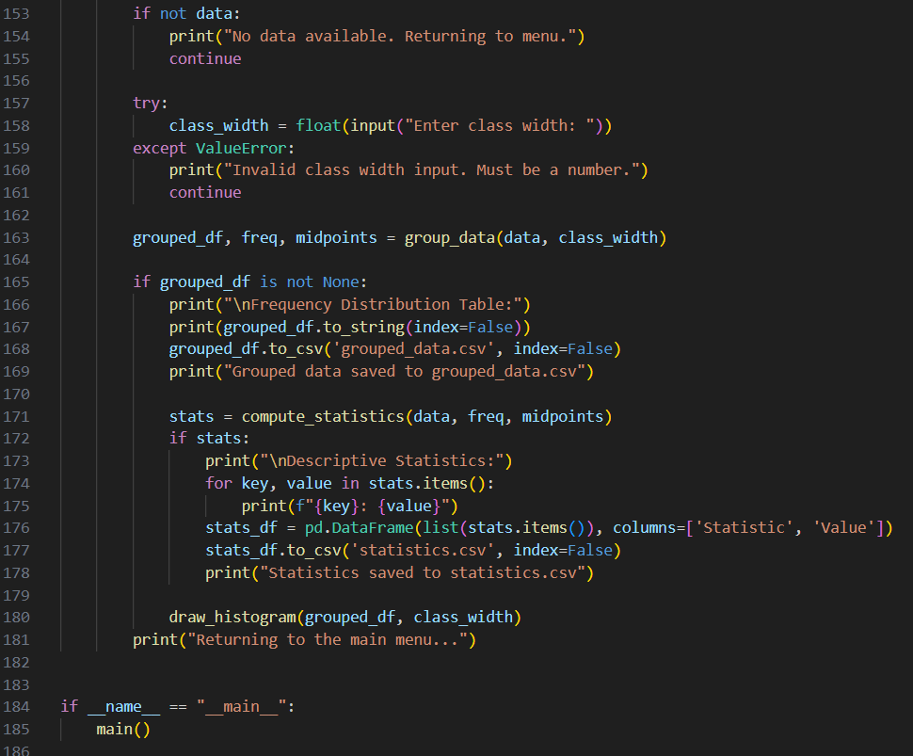

Appendix B (ReadMe file)
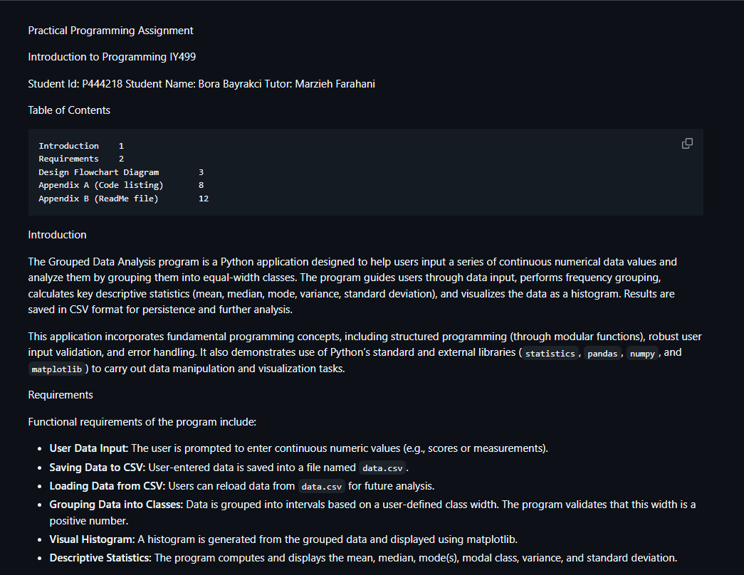
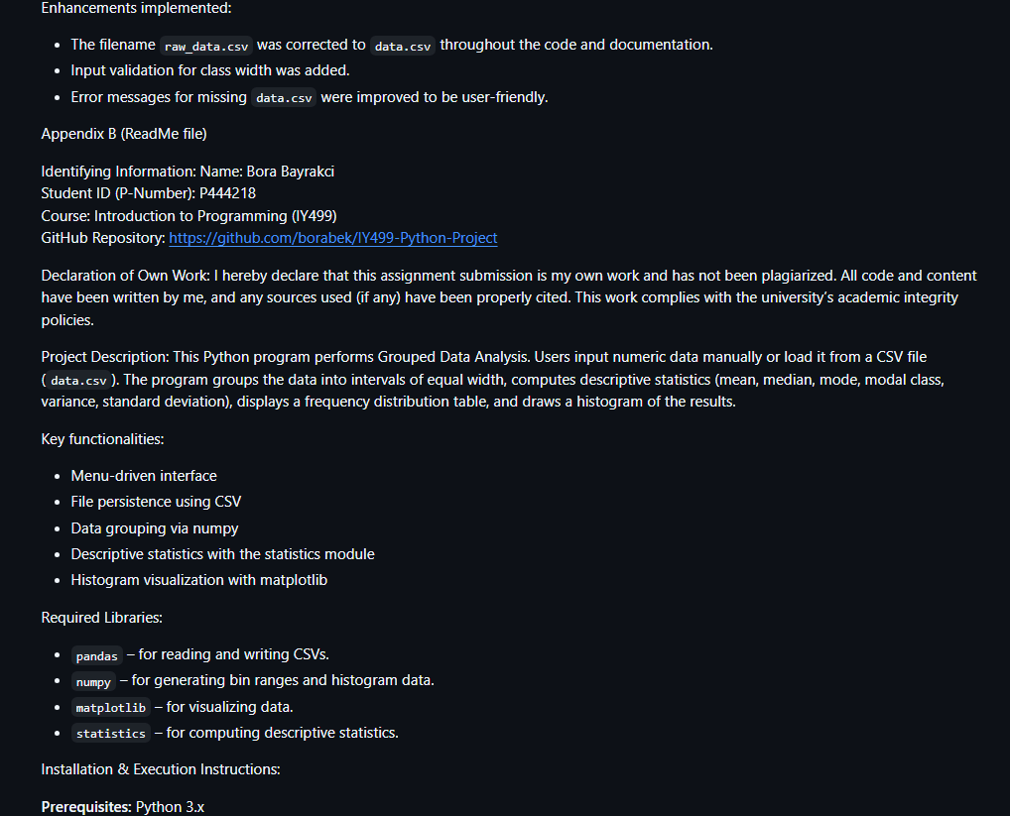
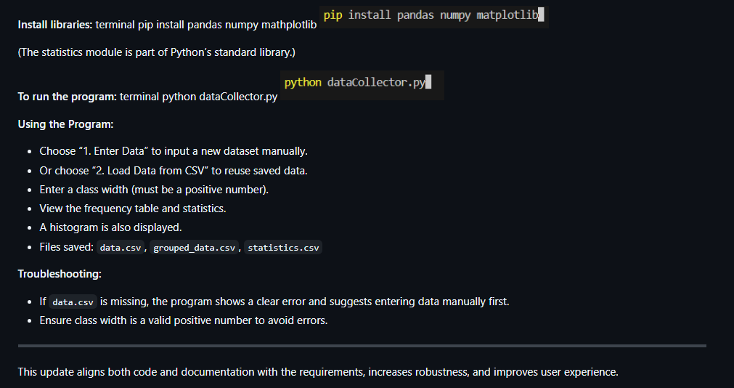

Practical Programming Assignment

Introduction to Programming IY499

Student Id: P444218
Student Name: Bora Bayrakci
Tutor: Marzieh Farahani

Table of Contents

Introduction 1
Requirements 2
Design Flowchart Diagram 3
Appendix A (Code listing) 8
Appendix B (ReadMe file) 12

Introduction

The Grouped Data Analysis program is a Python application designed to help users input a series of continuous numerical data values and analyze them by grouping them into equal-width classes. The program guides users through data input, performs frequency grouping, calculates key descriptive statistics (mean, median, mode, variance, standard deviation), and visualizes the data as a histogram. Results are saved in CSV format for persistence and further analysis.

This application incorporates fundamental programming concepts, including structured programming (through modular functions), robust user input validation, and error handling. It also demonstrates use of Python’s standard and external libraries (`statistics`, `pandas`, `numpy`, and `matplotlib`) to carry out data manipulation and visualization tasks.

Requirements

Functional requirements of the program include:

- **User Data Input:** The user is prompted to enter continuous numeric values (e.g., scores or measurements).
- **Saving Data to CSV:** User-entered data is saved into a file named `data.csv`.
- **Loading Data from CSV:** Users can reload data from `data.csv` for future analysis.
- **Grouping Data into Classes:** Data is grouped into intervals based on a user-defined class width. The program validates that this width is a positive number.
- **Visual Histogram:** A histogram is generated from the grouped data and displayed using matplotlib.
- **Descriptive Statistics:** The program computes and displays the mean, median, mode(s), modal class, variance, and standard deviation.

Enhancements implemented:

- The filename `raw_data.csv` was corrected to `data.csv` throughout the code and documentation.
- Input validation for class width was added.
- Error messages for missing `data.csv` were improved to be user-friendly.

Appendix B (ReadMe file)

Identifying Information:
Name: Bora Bayrakci
Student ID (P-Number): P444218
Course: Introduction to Programming (IY499)
GitHub Repository: https://github.com/borabek/IY499-Python-Project

Declaration of Own Work:
I hereby declare that this assignment submission is my own work and has not been plagiarized. All code and content have been written by me, and any sources used (if any) have been properly cited. This work complies with the university’s academic integrity policies.

Project Description:
This Python program performs Grouped Data Analysis. Users input numeric data manually or load it from a CSV file (`data.csv`). The program groups the data into intervals of equal width, computes descriptive statistics (mean, median, mode, modal class, variance, standard deviation), displays a frequency distribution table, and draws a histogram of the results.

Key functionalities:
- Menu-driven interface
- File persistence using CSV
- Data grouping via numpy
- Descriptive statistics with the statistics module
- Histogram visualization with matplotlib

Required Libraries:
- `pandas` – for reading and writing CSVs.
- `numpy` – for generating bin ranges and histogram data.
- `matplotlib` – for visualizing data.
- `statistics` – for computing descriptive statistics.

Installation & Execution Instructions:

**Prerequisites:** Python 3.x

**Install libraries:**
terminal
pip install pandas numpy mathplotlib

(The statistics module is part of Python’s standard library.)

**To run the program:**
terminal
python dataCollector.py
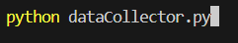
**Using the Program:**
- Choose “1. Enter Data” to input a new dataset manually.
- Or choose “2. Load Data from CSV” to reuse saved data.
- Enter a class width (must be a positive number).
- View the frequency table and statistics.
- A histogram is also displayed.
- Files saved: `data.csv`, `grouped_data.csv`, `statistics.csv`

**Troubleshooting:**
- If `data.csv` is missing, the program shows a clear error and suggests entering data manually first.
- Ensure class width is a valid positive number to avoid errors.

--

This update aligns both code and documentation with the requirements, increases robustness, and improves user experience.

