





Computer Engineering Program

CNG 300

SUMMER PRACTICE REPORT

Name of Student:
ID Number:
Name of Company:
Project Title: Linux System Administration and Database Management in DevOps Environments
Date of Submission: 10/11/2025

Abstract
……..

Table of Contents
1 4
- INTRODUCTION 5
- PROBLEM STATEMENT 6
- SOLUTIONS 6
  - Linux 7
    - SQL 7
    - Bash 8
  - INSTALLING MYSQL 8
    - Install & start 8
    - Secure the fresh instance 9
    - First look inside MySQL 9
    - Why this setup mattered 11
  - SQL Problem-Solving in Practice 11
    - Servers with consistently slow backups 11
    - Largest tables in each schema 12
    - Schemas that missed a successful backup in 24 hours 12
    - Replica and primary version drift 13
  - Read replicas 14
    - Why we run with replicas 14
    - What we look at in cluster status 14
    - Illustrative cluster status 15
    - What each field told us and why we check it 16
    - How we validated the setup 16
  - Backup, restore, and automation 16
    - Daily logical backup 17
    - Restore into a clean schema 17
    - Sanity checks right after restore 18
    - Schedule the job and rotate, and log housekeeping 18
    - MongoDB snapshot and restore 19
    - MongoDB quick checks 19
CONCLUSION 20
REFERENCES 22

Table of Figures
Figure 1: Local MySQL installation 8
Figure 2: Security of a MySQL 9
Figure 3: MySQL Command Line Client on macOS showing default system schemas. 10
Figure 4: Servers with slow backups 11
Figure 5: Largest tables per schema 12
Figure 6: Missed backups in last 24h 13
Figure 7: Replica/primary version drift 13
Figure 8: Primary–replica database replication (single-primary) 14
Figure 9: MySQL cluster status 15
Figure 10: Daily backup script 17
Figure 11: Test restore 18
Figure 12: Sanity checks 18
Figure 13: Cron entry 18
Figure 14: MongoDB snapshot & restore 19
Figure 15: MongoDB sanity checks 19

ABC Teknoloji Bilişim Çözümleri A.Ş.
………………

Introduction
…………………………………

Problem Statement
……………………………………………………….

Solutions
This section describes the systems and tasks I worked with during my internship, including their significance and how I approached them in practice. Where com-pany policy applies, the information is presented in a generalized form (without internal paths, configurations, or proprietary code).

Linux
………………………………………………………….

SQL
…………………………………………………………..

Bash
…………………………………………

Installing MySQL
…………………………………….

Install & start
…………….………………………….

Secure the fresh instance
………………………………….

First look inside MySQL
…………………………………

Why this setup mattered
…………..

SQL Problem-Solving in Practice
……………………

Servers with consistently slow backups
…………………………

Largest tables in each schema
…………………….

Schemas that missed a successful backup in 24 hours
……………………………

Replica and primary version drift
……………………………………

Read replicas
We worked with a primary database that takes all writes and several replicas that stay read-only……………………………..
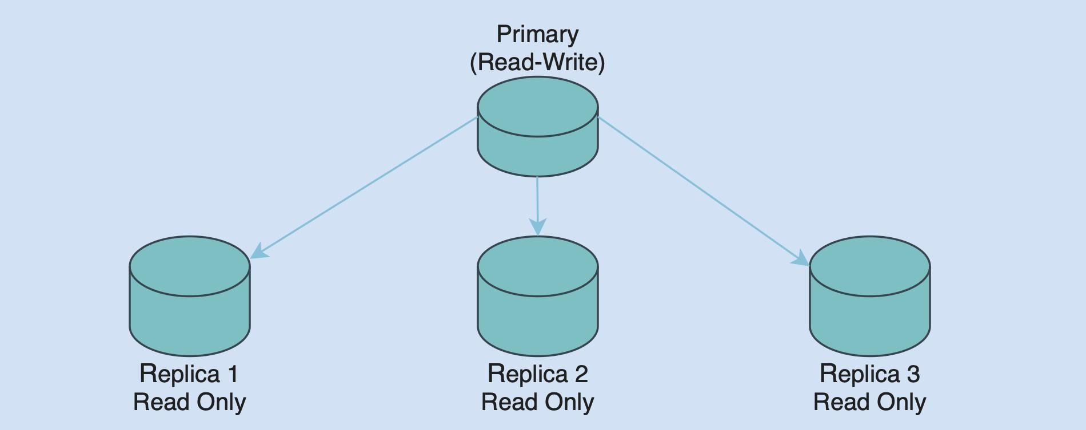
Figure 8: Primary–replica database replication (single-primary).

Why we run with replicas
………………………..

What we look at in cluster status
…………………………….

Illustrative cluster status
………………………….

What each field told us and why we check it.
…………………………………..

How we validated the setup
……………………………………..

Backup, restore, and automation
………………………………….

Daily logical backup
………………………………………….

Restore into a clean schema
………………………

Sanity checks right after restore
……………………………….

Schedule the job and rotate, and log housekeeping
………………………………….

MongoDB snapshot and restore
…………………………………………………

MongoDB quick checks
……………………………………………….

Conclusion
This summer practice focused on two things that………………………

I installed MySQL locally with Homebrew,............................

The main contribution was turning these pieces into a repeatable workflow:
………………………….

End result: …………………………..

Gains were both technical and judgment-oriented………………………………

References
- Rocky Linux Project. (n.d.). Rocky Linux documentation. https://docs.rockylinux.org/
- Red Hat, Inc. (n.d.). Red Hat Enterprise Linux system administration guide. https://access.redhat.com/documentation/en-us/red_hat_enterprise_linux/
- Oracle Corporation. (n.d.). MySQL documentation – What is MySQL?
https://dev.mysql.com/doc/refman/8.0/en/what-is-mysql.html
- Oracle Corporation. (n.d.). MySQL InnoDB and ACID properties. https://dev.mysql.com/doc/refman/8.0/en/innodb-introduction.htm l
- Free Software Foundation. (n.d.). GNU Bash manual. https://www.gnu.org/software/bash/manual/
- HackerRank. (n.d.). SQL.
HackerRank. https://www.hackerrank.com/domains/sql

