Name -Rushil Borad

Enroll No- AU1940179

Description:

2(a)

1)Round Robin algorithm:

Round robin is a CPU scheduling algorithm that is designed especially for time sharing systems. It is more like a FCFS scheduling algorithm with one change that in Round Robin processes are bounded with a quantum time size.

Also known as time slicing, because each process is given a slice of time before being preempted.

Clock interrupt is generated at periodic intervals.

When an interrupt occurs, the currently running process is placed in the ready queue and the next ready job is selected on FIFO basis.

Algorithm:

* We first have a queue where the processes are arranged in FIFO order.
* A quantum value is allocated to execute each process.
* The first process is executed until the end of the quantum value. After this, an interrupt is generated and the state is saved.
* The CPU then moves to the next process and the same method is followed.
* Same steps are repeated till all the processes are over.

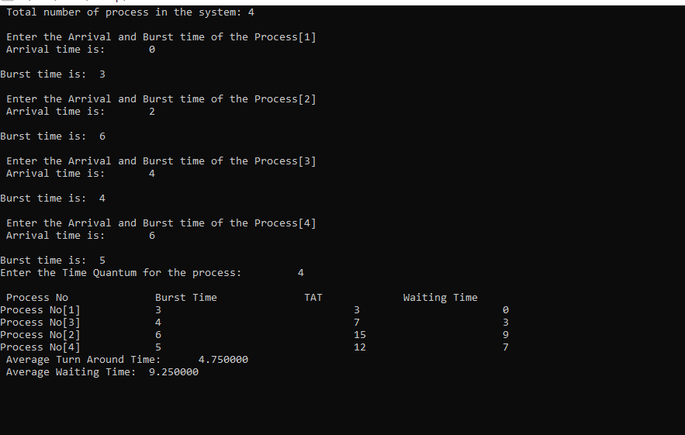

2)Modified Round Robin:

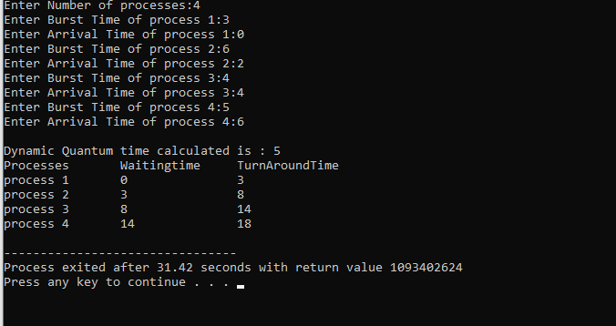

Modified Round robin CPU scheduling algorithm which will perform better than current round robin algorithm and, in most cases, better than other algorithms as well in terms of minimizing average waiting time, average turnaround time and number of context switches.

CPU Scheduling Algorithm centers around enhancing more on the enhanced Round Robin CPU scheduling algorithm.

The algorithm diminishes the waiting up time and turnaround time definitely contrasted with the basic Round Robin.

This proposed calculation works comparably as yet with some adjustment.

Comparison:

The proposed algorithms actively monitor the burst time of the executing processes and updates the TQ accordingly. Therefore, it overcomes all the drawbacks of the RR algorithm as the proposed algorithm has lesser context switches, lesser turnout and waiting time. This will help to improve the performance of the system.