No OS Experiment
NoOSE

by Rob J Ronda

Forge Reality

all rights reserved
© 2020 rob j ronda

published by BorAdnor::Technologies using Lulu.com

Content
Preface 2
Bring/Fetch your project to GitHub 6
Install VirtualBox 9
Install Ubuntu bionic minimal on VirtualBox on your host Windows PC 9
Linux kernel Background 10
Linux.img as C programming environment 17
First init.o 19
NoOSE as second harddisk for a VirtualBox VM 19
Eind Text 20

Preface
This project started as an experiment to see if a program can be constructed “Without an OS”. The issue is the definition “without an OS”.
It is possible to boot your own program and start from there. This means all devices available on the hardware must be initialized and for each device a driver must be constructed if you want you program to have any meaning.
On the other hand Linux is freely available and one can fetch a source and start to strip away all unnecessary parts.
First you can look into LFS or DSL but still a large effort has to be taken before the larger part of linux is disabled to speak of a “No OS Solution”.
Is it possible to boot Linux and then run your program in some standalone situation. Searching for this on Internet came up with an interesting idea:
- Search 'stop linux kernel and delegate control to single program':
  - https://www.cs.rutgers.edu/~pxk/419/notes/access.html
  - https://nixos.org/manual/nixos/stable/index.html#preface
- Search ‘Linux single user system’:
  - https://lwn.net/Articles/631853/
  - https://access.redhat.com/documentation/en-us/red_hat_enterprise_linux/5/html/installation_guide/s1-rescuemode-booting-single
- Search ‘linux run single application’:
  - https://unix.stackexchange.com/questions/61601/linux-os-running-a-single-application
look at LFS.
http://www.linuxfromscratch.org/
Take a look at DSL(Damn Small Linux).

- Search ‘Linux: single program’:
  - https://unix.stackexchange.com/questions/122717/how-to-create-a-custom-linux-distro-that-runs-just-one-program-and-nothing-else
Minimal init hello world program step-by-step
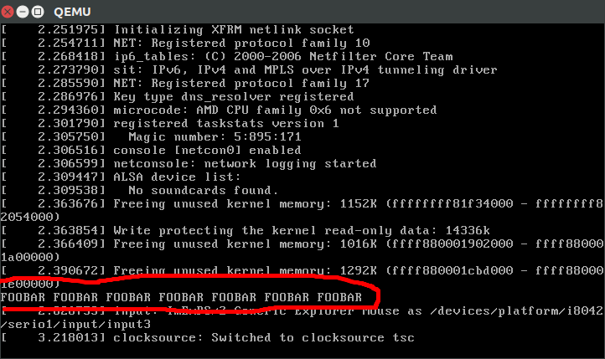
Compile a hello world without any dependencies that ends in an infinite loop. init.S:
.global _start
_start:
mov $1, %rax
mov $1, %rdi
mov $message, %rsi
mov $message_len, %rdx
syscall
jmp .
message: .ascii "FOOBAR FOOBAR FOOBAR FOOBAR FOOBAR FOOBAR FOOBAR\n"
.equ message_len, . - message
We cannot use the exit system call, or else the kernel panics, the only way to exit gracefully from the init is to poweroff the machine with the reboot syscall.
Then:
mkdir d
as --64 -o init.o init.S # assemble
ld -o d/init init.o # link
cd d
find . | cpio -o -H newc | gzip > ../rootfs.cpio.gz
ROOTFS_PATH="$(pwd)/../rootfs.cpio.gz"
This creates a filesystem with our hello world at /init, which is the first userland program that the kernel will run. We could also have added more files to d/ and they would be accessible from the /init program when the kernel runs.
Then cd into the Linux kernel tree, build is as usual, and run it in QEMU:
git clone git://git.kernel.org/pub/scm/linux/kernel/git/torvalds/linux.git
cd linux
git checkout v4.9
make mrproper
make defconfig
make -j"$(nproc)"
qemu-system-x86_64 -kernel arch/x86/boot/bzImage -initrd "$ROOTFS_PATH"
And you should see a line:
FOOBAR FOOBAR FOOBAR FOOBAR FOOBAR FOOBAR FOOBAR
on the emulator screen! Note that it is not the last line, so you have to look a bit further up.
You can also use C programs if you link them statically:
#include <stdio.h>
#include <unistd.h>

int main() {
printf("FOOBAR FOOBAR FOOBAR FOOBAR FOOBAR FOOBAR FOOBAR\n");
sleep(0xFFFFFFFF);
return 0;
}
with:
gcc -static init.c -o init
Dynamic linking would require setting up a the dynamic linker executable, the most common of which are part of C standard libraries like glibc.
You can run on real hardware with a USB on /dev/sdX and:
make isoimage FDINITRD="$ROOTFS_PATH"
sudo dd if=arch/x86/boot/image.iso of=/dev/sdX
Great source on this subject: Tech Tip: How to use initramfs | landley.net It also explains how to use gen_initramfs_list.sh, which is a script from the Linux kernel source tree to help automate the process.
Tested on Ubuntu 16.10, QEMU 2.6.1.
Next steps
The next thing you want to do, is to setup BusyBox.
BusyBox implements basic POSIX-y CLI utilities, including a POSIX-y shell, which you allow you to more easily experiment with the system interactively.
Personally, at this point I prefer to just rely on Buildroot, which is an amazing set of scripts that automates building everything from source and making the root filesystem.
I have uploaded a highly detailed and automated helper for that at: https://github.com/cirosantilli/linux-kernel-module-cheat

- Search ‘linux busybox init’:
  - https://subscription.packtpub.com/book/networking_and_servers/9781784392536/9/ch09lvl1sec97/busybox-init
  - https://git.busybox.net/busybox/tree/examples/inittab
  - https://unix.stackexchange.com/questions/59018/create-and-control-start-up-scripts-in-busybox
  - https://stackoverflow.com/questions/27143885/busybox-init-does-not-start-etc-init-d-rcs
- Search ‘Linux write your own init’:
  - https://stackoverflow.com/questions/35245247/writing-my-own-init-executable
Your stdin, stdout and stderr might not be connected when your init starts. It's common to see a sequence similar to the following at the start of an init program:
int onefd = open("/dev/console", O_RDONLY, 0);
dup2(onefd, 0); // stdin
int twofd = open("/dev/console", O_RDWR, 0);
dup2(twofd, 1); // stdout
dup2(twofd, 2); // stderr

if (onefd > 2) close(onefd);
if (twofd > 2) close(twofd);
This ensures that stdin, stdout and stderr are connected to the system console.

  - https://medium.com/@mustafaakin/writing-my-own-init-with-go-part-1-22e81495a246
  - http://www.softpanorama.org/Commercial_linuxes/Startup_and_shutdown/creating_your_own_init_scripts.shtml

These references address an interesting approach “substitute init.o with your own program”. It is interesting since an existing linux distribution can be used to start with. It will boot initialize the hardware and finally start init.o to actually setup the OS. Intervention at this level will stop the booting into the OS and will start the single program without the OS.
Using a visualization this can be experimented on the existing host development environment.
This project is exactly about this. Set up a virtual Linux OS like Ubuntu and use it as development platform to create a boot-able version with an alternative init.o.
The OS can be replaced if the relevant devices can be made available in this init.o program just like reference 6.1 illustrates to make standard IO available in init.o.
If init.o is replaced by a static linked own program the booting is in place and the kernel will be executed.
The kernel creates a Hardware Abstraction Layer or HAL before it delegates to init.o to setup the OS.
This means this configuration creates the HAL for your program and NoOS is implemented.
If all works in a virtual environment the full installation of the “donor Linux” can be stripped down to the bare necessities and “your program will run standalone on the hardware”.
The project will describe how the development environment is set up and how a few important hardware resource are made available in “your program”.
The project is available at github '' for free. You can use it without any restrictions.

Bring/Fetch your project to GitHub
The concept of NoOSE is freely available. You can download it from GitHub create your “own program” and also create your own GitHub node for your project.
Currently this document is the only resource in the project. On the host it is located in some directory called '...\Noose\git'.
Lets: Upload the project directory into git 'NoOSE'.
- In the Browser: 'https://github.com/':
Create an account username, email and pasword;
Click [Sign up for github].
- In GitHub: Create a Repository:
Name it;
Create it.
Issue: Get the source location.
- In Browser: 'https://github.com/':
Find Repository: boradnor/NoOSE or click the predefined link 'boradnor/NoOSE'.
- The webpage is 'https://github.com/boradnor/NoOSE' which is the source location
Done.
To access the repository you need to install git on your host.
- Search 'git':
  - https://git-scm.com/
  - https://git-scm.com/download/gui/win

Git is basically a commandline tools. As the above references show it comes with a GUI client 'git-gui'.

Lets: Install git and pull the repository 'NoOSE'.
- On host in Browser: 'https://git-scm.com/':
Click [Download 2.29.2 for Windows].
- On host: run Git-2.29.2.2-64-bit.exe:
Standard config but use notepad++.
- On the host Git GUI is available: Start it.
- In Git GUI: At start up:
Click: Clone Existing Repository;
Source Location: https://github.com/boradnor/NoOSE;
Target Directory: .../Noose/github.
Done, the github content is available in the local repository:
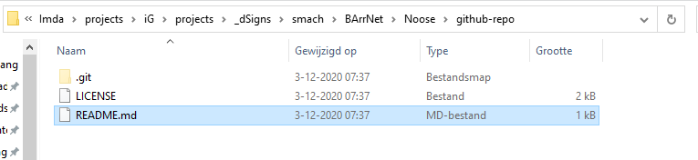
Only the readme-file is available.
Lets: Move the current project in '…/git' to 'github'.
- Close this document.
- Copy it to 'github' including the other files.
- In Git GUI:
Click: Rescan, The new files appear as unstaged;
Click: Stage Changed, The new files appear as staged;
Click: Commit.
Issue:
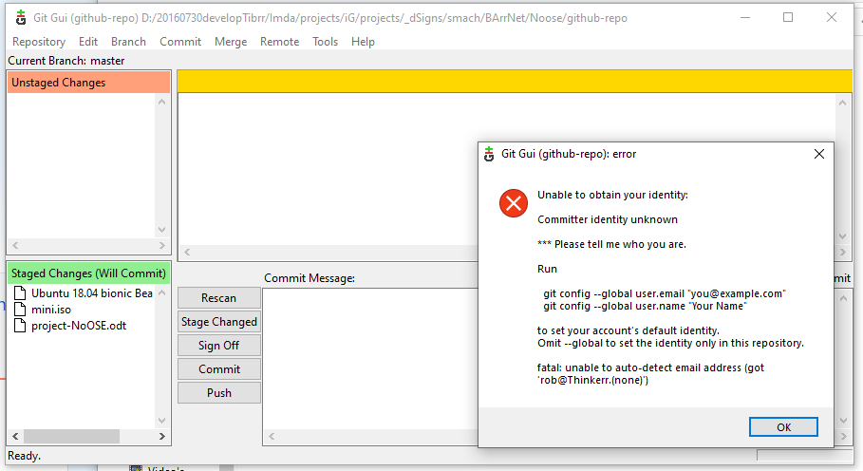
- On CMD:
git config --global user.email "r.r@i.n"
git config –global user.name "ba"
Issue:
Lets: See if the configuration can be performed in Git GUI?
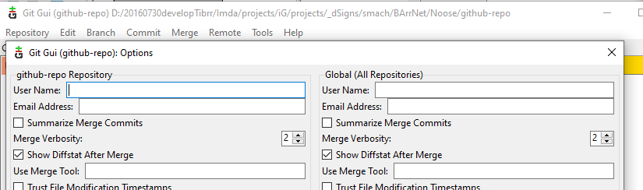
- In Git GUI: Menu>> Edit>> Options:
Fill in the proper data.
- In Git GUI:
Edit Commit message;
Click [Commit] (master/origin);
Click [Push] (follow credential instructions boradnor;.tgithib.33)
Remark: The local master is pushed to the origin which is github.
- In Browser at github 'https://github.com/boradnor/NoOSE':
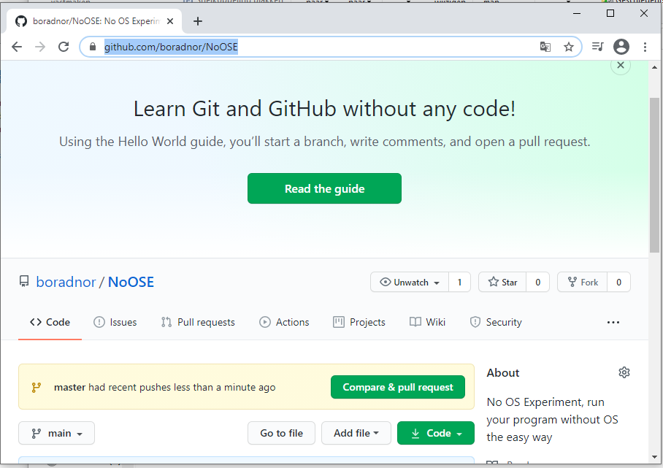
Here we see a push of the new master which is to be pulled to be in the origin at github finally.
- In github-noose: Click [Compare & pull request].
Done.

Install VirtualBox
https://www.virtualbox.org/wiki/Downloads
Click VirtualBox 6.1.1.16 platform packages>> Window hosts.
After download, run: VirtualBox-6.1.16-140961-Win.exe

Install Ubuntu bionic minimal on VirtualBox on your host Windows PC
Lets: Download Ubuntu bionic headless server iso.
- On host in Browser: 'https://help.ubuntu.com/community/Installation/MinimalCD'.
- On 'Installation/MinimalCD':
Section '64-bit PC (amd64, x86_64)': Open link '1. Ubuntu 18.04 bionic Beaver' in a new window,
Download of 'mini.iso' start;
Rename the file to 'Ubuntu 18.04 bionic Beaver-mini.iso';
Copy iso to github-repo directory;
RClick the iso-file; mount (koppelen) and the content of the iso-file is visible.
Done.
Lets: Create a VirtualBox VirtualMachine.
- On Host: Start VirtualBox.
- In VirtualBox: In toolbar click [New].
- In Create:
Name: Ubuntu mini GNU C Development;
Machine dir: D:\VirtualMachines\VBox;
Type: Linux;
Version: Ubuntu (64 bit);
Next.
- In Memory: 1024 Mb; Next.
- Hard disk: select 'Create virtual hard disk'; Create.
- Disk Type: VHD; Next
- Disk size: Fixed; Next
4 Gb; Create.
- In VirtualBox:
Ubuntu mini GNU C Developer>> RClick Start>> Normal Start.
- In Select Boot Disk:
Select: 'D:\20160730developTibrr\Imda\projects\iG\projects\_dSigns\smach\BArrNet\Noose\github' iso image 'mini.iso'.
- In VM: Install Ubuntu Server base system only (rob; BA)
- In the bottom second icon: Eject CDROM.
- Restart VM and UbuntuDevelop boots up.
Done, ubuntu is installed.

The 'Ubuntu mini GNU C Development' short 'Develop' is used as development machine to create a NoOSE image.

Linux kernel Background
In the previous a basic linux image was created which servers the purposes as development machine. But it is also linux which is to be disabled.
To achieve this some background information is needed. In the following a collection of references is given and some relevant content.
linux kernel code overview:
https://www.kernel.org/doc/html/v4.10/process/howto.html
https://kernelnewbies.org/
https://kernelnewbies.org/Documentation/Subsystems
https://kernelnewbies.org/FirstKernelPatch
https://kernelnewbies.org/KernelHacking
https://kernelnewbies.org/KernelSafari
https://kernelnewbies.org/Kernel001WalkThrough

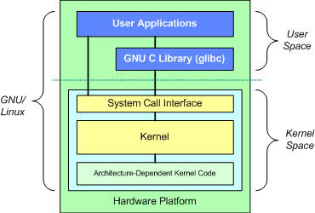
https://developer.ibm.com/technologies/linux/articles/l-linux-kernel/
What is a kernel?
As shown in Figure 3, a kernel is really nothing more than a resource manager. Whether the resource being managed is a process, memory, or hardware device, the kernel manages and arbitrates access to the resource between multiple competing users (both in the kernel and in user space).

And while each user-space process occupies its own virtual address space, the kernel occupies a single address space.

At the top is the system call interface, which implements the basic functions such as read and write.

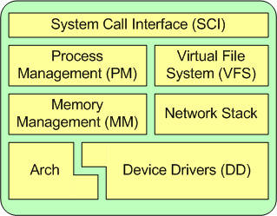
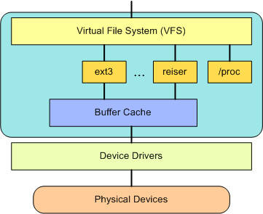

Does init runs in kernel space?
https://stackoverflow.com/questions/23277706/does-linux-init-process-run-in-kernel-or-user-mode#:~:text=Init%20is%20a%20user%20process,it%20goes%20into%20user%20mode.
Init is a user process like any other processes, so it is using virtual memory. The only thing that is special about init is that it is one of the two processes that the kernel started initially. When init is started by the kernel, it goes into user mode. When init calls system call fork(), it traps into the kernel mode, and the kernel does a bunch of things to create the new process, and the new process will be scheduled in the future. When the fork() returns, the original process is back to user mode.
Btw, even kernel is also using virtual memory, the mapping of kernel memory addresses are shared among processes.

https://unix.stackexchange.com/questions/408127/how-do-i-determine-if-a-program-is-running-in-kernel-space-or-user-space
I was making a Linux OS from scratch. I came accross this article, which creates a bare minimum Linux OS which just prints hello world once linux kernel boot.
So my question is , in which space [kernel or user space] such a helloworld program is running ? My conscience says its kernel space, then how do I make it run in user space ?
For people who do not want to read that lengthy article here is what it does in short.
- I formatted my USB flash drive [/dev/sdb on my linux system] with ext4 file format.
- Mounted it to /mnt/mylinux folder.
- Created folders /boot and /bin in it.
- Placed a copy of Linux Kernel [I compiled from github source code.] bzImage in /boot folder
- Installed grub2 in /boot folder of /dev/sdb, and created grub.cfg file to specify my init program.
My init program.
#include <stdio.h>
#include <unistd.h>

int main(void){
while(1){
printf("Hello World\n");
sleep(1);
}
}
My init program is statically compiled and placed in /bin folder.
So when I boot this drive , it starts printing : Hello World
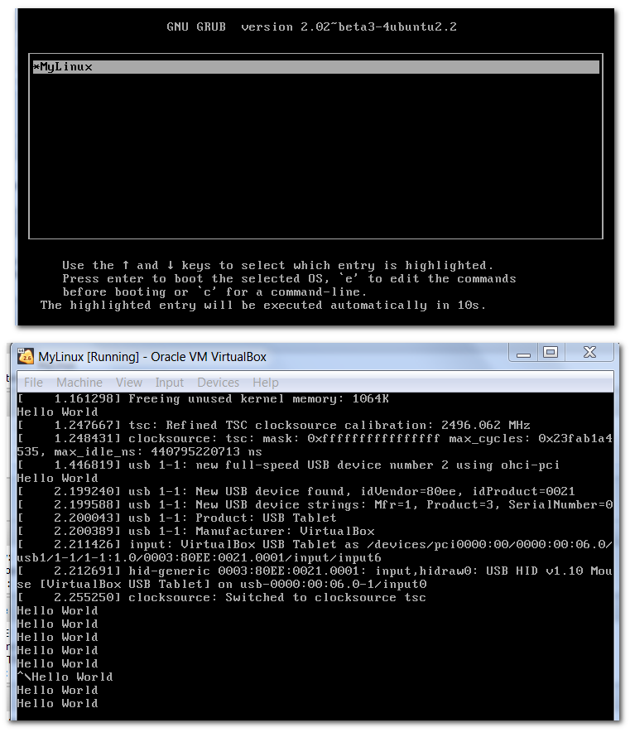

https://suchprogramming.com/barebones-linux-system

The main observation is the init.o program runs in user-space. This means it can use the GNU C library. It means init.o is a single user program running before the linux OS is setup. Also it is clear the linux kernel is a Hardware Abstraction Layer.
Also again a simple procedure is given to install a user program as init.o.
The installation procedure to install ubuntu bionic at a certain moment raises the question to install the “basic server”. There is also an option to skip this.
Also 32 G is used as harddisk which also could be reduced.
The next step is to create a much smaller installation and then adjust init.o as mentioned above. The the user-program will start but still a lot of “linux requirements” are installed. If init.o is compiled using static linking on the development environment all those requirements can be removed.
Achiving a small linux.img file which has the boot, the kernel and the standalone user program.
That linux.img file will actually be a NoOSE.img, a user program using the benefits of the linux HAL with linux as an operating system.
The main target of this project is is achieve harddisk and network access in the user-program in a NoOSE.img OS-free implementation.

The first time ubuntu starts the root directory can be displayed:
Is the procedure above applicable to this configuration?
The above speaks about 'boot\grub\grub.cfg'.:
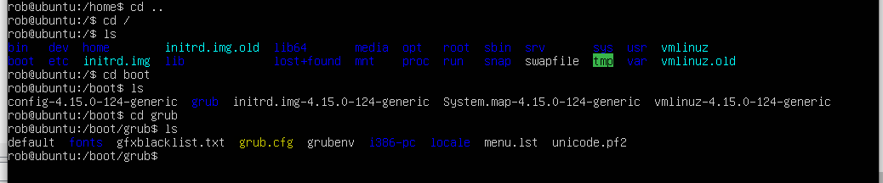
and using 'vim grub.cfg':
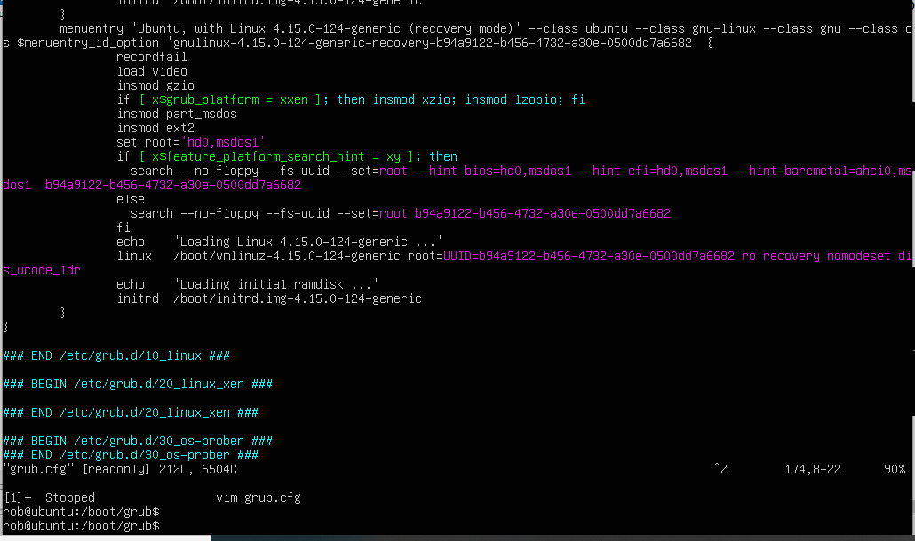
The above boot sequences involving init.o are not found in this grub boot procedure of ubuntu bionic.
More background is needed to create init.o situations with ubuntu bionic.
- Search 'ubuntu bionic init.o':

- Search 'ubuntu bionic boot sequence':
  - http://manpages.ubuntu.com/manpages/bionic/man7/bootup.7.html
  - https://www.crybit.com/linux-boot-process/
The kernel then starts to detect the system’s hardware. The root file system on disk takes over from the one in memory. The boot process then starts INIT (SYSTEMD) and the software daemons according to the Sys Admin’s settings. This can be done at next stages.
Step 5. INIT
The kernel, once it is loaded in step 4, it finds init in sbin (/sbin/init) and executes it. [In RHEL/CentOS 7 /sbin/init is linked to ../lib/systemd/systemd]. When init starts, it become the first or parent process on your Linux machine/server.

Mean while create a small linux.img of 1G and no basic server:
During a startup of linux.img of 32G it showed about 10% harddisk space was used after initial installation. About 4G is a minimal disksize.
Use VirtualBox and create a NoOSE VM with only the base system installed, no software or packages even not the minimal server package.

During installing of NoOSE the init.o location is fond '/sbin/init'. And indeed the file also exists:
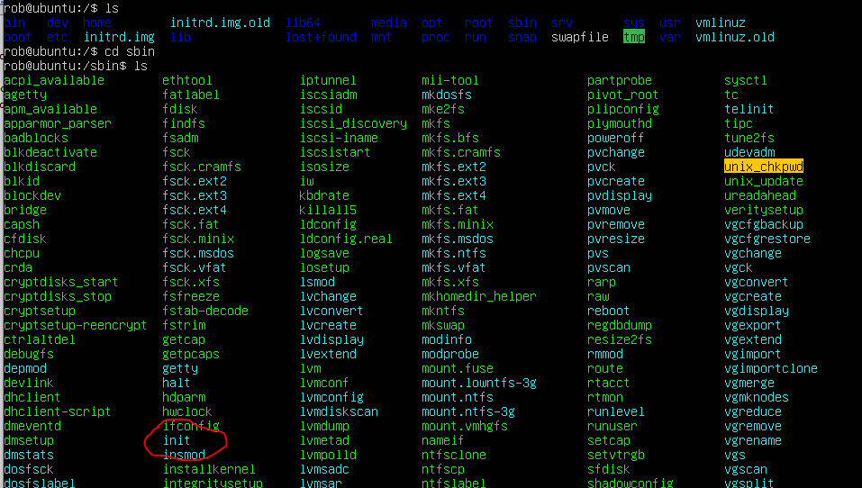
The idea is to write a new init.o hello world using Ubuntu Develop and change in NoOSE the init-file by the new one.
If it runs we can start to delete all other files to minimize the NoOSE.
Then build up access to resources using static linking and see if it runs in NoOSE. If resources are available NoOSE.img is available.
Also we know the minimal amount of libs and programs needed.

Linux.img as C programming environment
Is the GNU C programming environment available?
- Search 'Ubuntu Bionic is GNU C installed?':
  - https://linuxconfig.org/how-to-install-gcc-the-c-compiler-on-ubuntu-18-04-bionic-beaver-linux
Test if is installed:

gcc --version
The following linux command will install gcc compiler on on Ubuntu 18.04 Bionic Beaver. Open up terminal and enter:
$ sudo apt install gcc
Another way to install gcc compiler is to install it as part of build-essential package. build-essential package will also install additional libraries as well as g++ compiler. In most cases or if unsure this is exactly what you need:
$ sudo apt install build-essential
Compile a simple C "Hello World" code:
#include <stdio.h>
int main()
{
printf("Hello, World!");
return 0;
}
$ gcc -o hello hello.c
$ ./hello
Hello, World!

Result: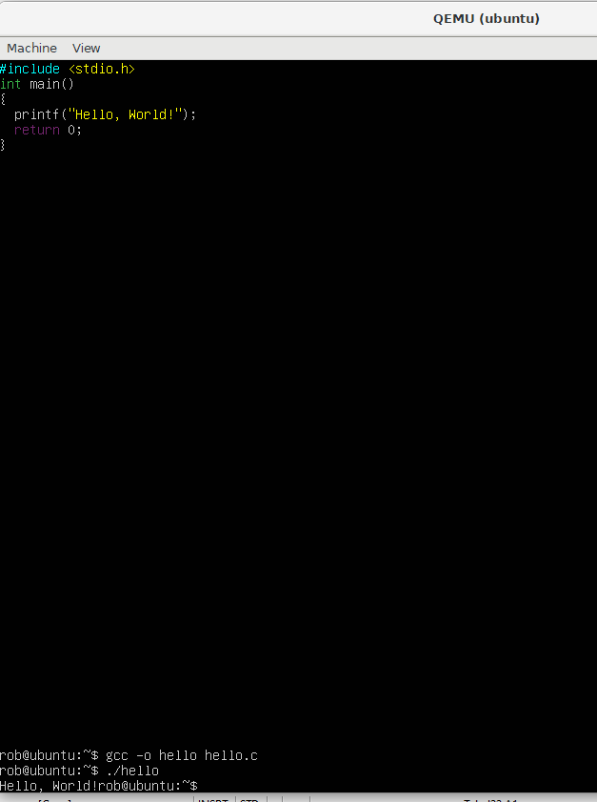

First init.o
In the previous two VMs are created based on ubuntu bionic beaver 18.04 in VirtualBox.
One is Develop which serves as C-development environment and a second called NoOSE which holds a minimal ubuntu bionic beaver 18.04 installation. Only a base system even no bare server installation.
Using Develop a init.o file is created which is installed on the NoOSE instead of the original init.o.
To get access to the NoOSE it is attached as a second harddisk to the Develop session.

NoOSE as second harddisk for a VirtualBox VM
The idea is to add the NoOSE vhd as second hard disk to the VM Decelop. If a new init.o is created it can be changed in the NoOSE image.
Even better, the development can be performed in the NoOSE vhd making it the only holder of the changes made. It contains both the source and object files and is always in NoOSE running order.
https://www.techrepublic.com/article/how-to-add-new-drives-to-a-virtualbox-virtual-machine/
Lets: Connect NoOSE.vhd as harddisk to Develop.
- On Host: Start VirtualBox.
- In VirtualBox:
Select on Virtual Machine Ubuntu mini GNU C Development;
Click Settings.
- In Settings>> Storage>> Controller SATA: Click Add Harddisk:
Add from 'D:\VirtualMachines\VBox\NoOSE Ubuntu mini' the harddisk file 'NoOSE Ubuntu mini.vhd'.
Done, the VM Develop has the NoOSE system harddisk attached.

Mount the NoOSE hard disk in VM Develop
If the hard disk is attached as SATA the system info in VirtualBox shows the second harddisk is sata1:
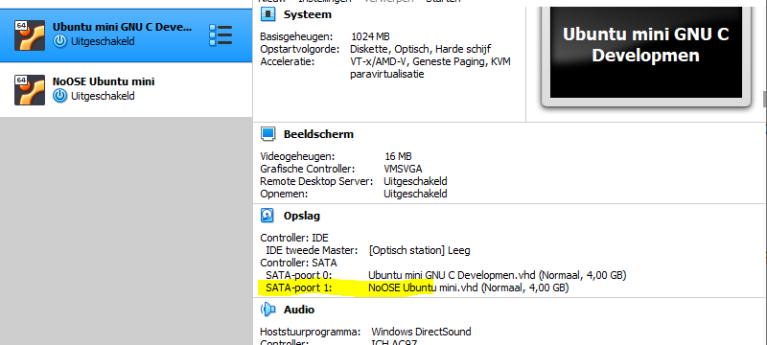
- Search 'Ubuntu verify filesystem available hard disks':
  - https://askubuntu.com/questions/182446/how-do-i-view-all-available-hdds-partitions
sudo lsblk -o NAME,FSTYPE,SIZE,MOUNTPOINT,LABEL

sudo mount -t cifs -o ro /dev/sda3 /media/my_test_mount

Running the command shows:
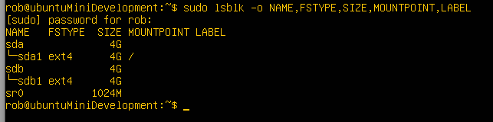
We see sata0 is available as sdb1 but not mounted.
Do a mount:
cd /media
sudo mkdir NoOSE
sudo mount /dev/sdb1 /media/NoOSE
With the result:
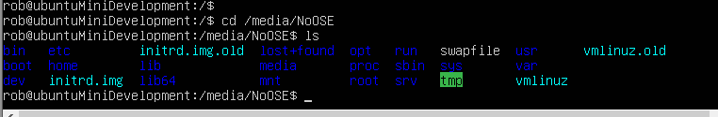
The NoOSE Programming environment is ready.
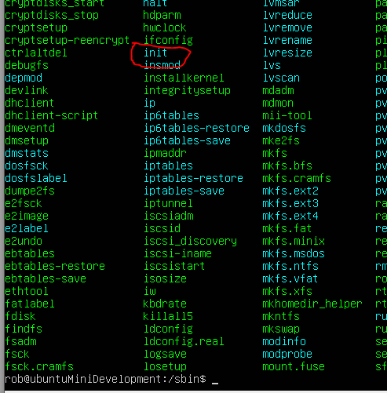

Make a Host directory available in VM Develop
Since the VM Develop environment is a headless minimal ubuntu distibution editting and access to a file to be eddited is tedious.
The idea is to write the init.c program on the Host system in the NoOSE github project directory '...\Noose\github'.
If this file is connected to the VM Develop the init.c can be editted using notepad++ and simply copied in the VM Develop from the host directory to the NoOSE sbin directory to be compiled.
In VirtualBox but also when VM Develop is running 'shared folders' is an option which can be configured.
- Search 'VirtualBox share folder from host':
  - https://helpdeskgeek.com/virtualization/virtualbox-share-folder-host-guest/
- Search 'virtualbox shared folder windows 10':
  - https://www.youtube.com/watch?v=9-teQnZ8LEY
>whoami
xxx
>sudo adduser xxx vboxsf

- Search 'virtualbox shared folder not showing':
  - https://forums.virtualbox.org/viewtopic.php?f=2&t=35746#:~:text=Re%3A%20Shared%20folders%20not%20showing%20up&text=You%20can%20create%20a%20share,mount%20the%20share%20in%20Windows.&text=Replace%20sharename%20with%20the%20name,up%20in%20your%20file%20manager.
- Search 'virtualbox shared folder not showing ubuntu guest headless':
  - https://askubuntu.com/questions/817288/virtualbox-shared-folder-headless
  - https://gist.github.com/estorgio/0c76e29c0439e683caca694f338d4003
  - https://serverfault.com/questions/674974/how-to-mount-a-virtualbox-shared-folder/674978
- Search 'Headless Ubuntu 18.04 install guest shared folder support':
  - Same results as earlier.
- Search 'Headless Ubuntu 18.04 install guest shared folder support VBoxLinuxAdditions not found':
  - https://linuxize.com/post/how-to-install-virtualbox-guest-additions-in-ubuntu/
- Search 'Headless Ubuntu 18.04 install virtualbox-guest':
  - https://www.techrepublic.com/article/how-to-install-virtualbox-guest-additions-on-a-gui-less-ubuntu-server-host/

It is a complex route in the above references. The issue is the mini.iso used in this installation does not hold ./VBoxLinuxAdditions.run.
Finally a combination of the install virtualbox-guest-utils and mounting as decribed when './VBoxLinuxAdditions.run' is used is combined to get access to the host directory.
But first the shared directory is to be assigned to the VM Develop.

Lets: Make the host directory '...\Noose\github' available in VM Develop.
- On Host in VirtualBox: Select VM Develop;
Click op Settings.
- In Settings: Shared folders>> Config shared folders:
Klik [+] (Add).
- In Add shared folder:
Path: '...\Noose\github';
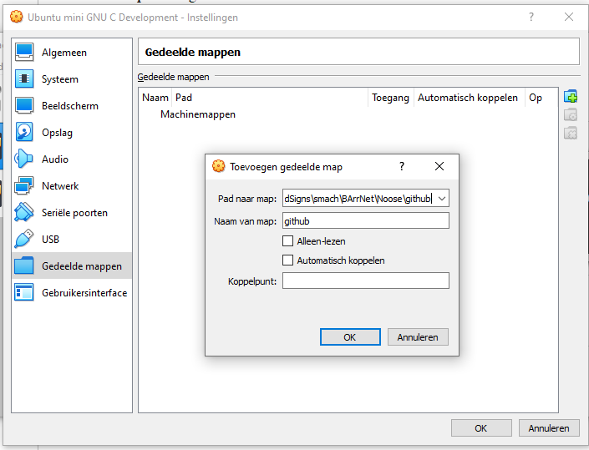
- Click OK; OK.
Done.
Next the virtualbox guest tools must be installed on the guest linux.img Develop. Use the Foldername 'github(or xxx in your case)' from the above to mount properly.
Lets: Make VM Develop ready to do shared files.
- On host start VirtualBox: Run VM Develop.
- In VM Develop:
sudo apt-get update
sudo apt-get install --no-install-recommends virtualbox-guest-utils
whoami
rob
sudo adduser rob vboxsf
sudo reboot
lsmod | grep -io vboxguest
vboxguest
modinfo vboxguest
shows info
sudo mkdir /media/github
sudo mount -t vboxsf github /media/github
ls /media/github

Done, result:
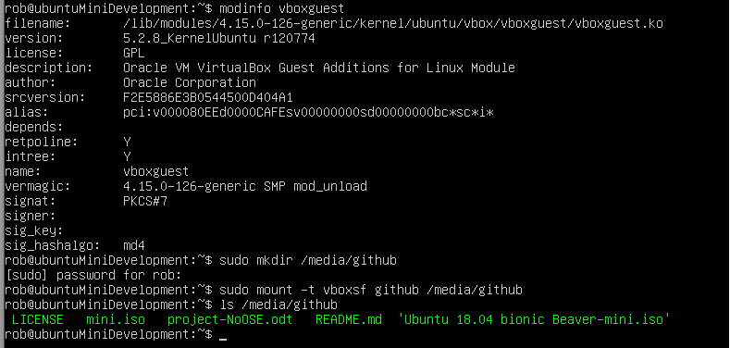
Finally see for it the mount to /media/git is permanently:
Lets: Config fstab on VM Develop.
- On Host start VirtualBox: Start VM Develop.
- In Develop:
log in;
Do the following:
>sudo nano /etc/fstab
Add the following line to fstab (separated by tabs). Make sure to replace <username> with your username. Save the file.
github /media/github vboxsf defaults 0 0

>sudo nano /etc/modules
Add the following line to /etc/modules and save
vboxsf

>sudo shutdown -r now

restart
log in
ls /media/github

Done, Result:
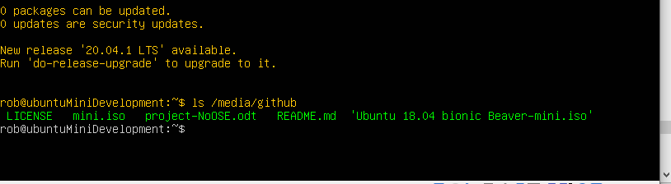
Immediately after reboot and login the host directory is available.

Make init.c
Having the host directory available in VM Develop the new init.c code can be maintained on the host in the github directory.
Lets: Create the initial init.c as stated in the previous of this ducument.
- On the host in '...\Noose\github': Create file 'init.c' having the following content:
#include <stdio.h>
#include <unistd.h>

int main(void){
while(1){
printf("Hello World\n");
sleep(1);
}
}

- In VM Develop:
>ls /media/github
Done, with result:
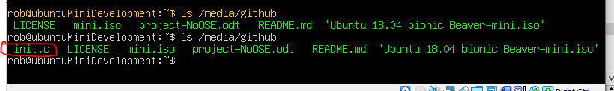

No OS
The development environment for a system without an OS is ready. In this section accessing the system resources from the kernel of HAL is investigated.
To get a basic user program operational the following resources are investigated:
- Network
- Hard disk
- Memory

NoOSE Development
The linux image for NoOSE is attached as second hard drive to Develop. In this way Develop can directly access the NoOSE filesystem.
On both linux images (Develop and NoOSE) the init program is located in /sbin.
The project and development environment for NoOSE will not be located in a separate development directory but in /sbin itself of the NoOSE limux image.
Lets: Create an init-original copy of the current init file also to show the development directory explicitly.
- On the Host in VirtBox: Start VM Develop having the NoOSE.vhd attached as second hard drive (sdb1).
- Log in as development user.
- In Develop:
sudo mount -t ext4 /dev/sdb1 /media/NoOSE
and for permanent mounting:

>sudo nano /etc/fstab
Add the following line to fstab (separated by tabs). Make sure to replace <username> with your username. Save the file.
/dev/sdb1 /media/NoOSE ext4 defaults 0 0

- Copy /media/NoOSE/sbin/init to /media/NoOSE/sbin/init-original:
sudo cp /media/NoOSE/sbin/init /media/NoOSE/sbin/init-original

Done.

Hello World Experiment, basic development cycle
On the host in the github directory is init.c as source code available. It already holds the No OS hello world source code.
Since this file is available in the VM Develop as '/media/github/init.c' and the target directory '/media/NoOSE/sbin' is available the gcc-compiler can be instructed to compile the init.c from the github directory into the target directory the new init will be actuvated immediately after compilation.
To actually test the new init file the VM Develop must be stopped so the NoOSE.vhd is released and the VM NoOSE can be started.
Hello world should be starting instead of linux OS.
Lets: Implement the basic development cycle.
- On host in VirtualBox: Start VM Develop.
- In VM Develop: log in;
Do:
sudo gcc -o /media/NoOSE/sbin/init /media/github/init.c
sudo shutdown -h now

- In VirtualBox: Start VM NoOSE.
Done, with result:
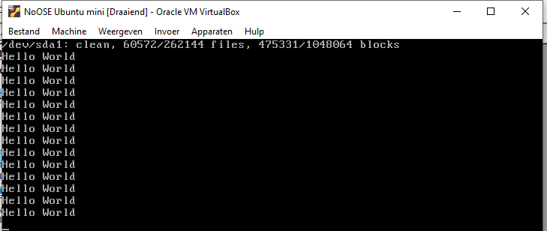

C test environment
To test NoOSE the VM Develop must be shutdown. This is not very practical during development.
The VM Develop user-root will be used as test environment. Both VM Develop and VM NoOSE run the same linux. This means a test run of init.c can be performed on VM Develop itself by just running it as a normal c-program.
This works since both normal c-program and the init.c program run in user space.
Lets: Test run init.c
- On host in VirtualBox: Start VM Develop.
- In VM Develop: log in;
Do:
gcc -o ~/init /media/github/init.c
./init

Use Ctrl C to break the program.

Done, with result:
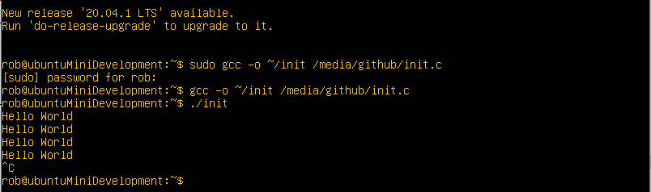

Hard Disk
The first resource to incorporate is the hard disk the system is running on. The init-program runs in user-space. How can C list the available hard disks and setup access to them?
- Search 'Linux c-programming list hard disks and access':
  - https://stackoverflow.com/questions/9492577/get-physical-hdds-list-in-c
(libsysfs)
  - https://stackoverflow.com/questions/7289453/reading-hard-disk-sectors-in-c-on-linux
  - https://stackoverflow.com/questions/3520459/direct-access-to-hard-disk-with-no-fs-from-c-program-on-linux
  - https://stackoverflow.com/questions/25916345/linux-c-access-file-on-disk-by-address
  - http://linux-diag.sourceforge.net/Sysfsutils.html
  - https://www.tenouk.com/Module9.html
- Search 'c libsysfs example':
  - https://stackoverflow.com/questions/4673564/what-is-the-best-way-to-process-the-content-of-sysfs-using-c-c
  - http://nagyak.eastron.hu/doc/libsysfs-2.1.0/libsysfs.txt
  - Search 'linux check disks attached programatically by c':
    - https://stackoverflow.com/questions/7243988/how-to-list-the-harddisks-attached-to-a-linux-machine-using-c

List hd devices
Reference 3.1 gave the idea to use /proc/mounts. If one looks at the file one can find out each sentence starting with '/dev' is the mount of the various hard disks:

This brings the idea to write a c-program which reads the /proc/mounts and evaluate each line which greps on '^/dev'.
- Search 'linux c: read a file line by line':
  - https://stackoverflow.com/questions/3501338/c-read-file-line-by-line
#include <stdio.h>
#include <stdlib.h>

int main(void)
{
FILE * fp;
char * line = NULL;
size_t len = 0;
ssize_t read;

fp = fopen("/proc/mounts", "r");
if (fp == NULL)
exit(EXIT_FAILURE);

while ((read = getline(&line, &len, fp)) != -1) {
printf("Retrieved line of length %zu:\n", read);
printf("%s", line);
}

fclose(fp);
if (line)
free(line);
exit(EXIT_SUCCESS);
}

- Search 'linux c grep.c':
  - https://stackoverflow.com/questions/29559414/how-to-get-the-output-of-grep-in-c
#include <stdio.h>
#include <stdlib.h>

FILE *popen(const char *command, const char *mode);
int pclose(FILE *stream);

int main(void)
{
FILE *cmd;
char result[1024];

cmd = popen("grep bar /proc/mounts", "r");
if (cmd == NULL) {
perror("popen");
exit(EXIT_FAILURE);
}
while (fgets(result, sizeof(result), cmd)) {
printf("%s", result);
}
pclose(cmd);
return 0;
}

Based on these references:
#include <stdio.h>
#include <stdlib.h>
#include <unistd.h>

FILE *popen(const char *command, const char *mode);
int pclose(FILE *stream);

int main(void)
{
FILE *cmd;
char result[1024];

cmd = popen("grep '^/dev' /proc/mounts", "r");
if (cmd == NULL) {
perror("popen");
exit(EXIT_FAILURE);
}
while (fgets(result, sizeof(result), cmd)) {
printf("%s", result);
}
pclose(cmd);

while(1){
printf("Hello World\n");
sleep(1);
}
return 0;
}

With result on NoOSE:
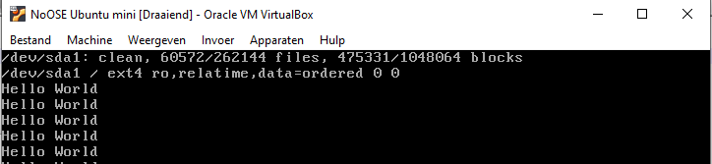
The code finds the hard disk dev file name. This means this device can be accessed by the program.

Access listed hd devices
Having a list of the devices they can be accessed by their device name '/dev/sdxx'. This implies to isolate this name from the line and store the name in an array.
The second element in the line is the mounting point. It alwaus starts with '/'. This means each line must be split into its white space separated elements and the first two are relevant. The second must begin with '/' to signal a proper line.
Finally a device can be stored only one.
If the lines for VM NoOSE are studied only one device is found '/dev/sda1'. It is mounted at '/'. It looks like there is an issue. In the rest of the line 'ro,' is found which could mean it is mounted read only.
First file acces via the mounting point must be established and see if a file is also read only. Then the issue is to be addressed.
At this point the relevant data must be extracted and stored for further use.

Heap of objects
At this stage data is to be extracted and stored for further use. The data represents various objects. The representation of this objects must be implemented first.
In the previous program a few objects are stored. Since the objects needed are know on fore hand they can be declared statically as a c-variable.
The number of devices is not known on forehand so some dynamic storage must be constructed. Various types of objects may occure which implies some generic storage must be used.
Such a storage is called a "Heap".
Next to the heap the individual objects on the heap must be identified. By storing a list of addresses which point into the heap each object on the heap is represented by an index in the list of addresses.

dia001
The object array is of fixed length and contains '#define MAX_OBJS 80' of void ponters. The heap is a data block of char as the representation of bytes.
Each object found gets an index. If a particular object is known it is declared as an int variable which holds the obj arr index of the actual object on the heap.
If there is a 'mount obj' there will be a c variable declared as 'int mount;'. If the mount object is found it is stored on the heap and its address is stored in obj arr and its obj arr index is assigned to int mount.
If 'int mount' contains '3' the 3th object on the heap is the value of 'mount'.
In case of devices it is not known on forehand how many harddisk will be found. Then an array od devices is needed.
Finally if a device is a structure of multiple objects a second array is added.
In this way a 'heap of objects' can be represented as follows:

Dia002
The following c-code represents the heap and object array:
#define MAX_HEAP 2*1024
#define MAX_OBJS 64
char heap[MAX_HEAP];
int pheap;
void *obj_arr[MAX_OBJS];
int pobj;

To know which kind of object-variable are needed can only be decided if the logic of the listed devices is further defined.

Split a white space separated mount specification
In linux a white space separated line of text specifying stuff is used in many cases. Which c-code is used to parse a whitespace separated line:
- Search 'linux c parse a whitespace separated text string':
  - https://www.codingame.com/playgrounds/14213/how-to-play-with-strings-in-c/string-split
- Search 'linux c parse config file':
  - https://stackoverflow.com/questions/2250607/what-c-lib-to-use-when-i-need-to-parse-a-simple-config-file-under-linux
  - https://hyperrealm.github.io/libconfig/
  - https://www.tutorialspoint.com/c_standard_library/c_function_fgets.htm
- Search 'c parse on whitespace':
  - https://stackoverflow.com/questions/4513316/split-string-in-c-every-white-space
Parameters
- str
  - C string to truncate.
  - Notice that this string is modified by being broken into smaller strings (tokens). Alternativelly [sic], a null pointer may be specified, in which case the function continues scanning where a previous successful call to the function ended.
- delimiters
  - C string containing the delimiter characters.
  - These may vary from one call to another.
/* strtok example */
#include <stdio.h>
#include <string.h>

int main ()
{
char str[] ="- This, a sample string.";
char * pch;
printf ("Splitting string \"%s\" into tokens:\n",str);
pch = strtok (str," ,.-");
while (pch != NULL)
{
printf ("%s\n",pch);
pch = strtok (NULL, " ,.-");
}
return 0;
}

Multiple characters can be used a a delimiter thus ' \t\r\n' will do on each whitespace.
Use NULL to continue on the current position.
- Search 'linux c getline':
  - https://man7.org/linux/man-pages/man3/getline.3.html
#include <stdio.h>

ssize_t getline(char **lineptr, size_t *n, FILE *stream);

ssize_t getdelim(char **lineptr, size_t *n, int delim, FILE *stream);
getline() reads an entire line from stream, storing the address of
the buffer containing the text into *lineptr. The buffer is null-
terminated and includes the newline character, if one was found.

Actually the strtok construct only needs to be applied twice. The first found should have '/dev' as first and the second must have '/' as first.
If the devices are parsed and found only the mounting points are needed. The device is not needed any more.
If the mounting points are found the can be used as directories and directory file based handling can be initiated.
This means only an array of mounts are needed.

Now the actual parsing must be designed. Lines are retrieved from the '/proc/mounts' file using getline().
Then the strtok() only have to be applied twice on the line found. And if a proper line was found the second must be retrieved as a 'mount'.
The basic loop is already used in the previous:
while ((read = getline(&line, &len, fp)) != -1) {
printf("Retrieved line of length %zu:\n", read);
printf("%s", line);
}

To use strtok '\0' characters are placed in the string used in strtok. The first thought was to make a copy since getline works directly in the current buffer it uses to read.
But it is no problem if in that buffer '\0' characters are written. The buffer is not needed any more after the parse is performed.
At the moment a relevant value is found, it will be copied onto the heap.
The current code loops the proc-file using the following:
while (fgets(result, sizeof(result), cmd)) {
printf("%s", result);
}
each line found must be tested on a valid device:
char * pch;
...
while (fgets(result, sizeof(result), cmd)) {
printf("%s", result);
pch = strtok (result," \t\r\n");
printf("eerste strtok\n");
while (pch != NULL){
printf ("%s\n",pch);
pch = strtok (NULL, " \t\r\n");
}
}
pclose(cmd);
...
With result:
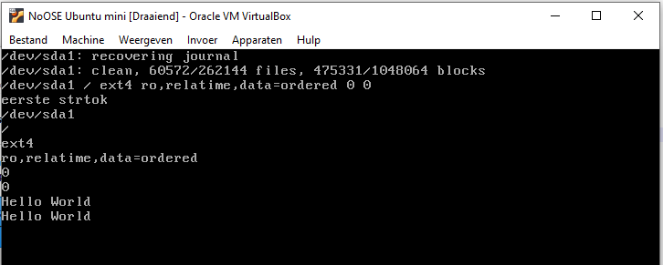
To test the if the first string found is '/dev' the following code can be used:
while (fgets(result, sizeof(result), cmd)) {
printf("%s", result);
pch = strtok (result," \t\r\n");
printf ("%s\n",pch);
if(strncmp(pch, "/dev", 4) == 0) {
printf ("Device: %s\n",pch);
pch = strtok (NULL, " \t\r\n");
printf ("Mount: %s\n",pch);
}

}
With result:
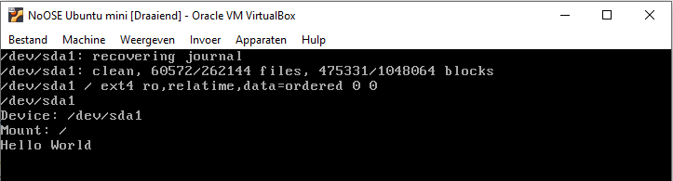
The code filters the Device and its mount. Using strcpy() both the string describing the device and the string describing the mount can be copied onto the heap.

Devices and their mounts on the heap
In the example above just one device and its mount is found. If the code is running on a rock pi using a 'SATA HAT' 5 devices are added next to the primary device. Since all variables must be of fixed size lets assume '#define MAX_DEVICES 12' so two arrays can be defined to store the heap indices for the devices and mounts:
#define MAX_HEAP 2*1024
#define MAX_OBJS 64
char heap[MAX_HEAP];
int pheap=0;
void *obj_arr[MAX_OBJS];
int pobj=0;

//Heap objects devices
#define MAX_DEVICES 12
int devices[MAX_DEVICES];
int mounts[MAX_DEVICES];
int pdevs= 0;
If more then 12 devices are found the init-code will halt and issue an error message. Having the heap and having the devices the following code creates the device objects on the heap:
while (fgets(result, sizeof(result), cmd)) {
printf("%s\n", result);
sleep(10);
pch = strtok (result," \t\r\n");
printf ("%s\n",pch);
sleep(10);
if(strncmp(pch, "/dev", 4) == 0) {
if(pdev >= MAX_DEVICES) {
while(1){
printf("To many devices detected, max is %d\n", pdev);
sleep(2*10);
}
}
if(pobj >= MAX_OBJS) {
while(1){
printf("To many objects needed, max is %d\n", pobj);
sleep(2*10);
}
}
int len;
len= strlen(pch) +1; // count the '\0'-character also
printf ("Device(%d) pheap(%d): %s\n", len, pheap, pch);
sleep(10);
if(pheap + len >= MAX_HEAP) {
while(1){
printf("Heap is full, pheap is %d en len device is %d\n", pheap, len);
sleep(2*10);
}
}
else {
obj_arr[pobj]= &(heap[pheap]);
strcpy(&(heap[pheap]), pch);
devices[pdev]= pobj;
pheap+= len;
pobj++;
}
pch = strtok (NULL, " \t\r\n");
len= strlen(pch) +1; // count the '\0'-character also
printf ("Mount(%d) pheap(%d): %s\n", len, pheap, pch);
sleep(10);
if(pheap + len >= MAX_HEAP) {
while(1){
printf("Heap is full, pheap is %d en len mount is %d\n", pheap, len);
sleep(2*10);
}
}
else {
obj_arr[pobj]= &(heap[pheap]);
strcpy(&(heap[pheap]), pch);
mounts[pdev]= pobj;
pheap+= len;
pobj++;
}
pdev++;
}

}
pclose(cmd);
printf ("Num of objs= %d\n",pobj);

printf ("Show devices(num= %d)\n",pdev);
printf ("dev\t\t\tmount\n");
int i= 0;
while(i < pdev){
printf("%s\t\t\t%s\n",(char *)obj_arr[devices[i]],(char *)obj_arr[mounts[i]]);
i++;
}

Results in:
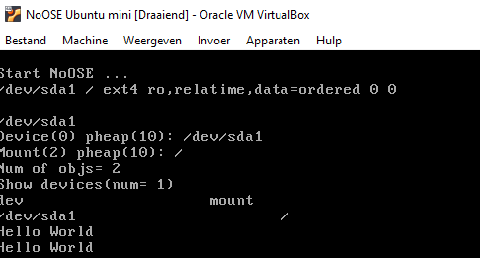
The device is found and stored on the heap.
Having the mounting point of the device the mount can be accessed.
- Search 'linux c list directory':
  - https://stackoverflow.com/questions/4204666/how-to-list-files-in-a-directory-in-a-c-program
/*
* This program displays the names of all files in the current directory.
*/

#include <dirent.h>
#include <stdio.h>

int main(void) {
DIR *d;
struct dirent *dir;
d = opendir(".");
if (d) {
while ((dir = readdir(d)) != NULL) {
printf("%s\n", dir->d_name);
}
closedir(d);
}
return(0);
}

  - https://www.gnu.org/software/libc/manual/html_node/Directory-Entries.html

Using this code it can be tested if the device can be accessed via the mounting point:
#include <dirent.h>
#define NORMAL_COLOR "\x1B[0m"
#define GREEN "\x1B[32m"
#define BLUE "\x1B[34m"

...

DIR *d;
struct dirent *dir;
d = opendir((char *)obj_arr[mounts[0]]);
if (d) {
while ((dir = readdir(d)) != NULL) {
if (dir->d_type == DT_REG) printf("%sFile: %s\n", BLUE, dir->d_name);
else if (dir->d_type == DT_DIR) printf("%sDir: %s\n", GREEN, dir->d_name);
else printf("%s%s\n", NORMAL_COLOR, dir->d_name);
sleep(5);
}
closedir(d);
}

With result:
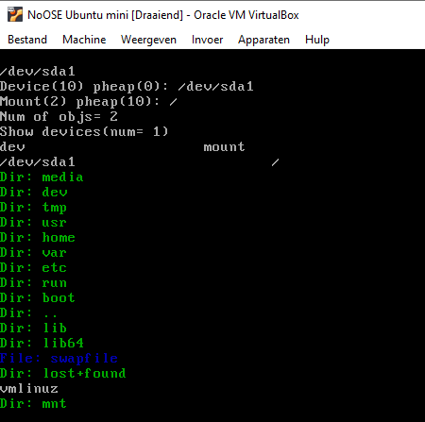

Network
The next step is to make the network available. How can we detect the network devices using c.
- Search 'linux c network devices':
  - https://stackoverflow.com/questions/3055622/howto-check-a-network-devices-status-in-c
#include <stdlib.h>
#include <stdio.h>
#include <string.h>
#include <sys/ioctl.h> /* ioctl() */
#include <sys/socket.h> /* socket() */
#include <arpa/inet.h>
#include <unistd.h> /* close() */
#include <linux/if.h> /* struct ifreq */

int main(int argc, char* argv[])
{
/* this socket doesn't really matter, we just need a descriptor
* to perform the ioctl on */
int fd = socket(PF_INET, SOCK_STREAM, IPPROTO_TCP);

struct ifreq ethreq;

memset(&ethreq, 0, sizeof(ethreq));

/* set the name of the interface we wish to check */
strncpy(ethreq.ifr_name, "eth0", IFNAMSIZ);
/* grab flags associated with this interface */
ioctl(fd, SIOCGIFFLAGS, &ethreq);
if (ethreq.ifr_flags & IFF_PROMISC) {
printf("%s is in promiscuous mode\n",
ethreq.ifr_name);
} else {
printf("%s is NOT in promiscuous mode\n",
ethreq.ifr_name);
}

close(fd);

return 0;
}
You need to know the available devices.
  - https://gist.github.com/edufelipe/6108057
#include <string.h>
#include <stdio.h>
#include <unistd.h>
#include <ifaddrs.h>
#include <sys/types.h>
#include <sys/ioctl.h>
#include <sys/socket.h>
#include <linux/wireless.h>

int check_wireless(const char* ifname, char* protocol) {
int sock = -1;
struct iwreq pwrq;
memset(&pwrq, 0, sizeof(pwrq));
strncpy(pwrq.ifr_name, ifname, IFNAMSIZ);

if ((sock = socket(AF_INET, SOCK_STREAM, 0)) == -1) {
perror("socket");
return 0;
}

if (ioctl(sock, SIOCGIWNAME, &pwrq) != -1) {
if (protocol) strncpy(protocol, pwrq.u.name, IFNAMSIZ);
close(sock);
return 1;
}

close(sock);
return 0;
}

int main(int argc, char const *argv[]) {
struct ifaddrs *ifaddr, *ifa;

if (getifaddrs(&ifaddr) == -1) {
perror("getifaddrs");
return -1;
}

/* Walk through linked list, maintaining head pointer so we
can free list later */
for (ifa = ifaddr; ifa != NULL; ifa = ifa->ifa_next) {
char protocol[IFNAMSIZ] = {0};

if (ifa->ifa_addr == NULL ||
ifa->ifa_addr->sa_family != AF_PACKET) continue;

if (check_wireless(ifa->ifa_name, protocol)) {
printf("interface %s is wireless: %s\n", ifa->ifa_name, protocol);
} else {
printf("interface %s is not wireless\n", ifa->ifa_name);
}
}

freeifaddrs(ifaddr);
return 0;
}

- Search 'linux /proc ethernet devices':
  - https://stackoverflow.com/questions/5281341/get-local-network-interface-addresses-using-only-proc
ifconfig does:

fd = socket(PF_INET, SOCK_DGRAM, IPPROTO_IP)
ioctl(fd, SIOCGIFCONF, ...)

You'll get something like this:

ioctl(4,
SIOCGIFCONF,
{120, {{"lo", {AF_INET, inet_addr("127.0.0.1")}},
{"eth0", {AF_INET, inet_addr("10.6.23.69")}},
{"tun0", {AF_INET, inet_addr("10.253.10.151")}}
}
}
)

There is no clear way to find the ethernet devices using '/proc'. In the first example the name of the ethernet device is needed but it is that name we are lokkoing for.
Obvious the ioctl structure has those names.
In reference 1.2 the code accesses the list.
Lets: Show the list in init.c.
- Add the following code:
struct ifaddrs *ifaddr, *ifa;
if (getifaddrs(&ifaddr) == -1) {
while(1){
printf("No network found\n");
sleep(2*10);
}
}

for (ifa = ifaddr; ifa != NULL; ifa = ifa->ifa_next) {
if (ifa->ifa_addr == NULL || ifa->ifa_addr->sa_family != AF_PACKET) continue;
printf("interface %s\n", ifa->ifa_name);
}
freeifaddrs(ifaddr);

Done, with result:
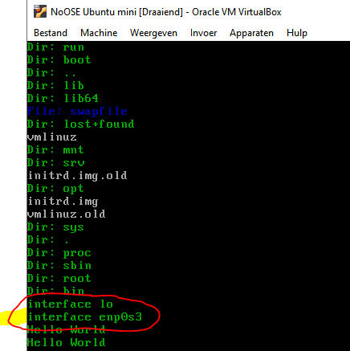
This is in the virtual environment which lets the ethernet device show up as 'enp0s3'. This shows the code works. The relevant data can be fetched from the structure like the ip-address.
The same construct for the hard disk devices can be used here by adding 'MAX_NETWORK. nets[] and ips[]' and represent the networkname and ip-address as strings on the heap.
To get the proper information the fields 'struct ifaddrs' must be known.
- Search 'linux c struct ifaddrs':
  - https://sites.uclouvain.be/SystInfo/usr/include/ifaddrs.h.html
  - https://www.man7.org/linux/man-pages/man3/getifaddrs.3.html
struct ifaddrs {
struct ifaddrs *ifa_next; /* Next item in list */
char *ifa_name; /* Name of interface */
unsigned int ifa_flags; /* Flags from SIOCGIFFLAGS */
struct sockaddr *ifa_addr; /* Address of interface */
struct sockaddr *ifa_netmask; /* Netmask of interface */
union {
struct sockaddr *ifu_broadaddr;
/* Broadcast address of interface */
struct sockaddr *ifu_dstaddr;
/* Point-to-point destination address */
} ifa_ifu;
#define ifa_broadaddr ifa_ifu.ifu_broadaddr
#define ifa_dstaddr ifa_ifu.ifu_dstaddr
void *ifa_data; /* Address-specific data */
};

  - https://stackoverflow.com/questions/4139405/how-can-i-get-to-know-the-ip-address-for-interfaces-in-c
#include <arpa/inet.h>
#include <sys/socket.h>
#include <ifaddrs.h>
#include <stdio.h>

int main ()
{
struct ifaddrs *ifap, *ifa;
struct sockaddr_in *sa;
char *addr;

getifaddrs (&ifap);
for (ifa = ifap; ifa; ifa = ifa->ifa_next) {
if (ifa->ifa_addr && ifa->ifa_addr->sa_family==AF_INET) {
sa = (struct sockaddr_in *) ifa->ifa_addr;
addr = inet_ntoa(sa->sin_addr);
printf("Interface: %s\tAddress: %s\n", ifa->ifa_name, addr);
}
}

freeifaddrs(ifap);
return 0;
}

Reference 1.3 has the exact code we want.
Lets: Use the 1.3 code example to get the proper network data on the heap:
- In init.c do the following:
char buffer[1024];
...

#include <arpa/inet.h>
#include <sys/socket.h>
#include <ifaddrs.h>
...
//Heap objects network
#define MAX_NETWORK 4
int nets[MAX_NETWORK];
int ips[MAX_NETWORK];
int pnet= 0;
...

struct ifaddrs *ifaddr, *ifa;
struct sockaddr_in *sa;
char *addr;
if (getifaddrs(&ifaddr) == -1) {
while(1){
printf("No network found\n");
sleep(2*10);
}
}

for (ifa = ifaddr; ifa != NULL; ifa = ifa->ifa_next) {
if (ifa->ifa_addr == NULL || ifa->ifa_addr->sa_family != AF_PACKET) continue;
sa = (struct sockaddr_in *) ifa->ifa_addr;
addr = inet_ntoa(sa->sin_addr);
printf("Interface: %s\tAddress: %s\n", ifa->ifa_name, addr);

if(pnet >= MAX_NETWORK) {
while(1){
printf("To many devices detected, max is %d\n", pdev);
sleep(2*10);
}
}
if(pobj >= MAX_OBJS) {
while(1){
printf("To many objects needed, max is %d\n", pobj);
sleep(2*10);
}
}
int len;
len= strlen(ifa->ifa_name) +1; // count the '\0'-character also
printf ("Network(%d) pheap(%d): %s\n", len, pheap, ifa->ifa_name);
//sleep(10);
if(pheap + len >= MAX_HEAP) {
while(1){
printf("Heap is full, pheap is %d en len device is %d\n", pheap, len);
sleep(2*10);
}
}
else {
obj_arr[pobj]= &(heap[pheap]);
strcpy(&(heap[pheap]), ifa->ifa_name);
nets[pnet]= pobj;
pheap+= len;
pobj++;
}
if(pobj >= MAX_OBJS) {
while(1){
printf("To many objects needed, max is %d\n", pobj);
sleep(2*10);
}
}
len= strlen(addr) +1; // count the '\0'-character also
printf ("Ip(%d) pheap(%d): %s\n", len, pheap, addr);
//sleep(10);
if(pheap + len >= MAX_HEAP) {
while(1){
printf("Heap is full, pheap is %d en len device is %d\n", pheap, len);
sleep(2*10);
}
}
else {
obj_arr[pobj]= &(heap[pheap]);
strcpy(&(heap[pheap]), addr);
ips[pnet]= pobj;
pheap+= len;
pobj++;
}
pnet++;

}
freeifaddrs(ifaddr);

printf ("Show Networks(num= %d)\n",pnet);
printf ("net\t\t\tip\n");
i= 0;
while(i < pnet){
printf("%s\t\t\t%s\n",(char *)obj_arr[nets[i]],(char *)obj_arr[ips[i]]);
i++;
}

Done with the following result:
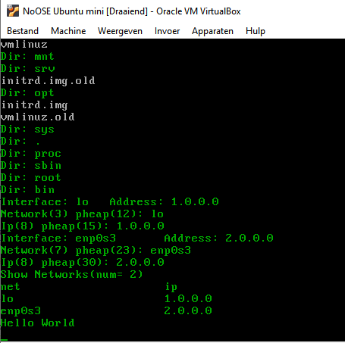

Memory
Finally the memory. The available memory must be investigated.
- Search 'linux c amount of used and free memory':
  - https://stackoverflow.com/questions/391107/how-do-i-find-out-how-much-free-memory-is-left-in-gnu-c-on-linux
on linux you can read /proc/pid/status
+------------+
| stack | high addresses
| v |
+------------+
| unused |
+------------+
| ^ |
| heap |
| |
+------------+
| bss |
+------------+
| data |
+------------+
| text | low addresses
+------------+

This is a C function to return the amount of free memory on the Raspberry PI. It works by reading the /proc/meminfo. I'm not sure if it works for other systems.

#include <stdio.h>
#include <string.h>
// Return the amount of free memory in kbytes.
// Returns -1 if something went wrong.
int getfreememory()
{
int returnValue;
const int BUFFER_SIZE = 1000;
char buffer[BUFFER_SIZE];
FILE *fInput;
int loop;
int len;
char ch;
returnValue = -1;
fInput = fopen("/proc/meminfo","r");
if (fInput != NULL)
{
while (!feof(fInput))
{
fgets(buffer,BUFFER_SIZE-1,fInput);
if (feof(fInput))
{
break;
}
buffer[BUFFER_SIZE-1] = 0;
// Look for serial number
if (strncmp(buffer,"MemFree:",8)==0)
{
// Extract mem free from the line.
for(loop=0;loop<BUFFER_SIZE;loop++)
{
ch = buffer[loop];
if (ch == ':')
{
returnValue = 0;
continue;
}
if (ch == 0)
{
break;
}
if (returnValue >=0)
{
if (ch >='A')
{
break;
}
if ((ch >='0') && (ch <='9'))
{
returnValue = returnValue * 10 + (ch-'0');
}
}
}
break;
}
}
fclose(fInput);
}
return returnValue;
}

  - https://www.cyberciti.biz/faq/linux-check-memory-usage/ (various command lines)
  - https://gist.github.com/ajithbh/8154257
void mem_avail(void)
{
char *cmd = "awk '{ if (NR == 2) { print $4 }}' /proc/meminfo";

FILE *cmdfile = popen(cmd, "r");
char result[256] = { 0 };

while (fgets(result, sizeof(result), cmdfile) != NULL) {
printf("%s\n", result);
}

pclose(cmdfile);
}

// Alternately for free memory and other info
//------------------------------------------

#inclde <sys/sysinfo.h>

int sysinfo(struct sysinfo *info);

struct sysinfo {
long uptime; /* Seconds since boot */
unsigned long loads[3]; /* 1, 5, and 15 minute load averages */
unsigned long totalram; /* Total usable main memory size */
unsigned long freeram; /* Available memory size */
unsigned long sharedram; /* Amount of shared memory */
unsigned long bufferram; /* Memory used by buffers */
unsigned long totalswap; /* Total swap space size */
unsigned long freeswap; /* swap space still available */
unsigned short procs; /* Number of current processes */
unsigned long totalhigh; /* Total high memory size */
unsigned long freehigh; /* Available high memory size */
unsigned int mem_unit; /* Memory unit size in bytes */
char _f[20-2*sizeof(long)-sizeof(int)]; /* Padding to 64 bytes */
};

unsigned long mem_avail()
{
struct sysinfo info;

if (sysinfo(&info) < 0)
return 0;

return info.freeram;
}

Two routes are of interest. Using '/proc/meminfo' or the use of the sys/sysinfo-lib.
First to start inspecting /proc/meminfo:
>cat /proc/meminfo | more
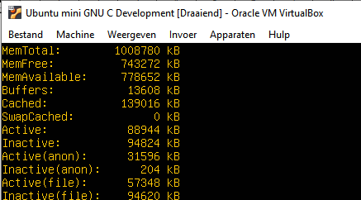
This is on a normal VM running linux. It is interesting to see '/proc/meminfo' in init.c.
Lets: Show /proc/meminfo in init.c.
- In init.c:
cmd = popen("cat /proc/meminfo", "r");

while (fgets(buffer, sizeof(buffer), cmd) != NULL) {
printf("%s\n", buffer);
sleep(5);
}

pclose(cmd);
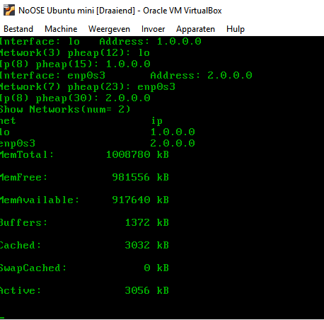

- Using sys/sysinfo:
#include <sys/sysinfo.h>

// struct sysinfo {
// long uptime; /* Seconds since boot */
// unsigned long loads[3]; /* 1, 5, and 15 minute load averages */
// unsigned long totalram; /* Total usable main memory size */
// unsigned long freeram; /* Available memory size */
// unsigned long sharedram; /* Amount of shared memory */
// unsigned long bufferram; /* Memory used by buffers */
// unsigned long totalswap; /* Total swap space size */
// unsigned long freeswap; /* swap space still available */
// unsigned short procs; /* Number of current processes */
// unsigned long totalhigh; /* Total high memory size */
// unsigned long freehigh; /* Available high memory size */
// unsigned int mem_unit; /* Memory unit size in bytes */
// char _f[20-2*sizeof(long)-sizeof(int)]; /* Padding to 64 bytes */
// };

struct sysinfo info;
sysinfo(&info);
printf("totalram: %lu\n",info.totalram);
printf("freeram : %lu\n",info.freeram);

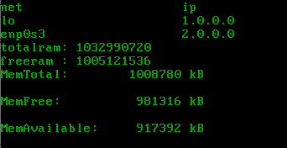

Fail, both construct do not have the same result.
The /proc/meminfo is the acurate value. The module sys/sysinfo is not reliable since we are in init.c. The code to make the meminfo text into a numeric value in the above can be used.
Total and FreeMemory can be extracted and stored in two variables 'long totalmem' and 'freemem' in bytes.
Lets: Extract 'totalmem' and 'freemem' from /proc/infomem.
- In init.c:
cmd = popen("cat /proc/meminfo", "r");
long totalmem;
long freemem;
int loop;
int len;
char ch;
while (fgets(buffer, sizeof(buffer), cmd) != NULL) {
printf("%s\n", buffer);
if (strncmp(buffer,"MemTotal:",9)==0) {
totalmem= -1;
// Extract mem free from the line.
for(loop=0;loop<=strlen(buffer);loop++)
{
ch = buffer[loop];
if (ch == ':')
{
totalmem = 0L;
continue;
}
if (ch == 0)
{
break;
}
if (totalmem >=0L)
{
if (ch >='A')
{
break;
}
if ((ch >='0') && (ch <='9'))
{
totalmem = totalmem * 10 + (ch-'0');
}
}
}
totalmem*= 1024;
printf("MemTotal: %ld\n",totalmem);
}
if (strncmp(buffer,"MemFree:",8)==0) {
freemem= -1;
// Extract mem free from the line.
for(loop=0;loop<=strlen(buffer);loop++)
{
ch = buffer[loop];
if (ch == ':')
{
freemem = 0;
continue;
}
if (ch == 0)
{
break;
}
if (freemem >=0)
{
if (ch >='A')
{
break;
}
if ((ch >='0') && (ch <='9'))
{
freemem = freemem * 10 + (ch-'0');
}
}
}
freemem*= 1024;
printf("MemFree: %ld\n",freemem);
}
sleep(5);
}

pclose(cmd);

Done, remark:
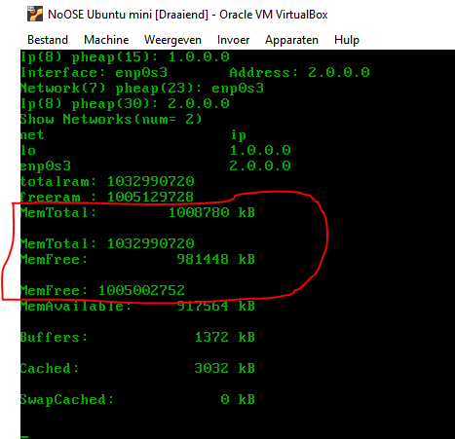
The final calculation is the value found * 1024 to represent the amount of bytes instead of KB.

Conclusion
The intend was to create an OS less programming environment based on the Linux HAL. The idea was to rewrite init.c.
The issue was to see if the various resources are available in init.c and can be accessed without any problem.
The code base presented in this project is doing this. There is a code base to find and access the harddisk, the network and the memory parameters.
In this way the program in init.c can be regarded as a function running without an Operating System or OS.
The NoOSE was successful and shows a program without OS can be implemented.

Complete install of NoOSe Development Environment
The NoOSe development environment is a clever combination of two virtual linux machines using VirtualBox and the host file system, which is windows in this case.
The one VM is the development environment using gcc and the standard libc modules to create the init.o object file.
The develop VM is also connected to the repository directory on the host filesystem in which init.c resides.
Changes are made in this init.c file on the host filesystem which also holds the init.o compiled target.
The other VM is the NoOSe virtual machine.
Each virtual machine has a root harddisk VHD on which the linux system is installed.
The development VM also gets the NoOSe root vhd as the second harddisk. In this way the develop VM is connected to the NoOSe VM. If the NoOSe VM is not running the development VM can access the NoOSe root harddisk.
If a new init.o object file is compiled using gcc it can be copied to the NoOSe VM root harddisk. If the develop VM suspends the NoOSe VM can be started which will use the new init.o file.

In this chapter the complete installation of this configuration is described without further comment. Details can be found in the previous.

Install Virtual Box
https://www.virtualbox.org/wiki/Downloads
Click VirtualBox 6.1.1.16 platform packages>> Window hosts.
After download, run: VirtualBox-6.1.16-140961-Win.exe

Install Develop VM
Lets: Download Ubuntu bionic headless server iso.
- On host in Browser: 'https://help.ubuntu.com/community/Installation/MinimalCD'.
- On 'Installation/MinimalCD':
Section '64-bit PC (amd64, x86_64)': Open link '1. Ubuntu 18.04 bionic Beaver' in a new window,
Download of 'mini.iso' start;
Rename the file to 'Ubuntu 18.04 bionic Beaver-mini.iso';
Copy iso to github-repo directory;
RClick the iso-file; mount (koppelen) and the content of the iso-file is visible.
Done.
Lets: Create a VirtualBox VirtualMachine.
- On Host: Start VirtualBox.
- In VirtualBox: In toolbar click [New].
- In Create:
Name: Ubuntu mini GNU C Development;
Machine dir: D:\VirtualMachines\VBox;
Type: Linux;
Version: Ubuntu (64 bit);
Next.
- In Memory: 1024 Mb; Next.
- Hard disk: select 'Create virtual hard disk'; Create.
- Disk Type: VHD; Next
- Disk size: Fixed; Next
4 Gb; Create.
- In VirtualBox:
Ubuntu mini GNU C Developer>> RClick Start>> Normal Start.
- In Select Boot Disk:
Select: 'D:\20160730developTibrr\Imda\projects\iG\projects\_dSigns\smach\BArrNet\Noose\github' iso image 'mini.iso'.
- In VM: Install Ubuntu Server base system only, last item in the software lisr (rob; BA)
- In the bottom second icon: Eject CDROM.
- Restart VM and UbuntuDevelop boots up.
Done, ubuntu is installed.

Install NoOSe VM
Lets: Create a VirtualBox VirtualMachine.
- On Host: Start VirtualBox.
- In VirtualBox: In toolbar click [New].
- In Create:
Name: NoOSe;
Machine dir: D:\VirtualMachines\VBox;
Type: Linux;
Version: Ubuntu (64 bit);
Next.
- In Memory: 1024 Mb; Next.
- Hard disk: select 'Create virtual hard disk'; Create.
- Disk Type: VHD; Next
- Disk size: Fixed; Next
4 Gb; Create.
- In VirtualBox:
Ubuntu mini GNU C Developer>> RClick Start>> Normal Start.
- In Select Boot Disk:
Select: 'D:\20160730developTibrr\Imda\projects\iG\projects\_dSigns\smach\BArrNet\Noose\github' iso image 'mini.iso'.
- In VM: Install Ubuntu Server base system only, last item in the software lisr (rob; BA)
- In the bottom second icon: Eject CDROM.
- Restart VM and UbuntuDevelop boots up.
Done, ubuntu is installed.

Make a Host directory available in VM Develop
Lets: Make the host directory '...\Noose\github' available in VM Develop.
- On Host in VirtualBox: Select VM Develop;
Click op Settings.
- In Settings: Shared folders>> Config shared folders:
Klik [+] (Add).
- In Add shared folder:
Path: '...\Noose\github';
- Click OK; OK.
Done.
Next the virtualbox guest tools must be installed on the guest linux.img Develop. Use the Foldername 'github(or xxx in your case)' from the above to mount properly.
Lets: Make VM Develop ready to do shared files.
- On host start VirtualBox: Run VM Develop.
- In VM Develop:
sudo apt-get update
sudo apt-get install --no-install-recommends virtualbox-guest-utils
whoami
rob
sudo adduser rob vboxsf
sudo reboot
lsmod | grep -io vboxguest
vboxguest
modinfo vboxguest
shows info
sudo mkdir /media/github
sudo mount -t vboxsf github /media/github
ls /media/github

Done, result:
Finally see for it the mount to /media/git is permanently:
Lets: Config fstab on VM Develop.
- On Host start VirtualBox: Start VM Develop.
- In Develop:
log in;
Do the following:
>sudo nano /etc/fstab
Add the following line to fstab (separated by tabs). Make sure to replace <username> with your username. Save the file.
github /media/github vboxsf defaults 0 0

>sudo nano /etc/modules
Add the following line to /etc/modules and save
vboxsf

>sudo shutdown -r now

restart
log in
ls /media/github

Done, Result:
Immediately after reboot and login the host directory is available.

Join the NoOSe root HD to Develop VM
Lets: Connect NoOSE.vhd as harddisk to Develop.
- On Host: Start VirtualBox.
- In VirtualBox:
Select on Virtual Machine Ubuntu mini GNU C Development;
Click Settings.
- In Settings>> Storage>> Controller SATA: Click Add Harddisk:
Add from 'D:\VirtualMachines\VBox\NoOSE Ubuntu mini' the harddisk file 'NoOSE Ubuntu mini.vhd'.
Done, the VM Develop has the NoOSE system harddisk attached.

Lets: Create an init-original copy of the current init file also to show the development directory explicitly.
- On the Host in VirtBox: Start VM Develop having the NoOSE.vhd attached as second hard drive (sdb1).
- Log in as development user.
- In Develop:
sudo mount -t ext4 /dev/sdb1 /media/NoOSE
and for permanent mounting:

>sudo nano /etc/fstab
Add the following line to fstab (separated by tabs). Make sure to replace <username> with your username. Save the file.
/dev/sdb1 /media/NoOSE ext4 defaults 0 0

- Copy /media/NoOSE/sbin/init to /media/NoOSE/sbin/init-original:
sudo cp /media/NoOSE/sbin/init /media/NoOSE/sbin/init-original

Done.

